Title of the Project

University Logo

2017-FYP-AB

Group Members

2017-EE-abc Name

2017-EE-abc Name

2017-EE-abc Name

2017-EE-abc Name

Supervisor

Dr. XYZ

Co-Supervisor

Dr. XYZ

**Department of Electrical Engineering**

**University of Engineering and Technology, Lahore**

# 

**Table of Contents**

**Abstract** **2**

**Introduction** **2**

**Problem Statement** **2**

**Literature Review** **3**

**Project Overview and Objectives** **3**

**Project Development Methodology/Architecture** **3**

**Project Milestones and Deliverables** **3**

**Block Diagram** **3**

**Flow Chart** **3**

**Work Division** **3**

**Costing** **4**

**References** **4**

# Abstract

Abstract of the project proposal (Maximum 350 words)

# Introduction

Discuss the opening perspective of the problem area, the challenge in that area, and refine the challenge into a concise statement. (1 to 2 pages)

# Problem Statement

Unmet need or problem,

what is the unmet need or problem the FYP is aiming to solve?

How significant is the problem? Quantify as much as possible.

In case of a research problem, show the significance of the unsolved problem. Who needs it?

List the type of customers who want a solution to the problem.

For each type of customers indicate the potential market size. In case of a research problem, identify where this research will be used? (1 page)

# Literature Review

What has been done by others to solve the problem?

What solutions are already present in the market?

what are their disadvantages?

In the case of a research problem, a literature review of the state-of-the-art should be included.

At least 10 latest research paper references should be cited in the literature review. (2-3 pages)

Over the last decade, retailers are facing significant obstacles, such a staff planning, unavailability of stocks, accumulation of unwanted items, and the inability to accurately forecast demands, etc. It has been known, that without adequate preparation and strategy, the attempt to capture more of the market is useless.

When a customer shops from a store, many questions come in mind of retailers such as what items were purchased? At what time? How long did they shop? and so, that retailers struggle to understand what data to focus on. To make it more difficult, nowadays trend changes within a couple of seconds. Customer have an abundance of choices to make and their preferences changes according to the trend at that moment, making it harder for retailers, to keep up with the comping changes in the trend as well as customer's shopping behavior.

Complex retail operations and management is also not an easy task for retailers. All these problems result in poor performance/sales, and ultimately, result in profit loss. Thus, to prevent these issues, we propose an effective method, based on crowd features analysis and AI, for better retail operations, customer satisfaction, and profit.

This project is modeled upon a people counter, namely, "Smart Crowd Analyzer", which is a bidirectional wireless crowd analysis device based on a smart networked video-camera that analyses crowd using artificial intelligence and deep learning algorithm. The project is based on prior research with the addition of embedded features such as group detection, age detection, height detection, gender determination, regular customer detection, and bag detection. These features allow us to determine a pattern in the customer’s behavior.

The methodology adopted in this work is to track and count people individually as well as in a group. The dataset is obtained by capturing images and by calibrating the camera position at the entrance to achieve precise camera projection. According to the traits, an analytical report is generated, that optimize sales, and helps in producing efficient marketing schemes.

The proposed work is aimed to gain deep analysis and tracking in retail operations. Furthermore, a comprehensive understanding of customer behavior and interaction, not only help retailers to build a relationship of loyalty with the customers but also help retailers in amplifying their sales and create mass production. The project also aims to aid our investors in tracking their business (especially when they have chain stores), automate task distribution, and ensure proper working process, such as automatically sends a message for the restocking.

For Future aspects, the proposed algorithm can be modified by adding an object detector, in case of theft/for security purposes. Further improvements can be made in the data collection section, such as setting goals, maintaining customer record and creating a backup on Cloud.

Adopting deep learning algorithms, the product features an accuracy of 97% or greater,a smart crowd analyzer that tops the industry of crowd analysis devices.

The notion of a simple people counter can go a long extends in solving pesky situations we, as humans, encounter. For instance, a supermarket company, being unaware of how many customers visit during the peak hours of the market itself, can transpire into problems such as attaining lack of analysis regarding which stocks are more coveted, followed by the more unpopular choices, which ultimately leads to the wastage of stock items, sales stagnation, and may lead to a loss in overall profit for the company running the market.

Given how global business has blossomed over the years, it is imperative for various companies and firms to get to grips with the latest technological advancements that may help in maintaining the development of their respective businesses, no matter how small or trivial the instalment may seem. In other words, stock handling, as well as stock distribution to different franchises can be monitored efficiently by knowing how many people are interested in products. Having the knowledge of how many people come and purchase such items can be of much benefit. Another main prerogative of this project is to be of importance in other various locations, such as the aforementioned football stadiums, in restaurants/ café’s, concerts, libraries, museums etc. Acquiring information of the number of people being present at such places can prove to be statistically significant, enabling the owners to survey and compare the influx of the public at such places. This will allow them to keep track of how these places are doing in terms of attracting the public and what amendments do they need to make in order for a larger influx of people.

People monitoring and counting is an active area of research and has seen several developments since the inception of deep learning. The typical people counting processes involved a person standing with a clicker physically counting people as they passed. As an individual can imagine, this is a job that is tedious and prone to errors. However, as technology has blossomed over the past few decades, various algorithms to employ people counting is now available, utilizing different types of cameras, sensors, and trackers.

Single beam infrared sensors project a beam of infrared light across a doorway. When a person breaks the beam of light by passing through the doorway, their presence is detected. Single beam sensors only offer limited accuracy as they cannot distinguish multiple people walking together. They also do not record whether a person is entering or leaving the room.

Thermal cameras use people’s body heat to detect their presence. They use motion to distinguish people and can record which direction a person is moving in. However, they can struggle to count people accurately if they stand still, walk close to each other, and are also prone to error when, for example, the door of an air-conditioned building is opened on a hot day.

CCTV people counters rely on installing software into existing CCTV systems. As CCTV systems typically use one camera to count people, they suffer from reduced accuracy due to a lack of depth perception and interference from environmental factors such as shadows. installations are typically aimed at security concerns and are often not positioned in the optimal way for people counting duties. There is also a growing concern over privacy and GDPR compliance due to the fact CCTV cameras capture images of people’s faces, which enables identification.

Stereovision people counting systems use two cameras to provide depth perception and improved counting accuracy compared with single-camera solutions. Stereovision is more expensive than other people counting technologies and is still limited by environmental conditions such as ambient lighting conditions.

It must be understood that each method has its limitations, which, due to the nature of the equipment, typically concerns accuracy and privacy protection of people moving around a space.

Thus, in-order to prevent such, we have pitched the idea to design a state-of-the-art people counter, namely the *Smart Crowd Analyser.* In simple context it is a real-time system for indoor people counting, based on a slightly-aligned wireless sensing-video camera. There is a booming interest in video-based solutions akin to people monitoring, as well as counting in business and security applications. Unlike the classic sensor-based implementations, these ones allow for more versatile functionalities, (such as emotional detection, individual tracking as well as group detection, bi-directional counter, age, height, gender determination, along with that, regular customer detection and staff exclusion solution has also been employed, for better functioning of people counter system.

In group counting, the project will have the capability to count large groups of people as well as individuals. This feature will display and will depict the data on how many families/large gatherings have been visiting a specific location at a specific time. On the other hand, physical characteristics (age, height and gender) will result in knowing what age group of the common people is interested in certain products, coupled with the dominant gender of these people. A more obvious feature of this analyser is that it will have the capability to distinguish the persons entering or leaving a particular place, so that a person, is not counted twice in the total amount. This will also help in time spent by each individual at a shop in, suppose, a shopping mall, and other tricky places, where finding the number of people may prove to be difficult at hindsight.

Through this project we gain deep insights into our retail operations and helps in producing marketing initiatives and develop a comprehensive understanding of customer behavior and interaction within our stores or in shopping malls and public environments. Which will help in increases sales and create mass productivity, hence, business will flourish. This project will also aid our investors in tracking their business especially when they have a chain stores.

Our service includes:

* Stock Management
* Sales Conversion
* Visual Surveillance
* Public Space Designing
* Retail Analysis Report

Further improvements can be made in data collection section, such as setting goals, and maintain customer record with the products and creating a backup on Cloud. In case of Security, we can add Tracking detector and an Object detector, in case of theft.

In Public sector, our project can be utilized in such a way, it may help during voting period. Managing data which will ease the workers and will save time in generating result. Similarly, it can be used in Administration Sector such as NADRA. Or in daily used public service system such as, in bus terminals.

Adopting deep learning algorithms, the product features an accuracy of 97% or greater,a smart crowd analyzer that tops the industry of crowd analysis devices.

# Project Overview and Objectives

Discuss the overview/goal of the project and highlight the proposed solution.

Give your value proposition. How is your solution going to be different and better than others?

Students must describe to maximum detail the final project output, it’s expected packaging, and hardware and software components.

In case of a research problem, how the proposed research solution is expected to be better than the state-of-the-art?

\subsection{}

The objective of the project is to develop an algorithm to count and monitor multiple people and through their traits, we predict the need for availability of that precise (size) of the item and through analyses of the sales, we comprehend the restocking of items.

The goal of this project is to use open-Frameworks C++ application on the Raspberry Pi to handle the camera input, image abstraction, tracking, and people counting.

* Detect the **gender** of people visiting.
* Detect the **age**of people with respect to classified age groups.
* Detect the **height**of customers, for future stock management.
* Detect the **regular customers,** for bridging the gap between retailers and customers. Also generating some discounts or priority for them.
* **Omit staff** from detection, in order to make counting of customers more precise.
* Detect **groups of people** visiting a shop. Hence, will be able to comprehend the days/ the month, when families or groups mostly visit a shop/retail.
* Generate **real time** stats and analysis report**.**
* Generate **daily, weekly**, **monthly**and **yearly** chart reports.

# Project Development Methodology/Architecture

Distribute the project goals into smaller objectives/modules and highlight deliverables for each objective.

Explain the modules of the project through a system-level block diagram.

Students may also mention tools, technologies, and suitability of the method(s) to be employed with justification.

In case of a research problem, show the few approaches that will be investigated in the project? (2-3 pages)

\section{ Project Development Methodology/Architecture}

The methodology adopted for the features are categorized as the following below:

\subsection{Door Counting}

**\begin{itemize}**

**\item \textbf{Age Detection}**

**\newline**  
Once facial features (e.g. eyes, nose, mouth, etc.) are localized by PiCamera, their sizes and distances measured, ratios between them are calculated. Then, face classification is done into different age categories according to self-made rules. PiCamera will detect facial features live time and will compare it with models on which the system would be trained. LBP descriptor variations and a dropout-SVM classifier will be used to increase the accuracy of detection.

**\item \textbf{ Gender Detection}**

**\newline**  
Webers Local texture Descriptor will be used for gender recognition, demonstrating near-perfect performance on the FERET benchmark. Popular Labeled Faces in the Wild (LFW) benchmark, primarily used for face recognition, will be used for this project. The method is a combination of LBP features with an AdaBoost classifier. As with age estimation,  the main focus will be on the Adience set which contains images more challenging than those provided by LFW.

**\item \textbf{ Height detection}**

**\newline**

Through HoG (History of Orientated Gaussians) and SVN (Support Vector Machines) detector, tracking will be computed. The height of the person will be obtained by measuring the height of the contour of that person, after getting the coordinates from the bounding box pixel height is estimated.  Afterward, some correlation could be estimated between pixel height and real-world height.

**\item \textbf{ Group of People Detection}**

**\newline**

HoG (History of Orientated Gaussians) and SVN (Support Vector Machines)  detector will help to compute the tracking (similar to counter and height detection). In this case, contour dependence on each other is checked with time. From the initial position to the final position. If their contours have some relatable movement and are close to each other, it means that they are of the same group. Hence, this way, a group of peoples in the area will be detected.

**\item \textbf{ Regular Customer Detection}**

**\newline**

Datasets will be generated containing the different faces of customers coming inside. Then, if that person comes again and his facial features will be matched with previously-stored datasets. It will be deduced that the person is a regular customer in a retail store.And we can also Find regular customer by tracking the WiFi Ip of the customer and if the person with same WiFi ip enters again , regularity would be found.

**\item \textbf{Bi-Directional Counter}**

**\newline**

**\item \textbf{Staff Exclusion}**

**\newline**

\item **\textbf{** **Heat map }**

\newline  
Heatmap helps us in occupancy management. It shows the area more filled and the path the customers take. Which side of shop/platform attracts them more. We can generate heat map with WiFi IP of customers or by camera . For camera we will have to use multicam. This will help in occupancy management.

\end{itemize}

\subsection{Analysis Report}

\begin{itemize}

\item **\textbf{** **Statistics Generation}**

**\newline**  
Data will be displayed in Chartjs.org. ChartJS is a lightweight javascript library that uses HTML5 and Canvas to generate and render charts. It will display data in a number of different chart types such as pie, bar, line and polar. It will obtain data from the database (MySQL, PHP, and Javascript) and then generate, display and update charts. This will include the outcomes of door counting and the business trends with the efficiencies of stocks etc. This will be our final outcome which can be delivered in MOBILE APP or as a monthly report.

\item **\textbf{** **Sales Conversion}**

**\newline**  
Sale conversion is a ratio of number of people doing shopping to number of people entering the shop. It tells about the effectiveness of stock . Number of people entering the shop will be counted by door counter and number of people doing shopping can be counted by tracking shopping bags or number of transactions being made at counter. We can use any of this method to count number of people doing shopping.

\item **\textbf{Stock Management}**

**\newline**

\item **\textbf{Staff Management}**

**\newline**

\item **\textbf{Discount/Deals Management}**

**\newline**

\item **\textbf{Business Trend Monitoring}**

**\newline**

**\end{itemize}**

# Project Milestones and Deliverables

Clear milestones should be defined at the start of the project which includes **a Gantt chart** in the project management document. It is recommended to use excel or some equivalent software to make a Gantt chart (1-2 pages)

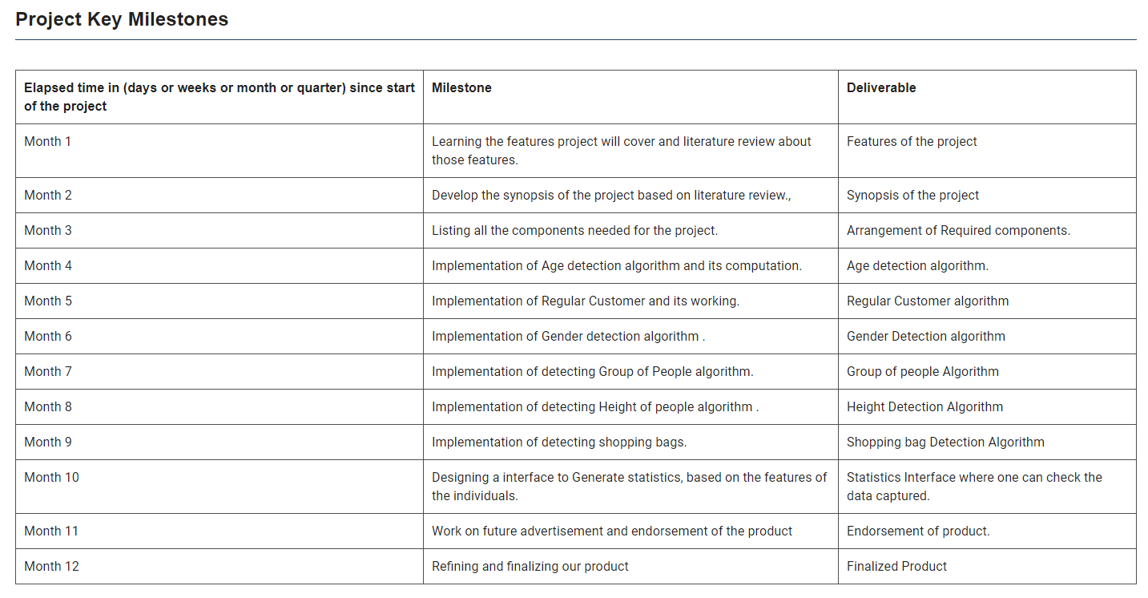

\subsection{Project Deliverables}

The project provides its users with vivid of benefits such as:

\begin{itemize}

\item Combination of embedded features such as group counting, age, height, gender determination, regular customer detection, staff exclusion.

\item In Group Detection, our study has the capability to count groups of people rather than picking them off as individuals. It will comprehend the number of families/groups that visit a specific location and a specific time and using Machine Learning algorithms may introduce family/friends discounts on specific days/timings.

\item The People Counting algorithm will distinguish the person from entering and leaving a particular place, so that they are not counted twice in the total.

\item Physical traits of crowd such as age, height, and gender, will result in generating data, such as comprehending what sort of age group is interested in certain products, coupled with the dominant gender of the people.

\item Furthermore, it will generate an accurate retail statistics report, monitoring the transactions, number of visitors, and management of staff schedule, and stock, also providing public space design suggestions and visual surveillance service, on daily/weekly/monthly/yearly basis.

\end{Itemize}

This study hopes to benefit its retailers, with deep insights into retail operations and motivate effective marketing initiatives that would increment their sales. This study is also helpful for researchers and socialists, helping them develop a comprehensive understanding of customer behavior and interaction within stores or in shopping malls and public environments. This project also targets enthusiastic investors, interested in tracking their business especially when they have chain stores.

# Block Diagram

Draw a clear block diagram of your project and explain it in brief. (1 page)

# Flow Chart

Flow chart of the project/sub-divisions/member wise activities (1- page)

# Work Division

Clear work division among group members to be shown (1 page)

# Costing

Make a table of major required components with estimated prices (1 page)

NVIDIA

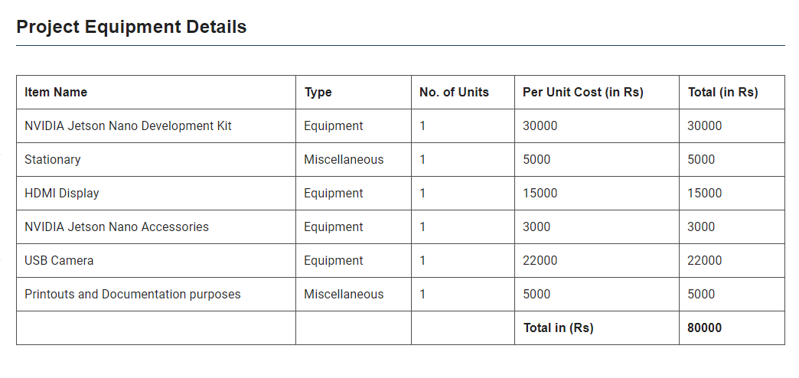

# References

Any material/information referred from research papers, books or/and websites should be acknowledged under this heading. Use the IEEE template for the references. All the references must be properly cited in the text and linked. (1-2 pages)

**General Instructions**

* Times New Roman, Font Size 12 for headings and text, spacing 1.5, margin 1 inch
* Title font size 18-24, rest of the text size is 14
* No screenshot is allowed.
* Use Latex to compile your document, no other software will be accepted.
* Use the picture of high resolutions
* Do not use the basic pin diagram or datasheet pictures.
* There should be a proper table of contents at the start
* **Add the evaluation sheet and rubrics sheet at the end of the synopsis, get it filled by the supervisor before submission (a scanned copy is to to be attached in the soft form)**
* The deadline for the synopsis submission to the supervisor is **25 September 2020** and online submission is **1st October 2020.**
* All submissions of the FYP will be checked for plagiarism. For plagiarism**, more than 15%, F grade will be awarded.**
* A link will be shared for the submission of the synopsis. Upload the complete synopsis signed and evaluated by your supervisor with the file name 2017-FYP-Group No. in pdf format only. The file with a different name will be deleted and will be awarded a zero mark.
* Use Overleaf online Latex compiler to prepare the synopsis
* Use the Grammarly extension in Chrome to check grammar errors.
* Useful link: <https://plagiarism.org/>