**Basic MongoDB** **Commands**

**show databases**

Show All Databases-Displays all existing databases.

**use unidb**

Switch to a Database-If unidb exists, it switches to it. If not, MongoDB creates it when you insert data**.**

**Show Collections**

Lists all collections (like tables) in the current database.

**MongoDB Compass Commands (GUI)**

| Command | Meaning |
| --- | --- |
| { age: { "$gt": 25 } } | Finds people older than 25. |
| { age: { "$lt": 25 } } | Finds people younger than 25. |
| { age: 25 } | Finds people whose age is 25. |
| { name: 1 } | Shows only name (with _id). |
| { name: 1, _id: 0 } | Shows name, hides _id field. |
| { skills: { "$in": ["NoSql"] } } | Finds if skills include "NoSql". |
| { skills: { "$in": ["NoSql", "JS"] } } | Finds if skills have either value. |
| { skills: { "$nin": ["NoSql"] } } | Finds if skills do not include "NoSql". |
| { gender: "female" } | Finds documents where gender is female. |
| { age: 1 } | Sorts by age ascending. |
| { age: -1 } | Sorts by age descending. |

**MongoDB Console (mongosh) Commands**

These are typed in the terminal or shell.

|  |  |
| --- | --- |
| Command | Meaning |
| db.students.insertMany([...]) | Adds multiple documents. |
| db.students.find() | Shows all documents. |
| db.students.findOne() | Shows one document. |
| db.students.find({ regno: "2021ict126" }) | Finds document where regno matches. |
| db.students.find({}, { name: 1 }) | Show only the name field. |
| db.students.find({}, { name: 1, _id: 0 }) | Show name only, hide _id. |
| db.students.find().sort({ age: 1 }) | Sorts documents by age ascending. |
| db.students.find().sort({ age: -1 }) | Sorts documents by age descending. |
| db.students.find({ age: { "$gt": 25 } }) | Finds people with age greater than 25. |
| db.students.find({ age: { "$lt": 25 } }) | Finds people with age less than 25. |
| db.students.find({ age: 25 }) | Finds people with age equal to 25. |
| db.students.find({ skills: { "$in": ["NoSql"] } }) | Finds those with "NoSql" in skills. |
| db.students.find({ skills: { "$nin": ["NoSql"] } }) | Finds those without "NoSql" skill. |
| db.students.find({ degree: "CSC", gender: "male" }).sort({ age: -1 }) | Find CSC male students, sort by age descending. |

**Create a database and collection**

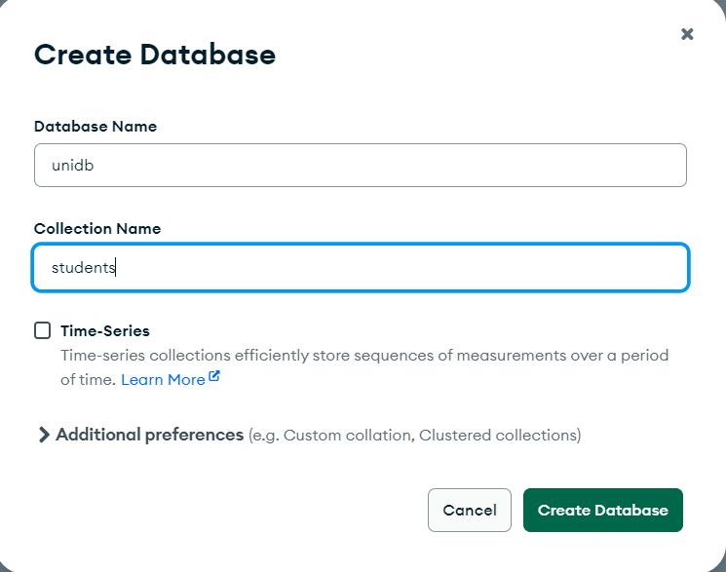

**Show databases**

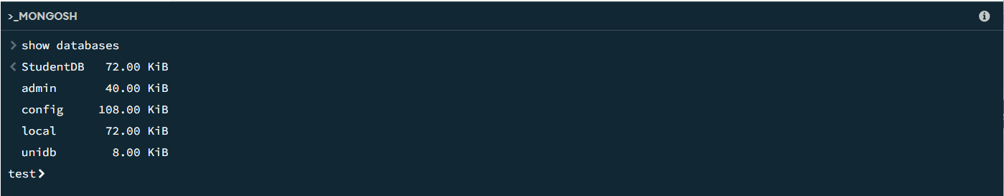

**use unidb**



**show collections**



**Insert document-Using Compass**

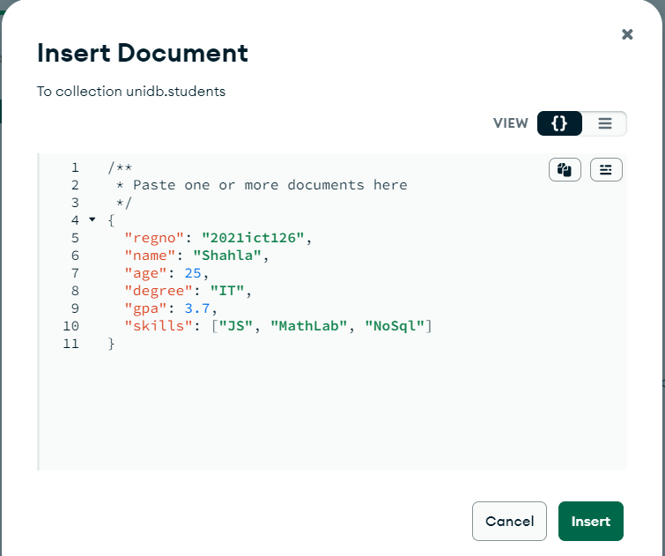

**Insert document-Using Console -------> "insertOne"**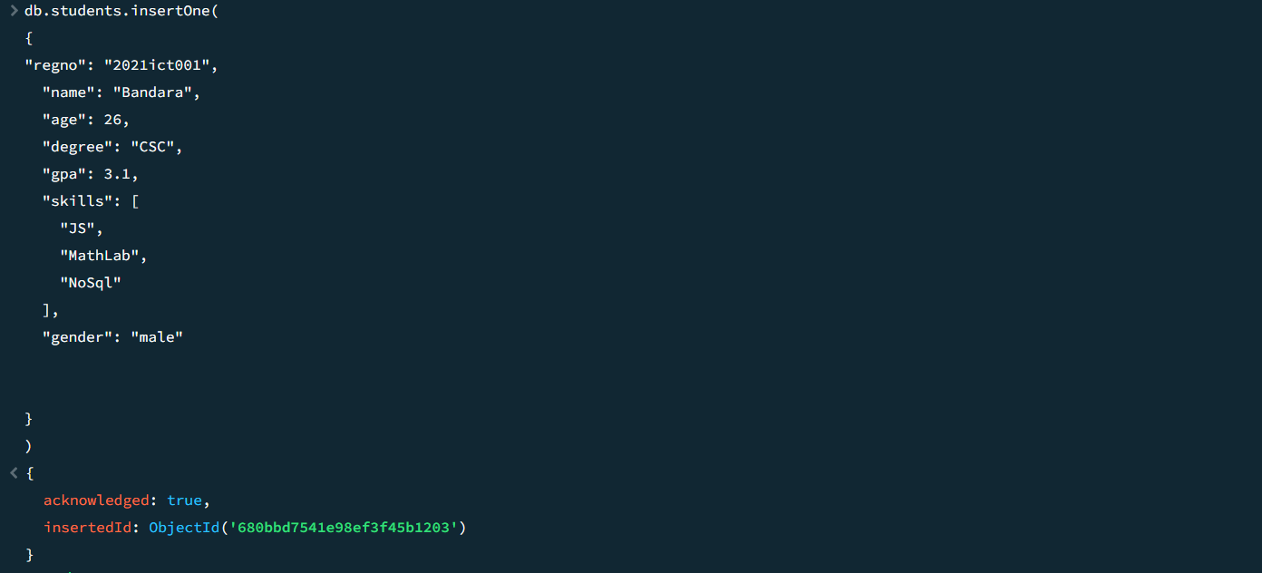

**Insert document-Using Console -------> "insertMany"**

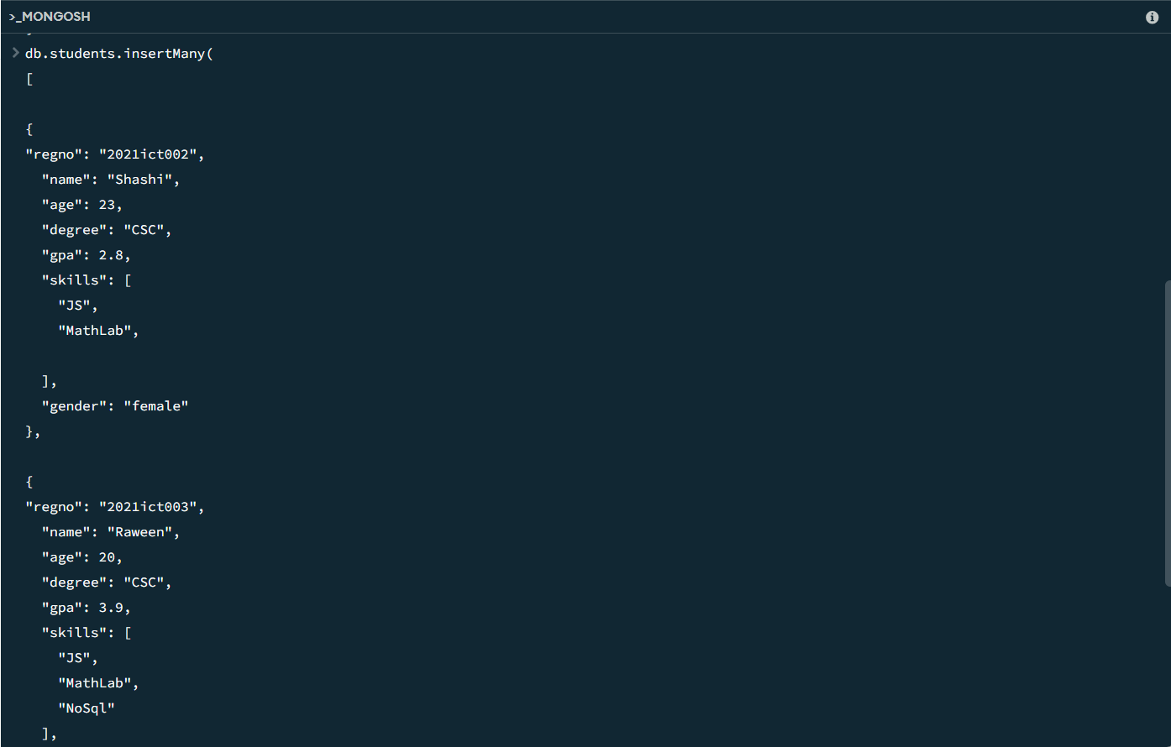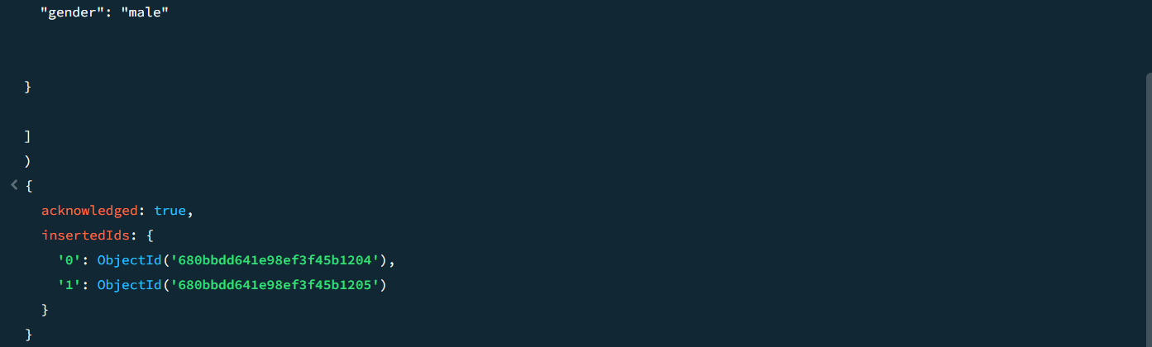

**Display all documents - Click the button find**

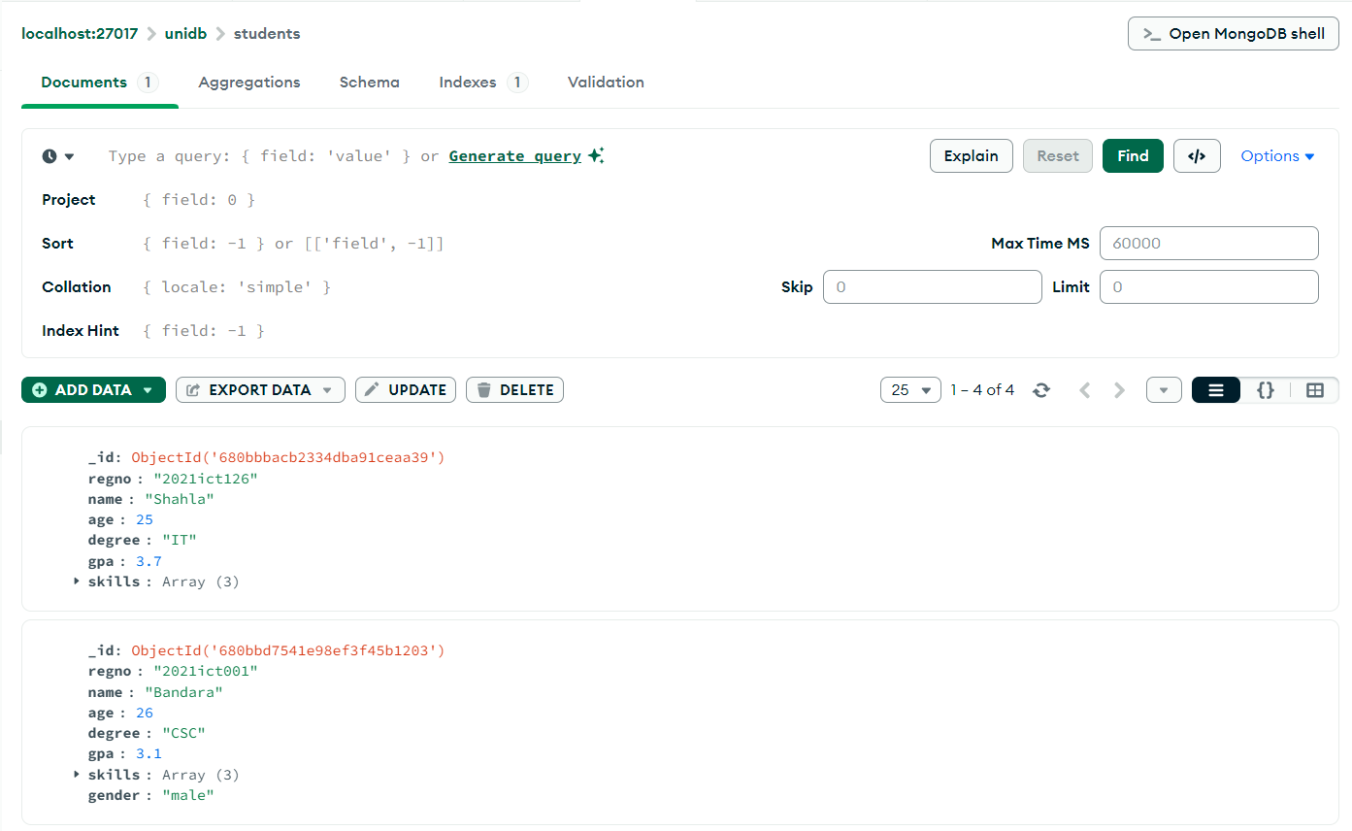

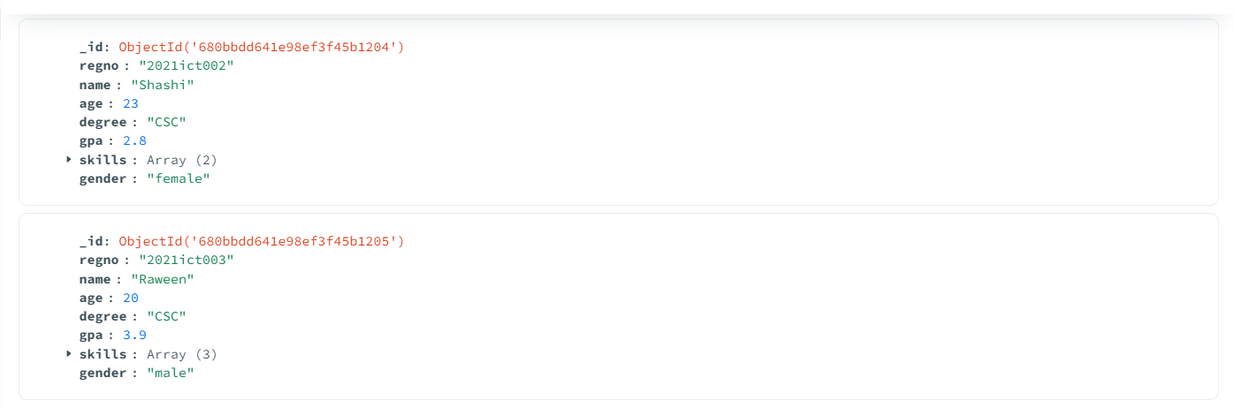

**Retrieve specific fields only**

**1.Shows name,age (with _id**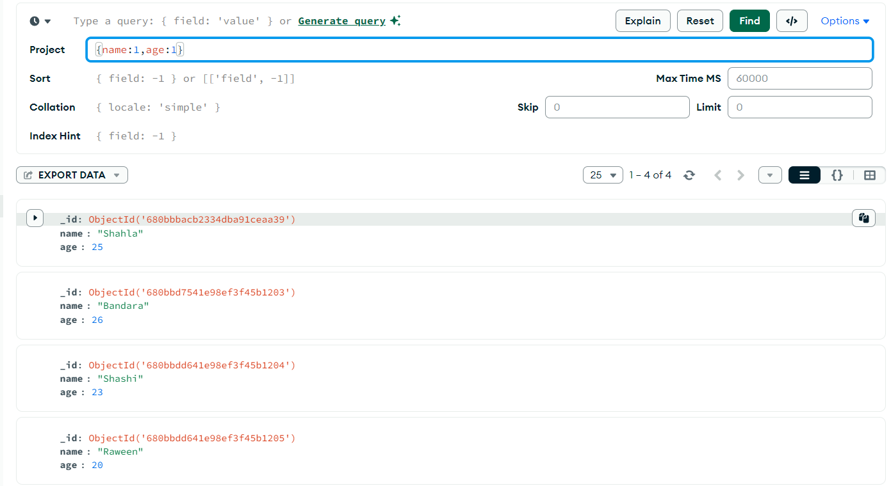

**2.Shows name,age hides _id field.**

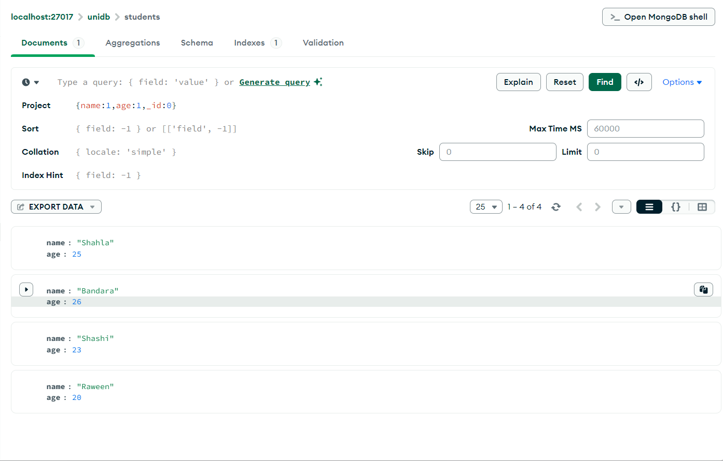

**Retrieve documents using specific value**

**1.Shows documents which regno "2021ict126" .**

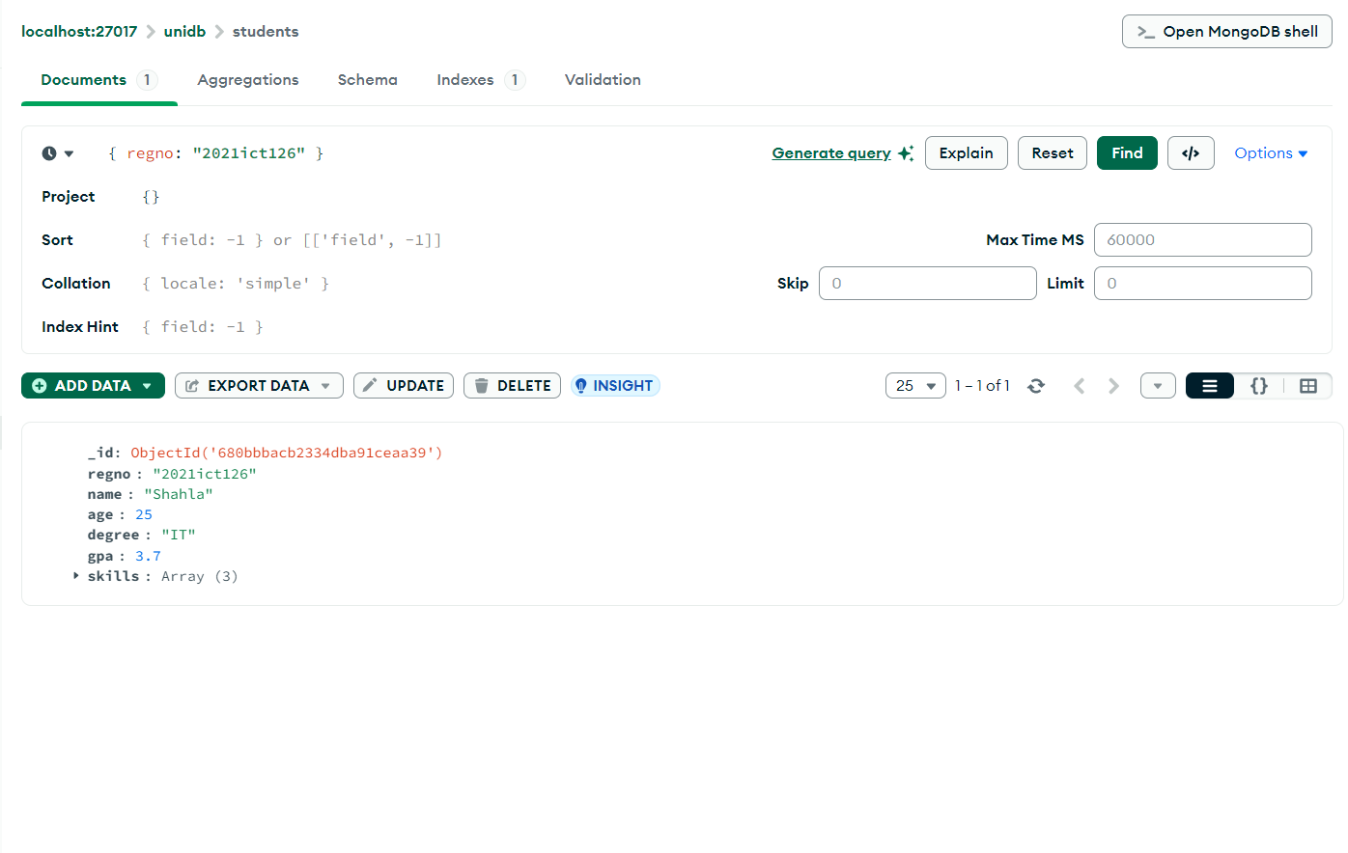

**2.Shows documents those are female.**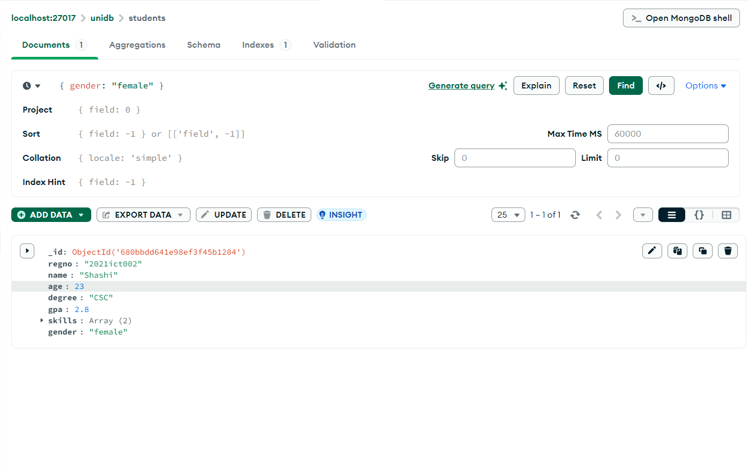

**Retrieve documents using specific value------> using console**

**1.Shows documents those are male** 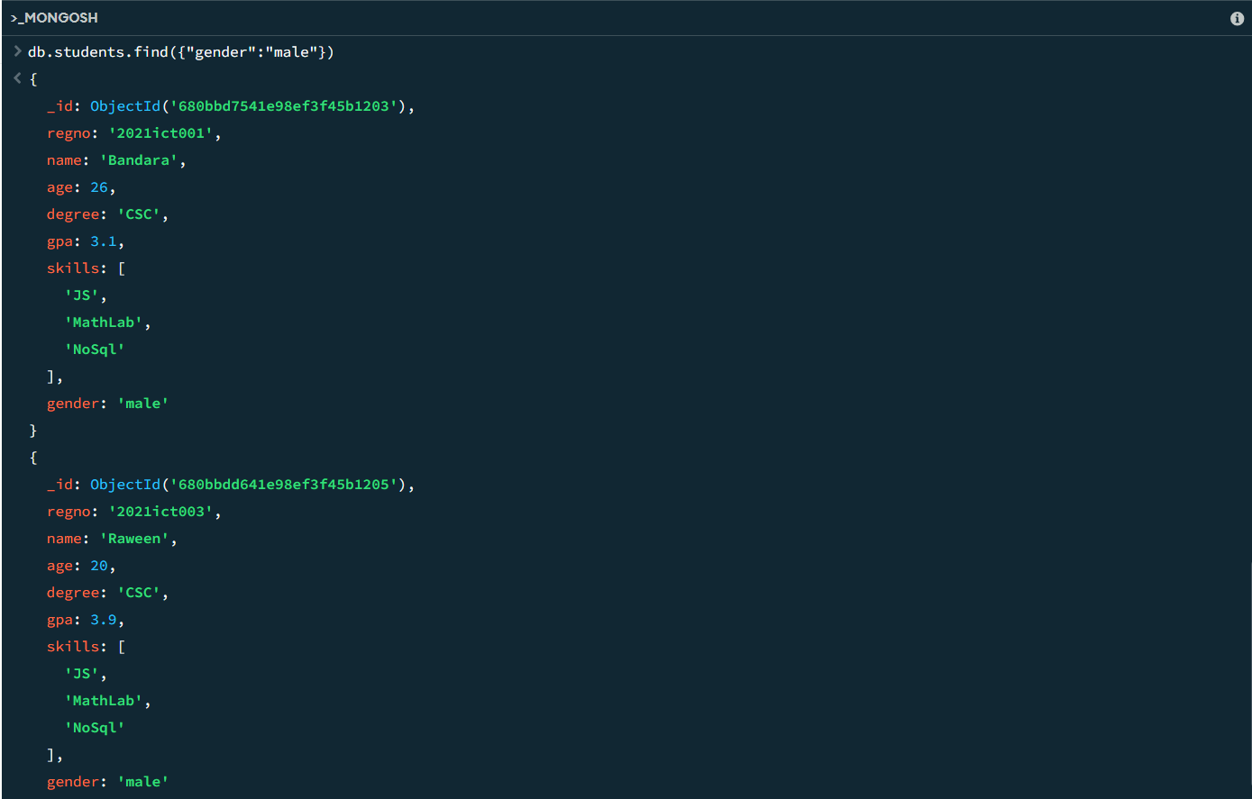

**2.Shows documents those are male--------> "findOne"**

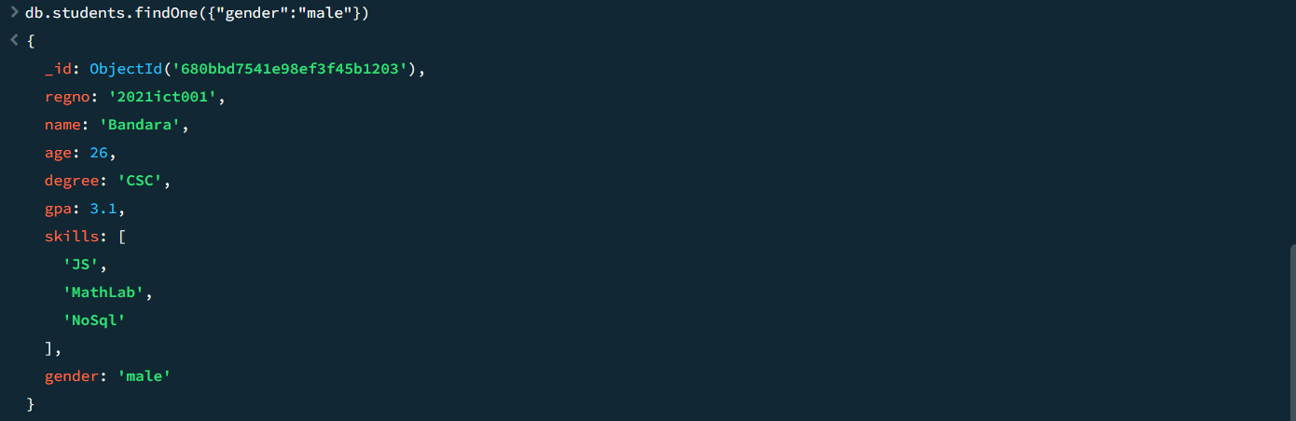

**Sort in ascending Order**

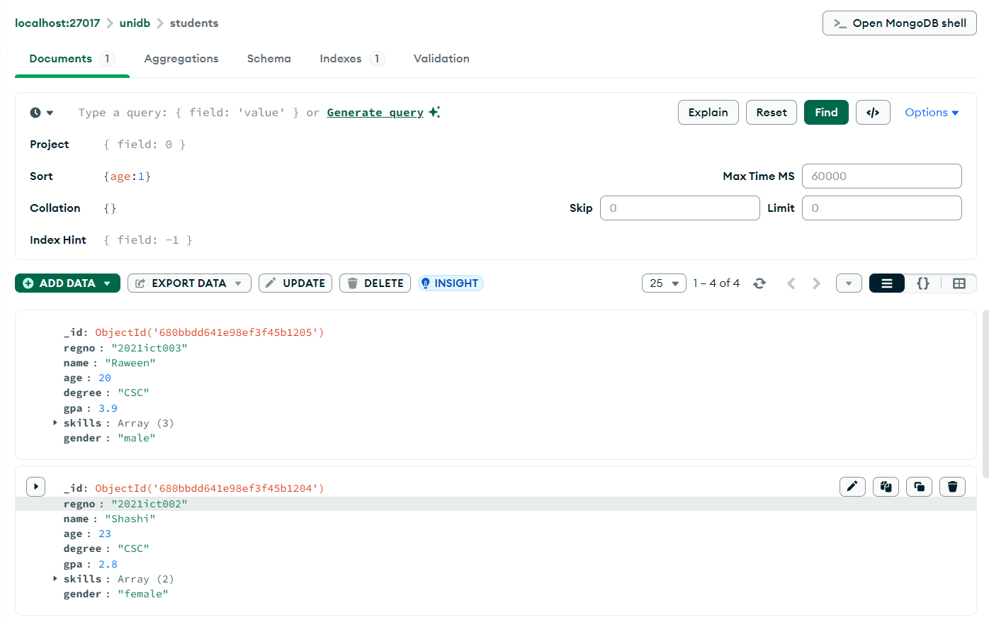

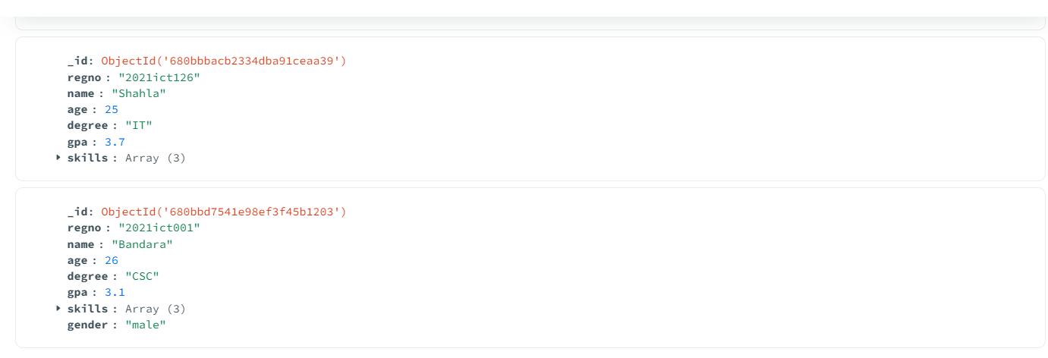

**Sort in descending order**

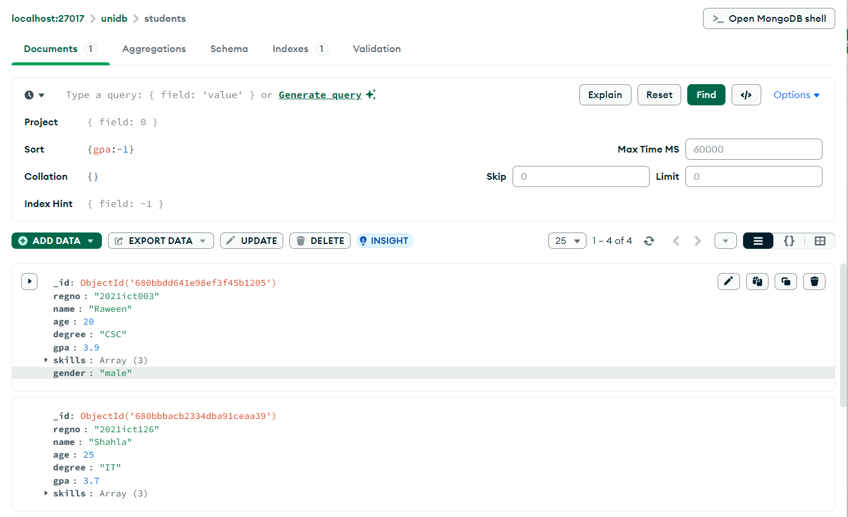

**Find the documents with comparision**

**1.Finds people with age greater than 25**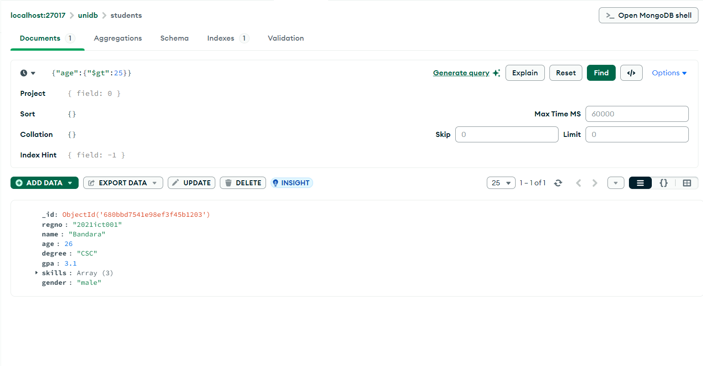

**2.Finds people with age less than 25.**

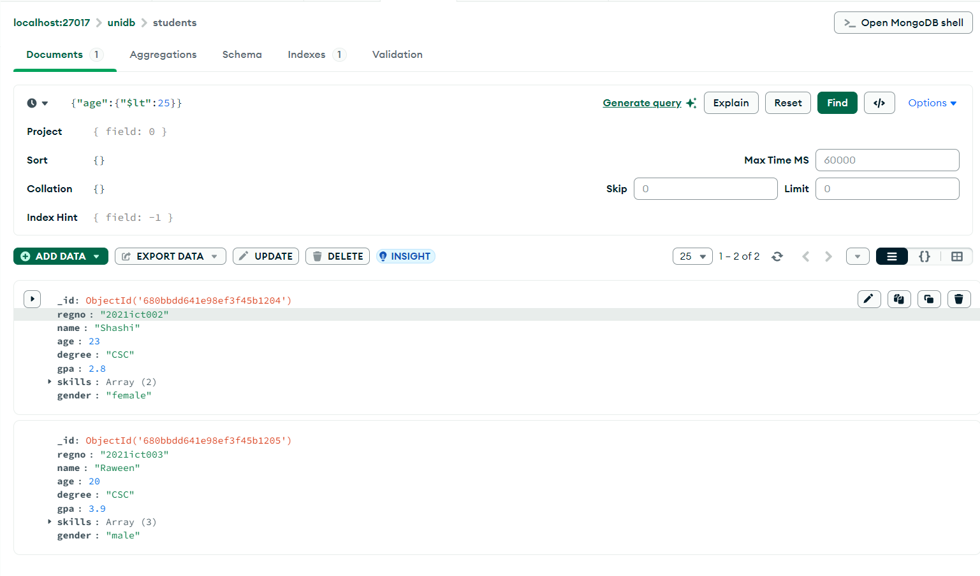

**3.Finds people with age equal to 25.**

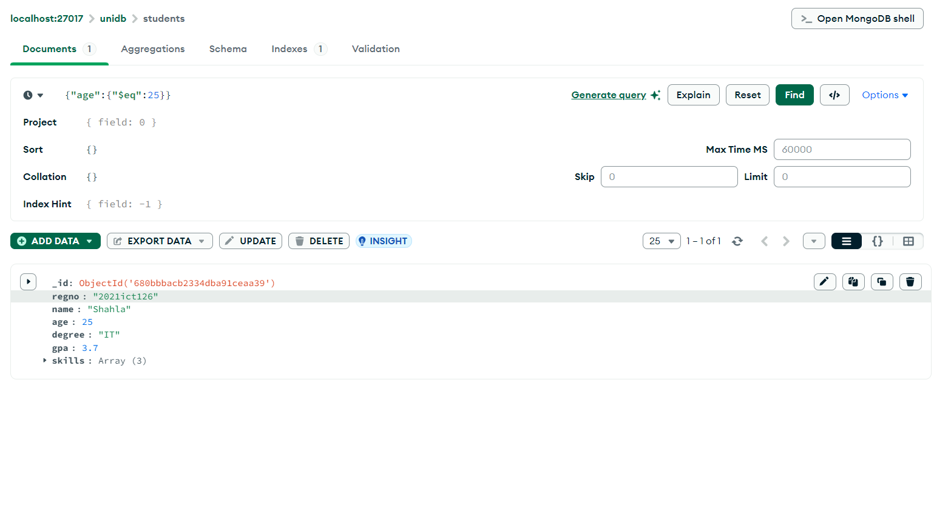**Find the documents using $in,$nin**

**1.Finds those with "NoSql" skills.**

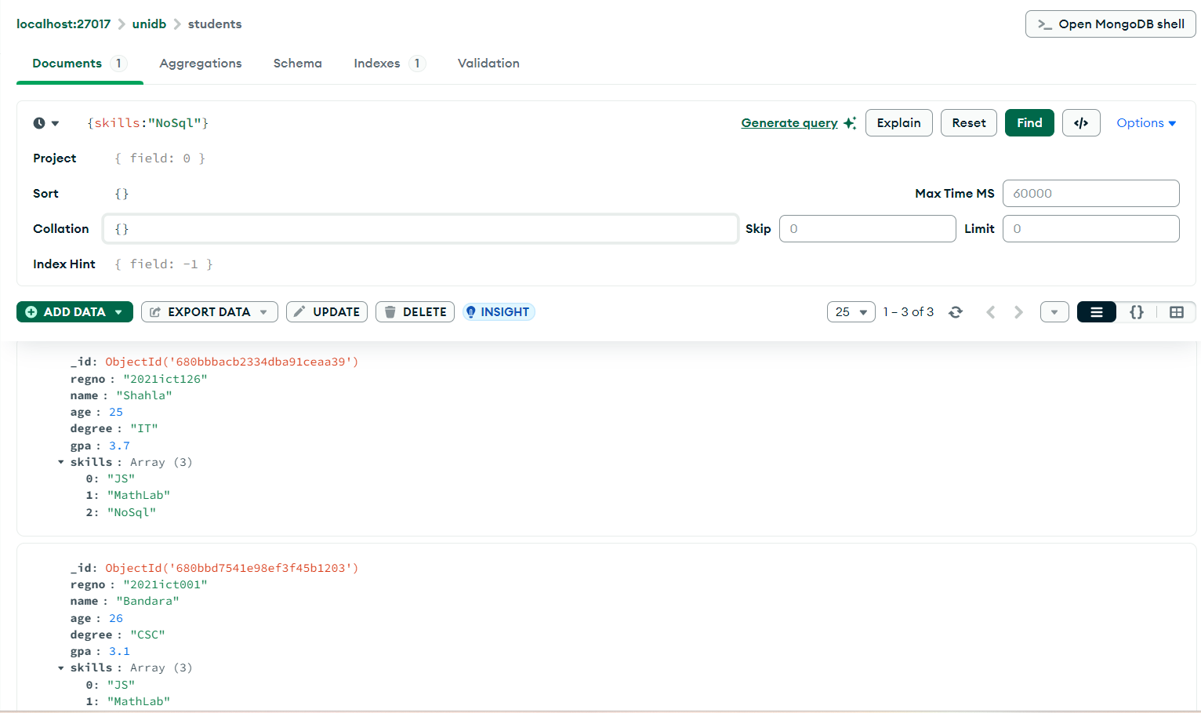

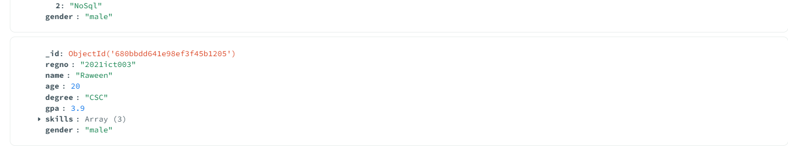

**2.Finds those with "NoSql" OR JS skills.**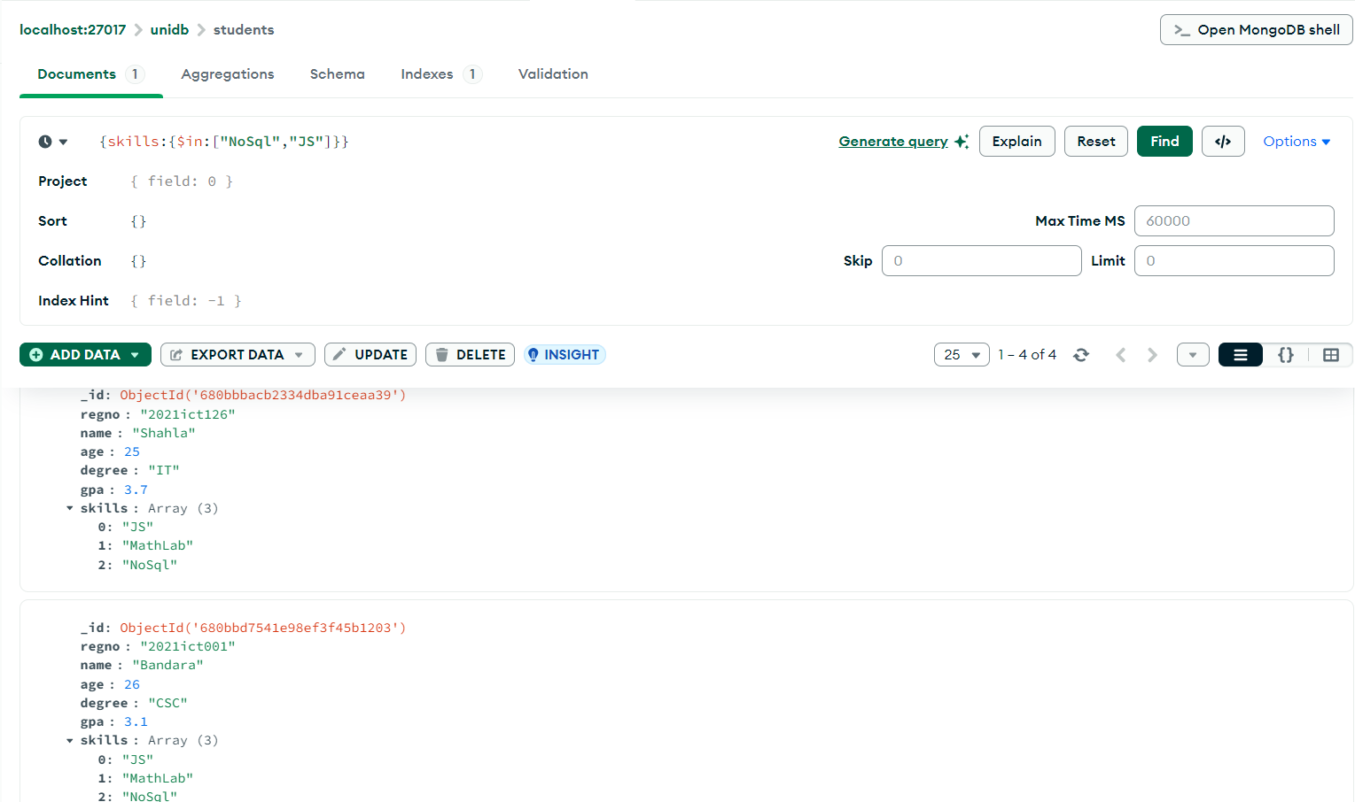

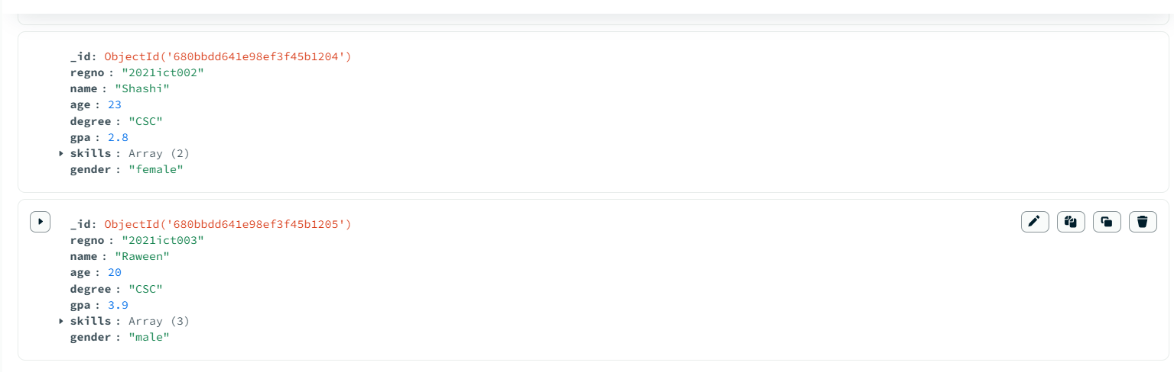

**3.Finds those without "NoSql" skill.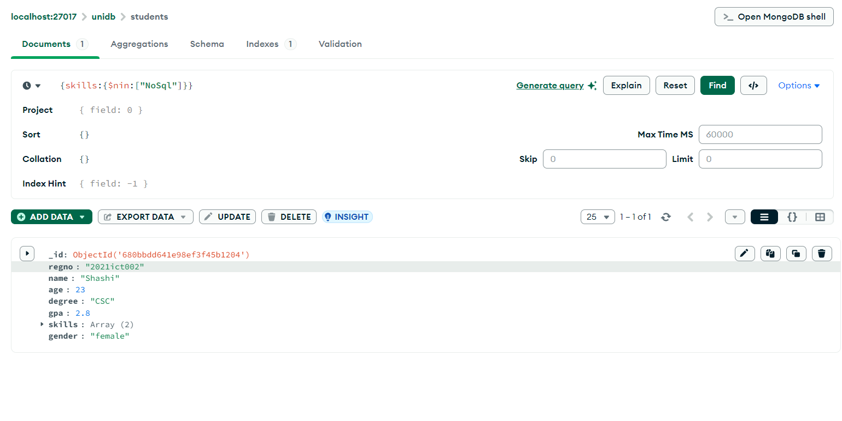Sort in descending Order ----->using console**

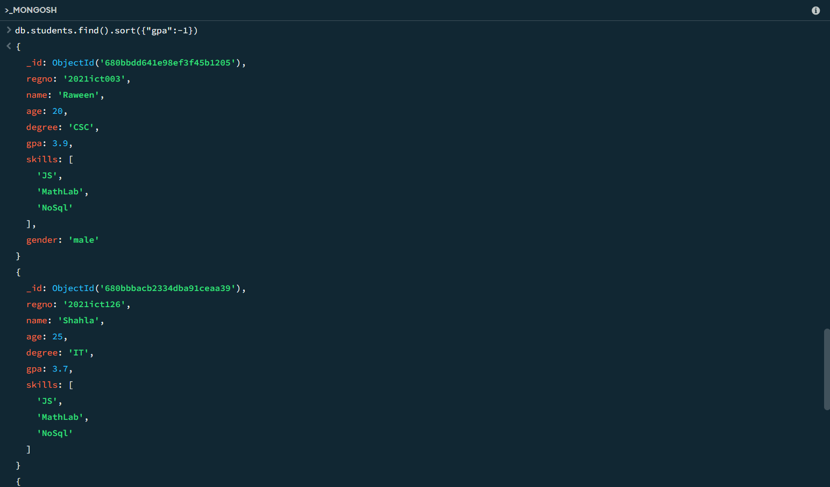

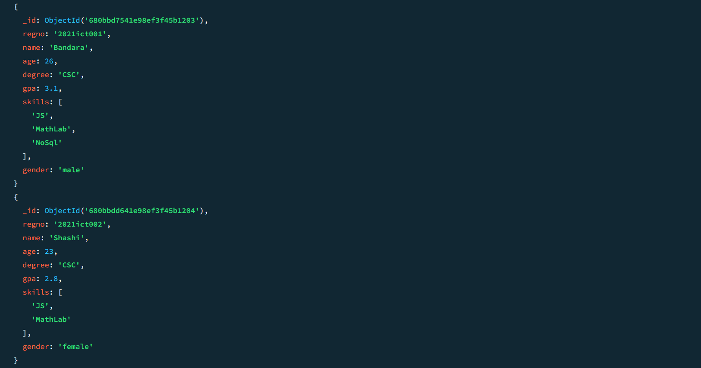

**Find who follow csc dgree,sort their gpa in ascending order**

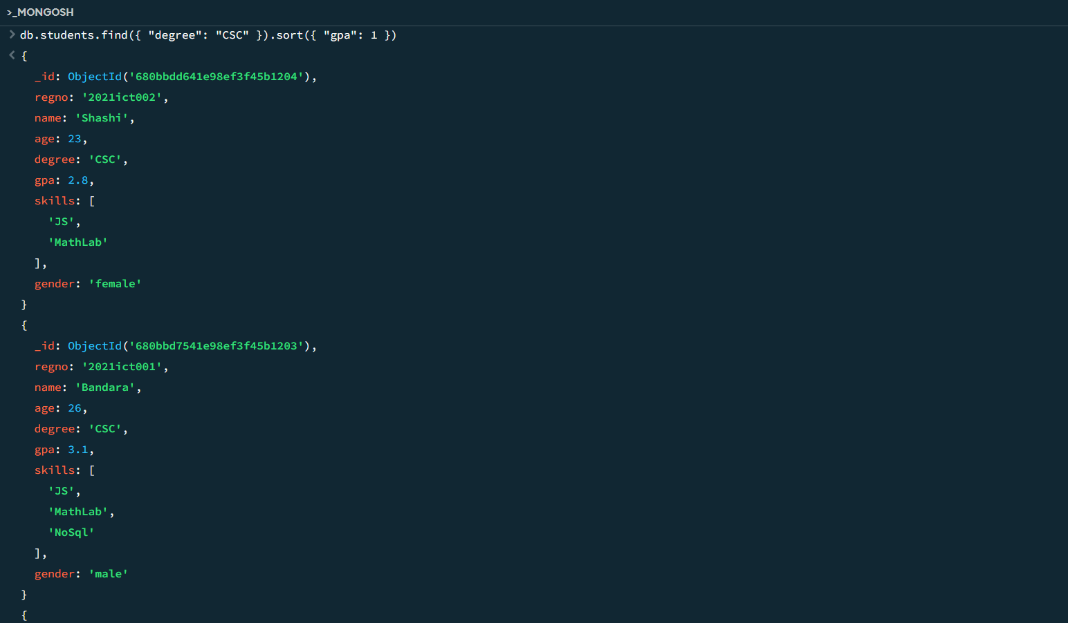

**Find CSC male students, sort their age in descending.**

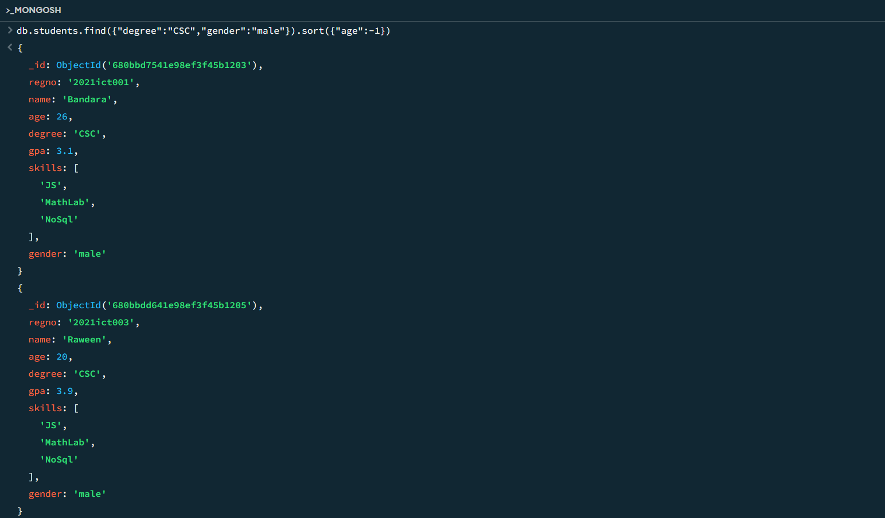

**Find the details with comparision---->using console**

