Student Name: Shahmeer Shahzad
Registration Number: FA24-BCS-103
Task 1:
375px:
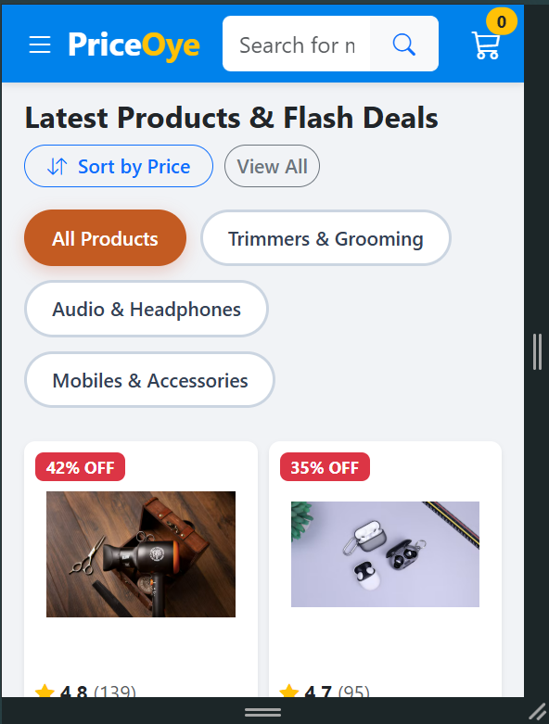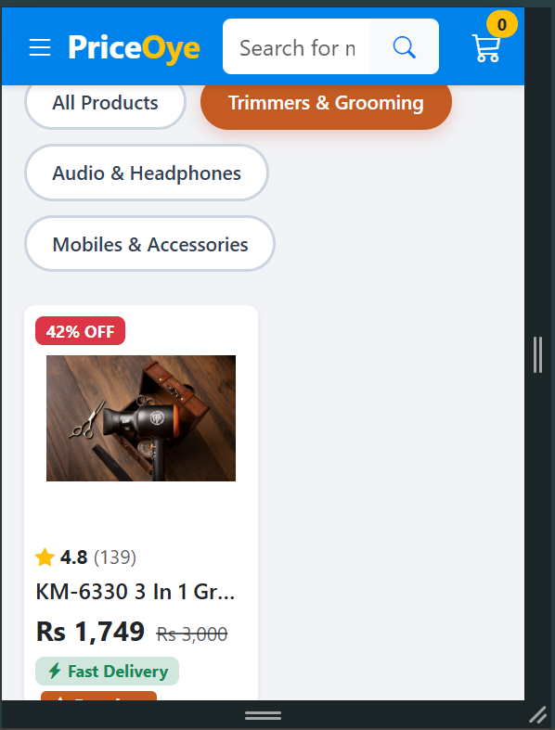

BP (603)px:
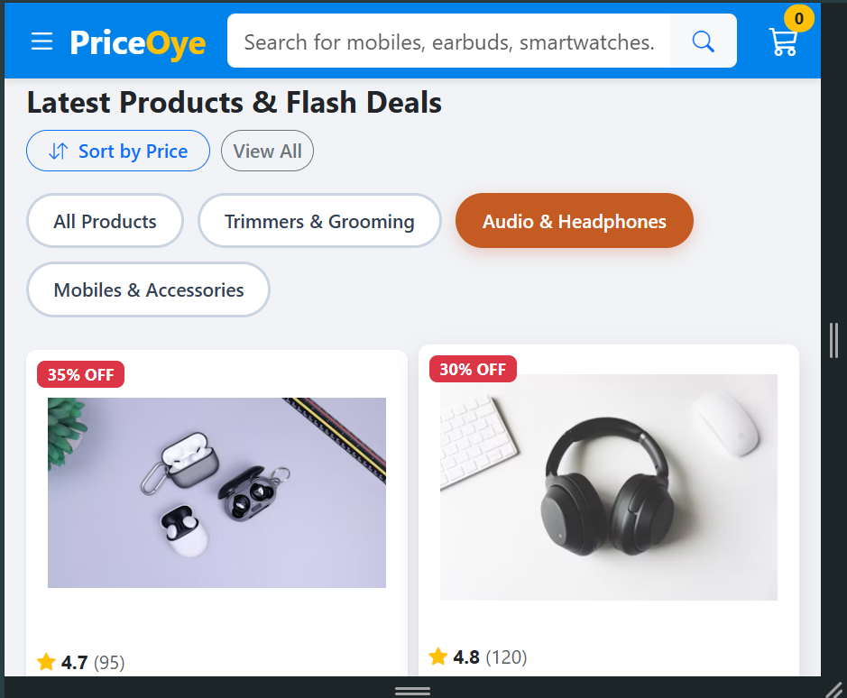
1280px:
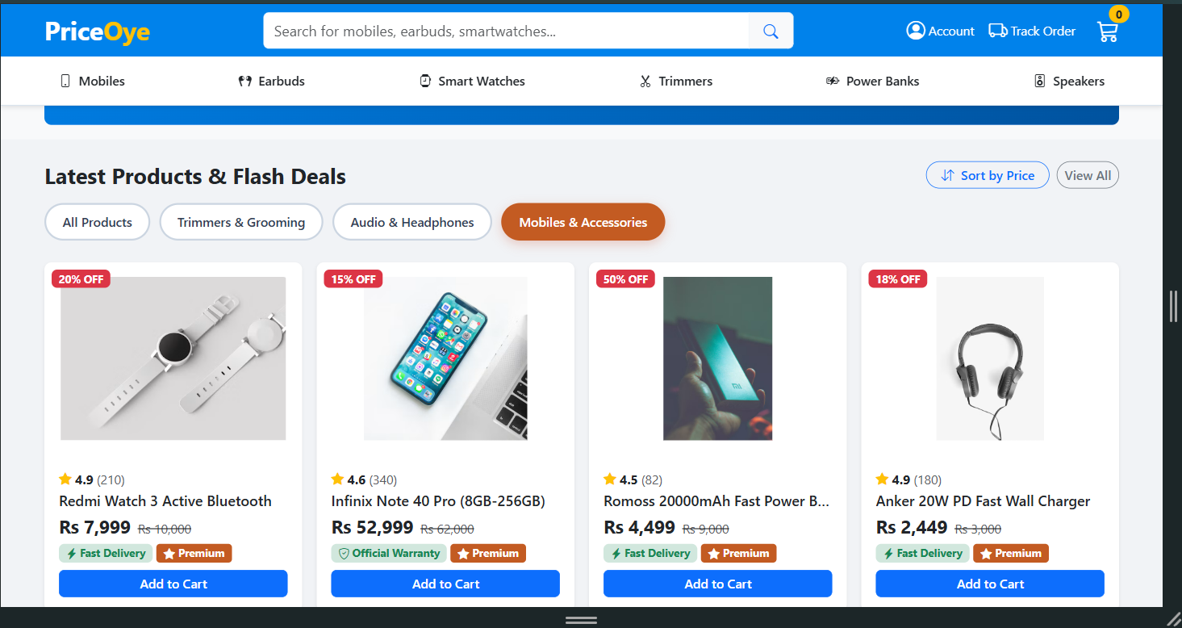

Task 2:
375px:
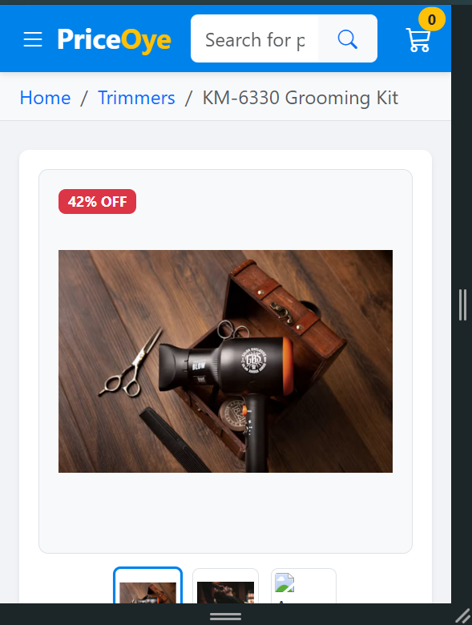
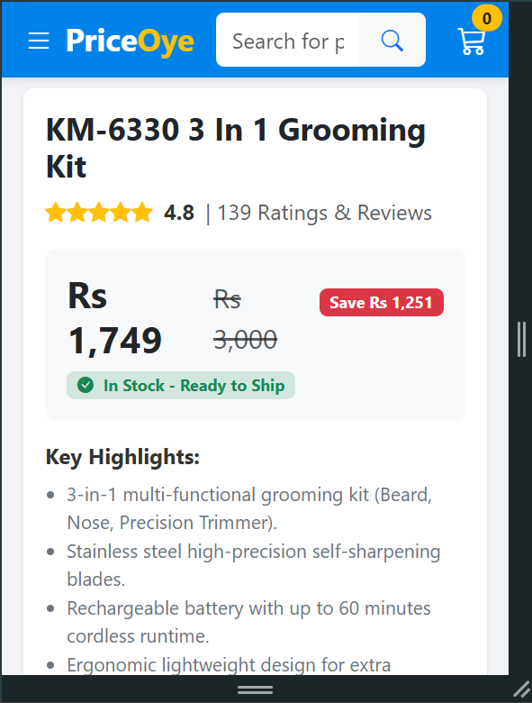

BP (603) px:
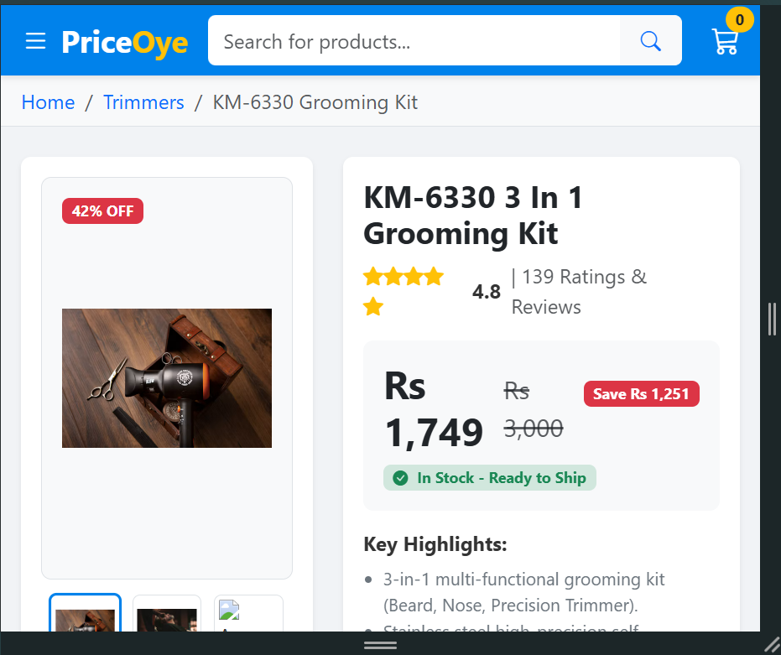
1280px:
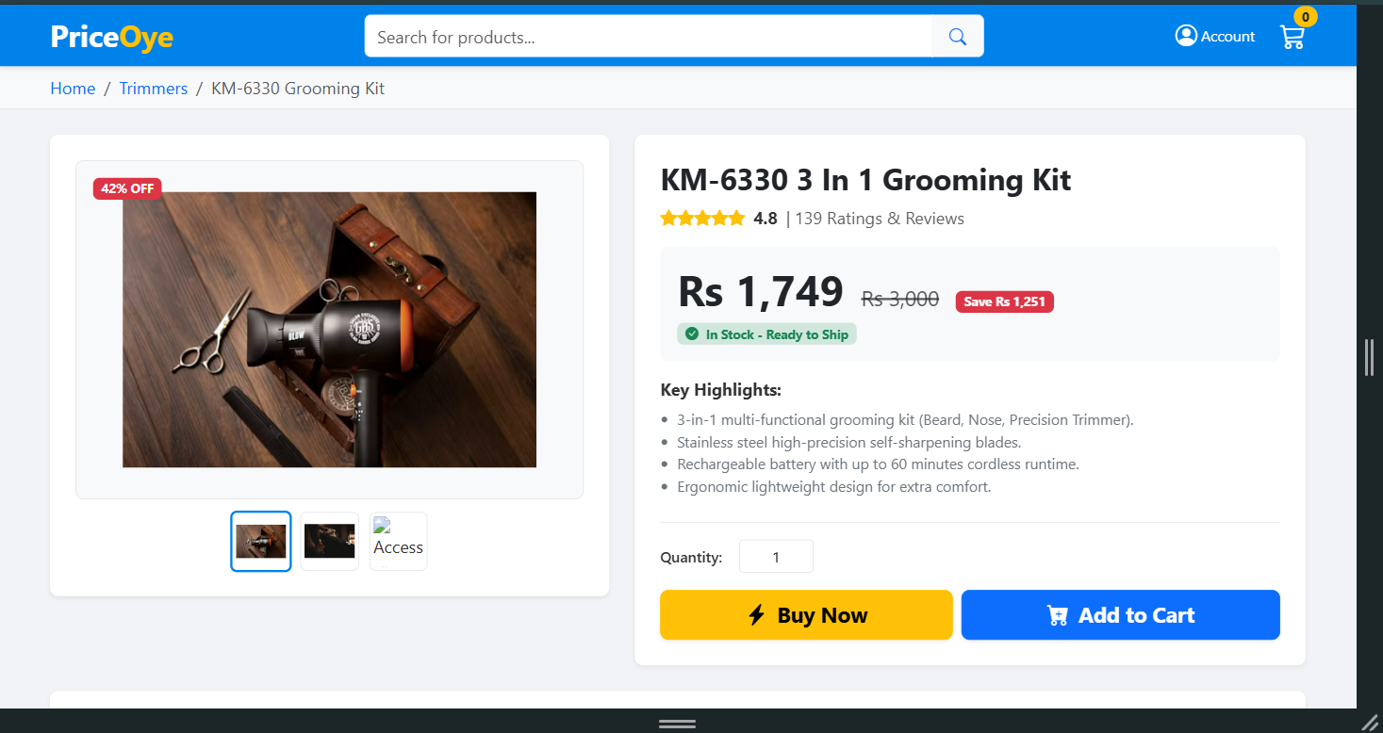

Task 3:
375px:

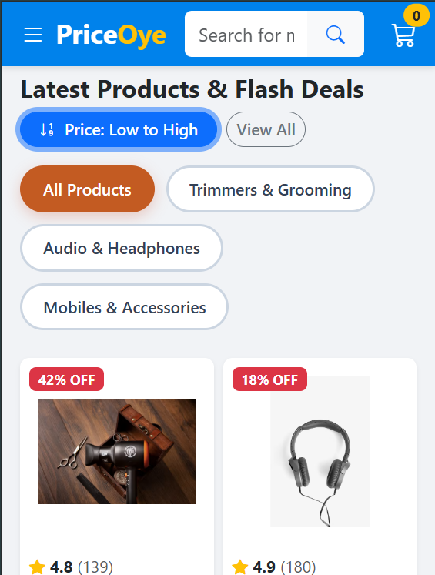
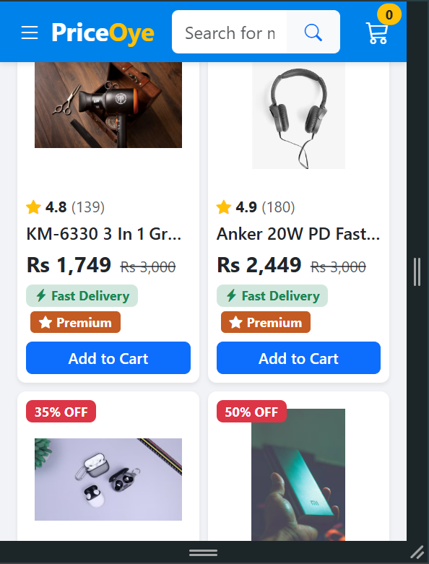
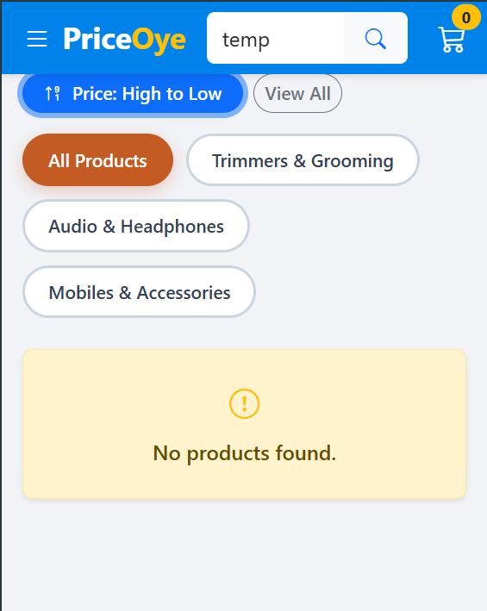
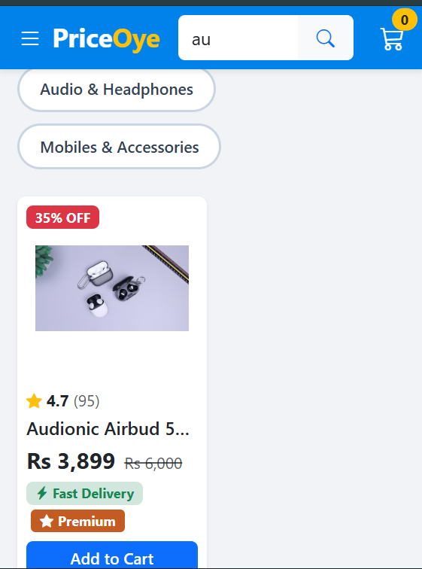

BP (603) px:

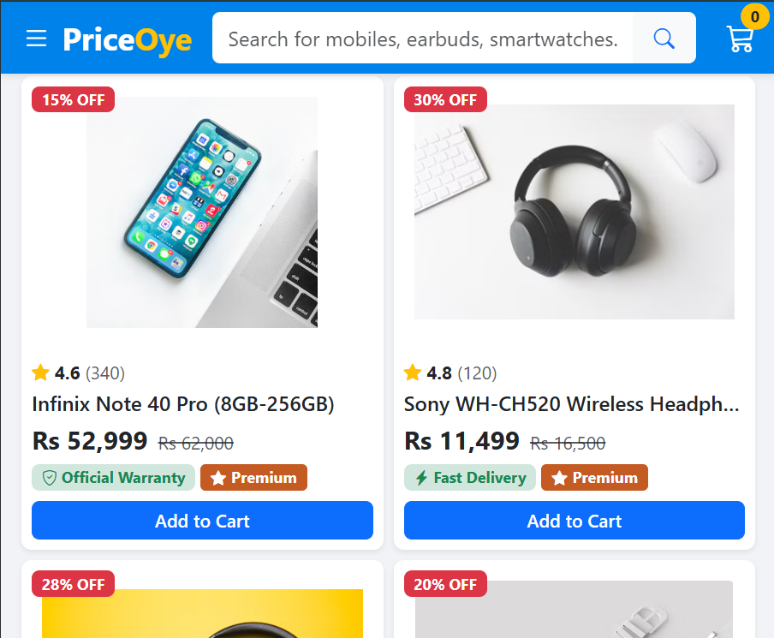
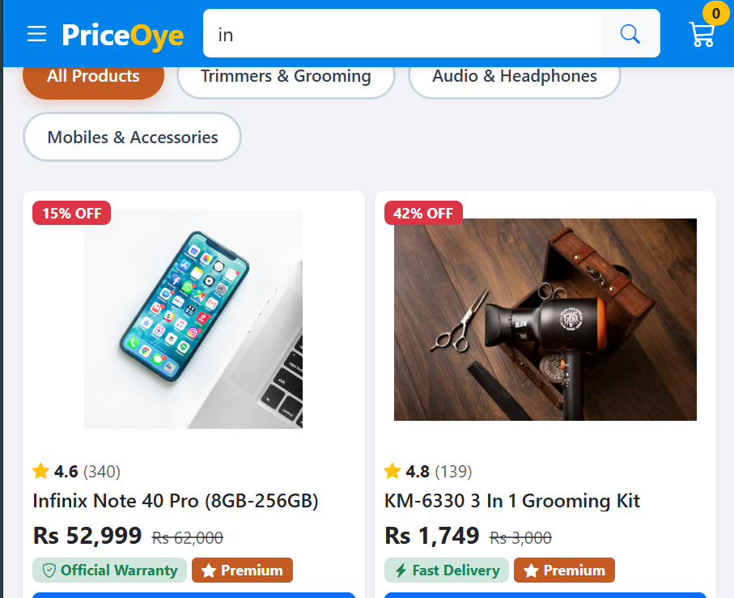
1280px:
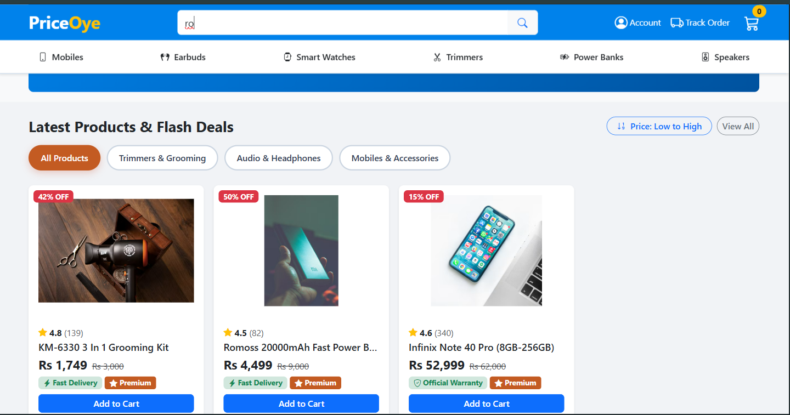
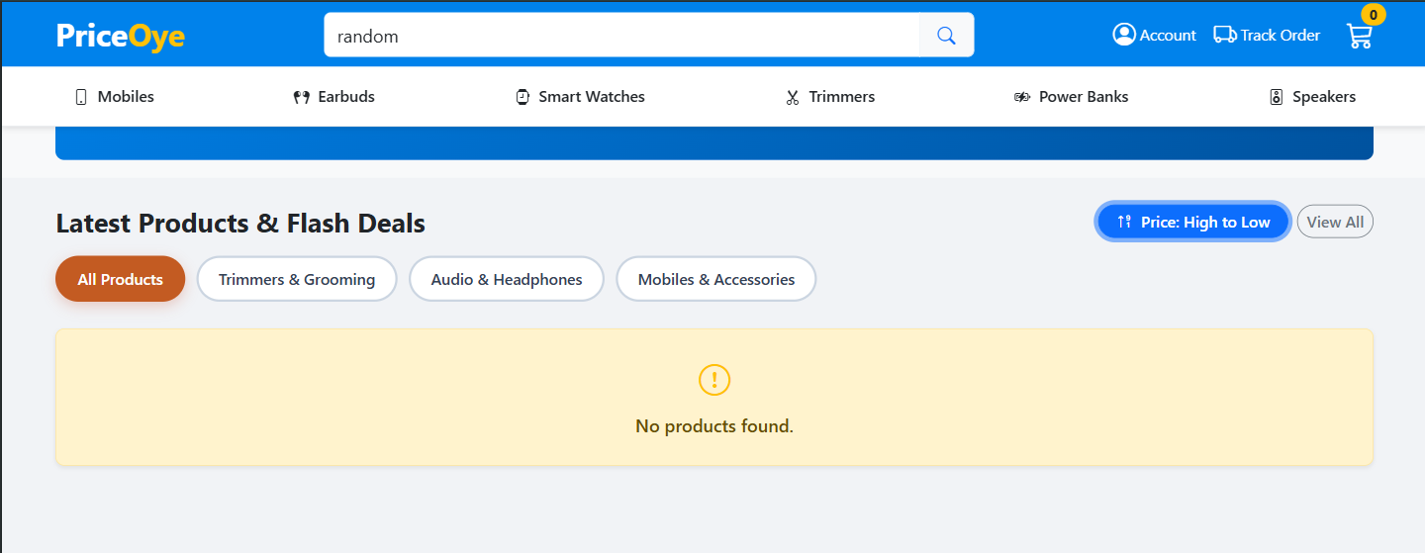
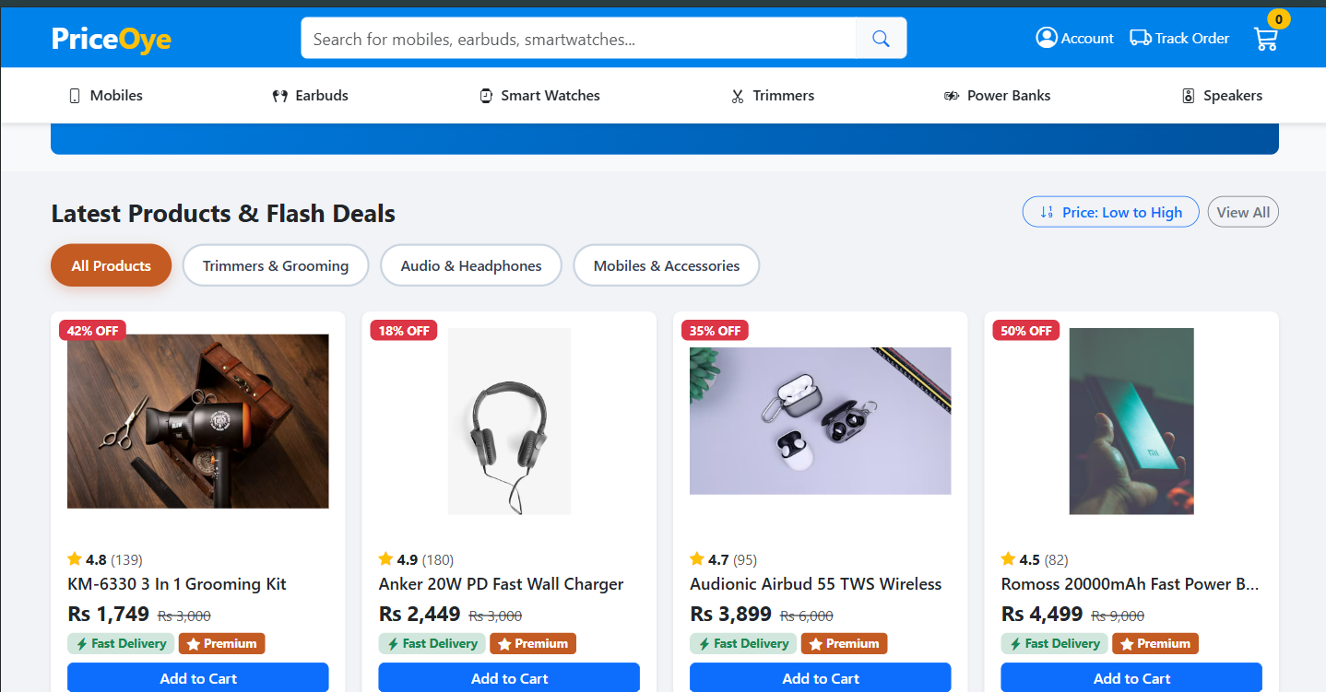
Changed Code:
Task 1:
index.html:
<!-- TASK 1: CATEGORY FILTER RADIO BUTTONS -->
<div class="category-filter-wrapper mb-4">
<input type="radio" id="cat-all" name="category" value="all" class="category-radio-btn" checked>
<label for="cat-all" class="category-filter-btn">All Products</label>

<input type="radio" id="cat-trimmers" name="category" value="cat-trimmers" class="category-radio-btn">
<label for="cat-trimmers" class="category-filter-btn">Trimmers & Grooming</label>

<input type="radio" id="cat-audio" name="category" value="cat-audio" class="category-radio-btn">
<label for="cat-audio" class="category-filter-btn">Audio & Headphones</label>

<input type="radio" id="cat-mobiles" name="category" value="cat-mobiles" class="category-radio-btn">
<label for="cat-mobiles" class="category-filter-btn">Mobiles & Accessories</label>
</div>

styles.css:
/* ==========================================================================
TASK 1: CSS-ONLY CATEGORY FILTER (Accent Hsl: hsl(21, 70%, 45%))
========================================================================== */
.category-filter-wrapper {
display: flex;
gap: 10px;
flex-wrap: wrap;
align-items: center;
}

.category-radio-btn {
display: none !important;
}

.category-filter-btn {
display: inline-block;
padding: 8px 18px;
border: 2px solid #cbd5e1;
border-radius: 24px;
background-color: #ffffff;
color: #334155;
font-weight: 600;
font-size: 0.875rem;
cursor: pointer;
transition: all 0.2s ease-in-out;
user-select: none;
}

.category-filter-btn:hover {
border-color: var(--po-accent);
color: var(--po-accent);
}

/* Checked state retains exact mandatory Accent Hue hsl(21, 70%, 45%) */
.category-radio-btn:checked + .category-filter-btn {
background-color: var(--po-accent) !important;
border-color: var(--po-accent) !important;
color: #ffffff !important;
box-shadow: 0 4px 12px rgba(199, 72, 35, 0.25);
}

/* Pure CSS Filtering Logic targeting updated categories */
#product-section:has(#cat-trimmers:checked) .product-card:not(.cat-trimmers) {
display: none !important;
}

#product-section:has(#cat-audio:checked) .product-card:not(.cat-audio) {
display: none !important;
}

#product-section:has(#cat-mobiles:checked) .product-card:not(.cat-mobiles) {
display: none !important;
}

Task 2:
product.html:
<!-- TASK 2: PRODUCT DETAIL SECTION WITH NAMED CSS GRID AREAS -->
<main class="py-4">
<div class="container-fluid px-3 px-lg-5">
<div class="pdp-grid-container">

<!-- GRID AREA 1: IMAGE -->
<div class="pdp-area-image bg-white p-3 p-md-4 rounded-3 shadow-sm">
<div class="po-pdp-box p-3 border rounded-3 position-relative">
<span class="badge bg-danger position-absolute top-0 start-0 m-3 z-1">42% OFF</span>
<img src="https://images.unsplash.com/photo-1621607512214-68297480165e?w=500&auto=format&fit=crop&q=80" alt="KM-6330 3 In 1 Grooming Kit" class="img-fluid po-pdp-img">
</div>
<div class="po-thumb-container">
<img src="https://images.unsplash.com/photo-1621607512214-68297480165e?w=150&auto=format&fit=crop&q=80" class="po-thumb active" alt="Front View">
<img src="https://images.unsplash.com/photo-1503951914875-452162b0f3f1?w=150&auto=format&fit=crop&q=80" class="po-thumb" alt="Side View">
<img src="https://images.unsplash.com/photo-1622774161048-963a7a988d87?w=150&auto=format&fit=crop&q=80" class="po-thumb" alt="Accessories View">
</div>
</div>

<!-- GRID AREA 2: DETAILS (STICKY BOX AT >= 603px, top: 73px) -->
<div class="pdp-area-details bg-white p-3 p-md-4 rounded-3 shadow-sm">
<h1 class="h3 fw-bold text-dark mb-2">KM-6330 3 In 1 Grooming Kit</h1>

<div class="d-flex align-items-center gap-2 mb-3">
<div class="text-warning"><i class="bi bi-star-fill"></i><i class="bi bi-star-fill"></i><i class="bi bi-star-fill"></i><i class="bi bi-star-fill"></i><i class="bi bi-star-fill"></i></div>
<span class="fw-bold">4.8</span>
<span class="text-muted">| 139 Ratings & Reviews</span>
</div>

<div class="p-3 bg-light rounded-3 mb-3">
<div class="d-flex align-items-baseline gap-3">
<span class="display-6 fw-bold text-dark">Rs 1,749</span>
<span class="text-muted text-decoration-line-through fs-5">Rs 3,000</span>
<span class="badge bg-danger">Save Rs 1,251</span>
</div>
<span class="badge bg-success-subtle text-success mt-2"><i class="bi bi-check-circle-fill me-1"></i> In Stock - Ready to Ship</span>
</div>

<div class="mb-4">
<h2 class="h6 fw-bold">Key Highlights:</h2>
<ul class="small text-secondary ps-3 mb-0">
<li>3-in-1 multi-functional grooming kit (Beard, Nose, Precision Trimmer).</li>
<li>Stainless steel high-precision self-sharpening blades.</li>
<li>Rechargeable battery with up to 60 minutes cordless runtime.</li>
<li>Ergonomic lightweight design for extra comfort.</li>
</ul>
</div>

<div class="pt-3 border-top">
<div class="d-flex align-items-center gap-3 mb-3">
<label for="quantitySelect" class="fw-semibold small">Quantity:</label>
<input type="number" id="quantitySelect" class="form-control form-control-sm text-center" value="1" min="1" max="5" style="width: 70px;">
</div>
<div class="d-flex flex-column flex-sm-row gap-2">
<button class="btn btn-warning btn-lg flex-fill fw-bold shadow-sm" type="button"><i class="bi bi-lightning-charge-fill me-1"></i> Buy Now</button>
<button class="btn btn-primary btn-lg flex-fill fw-bold shadow-sm" type="button"><i class="bi bi-cart-plus-fill me-1"></i> Add to Cart</button>
</div>
</div>
</div>

<!-- GRID AREA 3: DESCRIPTION (FULL WIDTH UNDERNEATH AT >= 603px) -->
<div class="pdp-area-description bg-white p-3 p-md-4 rounded-3 shadow-sm">
<h2 class="h4 fw-bold mb-3 border-bottom pb-2">Comprehensive Product Description</h2>

<p class="text-secondary">The <strong>Kemei KM-6330 3-in-1 Grooming Kit</strong> is an all-in-one personal grooming set engineered to deliver precise, salon-quality styling in the comfort of your home. Equipped with three versatile interchangeable heads—a full-size beard trimmer, a precision nose/ear hair trimmer, and a detail shaver head—it caters to every facial grooming requirement effortlessly.</p>

<h3 class="h5 fw-bold mt-4 mb-2">Advanced Blade System & Precision</h3>
<p class="text-secondary">Crafted with skin-friendly stainless steel blades, the KM-6330 ensures smooth, snag-free cutting without irritating delicate skin. The self-sharpening technology maintains blade sharpness over extended periods, providing consistent cutting power across dense or fine facial hair.</p>

<h3 class="h5 fw-bold mt-4 mb-2">Battery & Operational Performance</h3>
<p class="text-secondary">Powered by an internal high-density rechargeable battery, the trimmer offers up to 60 minutes of uninterrupted cordless operation on an 8-hour charge cycle. The compact design makes it an essential travel companion for business trips and vacations.</p>

<h3 class="h5 fw-bold mt-4 mb-3">Technical Specifications Table</h3>
<table class="table table-striped table-bordered small mb-4">
<tbody>
<tr><th style="width: 30%;">Brand</th><td>Kemei</td></tr>
<tr><th>Model Number</th><td>KM-6330</td></tr>
<tr><th>Attachment Heads</th><td>3 (Beard Trimmer, Nose/Ear Trimmer, Detail Shaver)</td></tr>
<tr><th>Blade Material</th><td>High-Grade Stainless Steel</td></tr>
<tr><th>Charging Time</th><td>8 Hours</td></tr>
<tr><th>Operating Time</th><td>60 Minutes Cordless</td></tr>
<tr><th>Power Source</th><td>Rechargeable AC 220V 50/60Hz 3W</td></tr>
<tr><th>Warranty</th><td>7 Days Replacement Warranty</td></tr>
</tbody>
</table>

<h3 class="h5 fw-bold mt-4 mb-2">Maintenance & Cleaning Instructions</h3>
<p class="text-secondary">To ensure optimal performance and longevity, detach the trimmer heads after each use and clean off excess hair using the included cleaning brush. Apply a drop of lubricating oil onto the blades periodically to keep the motor running silently and smoothly.</p>
</div>

</div>
</div>
</main>
styles.css:
/* ==========================================================================
TASK 2: PRODUCT PAGE LAYOUT & STICKY DETAILS BOX
Breakpoint BP = 603px | Sticky Top Offset = 73px
========================================================================== */
.pdp-grid-container {
display: grid;
gap: 1.5rem;
grid-template-areas:
"image"
"details"
"description";
}

.pdp-area-image {
grid-area: image;
}

.pdp-area-details {
grid-area: details;
}

.pdp-area-description {
grid-area: description;
}

/* Responsive Grid Layout & Sticky Box at BP = 603px */
@media (min-width: 603px) {
.pdp-grid-container {
grid-template-columns: 1fr 1.2fr;
grid-template-areas:
"image details"
"description description";
align-items: start; /* Essential for sticky element to move independently in grid */
}

.pdp-area-details {
position: sticky;
top: 73px; /* Formula: (3 mod 40) + 70 = 73px */
z-index: 10;
}
}

Task 3:
index.html:
<!-- Live Search Input ID -->
<input type="text" id="live-search-input" class="form-control border-0 shadow-none py-2" placeholder="Search for mobiles, earbuds, smartwatches...">

<!-- Sort Button -->
<button id="sort-price-btn" class="btn btn-outline-primary btn-sm rounded-pill fw-semibold px-3">
<i class="bi bi-arrow-down-up me-1"></i> Sort by Price
</button>

<!-- No Products Found Message Container -->
<div id="no-products-msg" class="alert alert-warning text-center d-none my-4 fw-semibold p-4 rounded-3 shadow-sm">
<i class="bi bi-exclamation-circle fs-3 d-block mb-2 text-warning"></i>
No products found matching your search criteria.
</div>

<!-- Script Inclusion before closing body tag -->
<script src="script.js"></script>
styles.css:
/* ==========================================================================
TASK 3: SEARCH HIDDEN & PREMIUM BADGE
========================================================================== */
.search-hidden {
display: none !important;
}

.badge-premium {
background-color: var(--po-accent);
color: #ffffff;
font-weight: 700;
font-size: 0.75rem;
padding: 4px 8px;
border-radius: 4px;
}

script.js:
/* ==========================================================================
TASK 3: JAVASCRIPT LIVE SEARCH, PRICE SORT & PREMIUM LABEL
Roll Number: FA24-BCS-103 | N = 3
========================================================================== */

function runTask3() {
console.log("--> Task 3 Script Running Successfully!");

const N = 3;
const premiumThreshold = N * 100; // 3 * 100 = Rs 300

const productGridRow = document.getElementById('product-grid-row');
const productCards = Array.from(document.querySelectorAll('.product-card'));
const searchInput = document.getElementById('live-search-input');
const sortBtn = document.getElementById('sort-price-btn');
const noProductsMsg = document.getElementById('no-products-msg');
const categoryRadios = document.querySelectorAll('input[name="category"]');
const searchBtn = searchInput ? searchInput.nextElementSibling : null;

// 1. Extract numeric price from product card
function extractPrice(card) {
const priceElement = card.querySelector('.product-price');
if (!priceElement) return 0;
const cleanDigits = priceElement.textContent.replace(/[^0-9]/g, '');
return parseInt(cleanDigits, 10) || 0;
}

// 2. Attach "Premium" badge to products priced > Rs 300
productCards.forEach(card => {
const price = extractPrice(card);
if (price > premiumThreshold) {
const cardBody = card.querySelector('.card-body');
if (cardBody && !cardBody.querySelector('.badge-premium')) {
const premiumBadge = document.createElement('span');
premiumBadge.className = 'badge badge-premium mt-1 ms-1 d-inline-block';
premiumBadge.innerHTML = '<i class="bi bi-star-fill me-1"></i>Premium';

const deliveryBadge = cardBody.querySelector('.badge.bg-success-subtle');
if (deliveryBadge) {
deliveryBadge.insertAdjacentElement('afterend', premiumBadge);
} else {
cardBody.appendChild(premiumBadge);
}
}
}
});

// 3. Live Search & Category Filter Visibility Check
function evaluateVisibility() {
const query = searchInput ? searchInput.value.toLowerCase().trim() : '';
const activeRadio = document.querySelector('input[name="category"]:checked');
const activeCategory = activeRadio ? activeRadio.value : 'all';

let visibleCount = 0;

productCards.forEach(card => {
const imgElement = card.querySelector('img');
const cardText = card.textContent.toLowerCase() + ' ' + (imgElement ? imgElement.alt.toLowerCase() : '');

const matchesSearch = query === '' || cardText.includes(query);
const matchesCategory = (activeCategory === 'all' || card.classList.contains(activeCategory));

// Toggle search-hidden class
if (matchesSearch) {
card.classList.remove('search-hidden');
} else {
card.classList.add('search-hidden');
}

if (matchesSearch && matchesCategory) {
visibleCount++;
}
});

// Toggle "No products found" message
if (noProductsMsg) {
if (visibleCount === 0) {
noProductsMsg.classList.remove('d-none');
} else {
noProductsMsg.classList.add('d-none');
}
}
}

// Event Listeners for Search
if (searchInput) {
searchInput.addEventListener('input', evaluateVisibility);
searchInput.addEventListener('keyup', evaluateVisibility);
searchInput.addEventListener('search', evaluateVisibility);
}

if (searchBtn) {
searchBtn.addEventListener('click', evaluateVisibility);
}

categoryRadios.forEach(radio => {
radio.addEventListener('change', evaluateVisibility);
});

// 4. Sort by Price via DOM re-ordering (.appendChild)
let isAscending = true;

if (sortBtn && productGridRow) {
sortBtn.addEventListener('click', () => {
productCards.sort((cardA, cardB) => {
const priceA = extractPrice(cardA);
const priceB = extractPrice(cardB);
return isAscending ? priceA - priceB : priceB - priceA;
});

productCards.forEach(card => {
productGridRow.appendChild(card);
});

sortBtn.innerHTML = isAscending
? '<i class="bi bi-sort-numeric-down me-1"></i> Price: Low to High'
: '<i class="bi bi-sort-numeric-up-alt me-1"></i> Price: High to Low';

isAscending = !isAscending;
evaluateVisibility();
});
}

// Run initial visibility evaluation
evaluateVisibility();
}

// Execute immediately when loaded
runTask3();

