Draw the Path: Portfolio Sitemap + Toolkit
Submitted by Shahmir Qureshi

1. Portfolio Sitemap
One person: A hiring manager / recruiter screening for junior Data Analyst / Data Scientist roles in Pakistan and remote.
Claim: "I turn messy, real-world data into decisions — not just clean-CSV exercises."
One action: Book a call / message on LinkedIn.
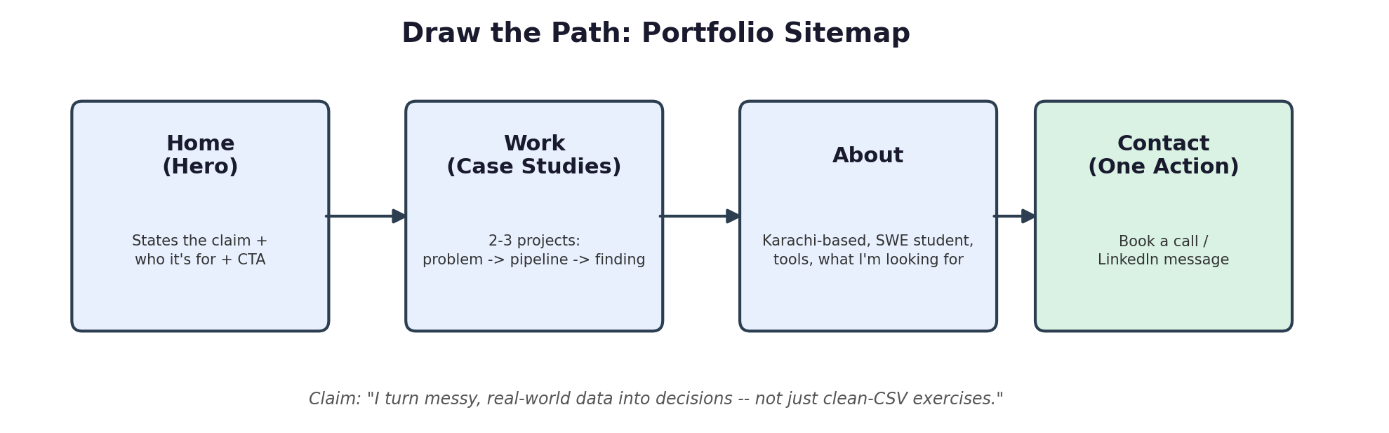
Pages, in order, and why each earns its place:
- Home (Hero) — states the claim, who it's for, and the call to action up front.
- Work (Case Studies) — 2–3 projects, each framed as problem → pipeline → key finding, to prove the claim.
- About — 3–4 lines: Karachi-based, Software Engineering student, tools used, what role I'm looking for.
- Contact — the single action: book a call or LinkedIn message. Nothing else on this page.
No page was added "just because" — each one moves the reader from landing to believing to acting.

2. Toolkit Setup
- Accounts created: Claude, ChatGPT, Gemini, Perplexity (free tiers).
- Main build partner selected: Claude.

3. AI Workspace — Claude Project
Project name: Portfolio Build — Shahmir
Custom instructions:
I'm Shahmir Qureshi, a Data Analyst/Data Scientist based in Karachi, currently studying Software Engineering at Sir Syed University. My tools: Python, SQL, Pandas, data visualization (Plotly/Seaborn).
My portfolio claim: "I turn messy, real-world data into decisions — not just clean-CSV exercises."
Target reader: hiring managers screening junior Data Analyst/Data Scientist roles.
One action I want them to take: book a call / message me on LinkedIn.
Act as a tutor: when I ask you to review my portfolio, sitemap, or projects, explain your reasoning, don't just hand me a fix. Push back if something is generic or doesn't support my claim.

4. Pressure-Test Prompt and Output
Prompt run inside the Project:
Here's my portfolio sitemap: Home → Work → About → Contact. Home states the claim "I turn messy, real-world data into decisions." The one action is: book a call / LinkedIn message.
Pressure-test this: does every page earn its place against the claim and the action? What would you cut, and what's the one thing most likely to be missing?
Output:
All four pages earn their place — nothing to cut. The gap: the Work section risks reading as "assignments I did" rather than "decisions I enabled." Each case study needs to open with the business question or decision at stake, not the dataset, or a recruiter skimming for 10 seconds won't connect it to the claim. Also worth adding: a one-line result/impact statement per project (e.g. "identified X, which would change Y") right under each case study title, so the value is visible without reading the full write-up.

5. What I'll Change
Based on the pressure-test, I'll rewrite each Work case-study entry to lead with the decision or question it answers, and add a one-line impact statement under each title before the reader has to scroll into the detail.

