How annual members and casual riders use Cyclistic bike differently?

Shahmir Zubair

2023-01-20

## About Project

Cyclistic is a fictional company. In 2016, Cyclistic launched a successful bike-share oﬀering. Since then, the program has grown to a ﬂeet of 5,824 bicycles that are geotracked and locked into a network of 692 stations across Chicago. The bikes can be unlocked from one station and returned to any other station in the system anytime.

Until now, Cyclistic’s marketing strategy relied on building general awareness and appealing to broad consumer segments. One approach that helped make these things possible was the ﬂexibility of its pricing plans: single-ride passes, full-day passes, and annual memberships. Customers who purchase single-ride or full-day passes are referred to as casual riders. Customers who purchase annual memberships are Cyclistic members.

Cyclistic’s ﬁnance analysts have concluded that annual members are much more proﬁtable than casual riders. Although the pricing ﬂexibility helps Cyclistic attract more customers, Moreno believes that maximizing the number of annual members will be key to future growth. Rather than creating a marketing campaign that targets all-new customers, Company believes there is a very good chance to convert casual riders into members. Company notes that casual riders are already aware of the Cyclistic program and have chosen Cyclistic for their mobility needs.

Company has set a clear goal: Design marketing strategies aimed at converting casual riders into annual members. In order to do that, however, the marketing analyst team needs to better understand how annual members and casual riders diﬀer, why casual riders would buy a membership, and how digital media could aﬀect their marketing tactics. Company is interested in analyzing the Cyclistic historical bike trip data to identify trends.

## About Data

This Data has been made available by Motivate International Inc. This is public data and can be used to answer the buisness question. There are 12 csv files for the 12 months of year 2022.

## Summary of Analysis

### Number of Rides

Annual Members account for a larger number of rides for Cyclistic. Annual Members are also much more likely to use the bikes on a regular basis than casual riders. (Data does not provide information about each rider. This makes it difficult to confirm that an Annual Members use bikes regularly) 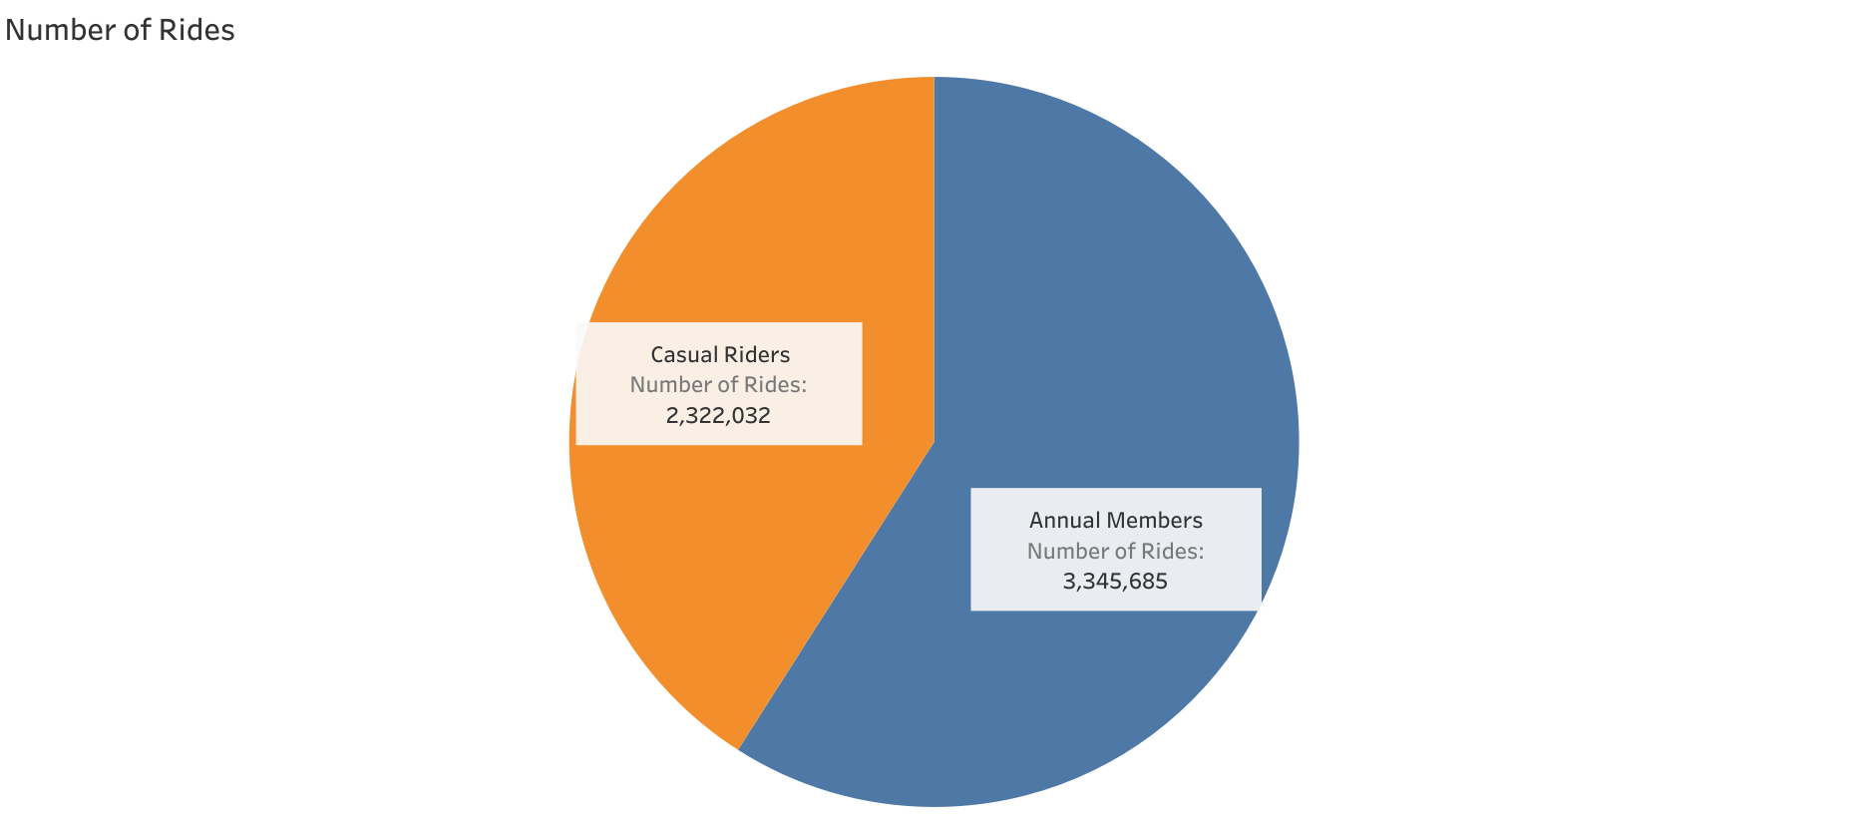

### Effect of Weekends

Casual Riders often use bikes more on weekends than weekdays. Whereas the distribution is almost even for Annual Members. This indicates that Annual Members are more likely to use bikes for commute to work.

***Note:*** *Weekend is Saturday and Sunday. And Weekday is the rest of the days.* 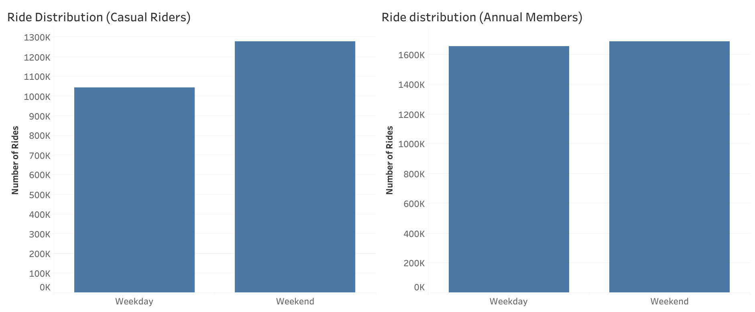

### Average Ride Length

Casual Riders have a longer ride than Annual Members on average. This may be due to Casual Riders using full-day passes. 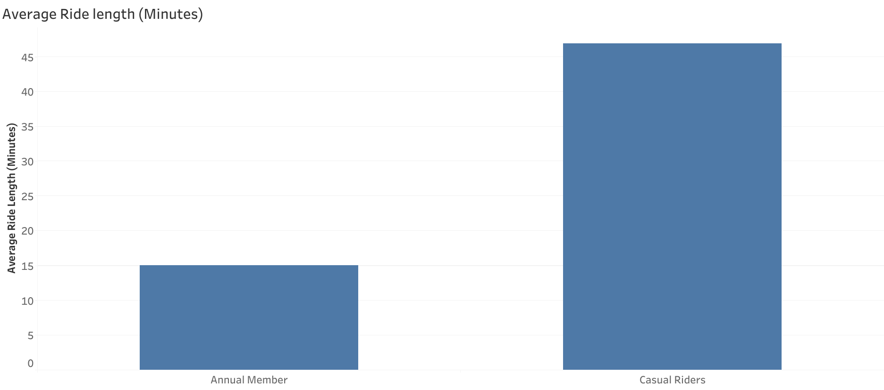

### Scatteredness of ride lengths

#### Box Plot

***Note:***The box represents 50% of the ride lengths and the upper and lower whiskers (lines) represent the rest of the ride lengths. The length of the box shows the scatteredness of the ride lengths.

Rides lengths for Annual Members are far less scattered than Casual Riders. This is further evidence that Annual Members use bikes for commute as the ride lengths do not vary as much. 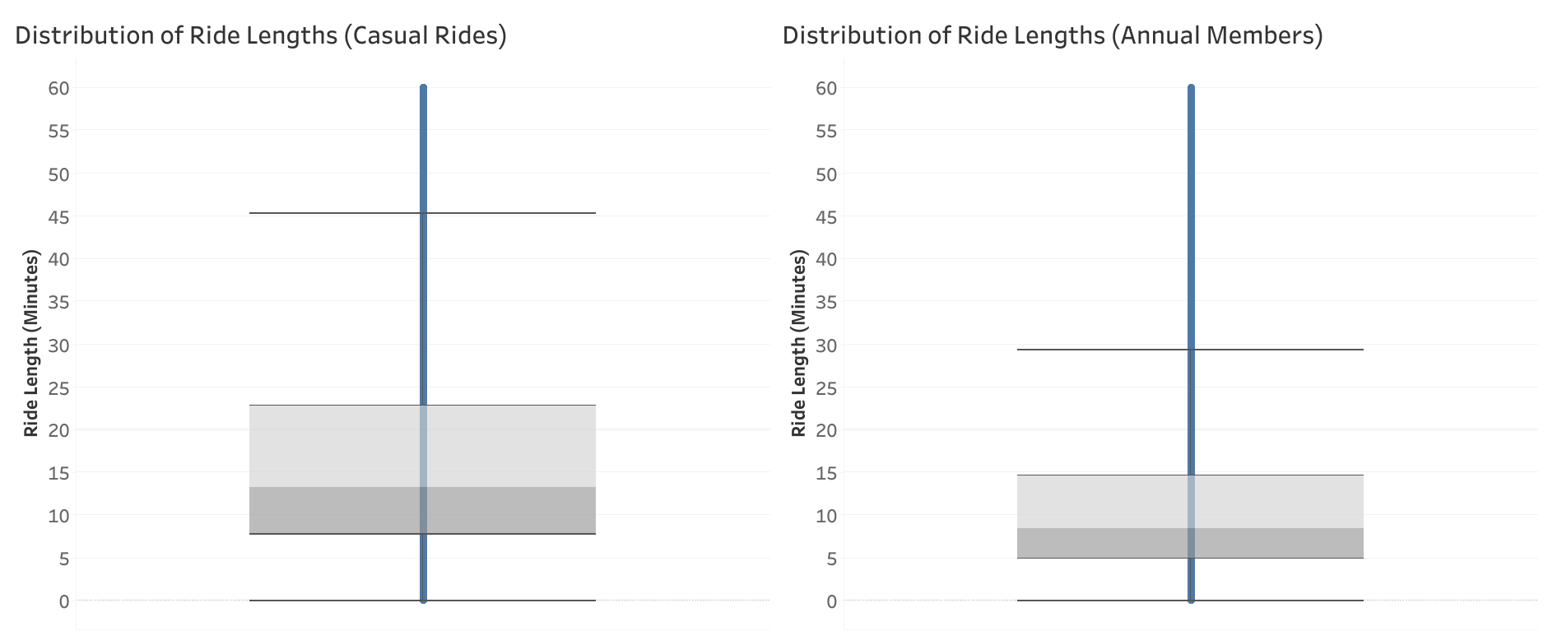

### Hypothesis

All of the the analysis above indicate that Annual Members are much more likely to use Cyclistic’s bike for regular commute.

## Recommendations

1. Casual Riders who use bikes on a regular basis are much more likely to convert to Annual membership.

2. Company should collect data about each customer patterns of bike usage and target casual riders who use bikes regularly.

3. For Digital Marketing Campaigns, we should present Annual Memberships for regular casual riders. These memberships should provide them a better alternative single or full-day passes.

### Thank You