

**MOBILE APPLICATION DEVELOPMENT**

**PROJECT PROPOSAL: “Music Player”**

***Instructions****: Copied or shown assignments will be marked zero. Late submissions are not entertained in any case.*

* **Submitted To:** Mr. Umair
* **Student Name:** M. Shahmir Raza

* **Roll Number:** RCF – (50003)
* **Submission Date:** 27th May 2024
* **Course & Dept.:** BS-IT (6th SEM), Software Engineering

1. **MainActivity**

**MainActivity Class**

public class MainActivity extends AppCompatActivity {  
ListView listView;  
String[] items;  
Toolbar toolbar;

* This defines the MainActivity class, which extends AppCompatActivity. It declares member variables for a ListView, an array of song items, and a Toolbar.

**OnCreate Method**

@Override  
 protected void onCreate(Bundle savedInstanceState) {  
 super.onCreate(savedInstanceState);  
 toolbar = findViewById(R.id.*toolbar*);  
 setSupportActionBar(toolbar);  
 setContentView(R.layout.*activity_main*);  
 listView = findViewById(R.id.*listViewSong*);  
  
 runtimePermission();  
  
 }

* This method is called when the activity is created. It initializes the Toolbar and ListView, sets the content view, and requests runtime permissions.

**Runtime Permission Method**

public void runtimePermission()  
 {  
 Dexter.*withContext*(this).withPermissions(Manifest.permission.*READ_EXTERNAL_STORAGE*, Manifest.permission.*RECORD_AUDIO*)  
 .withListener(new MultiplePermissionsListener() {  
 @Override  
 public void onPermissionsChecked(MultiplePermissionsReport multiplePermissionsReport) {  
 displaySongs();  
 }  
  
 @Override  
 public void onPermissionRationaleShouldBeShown(List<PermissionRequest> list, PermissionToken permissionToken) {  
 permissionToken.continuePermissionRequest();  
 }  
 }).check();  
 }

* This method requests runtime permissions for reading external storage and recording audio using the Dexter library. If permissions are granted, it calls displaySongs(). If the user needs further explanation about the permissions, onPermissionRationaleShouldBeShown handles it.

**Find Song Method**

public ArrayList<File> findSong(File file) {  
 ArrayList<File> arrayList = new ArrayList<>();  
  
 *// Check if file is null or if it's not a directory* if (file == null || !file.isDirectory()) {  
 return arrayList;  
 }  
  
 File[] files = file.listFiles();  
 if (files != null) {  
 for (File singlefile : files) {  
 if (singlefile.isDirectory() && !singlefile.isHidden()) {  
 arrayList.addAll(findSong(singlefile));  
 } else {  
 if (singlefile.getName().endsWith(".mp3") || singlefile.getName().endsWith(".wav")) {  
 arrayList.add(singlefile);  
 }  
 }  
 }  
 }  
 return arrayList;  
 }

* This method recursively searches for .mp3 and .wav files in the given directory and its subdirectories. It returns an ArrayList of found song files.

**Display Songs Method**:

void displaySongs()  
 {  
 final ArrayList<File> mySongs = findSong(Environment.*getExternalStorageDirectory*());  
 items = new String[mySongs.size()];  
 for (int i = 0; i<mySongs.size(); i++)  
 {  
 items[i] = mySongs.get(i).getName().toString().replace(".mp3", "").replace(".wav", "");  
 }  
 customAdapter customAdapter = new customAdapter();  
 listView.setAdapter(customAdapter);  
  
 listView.setOnItemClickListener(new AdapterView.OnItemClickListener() {  
 @Override  
 public void onItemClick(AdapterView<?> parent, View view, int i, long l) {  
 String songName = (String) listView.getItemAtPosition(i);  
 startActivity(new Intent(getApplicationContext(), PlayerActivity.class)  
 .putExtra("songs", mySongs)  
 .putExtra("songname", songName)  
 .putExtra("pos", i));  
 }  
 });  
  
 }

* This method displays the found songs in the ListView. It first calls findSong to get the list of song files, extracts the names of the songs, and then sets up a custom adapter (customAdapter) to display these names. It also sets up an OnItemClickListener to handle clicks on the song items, starting the PlayerActivity with the selected song's details.

**Custom Adapter Class**

class customAdapter extends BaseAdapter  
 {  
  
 @Override  
 public int getCount() {  
 return items.length;  
 }  
  
 @Override  
 public Object getItem(int position) {  
 return null;  
 }  
  
 @Override  
 public long getItemId(int position) {  
 return 0;  
 }  
  
 @Override  
 public View getView(int position, View convertView, ViewGroup parent) {  
 View myView = getLayoutInflater().inflate(R.layout.*list_item*, null);  
 TextView textSong = myView.findViewById(R.id.*txtSongName*);  
 textSong.setSelected(true);  
 textSong.setText(items[position]);  
  
 return myView;  
 }  
 }  
}

* This inner class extends BaseAdapter to create a custom adapter for the ListView. It overrides necessary methods:
* getCount returns the number of items.
* getItem and getItemId return null and 0 respectively (not used in this example).
* getView inflates a custom layout (list_item) and sets the song name to a TextView.

**Layout:**

*<?*xml version="1.0" encoding="utf-8"*?>*<RelativeLayout xmlns:android="http://schemas.android.com/apk/res/android"  
 xmlns:tools="http://schemas.android.com/tools"  
 android:layout_width="match_parent"  
 android:layout_height="match_parent"  
 android:background="@color/black"  
 tools:context=".MainActivity">  
   
 <androidx.appcompat.widget.Toolbar  
 android:id="@+id/toolbar"  
 android:layout_width="match_parent"  
 android:layout_height="?attr/actionBarSize"  
 android:background="@color/black">  
  
 <RelativeLayout  
 android:layout_width="110dp"  
 android:layout_height="wrap_content"  
 android:layout_gravity="center">  
  
 <ImageView  
 android:id="@+id/logoimage"  
 android:layout_width="wrap_content"  
 android:layout_height="wrap_content"  
 android:layout_marginTop="10dp"  
 android:src="@drawable/icons1assassins_creed">  
 </ImageView>  
  
</RelativeLayout>  
 </androidx.appcompat.widget.Toolbar>  
  
  
 <ListView  
 android:id="@+id/listViewSong"  
 android:layout_below="@id/toolbar"  
 android:layout_marginTop="10dp"  
 android:divider="@android:color/transparent"  
 android:dividerHeight="10.0sp"  
 android:padding="8dp"  
 android:layout_width="match_parent"  
 android:layout_height="match_parent"/>  
  
</RelativeLayout>

1. **PlayerActivity**

public class PlayerActivity extends AppCompatActivity {  
  
 Button btnplay, btnnext, btnprev, btnff, btnfr;  
 TextView txtsname, txtsstart, txtsstop;  
 SeekBar seekmusic;  
 BarVisualizer visualizer;  
 ImageView imageView;  
 Toolbar toolbar1;  
  
 String sname;  
 public static final String *EXTRA_NAME* = "song_name";  
 static MediaPlayer *mediaPlayer*;  
 int position;  
 ArrayList<File> mySongs;  
 Thread updateseekbar;

* **Class Declaration**: **PlayerActivity** extends **AppCompatActivity**, indicating this is an activity class.
* **UI Components**: Declares buttons (**btnplay**, **btnnext**, **btnprev**, **btnff**, **btnfr**), text views (**txtsname**, **txtsstart**, **txtsstop**), a seek bar (**seekmusic**), an audio visualizer (**visualizer**), an image view (**imageView**), and a toolbar (**toolbar1**).
* **Media Player Variables**: **sname** for the song name, **mediaPlayer** for the media player instance, **position** for the current song position, **mySongs** for the list of songs, and **updateseekbar** for a thread to update the seek bar.

@Override  
 public boolean onOptionsItemSelected(@NonNull MenuItem item) {  
 if (item.getItemId()==android.R.id.*home*);  
 {  
 onBackPressed();  
 }  
 return super.onOptionsItemSelected(item);  
 }

* Handles the back button in the toolbar. If the home button is pressed, **onBackPressed** is called to navigate back.  
    
   @Override  
   protected void onDestroy() {  
   if (visualizer != null)  
   {  
   visualizer.release();  
   }  
   super.onDestroy();  
   }
* Releases the audio visualizer resources when the activity is destroyed to prevent memory leaks.

**onCreate Method**

@Override  
 protected void onCreate(Bundle savedInstanceState) {  
 super.onCreate(savedInstanceState);  
 setContentView(R.layout.*activity_player*);

Initializes the activity and sets the layout to **activity_player**.

**Toolbar Setup**

toolbar1 = findViewById(R.id.*toolbar1*);  
 setSupportActionBar(toolbar1);  
 getSupportActionBar().setDisplayHomeAsUpEnabled(true);  
 getSupportActionBar().setDisplayShowHomeEnabled(true);

* Sets up the toolbar with home button support.

**Initialize UI Components**

btnprev = findViewById(R.id.*btnprev*);  
 btnplay = findViewById(R.id.*playbtn*);  
 btnnext = findViewById(R.id.*btnnext*);  
 btnff = findViewById(R.id.*btnff*);  
 btnfr = findViewById(R.id.*btnfr*);  
 txtsname = findViewById(R.id.*txtsn*);  
 txtsstart = findViewById(R.id.*txtsstart*);  
 txtsstop = findViewById(R.id.*txtsstop*);  
 seekmusic = findViewById(R.id.*seekbar*);  
 visualizer = findViewById(R.id.*blast*);  
 imageView = findViewById(R.id.*imageview*);

* Finds and assigns the UI components by their IDs.

**Media Player Setup**

if (*mediaPlayer* != null)  
 {  
 *mediaPlayer*.stop();  
 *mediaPlayer*.release();  
 }

* Stops and releases any existing media player instance to prevent conflicts.

**Get Intent Data**

Intent i = getIntent();  
 Bundle bundle = i.getExtras();  
  
 mySongs = (ArrayList) bundle.getParcelableArrayList("songs");  
 String songName = i.getStringExtra("songname");  
 position = bundle.getInt("pos", 0);  
 txtsname.setSelected(true);  
 Uri uri = Uri.*parse*(mySongs.get(position).toString());  
 sname = mySongs.get(position).getName();  
 txtsname.setText(sname);

* Retrieves the song list, current song name, and position from the intent extras. Sets the song name to the text view.

**Media Player Initialization**

*mediaPlayer* = MediaPlayer.*create*(getApplicationContext(), uri);  
 *mediaPlayer*.start();

* Creates and starts the media player with the selected song.

**Seek Bar Update Thread**

updateseekbar = new Thread()  
 {  
 @Override  
 public void run() {  
 int totalDuration = *mediaPlayer*.getDuration();  
 int currentposition = 0;  
  
 while (currentposition<totalDuration)  
 {  
 try {  
 *sleep*(500);  
 currentposition = *mediaPlayer*.getCurrentPosition();  
 seekmusic.setProgress(currentposition);  
 }  
 catch (InterruptedException | IllegalStateException e)  
 {  
 e.printStackTrace();  
 }  
 }  
 }  
 };  
 seekmusic.setMax(*mediaPlayer*.getDuration());  
 updateseekbar.start();

* Sets up a thread to update the seek bar every 500 milliseconds based on the media player's current position.

**Seek Bar Color and Listener**

seekmusic.getProgressDrawable().setColorFilter(getResources().getColor(R.color.*purple_200*), PorterDuff.Mode.*MULTIPLY*);  
 seekmusic.getThumb().setColorFilter(getResources().getColor(R.color.*purple_200*), PorterDuff.Mode.*SRC_IN*);  
  
 seekmusic.setOnSeekBarChangeListener(new SeekBar.OnSeekBarChangeListener() {  
 @Override  
 public void onProgressChanged(SeekBar seekBar, int progress, boolean fromUser) {  
 }  
  
 @Override  
 public void onStartTrackingTouch(SeekBar seekBar) {  
  
 }  
  
 @Override  
 public void onStopTrackingTouch(SeekBar seekBar) {  
 *mediaPlayer*.seekTo(seekBar.getProgress());  
  
 }  
 });

* Sets the color for the seek bar and its thumb. Adds a listener to update the media player position when the seek bar is moved.

**Update Start and Stop Time**

String endTime = createTime(*mediaPlayer*.getDuration());  
 txtsstop.setText(endTime);  
  
 final Handler handler = new Handler();  
 final int delay = 1000;  
  
 handler.postDelayed(new Runnable() {  
 @Override  
 public void run() {  
 String currentTime = createTime(*mediaPlayer*.getCurrentPosition());  
 txtsstart.setText(currentTime);  
 handler.postDelayed(this, delay);  
 }  
 }, delay);

* Sets the end time and updates the start time every second using a handler.

**Play/Pause Button**

btnplay.setOnClickListener(new View.OnClickListener() {  
 @Override  
 public void onClick(View v) {  
 if (*mediaPlayer*.isPlaying())  
 {  
 btnplay.setBackgroundResource(R.drawable.*ic_play*);  
 *mediaPlayer*.pause();  
 }  
 else  
 {  
 btnplay.setBackgroundResource(R.drawable.*ic_pause*);  
 *mediaPlayer*.start();  
 }  
 }  
 });

* Toggles play and pause state of the media player and updates the button icon accordingly.

**Media Player Completion Listener**

*mediaPlayer*.setOnCompletionListener(new MediaPlayer.OnCompletionListener() {  
 @Override  
 public void onCompletion(MediaPlayer mp) {  
 btnnext.performClick();  
 }  
 });

* Plays the next song when the current song finishes.

**Audio Visualizer**

int audiosessionId = *mediaPlayer*.getAudioSessionId();  
 if (audiosessionId != -1)  
 {  
 visualizer.setAudioSessionId(audiosessionId);  
 }

* Sets the audio session ID for the visualizer to visualize the audio.

**Next Button**

btnnext.setOnClickListener(new View.OnClickListener() {  
 @Override  
 public void onClick(View v) {  
 *mediaPlayer*.stop();  
 *mediaPlayer*.release();  
 position = ((position+1)%mySongs.size());  
 Uri u = Uri.*parse*(mySongs.get(position).toString());  
 *mediaPlayer* = MediaPlayer.*create*(getApplicationContext(), u);  
 sname = mySongs.get(position).getName();  
 txtsname.setText(sname);  
 *mediaPlayer*.start();  
 btnplay.setBackgroundResource(R.drawable.*ic_pause*);  
 startAnimation(imageView);  
 int audiosessionId = *mediaPlayer*.getAudioSessionId();  
 if (audiosessionId != -1)  
 {  
 visualizer.setAudioSessionId(audiosessionId);  
 }  
 String endTime = createTime(*mediaPlayer*.getDuration());  
 txtsstop.setText(endTime);  
 seekmusic.setMax(*mediaPlayer*.getDuration());  
 }  
 });

* Plays the next song, updates the media player, UI components, and starts an animation.

**Previous Button**

btnprev.setOnClickListener(new View.OnClickListener() {  
 @Override  
 public void onClick(View v) {  
 *mediaPlayer*.stop();  
 *mediaPlayer*.release();  
 position = ((position-1)<0)?(mySongs.size()-1):(position-1);  
 Uri u = Uri.*parse*(mySongs.get(position).toString());  
 *mediaPlayer* = MediaPlayer.*create*(getApplicationContext(), u);  
 sname = mySongs.get(position).getName();  
 txtsname.setText(sname);  
 *mediaPlayer*.start();  
 btnplay.setBackgroundResource(R.drawable.*ic_pause*);  
 startAnimation(imageView);  
 int audiosessionId = *mediaPlayer*.getAudioSessionId();  
 if (audiosessionId != -1)  
 {  
 visualizer.setAudioSessionId(audiosessionId);  
 }  
 String endTime = createTime(*mediaPlayer*.getDuration());  
 txtsstop.setText(endTime);  
 seekmusic.setMax(*mediaPlayer*.getDuration());  
 }  
 });

* Plays the previous song, updates the media player, UI components, and starts an animation.

**Fast Forward and Rewind Buttons**

btnff.setOnClickListener(new View.OnClickListener() {  
 @Override  
 public void onClick(View v) {  
 if (*mediaPlayer*.isPlaying())  
 {  
 *mediaPlayer*.seekTo(*mediaPlayer*.getCurrentPosition()+10000);  
 }  
 }  
 });  
  
 btnfr.setOnClickListener(new View.OnClickListener() {  
 @Override  
 public void onClick(View v) {  
 if (*mediaPlayer*.isPlaying())  
 {  
 *mediaPlayer*.seekTo(*mediaPlayer*.getCurrentPosition()-10000);  
 }  
 }  
 });

}

* Fast forwards and rewinds the song by 10 seconds if the media player is playing.

**Animation Method**

public void startAnimation(View view)  
 {  
 ObjectAnimator animator = ObjectAnimator.*ofFloat*(imageView, "rotation", 0f,360f);  
 animator.setDuration(1000);  
 AnimatorSet animatorSet = new AnimatorSet();  
 animatorSet.playTogether(animator);  
 animatorSet.start();  
 }

* Starts a rotation animation for the image view.

**Create Time Method**

public String createTime(int duration)  
 {  
 String time = "";  
 int min = duration/1000/60;  
 int sec = duration/1000%60;  
  
 time+=min+":";  
  
 if (sec<10)  
 {  
 time+="0";  
 }  
 time+=sec;  
  
 return time;  
  
 }  
}

* Converts milliseconds to a formatted time string (minutes).

**Layout:**

*<?*xml version="1.0" encoding="utf-8"*?>*<LinearLayout  
 xmlns:android="http://schemas.android.com/apk/res/android"  
 xmlns:tools="http://schemas.android.com/tools"  
 android:layout_width="match_parent"  
 android:layout_height="match_parent"  
 android:background="@color/black"  
 android:orientation="vertical"  
 android:weightSum="10"  
 tools:context=".PlayerActivity">  
  
 <androidx.appcompat.widget.Toolbar  
 android:id="@+id/toolbar1"  
 android:layout_width="match_parent"  
 android:layout_height="?attr/actionBarSize"  
 android:background="@color/black">  
  
 <RelativeLayout  
 android:layout_width="110dp"  
 android:layout_height="wrap_content"  
 android:layout_gravity="center">  
  
 <TextView  
 android:id="@+id/title2"  
 android:text=" Now Playing"  
 android:textStyle="normal"  
 android:layout_width="wrap_content"  
 android:layout_height="wrap_content">  
  
 </TextView>  
  
 </RelativeLayout>  
 </androidx.appcompat.widget.Toolbar>  
  
 <LinearLayout  
 android:layout_width="match_parent"  
 android:layout_height="0dp"  
 android:layout_weight="7"  
 android:gravity="center"  
 android:orientation="vertical">  
  
 <TextView  
 android:id="@+id/txtsn"  
 android:layout_margin="20dp"  
 android:ellipsize="marquee"  
 android:marqueeRepeatLimit="marquee_forever"  
 android:padding="10dp"  
 android:singleLine="true"  
 android:text="Song Name"  
 android:textColor="#FFF"  
 android:textSize="22sp"  
 android:textAlignment="center"  
 android:textStyle="bold"  
 android:layout_width="match_parent"  
 android:layout_height="wrap_content">  
 </TextView>  
  
 <ImageView  
 android:id="@+id/imageview"  
 android:layout_marginBottom="8dp"  
 android:src="@drawable/icons1assassins_creed"  
 android:layout_width="250dp"  
 android:layout_height="250dp">  
 </ImageView>  
  
 <RelativeLayout  
 android:layout_width="match_parent"  
 android:layout_height="60dp">  
 <SeekBar  
 android:id="@+id/seekbar"  
 android:layout_centerInParent="true"  
 android:layout_alignParentBottom="true"  
 android:layout_margin="20dp"  
 android:layout_marginBottom="40dp"  
 android:layout_width="250dp"  
 android:layout_height="wrap_content">  
  
 </SeekBar>  
  
 <TextView  
 android:id="@+id/txtsstart"  
 android:layout_toLeftOf="@+id/seekbar"  
 android:layout_centerInParent="true"  
 android:layout_alignParentLeft="false"  
 android:layout_marginLeft="10dp"  
 android:text="0:10"  
 android:textColor="@color/white"  
 android:textSize="14sp"  
 android:layout_width="wrap_content"  
 android:layout_height="wrap_content">  
 </TextView>  
  
 <TextView  
 android:id="@+id/txtsstop"  
 android:layout_toRightOf="@+id/seekbar"  
 android:layout_centerInParent="true"  
 android:layout_alignParentRight="false"  
 android:layout_marginRight="10dp"  
 android:text="4:10"  
 android:textColor="@color/white"  
 android:textSize="14sp"  
 android:layout_width="wrap_content"  
 android:layout_height="wrap_content">  
 </TextView>  
  
 </RelativeLayout>  
 </LinearLayout>  
 <LinearLayout  
 android:layout_width="match_parent"  
 android:layout_height="0dp"  
 android:layout_weight="3">  
  
 <RelativeLayout  
 android:layout_width="match_parent"  
 android:layout_height="match_parent"  
 tools:ignore="MissingClass">  
 <Button  
 android:id="@+id/playbtn"  
 android:layout_centerHorizontal="true"  
 android:background="@drawable/ic_pause"  
 android:layout_width="70dp"  
 android:layout_height="70dp">  
  
 </Button>  
  
 <Button  
 android:id="@+id/btnnext"  
 android:layout_toRightOf="@id/playbtn"  
 android:layout_marginTop="15dp"  
 android:background="@drawable/ic_next"  
 android:layout_width="50dp"  
 android:layout_height="50dp">  
 </Button>  
  
 <Button  
 android:id="@+id/btnprev"  
 android:layout_toLeftOf="@id/playbtn"  
 android:layout_marginTop="15dp"  
 android:background="@drawable/ic_previous"  
 android:layout_width="50dp"  
 android:layout_height="50dp">  
 </Button>  
  
 <Button  
 android:id="@+id/btnff"  
 android:layout_toRightOf="@id/btnnext"  
 android:layout_marginTop="20dp"  
 android:layout_marginLeft="15dp"  
 android:background="@drawable/ic_fast_forward"  
 android:layout_width="40dp"  
 android:layout_height="40dp">  
 </Button>  
  
 <Button  
 android:id="@+id/btnfr"  
 android:layout_toLeftOf="@id/btnprev"  
 android:layout_marginTop="20dp"  
 android:layout_marginRight="15dp"  
 android:background="@drawable/ic_fast_rewind"  
 android:layout_width="40dp"  
 android:layout_height="40dp">  
 </Button>  
  
 <com.gauravk.audiovisualizer.visualizer.BarVisualizer  
 xmlns:custom="http://schemas.android.com/apk/res-auto"  
 android:id="@+id/blast"  
 android:layout_width="match_parent"  
 android:layout_height="70dp"  
 android:layout_alignParentBottom="true"  
 custom:avDensity="0.5"  
 custom:avType="outline"  
 custom:avWidth="4dp"  
 custom:avColor="@color/purple_200"  
 custom:avSpeed="normal"/>  
 </RelativeLayout>  
 </LinearLayout>  
  
</LinearLayout>

1. **SplashscreenActivity ( Launcher Activity )**

This Splashscreen activity is a full-screen splash screen that displays the app's version name and animates two text views with a ZoomIn effect using the YoYo animation library. The splash screen displays these animations sequentially with slight delays, and after a total of 3.2 seconds, it starts the MainActivity and finishes itself.

**Imports**

package com.example.srmusic;  
import androidx.appcompat.app.AppCompatActivity;  
import android.content.Intent;  
import android.os.Bundle;  
import android.os.Handler;  
import android.view.View;  
import android.view.WindowManager;  
import android.widget.TextView;  
import com.daimajia.androidanimations.library.Techniques;  
import com.daimajia.androidanimations.library.YoYo;

* **AppCompatActivity** from AndroidX library for activity support.
* **Intent**, **Bundle**, **Handler**, **View**, **WindowManager**, and **TextView** from Android framework for managing intents, UI, and handling delayed tasks.
* **Techniques** and **YoYo** from the **daimajia** animation library for animations.

**Class Declaration**

public class Splashscreen extends AppCompatActivity {

**onCreate Method**

@Override  
 protected void onCreate(Bundle savedInstanceState) {  
 super.onCreate(savedInstanceState);  
 getWindow().setFlags(WindowManager.LayoutParams.*FLAG_LAYOUT_NO_LIMITS*, WindowManager.LayoutParams.*FLAG_LAYOUT_NO_LIMITS*);  
  
 setContentView(R.layout.*activity_splashscreen*);

* **super.onCreate(savedInstanceState);**: Calls the superclass's onCreate method to perform any setup needed for the activity.
* **getWindow().setFlags**: Sets the window flags to make the layout extend to full screen by using **FLAG_LAYOUT_NO_LIMITS**.
* **setContentView(R.layout.activity_splashscreen);**: Sets the content view to the layout file **activity_splashscreen**.

**Initializing UI Components**

TextView textView = findViewById(R.id.*textView*);  
 TextView textView2 = findViewById(R.id.*textView2*);  
 TextView version = findViewById(R.id.*version*);  
  
 String ver = BuildConfig.*VERSION_NAME*;  
  
 version.setText(ver);

* **TextView textView = findViewById(R.id.textView);**: Finds and initializes the **textView** by its ID.
* **TextView textView2 = findViewById(R.id.textView2);**: Finds and initializes the **textView2** by its ID.
* **TextView version = findViewById(R.id.version);**: Finds and initializes the **version** TextView by its ID.
* **String ver = BuildConfig.VERSION_NAME;**: Retrieves the app version name from the build configuration.
* **version.setText(ver);**: Sets the version name to the **version** TextView.

**Handlers for Delayed Tasks and Animations**

new Handler().postDelayed(new Runnable() {  
 @Override  
 public void run() {  
 textView.setVisibility(View.*VISIBLE*);  
 YoYo.*with*(Techniques.*ZoomIn*).duration(400).playOn(findViewById(R.id.*textView*));  
 }  
 }, 2200);

* **new Handler().postDelayed(new Runnable() { ... }, 2200);**: Creates a new handler that will execute the provided **Runnable** after 2200 milliseconds (2.2 seconds).
* **textView.setVisibility(View.VISIBLE);**: Sets the visibility of **textView** to **VISIBLE**.
* **YoYo.with(Techniques.ZoomIn).duration(400).playOn(findViewById(R.id.textView));**: Applies a **ZoomIn** animation to **textView** with a duration of 400 milliseconds using the YoYo animation library

new Handler().postDelayed(new Runnable() {  
 @Override  
 public void run() {  
 textView2.setVisibility(View.*VISIBLE*);  
 YoYo.*with*(Techniques.*ZoomIn*).duration(400).playOn(findViewById(R.id.*textView*));  
 }  
 }, 2600);

* **new Handler().postDelayed(new Runnable() { ... }, 2600);**: Creates a new handler that will execute the provided **Runnable** after 2600 milliseconds (2.6 seconds).
* **textView2.setVisibility(View.VISIBLE);**: Sets the visibility of **textView2** to **VISIBLE**.
* **YoYo.with(Techniques.ZoomIn).duration(400).playOn(findViewById(R.id.textView));**: Applies a **ZoomIn** animation to **textView2** with a duration of 400 milliseconds using the YoYo animation library.

new Handler().postDelayed(new Runnable() {  
 @Override  
 public void run() {  
 Intent intent = new Intent(Splashscreen.this, MainActivity.class);  
 startActivity(intent);  
 finish();  
 }  
 }, 3200);

}  
}

* **new Handler().postDelayed(new Runnable() { ... }, 3200);:** Creates a new handler that will execute the provided **Runnable** after 3200 milliseconds (3.2 seconds).
* **Intent intent = new Intent(Splashscreen.this, MainActivity.class);**: Creates a new intent to start **MainActivity**.
* **startActivity(intent);**: Starts the **MainActivity**.
* **finish();**: Finishes the current **Splashscreen** activity, removing it from the back stack so the user cannot navigate back to it.

**Layout:**

*<?*xml version="1.0" encoding="utf-8"*?>*<RelativeLayout  
 xmlns:android="http://schemas.android.com/apk/res/android"  
 xmlns:app="http://schemas.android.com/apk/res-auto"  
 xmlns:tools="http://schemas.android.com/tools"  
 android:layout_width="match_parent"  
 android:layout_height="match_parent"  
 android:background="@color/black"  
 tools:context=".Splashscreen">  
  
 <com.airbnb.lottie.LottieAnimationView  
 android:id="@+id/animationView"  
 android:layout_width="230dp"  
 android:layout_height="230dp"  
 android:layout_marginTop="40dp"  
 android:layout_centerHorizontal="true"  
 app:lottie_rawRes="@raw/animation1"  
 app:lottie_autoPlay="true"  
 app:lottie_loop="false"/>  
  
 <TextView  
 android:id="@+id/textView"  
 android:layout_width="wrap_content"  
 android:layout_height="wrap_content"  
 android:text="SUPER PLAYER"  
 android:layout_centerHorizontal="true"  
 android:layout_below="@id/animationView"  
 android:textColor="@color/white"  
 android:textSize="36sp"  
 android:visibility="gone"  
 android:textStyle="bold"/>  
  
 <TextView  
 android:id="@+id/textView2"  
 android:layout_width="wrap_content"  
 android:layout_height="wrap_content"  
 android:layout_marginTop="5dp"  
 android:text="Let the Music Play 🎶"  
 android:textSize="20sp"  
 android:gravity="center"  
 android:textColor="@color/white"  
 android:layout_below="@+id/textView"  
 android:visibility="gone"  
 android:layout_centerHorizontal="true"  
 android:textAppearance="@style/TextAppearance.Compat.Notification.Info" />  
  
 <TextView  
 android:id="@+id/version"  
 android:layout_width="match_parent"  
 android:layout_height="wrap_content"  
 android:layout_alignParentBottom="true"  
 android:paddingBottom="60dp"  
 android:text="L.O.A.D.I.N.G>>>"  
 android:textAlignment="center"  
 android:textColor="@color/white"  
 android:textSize="20sp"  
 android:textAppearance="@style/TextAppearance.Compat.Notification.Info" />  
  
</RelativeLayout>

1. **Manifest File**

*<?*xml version="1.0" encoding="utf-8"*?>*<manifest xmlns:android="http://schemas.android.com/apk/res/android"  
 xmlns:tools="http://schemas.android.com/tools">

**Permissions**

**<uses-permission android:name="android.permission.READ_EXTERNAL_STORAGE" />  
 <uses-permission android:name="android.permission.RECORD_AUDIO" />**

* **READ_EXTERNAL_STORAGE**: Allows the app to read from external storage.
* **RECORD_AUDIO**: Allows the app to record audio

<application  
 android:allowBackup="true"  
 android:dataExtractionRules="@xml/data_extraction_rules"  
 android:fullBackupContent="@xml/backup_rules"

**App Icon:**

**android:icon="@drawable/icons1assassins_creed"  
 android:label="@string/app_name"  
 android:roundIcon="@drawable/icons1assassins_creed"**

* **android:icon**: Defines the launcher icon for the app.
* **android:label**: Specifies the app's name (label).
* 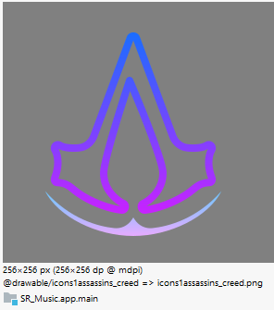**android:roundIcon**: Specifies the round version of the launcher icon.

android:supportsRtl="true"  
 android:theme="@style/Theme.SRMusic"  
 tools:targetApi="31">  
 <activity  
 android:name=".Splashscreen"  
 android:exported="true">  
 <intent-filter>  
 <action android:name="android.intent.action.MAIN" />  
  
 <category android:name="android.intent.category.LAUNCHER" />  
 </intent-filter>  
  
 <meta-data  
 android:name="android.app.lib_name"  
 android:value="" />  
 </activity>  
 <activity  
 android:name=".PlayerActivity"  
 android:exported="false">  
 <meta-data  
 android:name="android.app.lib_name"  
 android:value="" />  
 </activity>  
 <activity  
 android:name=".MainActivity"  
 android:exported="true">  
  
  
 <meta-data  
 android:name="android.app.lib_name"  
 android:value="" />  
 </activity>  
 </application>  
  
</manifest>

1. **Build.gradle (:app):**

dependencies **{** implementation 'androidx.appcompat:appcompat:1.6.1'

**implementation 'com.karumi:dexter:6.2.2'**

* **com.karumi:dexter:6.2.2**: Dexter simplifies the process of requesting permissions at runtime, handling the complex logic of the Android permission system.

implementation 'com.google.android.material:material:1.12.0'  
 implementation 'androidx.constraintlayout:constraintlayout:2.1.4'  
 testImplementation 'junit:junit:4.13.2'

***implementation 'com.gauravk.audiovisualizer:audiovisualizer:0.9.2'***

* **com.gauravk.audiovisualizer:audiovisualizer:0.9.2**: Provides visualizations for audio in Android applications, allowing the display of audio waveforms, bars, and other visual effects synchronized with audio playback.

androidTestImplementation 'androidx.test.ext:junit:1.1.5'  
 androidTestImplementation 'androidx.test.espresso:espresso-core:3.5.1'  
  
 def lottieVersion = "3.4.0"  
 implementation "com.airbnb.android:lottie:6.0.0"  
  
 ***implementation 'com.daimajia.androidanimations:library:2.4@aar'***

* **com.daimajia.androidanimations:library:2.4@aar**: This library provides a set of pre-defined animations, like bounce, fade, flip, etc., for Android views, which can be applied with minimal effort.

**}**

1. **Themes.xml:**

* Changed the status bar color:

<item name="android:windowLightStatusBar">true</item>  
 <item name="android:statusBarColor">@android:color/tertiary_text_light</item>  
</style>

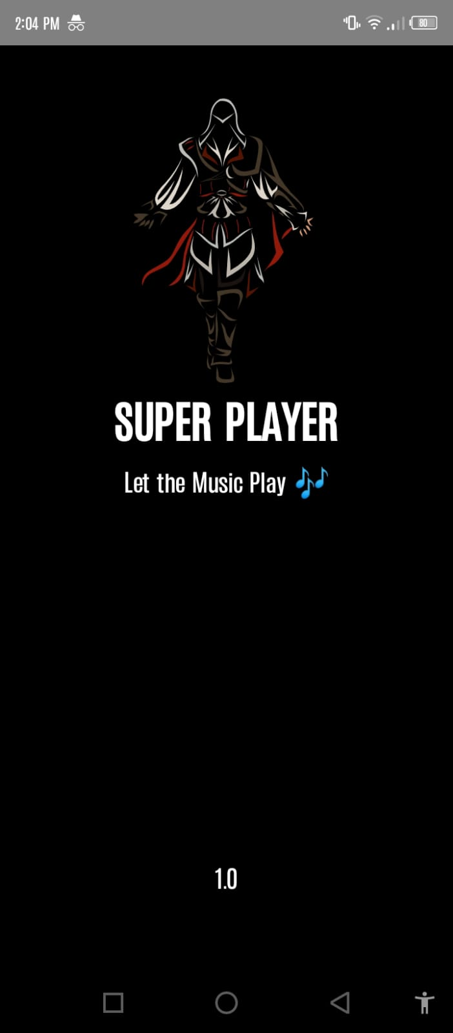

1. **Output of the App:**

*On next page--------------🡪*

* **Splashscreen:**
* **MainActivity:**

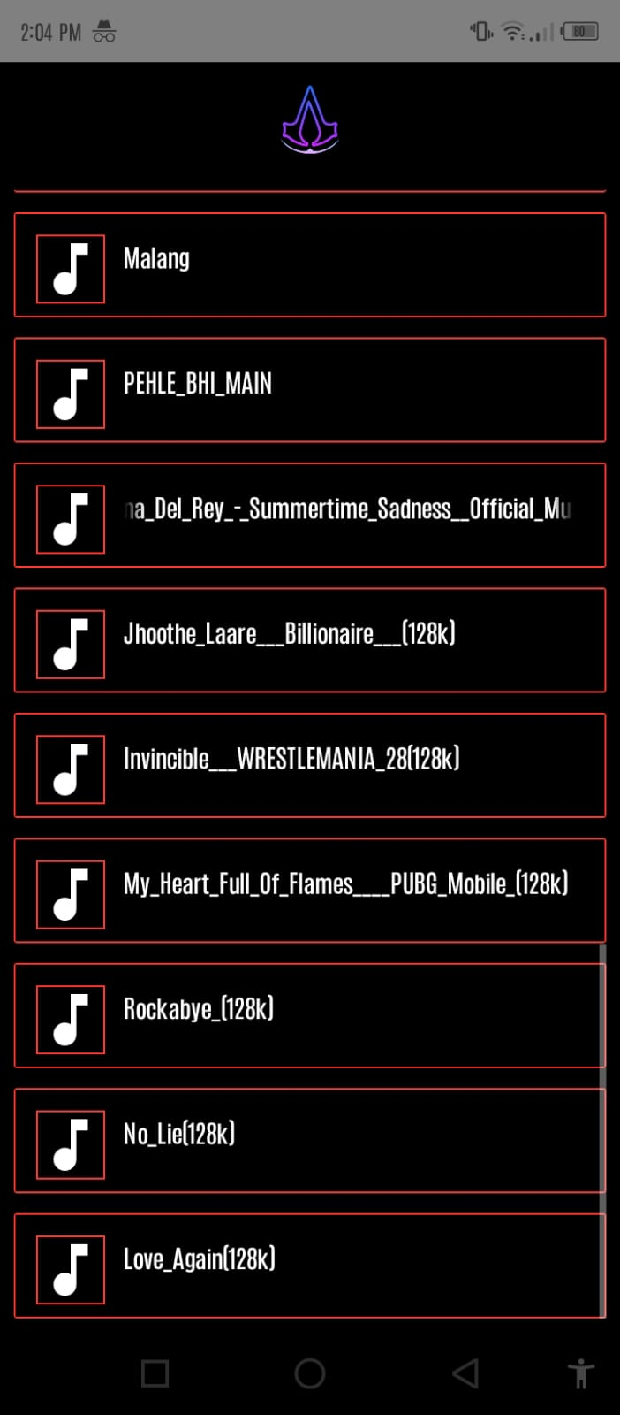

* **PlayerActivity:**

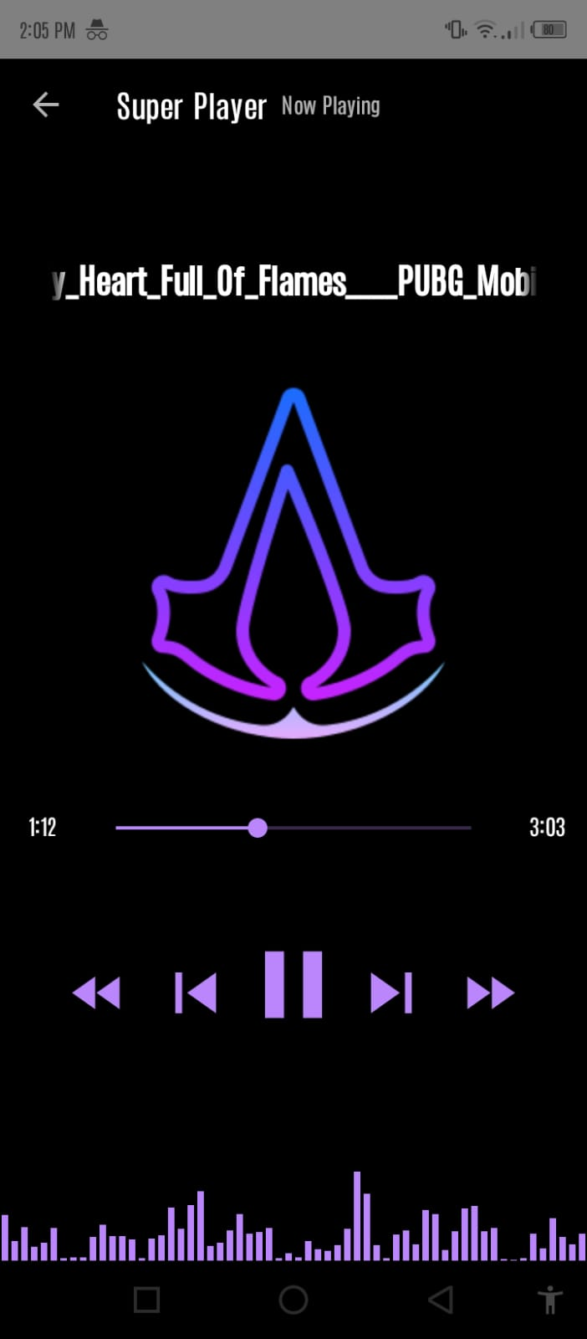

* **Permissions:**

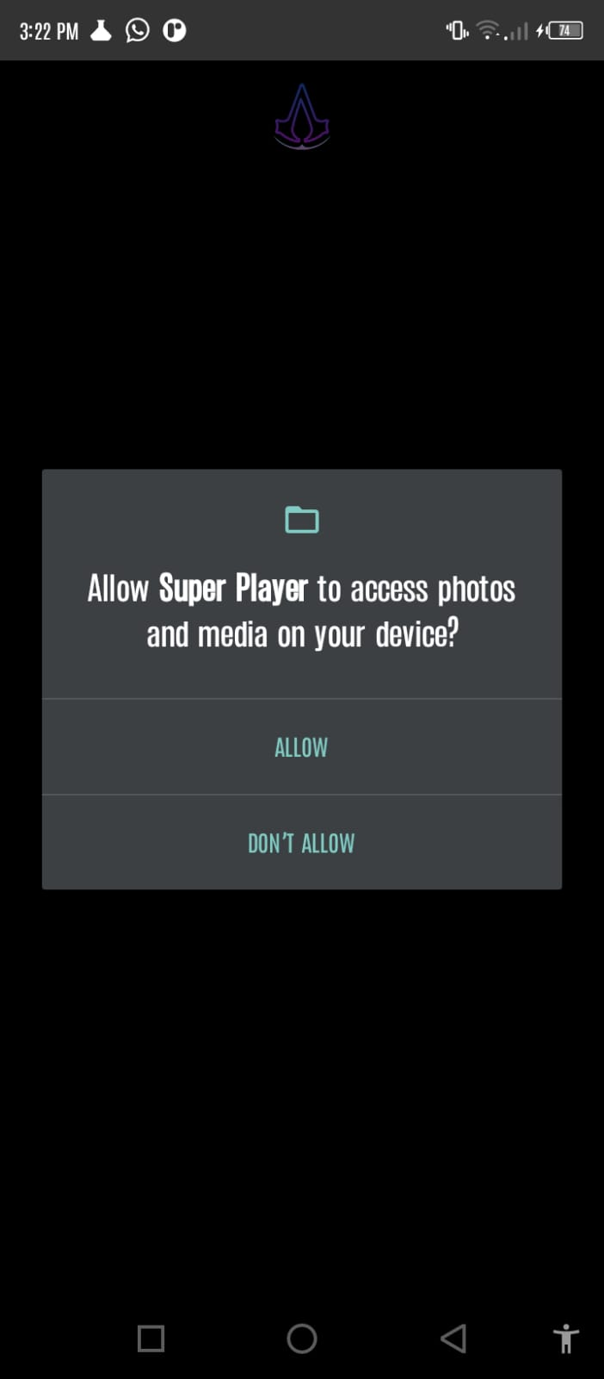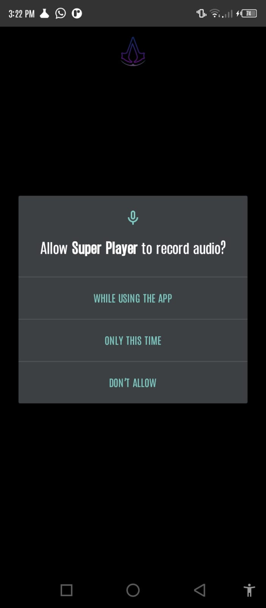

**THE END**