**GitHub Explore (Shaheryar Shahid 8256 )**

1. **Member 1-Module 3 (SRS-IEEE)**

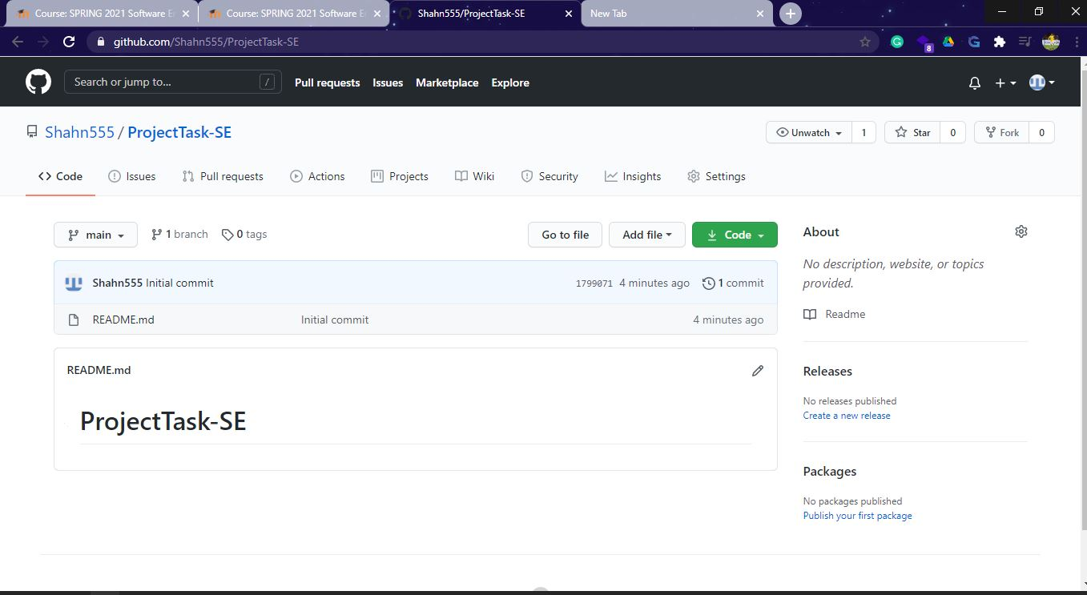

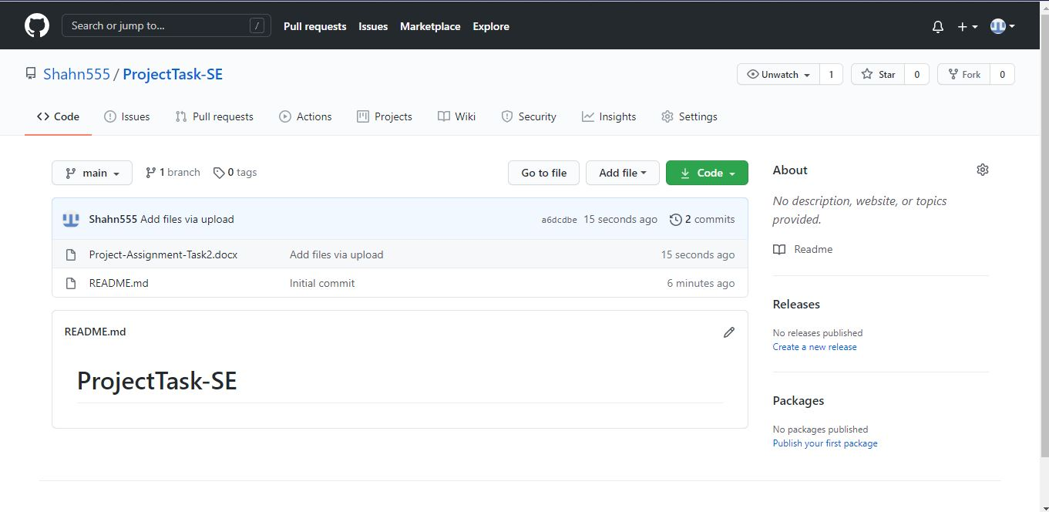

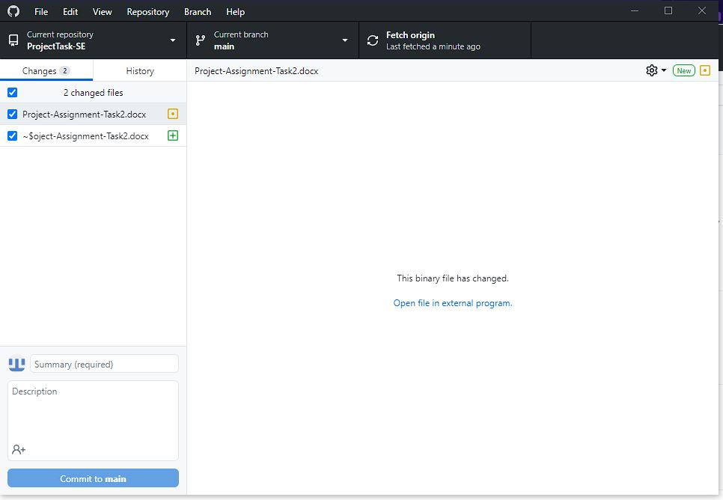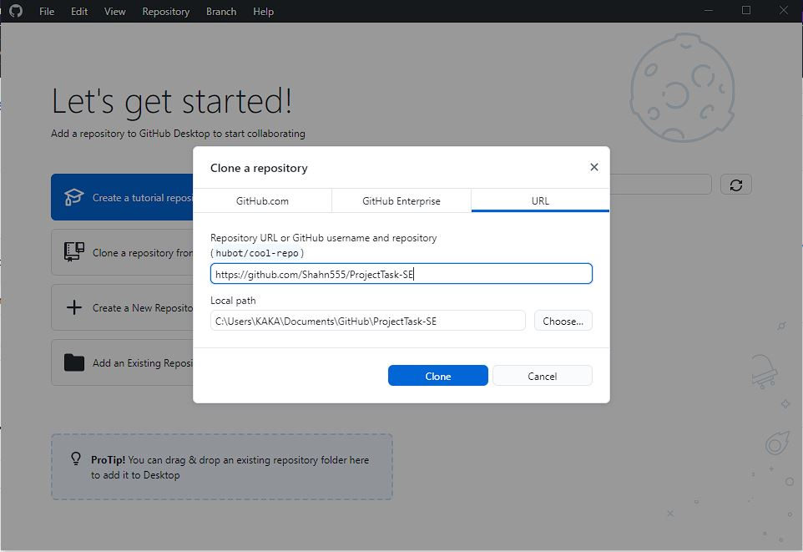

**3.1.4 Module 4 complete CRUD Make a Reservation Function**

**3.1.5 Module 5 complete CRUD Make a Reservation Function**

**3.1.6 Module 6 complete CRUD Make a Reservation Function**