Report prepared by

Shahnawaaz Rafeeq Bagwan
Capstone Project
E-Commerce Customer Segmentation
Final Capstone Research Presentation
Date: 07/05/2026

Project Report

1. Project Overview
This project analyzes an E-Commerce transaction dataset to understand sales behavior, customer patterns, and business performance. The work starts with domain understanding, continues with data collection and EDA, and ends with clustering-based customer segmentation. The final model is chosen not only by silhouette score, but also by cluster balance, silhouette structure, outlier handling, stability, and business usefulness.

The overall workflow follows the scaling, clustering, and evaluation ideas shown in the reference presentation provided with the project.

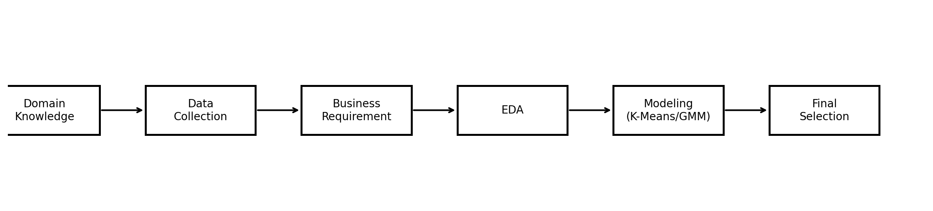
Figure 1. End-to-end project workflow.

2. Step-by-Step Project Flow
- Collected domain knowledge: Before touching the data, the business context was studied. For this project, the important idea was how an E-Commerce business earns revenue, how customers behave over time, and why segmentation helps marketing and retention.
- Collected the data: The transaction data was loaded from the source notebook environment and prepared for analysis in Pandas. Key fields included Customer_ID, Invoice, Description, Quantity, Price, Invoice_Date, and Country.
- Understood the business requirement: The main business goal was customer segmentation. The question was: how can we group customers with similar purchasing behavior so the business can target them more effectively?
- Performed EDA: The dataset was cleaned, visualized, and transformed into useful business features such as Total_price, Year, Month, and Hour.
- Compared clustering algorithms: K-Means and Gaussian Mixture Models were tested across multiple scaling methods. The final selection used a multi-criteria view, not a single metric.

3. Exploratory Data Analysis
EDA was used to understand the dataset,
- clean invalid records
- detect skewness and outliers and
- discover sales patterns
Several graphs were used because each graph answered a different question.

Graphs used in EDA and why
- Histogram for Quantity and Price: Used to see the distribution of transaction values and identify outliers. Both columns were skewed, which is common in sales data.
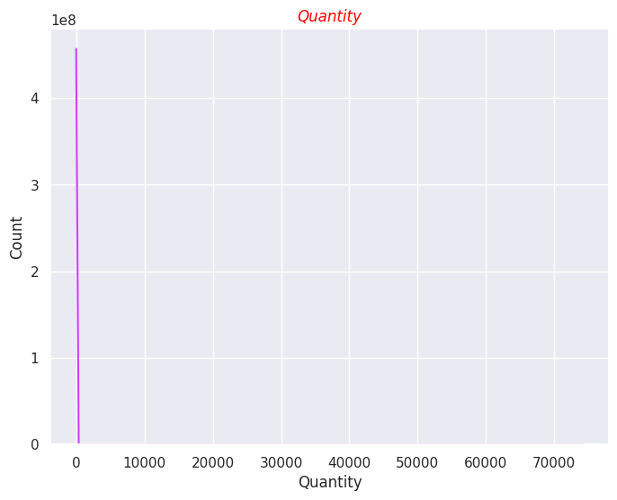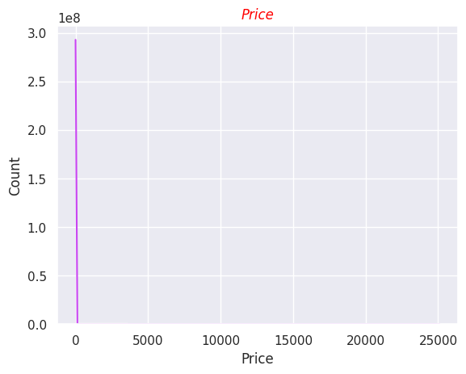

- Pie chart for top 10 selling products: Used to show which products contributed the most to total quantity sold.

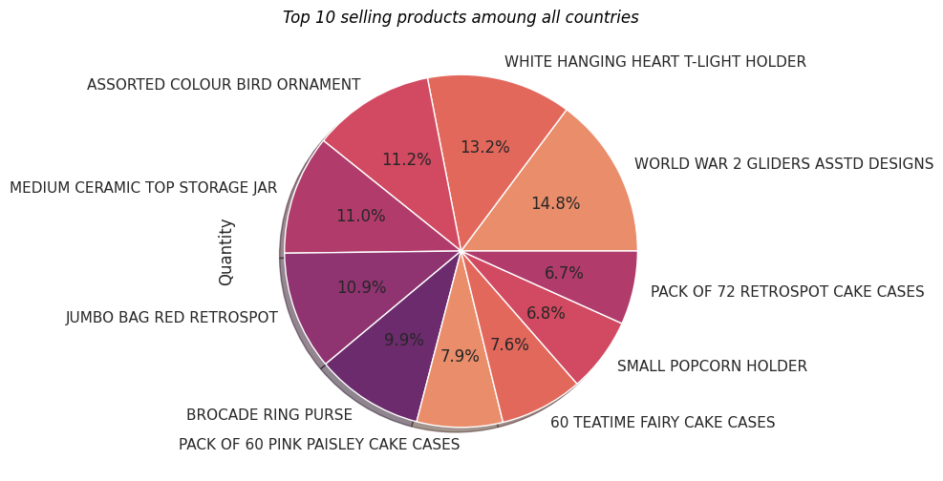

- Bar chart for yearly sales: Used to compare overall sales across years and detect growth.
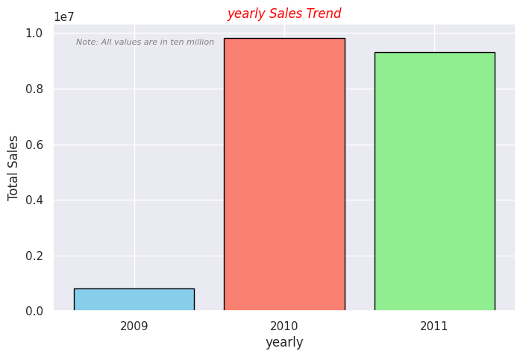

- Line chart for monthly sales by year: Used to observe seasonality and monthly movement in revenue.
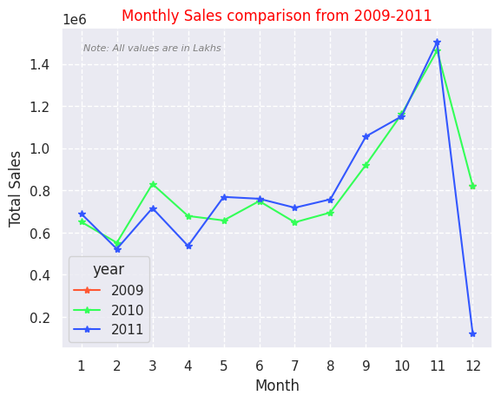

- Area chart for hourly sales: Used to identify the busiest shopping hours.
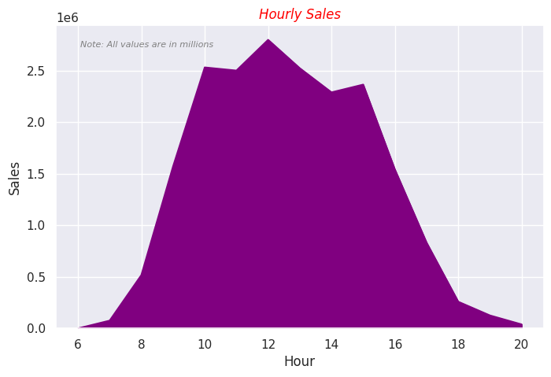
Bar chart for top 10 country revenue: Used to compare which countries contributed the most revenue.
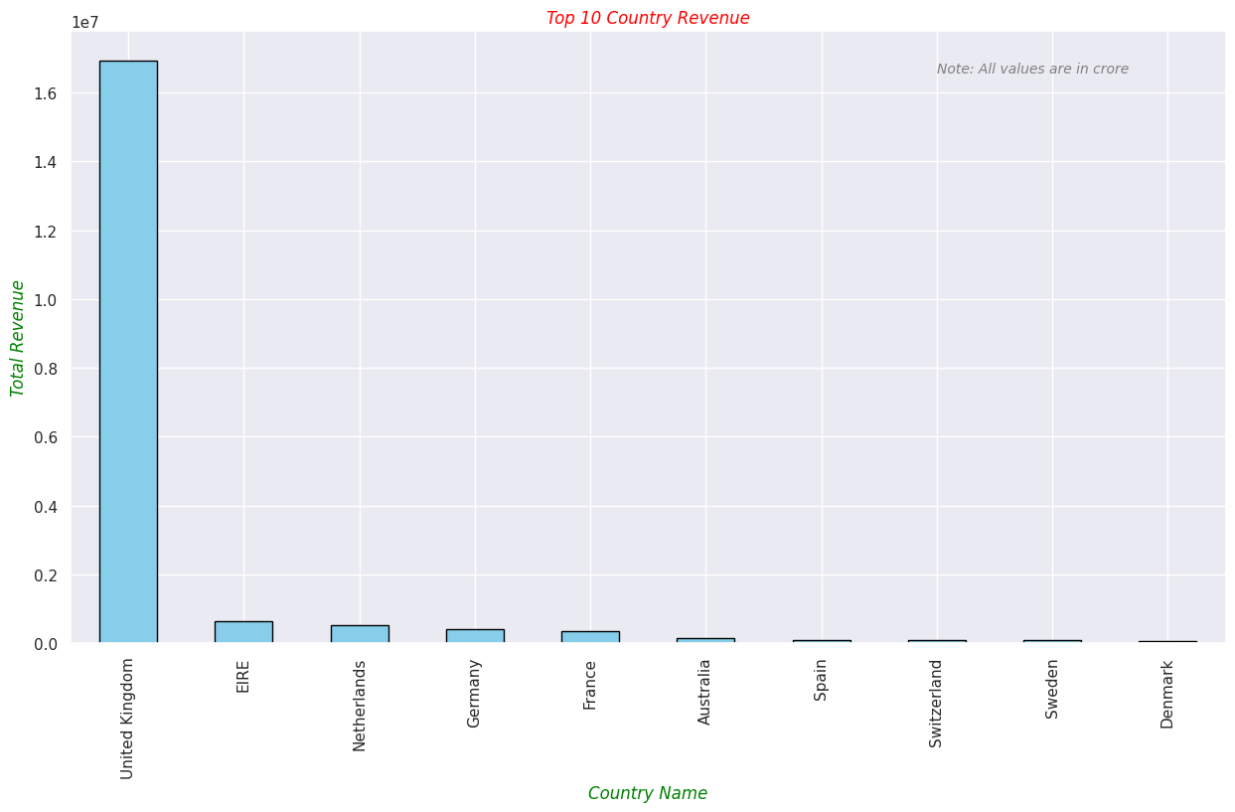

- Bar chart for top 10 countries by customer count: Used to show where the customer base was concentrated.

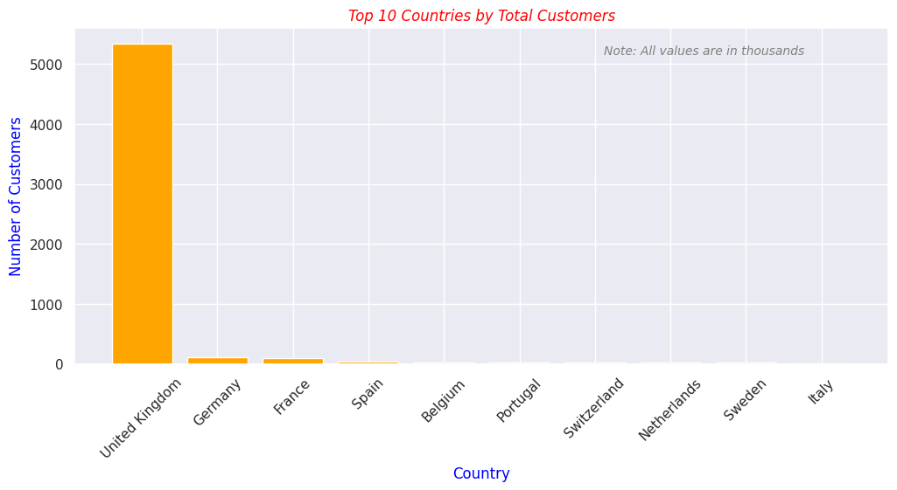

Key EDA insights
- Quantity and Price were highly skewed, so outlier handling and scaling were important before clustering.
- The top-selling products were concentrated in a small number of items, showing a typical Pareto-like pattern.
- 2010 and 2011 contributed the largest total sales; 2009 was much smaller, which likely reflects a partial year.
- Revenue was heavily concentrated in the United Kingdom, with a very large gap between the UK and the next countries.
- Monthly sales showed seasonal movement, especially in later months.

4. Modeling Strategy
The project tested two clustering families:
- K-Means
- Gaussian Mixture Models (GMM)
The aim was not simply to find the highest silhouette score, but to choose the model that gave the best practical segmentation.

Why scaling was tested
For that reason, multiple preprocessing techniques were tested before choosing the final model.

Evaluation criteria used
- Good cluster balance
- Better silhouette structure
- Handles outliers properly
- Stable customer segmentation
- Business-friendly clusters

Silhouette score was important, but it was only one part of the decision. A model with a higher score can still be less useful if it creates one dominant cluster or visually weak separation.

5. K-Means Comparison
The following K-Means variants were tested. The unscaled version had the highest silhouette score, but the cluster structure was not ideal. StandardScaler was selected because it gave a strong balance between score, cluster shape, and interpretability.

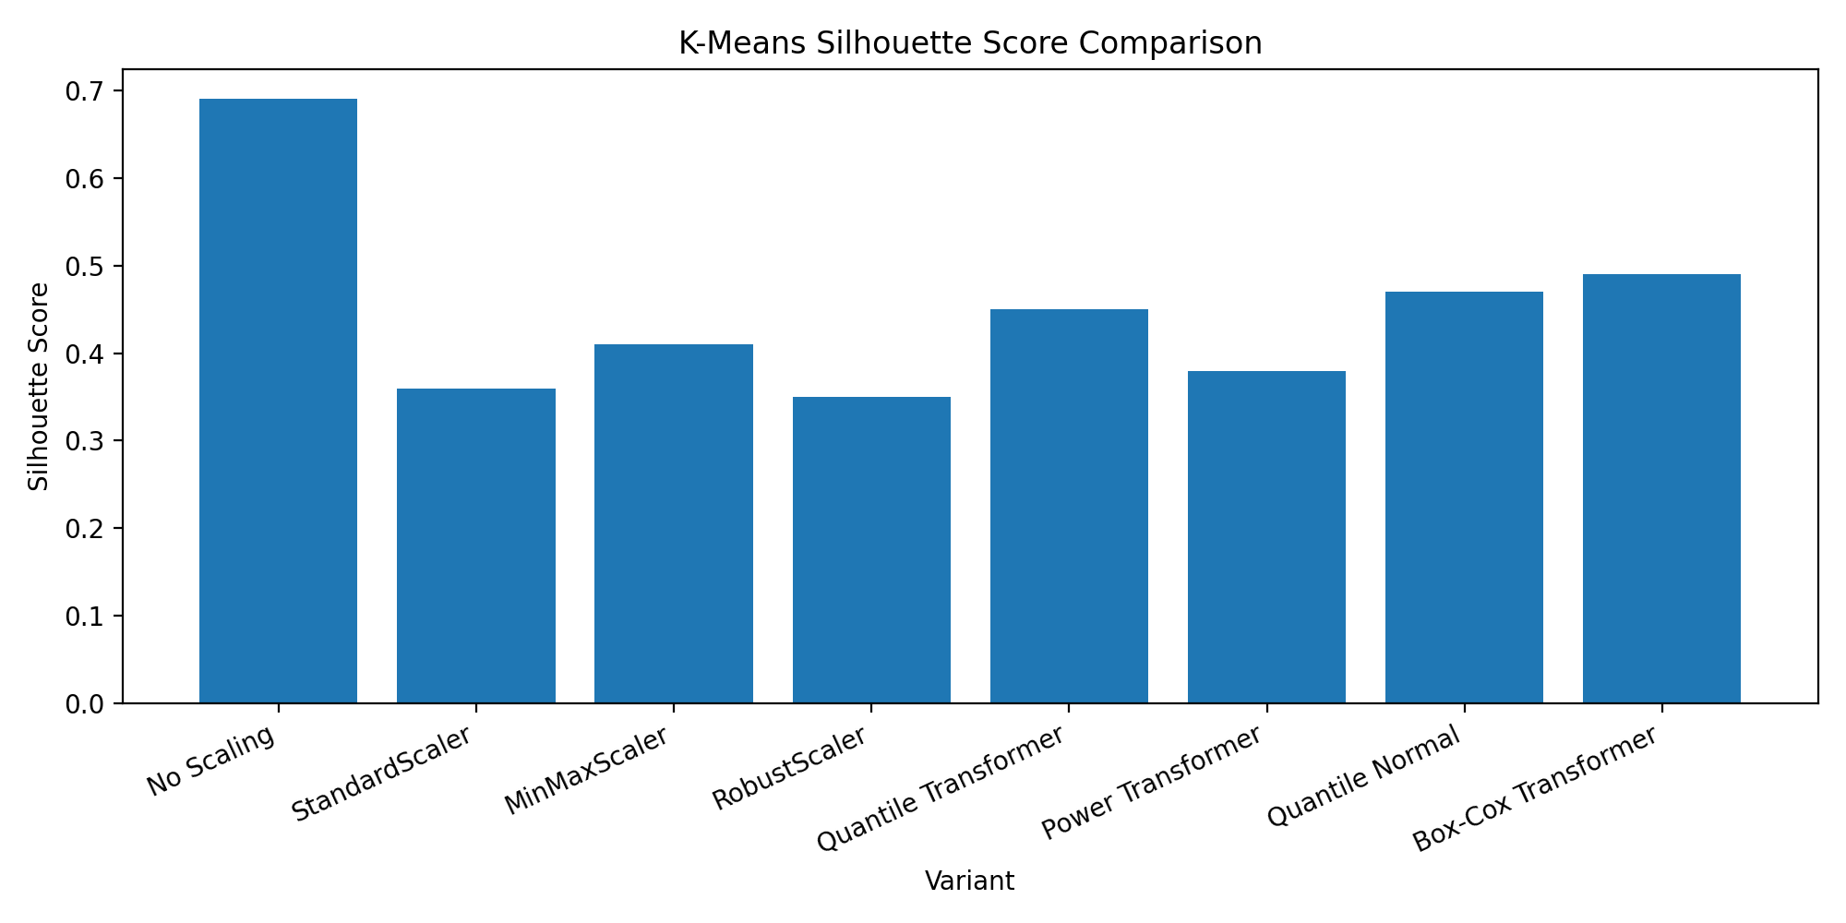

K-Means variant | Silhouette score
No Scaling | 0.69
StandardScaler | 0.36
MinMaxScaler | 0.41
RobustScaler | 0.35
Quantile Transformer | 0.45
Power Transformer | 0.38
Quantile Normal | 0.47
Box-Cox Transformer | 0.49

Observation:
the unscaled model has the best numeric score (0.69), but it is not the best practical choice because the cluster distribution is uneven and the silhouette plot is not visually clean.

Selected K-Means model
Selected model: K-Means + StandardScaler. It offers good feature fairness, a cleaner silhouette structure, and a more balanced cluster layout than the unscaled model

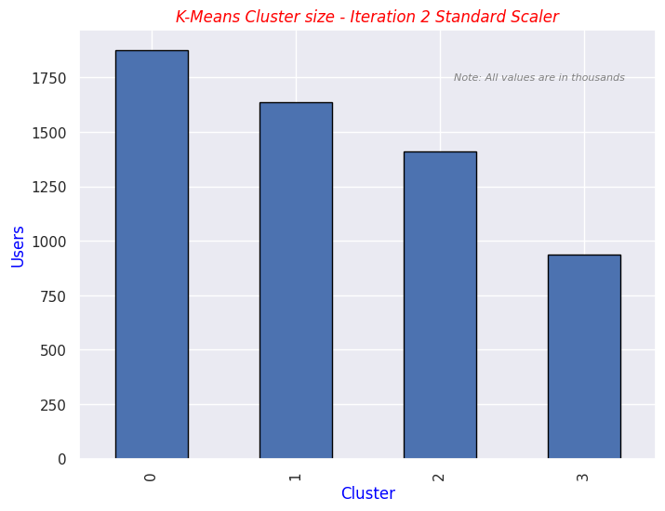

K-Means Standard Scaler Recency vs Frequency
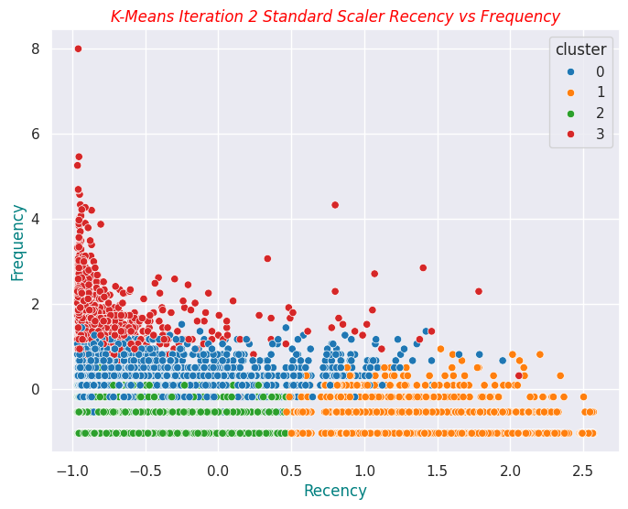

K-Means Standard Scaler Recency vs Monetary
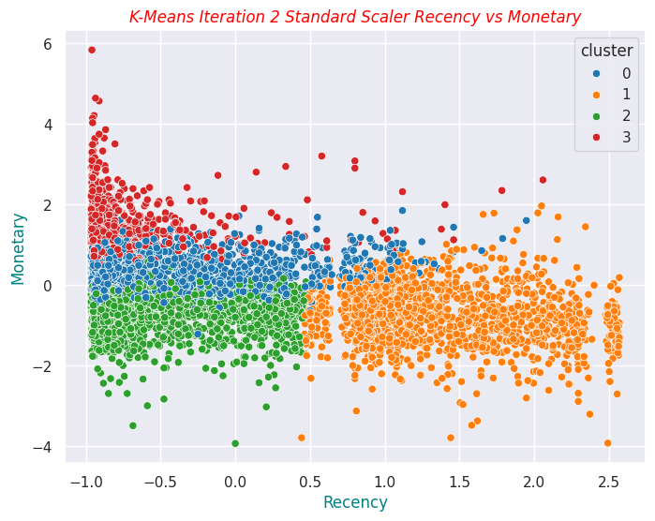

K-Means Standard Scaler Frequency vs Monetary
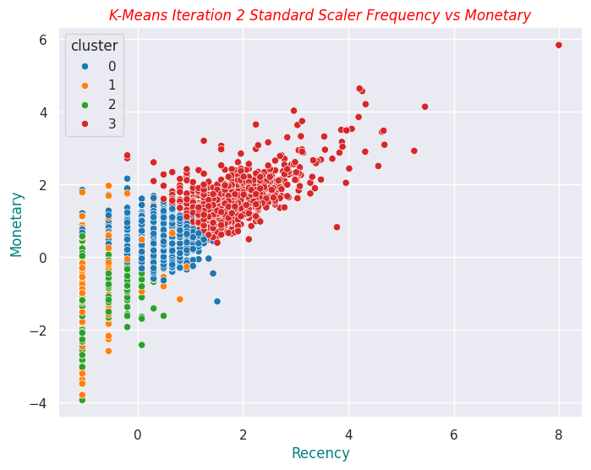

silhouette plot K-Means Standard Scaler
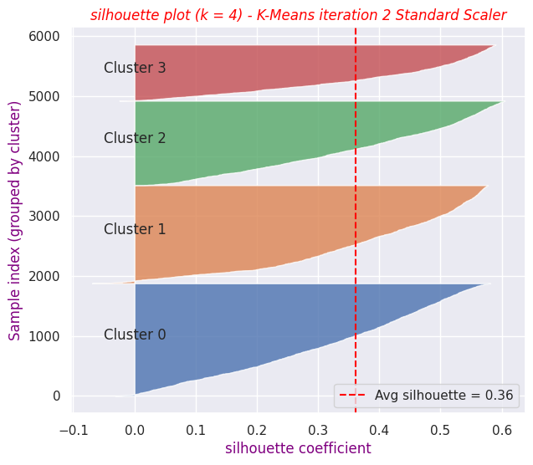

6. GMM Comparison
Gaussian Mixture Models were also tested because they support soft clustering and can model overlap between customer groups. Different covariance types and scalers were evaluated. In this project, GMM did not outperform the best K-Means setup in a practical way.
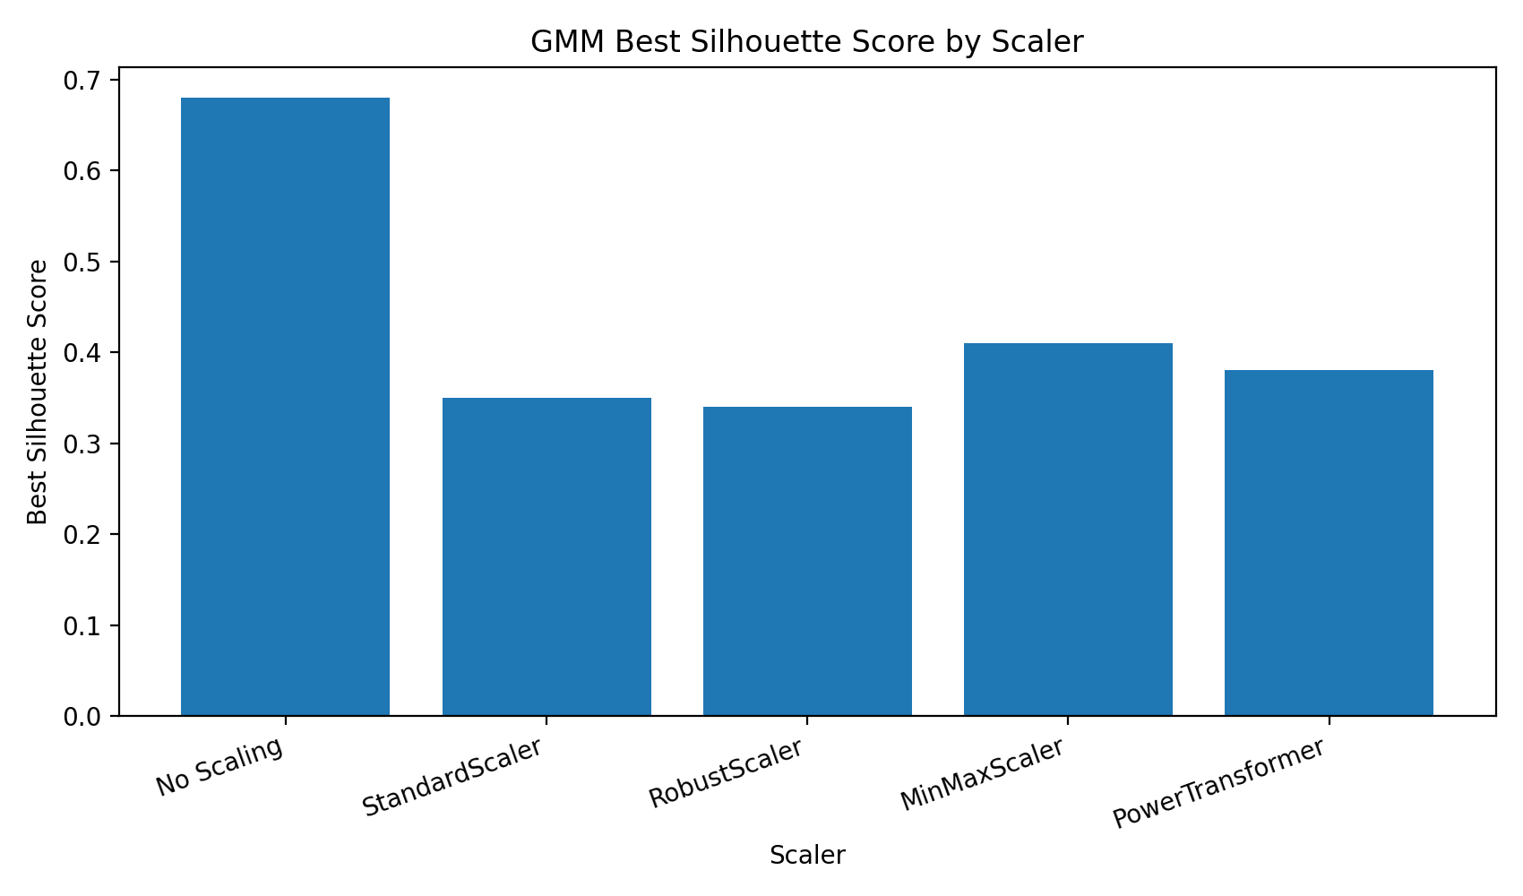

GMM scaler | Best silhouette score
No Scaling | 0.68
StandardScaler | 0.35
RobustScaler | 0.34
MinMaxScaler | 0.41
PowerTransformer | 0.381

7. Final Model Selection
Final selected model: K-Means + StandardScaler.
- Good cluster balance: the clusters are reasonably distributed and not dominated by one single group.
- Better silhouette structure: the silhouette plot is cleaner and easier to interpret.
- Handles scale differences well: StandardScaler gives all RFM features comparable weight.
- Stable customer segmentation: the groups are consistent and practical for business use.
- Business-friendly clusters: the segments are easier to explain to marketing and management.

This selection shows an important clustering principle: the best model is not always the one with the highest silhouette score. A model must also make business sense and produce usable customer groups.

8. Common Questions You Can Answer
Q. Why did you not choose the unscaled model?
A. Because the silhouette score was high, but the cluster structure was not as useful. The model created less practical separation and weaker balance.
Q. Why is StandardScaler preferred here?
A. Because RFM features are on different scales, and standardization gives each feature a fair contribution in K-Means.
Q. Why not select the model only by silhouette score?
A. Because silhouette score does not fully capture business usefulness, cluster balance, or interpretability.
Q. Why was GMM tested?
A. Because GMM can capture overlapping groups and soft assignments, which is useful when customer behavior is not perfectly separated.

9. Conclusion
The project successfully moved from data understanding to EDA, preprocessing, clustering experiments, and final model selection.
The final answer is not based on silhouette score alone. After comparing all experiments, K-Means with StandardScaler was selected because it gives the best overall combination of balance, structure, interpretability, and practical customer segmentation.

