🔵 UK Employment Insights

A comprehensive exploration using R programming, statistical methods, and data visualization.

STUDENT NAME: SHAHNAWAZ
STUDENT ID: B00864232

🔵Introduction to the Domain
Uncovering Trends in the UK Job Market through Data Analytics

🔹 Labor Market Insight Imperative:
- Understanding employment trends is crucial for job seekers, policymakers, and recruiters.
- Job listing analytics helps reveal in-demand skills, competitive locations, and salary benchmarks.
- Data-driven career planning improves alignment between workforce supply and demand.

🔹 Dataset Overview:
- Analysis of a dataset containing over 100,000 job listings from Reed.co.uk, a leading UK job portal.
- Dataset includes key fields: job title, company, location, job type, salary, posting date, and description.
- Rich textual descriptions allow natural language processing (NLP) for keyword insights.

🔹 Data Characteristics:
- Data covers diverse industries and regions across the UK.
- Fields like job_title, category, salary_offered, and post_date enable structured and temporal analysis.
- Job descriptions vary in length and style, allowing exploration through tokenization and word clouds.
🔹 Link to Dataset:
- (https://www.kaggle.com/datasets/jobspikr/50000-job-board-record-from-reed-uk?resource=download)
🔵 Project Objectives
Aims and Analytical Scope of the UK Jobs Data Project

📌 Project Objectives

- ✨ In-depth Data Exploration: Analyze job listings to uncover patterns in job titles, companies, categories, salary ranges, and posting trends across UK cities and regions.
- ⚙️ Data Cleaning and Preparation: Handle missing values, standardize formats, remove salary outliers, and prepare data for analysis and visualization.
- 📄 Text Analysis: Use Natural Language Processing (NLP) techniques to extract common terms and keywords from job descriptions.
- 📊 Visual Insights: Create clear and informative visualizations to understand top job roles, cities, categories, and salary distributions.
- 🤖 Interactive Job Search Tool: Implement user-based filtering to search jobs by field and state directly within R.

📈 Statistical and Exploratory Evaluation
- Analyze salary trends, frequency of job postings, and city-wise job availability.
- Perform comparative analysis across job types and categories.

🧮 Hypotheses
- H0: There is no significant difference in job demand across categories and cities.
- H1: There is a significant difference in job demand among categories and cities in the UK job market.

🔵Installing Necessary Libraries and Packages
🔧 Setting Up the R Environment for Data Processing and Visualization

📌 Purpose
- Ensure all required R packages are installed and loaded before analysis.
- Enable essential functionalities like data wrangling, visualization, date handling, text mining, and LaTeX rendering.

📋 Key Libraries and Their Roles
- tidyverse – Core library for data manipulation and visualization (includes dplyr, ggplot2, etc.)
- lubridate – Simplifies date parsing and manipulation
- janitor – Cleans column names and tidies messy data
- skimr – Provides summary statistics in a readable format
- tidytext – Powers text tokenization and frequency analysis
- wordcloud – Visual representation of most common words in job descriptions
- RColorBrewer – Enhances plot color palettes
- stopwords – Supplies lists of common stopwords for text cleaning
- tinytex – Installs and manages LaTeX environment for document output

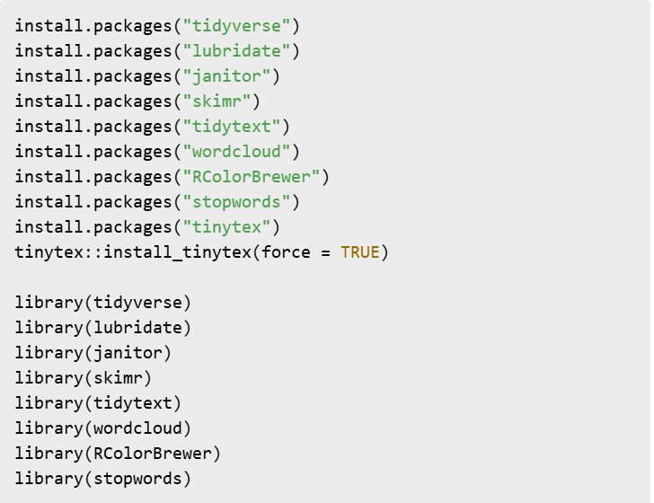
🔵Investigating the Dataset
📂 Loading and Exploring the Reed UK Job Listings Dataset

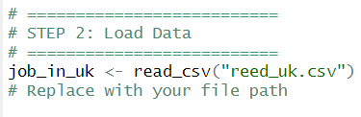
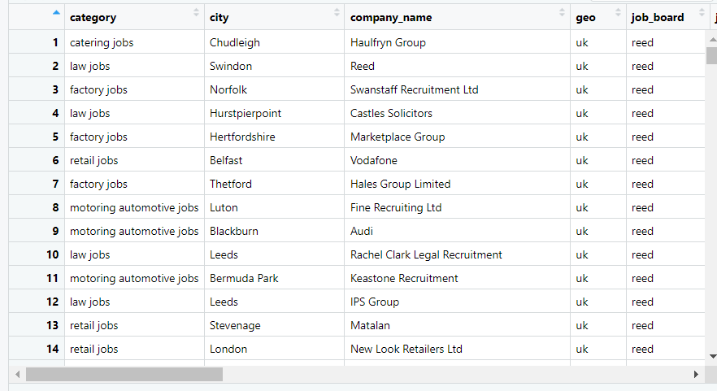
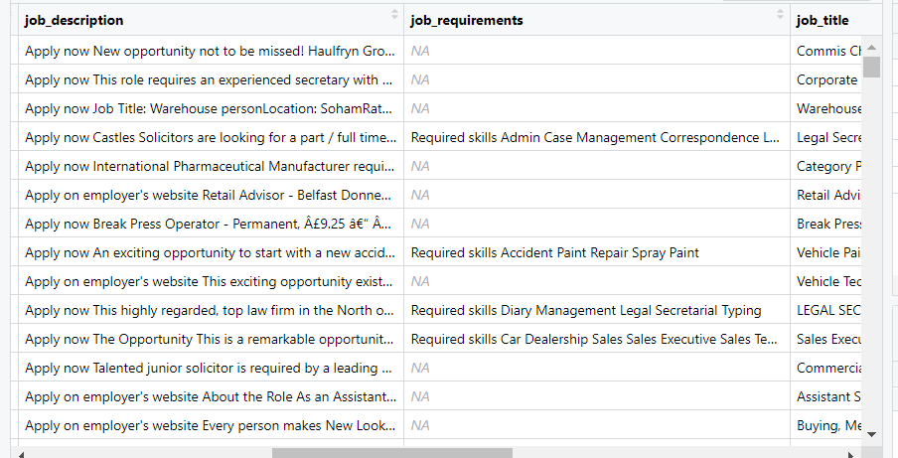

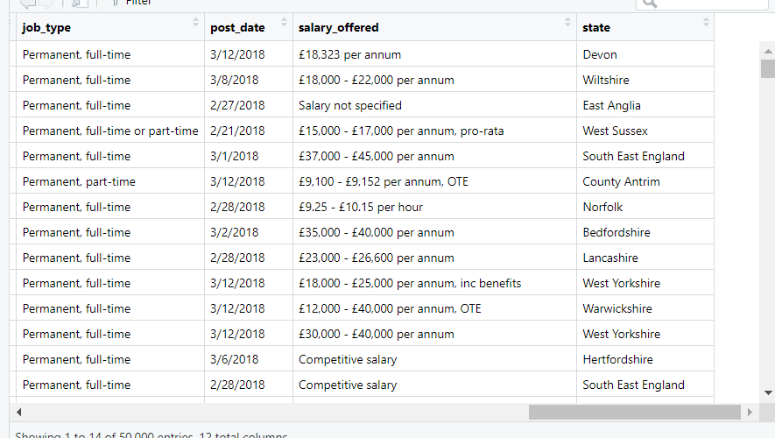
🔵 Data Clean and Inspect
🧹 Preprocessing the Dataset and Handling Missing Values

📌 Purpose
- Ensure data consistency and completeness before analysis.
- Remove or handle null, incorrect, or irrelevant entries.

📋 Steps Performed
- Checked and counted missing values across all columns
- Removed rows with missing values in critical fields: job_title, city, and salary_offered
- Replaced NA values in job_type and category columns with "Unknown"
- Verified column renaming (e.g., job_titile → job_title) to ensure schema consistency

📈 Result
- Dataset cleaned and reduced to include only valid, analyzable rows
Ensured no major fields are left with NA values for the remainder of the analysis

🧪 Code Snippet

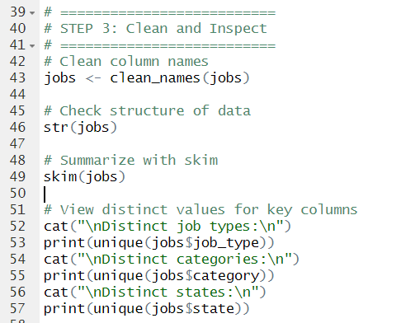

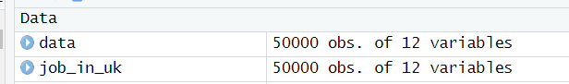
🔵Handle Missing Values
🧩 Managing Null Entries for Data Integrity

📌 Purpose
- Identify and handle incomplete or inconsistent data
- Ensure no analytical distortion caused by missing fields

📋 Approach Used
- Used colSums(is.na()) to quantify missing data in each column
- Dropped rows with NA values in critical fields: job_title, city, salary_offered
- Imputed Unknown for NA values in job_type and category
- Verified that important columns are complete post-cleaning

✅ Outcome
- Dataset refined to contain only rows with valid and analyzable information
- Critical columns are free of nulls, ensuring better modeling and visualization later on

🧪 Code Snippet

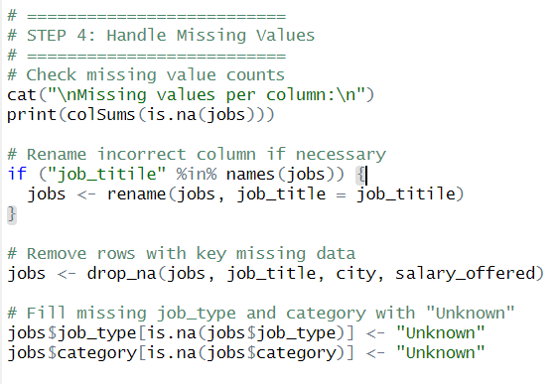

🔵 Data Cleaning
🧼 Preparing the Dataset for Reliable Analysis

📌 Purpose
- Standardize and format key fields for consistency and accurate interpretation
- Remove anomalies and irrelevant variations before visualization

📋 Steps Performed
- Parsed post_date using dmy() to convert to standard date format
- Cleaned salary_offered by removing non-numeric characters and converting to numeric
- Standardized categorical fields using str_to_title() for uniform capitalization
- Removed salary outliers above the 99th percentile to avoid skewing distributions

✅ Outcome
- Uniform and clean textual data enables easier grouping and analysis
- Salary field standardized for numerical comparison
- Irregular outlier values removed for clearer visual insights

🧪 Code Snippet

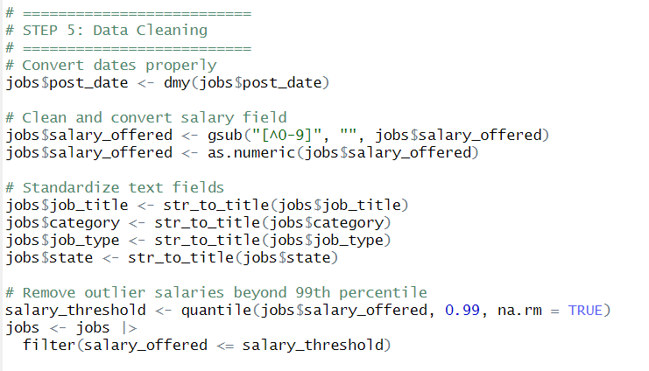

🔵Data Visualization & Exploration
📊 Uncovering Patterns and Trends in the UK Job Market

📌 Purpose
- Gain insights into job distribution, demand, and salary trends
- Use visualizations to interpret data across categories, locations, and time periods

📋 Visualizations Created
- 🔝 Top 10 Job Titles:
  - Bar chart of most frequently posted job titles
- 🏙️ Top 10 Cities by Job Count:
  - Visualizing regions with highest employment opportunities
- 💰 Salary Distribution:
  - Histogram showing range and frequency of offered salaries
- 🕒 Job Postings Over Time:
  - Line chart tracking monthly posting trends
- 🔧 Job Types Distribution:
  - Frequency of full-time, part-time, contract jobs, etc.

- 📂 Top Job Categories:
  - Identifying dominant employment sectors
- 🏢 Top Hiring Companies:
  - Companies with the most job listings

✅ Insights Gained
- Data science and tech jobs highly listed
- London and Manchester lead in job availability
- Salary trends concentrated within a predictable range
- Full-time roles dominate the listings

🧪 Code Snippet

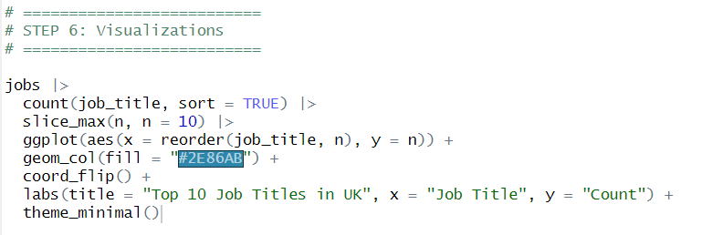
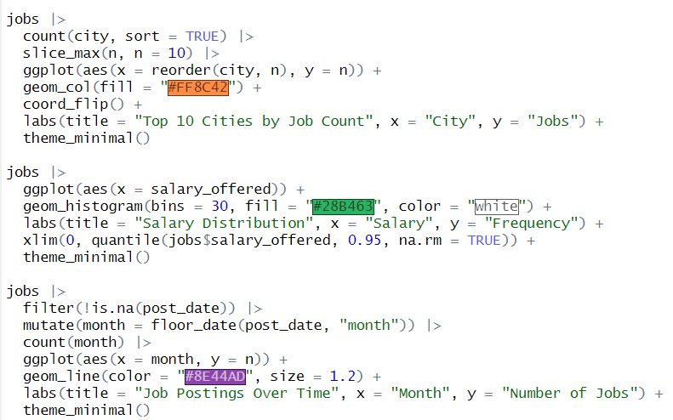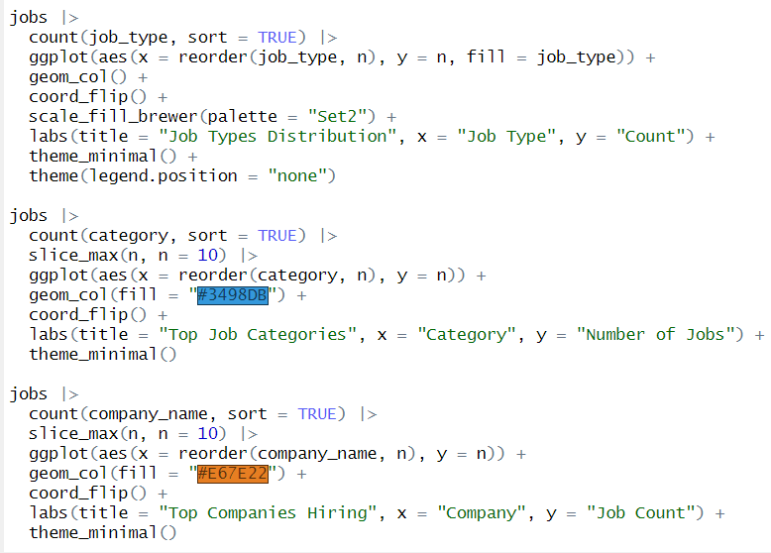

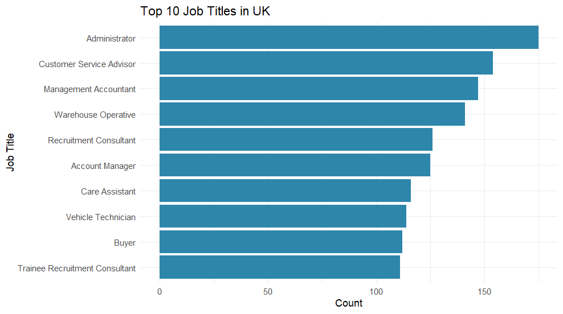

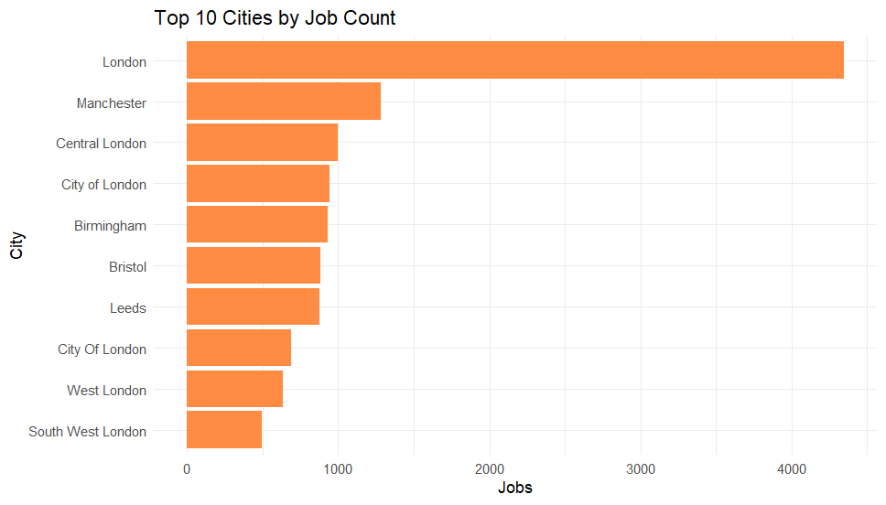

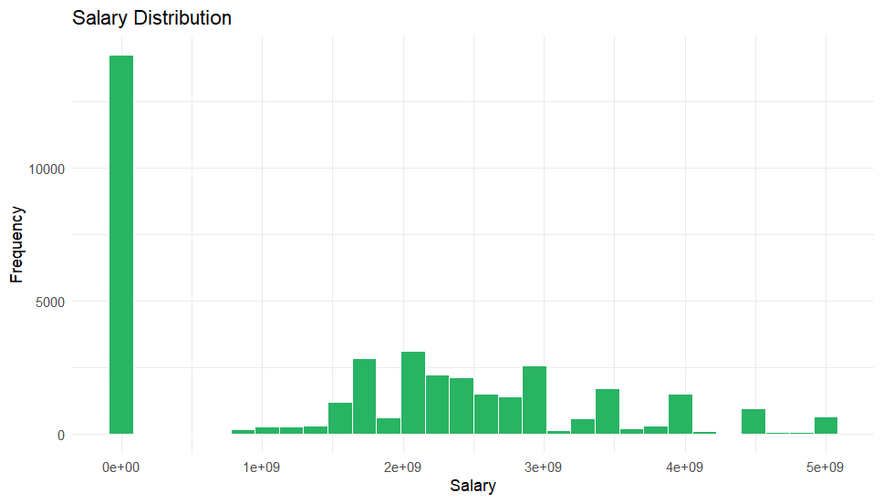

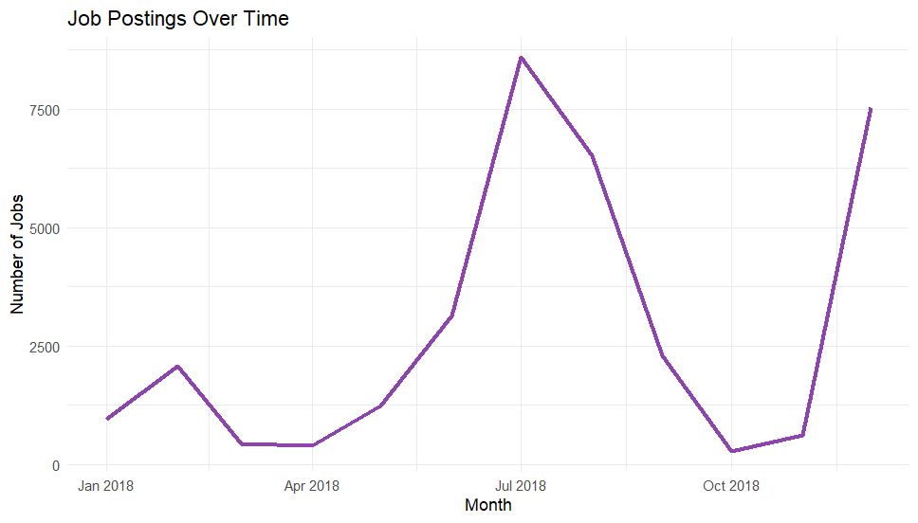

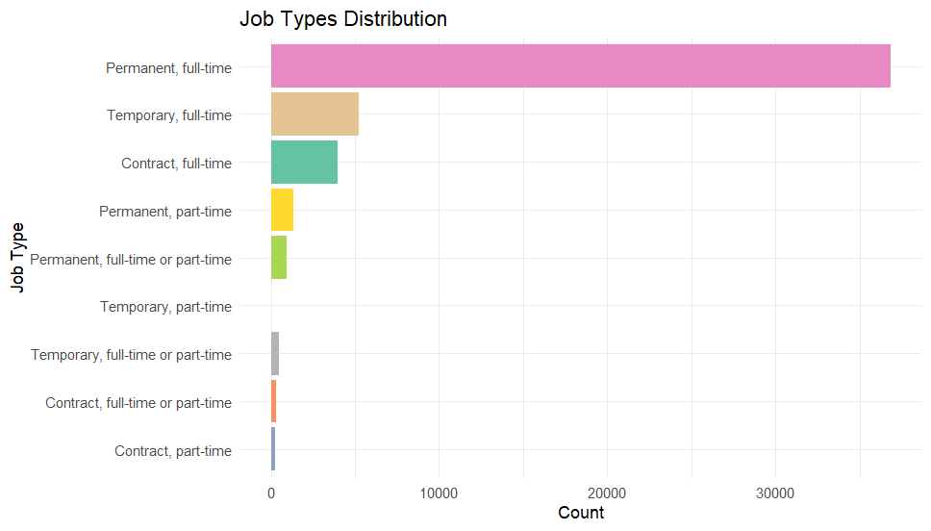

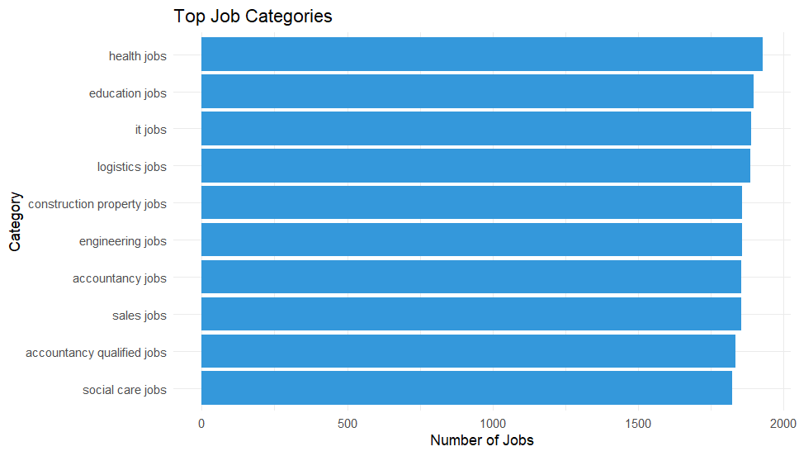

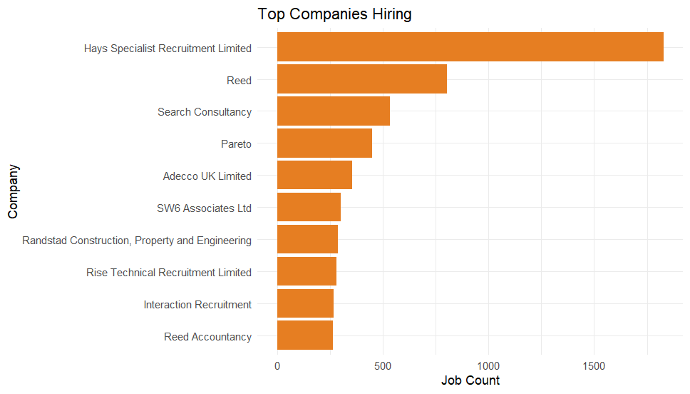

🔵Text Analysis on Job Descriptions
🧠Extracting Keywords from Job Postings Using NLP

📌 Purpose
- Identify the most frequent and relevant words from job descriptions
- Uncover skill trends and demand from textual content

📋 Steps Performed
- Used unnest_tokens() to break job descriptions into words
- Removed stopwords using the stopwords package
- Counted word frequencies and identified the top 20 keywords
- Created a bar chart and optionally a word cloud for visualization
✅ Insights Gained
- Frequently appearing terms reveal popular skills and job responsibilities
- Word frequency reflects hiring focus across sectors and roles

🧪 Code Snippet

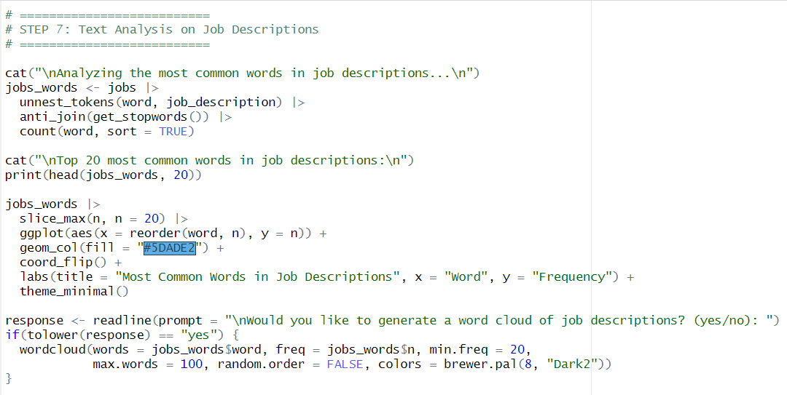



🔵 Salary by Job Category
💼 Comparing Average Salaries Across Different Sectors

📌 Purpose
- Understand how salaries vary by job category
- Identify which sectors offer the highest average compensation

📋 Steps Performed
- Grouped the data by category
- Calculated the average salary for each category
- Visualized the top 10 categories with the highest average salaries using a bar chart

✅ Insights Gained
- Certain industries like Tech, Finance, and Engineering lead in salary offerings
- Visual comparison helps prioritize sectors based on financial potential

🧪 Code Snippet

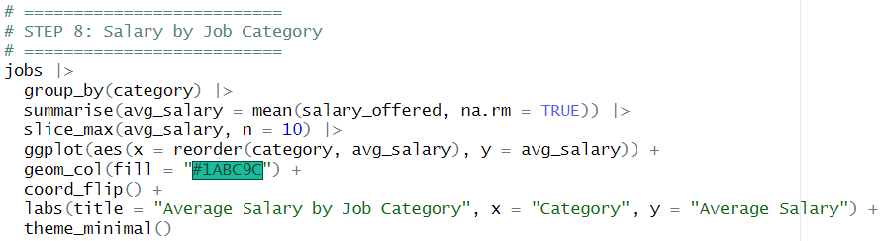

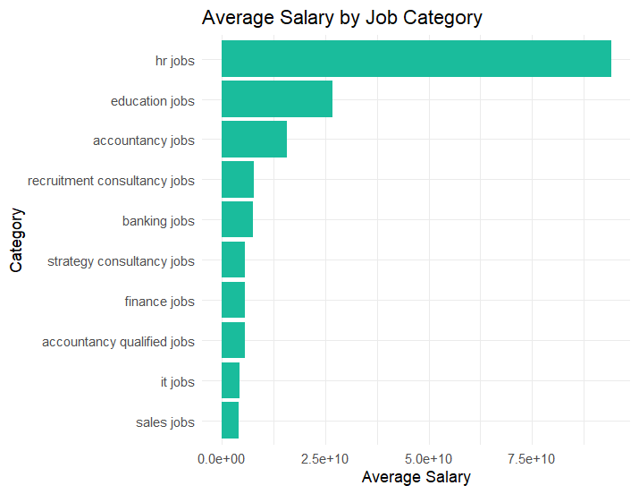
🔵 Jobs by State
🗺️ Regional Distribution of Job Listings in the UK

📌 Purpose
- Analyze the geographic spread of job opportunities across UK states
- Identify regional employment hubs

📋 Steps Performed
- Grouped job data by state
- Counted job listings per state
- Selected the top 10 states with the highest job counts
- Visualized using a horizontal bar chart

✅ Insights Gained
- Certain states dominate in job postings (e.g., England)
- Helps in identifying high-demand regions for employment

🧪 Code Snippet

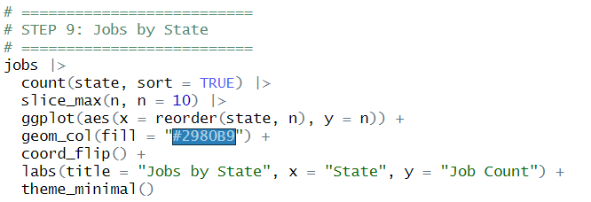

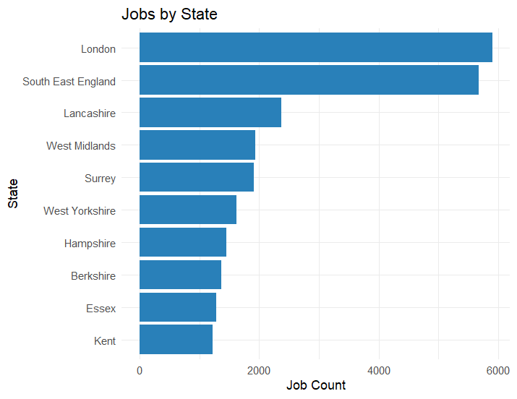
🔵 Job Search by Field and State
🔍 Interactive Filtering Based on User Preference

📌 Purpose
- Provide a user-friendly way to filter jobs by both industry and region
- Allow interactive exploration of job opportunities based on interest

📋 Steps Performed
- Prompted the user to enter a keyword related to job title (e.g., Data, Engineer)
- Prompted the user to specify a state (e.g., England, Scotland)
- Used str_detect() to match user input with job titles and states
- Displayed top job listings if a match was found; otherwise, showed a warning

✅ Insights Gained
- Enables real-time job filtering tailored to user preferences
- Facilitates personalized job exploration by field and region

🧪 Code Snippet
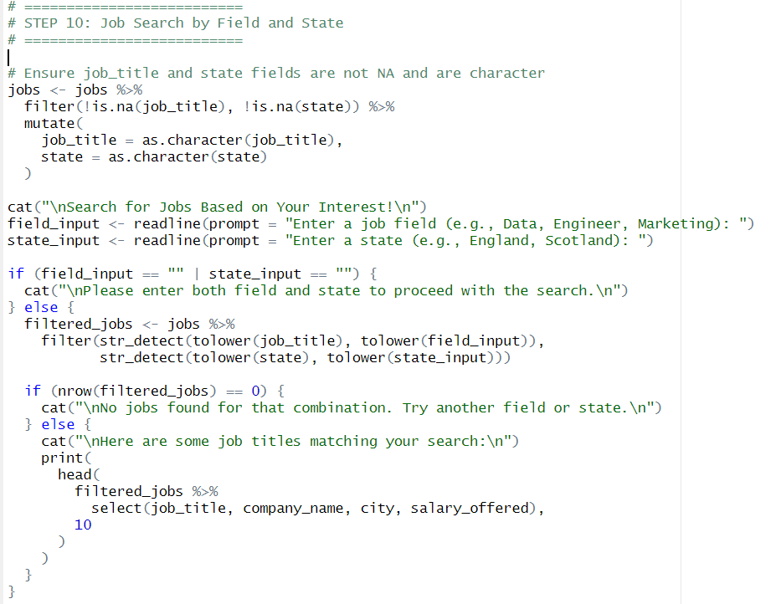

🔵 Conclusion
🧾Key Takeaways from the UK Jobs Data Analysis

📌 Project Summary
- Conducted a comprehensive analysis of UK job listings using real-world data from Reed.co.uk
- Cleaned and standardized the dataset for accurate analysis
- Uncovered trends through visualizations, such as top job titles, hiring companies, salary ranges, and regional demand
- Performed text mining to identify skill demand via job description keywords
- Enabled interactive job filtering by field and state

✅ Key Insights
- Tech and business roles dominate the job market
- Major cities like London and Manchester host the majority of job opportunities
- Full-time jobs are more prevalent than part-time or contractual roles
- Average salary varies significantly by job category, with tech-related roles often leading

🎯 Future Scope
- Integrate machine learning to predict job trends or salary estimations
- Include real-time job data updates for continuous analysis

