Department of: |  | Subject of:
Computer Systems Engineering |  | Object Oriented Programming
Mehran University of Engineering &Technology |  | Year | 1st | Semester | 2nD
Mehran University of Engineering &Technology |  | Batch | 25CS | Duration | 03  Hours
Jamshoro
Practical # 2
To practice programs using Variable, data types and operators
Objective
• Understand what variables are and why they are used in programming
• Identify and use basic data types in Java
• Declare and initialize variables correctly
• Use different types of operators in Java
• Write simple Java programs using variables, data types, and operators

Tools
- Eclipse IDE/IntelliJ Idea / Notepad++/VS CODE
Keywords: Variable, data types, and operators. | Duration:03 hours
- Overview of lab
  - Introduction
In programming, variables are used to store data that can be used and changed during program execution. Every variable has a data type, which tells the compiler what kind of data the variable can hold. To perform calculations or make decisions, we use operators.
This lab focuses on building a strong foundation by practicing basic Java programs using variables, data types, and operators. These concepts are essential before moving on to control structures and object-oriented concepts.

    - Variables in java: A variable is a name given to a memory location. It stores a value that can change during program execution.
Syntax
dataType variableName = value;

Rules for Naming Variables
- Variable names must start with a letter, underscore (_) or dollar sign ($)
- They cannot start with a number
- Meaningful names should be used

- Data Types:
Java supports eight primitive data types.
Primitive Data types | Reserved Memory | Type of Data store | Example
Int | Four byte memory | Store integer value | int i=3;
Float | Four byte memory | Store decimal value | float f=5.5f;
Double | Eight byte memory | Store decimal value | double d=4.5;
Character | Two byte memory | Store alphabets, characters & symbols. | char c=’A’;
Boolean | One byte memory | Store either true or false. | boolean x=true;

1.1.3 Operators:
These are some symbols or special characters which specify some specific operation.

Operators | Symbols | Number of Operands | Uses
Arithmetic | +, - , * , / , % | All are binary operators | Used for arithmetic operations
Assignment | = | Binary operator | Use for assign the value
Arithmetic Assignment | +=, -=, *=, /=, %= | All are binary operators | Used for summarize equations
Relational | <, >, <=, >=, ==, != | All are binary operators | Used to compare values
Logical | && , | | , ! | && and | | are binary. ! is unary operators | Used to compare expressions
Increment & Decrement | ++, -- | Unary operators | Used for increment and decrement
Bitwise | &, |, ^, !, >>, <<, >>> | All are binary operators except ! that is unary | Used to perform bit by bit operation

- Demonstration of practice examples.

- Default values of all data types (Example).

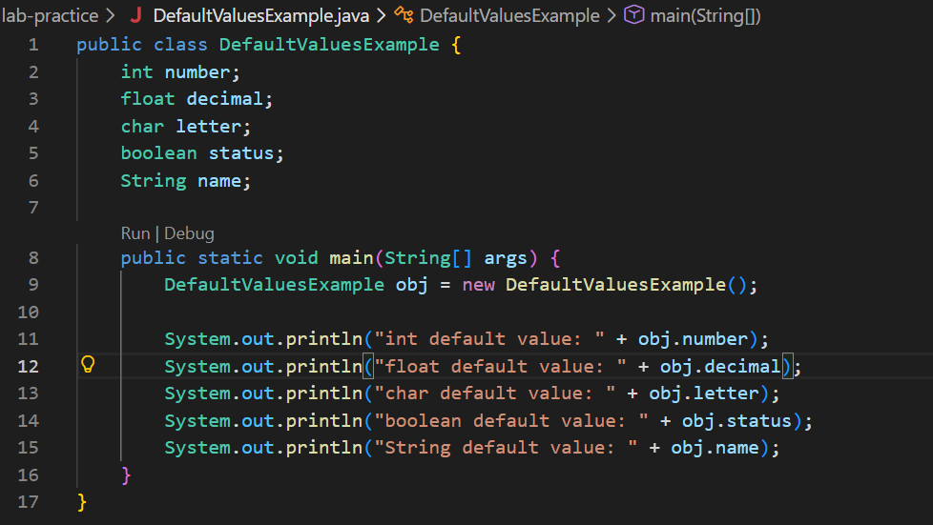
Output
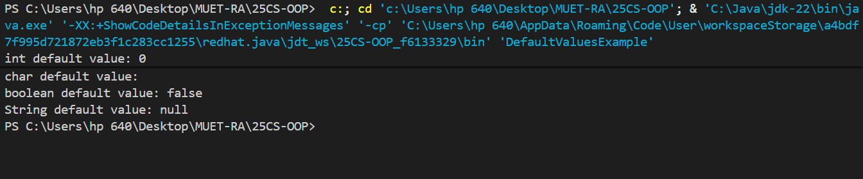

Exercise
1. Write a Java program to declare variables of type int, double, char, and boolean. Assign values to them and display the output.

Input:
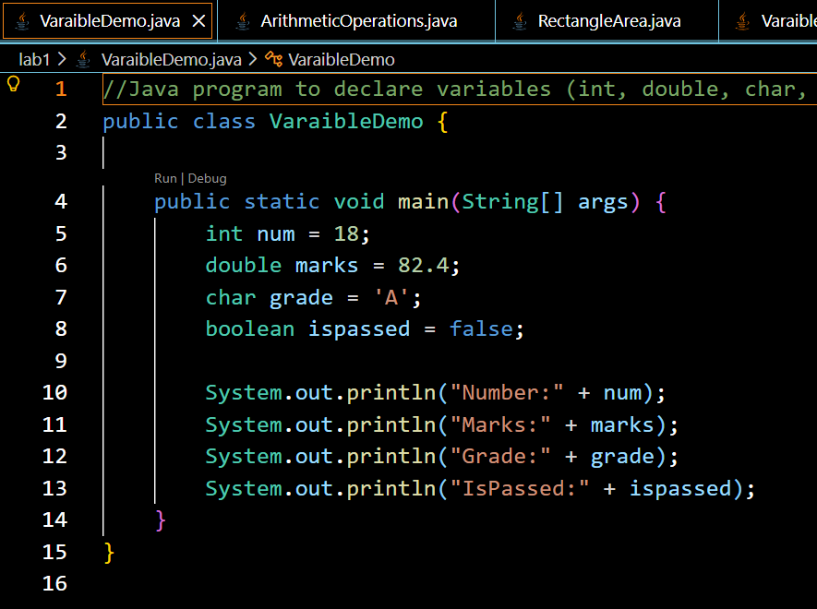

Output:
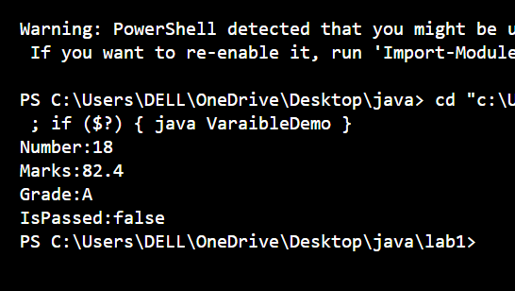

2. Write a program that takes two integer values and performs addition, subtraction, multiplication, division, and modulus operations.

Input:
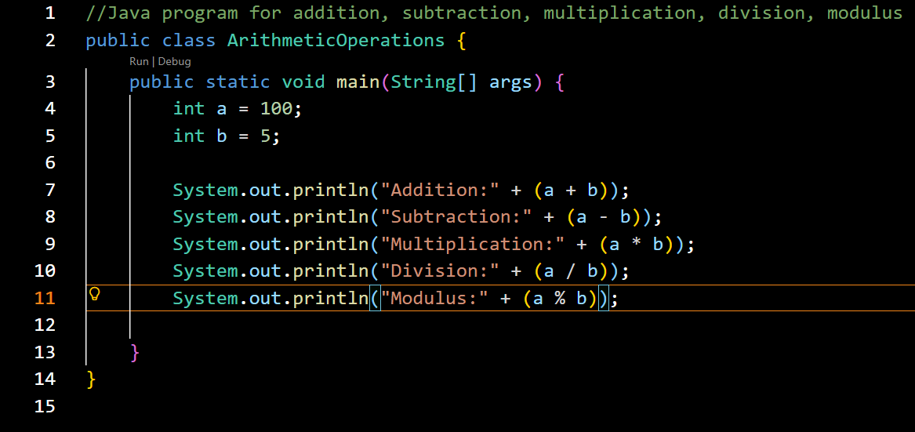

Output:
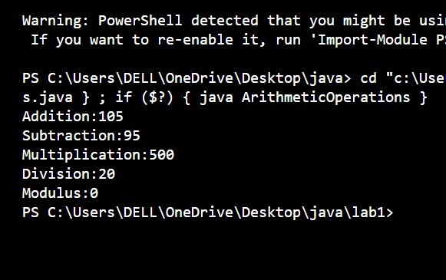
- Write a Java program to calculate the area of a rectangle using length and width stored in variables.

Input:
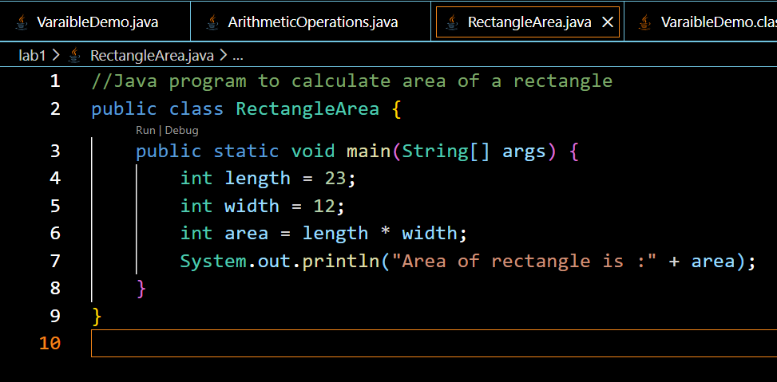

Output:
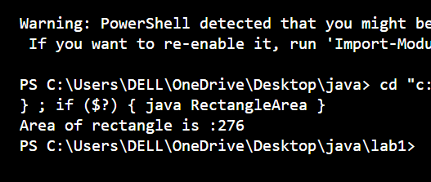
4. Write down the difference between primitive and non-primitive data types with code example.
Primitive Data Types
- Store single value
- Fixed size
- Faster
- Examples: int, double, char, boolean
int number = 10;
char letter = 'A';
Non-Primitive Data Types
- Store multiple values or complex data
- Size not fixed
- Examples: String, Array, Class
String name = "Shahneela";
int[] numbers = {1, 2, 3};

Lab Rubrics

Course code: |  | CS-153 |  | Course Name: |  |  | Object Oriented Programming
Lab 02: | To practice program using variables, datatypes and operators
Roll No: |  |  |  | Student Name:
Batch: |  |  | Section: |  |  | Group: |  |  | Date:

Rubric No. | Component | Proficient | Adequate | Just Acceptable | Unacceptable
1 | Problem Understanding & Object-Oriented Design | Student clearly understands the problem and designs an effective OOP solution using appropriate classes, objects, and relationships. Design reflects proper use of OOP principles. | Student understands the problem and applies OOP concepts reasonably, but class design or relationships could be improved. | Student shows basic understanding of the problem, but OOP design is weak or partially incorrect. | Student does not understand the problem and fails to apply object-oriented concepts.
2 | Code Originality & Structure | Code is original, well-structured, readable, and follows OOP best practices (modularity, naming conventions, reuse). | Code is mostly original and structured, with minor issues in readability or organization. | Code originality is minimal and structure is weak or inconsistent. | Code lacks originality, is poorly structured, or copied without understanding.
3 | Completeness & Functional Correctness | Program is complete, fully functional, and meets all problem requirements with correct output. | Program is mostly complete and functional, with minor logical or runtime issues. | Program runs partially but does not fully meet requirements. | Program does not run or fails to meet basic functional requirements.
4 | Analysis, Testing & Output Interpretation | Output is correct, well-tested, and results are clearly analyzed and interpreted based on program logic. | Output is mostly correct, but testing or interpretation of results is limited. | Output is generated but poorly analyzed or inconsistently interpreted. | Output is incorrect or student shows no understanding of results.
Teacher: Date:

