Lab 07
A* Search & Genetic Algorithm
Name: Shahnil Sharma
Roll No: 4-38/2023/004
Course: Artificial Intelligence Lab
Date: 5/11/2026

Task 1: A* Search (S to G)
Find the shortest path between node S and node G using A* search.

Code

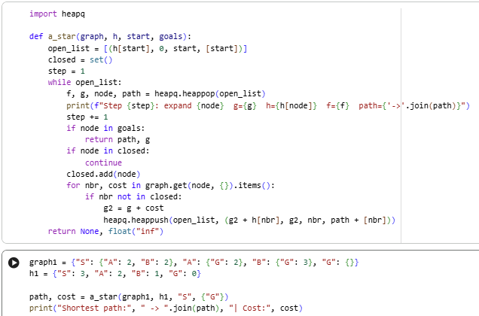

Output
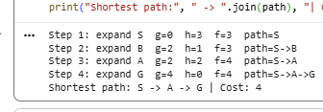

Task 2: A* Search (s to c or d)
Find the shortest path between node s and node c or d using A* search.

Code
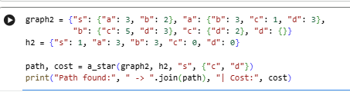

Output

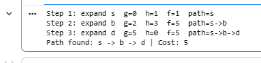

Task 3.1: Genetic Algorithm (Run the Given Code)
Run the given code of the Genetic Algorithm (Coin Toss Problem) and show the output.

Code
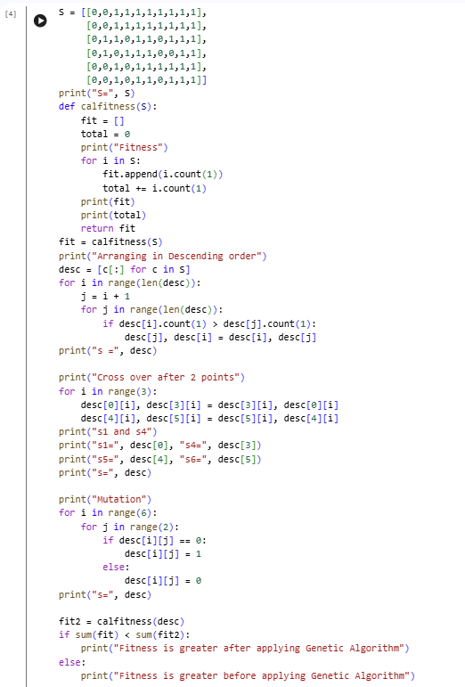

Output
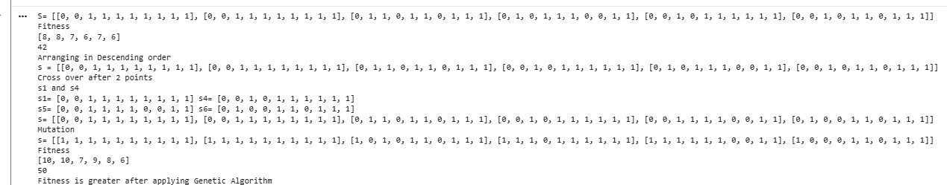

Task 3.2: Crossover between S2 and S3 after the 4th Point
Perform crossover between S2 and S3 after the 4th point in the given code and show the output.

Code

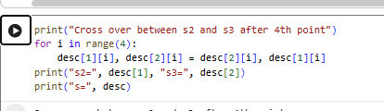

Output

Task 3.3: Chromosomes as Runtime Input
Modify the code to take the values of the chromosomes as input at run time and show the output.

Code

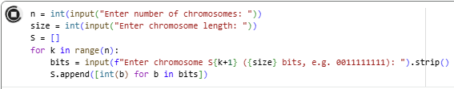

Output



