Course Code/Title:  Computer Organization & Assembly Langua | Assessment Activity: LAB-6 | Batch/Semester:  Batch(2023) Semester VI
Dated:2/19/2026 | OBE- Target: | Weight of Marks:
Student ID: 4-38/2023/004  Student Name: Shahnil Sharma | Teacher Name:  Ashar Ahmed | Score:

Objectives
• Perform subtraction using SUB instruction in 8086 Assembly.
• Understand difference between 8-bit registers (AL, BL) and 16-bit registers (AX, BX).
• Understand borrow concept using Carry Flag (CF).
• Observe register changes after subtraction.

Theory
The SUB instruction subtracts source operand from destination operand. In 8-bit operations, registers like AL and BL are used. In 16-bit operations, AX and BX are used. If subtraction requires borrow, the Carry Flag (CF) becomes 1.

Part A: 8-bit Subtraction
.model small
.stack 100h
.code
main:
MOV AL, 09H
MOV BL, 05H
SUB AL, BL
MOV AH, 4CH
INT 21H
end main
Expected Result: AL = 04H, CF = 0
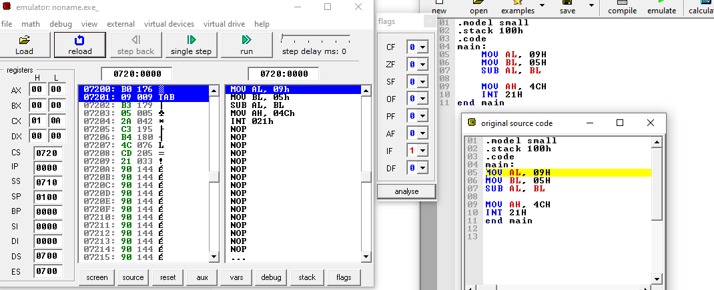
Step 1 execute
MOV AL, 09H
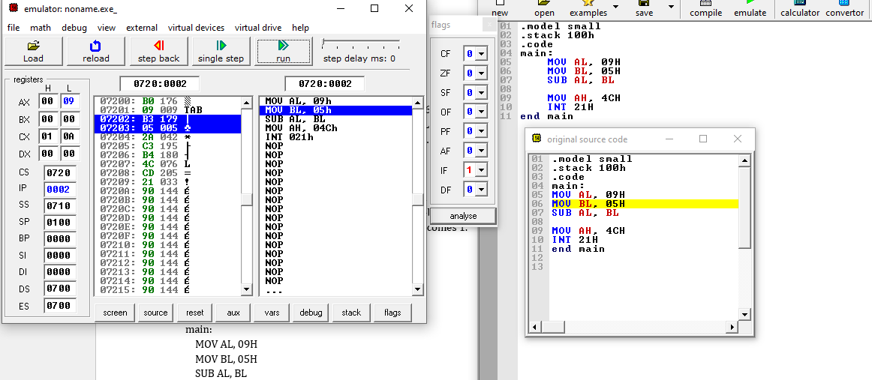
Registers panel
AL = 09
Step 2 execute
MOV BL, 05H
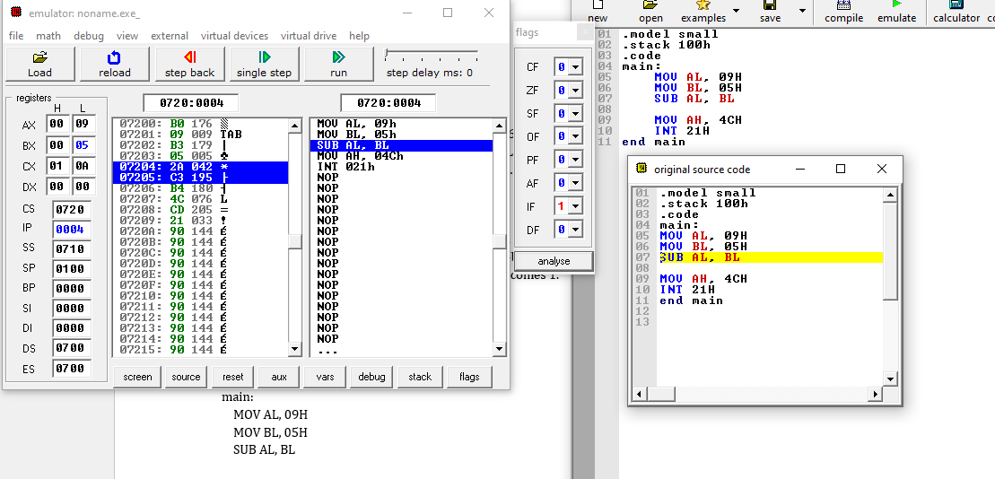
Registers Panel
: BL = 05
Step 3 execute
SUB AL, BL
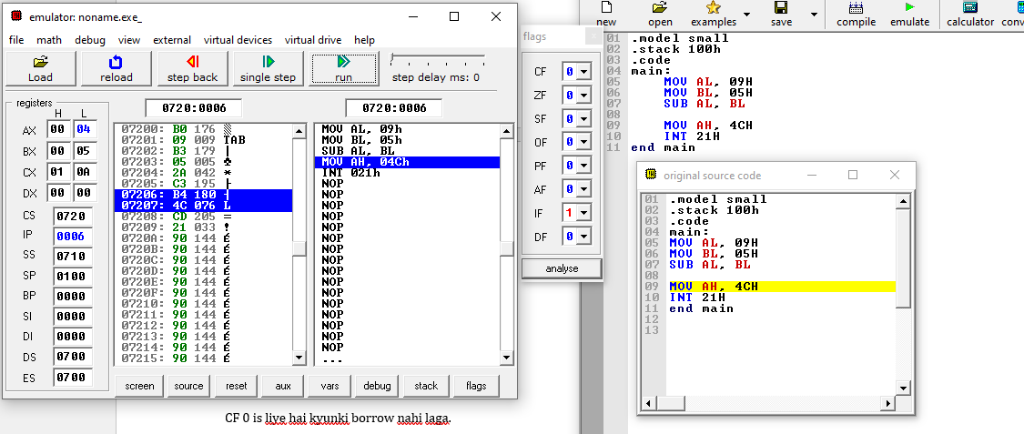
Expected result:
09H - 05H = 04H
Registers Panel
AL = 04
Flags panel
CF = 0 :because no borrow

Part B: 16-bit Subtraction
.model small
.stack 100h
.code
main:
MOV AX, 0005H
MOV BX, 0008H
SUB AX, BX
MOV AH, 4CH
INT 21H
end main
Expected Result: AX = FFFDH (0005H - 0008H = -3 in 16-bit form), CF = 1
Step 1
MOV AX, 0005H
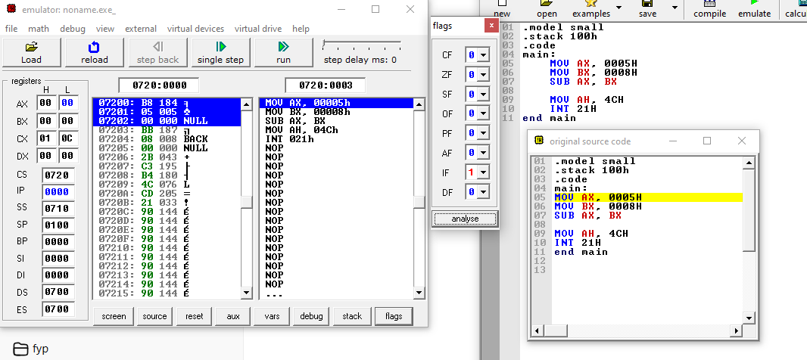
AX Shows
AH = 00
AL = 05
Step 2
MOV BX, 0008H
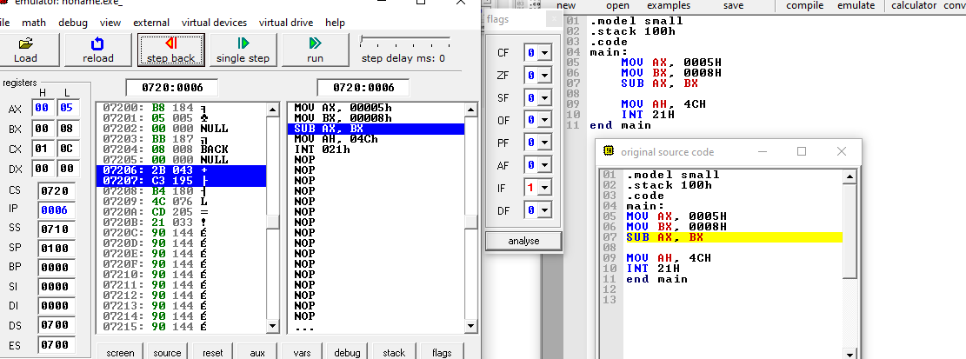
BX Shows
BH = 00
BL = 08
Step 3
SUB AX, BX
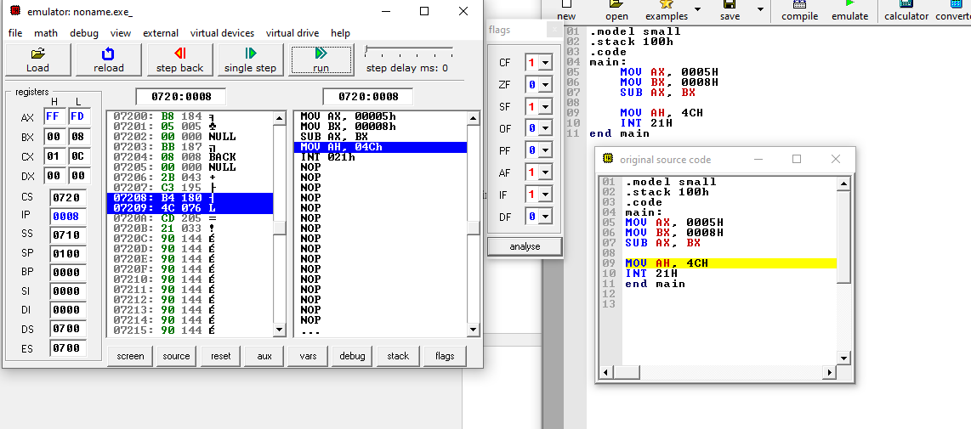Calculation:
0005H - 0008H = -3
AX = FFFD
AH = FF
AL = FD
Flags panel:
CF = 1 :this means Borrow executed

Observation
In 8-bit subtraction, result is stored in AL and no borrow occurs if destination is larger. In 16-bit subtraction, when subtracting a larger number from a smaller one, borrow occurs and Carry Flag becomes 1.

Conclusion
The lab demonstrates subtraction using both 8-bit and 16-bit registers. It also shows how the Carry Flag indicates borrow during subtraction.

