Course Code/Title:  Computer Organization & Assembly Langua | Assessment Activity: LAB-7 | Batch/Semester:  Batch(2023) Semester VI
Dated:2/19/2026 | OBE- Target: | Weight of Marks:
Student ID: 4-38/2023/004  Student Name: Shahnil Sharma | Teacher Name:  Ashar Ahmed | Score:

Objectives
• Design and implement addition and subtraction using 8086 Assembly.
• Apply concepts of 8-bit (AL, BL) and 16-bit (AX, BX) registers.
• Analyze Carry Flag (CF) and Zero Flag (ZF).
• Modify and extend the program logically.

Theory
The 8086 processor performs arithmetic operations using instructions such as ADD and SUB. 8-bit operations use registers like AL and BL, while 16-bit operations use AX and BX. Carry Flag (CF) indicates overflow or borrow in unsigned operations, and Zero Flag (ZF) becomes 1 if the result of an operation is zero.

Part A: 8-bit Arithmetic Program
.model small
.stack 100h
.code
main:
MOV AL, 08H
MOV BL, 04H
ADD AL, BL
SUB AL, BL
MOV AH, 4CH
INT 21H
end main
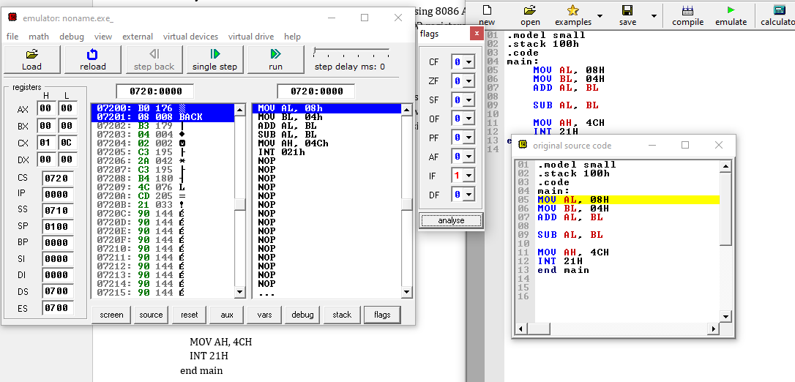
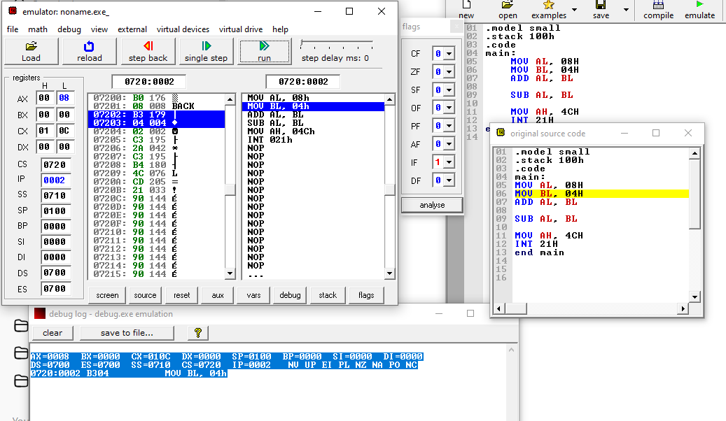
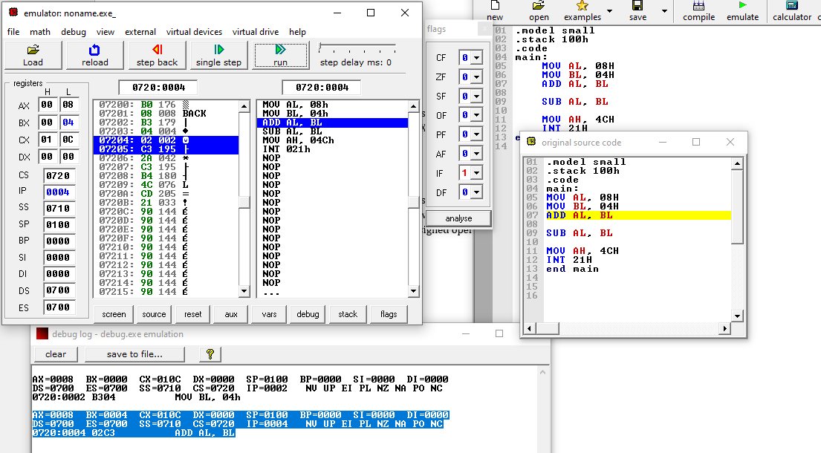
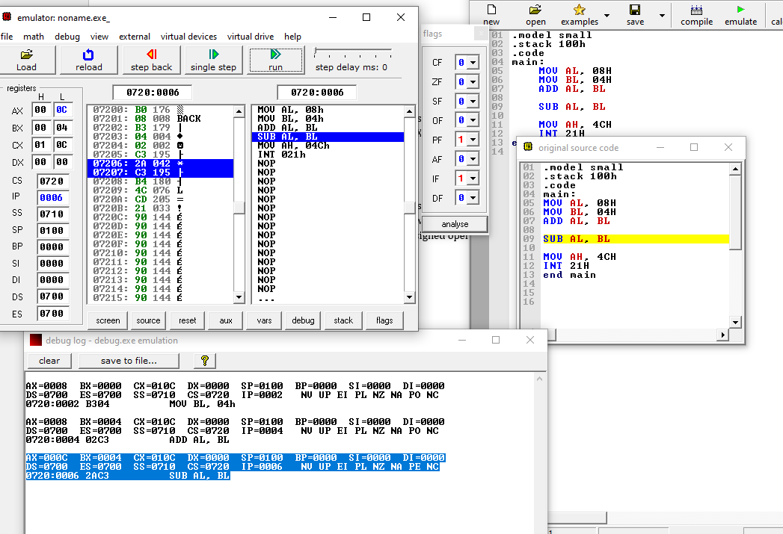
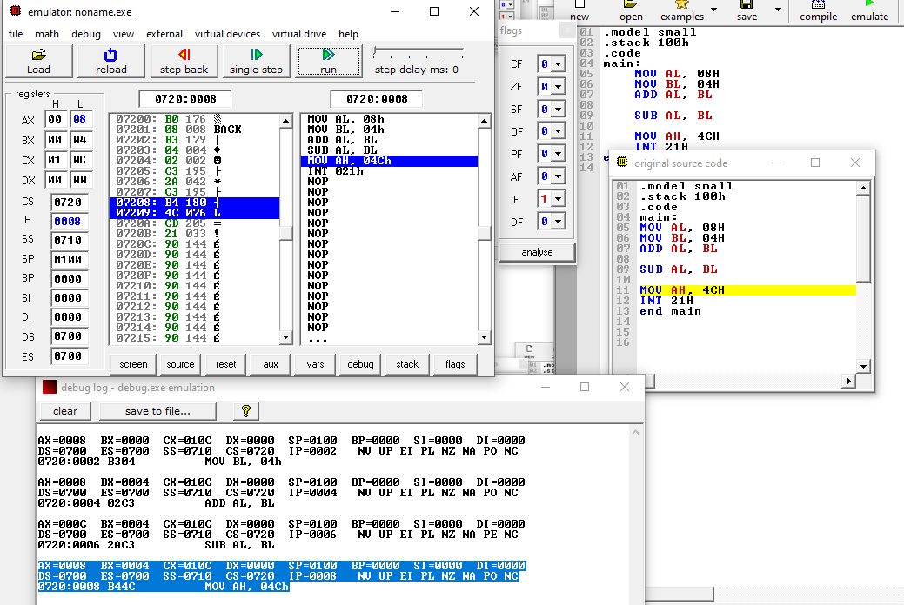
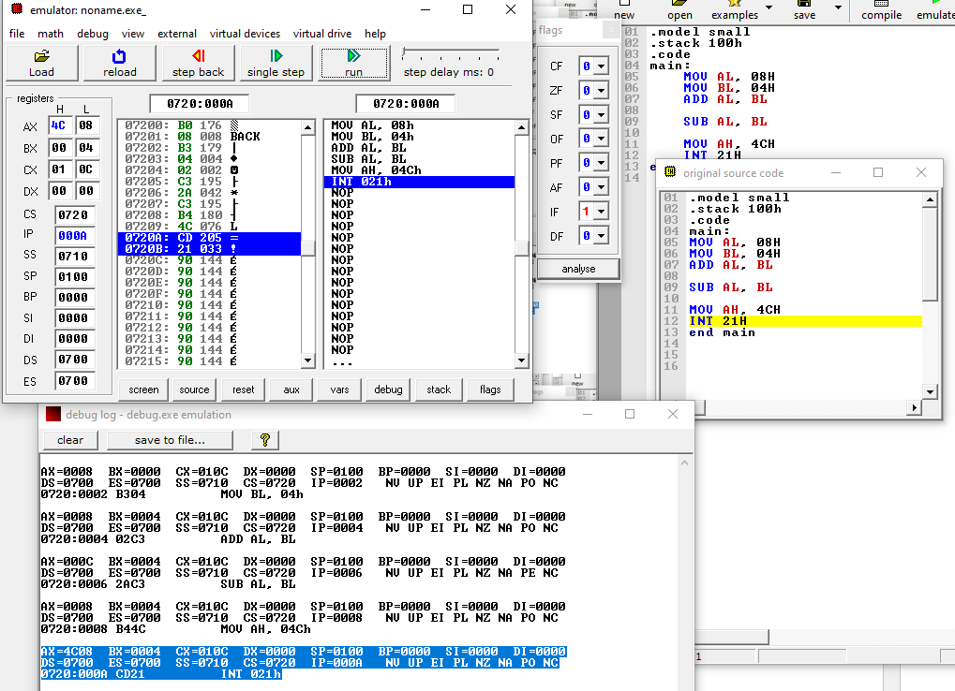
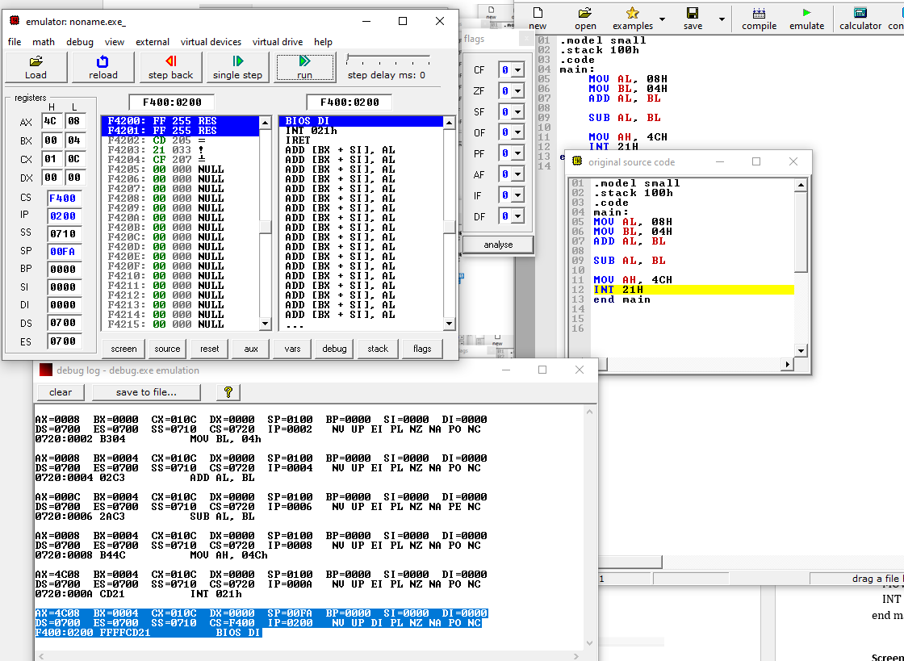

Part B: 16-bit Arithmetic Program
.model small
.stack 100h
.code
main:
MOV AX, 0005H
MOV BX, 0005H
ADD AX, BX
SUB AX, BX
MOV AH, 4CH
INT 21H
end main
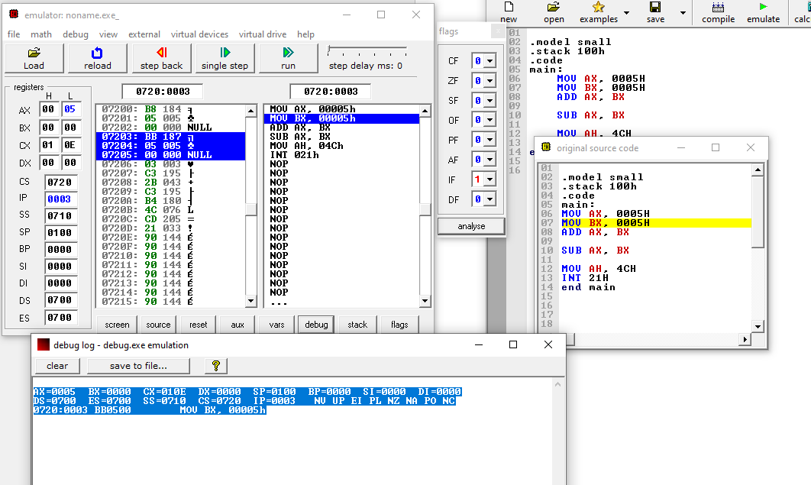
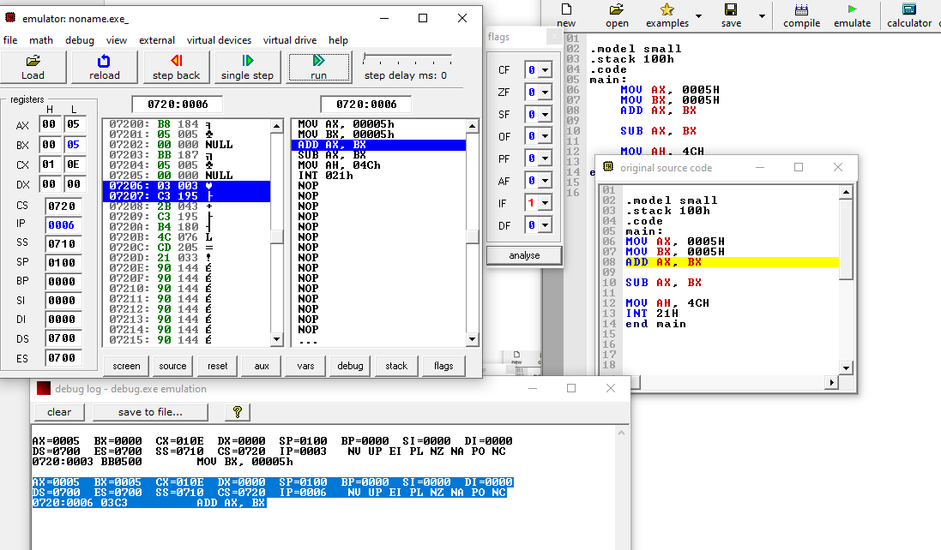
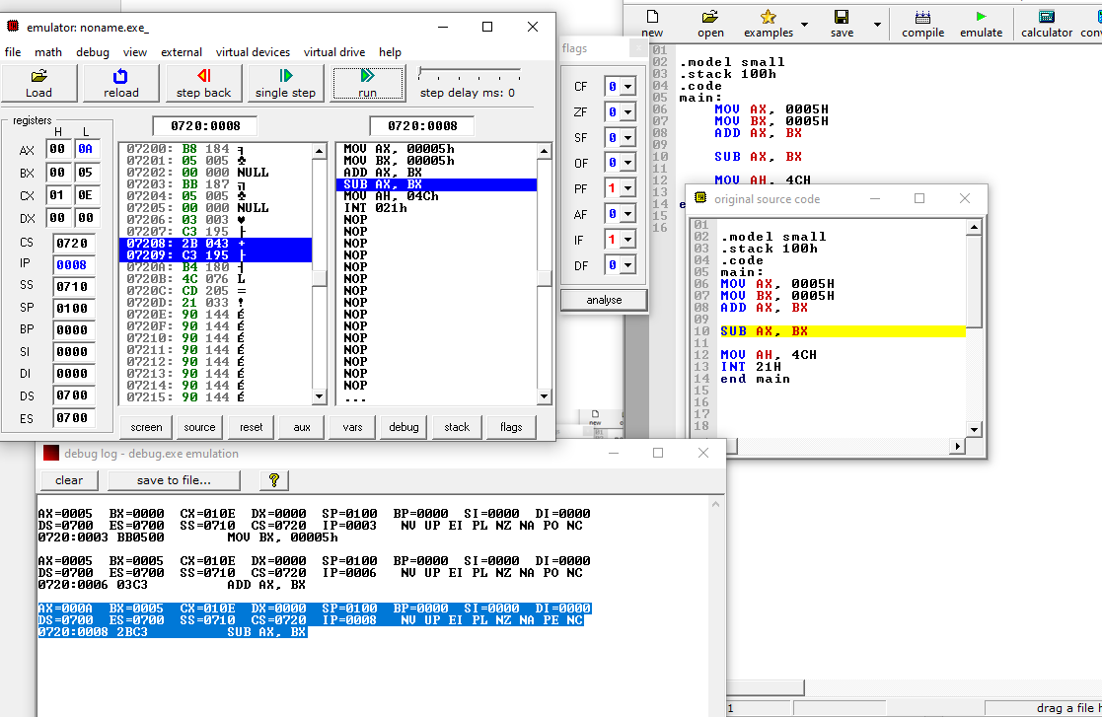
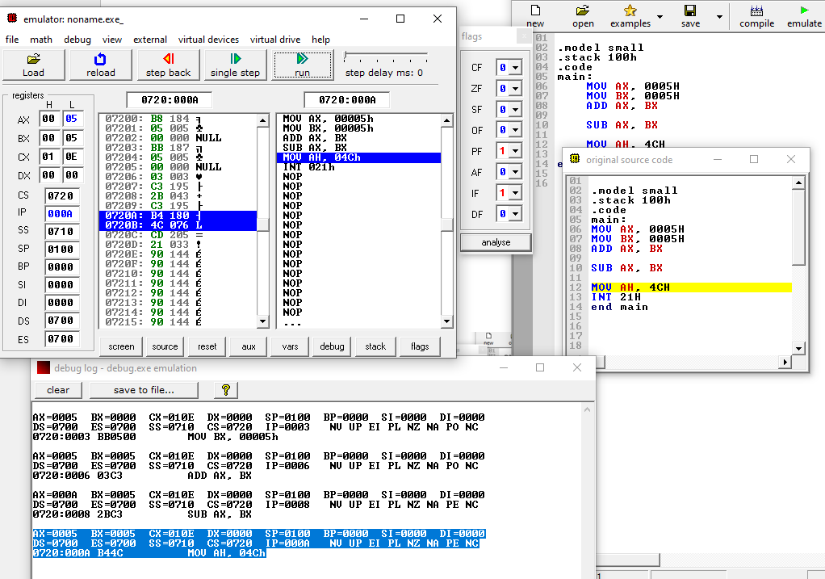

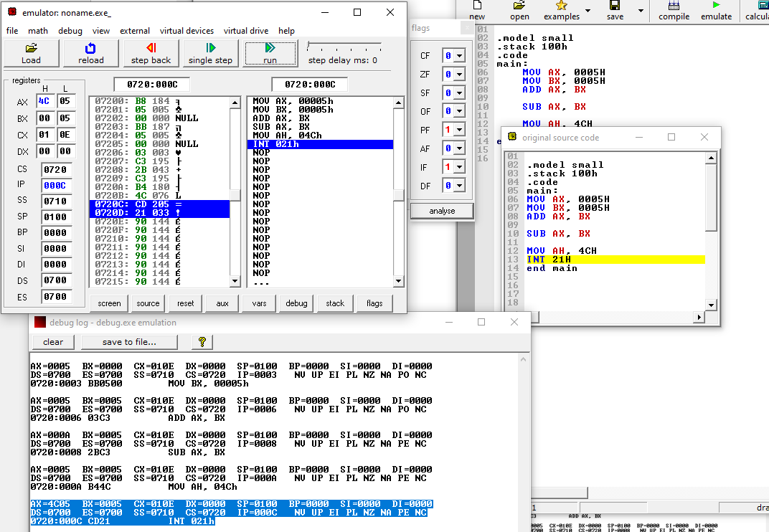
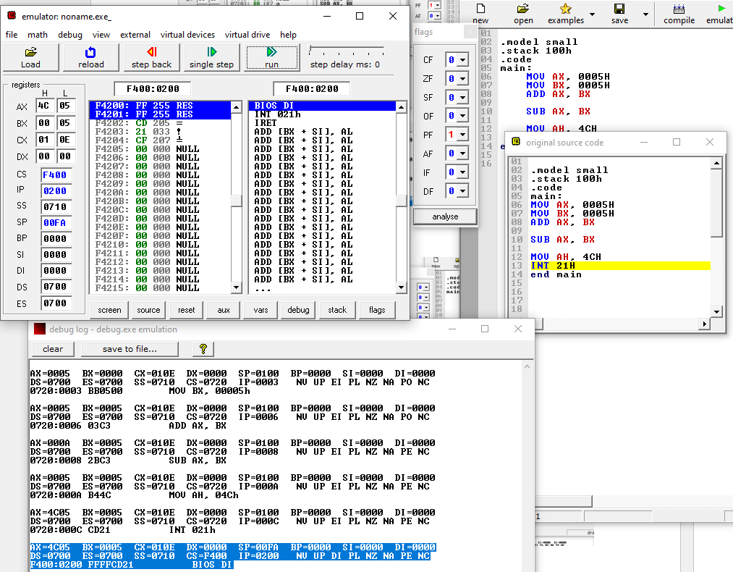

PF:FLAG=0

Observation
Carry Flag becomes 1 if overflow or borrow occurs. Zero Flag becomes 1 when the result of an operation is zero.

Conclusion
This lab demonstrates arithmetic operations using both 8-bit and 16-bit registers and shows how Carry and Zero flags help analyze results.

