Lab 08
Dataset Preparation and Preprocessing
Name: Shahnil Sharma
Roll No: 4-38/2023/004
Course: Artificial Intelligence Lab
Date: 30/10/2026

Task 1: Dataset Loading
Download a dataset from Kaggle or another open-data source and load it into a Pandas DataFrame. Display the first five rows, last five rows, dataset dimensions, column names, and data types.

Code

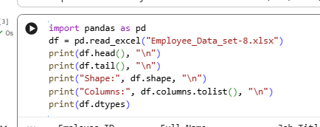

Output
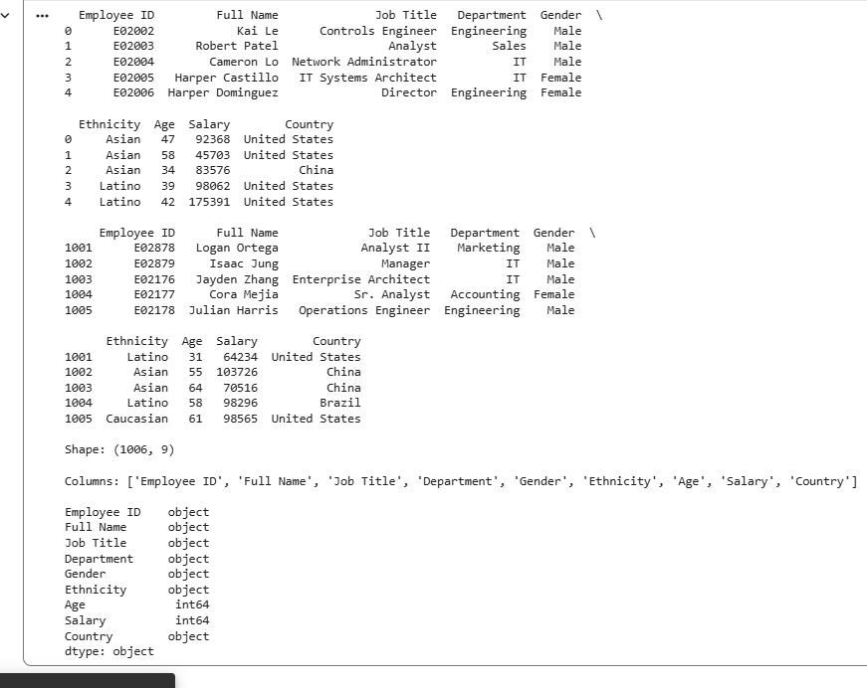

Task 2: DataFrame Creation and Inspection
Create a Pandas DataFrame containing four columns and five rows representing students' names, ages, marks, and attendance. Display the DataFrame.

Code
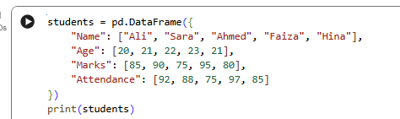

Output

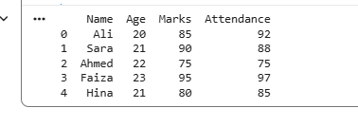

Task 3: Missing Values and Duplicate Records
Load an employees dataset and use Pandas to identify missing values and duplicate records. Fill missing values in the Gender column with "No Gender" and display the first ten rows of the cleaned dataset.

Code
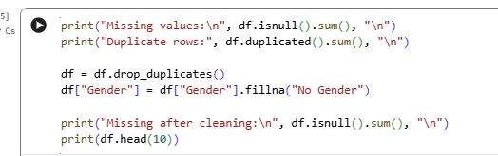

Output
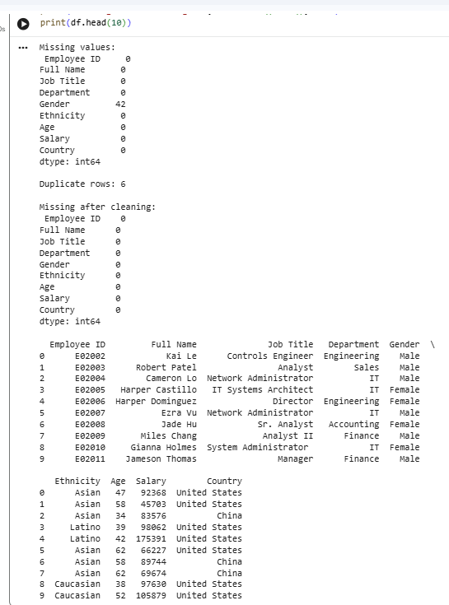

Task 4: Outlier Detection
Load a dataset containing numerical features such as Age and Salary. Detect potential outliers using the Interquartile Range (IQR) method and display the identified outlier records without removing them.

Code
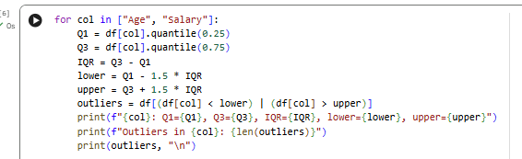

Output
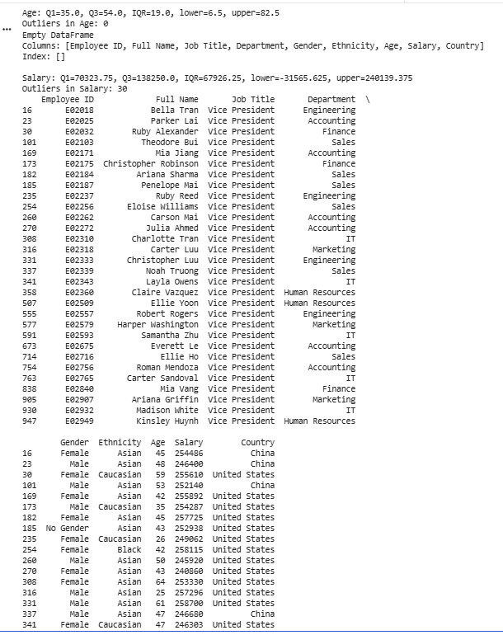

Task 5: Min-Max Normalization
Apply Min-Max Normalization to the Age and Salary features of a dataset using MinMaxScaler. Display the original and normalized values and verify one normalized value using the mathematical formula.

Code
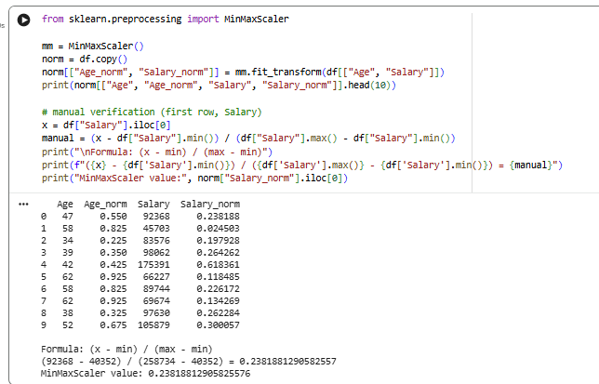

Output

Task 6: Standardization
Apply Standardization to the Age and Salary features using StandardScaler. Display the original and standardized values and verify one standardized value using the mean and standard deviation formula.

Code

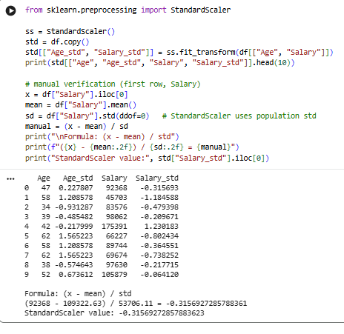

Output

