Lab 09
Supervised Learning (Decision Tree)
Name: Shahnil Sharma
Roll No: 4-38/2023/004
Course: Artificial Intelligence Lab
Date: 30/10/2026

Task 1: Iris Decision Tree (Step 1: Load Dataset)
Build a Decision Tree Classifier to predict the species of an iris flower. Load the dataset using Pandas.

Code
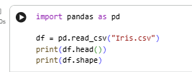S

Output
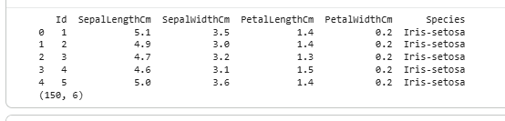

Task 1: Iris Decision Tree (Step 2: Features, Target and Train/Test Split)
Separate the input features (X) and target (y). Split the data into training and testing sets.

Code
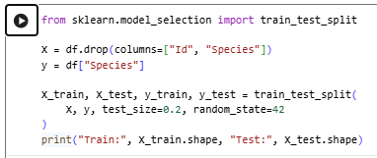

Output
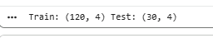

Task 1: Iris Decision Tree (Step 3: Train and Predict)
Train a DecisionTreeClassifier. Predict the species for a new flower.

Code
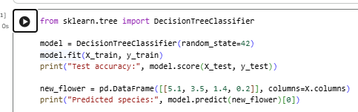

Output

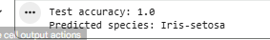

Task 1: Iris Decision Tree (Step 4: Display the Tree)
Display the decision tree.

Code
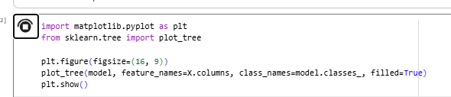

Output
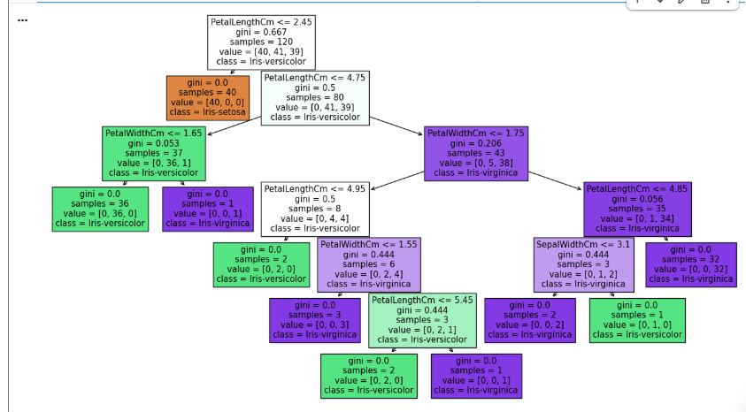

Task 2: Decision Tree on Table 1 (Step 1: Create Dataset)
Implement the Decision Tree algorithm on the data given in Table 1. Create the dataset from the table.

Code
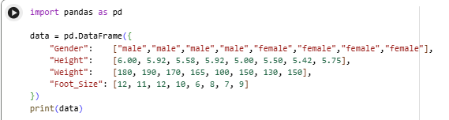

Output
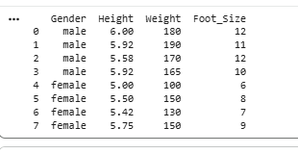

Task 2: Decision Tree on Table 1 (Step 2: Train and Predict New Entry)
Train the Decision Tree and predict the new entry entered by the user.

Code

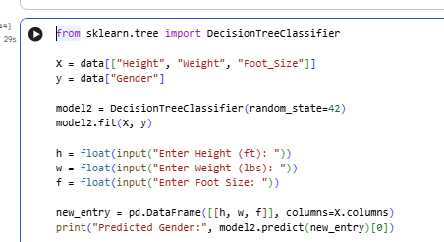

Output


