Course Code/Title:  Computer Organization & Assembly Langua | Assessment Activity: LAB-1 | Batch/Semester:  Batch(2023) Semester VI
Dated:2/16/2026 | OBE- Target: | Weight of Marks:
Student ID: 4-38/2023/004  Student Name: Shahnil Sharma | Teacher Name:  Ashar Ahmed | Score:

Lab Report
Lab Task: Understand how processor speed and memory access affect program execution

Objective
To observe how execution time changes as the number of iterations increases and to understand how processor speed and memory access influence program execution.

Theory
Processor speed determines how fast instructions are executed. When the number of iterations in a loop increases, the CPU performs more operations, which increases execution time. Memory access speed also affects performance, especially when large data structures are involved.

Experiment
The following Python program measures execution time for different iteration counts.
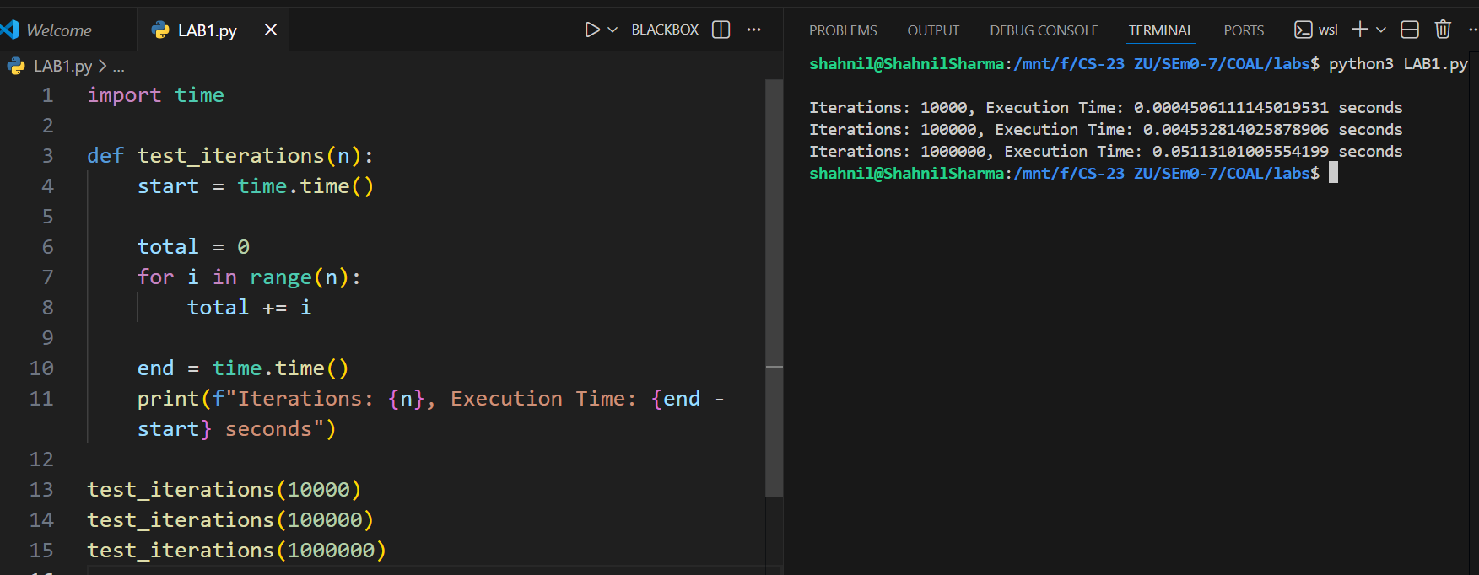

Observation
Execution time increases with number of iterations. As the loop runs more times, the processor performs more calculations, which results in higher execution time.

Result Table
Fill the table after running the program:
Iterations: 10000, Execution Time: 0.0004506111145019531 seconds
Iterations: 100000, Execution Time: 0.004532814025878906 seconds
Iterations: 1000000, Execution Time: 0.05113101005554199 seconds

Conclusion
The experiment confirms that execution time increases as the number of iterations increases. This demonstrates the impact of processor workload on program performance. Higher iteration counts require more CPU cycles, resulting in longer execution times.

