Course Code/Title:  Computer Organization & Assembly Langua | Assessment Activity: LAB-2 | Batch/Semester:  Batch(2023) Semester VI
Dated:2/16/2026 | OBE- Target: | Weight of Marks:
Student ID: 4-38/2023/004  Student Name: Shahnil Sharma | Teacher Name:  Ashar Ahmed | Score:

Objective
To understand how the CPU processes data using internal registers and how register operations are faster compared to memory operations.

Theory
CPU registers are small, high-speed storage locations inside the processor. They store data temporarily during instruction execution. Since registers are located inside the CPU, accessing them is much faster than accessing data from main memory (RAM).

Practical Task (x86 Assembly)
MOV AX, 05H
MOV BX, 03H
ADD AX, BX

Step-by-Step Explanation
1. MOV AX, 05H
The value 05H is loaded into register AX.
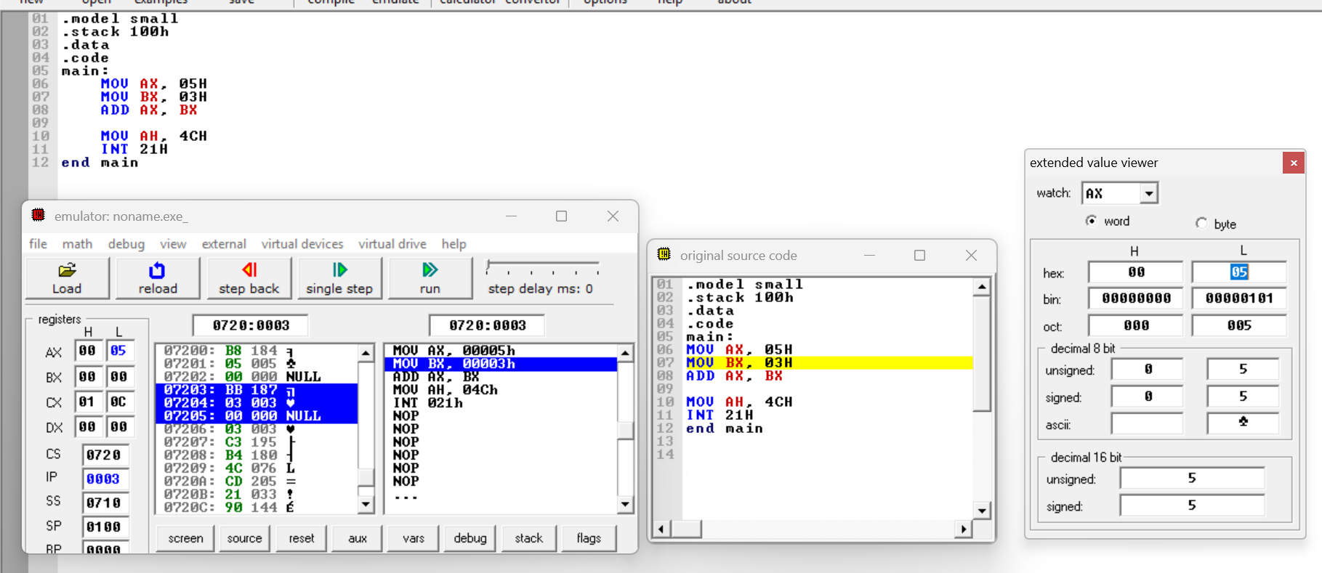
2. MOV BX, 03H
The value 03H is loaded into register BX.
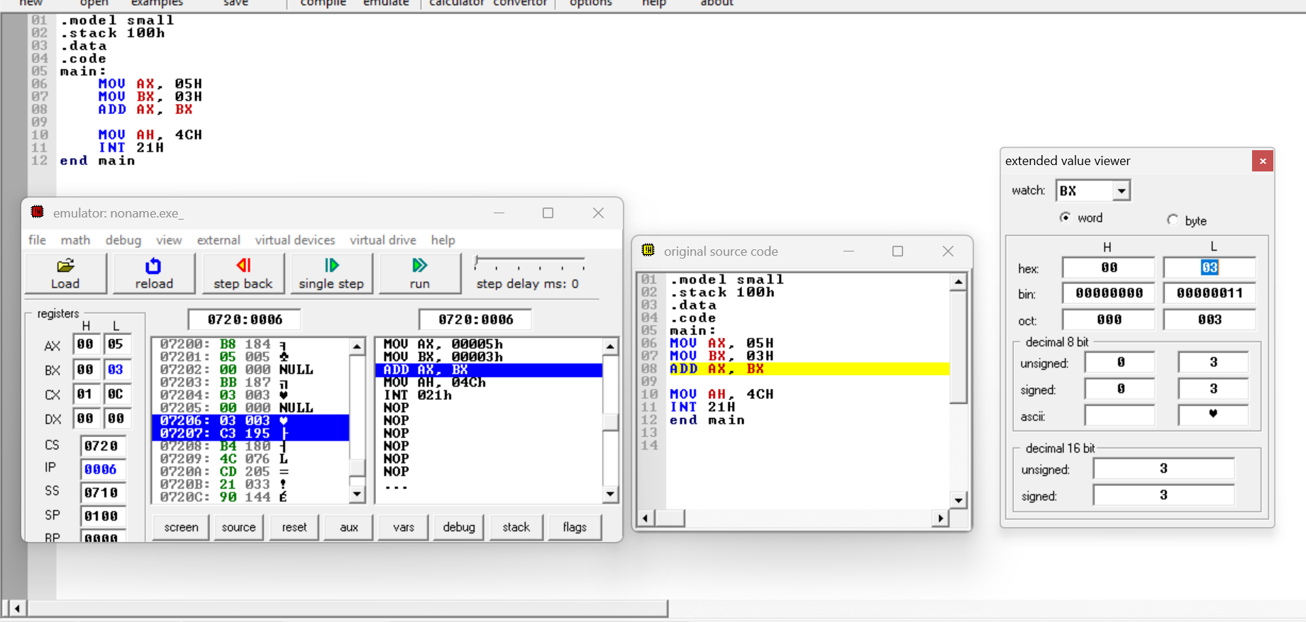
3. ADD AX, BX
The CPU adds the value stored in BX to AX.
AX = 05H + 03H = 08H.
The result 08H is stored back in register AX.
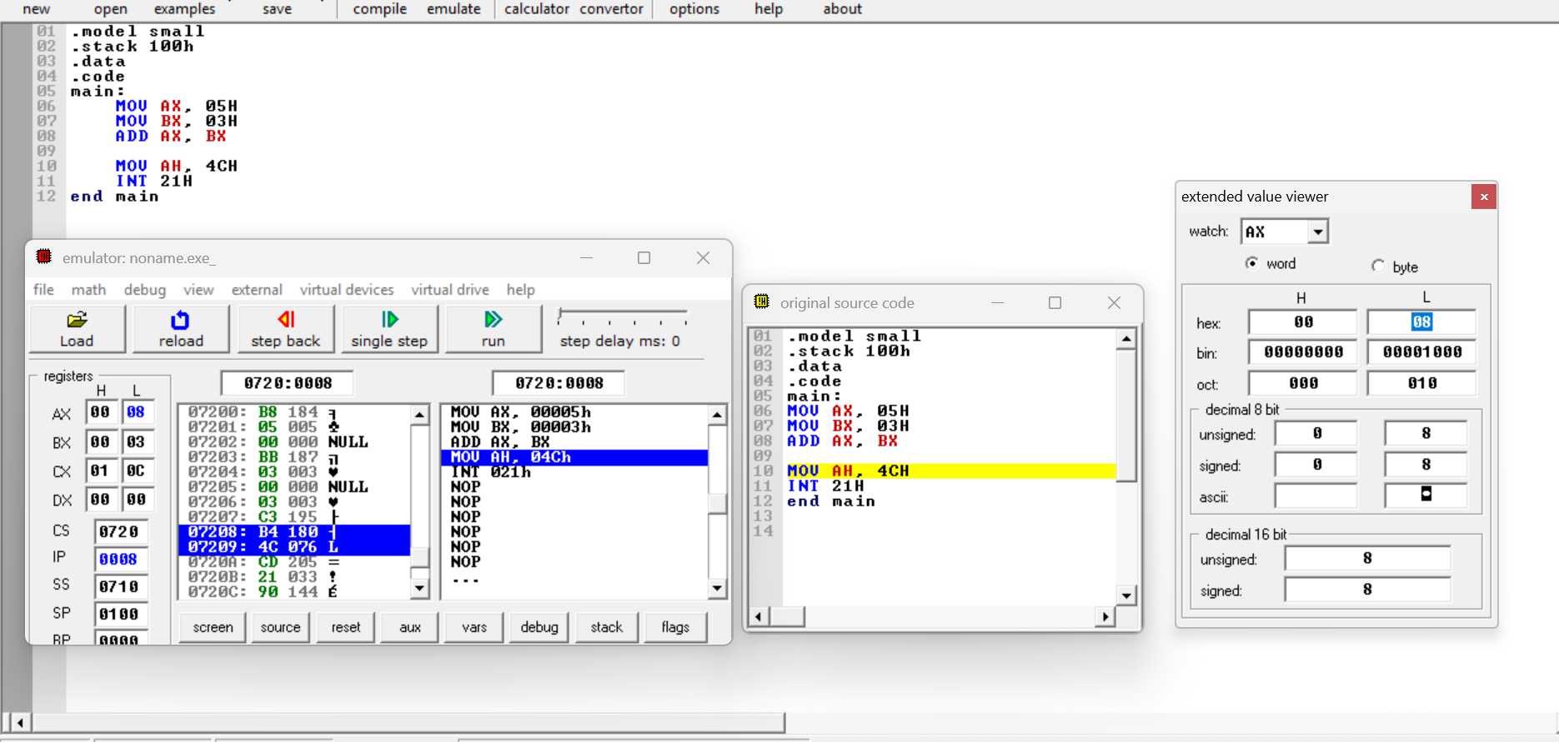

Outcome
This experiment demonstrates that registers store and process data directly inside the CPU, allowing faster execution compared to memory access. Because registers are part of the processor architecture, arithmetic operations performed on register values complete more quickly than operations involving main memory.

Conclusion
The lab confirms that CPU registers are the fastest storage locations in a computer system. Data processed inside registers results in minimal latency compared to memory-based operations, improving overall program performance.

