Course Code/Title:  Computer Organization & Assembly Langua | Assessment Activity: LAB-3 | Batch/Semester:  Batch(2023) Semester VI
Dated:2/16/2026 | OBE- Target: | Weight of Marks:
Student ID: 4-38/2023/004  Student Name: Shahnil Sharma | Teacher Name:  Ashar Ahmed | Score:

Objective
To understand how repeated computation works using loops and to observe how execution time increases as the number of iterations increases.

Theory
A loop allows a set of instructions to execute repeatedly. Each iteration consumes CPU cycles. As the number of iterations increases, the processor performs more operations, which increases execution time.

Practical Task (x86 Assembly Loop Example)
.model small
.stack 100h
.code
main:
MOV CX, 5
MOV AX, 0
LOOP_START:
ADD AX, 1
LOOP LOOP_START
MOV AH, 4CH
INT 21H
end main

Step-by-Step Explanation
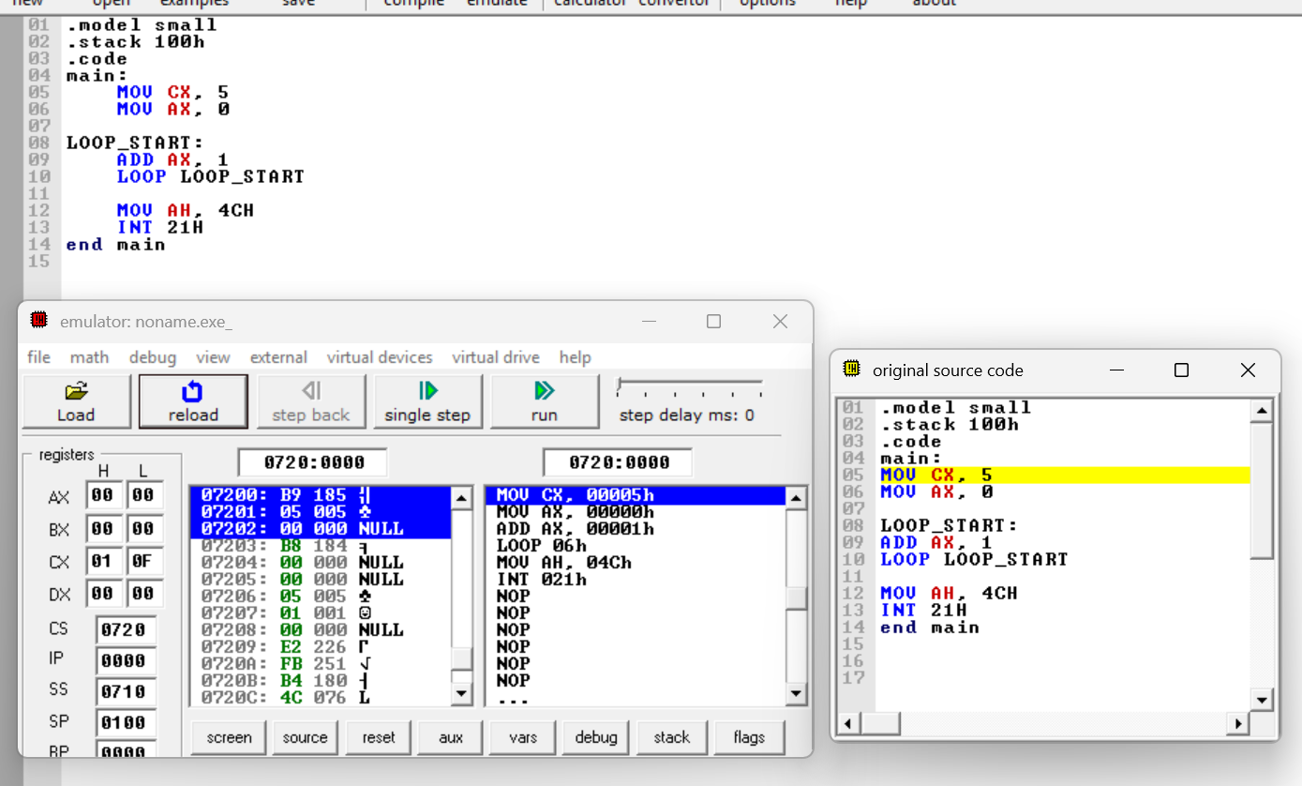
1. MOV CX, 5 initializes the loop counter to 5 iterations.
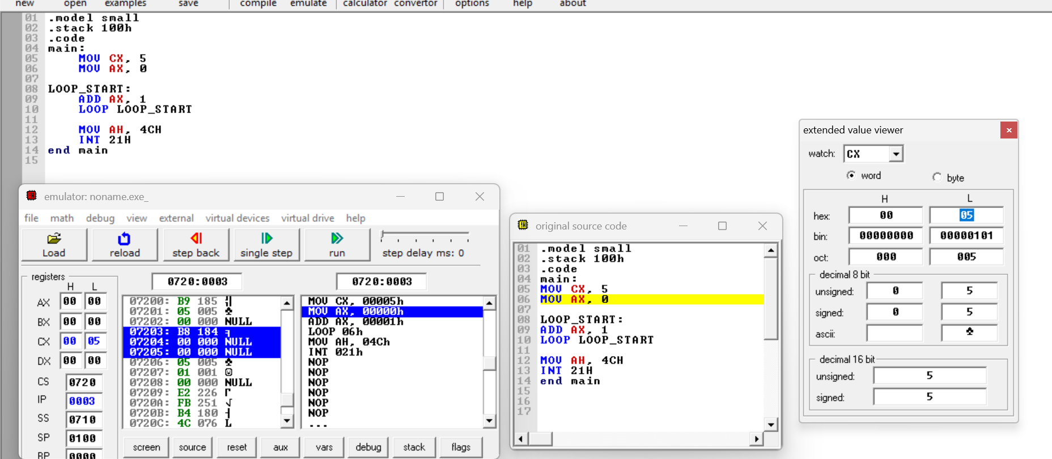
2. MOV AX, 0 initializes AX register.
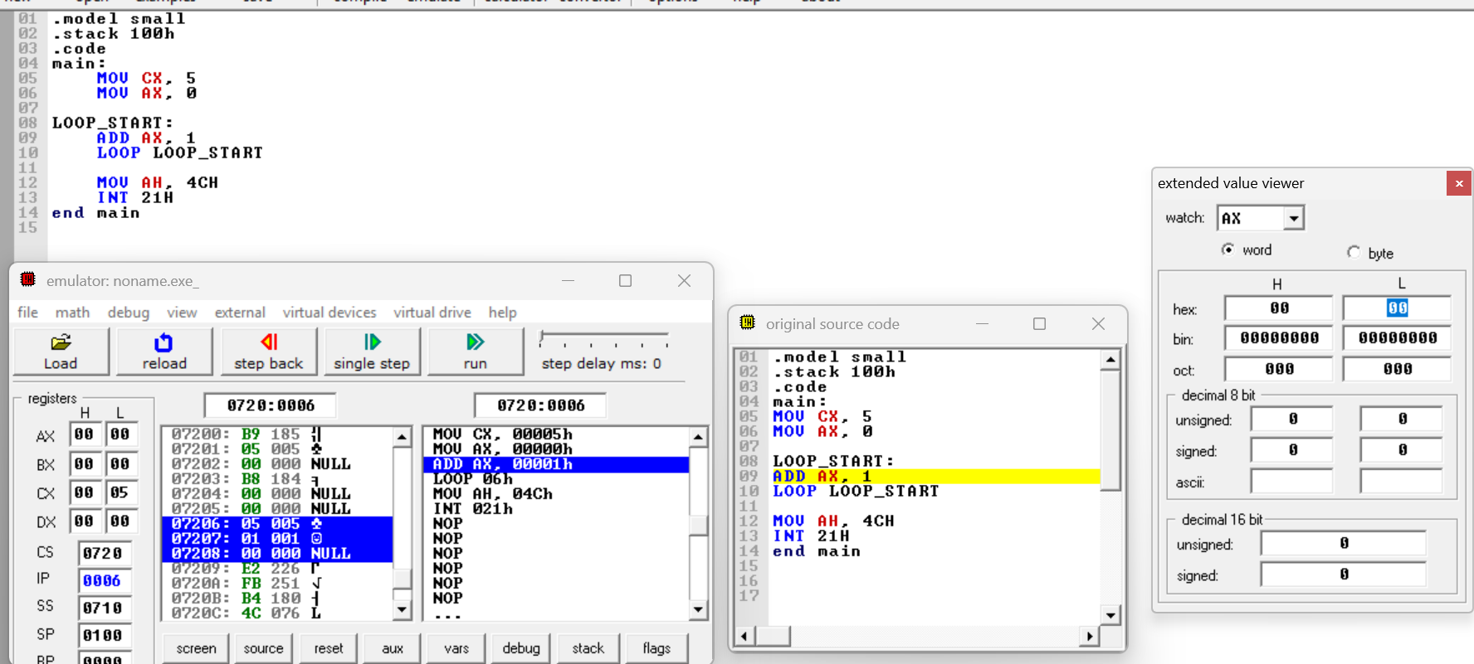
3. ADD AX, 1 increases AX by 1 in each iteration.
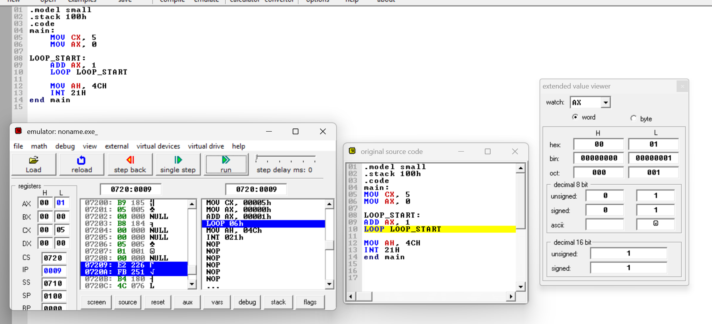
4. LOOP instruction decrements CX automatically and repeats the loop until CX becomes zero.
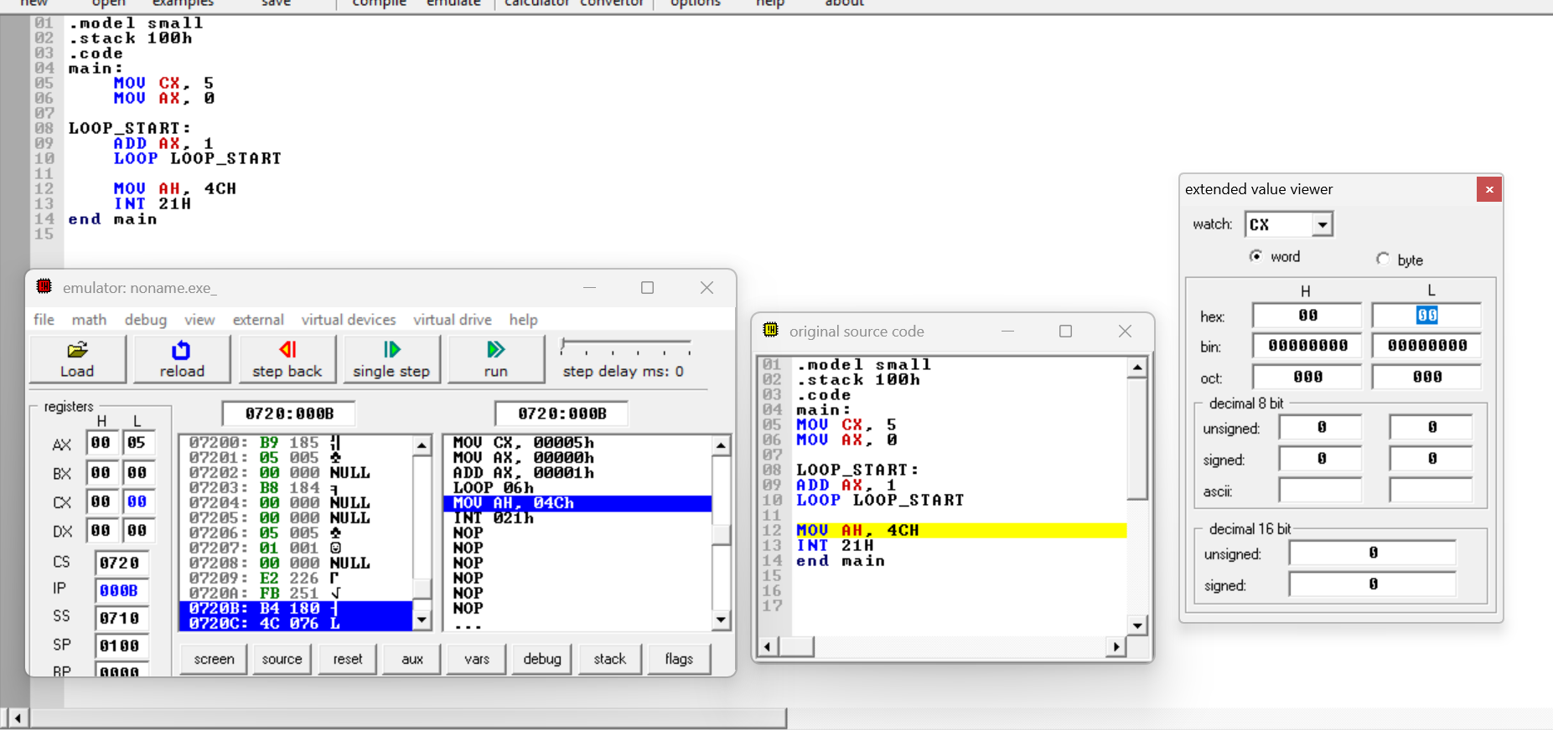
After execution, AX will contain 0005H.
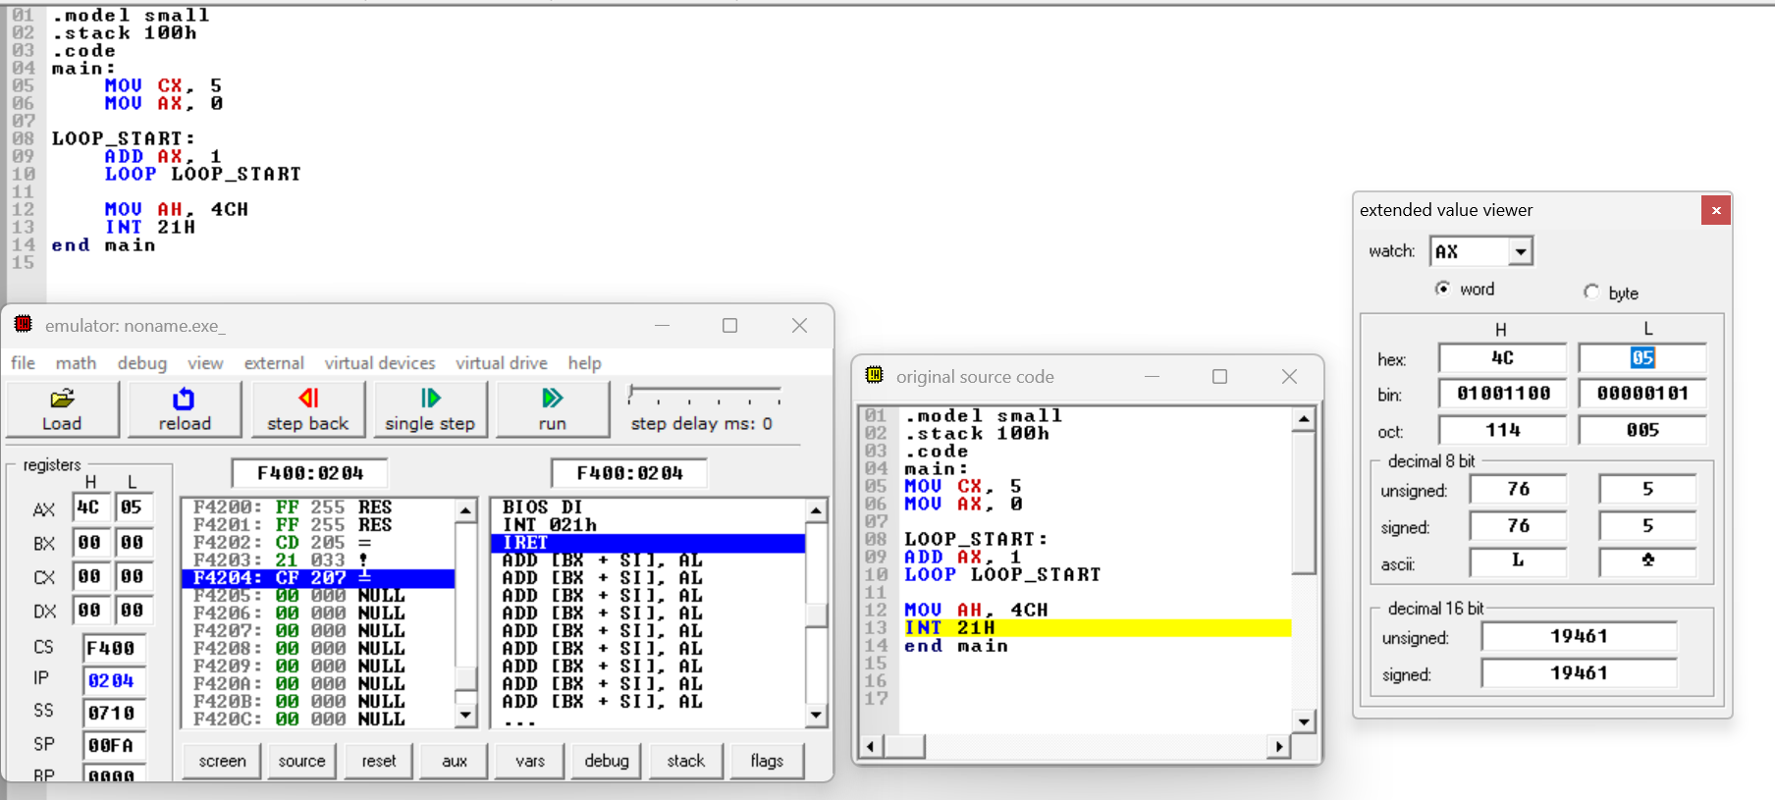

Observation
Execution time increases with number of iterations. When the loop counter value is increased, the processor performs more repeated computations, resulting in higher execution time.

Conclusion
This lab demonstrates how loops perform repeated computations. Increasing the number of iterations increases CPU workload, which directly affects execution time.

