Course Code/Title:  Computer Organization & Assembly Langua | Assessment Activity: LAB-4 | Batch/Semester:  Batch(2023) Semester VI
Dated:2/16/2026 | OBE- Target: | Weight of Marks:
Student ID: 4-38/2023/004  Student Name: Shahnil Sharma | Teacher Name:  Ashar Ahmed | Score:

Objective
To understand why sequential memory access is faster than random memory access and how memory architecture affects program performance.

Theory
Sequential memory access means reading or writing data in continuous memory locations (one after another). Random memory access means accessing memory locations in a non-ordered or scattered way. Modern CPUs use cache memory and prefetching techniques. When data is accessed sequentially, the CPU can predict and preload upcoming data into cache, reducing memory latency. Random access prevents effective caching, causing more cache misses and slower performance.

Practical Task (C Program Example)
#include <stdio.h>
#include <stdlib.h>
#include <time.h>

#define SIZE 100000000

int main() {
int *arr = malloc(SIZE * sizeof(int));
long long sum = 0;

clock_t start, end;

// Sequential Access Timing
start = clock();
for (int i = 0; i < SIZE; i++) {
arr[i] = i;
}
for (int i = 0; i < SIZE; i++) {
sum += arr[i];
}
end = clock();
double seq_time = (double)(end - start) / CLOCKS_PER_SEC;

// Random Access Timing
start = clock();
for (int i = 0; i < SIZE; i++) {
int index = rand() % SIZE;
sum += arr[index];
}
end = clock();
double rand_time = (double)(end - start) / CLOCKS_PER_SEC;

printf("Sequential Access Time: %f seconds\n", seq_time);
printf("Random Access Time: %f seconds\n", rand_time);

free(arr);
return 0;
}

Step-by-Step Explanation
1. Memory is allocated dynamically for a large array.
2. In sequential access, elements are accessed one after another (arr[i]). This allows the CPU cache to load nearby memory blocks efficiently.
3. In random access, indices are generated randomly. The CPU cannot predict which memory block will be needed next, leading to cache misses and slower execution.
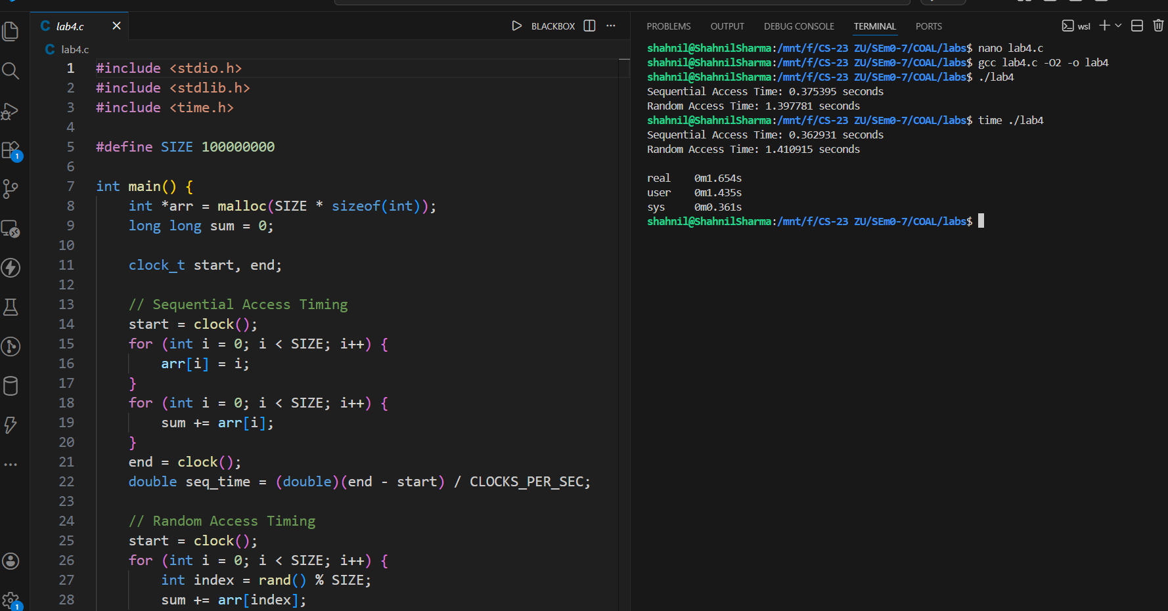

Outcome
This experiment demonstrates that sequential memory access is faster than random access because of CPU cache optimization and spatial locality. Sequential patterns reduce cache misses and improve overall system performance.

Conclusion
The lab confirms that memory access patterns significantly impact execution speed. Programs designed with sequential data access improve cache utilization and run faster compared to programs using random memory access.

