Course Code/Title:  Computer Organization & Assembly Langua | Assessment Activity: LAB-5 | Batch/Semester:  Batch(2023) Semester VI
Dated:2/16/2026 | OBE- Target: | Weight of Marks:
Student ID: 4-38/2023/004  Student Name: Shahnil Sharma | Teacher Name:  Ashar Ahmed | Score:

Objective
To understand the concept of parallel computing, compare sequential and parallel programs, and implement multiprocessing in Python.

Theory
Parallel computing is a computation model where multiple tasks are executed simultaneously using multiple CPU cores. In sequential computing, instructions execute one after another on a single core, increasing execution time for large tasks. Parallel computing divides a large task into smaller sub-tasks and executes them concurrently.
Python provides multiprocessing using the multiprocessing module. It creates separate processes that run on different CPU cores, allowing true parallel execution for CPU-bound operations.

Practical Task - Sequential Program
# Sequential Program
import time
def compute():
total = 0
for i in range(10_000_000):
total += i * i
return total
start = time.time()
compute()
end = time.time()
print("Sequential Execution Time:", end - start, "seconds")
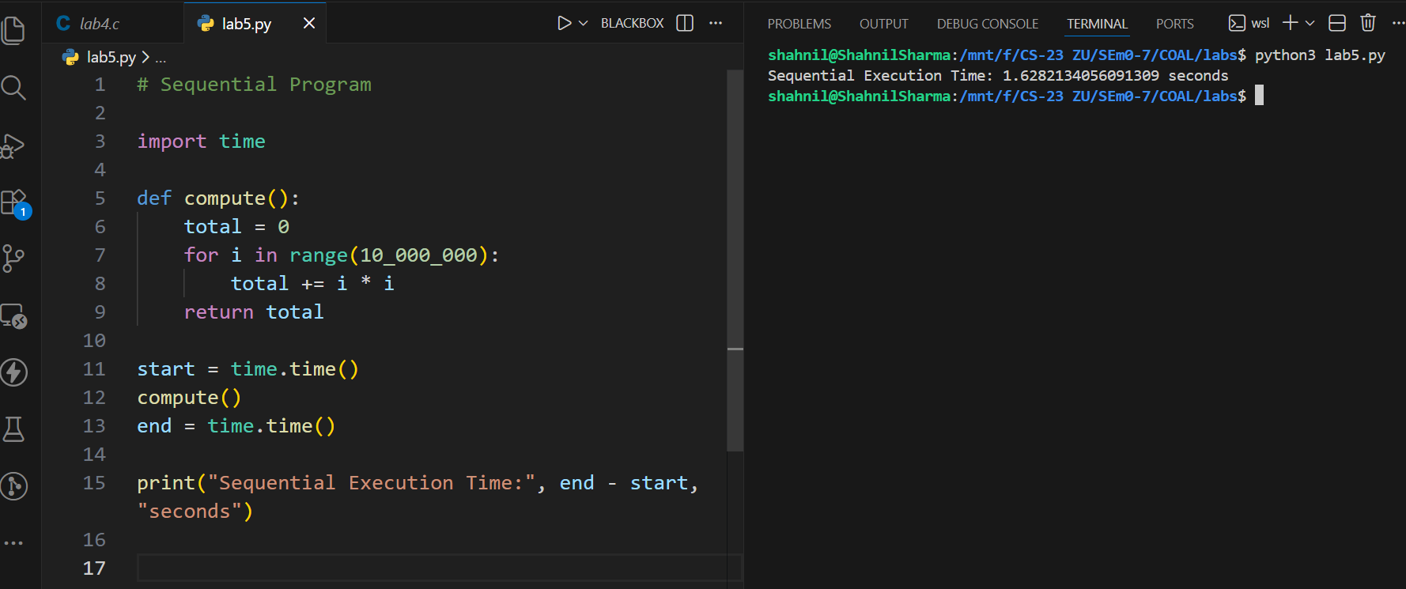

Practical Task - Parallel Program (Multiprocessing)
# Parallel Program
import time
from multiprocessing import Pool
import os
def square(number):
return number * number
if __name__ == "__main__":
numbers = list(range(10_000_000))
start = time.time()
with Pool(os.cpu_count()) as p:
result = p.map(square, numbers)
end = time.time()
print("Parallel Execution Time:", end - start, "seconds")

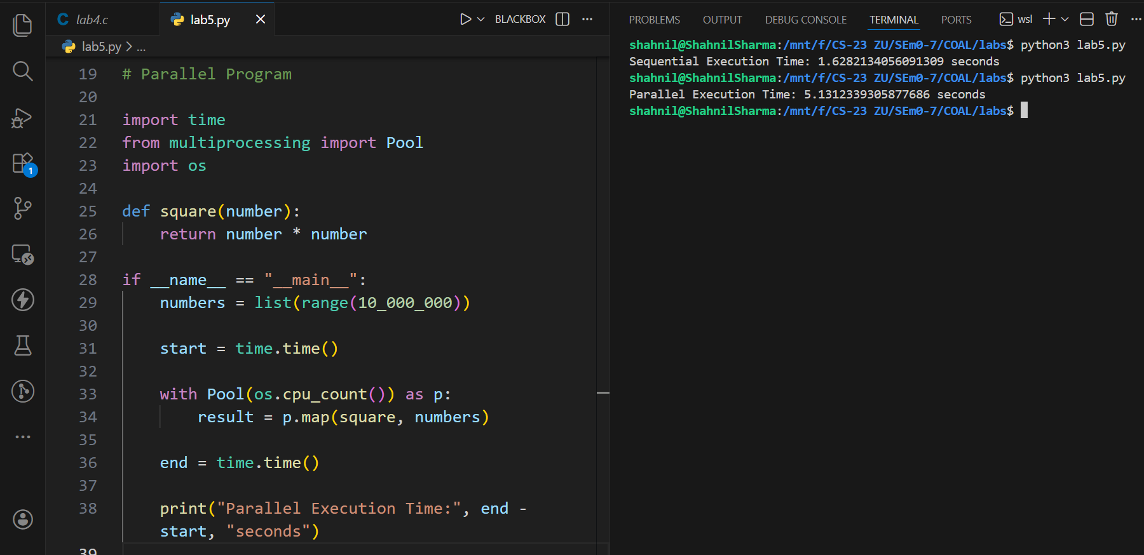

Sequential vs Parallel Comparison
1. Sequential program runs on a single CPU core.
2. Parallel program distributes work across multiple CPU cores.
3. Parallel execution reduces total execution time for CPU-intensive tasks.
4. Performance improvement depends on the number of available CPU cores.

Outcome
The experiment shows that parallel computing improves performance for large computational tasks. Multiprocessing in Python allows better utilization of CPU resources.

Conclusion
Parallel computing is important for performance optimization. By implementing multiprocessing in Python, programs can execute faster compared to sequential execution.

