Lab 10
Supervised Learning (Naive Bayes)
Name: Shahnil Sharma
Roll No: 4-38/2023/004
Course: Artificial Intelligence Lab
Date: 30/10/2026

Task 1: Play Prediction (Step 1: Create Dataset from Fig 1)
Implement the Naive Bayes algorithm on the dataset in Fig 1 to predict whether the players can play or not when the weather is overcast and the temperature is mild. Create the dataset.

Code

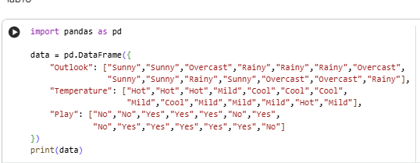

Output

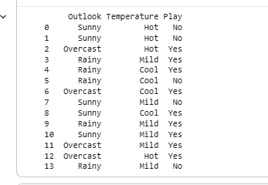

Task 1: Play Prediction (Step 2: Train and Predict)
Train the Naive Bayes model and predict for Outlook = Overcast, Temperature = Mild.

Code

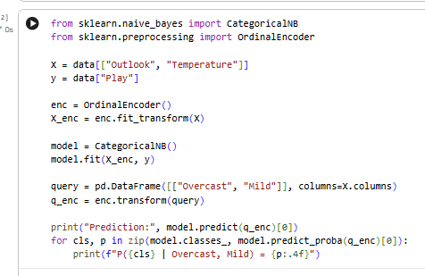

Output

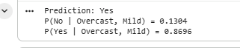

Task 2: buys_computer (Step 1: Create Dataset)
Consider the given dataset. Implement the Naive Bayes algorithm to classify youth / medium / yes / fair. Create the dataset.

Code

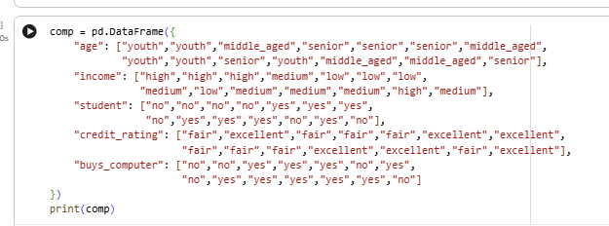

Output

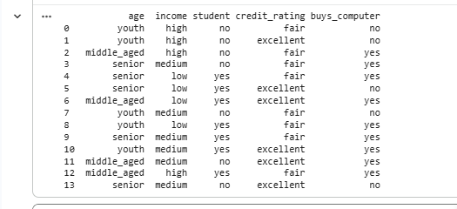

Task 2: buys_computer (Step 2: Train and Classify)
Train the Naive Bayes model and classify age = youth, income = medium, student = yes, credit_rating = fair.

Code

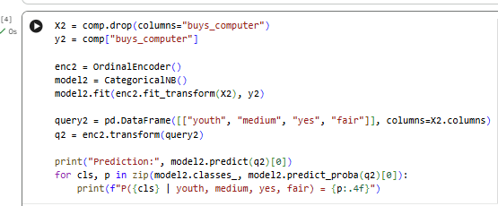

Output



