LAB NO: 01
NAME: Shahnil Sharma
ROLL NO: 004
- Calculate area of triangle.
INPUT:
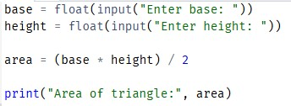
OUTPUT:
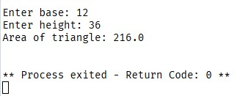
- Calculate circumference of circle.
INPUT:
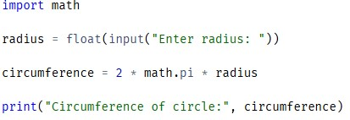
OUTPUT:
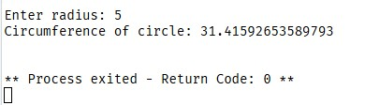
- Calculate cube of a number.
INPUT:
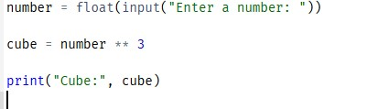
OUTPUT:
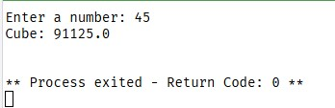
- Convert minutes into hours.
INPUT:
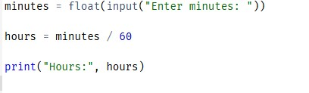
OUTPUT:
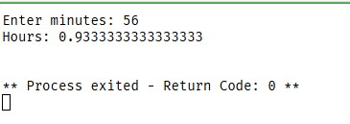
- Find average of five numbers.
INPUT:
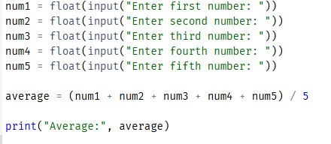
OUTPUT:
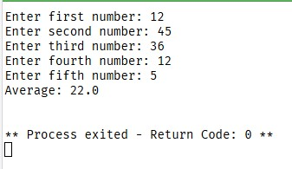

- Find square root of number.
INPUT:
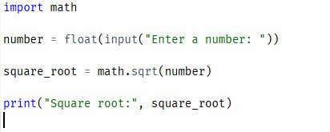
OUTPUT:
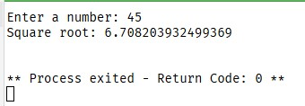
- Student Grade Calculator
INPUT:
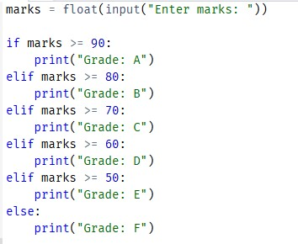
OUTPUT:
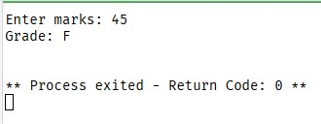
- Currency Converter
INPUT:
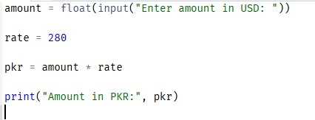
OUTPUT:
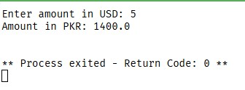

- Age Calculator
INPUT:
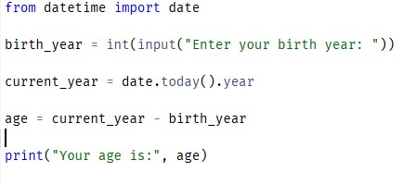
OUTPUT:


