LAB NO: 02
NAME: Shahnil Sharma
ROLL NO: 004
- Check whether a number is positive, negative, or zero.
INPUT:
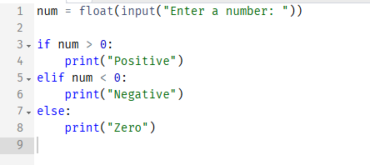
OUTPUT:
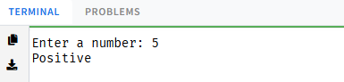
- Print all even numbers between 1 and 100.
INPUT:
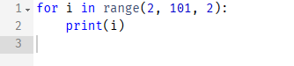
OUTPUT:
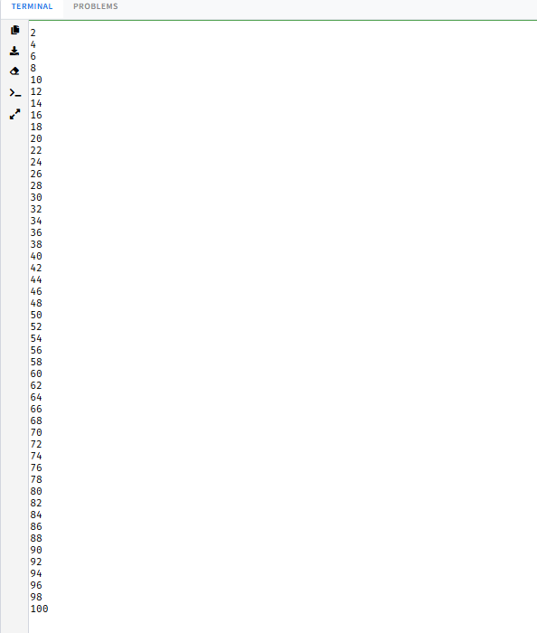
- Find the sum of odd numbers from 1 to 50.
INPUT:
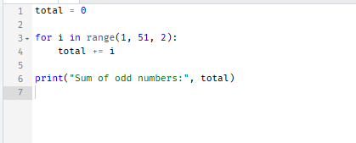
OUTPUT:
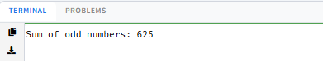
- Print the multiplication table of any number.
INPUT:
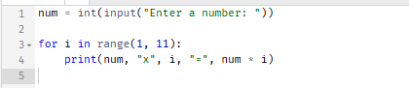
OUTPUT:
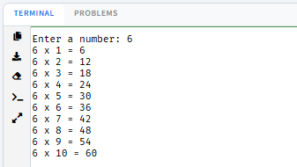
- Find the factorial using a loop.
INPUT:
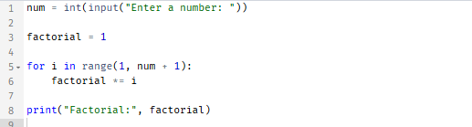
OUTPUT:
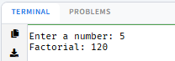
- Reverse a number.
INPUT:
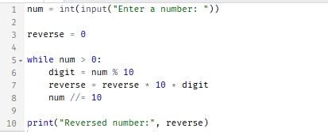
OUTPUT:
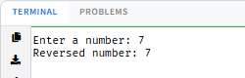
- Check whether a number is a palindrome.
INPUT:
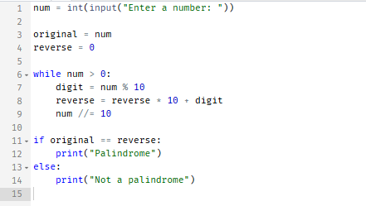
OUTPUT:
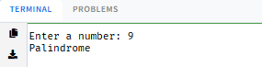
- Generate the Fibonacci series up to 20 terms.
INPUT:
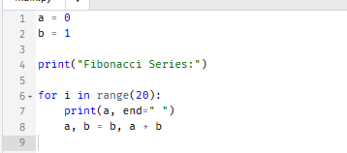
OUTPUT:
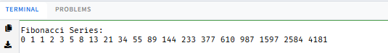
- Count the digits in a number.
INPUT:
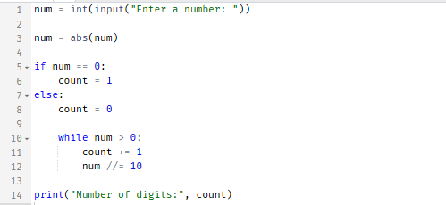
OUTPUT:
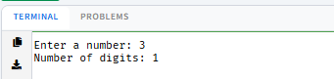
- Build a menu-driven calculator using functions.
INPUT:
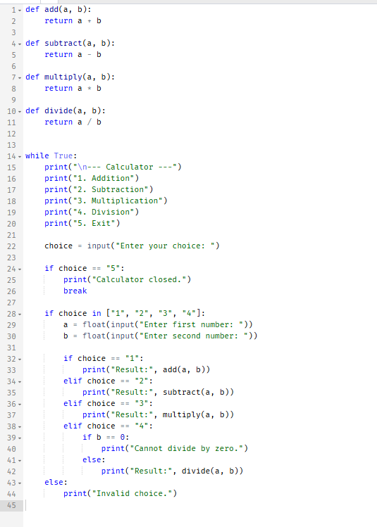
OUTPUT:
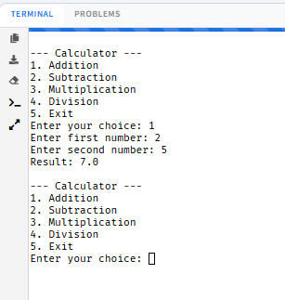
- Create a simple login system with three attempts.
INPUT:
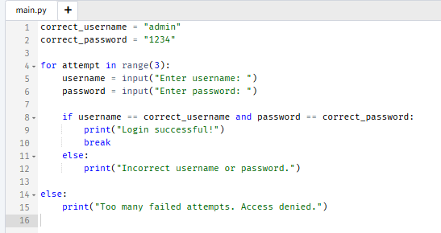
OUTPUT:
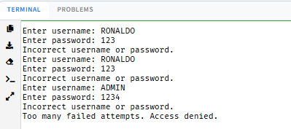
- Develop a student grade calculator with letter grades.
INPUT:
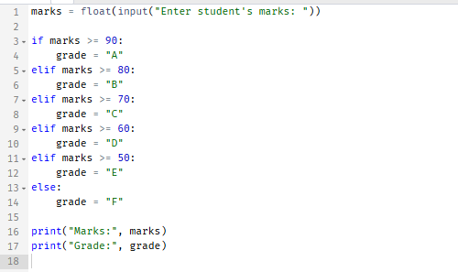
OUTPUT:
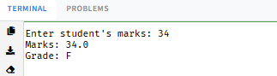
- Print various star (*) patterns using nested loops.
Pattern 1: Increasing triangle
INPUT:
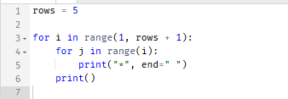
OUTPUT:
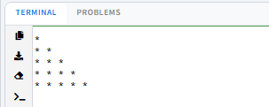
Pattern 2: Decreasing triangle
INPUT:
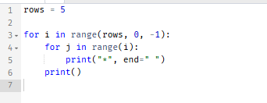
OUTPUT:
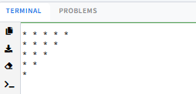
Pattern 3: Pyramid
INPUT:
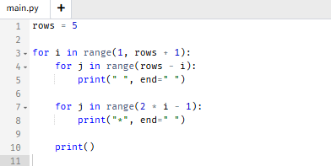
OUTPUT:
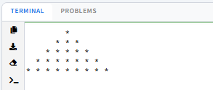

- Implement a number guessing game.
INPUT:
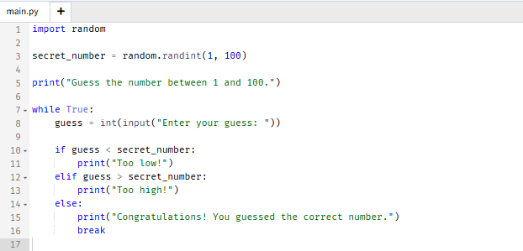
OUTPUT:


