ZIAUDDIN UNIVERSITY
College of Computing & Software Engineering
Artificial Intelligence & Machine Learning Lab
OPEN-ENDED LAB REPORT
Development of an Intelligent Campus Navigation and Search System using DFS, BFS, DLS and IDS
Field | Detail
Student Name | Shahnil
Roll Number | 4-38/2023/004
Program | BS Computer Science
Lab Type | Open-Ended
Duration | 3 Hours
Language / Version | Python 3.12
Source File | Shahnil_CampusSearch.py
Environment | Ubuntu (WSL) terminal, Visual Studio Code
Submission Date | 18-09-2026
Instructor | Miss Mariam

1. Problem Statement
A university campus contains many locations such as the main gate, reception, administration block, departments, laboratories, library, cafeteria, auditorium, examination hall, parking area and emergency exits. Students, teachers, visitors and security staff regularly need a route from one location to another, and the route they want is not always the same kind of route. A visitor wants the shortest walk, a security officer wants any reachable exit as fast as possible, and a maintenance team may need a route that avoids a corridor that is closed.
The task of this open-ended lab was to model the campus as a graph and to build a menu driven Python application that finds a route between any two locations using four uninformed search strategies: Depth First Search, Breadth First Search, Depth Limited Search and Iterative Deepening Search. The program must not only report that the goal was found, it must return the complete path, count the nodes it expanded, report the depth at which the goal was located, survive cycles in the graph, and allow the map itself to be modified at run time.
No fixed graph or starter program was provided. The campus map, the class design, the data structures, the menu and the search implementations in this report are my own design.

2. System Design
The system is written as a single Python file, Shahnil_CampusSearch.py, and is organised in four layers.
- Data structure layer: Stack (LIFO) and Queue (FIFO) classes written from scratch instead of using library helpers, so that the behaviour required by DFS and BFS is visible and can be printed during execution.
- Entity layer: the Location class, which stores a name, a location type and an OPEN or BLOCKED status, and the SearchResult class, which stores the statistics of a single search run.
- Logic layer: the CampusMap class, which owns the adjacency list, the graph editing methods and all four search algorithms, plus the comparison report.
- Interface layer: the menu driven main() function, which handles input, type conversion, validation and dispatch to the correct algorithm.
Every search returns a SearchResult object rather than printing and forgetting. Because the results are stored in a history list inside CampusMap, the comparison table in menu option 8 is produced from measurements that were actually recorded during the run, not from values typed by hand.

2.1 Control Flow
main()
-> build_default_campus() # 11 locations, 14 connections
-> print_menu() # loop until choice 14
-> ask_route() # input + validation
-> CampusMap.dfs() / dfs_recursive()
-> CampusMap.bfs()
-> CampusMap.dls(limit)
-> CampusMap.ids() # repeatedly calls dls()
-> SearchResult.display() + show_vertical_path()
-> CampusMap.comparison_table()

3. Graph Representation
The campus is stored as an adjacency list: a dictionary whose key is a location name and whose value is the list of directly connected locations. Connections are added in both directions, so the graph is undirected, which matches a real corridor that can be walked either way. The default map contains 11 locations and 14 connections, which satisfies the minimum requirement of 10 locations and 12 connections.
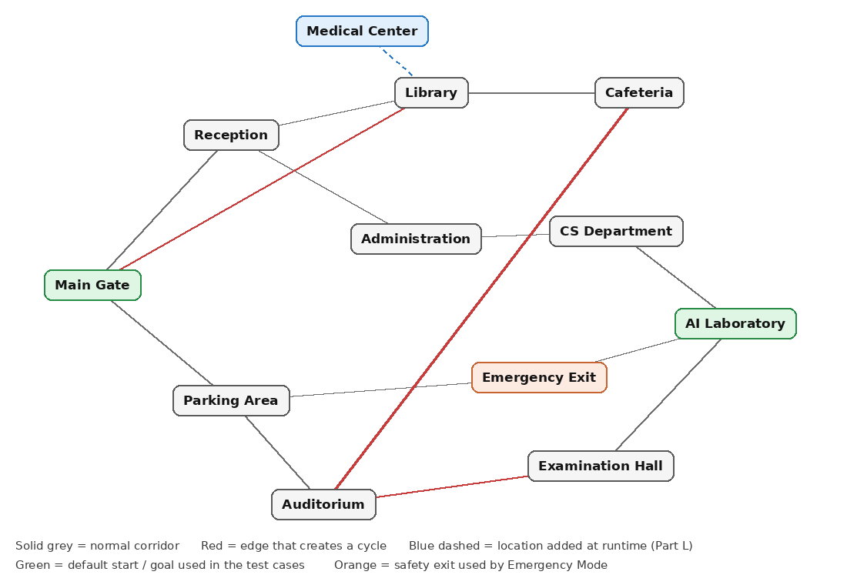
Figure 1: Campus graph designed for this lab. Red edges are the three edges that close a cycle.
Three edges deliberately close cycles: Library to Main Gate, Auditorium to Examination Hall, and Auditorium to Cafeteria. Without a visited structure these cycles would make DFS and DLS loop forever, so they are the test material for Part I.
Location | Type | Connected To
Main Gate | Entrance | Reception, Parking Area, Library
Reception | Service | Main Gate, Library, Administration
Parking Area | Utility | Main Gate, Auditorium, Emergency Exit
Library | Academic | Reception, Cafeteria, Main Gate
Administration | Office | Reception, CS Department
CS Department | Academic | Administration, AI Laboratory
AI Laboratory | Laboratory | CS Department, Examination Hall, Emergency Exit
Cafeteria | Facility | Library, Auditorium
Auditorium | Facility | Parking Area, Examination Hall, Cafeteria
Examination Hall | Academic | AI Laboratory, Auditorium
Emergency Exit | Safety | AI Laboratory, Parking Area

4. Class Design
Class | Attributes | Key Methods | Purpose
Stack | items | push, pop, peek, is_empty, contents | LIFO frontier for DFS and DLS
Queue | items (deque) | enqueue, dequeue, is_empty, contents | FIFO frontier for BFS
Location | name, location_type, status | is_open, display_location | One point on the campus
SearchResult | algorithm, found, path, visited_count, goal_depth, iterations, traversal | display, path_length, show_vertical_path | Statistics of one search run
CampusMap | locations, graph, history | add_location, add_connection, set_status, display_graph, dfs, dfs_recursive, bfs, dls, ids, comparison_table, recommend | Owns the graph and all search logic
Location is the blueprint and each campus point is an object created from it. CampusMap is a container class: it holds Location objects in a dictionary and the connections in a second dictionary, which keeps the entity data and the topology separate.

5. Source Code
The complete program is 614 lines. The screenshots below are taken from Visual Studio Code with the line numbers visible so that the listing can be checked against the submitted file Shahnil_CampusSearch.py.
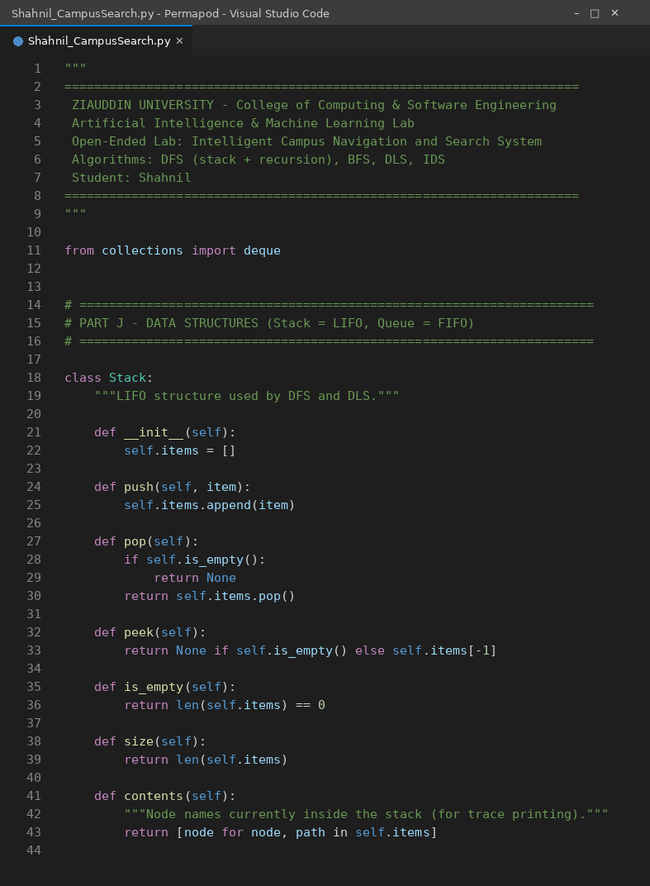
Code Screenshot 1: lines 1 to 45 of Shahnil_CampusSearch.py
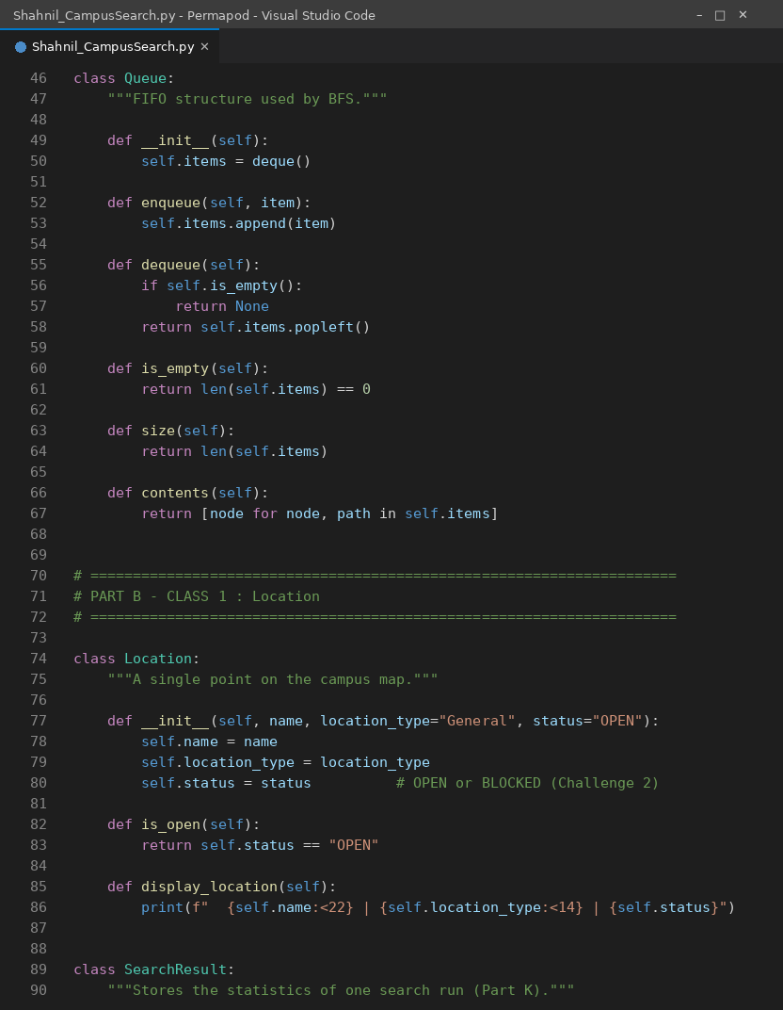
Code Screenshot 2: lines 46 to 90 of Shahnil_CampusSearch.py
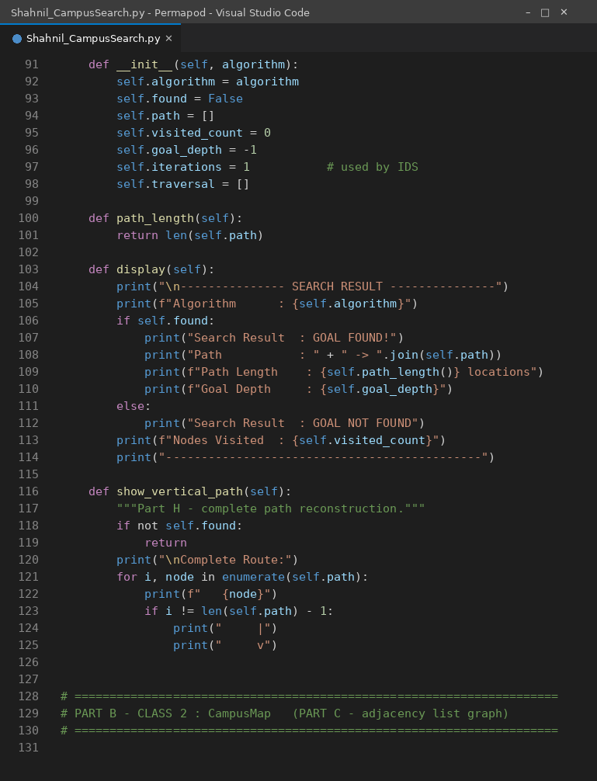
Code Screenshot 3: lines 91 to 132 of Shahnil_CampusSearch.py
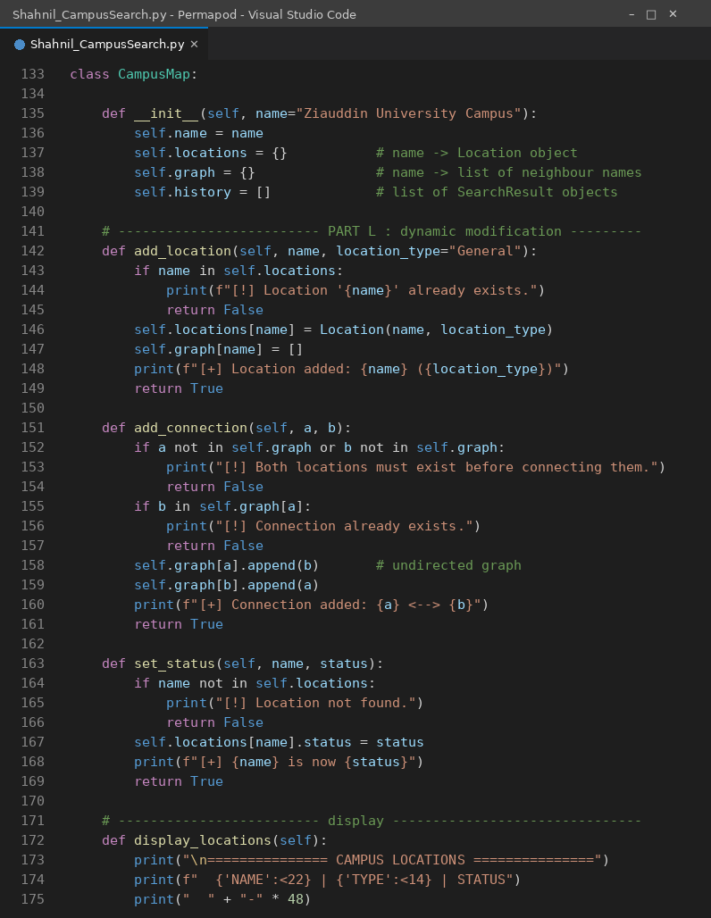
Code Screenshot 4: lines 133 to 175 of Shahnil_CampusSearch.py
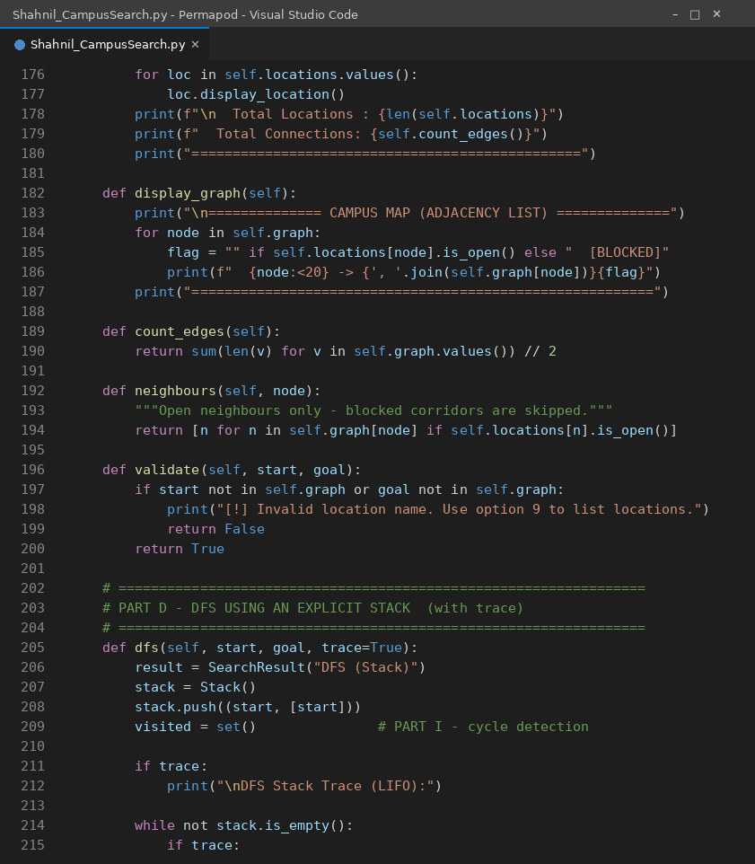
Code Screenshot 5: lines 176 to 215 of Shahnil_CampusSearch.py
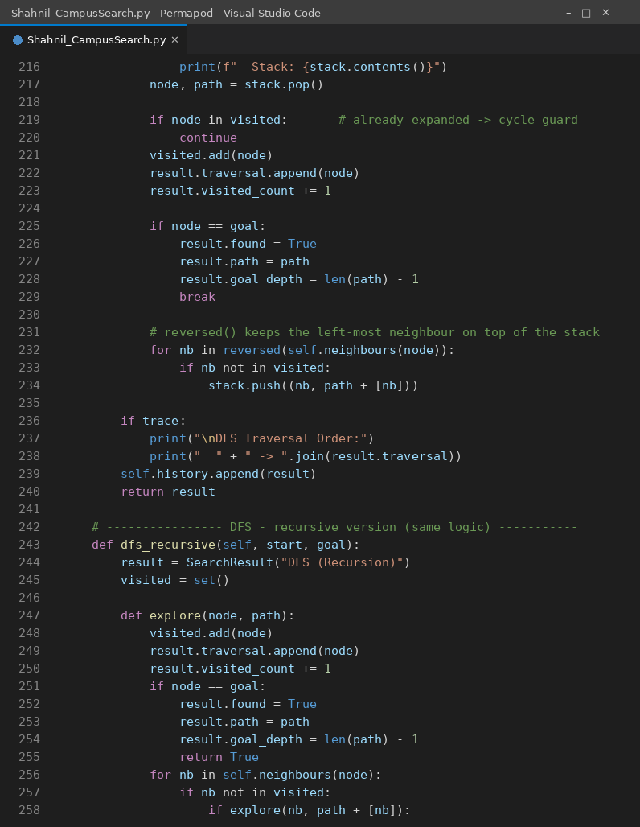
Code Screenshot 6: lines 216 to 258 of Shahnil_CampusSearch.py
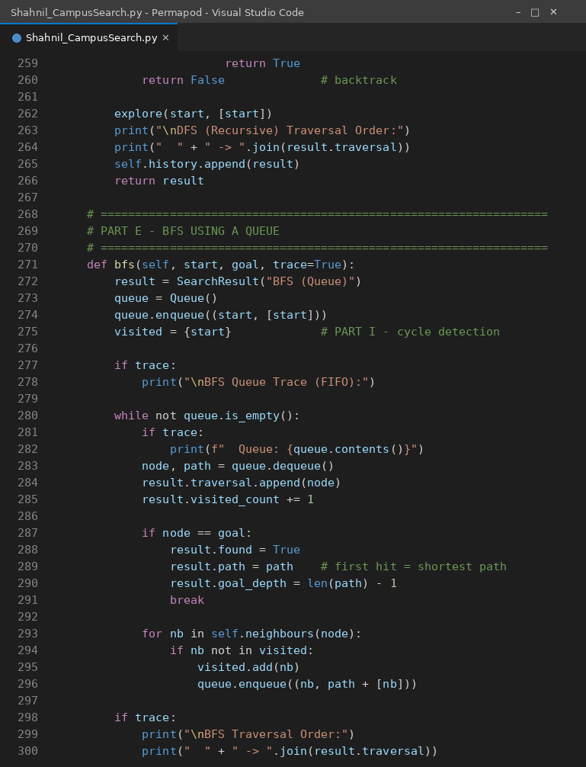
Code Screenshot 7: lines 259 to 300 of Shahnil_CampusSearch.py
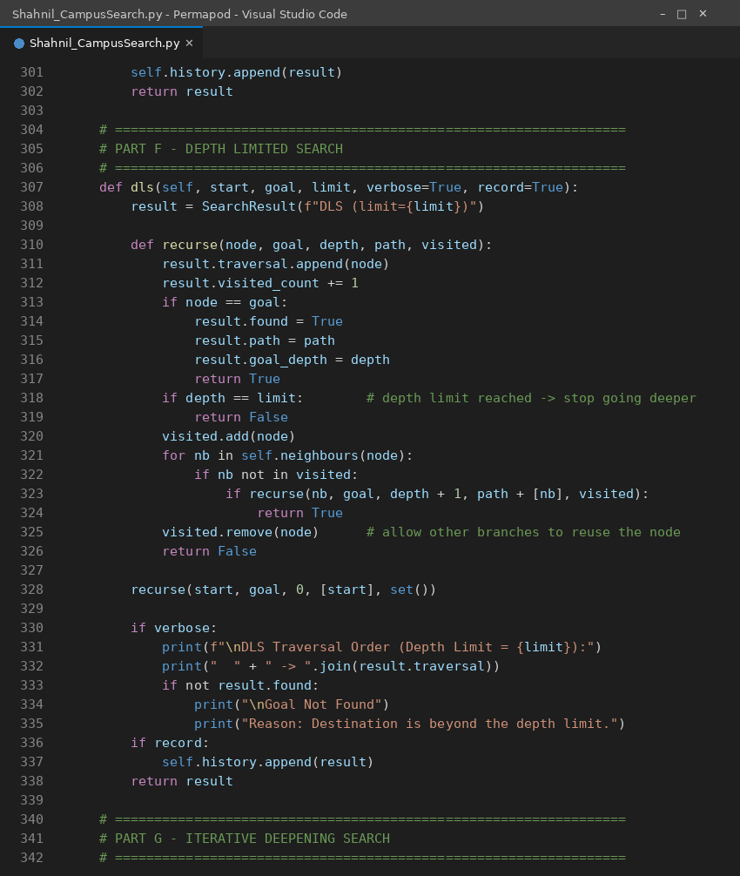
Code Screenshot 8: lines 301 to 342 of Shahnil_CampusSearch.py
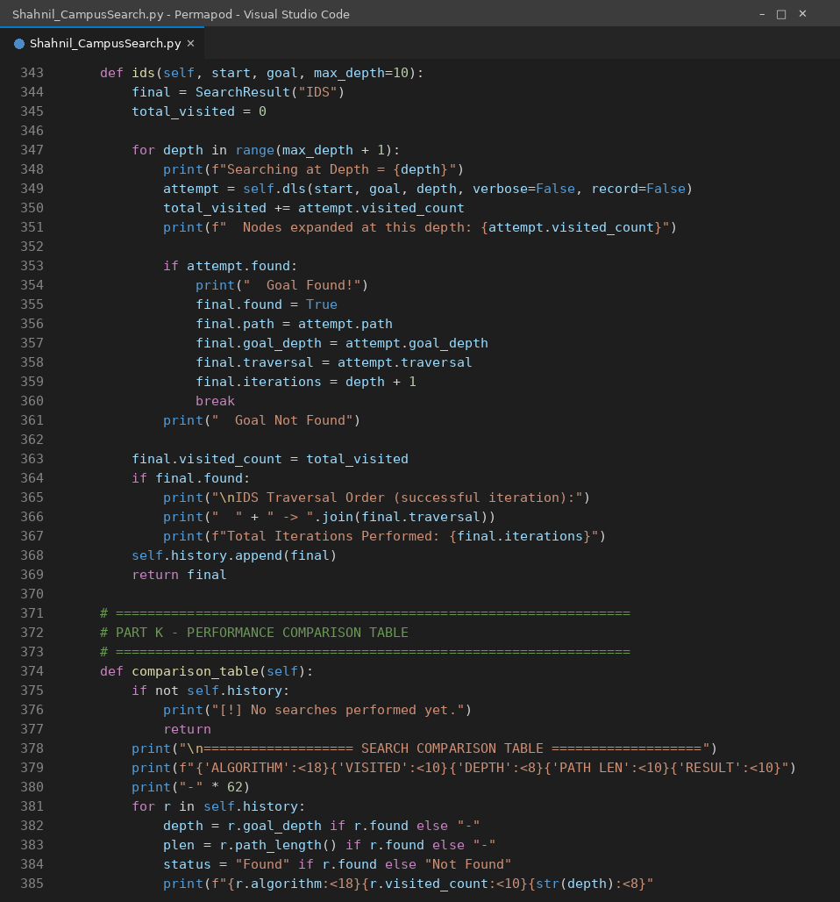
Code Screenshot 9: lines 343 to 385 of Shahnil_CampusSearch.py
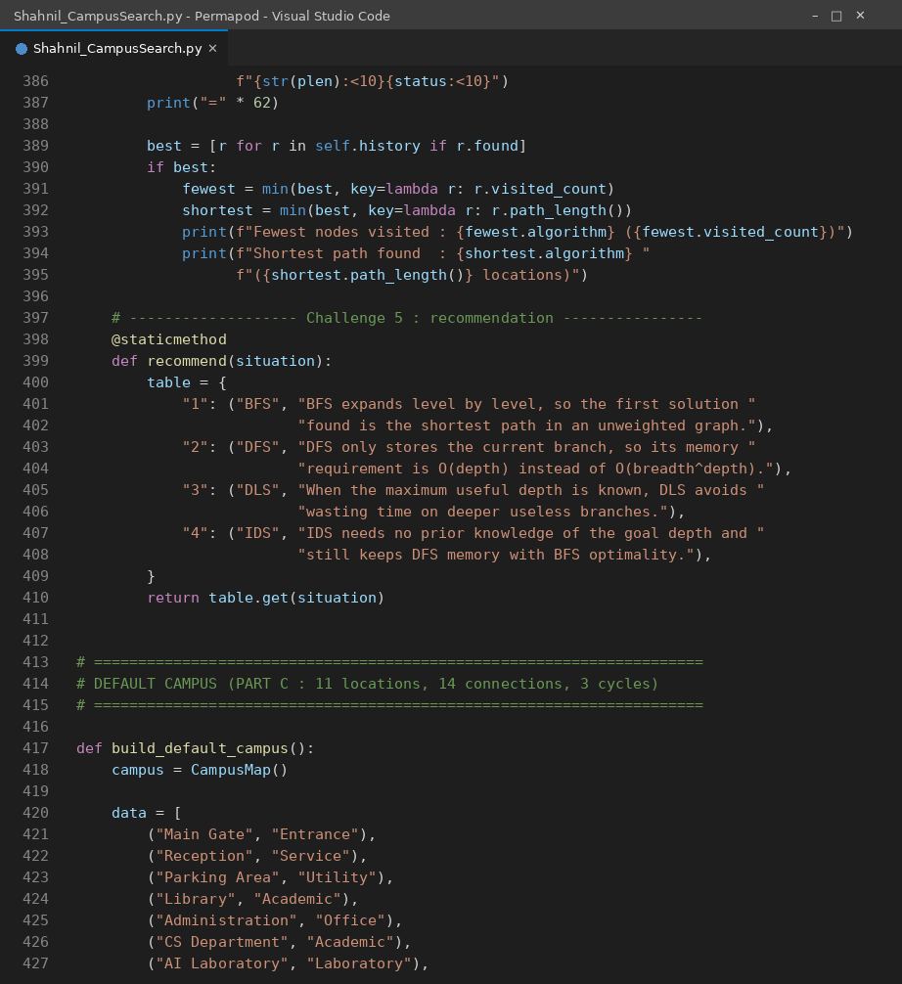
Code Screenshot 10: lines 386 to 427 of Shahnil_CampusSearch.py
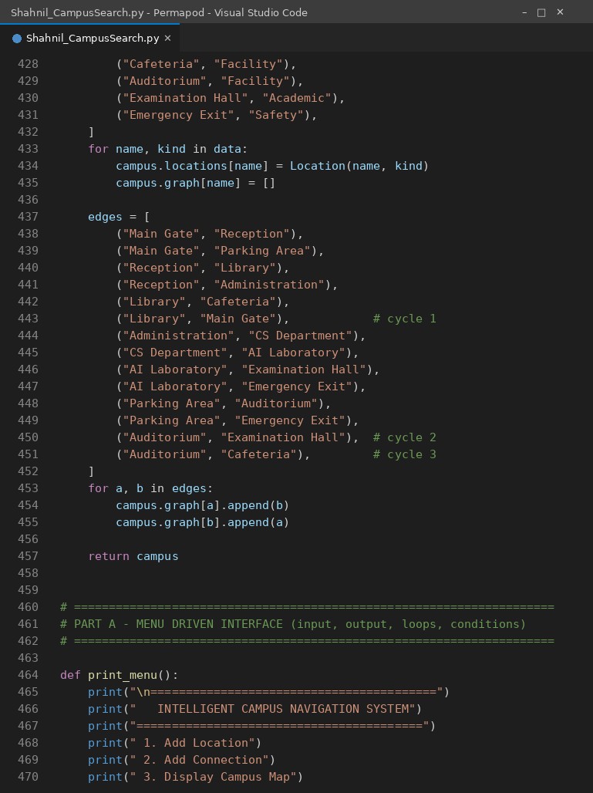
Code Screenshot 11: lines 428 to 470 of Shahnil_CampusSearch.py
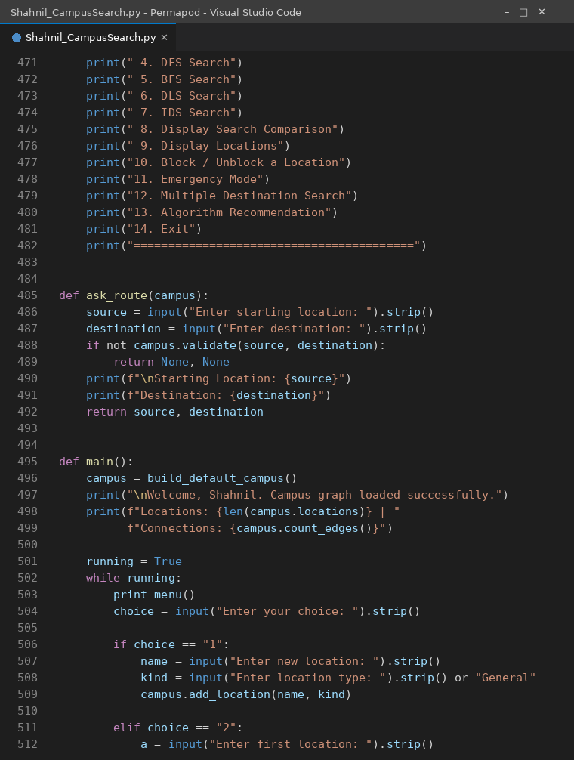
Code Screenshot 12: lines 471 to 512 of Shahnil_CampusSearch.py
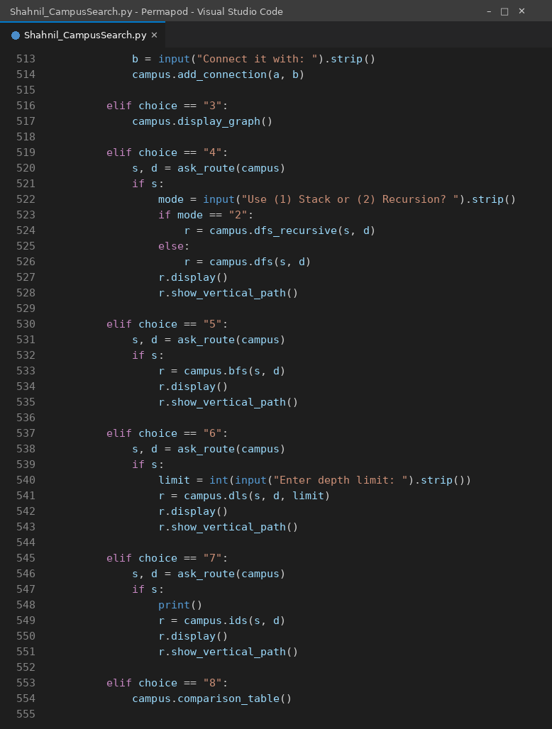
Code Screenshot 13: lines 513 to 555 of Shahnil_CampusSearch.py
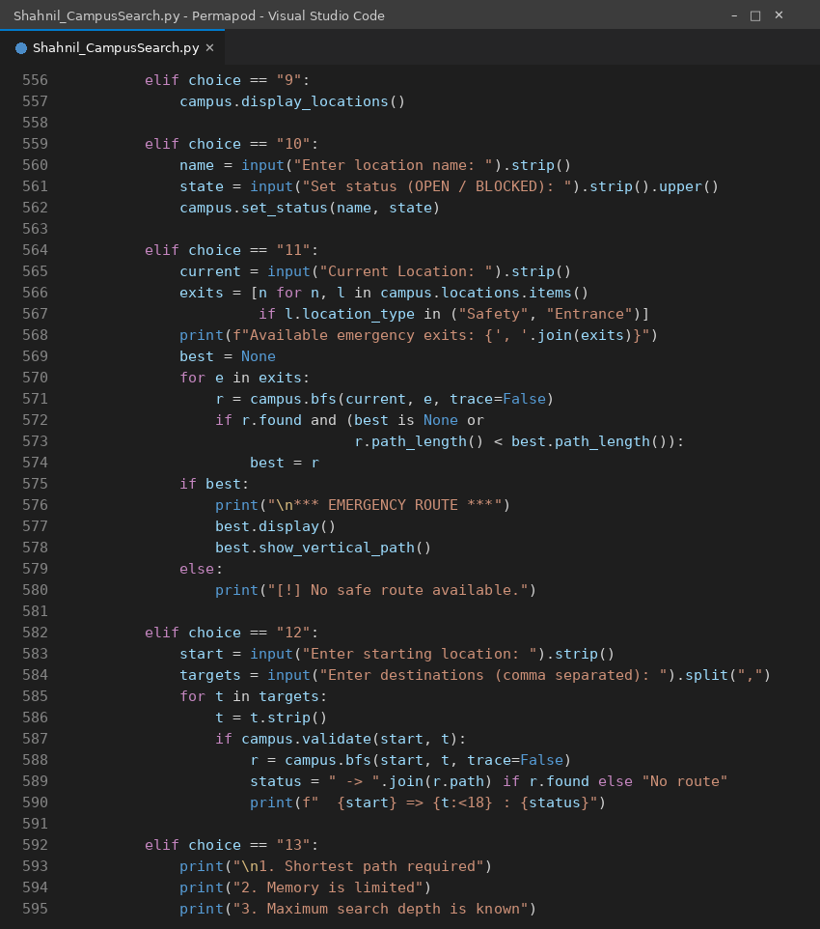
Code Screenshot 14: lines 556 to 595 of Shahnil_CampusSearch.py
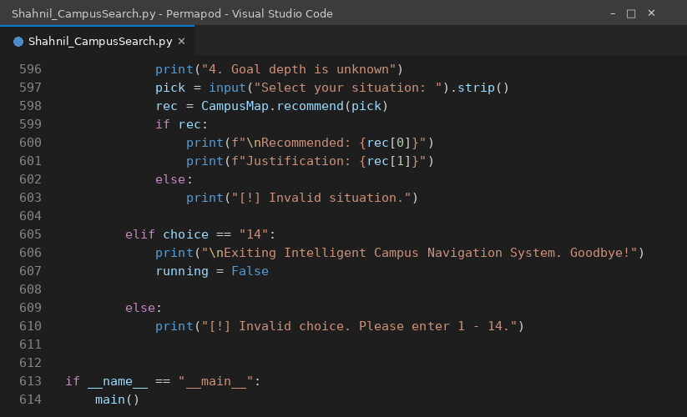
Code Screenshot 15: lines 596 to 614 of Shahnil_CampusSearch.py

6. Depth First Search (DFS)
DFS follows one branch as deep as it can go and only backtracks when that branch is exhausted. Two versions are implemented. The stack version pushes a tuple of (node, path so far) onto the Stack object, pops the top item, tests it against the goal and pushes its unvisited neighbours in reverse order so that the left most neighbour is expanded first. The recursive version performs the same traversal using the Python call stack, which makes the equivalence between recursion and an explicit stack easy to see.
Cycle handling is done with a visited set. A node is added to visited at the moment it is expanded, and any neighbour already in visited is never pushed again, so the Library to Main Gate cycle cannot restart the search.

6.1 Test Case 1: Main Gate to AI Laboratory using DFS
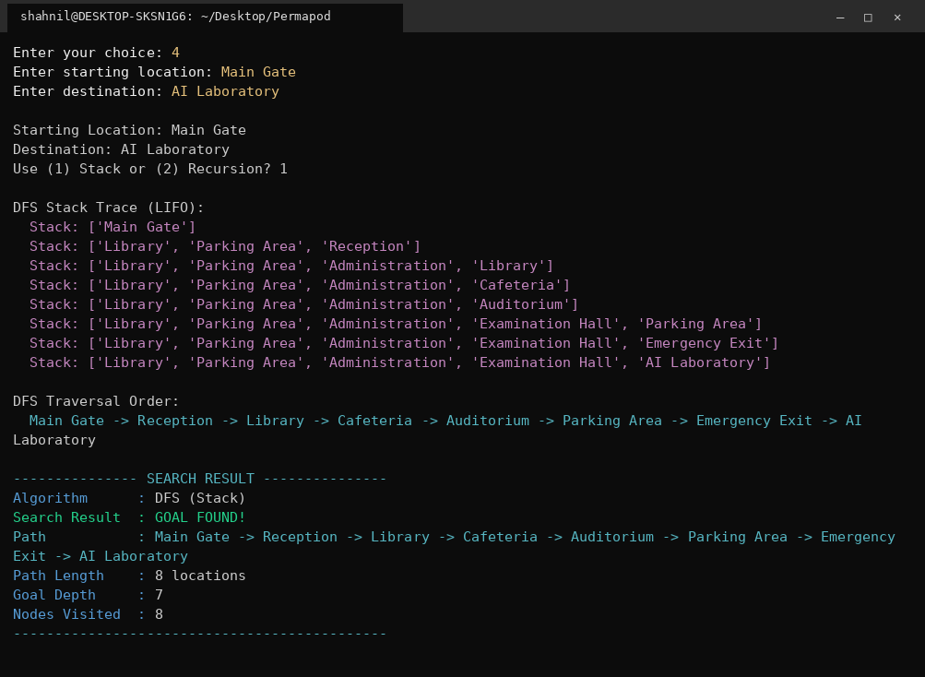
Figure 2: DFS run showing the live contents of the stack at every iteration.
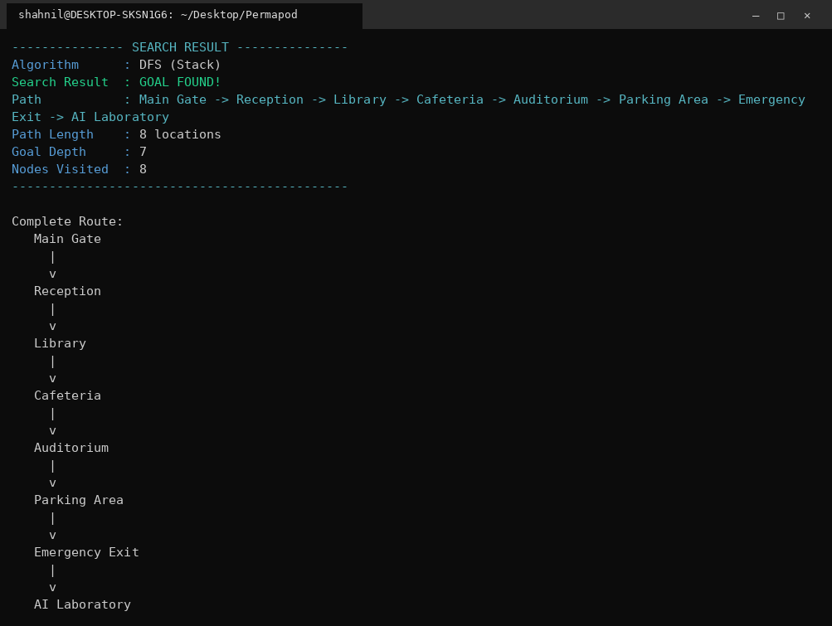
Figure 3: DFS result and reconstructed route (Part H).
DFS expanded only 8 nodes, which is the fewest of all four algorithms, but the route it returned is 8 locations long at depth 7. DFS committed to the Reception branch, went down through Library, Cafeteria, Auditorium and Parking Area, and reached the AI Laboratory from the Emergency Exit side. The answer is correct but it is not the shortest route, which is exactly the weakness DFS is known for.

7. Breadth First Search (BFS)
BFS uses the Queue object. The start node is enqueued with its path, the front node is dequeued and goal tested, and every unvisited neighbour is marked visited at insertion time and enqueued. Marking at insertion rather than at expansion prevents the same node from entering the queue twice, which is what keeps the frontier small on a cyclic graph.

7.1 Test Case 2: Main Gate to AI Laboratory using BFS
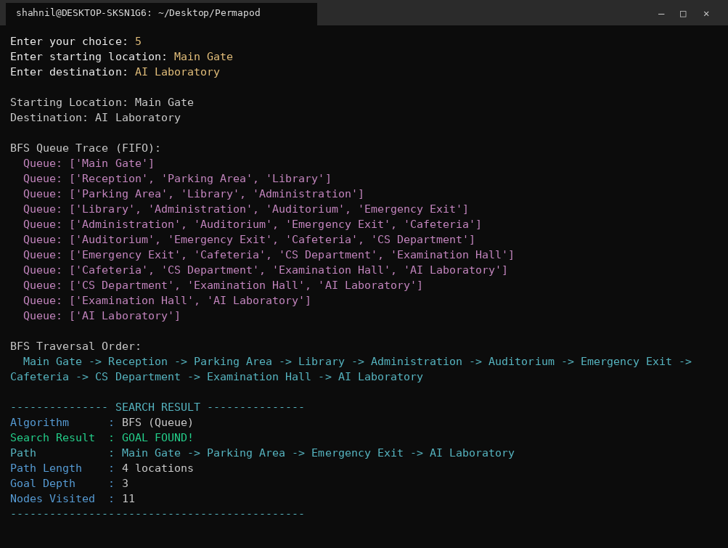
Figure 4: BFS run showing the FIFO queue after every dequeue.
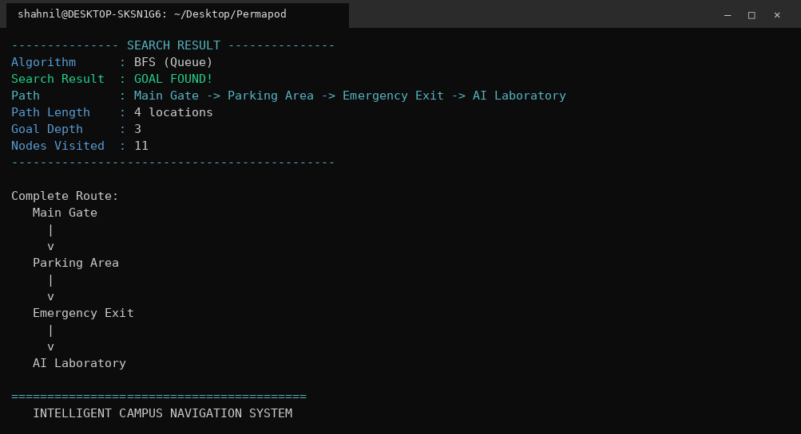
Figure 5: BFS result. The first time the goal is dequeued the path is already the shortest.
BFS expanded 11 nodes, more than DFS, but it returned a route of only 4 locations at depth 3: Main Gate, Parking Area, Emergency Exit, AI Laboratory. Because every edge costs the same, the level by level expansion guarantees that the first path to the goal is a shortest path.

8. Depth Limited Search (DLS)
DLS is DFS with a cut off. The recursion carries the current depth, and when depth equals the limit the branch is not expanded any further even if it has unexplored neighbours. The visited set here is path based: a node is removed from visited while backtracking, so a node that is unreachable within the limit on one branch can still be reached through a shorter branch. This is also what allows IDS to work correctly on top of DLS.

8.1 Test Case 3: Depth limit 2 (failure case)
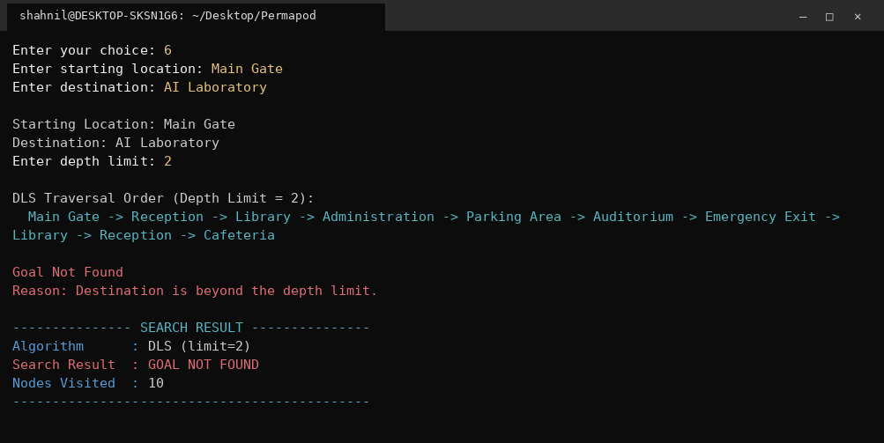
Figure 6: With a depth limit of 2 the goal lies beyond the horizon and the search fails after 10 expansions.

8.2 Depth limit 3 (success case)
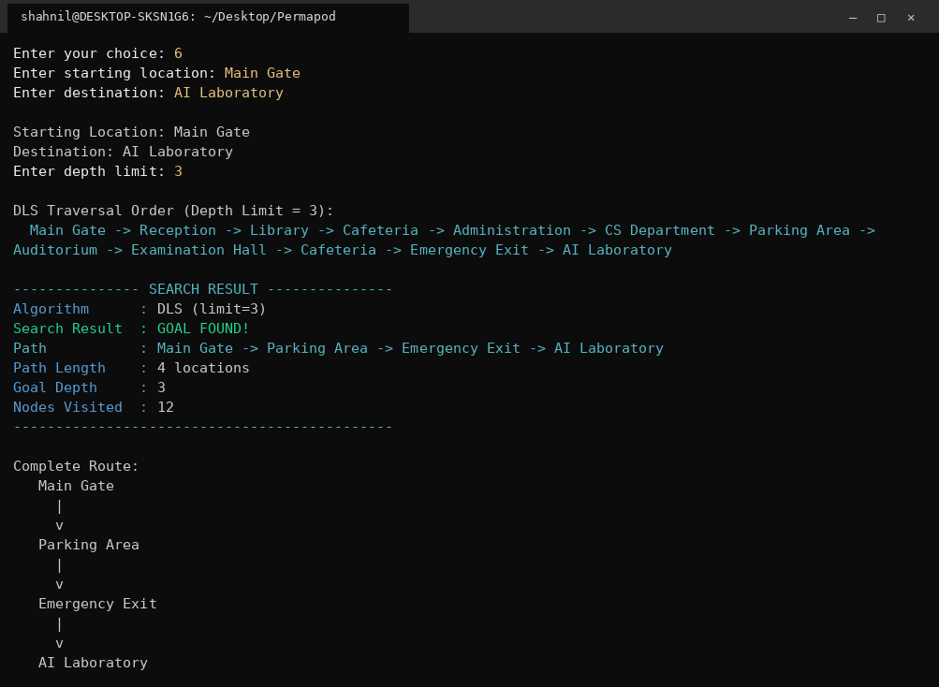
Figure 7: With a depth limit of 3 the same query succeeds with 12 nodes expanded.
This pair of runs demonstrates that DLS is incomplete. The goal exists and is reachable, but a limit that is smaller than the true goal depth reports Goal Not Found. The program prints the reason explicitly so the user can raise the limit instead of assuming the destination does not exist.

9. Iterative Deepening Search (IDS)
IDS calls DLS in a loop with limit 0, 1, 2, 3 and so on until the goal is found. It keeps the low memory profile of DFS because only one branch is ever held in memory, while the answer it returns is as shallow as the one BFS would return, because no deeper level is examined before the shallower ones are exhausted.

9.1 Test Case 4: Main Gate to AI Laboratory using IDS
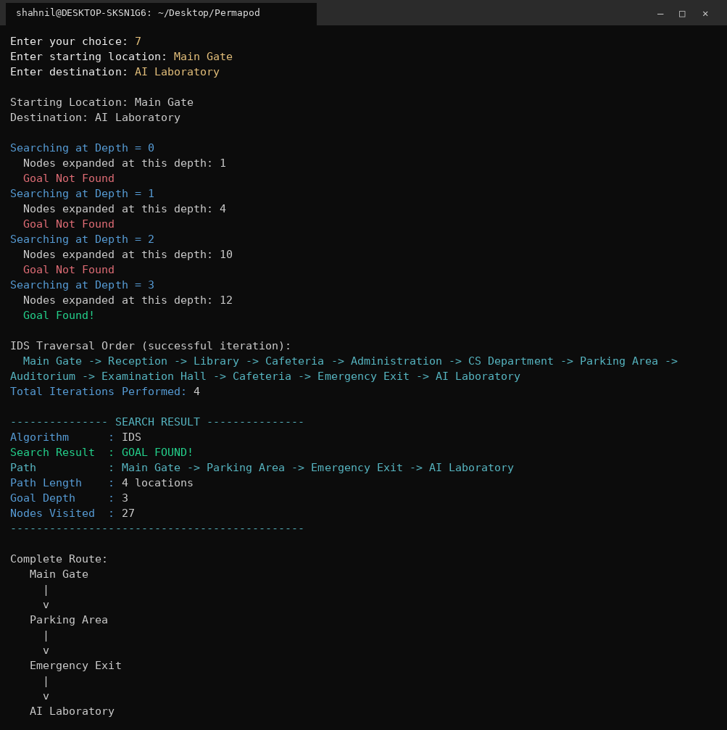
Figure 8: IDS performing four depth limited iterations before the goal appears at depth 3.
IDS performed 4 iterations and expanded 1, 4, 10 and 12 nodes, giving 27 expansions in total. That is the largest node count of all four algorithms, and the repeated work is the price IDS pays. The important detail is what that cost buys: the final route is the same 4 location route BFS found, and the maximum number of nodes held in memory at any moment stayed at the depth of the current branch.

10. Results and Output Screenshots

10.1 Main menu and campus locations
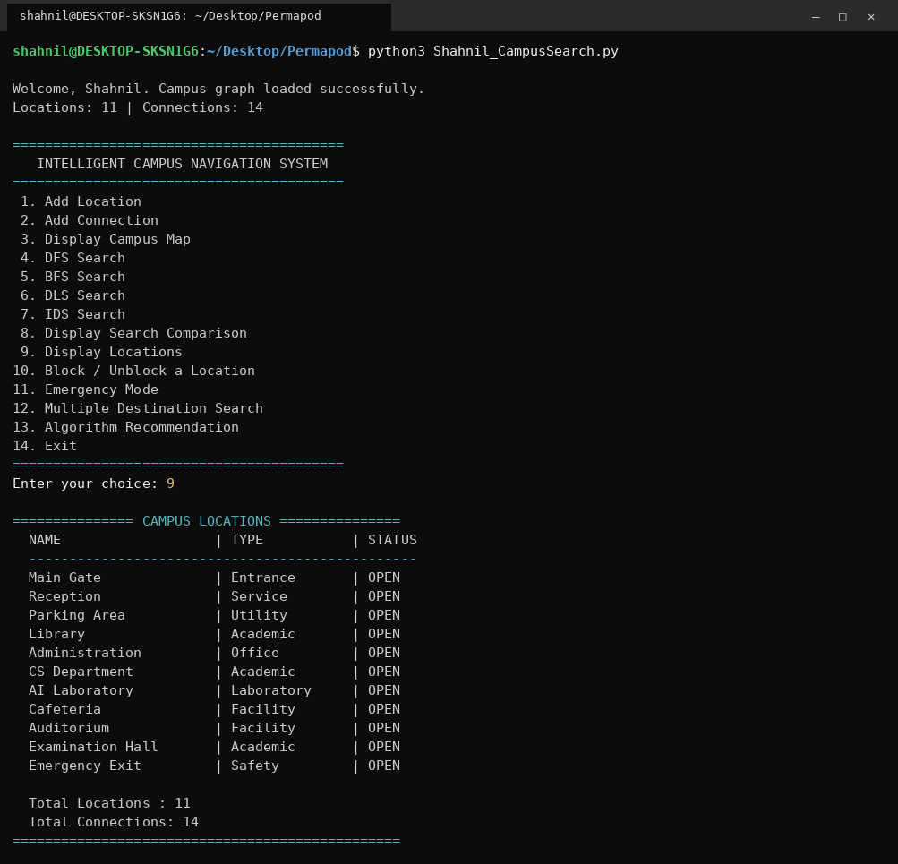
Figure 9: Program start, 14 option menu and the location list with type and status.

10.2 Campus map
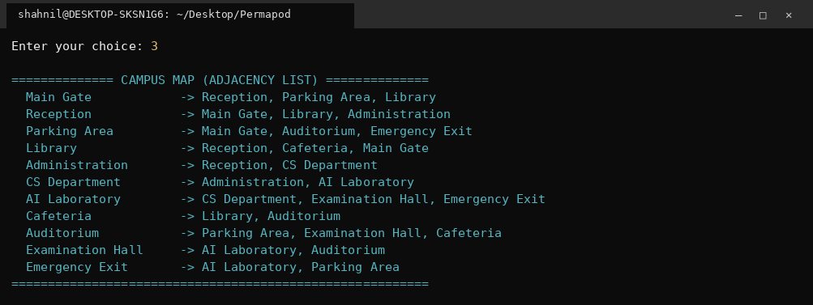
Figure 10: Adjacency list printed by menu option 3.

10.3 Cycle handling and blocked locations
The Emergency Exit was marked BLOCKED to simulate a corridor closed for maintenance. Blocked nodes are filtered out inside neighbours(), so every algorithm ignores them automatically without any change to the search code.
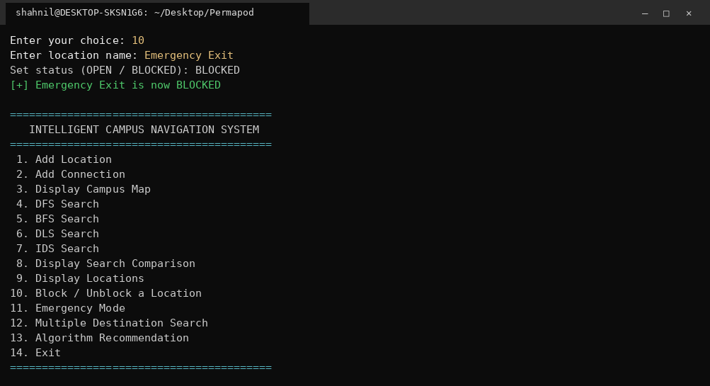
Figure 11: Marking a location as BLOCKED at run time.
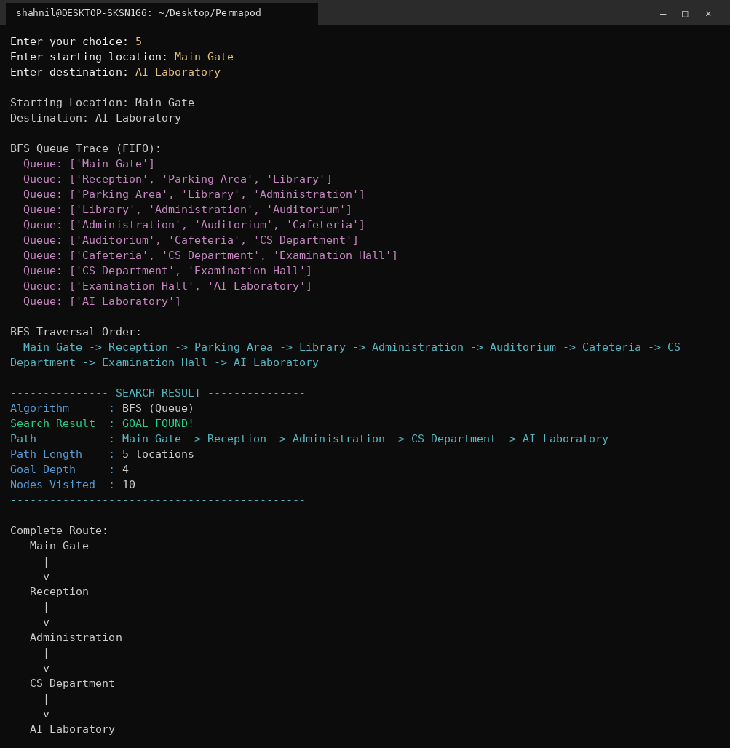
Figure 12: BFS re-routes through Administration and CS Department. The shortest route is now 5 locations at depth 4, and the search still terminates despite the three cycles in the graph.

10.4 Dynamic graph modification
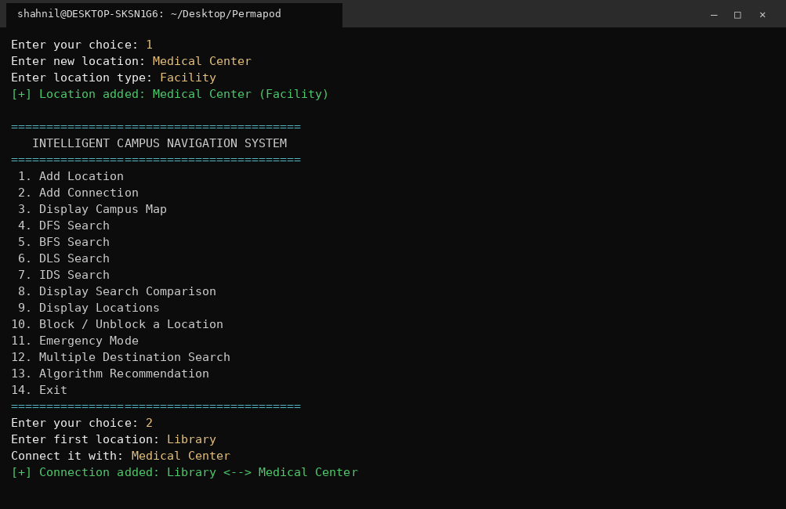
Figure 13: Adding the location Medical Center and connecting it to the Library.
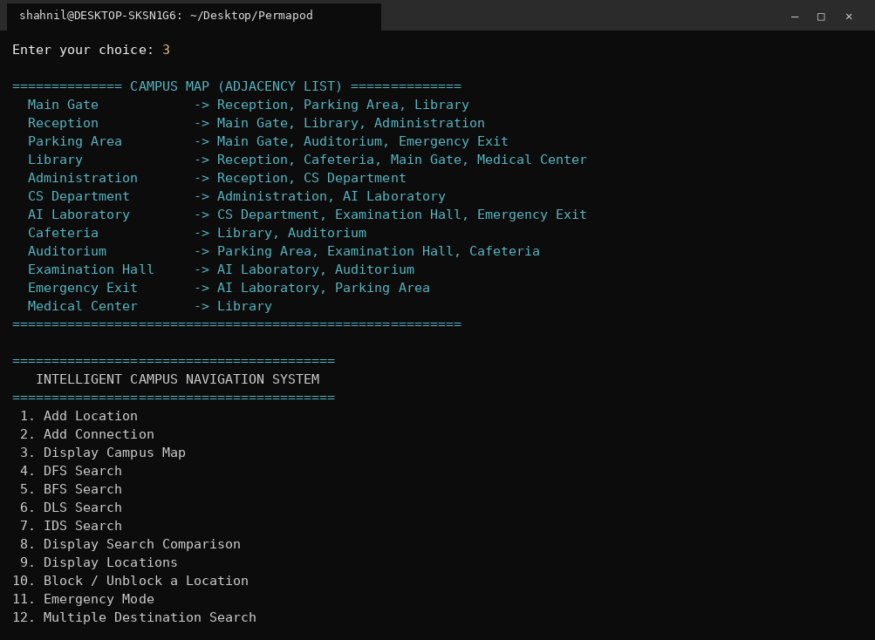
Figure 14: The adjacency list now shows 12 locations and 15 connections.
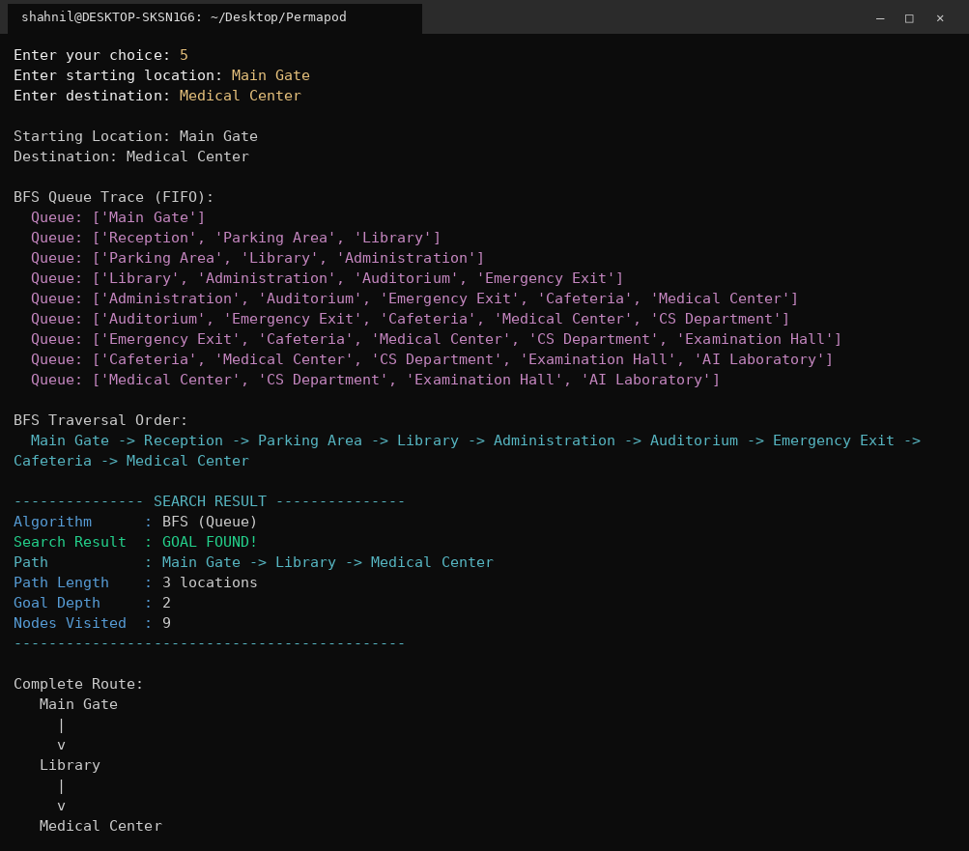
Figure 15: BFS on the modified graph finds Main Gate to Library to Medical Center immediately.

10.5 Emergency mode, multiple destinations and recommendation
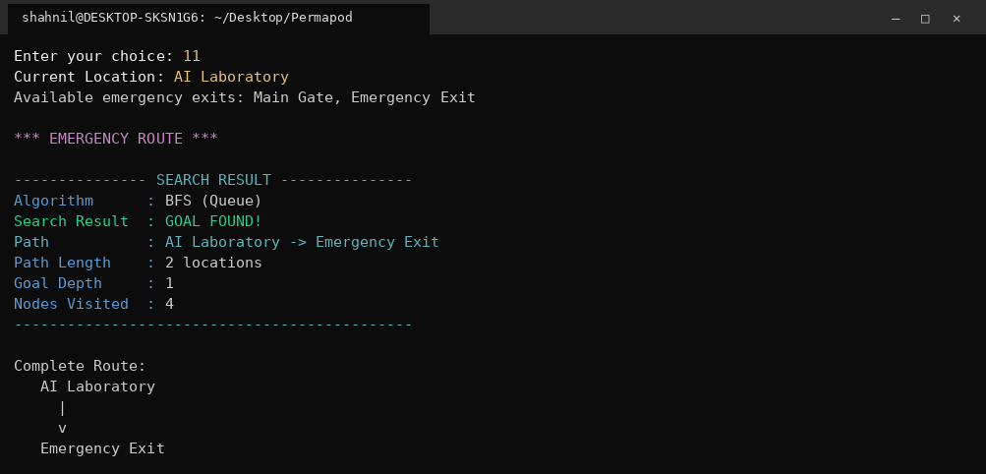
Figure 16: Emergency mode searches every safety exit and keeps the nearest one.
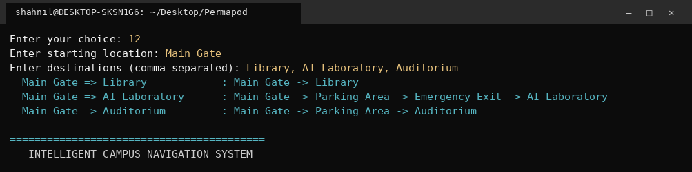
Figure 17: Three destinations solved from one starting point.
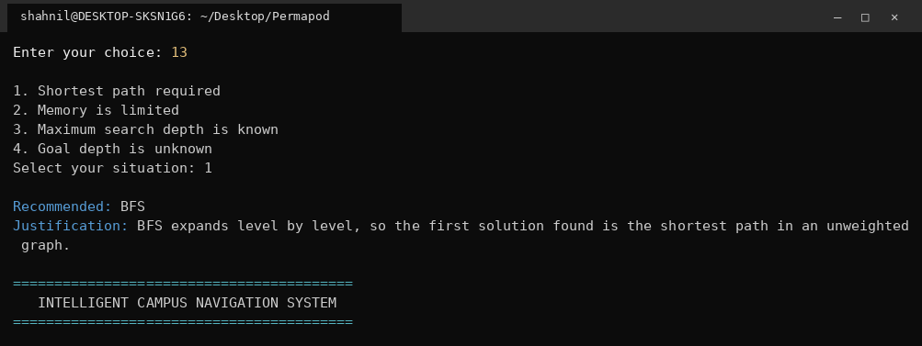
Figure 18: The system recommends an algorithm and justifies the choice.

11. Algorithm Comparison
All four algorithms were run in a single session on the same query, Main Gate to AI Laboratory, so the numbers below were produced by the program itself through menu option 8. The screenshot shows that session, which used a depth limit of 3 for DLS. The failing DLS row with limit 2 in the table underneath comes from the separate run in section 8.1 and is included so that both behaviours of DLS can be compared.
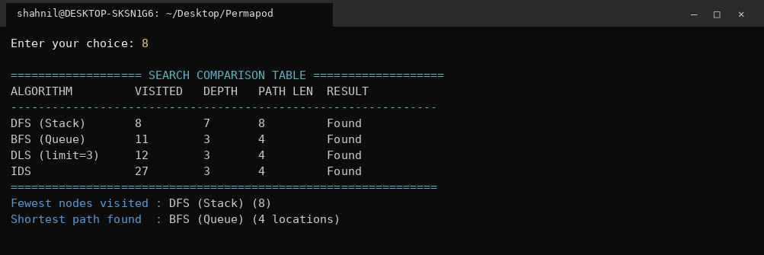
Figure 19: Comparison table generated from the recorded search history.
Algorithm | Nodes Visited | Goal Depth | Path Length | Search Result
DFS (Stack) | 8 | 7 | 8 | Found
BFS (Queue) | 11 | 3 | 4 | Found
DLS (limit = 2) | 10 | - | - | Not Found
DLS (limit = 3) | 12 | 3 | 4 | Found
IDS | 27 | 3 | 4 | Found

11.1 Analysis Questions
Question 1: Which algorithm visited the fewest nodes?
DFS, with 8 expansions. It was lucky rather than efficient: it dived into one branch and that branch happened to reach the AI Laboratory from the far side. On a different query the same behaviour can expand almost the whole graph.
Question 2: Which algorithm found the shortest path?
BFS, with a 4 location route at depth 3. DLS with limit 3 and IDS returned the same route. DFS returned a route twice as long.
Question 3: What happened when DLS was given a very small depth limit?
With limit 2 the search expanded 10 nodes and reported Goal Not Found, because the AI Laboratory sits at depth 3. The failure is a property of the limit, not of the map, so the program prints the reason instead of a plain failure message.
Question 4: How many times did IDS repeat its search?
Four iterations, at limits 0, 1, 2 and 3, expanding 1, 4, 10 and 12 nodes respectively for a total of 27. The shallow iterations are cheap, so the repeated work is far smaller than it first appears.
Question 5: Which algorithm required more memory?
BFS. Its queue held 4 entries at peak because an entire level must be stored before the next level starts, and each entry also carries its path. DFS, DLS and IDS only ever store the current branch, so their memory grows with depth rather than with breadth.
Question 6: What happens when additional branches are added to the graph?
Adding Medical Center and one connection increased the graph to 12 locations and 15 connections. BFS cost grows quickly because the extra branch widens a level, and IDS grows fastest because that wider level is re-expanded in every iteration. DFS cost changes unpredictably: a new branch explored before the goal branch can make it far worse, while a new branch that happens to lead to the goal can make it better.

12. Challenges Faced
- Cycles caused the first version of DFS to recurse forever. The fix was to mark a node visited at the moment it is expanded, not when it is pushed, and to skip any node already expanded when it is popped.
- The first DLS reused the DFS visited set, which permanently blocked nodes that had failed inside a shallow limit. IDS then reported Goal Not Found even for reachable goals. Removing the node from visited while backtracking fixed both.
- Returning the path rather than just a boolean. Carrying the path inside the frontier tuple, (node, path), turned out cleaner than keeping a separate parent dictionary and works identically for the stack and the queue.
- BFS looked wrong at first because it expanded more nodes than DFS. Printing the queue at every step showed the level by level behaviour clearly and confirmed that the higher node count is the cost of optimality.
- Counting nodes consistently across four algorithms. The rule adopted is that a node counts when it is expanded and goal tested, and for IDS the counts of all iterations are summed, which is the only honest way to show its repeated work.

13. Conclusion
The Intelligent Campus Navigation System meets every functional requirement of the lab: 11 locations and 14 connections in an adjacency list, custom Stack and Queue classes, five classes in total, DFS in both stack and recursive form, BFS, DLS, IDS built on DLS, full path reconstruction, cycle detection, node and depth statistics, a generated comparison table, run time graph editing and a 14 option menu, along with the advanced challenges for blocked locations, emergency mode, multiple destinations and algorithm recommendation.
The measured results match the theory taught in the lab. DFS is cheap in memory and can be cheap in expansions but gives no guarantee about path quality. BFS is optimal on an unweighted graph and pays for it with a frontier that grows with the breadth of the graph. DLS is only as good as the limit it is given and is incomplete when that limit is too small. IDS repeats work but combines DFS memory behaviour with BFS optimality, which makes it the safest default when the depth of the goal is unknown. For a real campus navigation application BFS is the right default for a visitor asking for directions, while IDS is the better choice when the map is large and the destination depth cannot be predicted.

