Lab 3
Classes, Queues, and Stack
NAME: Shahnil Sharma
ROLL NO: 004

Exercise 1: Create a Car class with attributes brand, model, and year.
Code
class Car:
def __init__(self, brand, model, year):
self.brand = brand
self.model = model
self.year = year

def display(self):
print("Brand :", self.brand)
print("Model :", self.model)
print("Year :", self.year)

car1 = Car("Toyota", "Corolla", 2022)
car2 = Car("Honda", "Civic", 2020)

print("--- Car 1 ---")
car1.display()
print("--- Car 2 ---")
car2.display()
Output
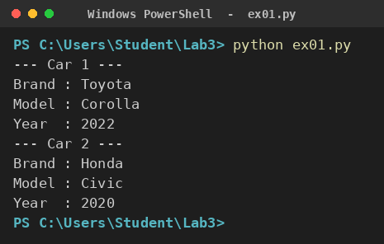

Exercise 2: Create an Employee class and display employee details.
Code
class Employee:
def __init__(self, name, emp_id, designation, salary):
self.name = name
self.emp_id = emp_id
self.designation = designation
self.salary = salary

def display(self):
print("Employee ID :", self.emp_id)
print("Name :", self.name)
print("Designation :", self.designation)
print("Salary :", self.salary)

emp = Employee("Ahmed Raza", "EMP-101", "Software Engineer", 85000)
emp.display()
Output
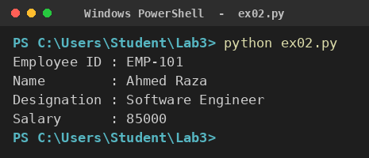

Exercise 3: Implement a stack to store five numbers.
Code
stack = []

for i in [10, 20, 30, 40, 50]:
stack.append(i)
print("Pushed :", i)

print("Stack :", stack)
print("Size :", len(stack))
print("Popped :", stack.pop())
print("Stack :", stack)
Output
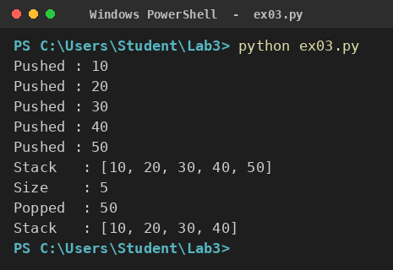

Exercise 4: Implement a queue for customer names.
Code
from collections import deque

queue = deque()

for name in ["Ali", "Sara", "Bilal", "Hina"]:
queue.append(name)
print("Customer joined :", name)

print("Queue :", list(queue))
print("Served :", queue.popleft())
print("Served :", queue.popleft())
print("Waiting :", list(queue))
Output
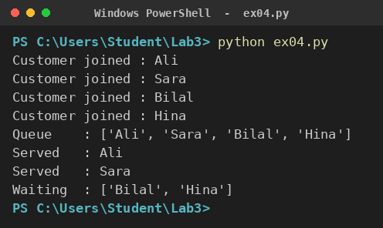

Exercise 5: Display the top element of a stack.
Code
stack = [10, 20, 30, 40]

def peek(s):
if len(s) == 0:
return "Stack is Empty"
return s[-1]

print("Stack :", stack)
print("Top Element :", peek(stack))

stack.pop()
print("After Pop :", stack)
print("Top Element :", peek(stack))
Output
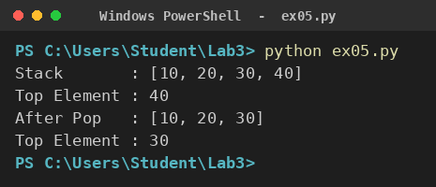

Exercise 6: Build a library management system using classes.
Code
class Book:
def __init__(self, title, author, isbn):
self.title = title
self.author = author
self.isbn = isbn
self.issued = False

class Library:
def __init__(self):
self.books = []

def add_book(self, book):
self.books.append(book)
print("Book Added :", book.title)

def issue_book(self, isbn):
for b in self.books:
if b.isbn == isbn and not b.issued:
b.issued = True
print("Book Issued :", b.title)
return
print("Book Not Available")

def display(self):
print("\n--- Library Records ---")
for b in self.books:
status = "Issued" if b.issued else "Available"
print(b.isbn, "|", b.title, "|", b.author, "|", status)

lib = Library()
lib.add_book(Book("Python Basics", "Mark Lutz", "B001"))
lib.add_book(Book("Data Structures", "Horowitz", "B002"))
lib.issue_book("B002")
lib.display()

Output
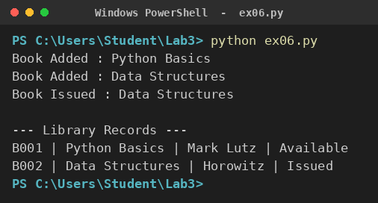

Exercise 7: Reverse a string using a stack.
Code
def reverse_string(text):
stack = []
for ch in text:
stack.append(ch)

result = ""
while len(stack) > 0:
result += stack.pop()
return result

word = "ZIAUDDIN"
print("Original :", word)
print("Reversed :", reverse_string(word))
Output
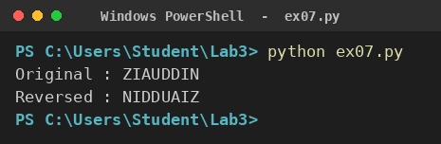

Exercise 8: Simulate a print queue using deque.
Code
from collections import deque

printer = deque()

printer.append("Assignment.pdf")
printer.append("Lab_Report.docx")
printer.append("Result.xlsx")

print("Jobs in Queue :", list(printer))

while len(printer) > 0:
print("Printing :", printer.popleft())

print("All Jobs Completed")
Output
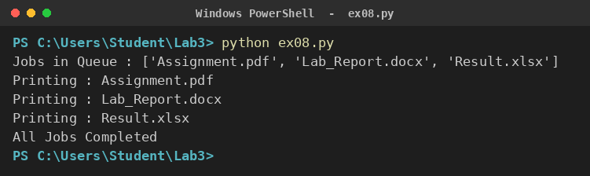

Exercise 9: Implement a menu-driven stack application.
Code
stack = []

while True:
print("\n1. Push")
print("2. Pop")
print("3. Peek")
print("4. Display")
print("5. Exit")

choice = int(input("Enter Choice: "))

if choice == 1:
item = input("Enter Item: ")
stack.append(item)
print("Pushed :", item)
elif choice == 2:
if len(stack) == 0:
print("Stack Underflow")
else:
print("Popped :", stack.pop())
elif choice == 3:
if len(stack) == 0:
print("Stack is Empty")
else:
print("Top :", stack[-1])
elif choice == 4:
print("Stack :", stack)
elif choice == 5:
print("Program Exited")
break
else:
print("Invalid Choice")

Output
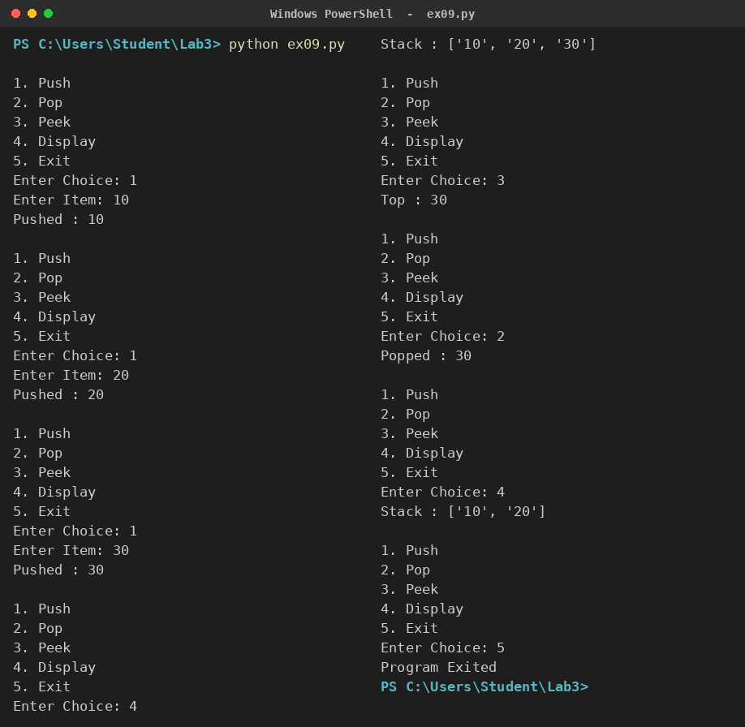

Exercise 10: Implement a menu-driven queue application.
Code
from collections import deque

queue = deque()

while True:
print("\n1. Enqueue")
print("2. Dequeue")
print("3. Front")
print("4. Display")
print("5. Exit")

choice = int(input("Enter Choice: "))

if choice == 1:
item = input("Enter Item: ")
queue.append(item)
print("Enqueued :", item)
elif choice == 2:
if len(queue) == 0:
print("Queue Underflow")
else:
print("Dequeued :", queue.popleft())
elif choice == 3:
if len(queue) == 0:
print("Queue is Empty")
else:
print("Front :", queue[0])
elif choice == 4:
print("Queue :", list(queue))
elif choice == 5:
print("Program Exited")
break
else:
print("Invalid Choice")

Output
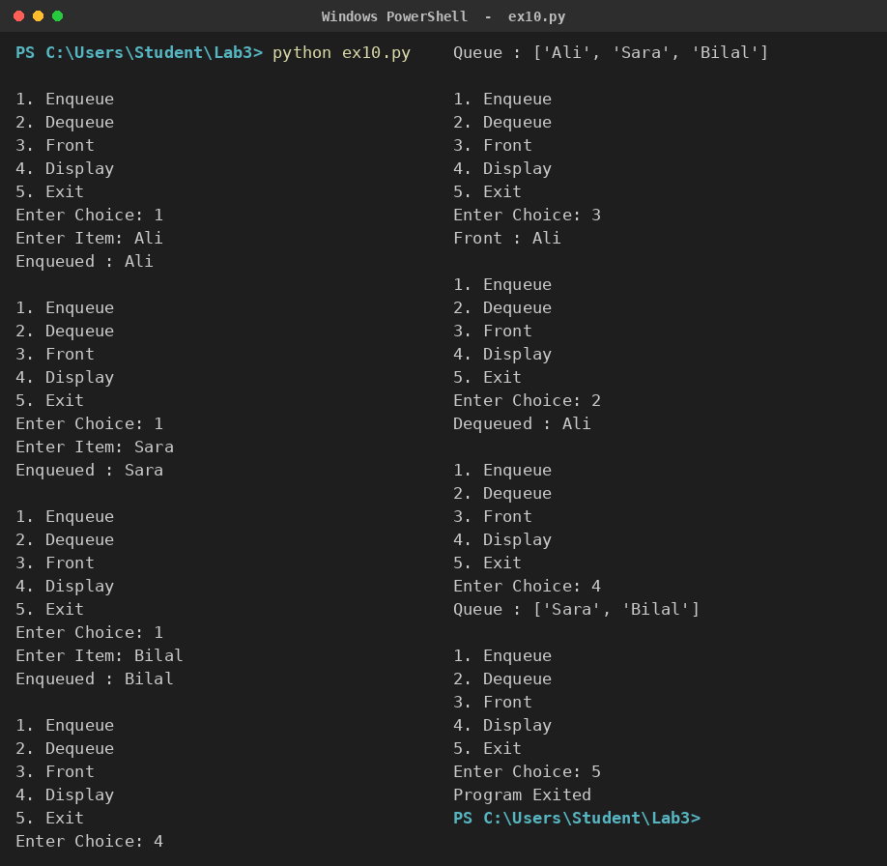

Exercise 11: Create a Student Management System with methods to add and display students.
Code
class Student:
def __init__(self, name, roll, semester):
self.name = name
self.roll = roll
self.semester = semester

class StudentManagement:
def __init__(self):
self.students = []

def add_student(self):
name = input("Enter Name: ")
roll = input("Enter Roll No: ")
semester = input("Enter Semester: ")
self.students.append(Student(name, roll, semester))
print("Student Added Successfully")

def display_students(self):
if len(self.students) == 0:
print("No Records Found")
return
print("\nRoll No Name Semester")
for s in self.students:
print(s.roll, " ", s.name, " ", s.semester)

system = StudentManagement()

while True:
print("\n1. Add Student")
print("2. Display Students")
print("3. Exit")

choice = int(input("Enter Choice: "))

if choice == 1:
system.add_student()
elif choice == 2:
system.display_students()
elif choice == 3:
print("Program Exited")
break
else:
print("Invalid Choice")

Output
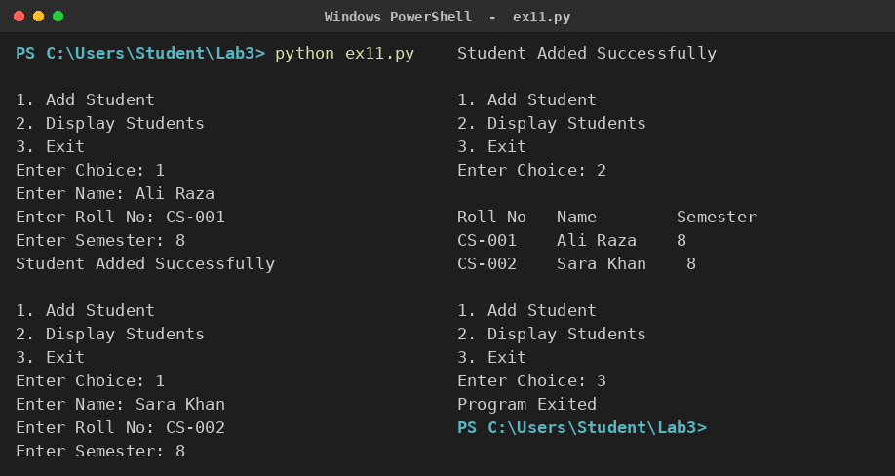

Exercise 12: Evaluate a postfix expression using a stack.
Code
def evaluate_postfix(expression):
stack = []
for token in expression.split():
if token.isdigit():
stack.append(int(token))
else:
b = stack.pop()
a = stack.pop()
if token == "+":
stack.append(a + b)
elif token == "-":
stack.append(a - b)
elif token == "*":
stack.append(a * b)
elif token == "/":
stack.append(a / b)
return stack.pop()

exp1 = "5 3 + 8 *"
exp2 = "10 2 / 4 +"

print("Expression :", exp1, "=", evaluate_postfix(exp1))
print("Expression :", exp2, "=", evaluate_postfix(exp2))
Output
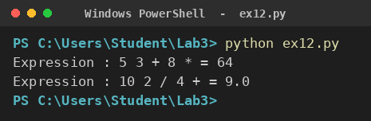

Exercise 13: Check balanced parentheses using a stack.
Code
def is_balanced(expression):
stack = []
pairs = {")": "(", "]": "[", "}": "{"}

for ch in expression:
if ch in "([{":
stack.append(ch)
elif ch in ")]}":
if len(stack) == 0 or stack.pop() != pairs[ch]:
return False
return len(stack) == 0

tests = ["(a+b)*[c-d]", "{(a+b])", "((x))", "(("]

for t in tests:
print(t, "->", "Balanced" if is_balanced(t) else "Not Balanced")
Output
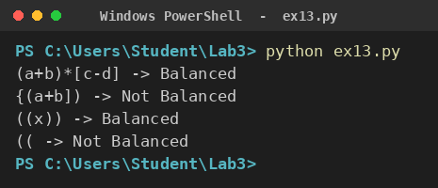

Exercise 14: Simulate a hospital patient queue.
Code
from collections import deque

class Hospital:
def __init__(self):
self.patients = deque()

def add_patient(self, name):
self.patients.append(name)
print("Patient Registered :", name)

def treat_patient(self):
if len(self.patients) == 0:
print("No Patients Waiting")
else:
print("Now Treating :", self.patients.popleft())

def show_queue(self):
print("Waiting Patients :", list(self.patients))

h = Hospital()
h.add_patient("Ali Khan")
h.add_patient("Sara Ahmed")
h.add_patient("Usman Tariq")

h.show_queue()
h.treat_patient()
h.treat_patient()
h.show_queue()
h.treat_patient()
h.treat_patient()

Output
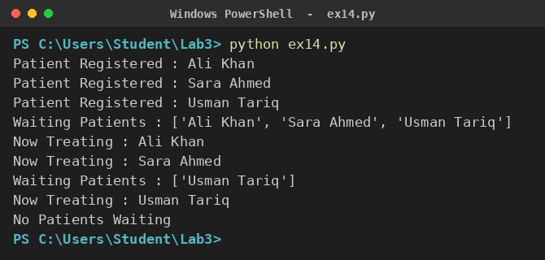

Exercise 15: Develop a menu-driven banking application using classes.
Code
class BankAccount:
def __init__(self, name, balance):
self.name = name
self.balance = balance

def deposit(self, amount):
self.balance += amount
print("Deposited :", amount)

def withdraw(self, amount):
if amount > self.balance:
print("Insufficient Balance")
else:
self.balance -= amount
print("Withdrawn :", amount)

def display(self):
print("Customer :", self.name)
print("Balance :", self.balance)

name = input("Enter Account Holder Name: ")
account = BankAccount(name, 0)

while True:
print("\n1. Deposit")
print("2. Withdraw")
print("3. Check Balance")
print("4. Exit")

choice = int(input("Enter Choice: "))

if choice == 1:
account.deposit(float(input("Enter Amount: ")))
elif choice == 2:
account.withdraw(float(input("Enter Amount: ")))
elif choice == 3:
account.display()
elif choice == 4:
print("Thank You for Banking With Us")
break
else:
print("Invalid Choice")

Output


