Lab 4
Depth-First Search (DFS) and Breadth-First Search (BFS)

NAME: Shahnil Sharma
ROLL NO: 004

Exercise 1: Implement DFS for the given graph.
Code
graph = {
'A': ['B', 'C'],
'B': ['D', 'E'],
'C': ['F'],
'D': [],
'E': [],
'F': []
}

visited = []

def dfs(node):
if node not in visited:
print(node, end=" ")
visited.append(node)
for neighbour in graph[node]:
dfs(neighbour)

print("DFS Traversal :", end=" ")
dfs('A')
print()
print("Visited List :", visited)
Output
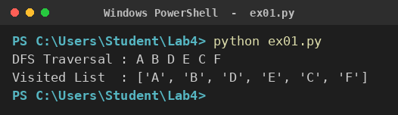

Exercise 2: Implement BFS for the same graph.
Code
from collections import deque

graph = {
'A': ['B', 'C'],
'B': ['D', 'E'],
'C': ['F'],
'D': [],
'E': [],
'F': []
}

visited = ['A']
queue = deque(['A'])

print("BFS Traversal :", end=" ")
while queue:
node = queue.popleft()
print(node, end=" ")
for neighbour in graph[node]:
if neighbour not in visited:
visited.append(neighbour)
queue.append(neighbour)

print()
print("Visited List :", visited)
Output
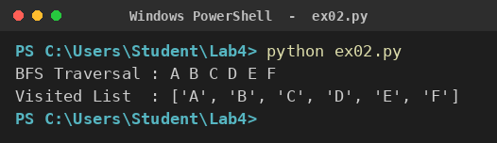

Exercise 3: Draw the traversal order manually.
Code
graph = {
'A': ['B', 'C'],
'B': ['D', 'E'],
'C': ['F'],
'D': [],
'E': [],
'F': []
}

print("Graph Structure")
print(" A")
print(" / \\")
print(" B C")
print(" / \\ \\")
print(" D E F")
print()

dfs_order = ['A', 'B', 'D', 'E', 'C', 'F']
bfs_order = ['A', 'B', 'C', 'D', 'E', 'F']

print("DFS Order :", " -> ".join(dfs_order))
print("BFS Order :", " -> ".join(bfs_order))
print()

print("Step wise DFS")
for i, node in enumerate(dfs_order, 1):
print("Step", i, ":", node)
Output
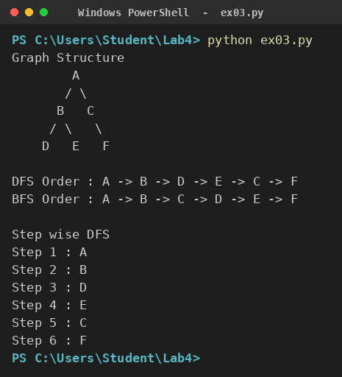

Exercise 4: Count the visited nodes.
Code
graph = {
'A': ['B', 'C'],
'B': ['D', 'E'],
'C': ['F'],
'D': [],
'E': [],
'F': []
}

visited = []

def dfs(node):
if node not in visited:
visited.append(node)
for neighbour in graph[node]:
dfs(neighbour)

dfs('A')

print("Visited Nodes :", visited)
print("Total Visited :", len(visited))
print("Total Nodes :", len(graph))

if len(visited) == len(graph):
print("All nodes were reached")
else:
print("Unreached Nodes :", [n for n in graph if n not in visited])
Output
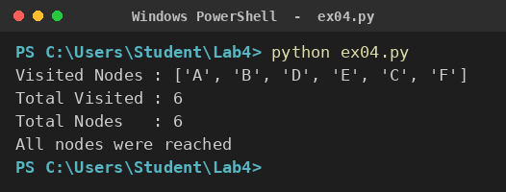

Exercise 5: Compare DFS and BFS outputs.
Code
from collections import deque

graph = {
'A': ['B', 'C'],
'B': ['D', 'E'],
'C': ['F'],
'D': [],
'E': [],
'F': []
}

def dfs(start):
visited = []
stack = [start]
while stack:
node = stack.pop()
if node not in visited:
visited.append(node)
stack.extend(reversed(graph[node]))
return visited

def bfs(start):
visited = [start]
queue = deque([start])
order = []
while queue:
node = queue.popleft()
order.append(node)
for n in graph[node]:
if n not in visited:
visited.append(n)
queue.append(n)
return order

d = dfs('A')
b = bfs('A')

print("DFS Output :", d)
print("BFS Output :", b)
print()
print("Feature DFS BFS")
print("Structure Stack Queue")
print("Strategy Depth Level")
print("Nodes Visited ", len(d), " ", len(b))
print("Same Order ", d == b)

Output
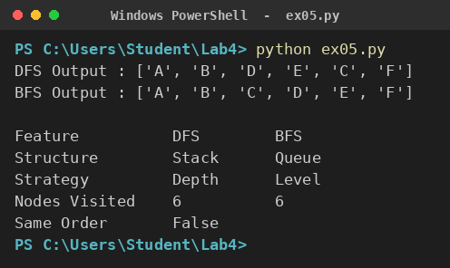

Exercise 6: Implement DFS using recursion.
Code
graph = {
'A': ['B', 'C'],
'B': ['D', 'E'],
'C': ['F'],
'D': [],
'E': [],
'F': []
}

def dfs_recursive(node, visited=None, depth=0):
if visited is None:
visited = []
if node in visited:
return visited
print(" " * depth + node)
visited.append(node)
for neighbour in graph[node]:
dfs_recursive(neighbour, visited, depth + 1)
return visited

print("Recursive DFS Tree")
result = dfs_recursive('A')
print()
print("Traversal :", " ".join(result))
Output
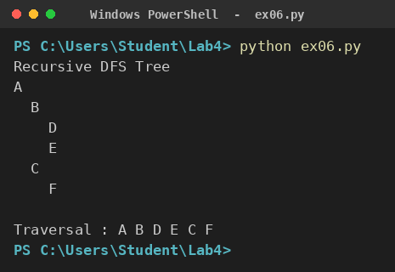

Exercise 7: Implement DFS using a stack.
Code
graph = {
'A': ['B', 'C'],
'B': ['D', 'E'],
'C': ['F'],
'D': [],
'E': [],
'F': []
}

stack = ['A']
visited = []

print("Step Stack Visited")
step = 1

while stack:
print(str(step).ljust(7), str(stack).ljust(20), visited)
node = stack.pop()
if node not in visited:
visited.append(node)
stack.extend(reversed(graph[node]))
step += 1

print()
print("DFS Traversal :", " ".join(visited))
Output
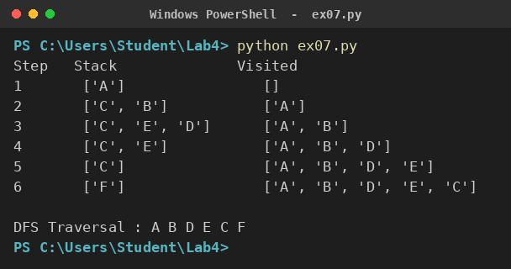

Exercise 8: Implement BFS using a queue.
Code
from collections import deque

graph = {
'A': ['B', 'C'],
'B': ['D', 'E'],
'C': ['F'],
'D': [],
'E': [],
'F': []
}

queue = deque(['A'])
visited = ['A']
order = []

print("Step Queue Visited")
step = 1

while queue:
print(str(step).ljust(7), str(list(queue)).ljust(20), visited)
node = queue.popleft()
order.append(node)
for n in graph[node]:
if n not in visited:
visited.append(n)
queue.append(n)
step += 1

print()
print("BFS Traversal :", " ".join(order))
Output
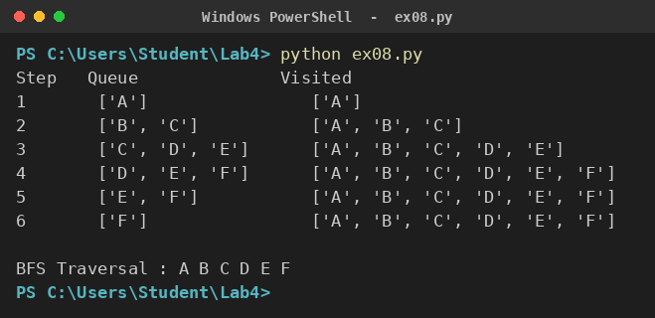

Exercise 9: Find whether a node exists in the graph.
Code
from collections import deque

graph = {
'A': ['B', 'C'],
'B': ['D', 'E'],
'C': ['F'],
'D': [],
'E': [],
'F': []
}

def search(start, target):
queue = deque([start])
visited = []
while queue:
node = queue.popleft()
if node == target:
return True
if node not in visited:
visited.append(node)
queue.extend(graph[node])
return False

for node in ['E', 'F', 'Z']:
if search('A', node):
print("Node", node, ": Found in the graph")
else:
print("Node", node, ": Not Found in the graph")
Output
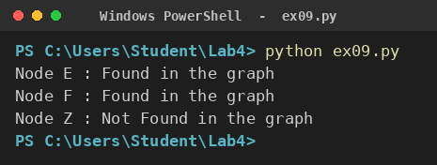

Exercise 10: Modify the graph by adding a new node and observe the traversal.
Code
from collections import deque

graph = {
'A': ['B', 'C'],
'B': ['D', 'E'],
'C': ['F'],
'D': [],
'E': [],
'F': []
}

def bfs(start):
visited = [start]
queue = deque([start])
order = []
while queue:
node = queue.popleft()
order.append(node)
for n in graph[node]:
if n not in visited:
visited.append(n)
queue.append(n)
return order

def show(title):
print(title)
for node in graph:
print(" ", node, "->", graph[node])
print(" BFS :", bfs('A'))

show("Before adding node")

graph['G'] = []
graph['E'].append('G')

print()
show("After adding node G under E")

Output
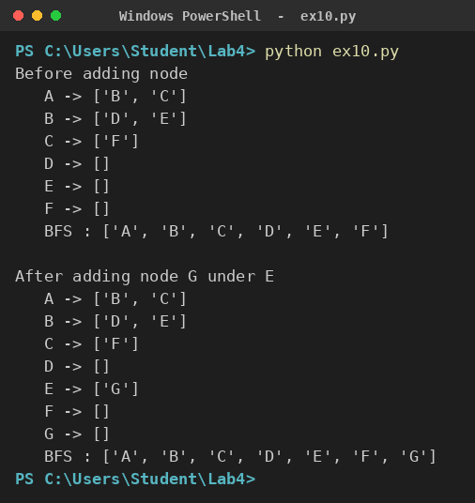

Exercise 11: Detect a path between two nodes using DFS.
Code
graph = {
'A': ['B', 'C'],
'B': ['D', 'E'],
'C': ['F'],
'D': [],
'E': [],
'F': []
}

def find_path(start, goal, path=None):
if path is None:
path = []
path = path + [start]

if start == goal:
return path

for neighbour in graph[start]:
if neighbour not in path:
result = find_path(neighbour, goal, path)
if result:
return result
return None

tests = [('A', 'E'), ('A', 'F'), ('B', 'F')]

for s, g in tests:
p = find_path(s, g)
if p:
print("Path", s, "to", g, ":", " -> ".join(p))
else:
print("Path", s, "to", g, ": No Path Found")
Output
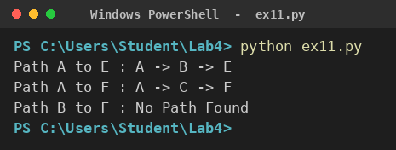

Exercise 12: Find the shortest path in an unweighted graph using BFS.
Code
from collections import deque

graph = {
'A': ['B', 'C'],
'B': ['A', 'D', 'E'],
'C': ['A', 'F'],
'D': ['B'],
'E': ['B', 'F'],
'F': ['C', 'E']
}

def shortest_path(start, goal):
queue = deque([[start]])
visited = [start]

while queue:
path = queue.popleft()
node = path[-1]

if node == goal:
return path

for n in graph[node]:
if n not in visited:
visited.append(n)
queue.append(path + [n])
return None

for s, g in [('A', 'F'), ('D', 'F'), ('D', 'C')]:
p = shortest_path(s, g)
print("Shortest", s, "->", g, ":", " -> ".join(p), "| Length:", len(p) - 1)
Output
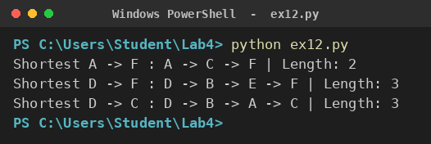

Exercise 13: Create a menu-driven graph traversal program.
Code
from collections import deque

graph = {
'A': ['B', 'C'],
'B': ['D', 'E'],
'C': ['F'],
'D': [],
'E': [],
'F': []
}

def dfs(start):
visited = []
stack = [start]
while stack:
node = stack.pop()
if node not in visited:
visited.append(node)
stack.extend(reversed(graph[node]))
return visited

def bfs(start):
visited = [start]
queue = deque([start])
order = []
while queue:
node = queue.popleft()
order.append(node)
for n in graph[node]:
if n not in visited:
visited.append(n)
queue.append(n)
return order

while True:
print("\n1. Show Graph")
print("2. DFS Traversal")
print("3. BFS Traversal")
print("4. Add Edge")
print("5. Exit")

choice = int(input("Enter Choice: "))

if choice == 1:
for k, v in graph.items():
print(k, "->", v)
elif choice == 2:
print("DFS :", " ".join(dfs(input("Start Node: "))))
elif choice == 3:
print("BFS :", " ".join(bfs(input("Start Node: "))))
elif choice == 4:
u = input("From Node: ")
v = input("To Node: ")
graph.setdefault(u, []).append(v)
graph.setdefault(v, [])
print("Edge Added :", u, "->", v)
elif choice == 5:
print("Program Exited")
break
else:
print("Invalid Choice")

Output
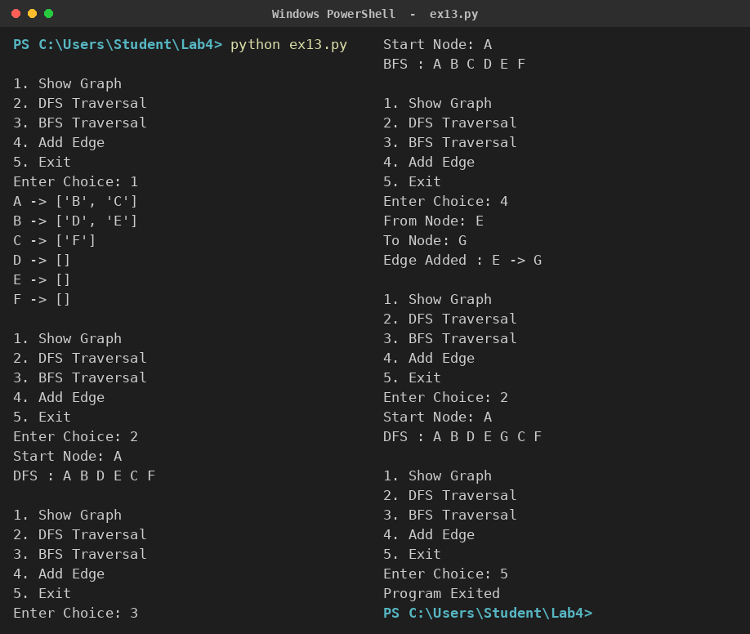

Exercise 14: Represent a graph using an adjacency matrix and perform BFS.
Code
from collections import deque

nodes = ['A', 'B', 'C', 'D', 'E', 'F']

matrix = [
[0, 1, 1, 0, 0, 0],
[1, 0, 0, 1, 1, 0],
[1, 0, 0, 0, 0, 1],
[0, 1, 0, 0, 0, 0],
[0, 1, 0, 0, 0, 0],
[0, 0, 1, 0, 0, 0]
]

print("Adjacency Matrix")
print(" " + " ".join(nodes))
for i, row in enumerate(matrix):
print(nodes[i], " ", " ".join(str(x) for x in row))

def bfs_matrix(start):
s = nodes.index(start)
visited = [s]
queue = deque([s])
order = []

while queue:
i = queue.popleft()
order.append(nodes[i])
for j in range(len(nodes)):
if matrix[i][j] == 1 and j not in visited:
visited.append(j)
queue.append(j)
return order

print()
print("BFS Traversal :", " ".join(bfs_matrix('A')))

Output
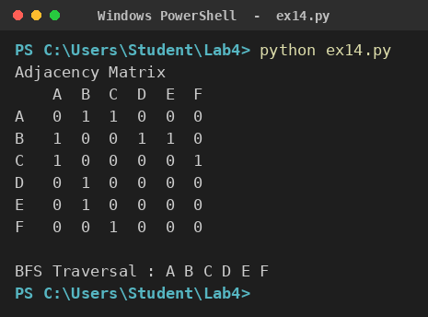

Exercise 15: Represent a graph using an adjacency list and perform DFS.
Code
graph = {
'A': ['B', 'C'],
'B': ['D', 'E'],
'C': ['F'],
'D': [],
'E': [],
'F': []
}

print("Adjacency List")
for node in graph:
print(node, "->", graph[node] if graph[node] else "No Neighbours")

visited = []

def dfs(node):
if node not in visited:
visited.append(node)
for neighbour in graph[node]:
dfs(neighbour)

dfs('A')

print()
print("DFS Traversal :", " ".join(visited))
print("Nodes Visited :", len(visited))
Output


