ZIAUDDIN UNIVERSITY
Artificial Intelligence & Machine Learning Lab
LAB 06
Implementation of Depth-Limited Search (DLS) and Iterative Deepening Search (IDS)
Field | Detail
Student Name | Shahnil
Roll Number | 4-38/2023/004
Lab No. | 06

Graph Used
A
/ \
B C
/ \ \
D E F
|
G

graph = {'A':['B','C'], 'B':['D','E'], 'C':['F'],
'D':['G'], 'E':[], 'F':[], 'G':[]}

Two more graphs are used where the exercises require them: an extended graph with nodes H and I for Exercise 9, and a cyclic graph with the edge G to A for Exercise 11.
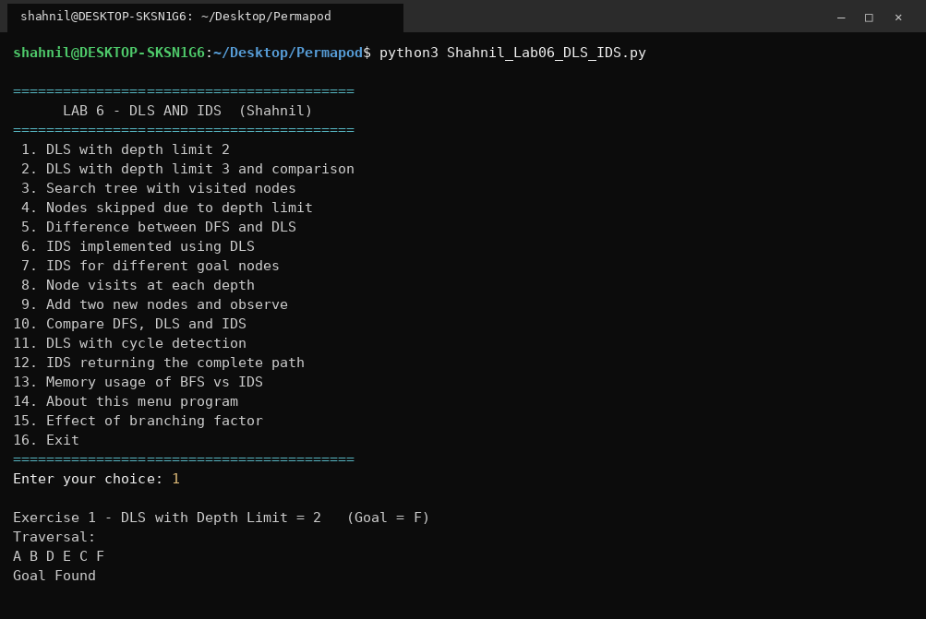
Program start and menu (Exercise 14).

Source Code
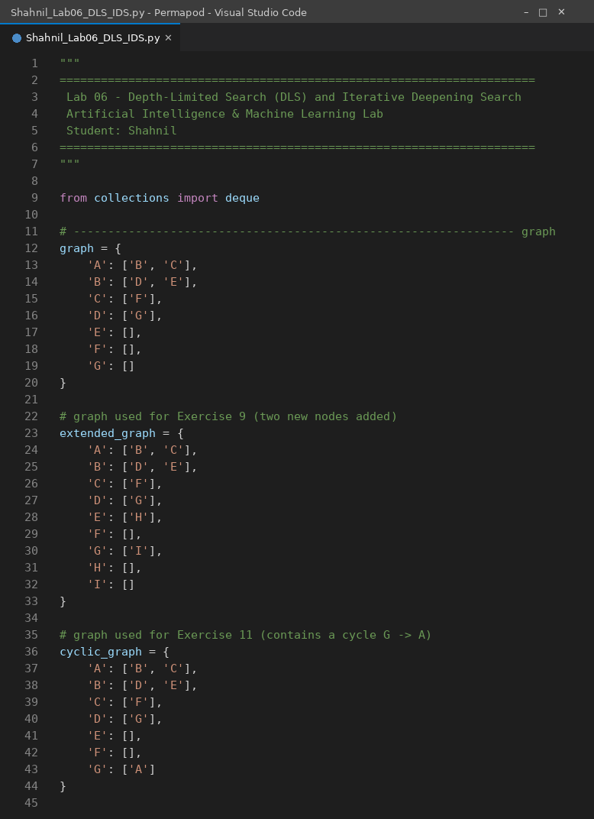
Code Screenshot 1: lines 1 to 45 of Shahnil_Lab06_DLS_IDS.py
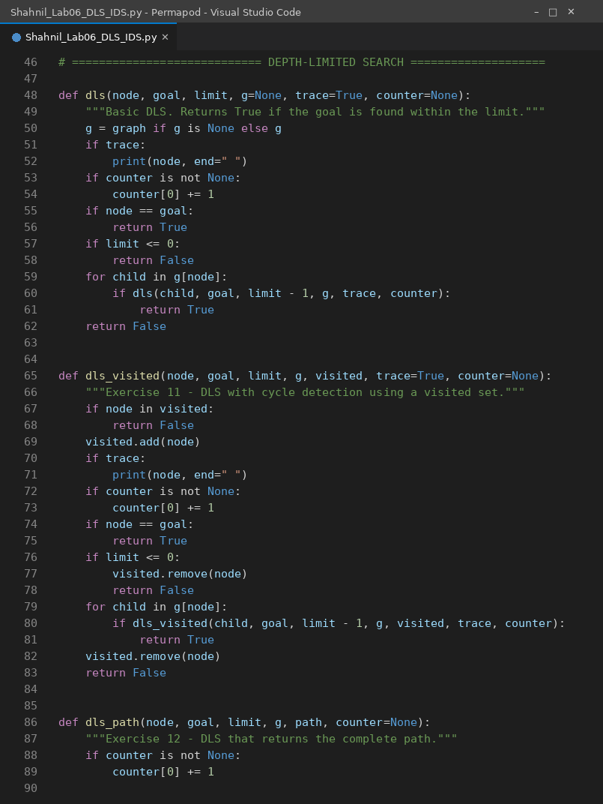
Code Screenshot 2: lines 46 to 90 of Shahnil_Lab06_DLS_IDS.py
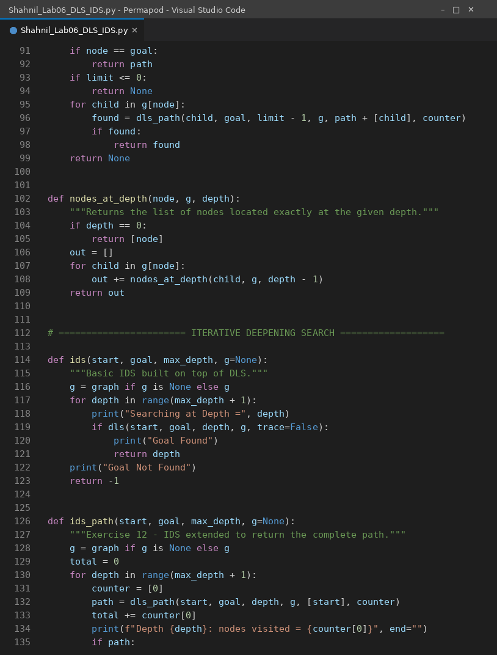
Code Screenshot 3: lines 91 to 135 of Shahnil_Lab06_DLS_IDS.py
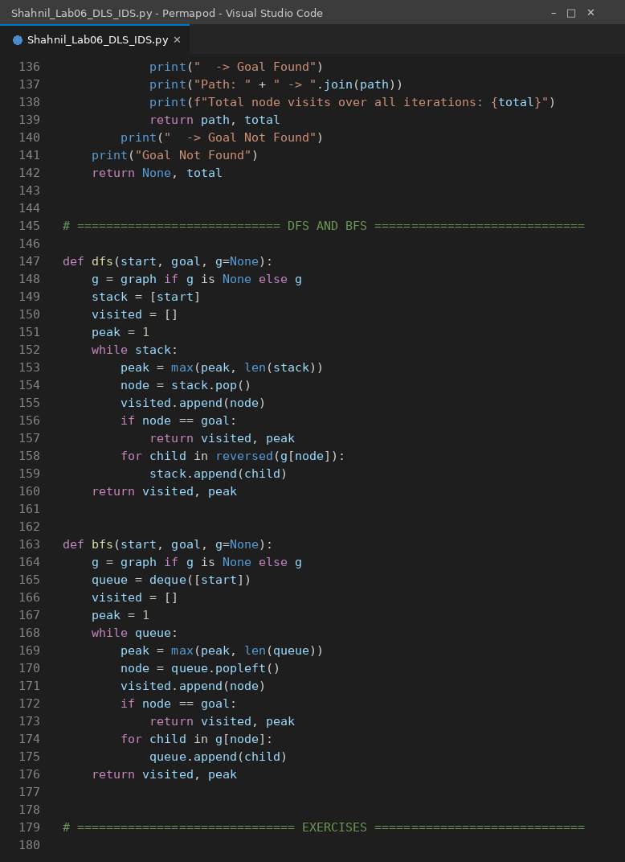
Code Screenshot 4: lines 136 to 180 of Shahnil_Lab06_DLS_IDS.py
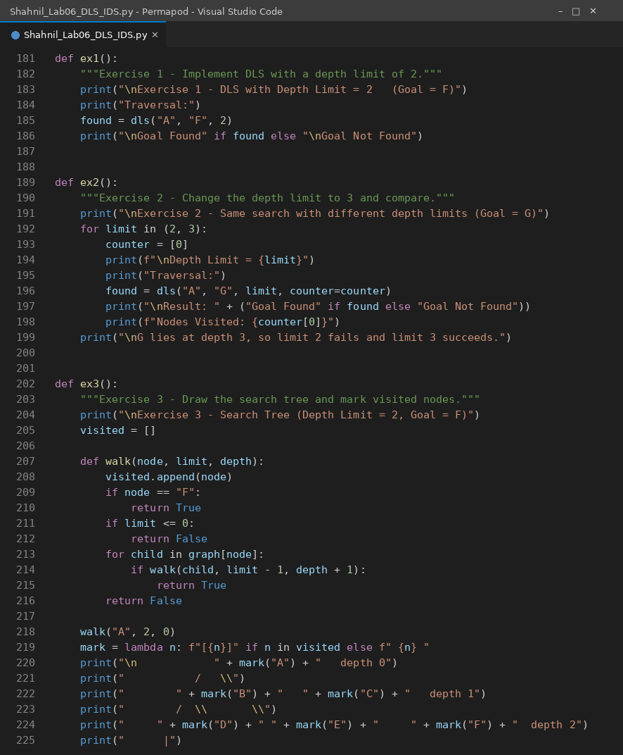
Code Screenshot 5: lines 181 to 225 of Shahnil_Lab06_DLS_IDS.py
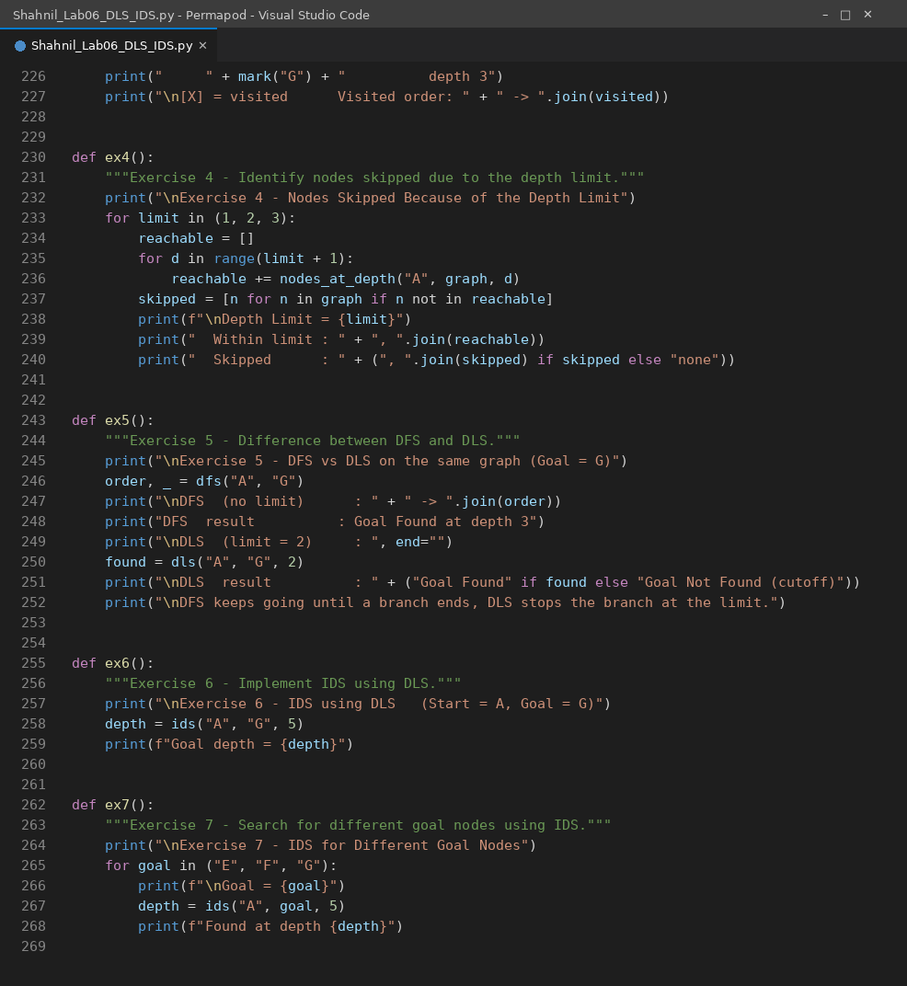
Code Screenshot 6: lines 226 to 270 of Shahnil_Lab06_DLS_IDS.py
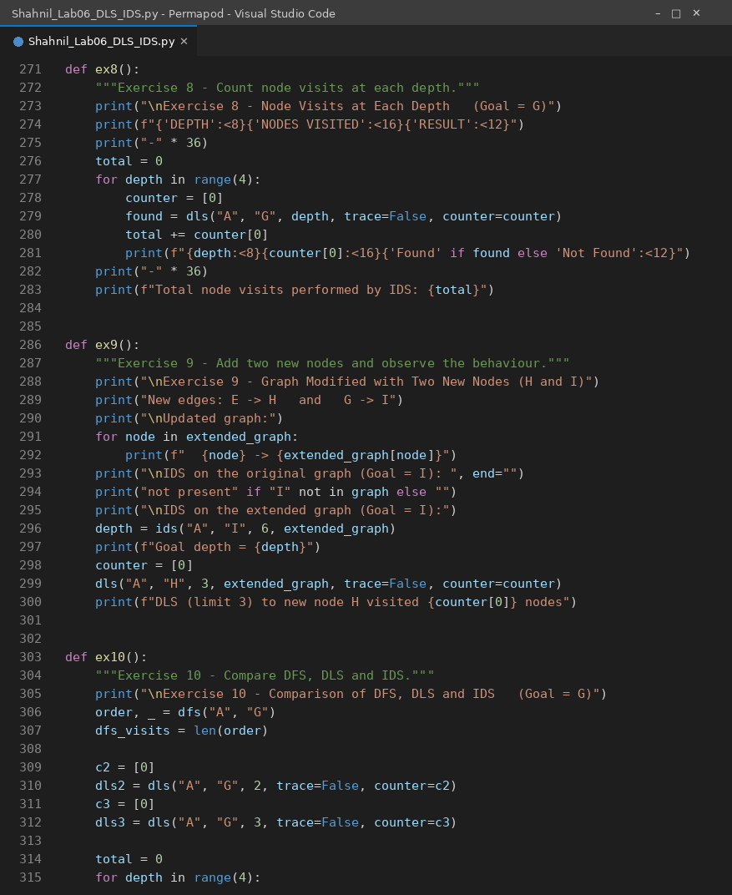
Code Screenshot 7: lines 271 to 315 of Shahnil_Lab06_DLS_IDS.py
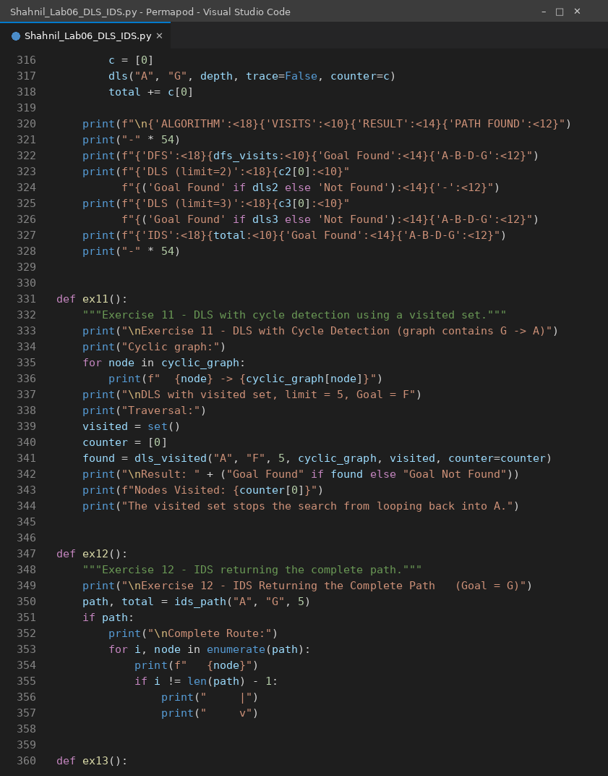
Code Screenshot 8: lines 316 to 360 of Shahnil_Lab06_DLS_IDS.py
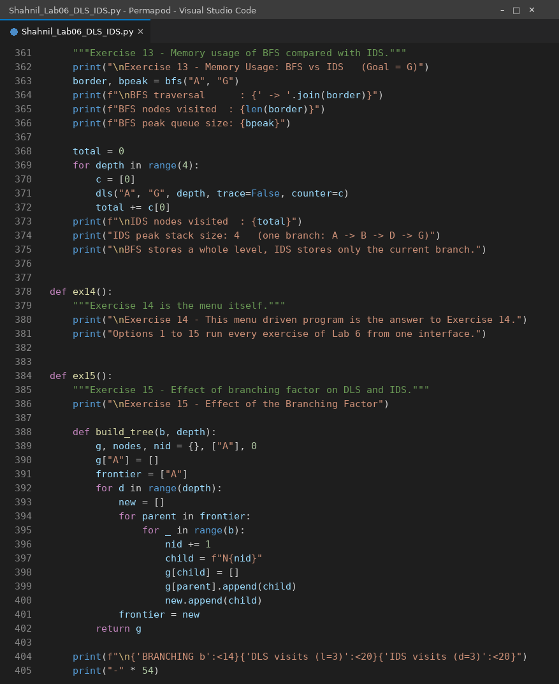
Code Screenshot 9: lines 361 to 405 of Shahnil_Lab06_DLS_IDS.py
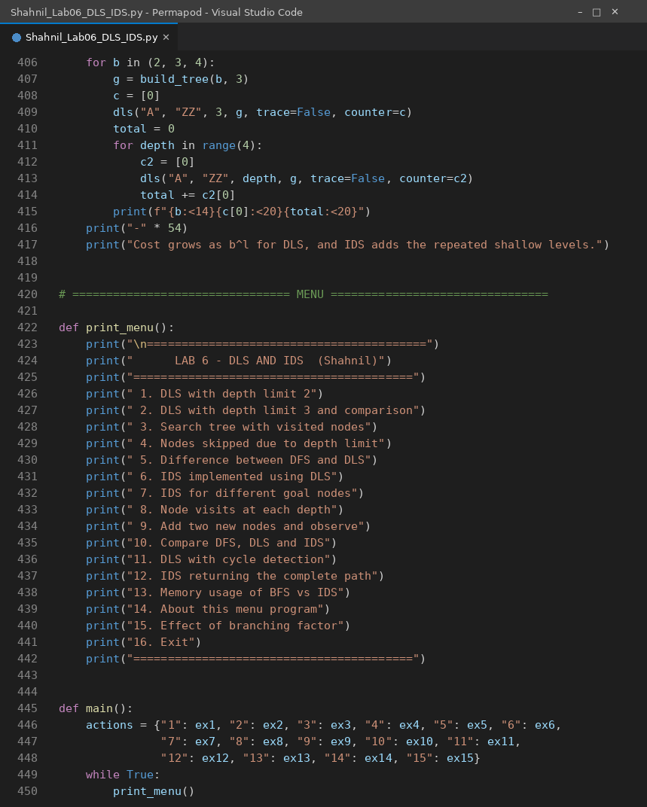
Code Screenshot 10: lines 406 to 450 of Shahnil_Lab06_DLS_IDS.py
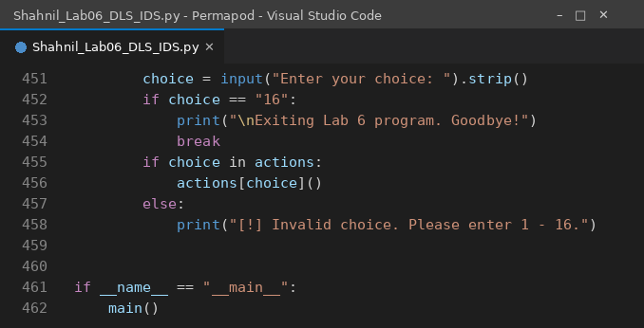
Code Screenshot 11: lines 451 to 462 of Shahnil_Lab06_DLS_IDS.py

Lab Exercises

Exercise 1: Implement DLS with a depth limit of 2.
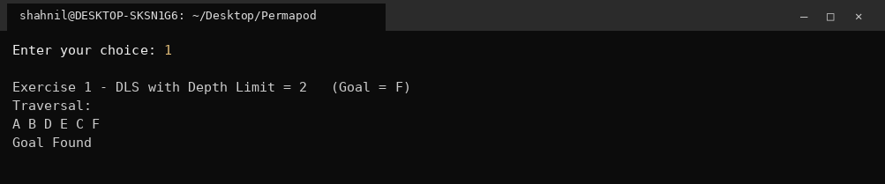
Output 1
Traversal A B D E C F, goal F found at depth 2.

Exercise 2: Change the depth limit to 3 and compare the results.
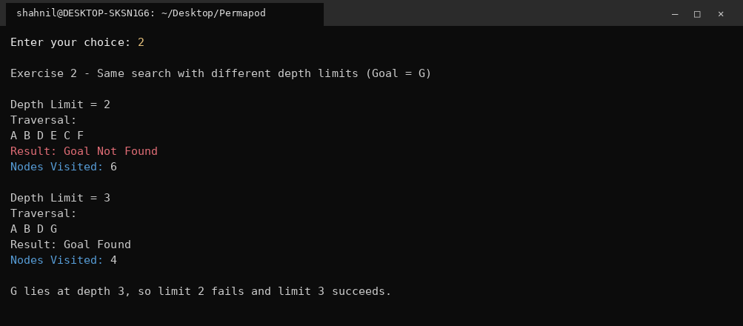
Output 2
Goal G lies at depth 3. Limit 2 visits 6 nodes and fails, limit 3 visits 4 nodes and succeeds.

Exercise 3: Draw the search tree and indicate visited nodes.
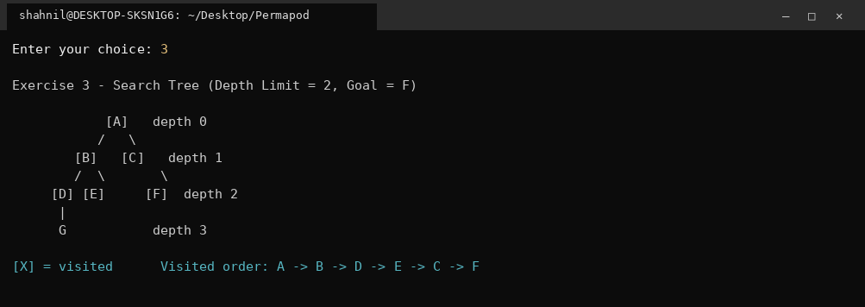
Output 3
Visited nodes are printed in brackets. With limit 2 the visited order is A, B, D, E, C, F and G stays unvisited.

Exercise 4: Identify nodes skipped due to the depth limit.
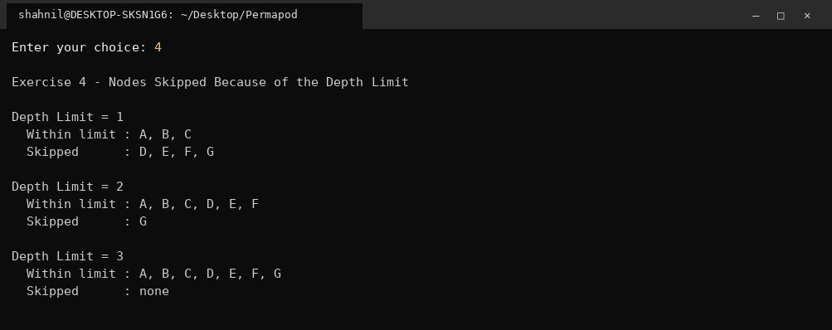
Output 4
Limit 1 skips D, E, F and G. Limit 2 skips only G. Limit 3 skips nothing.

Exercise 5: Explain the difference between DFS and DLS.
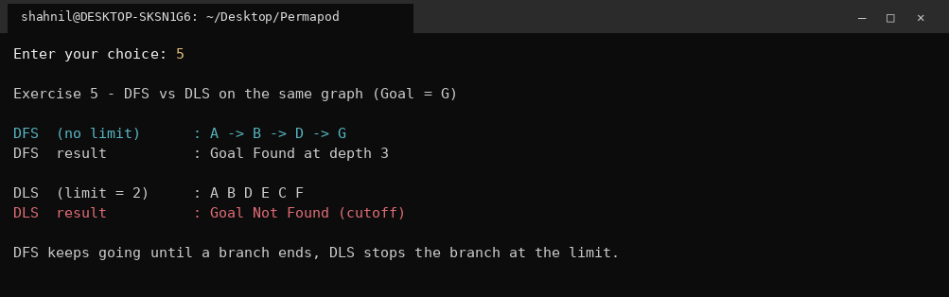
Output 5
DFS reaches G through A, B, D, G because nothing stops it. DLS with limit 2 cuts the same branch at D and returns a cutoff.

Exercise 6: Implement IDS using DLS.
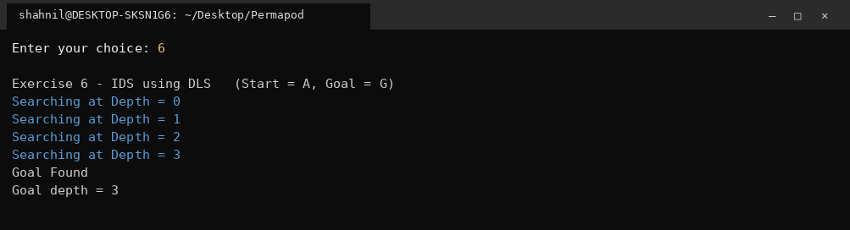
Output 6
IDS runs DLS at limits 0, 1, 2 and 3, and finds G in the fourth iteration.

Exercise 7: Search for different goal nodes using IDS.
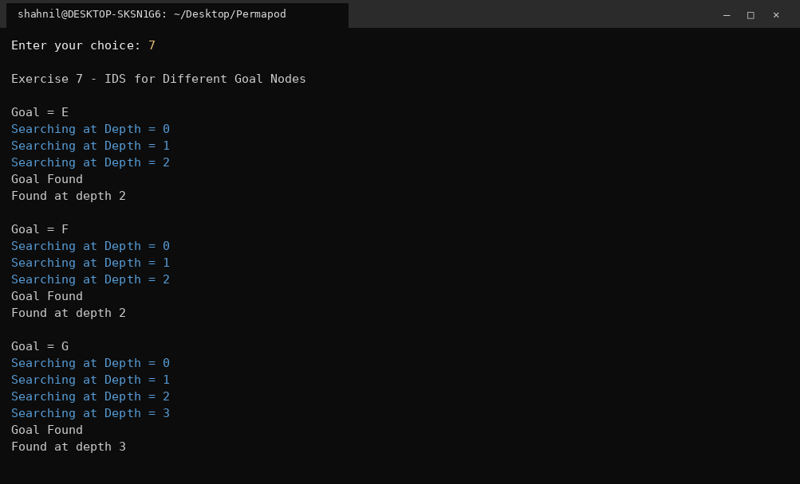
Output 7
E found at depth 2, F found at depth 2, G found at depth 3.

Exercise 8: Count the number of node visits at each depth.
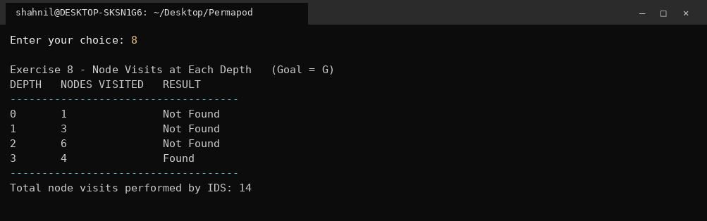
Output 8
Visits per depth are 1, 3, 6 and 4, giving 14 visits in total for IDS.

Exercise 9: Modify the graph by adding two new nodes and observe the behaviour.
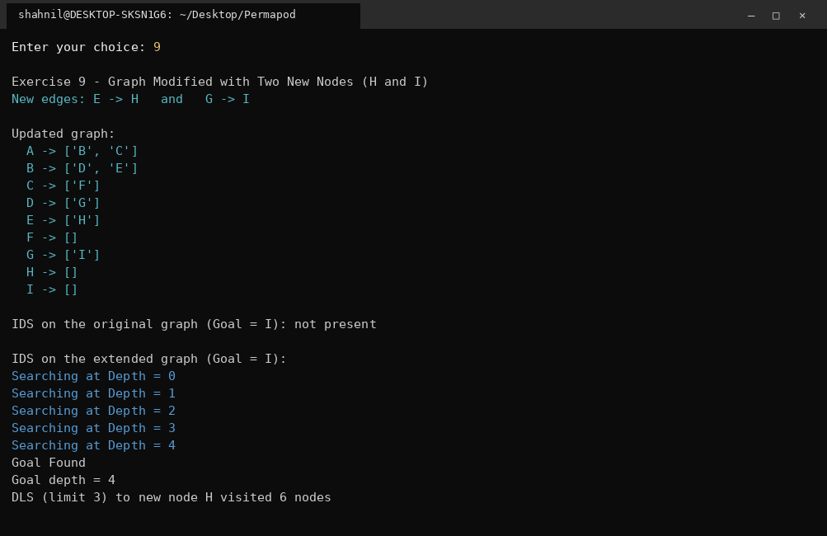
Output 9
Nodes H and I are added through the edges E to H and G to I. Goal I now needs an extra iteration and is found at depth 4.

Exercise 10: Compare execution results of DFS, DLS and IDS.
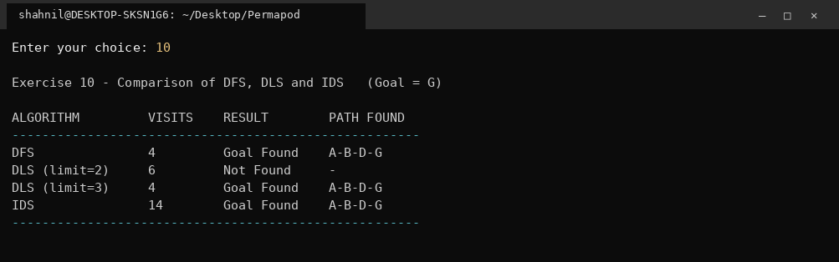
Output 10
DFS 4 visits, DLS limit 2 fails after 6 visits, DLS limit 3 succeeds in 4 visits, IDS succeeds after 14 visits.

Exercise 11: Implement DLS with cycle detection using a visited set.
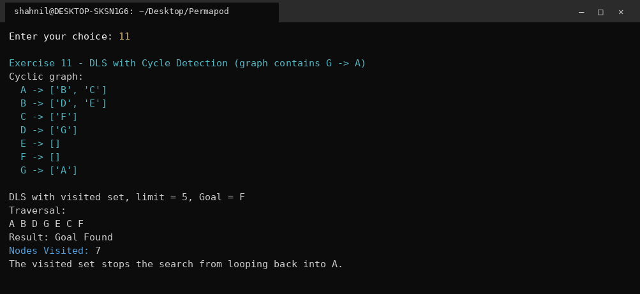
Output 11
The edge G to A creates a cycle. The visited set blocks the return into A, so the search ends after 7 visits and finds F.

Exercise 12: Extend IDS to return the complete path from the start node to the goal node.
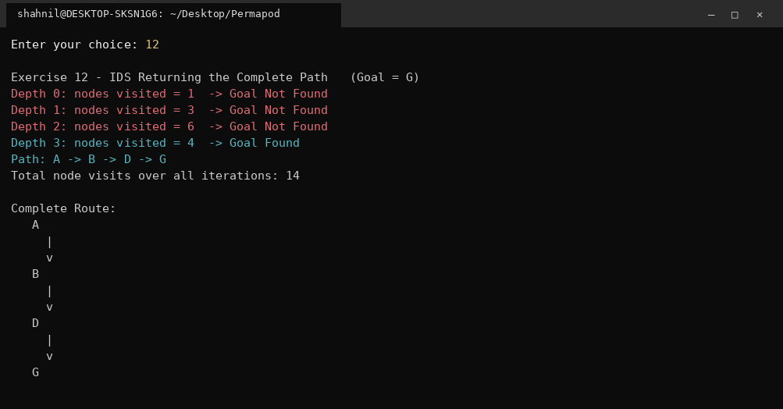
Output 12
The path A, B, D, G is returned along with the node visits of every iteration.

Exercise 13: Compare memory usage of BFS and IDS for the same graph.
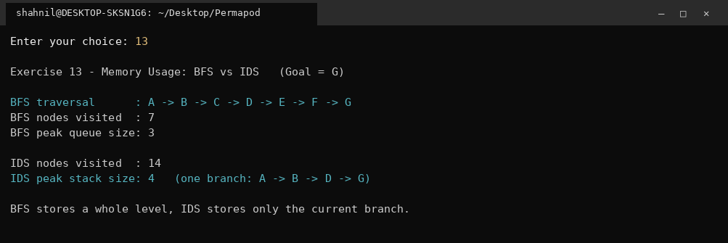
Output 13
BFS peak queue size is 3 while IDS never holds more than the current branch of 4 nodes. BFS visits 7 nodes, IDS visits 14.

Exercise 14: Build a menu driven program to perform DFS, DLS and IDS.
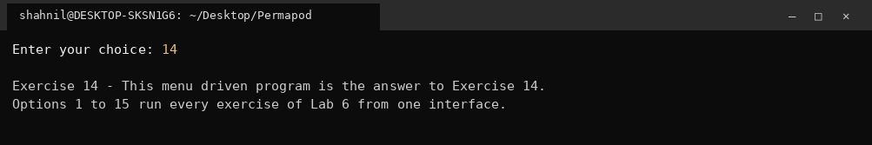
Output 14
The whole program is menu driven. Options 1 to 15 run every exercise from one interface.

Exercise 15: Analyze the effect of different branching factors on DLS and IDS performance.
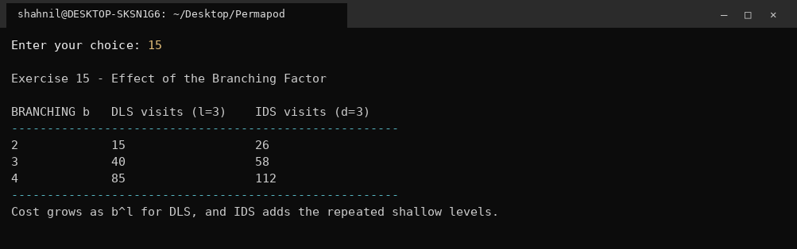
Output 15
On a tree of depth 3, DLS visits 15, 40 and 85 nodes for b equal to 2, 3 and 4, while IDS visits 26, 58 and 112.

Comparison of Search Algorithms
Feature | DFS | BFS | DLS | IDS
Data Structure | Stack | Queue | Stack | Stack
Complete | No | Yes | No | Yes
Finds Shortest Path | No | Yes | No | Yes (shallowest goal)
Memory Usage | Low | High | Low | Low
Requires Depth Limit | No | No | Yes | Yes (incremental)
Time Complexity | O(b^m) | O(b^d) | O(b^l) | O(b^d)
Space Complexity | O(bm) | O(b^d) | O(bl) | O(bd)

Conclusion
DLS and IDS were implemented and tested on the lab graph. DLS stops a branch once the depth limit is reached, so it never recurses forever, but it fails when the limit is smaller than the goal depth, which was confirmed by the limit 2 run for goal G. IDS removes that problem by running DLS at increasing limits, and it found the shallowest goal in every test while holding only one branch in memory. The measured cost of that convenience was 14 node visits against 4 for a correctly chosen DLS limit.

