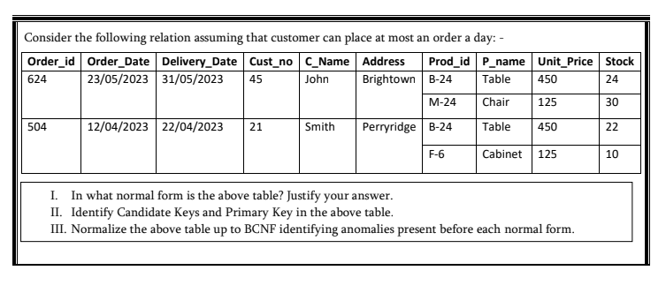

**I. Current Normal Form**

The table is currently in **First Normal Form (1NF)** but violates higher normal forms.

Justification:

* It satisfies 1NF because:
  + All attributes contain atomic values (no multi-valued attributes)
  + There are no repeating groups

**II. Keys Identification**

**Candidate Keys:**

* {Order_id, Prod_id} - This combination uniquely identifies each record

**Primary Key:**

* {Order_id, Prod_id} - Selected as the primary key since it's the minimal combination that uniquely identifies each record

**III. Normalization Process**

Initial Table (UNF - Unnormalized Form)

**Anomalies:**

* Insertion anomalies: Can't add a new product without an order
* Update anomalies: Changing customer address requires updates to multiple rows
* Deletion anomalies: Deleting an order might lose product information

**First Normal Form (1NF)**

The table is already in 1NF as shown.

**Second Normal Form (2NF)**

We need to eliminate partial dependencies by decomposing into:

1. **Orders** table (Order_id, Order_Date, Delivery_Date, Custom, C_Name, Address)
   * Primary Key: Order_id

|  |  |  |  |  |  |
| --- | --- | --- | --- | --- | --- |
| Order_id (PK) | Order_Date | Delivery_Date | Custom | C_Name | Address |
| 624 | **23/05/2023** | 31/05/2023 | 45 | John | Brightown |
| 504 | **12/04/2023** | **22/04/2023** | 21 | Smith | **Perryridge** |

1. **Products** table (Prod_id, P_name, Unit_Price, Stock)
   * Primary Key: Prod_id

|  |  |  |  |
| --- | --- | --- | --- |
| Prod_id (PK) | P_name | Unit_Price | Stock |
| B-24 | Table | 450 | 24 |
| M-24 | Chair | 125 | 30 |
| **F-6** | Cabinet | 125 | 10 |

1. **Order_Products** table (Order_id, Prod_id)
   * Primary Key: (Order_id, Prod_id)

|  |  |
| --- | --- |
| Order_id | Prod_id |
| **624** | B-24 |
| **624** | M-24 |
| 504 | B-24 |
| 504 | **F-6** |

**Anomalies addressed:**

* Eliminates partial dependencies
* Reduces data redundancy for customer and product information

**Third Normal Form (3NF)**

We need to eliminate transitive dependencies (customer details depend on Custom, not directly on Order_id):

1. **Orders** table (Order_id, Order_Date, Delivery_Date, Custom)
   * Primary Key: Order_id

|  |  |  |  |
| --- | --- | --- | --- |
| Order_id (PK) | Order_Date | Delivery_Date | Custom |
| 624 | **23/05/2023** | 31/05/2023 | 45 |
| 504 | **12/04/2023** | **22/04/2023** | 21 |

1. **Customers** table (Custom, C_Name, Address)
   * Primary Key: Custom

|  |  |  |
| --- | --- | --- |
| Custom (pk) | C_Name | Address |
| 45 | John | Brightown |
| 21 | Smith | **Perryridge** |

1. **Products** table (same as 2NF)
   * Primary Key: Prod_id

|  |  |  |  |
| --- | --- | --- | --- |
| Prod_id (PK) | P_name | Unit_Price | Stock |
| B-24 | Table | 450 | 24 |
| M-24 | Chair | 125 | 30 |
| **F-6** | Cabinet | 125 | 10 |

1. **Order_Products** table (same as 2NF)
   * Primary Key: (Order_id, Prod_id)

|  |  |
| --- | --- |
| Order_id | Prod_id |
| **624** | B-24 |
| **624** | M-24 |
| 504 | B-24 |
| 504 | **F-6** |

**Anomalies addressed:**

* Eliminates transitive dependencies
* Further reduces redundancy in customer data

**Boyce-Codd Normal Form (BCNF)**

The tables are already in BCNF because:

* For every functional dependency X → Y, X is a superkey in each table
* In Orders: Order_id → Order_Date, Delivery_Date, Custom (Order_id is a superkey)
* In Customers: Custom → C_Name, Address (Custom is a superkey)
* In Products: Prod_id → P_name, Unit_Price, Stock (Prod_id is a superkey)
* In Order_Products: (Order_id, Prod_id) is the primary key (superkey)

Final Normalized Schema (BCNF)

**Customers**

| **Custom** | **C_Name** | **Address** |
| --- | --- | --- |
| 45 | John | Brightown |
| 21 | Smith | Perryridge |

**Products**

| **Prod_id** | **P_name** | **Unit_Price** | **Stock** |
| --- | --- | --- | --- |
| B-24 | Table | 450 | 24 |
| M-24 | Chair | 125 | 30 |
| F-6 | Cabinet | 125 | 10 |

**Orders**

| **Order_id** | **Order_Date** | **Delivery_Date** | **Custom** |
| --- | --- | --- | --- |
| 624 | 23/05/2023 | 31/05/2023 | 45 |
| 504 | 12/04/2023 | 22/04/2023 | 21 |

**Order_Products**

| **Order_id** | **Prod_id** |
| --- | --- |
| 624 | B-24 |
| 624 | M-24 |
| 504 | B-24 |
| 504 | F-6 |

This normalized schema eliminates all the anomalies present in the original table while preserving all the information.