

**Software Requirements Specification Vaccination Portal**

**Prepared by**: Shahnoor Siddiqui (190250120086)

Prince Jain (190250120065)

Praveer Chhabra (190250120063)

Rohan Choudhary (190250120074)

**CDAC, ACT,**

**Bangalore**

**Development Tools:-**

* For client side :- Visual Studio Code
* For server side :- Eclipse Photon

**Project Description -:**

* It gives the details of Vaccines for new born baby to 10 years old child. As per their requirement and there time cycle.
* We also give the details of Hospitals which was Preview by the Admin.
* The user can see the Hospital Address their time schedule and also take an online appointment for Vaccination of Child.
* Hospital users see their appointments.
* Admin can do Enable and disable Hospital if it find something wrong.

It is implemented through REST API with Angular on Front End (Presentation Layer), Spring Boot on the Backend (Service Layer) and Hibernate as DAO Layer which connect our services to Database MySQL. On **Presentation Layer** we have three users’ kinds namely as:

1. Admin
2. Hospital
3. User

Admin can see the list of users and hospitals which are registered. After the Hospital registration admin verifies the hospital then it permits the hospital to take appointments from the users before that hospitals are disabled and can’t see by users. Admin can easily enable/disable the hospital if they found something wrong in it at any time.

There are a Login Page and Registration Page in starting where new users and hospitals do their registration. After user registration users can do login and schedule an appointment for their child vaccinations and also see the list of hospitals and their details. If the user wants to know the information about vaccination they can also view the details of Vaccination according to age.

Once Hospital completes their registration they wait for the confirmation (confirmation done by admin end it may take 15 days or more). After getting conformation Hospital can log in to the website in which hospitals can see their appointments which was taken by the users. After completion of the vaccination to child (Appointment) hospitals can mark the appointment as completed which was seen by the users.

On **Service Layer**, we’ve provided the REST API on Spring Boot (@**RestController** layer) which will handle the request from the presentation layer for login, registration, appointment, Appointment list, and Vaccination Details.

It transfers the request to the (@**Service Layer**) where it handles the request by using **DAO Layer** (@**Repository Layer**) by manipulating data from the database and sends back a response which was seen by the user.

**Technology Used:**

**MySQL** - It is an open source relational database management system which contains the database.

**Angular –** The JavaScript MVC framework used for web applications It is a JavaScript framework for building web applications and apps in JavaScript, html, and TypeScript, which is a superset of JavaScript. It’s the client side service which in connection to the server side helps the client to operate or use the application.

**Spring Boot-** Spring Boot is a project built on the top of the spring framework. It provides a simpler and faster way to set up, configure, and run both simple and web-based applications.Itis also an open source Java-based framework used to create a micro Service. It is developed by Pivotal Team and is used to build stand-alone and production ready spring applications.

**Hibernate**- Spring Boot uses Hibernate as the default JPA implementation. Hibernate is a Java framework that simplifies the development of Java application to interact with the database. It is an open source, lightweight, ORM (Object Relational Mapping) tool. Hibernate implements the specifications of JPA (Java Persistence API) for data persistence. Hibernate Query Language (HQL) is same as SQL (Structured Query Language) but it doesn't depends on the table of the database. Instead of table name, we use class name in HQL. So it is database independent query language.

**System design-**

**Class Diagram**- Class diagram is a static diagram. It represents the static view of an application.

**Er-Diagram-**

ER Diagram is a type of structural diagram for use in database design. An ERD contains different symbols and connectors that visualize two important information: The major entities within the system scope, and the inter-relationships among these entities.

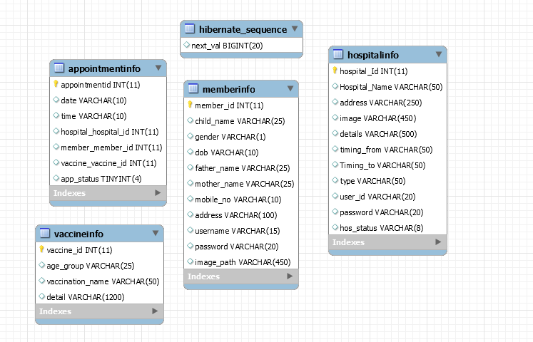

**Analysis:** The based on the existing system we’ve modified the way of operations in the Presentation layer and integrated the Service layer with the MySQL database for the proposed system.

**Flow of Execution-**

Take Appointment

Completed Appointment

Upcoming Appointment

Profile

Previous Appointment

Hospital List

User

Hospital

Upcoming Appointment

Admin

Vaccine

Details

Member List

**Take Appointment -**

* **Presentation Layer-**

In the presentation layer, we have age and Hospital 2 dropdown list in which data is coming from a database by HTTP Client Service. When the page is load user has to select the age of their child and hospital in which he/she wants an appointment. After that, they have to select a date and time for an appointment.

After selecting age, hospital, date and time users have to click on the submit button from which system calls an HTTP client service for the further background process.

* **Service Layer-**

In the service Layer, the system calls a web API which contains an object of appointment class form which it adds the appointment details to the appointment table.

In the controller layer of spring boot, it calls the service which was associated with web API.

In the service layer of spring boot, first, it creates a constructor of appointment class which consists of 2 parameter data and time. After that, we add the reference of the Hospital, Member and Vaccine class by using set methods because we are using **@OnetoOne** mapping and after that is save it in the database.

* **Dao Layer –**

In the DAO layer of spring boot, it saves the data in a database with foreign key constraints which are hospital_id, member_id and vaccine_id with the help of the JPA Repository and HQL.

**Project Link-**

Github Project link

<https://github.com/ShahnoorSiddiqui/cdacProject.git>

**Conclusion-**

* We learned to connect two servers front-end (Angular) and back-end (Spring Boot) via HTTPCLIENT.
* How to implement routing of Components and services in Angular.
* How to call web API from the presentation Layer by which services are called.
* We learned to connect database to our application by using Hibernate or we also learned how to create query in DAO layer or repository. And how to call that query in our services.
* How to use mapping in hibernate for creating relationship between two or three table.
* Used MySQL server for the database management of our project and also learned how to use the relational database.