Intelligent CV Analyzer using String Matching Algorithms
Generated: 2025-10-24 10:50

1. Introduction & Problem Definition
This report presents an intelligent CV analysis system that extracts and compares candidate CV contents against predefined job descriptions using classic string matching algorithms (Brute Force, Rabin–Karp, Knuth–Morris–Pratt).
The objective is to compute relevance scores and generate comparative reports, while measuring algorithmic performance (execution time and comparisons) across realistic workloads.

2. System Design & Architecture
The system follows a modular architecture with clear separation of concerns: Extractors (PDF/DOCX), Engine (algorithms and analyzer), GUI (PyQt5), Persistence (SQLite), and Reporting.
Data Flow: User selects CVs and provides a job description; text is extracted and normalized; the selected algorithm performs keyword matching; results are scored, ranked, visualized, and exported.

3. Algorithms & Implementation
Brute Force: O(n×m) worst/average, constant space; simple and robust baseline.
Rabin–Karp: O(n+m) average, O(n×m) worst; rolling hash enables multi-keyword efficiency; susceptible to collisions.
KMP: O(n+m) guaranteed; low comparisons via failure function; strong choice for real-time matching.
Algorithm | Best | Average | Worst | Space
Brute Force | O(n) | O(n×m) | O(n×m) | O(1)
Rabin–Karp | O(n+m) | O(n+m) | O(n×m) | O(1)
KMP | O(n+m) | O(n+m) | O(n+m) | O(m)

4. Experimental Setup
Dataset: Multiple CV documents from data/cvs/DataSet (PDF/DOCX).
Scenarios: (i) Single keyword vs (ii) Multiple keywords; (iii) Small vs (iv) Large CVs (by median text length).
Metrics: Execution time (s), comparison count, relevance score (match fraction + small density bonus).
Automation: reports/performance_runner.py generates CSV; reports/charts.py renders comparative charts.
Performance CSV: data/results/performance_20251024_014009.csv (rows: 108)

5. Results
Algorithm | Avg Time (s) | Avg Comparisons | Avg Relevance | Runs
KMP | 0.0008 | 6515 | 0.599 | 36
Brute Force | 0.0008 | 6540 | 0.599 | 36
Rabin-Karp | 0.0012 | 83 | 0.599 | 36
Selected Charts:
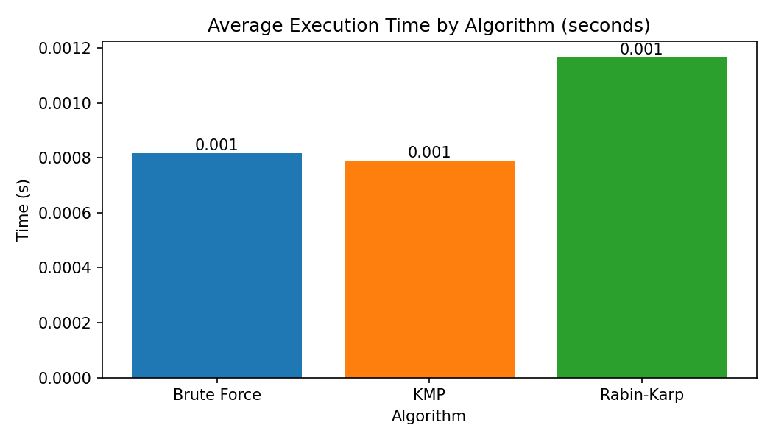
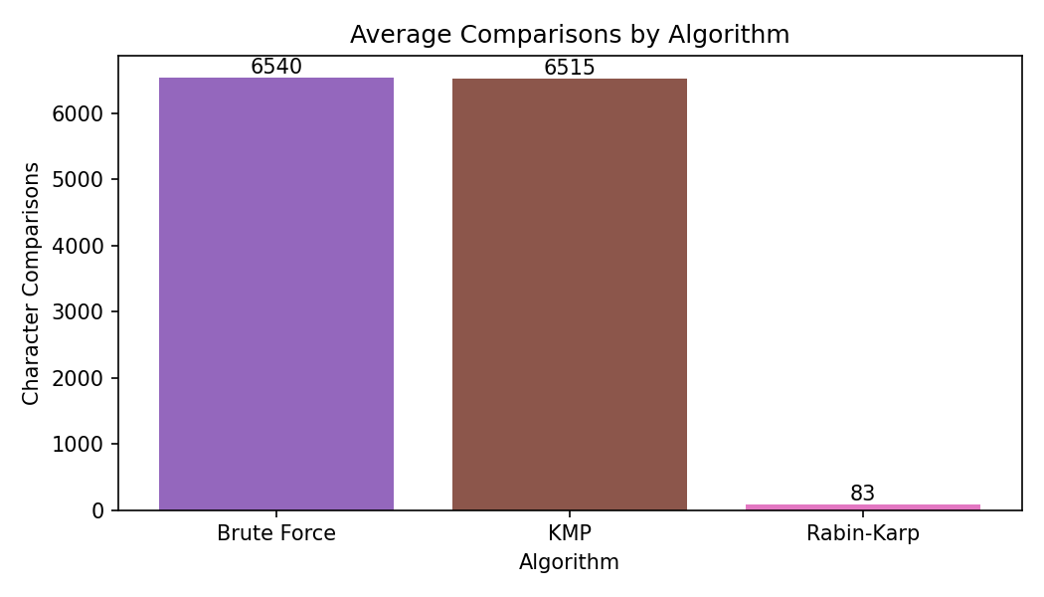
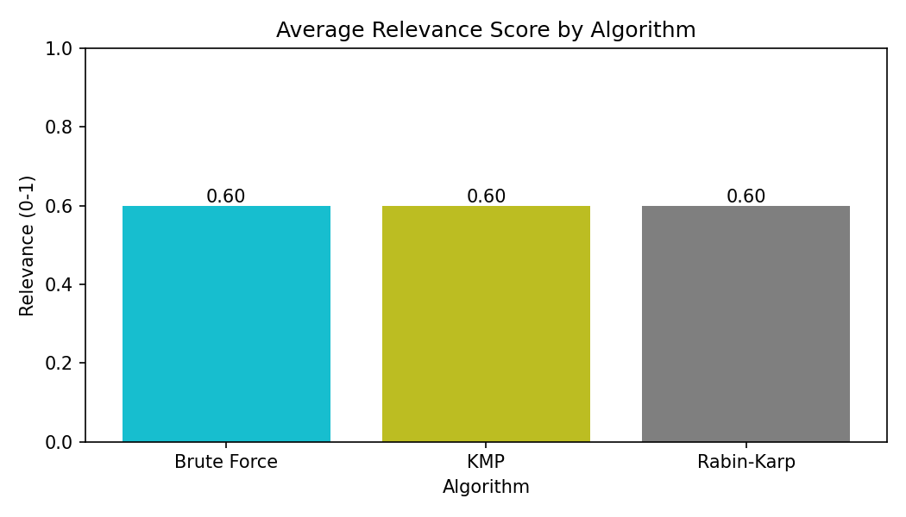
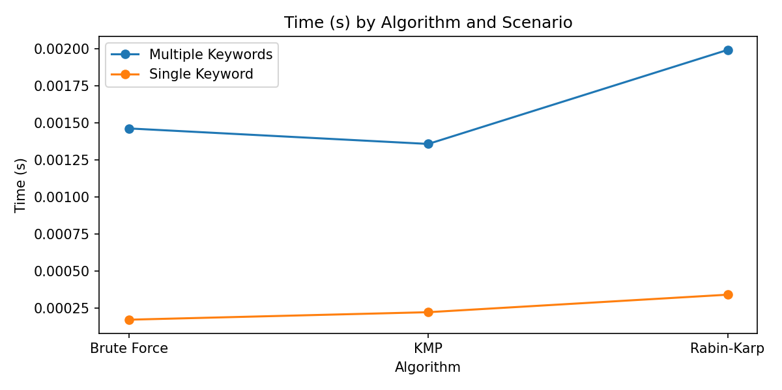
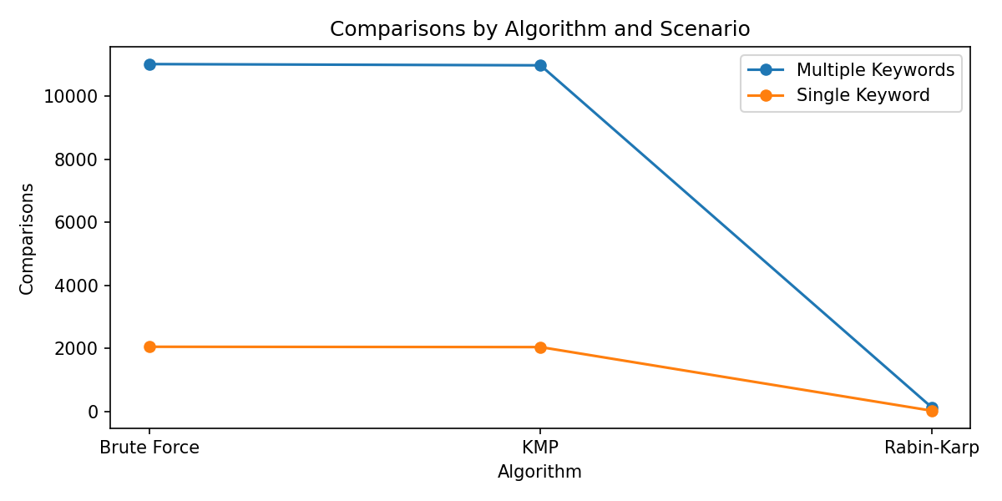
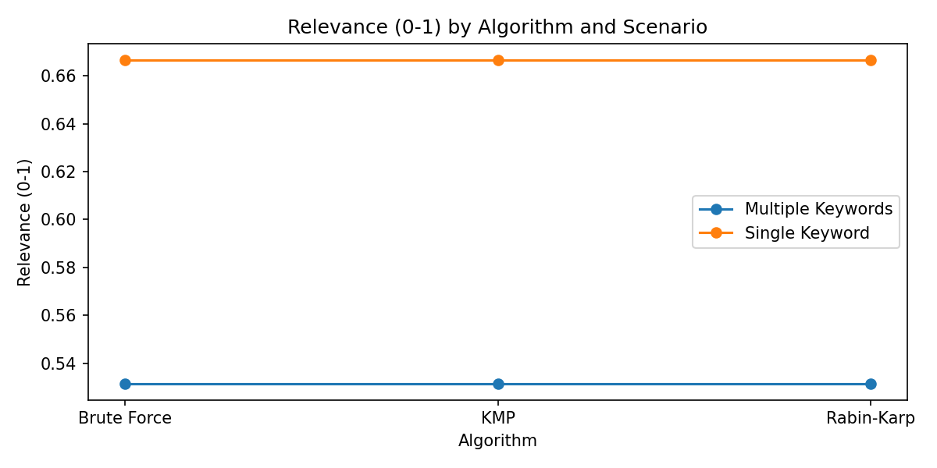
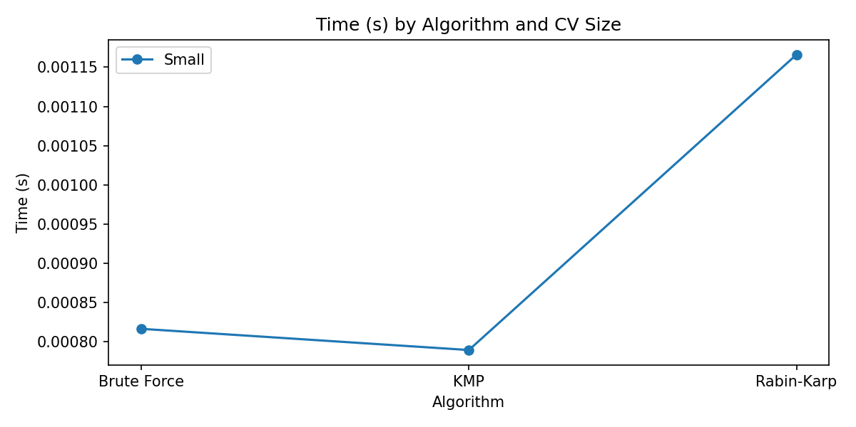
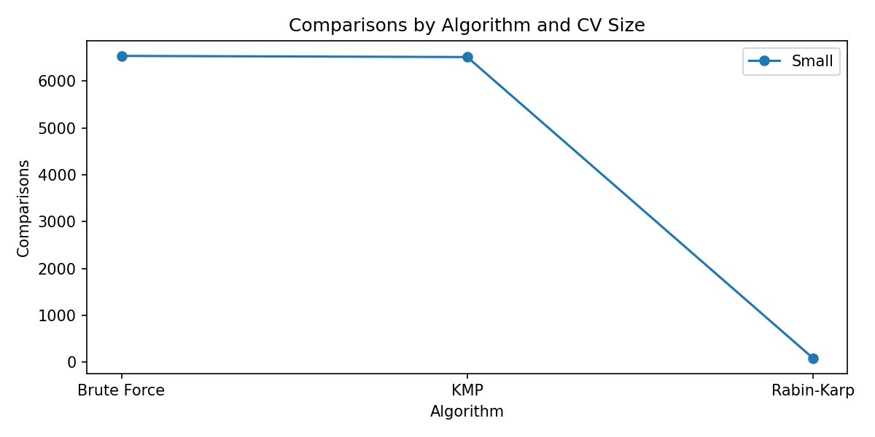
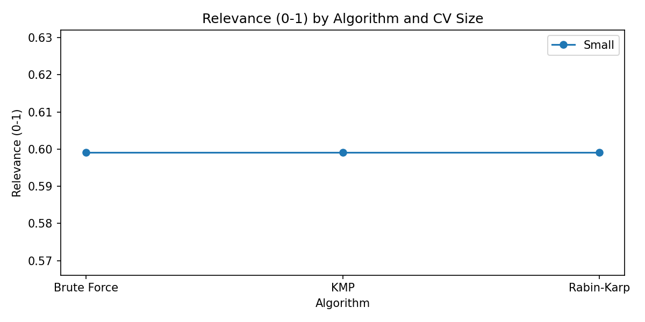

6. Discussion
KMP shows consistently strong runtime with low comparisons across sizes, aligning with its O(n+m) guarantee.
Rabin–Karp benefits when many keywords are searched (rolling hash reuse) but may degrade under collisions.
Brute Force is viable for small inputs but scales poorly; it remains a useful baseline for correctness checks.

7. Conclusion & Recommendation
Recommendation: Use KMP as the default for real-time CV analysis due to stable linear-time matching and low comparisons.
For batches of many keywords, consider Rabin–Karp to exploit hashing efficiency. For tiny or educational runs, Brute Force suffices.

8. Future Improvements
Integrate NLP techniques (lemmatization, synonyms, and TF–IDF weighting) for semantic matching.
Parallelize CV processing for reduced wall time; add caching of extracted texts.
Extend GUI with “Compare All” summaries and richer report export formats.

