Prove the following real integrals.

(i) 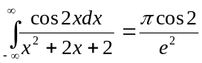 (ii) 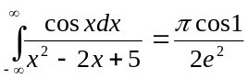
(iii) 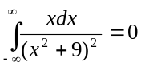 (iv) 