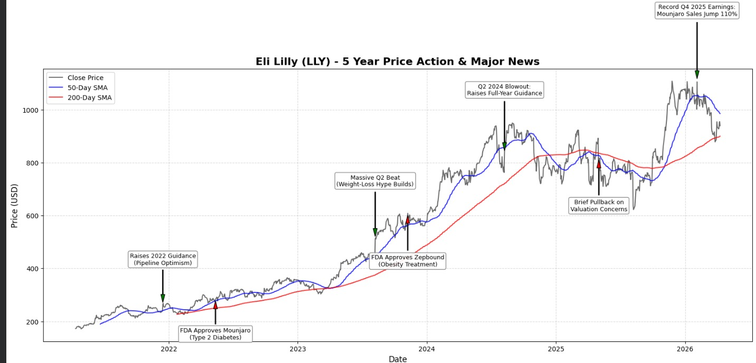

Eli Lilly 5 year Share Analysis
By looking at Eli Lilly in the last five years it has been nothing but Craziness to watch the stock drop to approximately 185 and then skyrocket to a play payout of over 1000 a 440% payout. at the beginning of 2021 it was merely a sound yet quite typical pharma company that relied on older drugs like trulicity and verzenio the most and was trading at a normal price.
While, the things started to shift at the end of that year, as they gave indeed optimism and starting give hint at their new pipeline specifically this one molecule known as tirzepatide which propelled the stock to around $265 which triggered a point that was actually hit when in may 2022 it was approved by the FDA as mounjaro in type 2 diabetes. The initial stock actually dropped a little into the $230s due to certain delays in data of an alzheimers drug and the fed increasing interest rates but once mounjaro was on the market all was different.
Still, the Wall Street quickly learned that patients were losing an unheard of tonne of weight on it as a by-product Eli lilly found itself finishing the year, more than 32, which is insane, because the rest of the market was literally crashing 19%. On mid 2023 the whole glp-1 slimming process became a massive cultural phenomenon in the world and their Q2 revenue was skyrocketing much higher than anticipated and the stock was on a streak to almost $590 in summertime.
Afterwards, the most notable business one was when the FDA eventually issued a license to zepbound that is basically tirzepatide but officially named to treat obesity in November 2023. the obesity market is huge with some 650 million adults in the world which totally overwhelmed the normal diabetes market such that the lilly had to invest 2.5 billion dollars in new plants so that it could at least attempt to match the demand. through to 2024 the momentum kept on building and in their 2nd quarter reports they not only raised their full year guidance by an amazing 3 billion dollars but also their alzheimer disease drug, kisunla, was approved. the stock soared more than 950 to be the most valuable pharma company in the world and the stock never goes up forever and the final part of 2024 provided the most sharp correction of the whole run.
Still, in October 2024 they had to miss their Q3 revenue targets largely due to shortages of supplies in various doses of zepbound. to crown it all the political risk people were really spooked as they believed that the new incoming trump administration was going to force them to make aggressive price cuts on medicare that would cause it to plummet 21 percent to a new low of about 750. But, the technical nuts and bolts that it dropped on the 200 day moving average, which was the best buying opportunity over the past 5 years. as of 2025 they recovered immensely when mounjaro sales shot up 109% and zepbound 185% turning lilly into the first trillion dollar pharma company of all time. they peaked at an all time high of $1,133 in November 2025, and their medications sold more than 36.5 billion making tirzepatide the highest selling drug in the world.
While, taking it this far in early 2026 its a mixed bag despite the company performing flawlessly and just reporting record breaking Q4 earnings and crazing good guidance. Despite all those blowout numbers the stock has in fact repaired about 18 per cent of that january high and is now trading in the 930s. the key causes of the decline include lilly confirmed a low to mid teens percentage price reduction around the world due to a deal with trump as well as the entire iran war energy shock is pulling down the overall market as well. but the long term planning is good in that morgan stanley increased their price target to all time high of 1,327 on 10 th April.

