Literature Handbook — v2
In-depth study notes for Chapter 2 of ‘This Time Is Different?’
Updated for the three-market design (ISEQ, S&P 500, DAX; FTSE for robustness). 51 paper cards with 12 fields each (summary, dataset, methodology, results, relation to your study, exact pages to read, what to skip, key terms, strengths, weaknesses, how to use) · 9 original figures from your own data · key numbers · Irish timeline · concept primers · 24 September 2026, updated 30 September 2026 (5 new cards and 3 figures for the exploratory extensions and the closest new work; Gallagher & Twomey correction)
Why there are no screenshots: No paragraphs or page images are copied from the papers. They are copyrighted, and copied text in your dissertation would be plagiarism. Instead, each card tells you exactly which section, pages, tables and figures to read in the original (field ‘Must read in the original’), and the figures in this handbook are original charts made from YOUR dataset that illustrate what each key paper describes. You may reuse these figures in your dissertation because they are your own analysis — describe them in your own words.

Card colour | Meaning
Green | FULL TEXT read in this session; page numbers refer to the open-access version in Part G
Yellow | ABSTRACT / summary read in this session; read the full paper before relying on details
Grey | STANDARD KNOWLEDGE, not re-read this session; confirm every detail and page before citing
Blue rows | The rows that matter most for you: relation to your study, what to read, and how to use it

Contents: A. Key numbers · B. Irish timeline · C. Concept primers with figures · D. Paper cards (2.2 theory, 2.3 crises & Ireland, 2.4 transmission, 2.5 forecasting, 2.6 explainability) · E. Reading order · F. From notes to paragraph · G. Where to read the originals.

A. Key numbers to remember
Fact | Number | Source
ISEQ pre-GFC peak → trough | 9,981 (20 Feb 2007) → 1,916 (9 Mar 2009): −80.8% | Your data
ISEQ 29 Sep 2008 / 30 Sep 2008 (guarantee day) | −13.0% / +7.9% | Your data
Irish bank CDS on guarantee day | ≈400 → ≈150 bp overnight; Irish sovereign CDS rose sharply | Acharya et al. (2014), p.3
European average CDS bank / sovereign | 63/14 bp before bailouts; 148/48 during; 184/112 after | Acharya et al. (2014)
Irish lending growth 1997→2008 | mortgages ≈7×; developer loans ≈11× | Kelly (2009)
EU/IMF programme (28 Nov 2010) | €85bn; €67.5bn external (€45bn EU & bilateral, €22.5bn IMF) | European Commission
Programme exit | 15 Dec 2013 | European Commission
Brexit: ISEQ 24 / 27 Jun 2016 | −7.7% / −9.9% | Your data
COVID: ISEQ 12 Mar 2020 | −9.9% | Your data
War: ISEQ 24 Feb 2022 | −4.6% | Your data
US daily moves >2.5%, 1900–2019 | >1,100, none attributed to pandemics | Baker et al. (2020)
COVID-attributed jumps 24 Feb–20 Apr 2020 | ≈ two dozen | Baker et al. (2020)
COVID excess mortality vs Spanish Flu | ≈1/25th | Baker et al. (2020)
Bekaert et al. sample | 415 country-sector portfolios, 55 markets, ≈725 weekly observations | Bekaert et al. (2014)
Diebold–Yilmaz sample | 19 markets, weekly, Jan 1992 – Nov 2007; VAR(2); 10-week horizon; 200-week rolling window | Diebold & Yilmaz (2009)
Christensen et al. sample | DJIA stocks, 29 Jan 2001 – 31 Dec 2017, 4,257 days | Christensen et al. (2023)
Bucci sample | monthly S&P 500, Feb 1950 – Dec 2017 (815 obs.); 245 out-of-sample forecasts, only 22 in the 2007–09 subsample | Bucci (2020)
Akhtaruzzaman et al. periods | pre-COVID 1 Jan 2013 – 30 Dec 2019; COVID 31 Dec 2019 – 20 Mar 2020 | Akhtaruzzaman et al. (2021)
ISEQ 20 value lost 2023–24 | ≈€74bn of ≈€152bn (CRH, Flutter, Smurfit) | Irish Times
Your main sample | 5,243 complete days, Jan 2003 – Aug 2023 | Your data
Diebold–Yilmaz (2012) set-up | daily range volatility, 4 US markets, 25 Jan 1999 – 29 Jan 2010 (2,771 days); VAR(4); 10-day horizon; 200-day windows; total spillover 12.6% | Diebold & Yilmaz (2012), pp.59–61
Danielsson et al. (2018) database | 60 countries, up to 211 years, 3,700 country-years, 259 banking crises; 1% below trend for 5 years → +1.01% crisis probability | Danielsson et al. (2018), pp.5–6
Your E1 (exploratory) | total spillover 34.0%; ISEQ net receiver −8.4; SHAP vs Diebold–Yilmaz agree in 4 of 8 direction checks | Your data
Your E2 (exploratory) | pre-GFC below-trend measure: Ireland 40th percentile (history 1970–2024), US 42nd, Germany 4th | Your data (FRED)

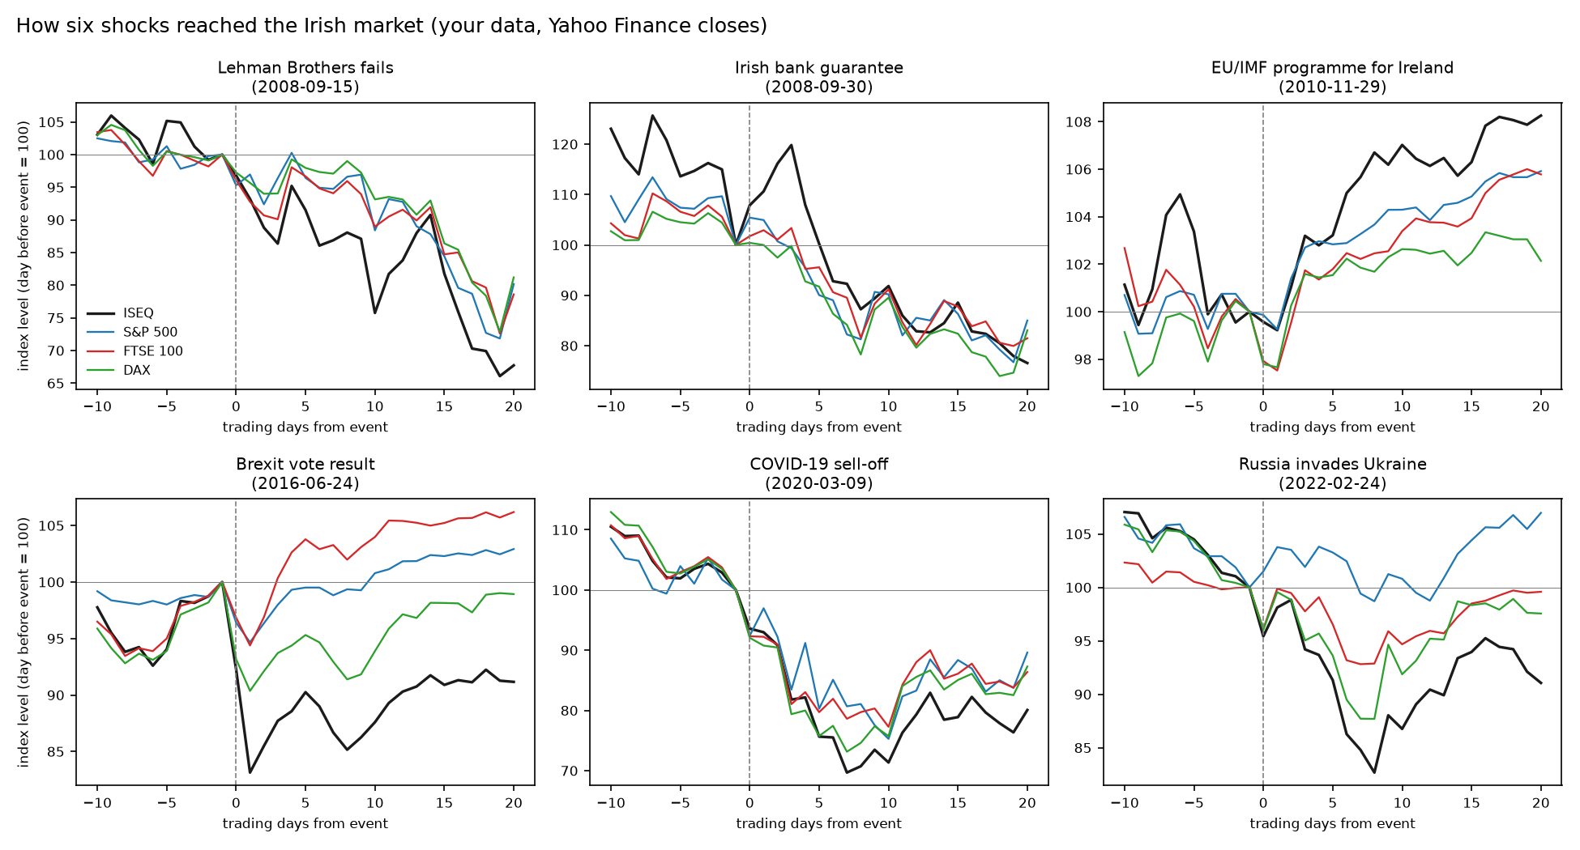
Figure H1. Your data: ISEQ, S&P 500, FTSE 100 and DAX around six events (index = 100 on the day before). Things to notice: after Lehman the ISEQ fell further than the others (domestic weakness — Bekaert et al.); on guarantee day the ISEQ jumped while others did not, then fell with them (Acharya et al.); after Brexit the ISEQ fell hardest while the FTSE 100 recovered (it is priced in sterling, which fell); in 2022 the ISEQ and DAX fell more than the S&P 500 (European exposure). These are descriptive — your models test them formally.

B. Irish crisis timeline
Date | Event | Why it matters for you
2003–2007 | Credit and property boom (mortgages ≈7×, developer loans ≈11× 1997 levels) | Minsky’s calm boom; your pre-GFC training data
20 Feb 2007 | ISEQ peak 9,981 (your data) | Irish decline starts before the global crisis
9 Aug 2007 | BNP Paribas freezes three funds (Brunnermeier, p.9–10) | Start of your GFC window
Sep 2007 | Northern Rock — first UK bank run in over a century (Brunnermeier) | Contagion to UK/Irish banks
15 Sep 2008 | Lehman Brothers fails | Peak global stress
30 Sep 2008 | Irish guarantee of six banks’ deposits (Acharya et al., p.3) | Bank risk moves to the state
Jan 2009 | Anglo Irish Bank nationalised | Domestic banking collapse
9 Mar 2009 | ISEQ trough 1,916 (your data) | End of GFC window
23 Apr 2010 | Greece requests EU/IMF aid | Start of Irish sovereign-debt window
28 Nov 2010 | €85bn EU/IMF programme for Ireland | Sovereign crisis peak for Ireland
26 Jul 2012 | Draghi: ‘whatever it takes’ | End of window; Whelan: turnaround from 2012
15 Dec 2013 | Ireland exits the programme | Recovery
23–27 Jun 2016 | Brexit vote; ISEQ −7.7% and −9.9% | UK-origin validation event
Feb–Mar 2020 | COVID-19; ISEQ −9.9% on 12 Mar | Exogenous crisis window
24 Feb 2022 | Russia invades Ukraine; ISEQ −4.6%; ECB hikes from Jul 2022 | Energy-shock validation event (euro channel)
Sep 2023 – Jul 2024 | CRH, Flutter, Smurfit leave the ISEQ | Sample ends 31 Aug 2023

C. Concept primers with figures from your data

C1. Crisis theory
- Efficient markets (Fama, 1970). Returns should be close to unpredictable; volatility is not — see Figure H5. This is why you forecast risk, not price.
- Minsky (1992). Hedge → speculative → Ponzi finance; Theorem 1: stable and unstable regimes exist; Theorem 2: long prosperity moves the economy toward the unstable regime; tight money can turn speculative units Ponzi.
- Kindleberger. Displacement → credit boom → euphoria → distress → panic → lender of last resort.
- Reinhart & Rogoff. Crises recur decades apart, so each generation thinks ‘this time is different’.
- Volatility paradox (Danielsson et al., 2018). Prolonged below-trend volatility — not high volatility — precedes banking crises; Minsky measured in data (Figure H9).
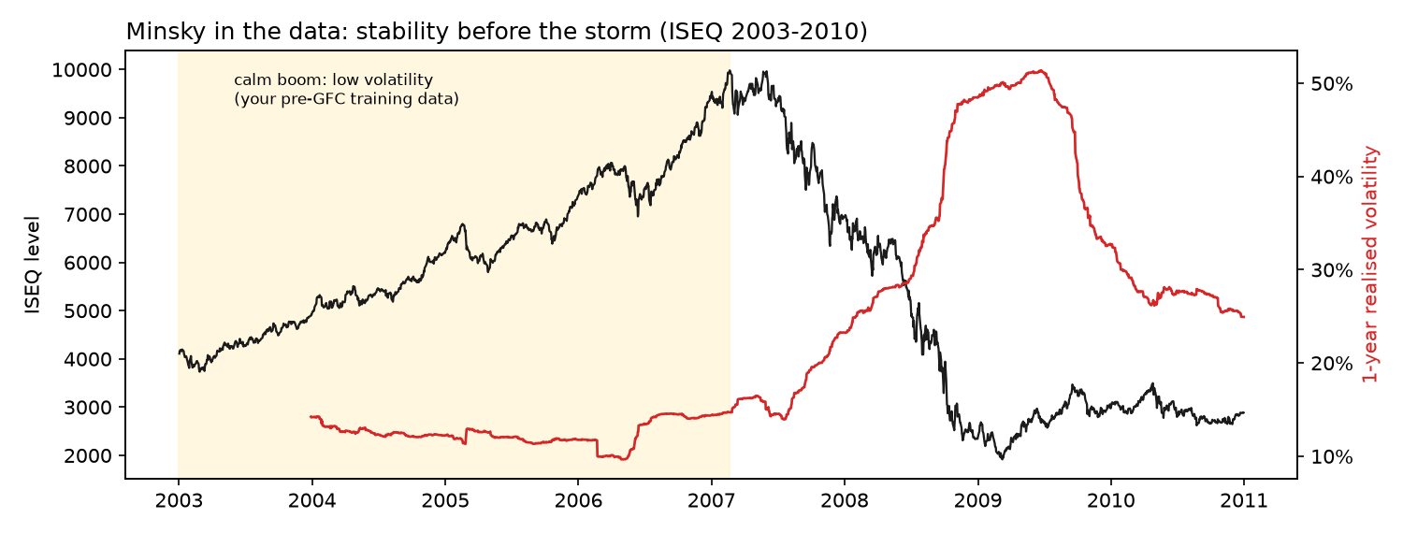
Figure H2. Your data: the ISEQ doubled between 2003 and early 2007 while its 1-year realised volatility stayed around 10–15%; volatility then rose to about 50% in 2008–09. This is what Minsky’s ‘stability breeds instability’ looks like in a market, and it is why RQ3 asks whether a model trained only on the calm boom can cope with the crash.

C2. Contagion and transmission
- Interdependence vs contagion (Forbes & Rigobon). Correlations rise mechanically when volatility rises; the adjusted correlation is ρ* = ρ / √(1 + δ(1 − ρ²)), δ = relative rise in the source market’s variance.
- Heat waves vs meteor showers (Engle, Ito & Lin). Own-market persistence vs volatility travelling between markets. Your ‘domestic’ channel (ISEQ) = heat wave; US (S&P 500) and euro (DAX) channels = meteor showers.
- Non-synchronous trading (Hamao et al.; Forbes & Rigobon). Markets close at different times. Forbes & Rigobon use two-day average returns; you instead align on the Irish calendar and use foreign closes up to day t (Figure H4).
- Spillover index (Diebold & Yilmaz). Share of a market’s forecast-error variance caused by other markets; volatility spillovers burst in crises. The 2012 version uses a generalized decomposition that does not depend on variable order and adds directional (to/from) and net spillovers — the method of your exploratory E1 (Figures H7–H8).
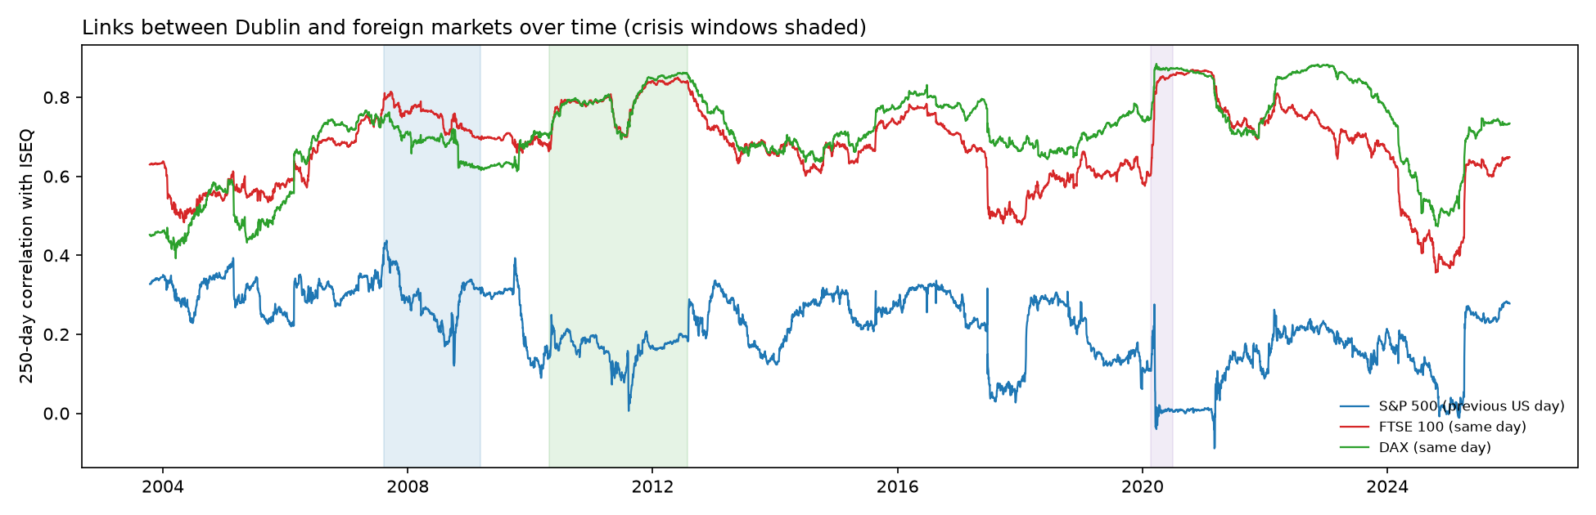
Figure H3. Your data: 250-day correlation of daily ISEQ returns with London and Frankfurt (same day) and New York (previous US day). Links with Europe rose towards 0.85 in the Irish debt crisis and COVID — the pattern Forbes & Rigobon warn can reflect volatility rather than contagion. The New York link is weaker and collapses when a few extreme days enter the window (e.g., early 2020), showing how fragile simple correlation is — one reason to use forecasting models and attributions instead.
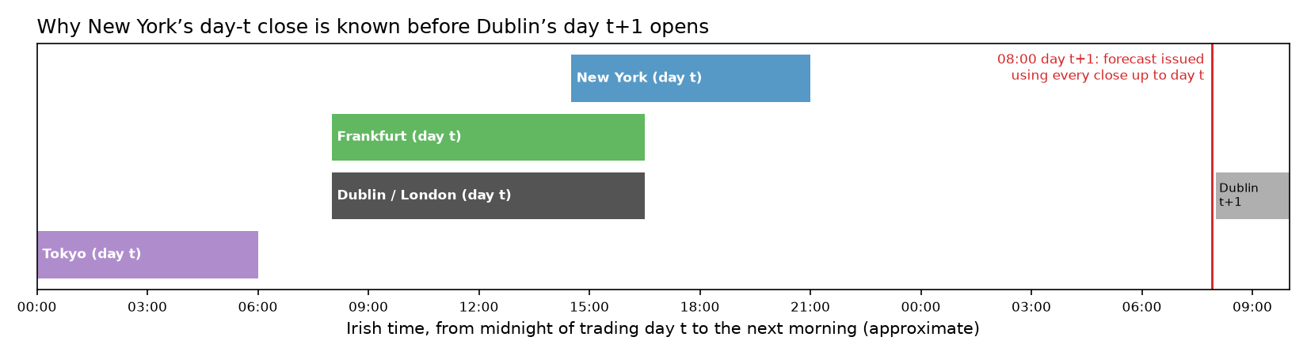
Figure H4. Original diagram: New York closes at about 21:00 Irish time, after Dublin. A forecast issued at 08:00 on day t+1 may legitimately use every market’s close up to day t — never day t+1 (Hamao, Masulis & Ng, 1990).

C3. Volatility econometrics
- Stylised facts (Cont, 2001). Little autocorrelation in returns, strong and slowly decaying autocorrelation in squared returns (Figure H5).
- GARCH(1,1). σ²(t) = ω + α·ε²(t−1) + β·σ²(t−1); α+β = persistence.
- HAR (Corsi, 2009). RV(t+1) = β0 + βd·daily + βw·weekly + βm·monthly (Figure H6).
- QLIKE (Patton, 2011). RV/F − ln(RV/F) − 1; robust to noisy volatility proxies; penalises under-prediction more.
- Diebold–Mariano + HLN. Test on the average loss difference; Newey–West with h−1 = 4 lags for 5-day forecasts; small-sample correction.
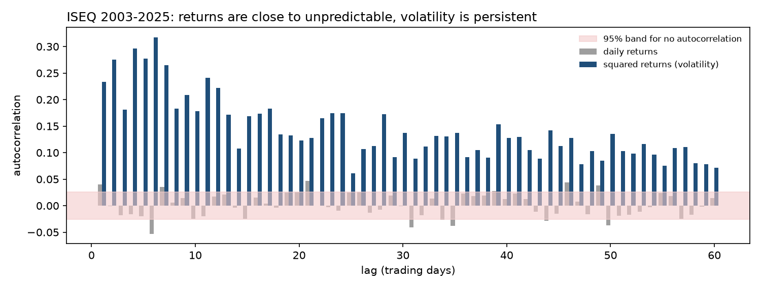
Figure H5. Your data: autocorrelation of ISEQ daily returns (grey) is almost always inside the ‘no autocorrelation’ band, but squared returns (blue) are strongly and persistently autocorrelated even 60 days back. Returns are hard to predict; volatility is not. Long memory like this is what HAR and LSTM are designed to capture.
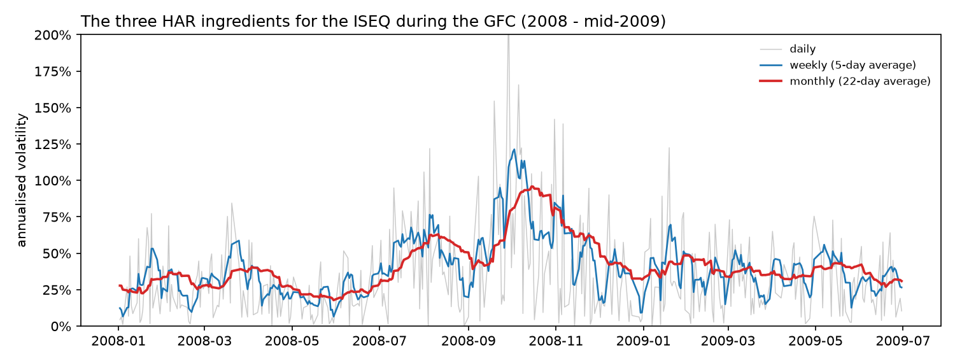
Figure H6. Your data: the three HAR ingredients during the GFC. The daily series (grey) is very noisy; the weekly average (blue) follows turning points; the monthly average (red) carries the slow, persistent level. HAR combines all three; your LSTM sees the same history day by day.

C4. LSTM and C5. Explainable AI (summary)
- LSTM. Cell state + gates (input, output; forget gate added by Gers et al., 2000) fix vanishing gradients.
- SHAP. Unique additive attribution with local accuracy, missingness, consistency (Lundberg & Lee).
- Integrated Gradients. Sensitivity + implementation invariance; completeness; depends on a baseline.
- Expected gradients / GradientSHAP. IG averaged over baselines drawn from real data (Erion et al.).
- Limits. Correlated features (Aas et al.); mathematical and human-centred problems (Kumar et al.); prefer interpretable models in high-stakes use (Rudin).

C6. Tools of the exploratory extensions (added 30 Sep 2026)
- Connectedness (E1). A VAR(4) on log 5-day realised variance of ISEQ, S&P 500 and DAX, re-estimated on each 200-day window. The ISEQ row of the generalized variance decomposition gives own / from-US / from-euro shares — comparable with your SHAP channel shares, but from a linear model of volatility only.
- One-sided HP trend (E2). For each year the trend is fitted to past years only; volatility below it counts as ‘calm’. The five-year average of that calm is Danielsson et al.’s crisis indicator.
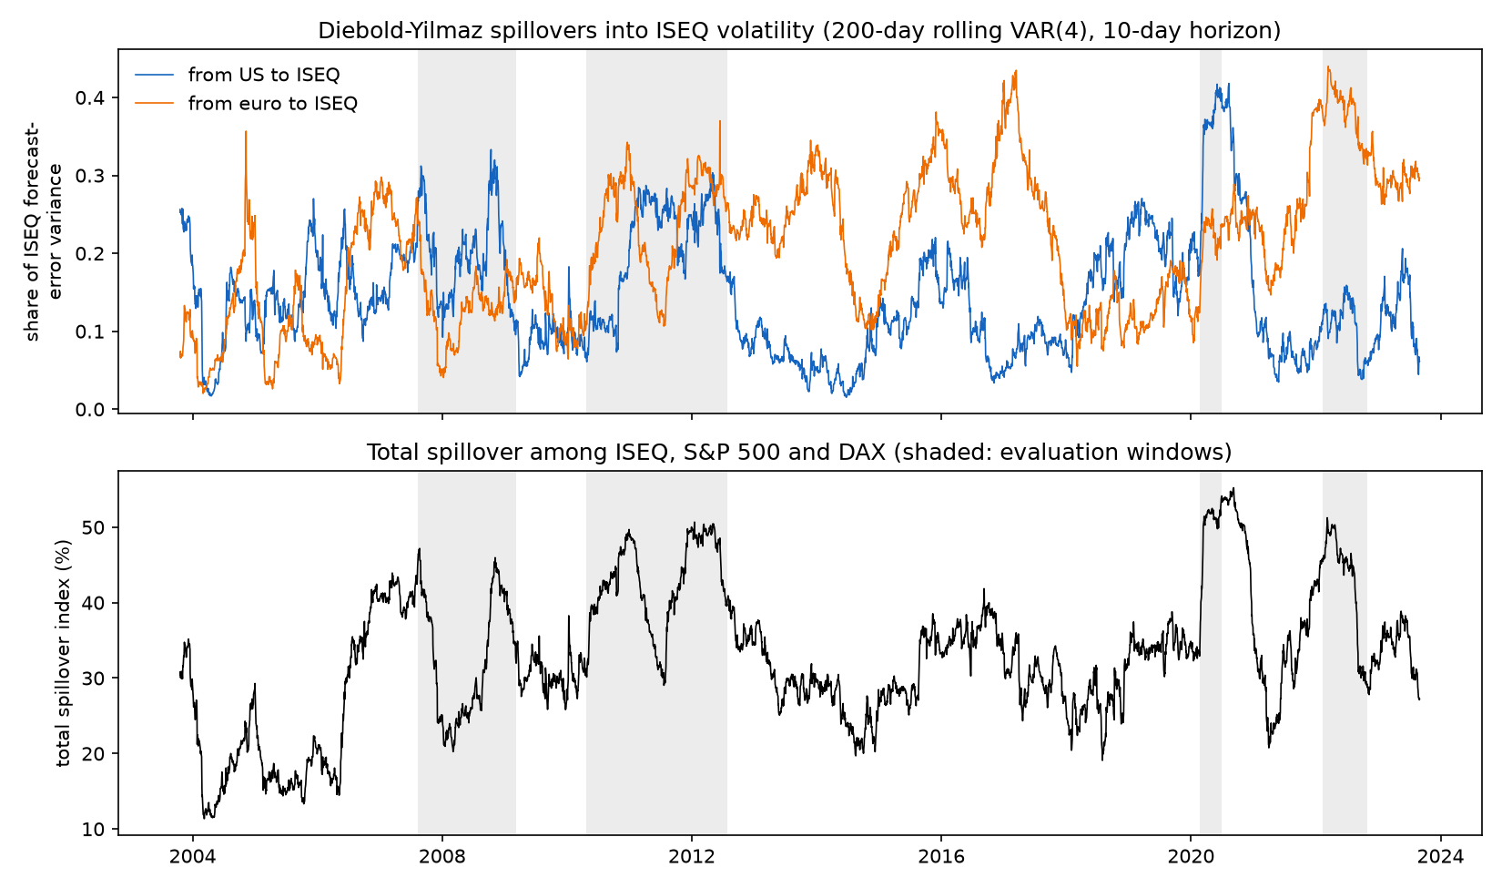
Figure H7. Your data: share of the ISEQ’s volatility forecast-error variance coming from the US (blue) and the DAX (orange) in a 200-day rolling VAR, and the total spillover index (bottom). The US share jumps in COVID-19; the DAX share is highest in 2016–17 and 2022; total spillover peaks at 55% in September 2020. Method: Diebold & Yilmaz (2012).
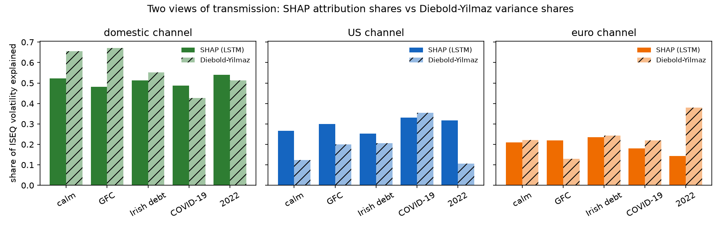
Figure H8. Your data: SHAP channel shares of the LSTM (solid) next to Diebold–Yilmaz shares (hatched) in each window. The two lenses agree that the US share was highest in COVID-19 and differ most in 2022 (Project Handbook, H9).
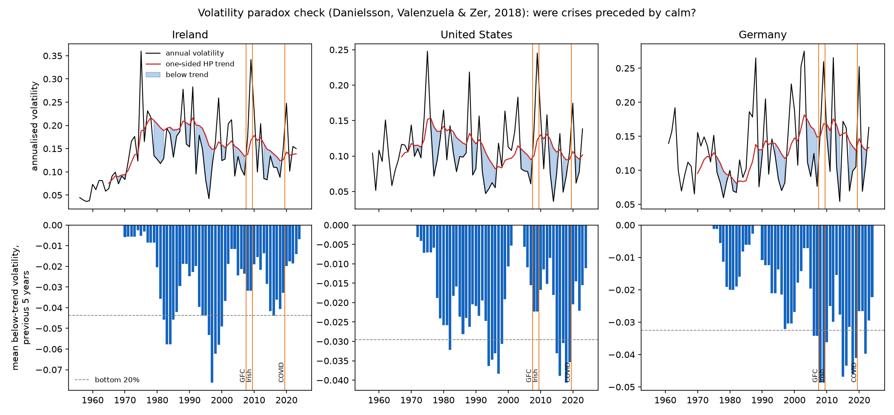
Figure H9. Your data (FRED, from 1955): annual volatility and its one-sided HP trend (top) and the five-year below-trend measure (bottom) for Ireland, the US and Germany. Only Germany was unusually calm before the GFC. Method: Danielsson, Valenzuela & Zer (2018).

D. Paper cards

D1. Section 2.2 — Why crises recur
Minsky, H. (1992) The Financial Instability Hypothesis. Levy Institute WP 74.
Source basis | FULL TEXT read in this session; page numbers refer to the open-access version in Part G
Summary | A short essay arguing that financial crises come from inside the economy: long periods of stability encourage ever-riskier borrowing until the system becomes fragile and a small shock causes a crash.
Dataset | None — a theoretical essay.
Methodology | Verbal theory building on Keynes; classification of borrowers by how their income covers debt payments.
Results | • Hedge units pay interest and principal from income; speculative units pay interest but must refinance principal; Ponzi units cannot even pay interest.  • Theorem 1: an economy has stable and unstable financing regimes.  • Theorem 2: long prosperity moves the economy from stable to unstable financing.  • The more speculative/Ponzi finance, the more the system amplifies shocks.  • Fighting inflation with tight money can turn speculative units into Ponzi units.
How it relates to MY study | The theory behind RQ3: your models learn from the calm 2003–07 boom (Figure H2) and are then tested on the crash. Also frames the 2022 rate shock (tight money).
Must read in the original | Whole paper (10 pages). Key: definitions of the three finance types and the two theorems (pp. 6–8).
Can skim / skip | Nothing — it is short.
Key terms | hedge / speculative / Ponzi finance; financial fragility; deviation-amplifying system
Strengths | Clear, influential, anticipates the GFC mechanism.
Weaknesses / critique | Not formally tested; hard to measure directly.
Use it as · where | Theory support · 2.2; H3; Discussion

Reinhart, C. & Rogoff, K. (2008/2009) This Time Is Different (NBER WP 13882; book 2009).
Source basis | FULL TEXT read in this session; page numbers refer to the open-access version in Part G
Summary | A historical database of crises across eight centuries showing that defaults and banking crises recur, that they cluster, and that each generation wrongly believes it is immune.
Dataset | 66 countries (Table 1, p.15), all regions including India and China; from the 14th century to 2008.
Methodology | Descriptive statistics on defaults, banking crises, inflation and currency crashes.
Results | • Serial default is nearly universal as countries develop.  • Defaults are years or decades apart, creating the ‘this time is different’ illusion.  • Crises often start in financial centres and spread through interest-rate and commodity-price shocks.  • The US sub-prime crisis was ‘hardly unique’.
How it relates to MY study | Your title; the US-origin expectation for the GFC (H2a); the history lens in your Discussion.
Must read in the original | Abstract (p.2); I. Introduction (pp.3–4); II. First insights (pp.5–15), especially Figure 1 (p.6, share of countries in default).
Can skim / skip | Data appendices (pp.56–125).
Key terms | serial default; ‘this time is different’ syndrome; financial centre
Strengths | Unmatched historical scope.
Weaknesses / critique | Annual macro data; about incidence, not market transmission or forecasting.
Use it as · where | Context + framing · 1, 2.2, 5

Fama, E. (1970) Efficient capital markets. Journal of Finance, 25(2), 383–417.
Source basis | STANDARD KNOWLEDGE, not re-read this session; confirm every detail and page before citing
Summary | The classic review defining weak, semi-strong and strong market efficiency.
Dataset | Review of empirical studies before 1970.
Methodology | Literature review and classification of tests.
Results | • Strong support for weak and semi-strong efficiency; little for the strong form.  • Tests of efficiency are joint tests with a model of expected returns.
How it relates to MY study | Why you forecast volatility (predictable) rather than returns (not).
Must read in the original | Introduction and the weak-form evidence section.
Can skim / skip | Detailed older test results.
Key terms | weak / semi-strong / strong form; joint hypothesis
Strengths | Foundational definitions.
Weaknesses / critique | About returns; pre-dates volatility-clustering evidence.
Use it as · where | Context · 2.2; Chapter 3 target choice

Kindleberger, C. & Aliber, R. (2015) Manias, Panics and Crashes, 7th edn.
Source basis | STANDARD KNOWLEDGE, not re-read this session; confirm every detail and page before citing
Summary | Narrative history showing that manias and crashes follow a recurring pattern.
Dataset | Historical episodes over several centuries.
Methodology | Comparative history built on Minsky.
Results | • Stages: displacement, credit boom, euphoria, distress, panic, lender of last resort.  • Crises spread internationally through trade, capital flows and psychology.
How it relates to MY study | Classify the ‘displacement’ (origin) of each of your three crises.
Must read in the original | The chapter on the anatomy of a typical crisis and the chapter on international contagion (check chapter numbers in your edition).
Can skim / skip | Individual historical cases outside your period.
Key terms | displacement; euphoria; revulsion; lender of last resort
Strengths | Readable, rich history.
Weaknesses / critique | Narrative, selective cases.
Use it as · where | Context · 2.2; origin table in 2.3

Kelly, M. (2009) The Irish credit bubble. UCD CER WP09/32.
Source basis | ABSTRACT / summary read in this session; read the full paper before relying on details
Summary | Documents the scale of Irish bank lending growth and warns of large bank losses.
Dataset | Irish bank lending and property data to 2008–09.
Methodology | Descriptive analysis and loss scenarios.
Results | • Mortgage lending ≈7× its 1997 value by 2008; developer lending ≈11×.
How it relates to MY study | Irish evidence of Minsky’s boom; supports a large domestic channel in the GFC (H2a).
Must read in the original | Whole paper (short working paper): lending figures and conclusions.
Can skim / skip | —
Key terms | credit bubble; developer lending
Strengths | Early, prescient.
Weaknesses / critique | Working paper.
Use it as · where | Support · 2.2–2.3.2; H2a; H3

Cont, R. (2001) Empirical properties of asset returns. Quantitative Finance, 1(2), 223–236.
Source basis | STANDARD KNOWLEDGE, not re-read this session; confirm every detail and page before citing
Summary | Lists the statistical regularities common to financial returns.
Dataset | Many assets and markets.
Methodology | Survey.
Results | • Weak return autocorrelation; strong, slowly decaying autocorrelation of absolute/squared returns.  • Heavy tails; asymmetry; volatility clustering; leverage effect.
How it relates to MY study | Figure H5 shows these facts in your ISEQ data; justifies log-RV target and Student-t GARCH.
Must read in the original | Section listing the stylised facts.
Can skim / skip | Technical estimation sections.
Key terms | stylised facts; volatility clustering; long memory; leverage effect
Strengths | Clear reference list of facts.
Weaknesses / critique | Descriptive.
Use it as · where | Support · 2.5; Chapter 3

Danielsson, J., Valenzuela, M. & Zer, I. (2018) Learning from history: volatility and financial crises. RFS, 31(7), 2774–2805.
Source basis | FULL TEXT read in this session; page numbers refer to the open-access version in Part G
Summary | Builds a 211-year, 60-country volatility database and asks whether volatility predicts banking crises. The level does not; long spells of volatility below its trend do — calm encourages credit and leverage (‘stability is destabilising’).
Dataset | Monthly real stock-index returns, 60 countries, up to 211 years (3,700 country-years; 62 years per country on average); 259 banking crises (Reinhart & Rogoff, 2009); BIS credit data (37 countries, from the 1960s); bank leverage (31 countries, from the 1980s).
Methodology | Annual volatility = standard deviation of 12 monthly returns (July–June); one-sided (recursive) Hodrick–Prescott trend, λ = 5,000; deviations split into high and low parts; 5-year backward averages; panel logit with decade and region fixed effects; signal-to-noise checks.
Results | • The level of volatility does not predict crises once controls are included.  • Prolonged low volatility does: 1% below trend for five years → about 1.01% higher crisis probability.  • High volatility: weak evidence only.  • Low volatility is followed by excess lending and higher bank leverage.  • Low volatility works as a crisis indicator with a good signal-to-noise ratio.
How it relates to MY study | Empirical anchor for your Minsky framing (RQ3) and the method of exploratory E2. In your data only Germany was unusually calm before the GFC (4th percentile); Ireland was calm but not unusually so (40th).
Must read in the original | Introduction pp.3–6 (findings in brief); Section 2.3 pp.13–14 (the decomposition — your E2 method); Sections 3.1–3.2 pp.19–22 (regression and main result); Conclusion p.32. Pages: LSE accepted version.
Can skim / skip | Control variables (2.5); later robustness tables. The Web Appendix has the same chart for other countries.
Key terms | volatility paradox; one-sided HP filter; high / low volatility; signal-to-noise ratio; excess credit
Strengths | Very long history; simple measure that uses only past data; links calm to credit and leverage.
Weaknesses / critique | Annual volatility from monthly data; banking crises only; the one-sided trend is unstable early in a series; a panel result, not a per-country test.
Use it as · where | Evidence + method · 2.2 (one or two sentences); Chapters 3–4 (E2); Discussion (Minsky)

D2. Section 2.3 — Three crises and Ireland
Brunnermeier, M. (2009) Deciphering the liquidity and credit crunch 2007–2008. JEP, 23(1), 77–100 (NBER WP 14612).
Source basis | FULL TEXT read in this session; page numbers refer to the open-access version in Part G
Summary | Explains how mortgage losses were amplified into a global crisis, with a day-by-day logbook and four amplification mechanisms.
Dataset | Market indicators 2007–08: ABX mortgage indices, commercial paper, interest-rate spreads, CDS spreads.
Methodology | Economic narrative plus a framework of amplification mechanisms.
Results | • 9 Aug 2007: BNP Paribas froze three funds, unable to value structured products.  • Northern Rock suffered the first UK bank run in over a century.  • Four mechanisms: balance-sheet loss and margin spirals; lending channel (banks hoard funds); runs on institutions (Bear Stearns, Lehman, Washington Mutual); network effects.  • US stock market wealth fell ≈$8 trillion between Oct 2007 and Oct 2008.
How it relates to MY study | Justifies your GFC start date (9 Aug 2007) and the US-origin expectation (H2a: US channel = S&P 500).
Must read in the original | Banking trends (pp.4–8); event logbook (pp.9–21; Figures 1–4 on pp.10, 12, 14, 20); amplifying mechanisms (pp.22–29; spirals figure p.24); conclusion (p.30).
Can skim / skip | Detailed product descriptions if short of time.
Key terms | originate-and-distribute; loss spiral; margin spiral; liquidity hoarding; bank run
Strengths | Clear mechanism; primary-event chronology.
Weaknesses / critique | Written mid-crisis; US-centred.
Use it as · where | Context + support · 2.3.2; H2a

Bekaert, G., Ehrmann, M., Fratzscher, M. & Mehl, A. (2014) The global crisis and equity market contagion. JF, 69(6), 2597–2649 (ECB WP 1381).
Source basis | FULL TEXT read in this session; page numbers refer to the open-access version in Part G
Summary | Asks how the GFC spread across world equity markets; finds that domestic weaknesses mattered more than direct links to the US.
Dataset | 415 country-sector equity portfolios in 55 markets; weekly data, ≈725 observations each.
Methodology | Factor asset-pricing model (US, global-financial and domestic factors); contagion = unexplained rise in factor loadings and residual correlations during the crisis.
Results | • Little systematic contagion from US markets despite the US origin.  • Systematic contagion from domestic markets to domestic portfolios.  • Weak fundamentals, poor policies and weak institutions → more contagion and larger falls.  • Debt and deposit guarantees partly shielded domestic equities (wake-up call hypothesis).
How it relates to MY study | Key basis for H2a: expect a large domestic channel for Ireland in the GFC, not only US channels. Matches the ISEQ’s +7.9% on guarantee day (Figure H1).
Must read in the original | Introduction (pp.8–10); 2.1.1 interdependence vs contagion (p.12); 3.2 contagion (pp.20–22); 3.3 channels (pp.23–24); conclusions (pp.25–26); Figure 3 (p.21).
Can skim / skip | Estimation diagnostics (pp.15–17) and appendix.
Key terms | interdependence; contagion; factor loadings; wake-up call hypothesis
Strengths | Very large cross-section; clear definition.
Weaknesses / critique | Result depends on the factor model; not a forecasting study.
Use it as · where | Central support · 2.3.2, 2.4; H2a

Acharya, V., Drechsler, I. & Schnabl, P. (2014) A Pyrrhic victory? JF, 69(6), 2689–2739.
Source basis | FULL TEXT read in this session; page numbers refer to the open-access version in Part G
Summary | Shows that bank bailouts transferred risk to governments, creating a two-way loop between bank and sovereign credit risk — with Ireland as the opening case.
Dataset | CDS spreads for European banks and sovereigns (2007 onwards); bond yields from Datastream.
Methodology | Theoretical model of the loop; event study around bailouts; panel regressions.
Results | • Ireland guaranteed six banks’ deposits on 30 Sep 2008.  • Irish bank CDS fell overnight from ≈400 to ≈150 bp while sovereign CDS rose sharply.  • By autumn 2010, the Irish–German spread widened and Ireland needed a bailout.  • Across Europe, bank/sovereign CDS: 63/14 → 148/48 → 184/112 bp (before/during/after bailouts).  • After bailouts, sovereign CDS changes help explain bank CDS changes.
How it relates to MY study | Explains how your GFC window led into your Irish debt-crisis window; basis for a strong domestic channel in 2010–12 (H2b).
Must read in the original | Introduction and Figure 1 (pp.2–4, the Irish case); empirical analysis: data (p.23), sovereign risk trigger (pp.24–27, Figures 8–9 p.25), feedback loop (pp.28–35, Table III p.30); conclusion (p.40).
Can skim / skip | Model sections (pp.8–22) unless interested in the theory.
Key terms | bank–sovereign loop; CDS; bailout; guarantee
Strengths | Clear mechanism; clean natural experiment.
Weaknesses / critique | Credit markets, not equity volatility.
Use it as · where | Support · 2.3.2–2.3.3; H2b

Honohan (2010); Regling & Watson (2010); Nyberg (2011) — official Irish reports.
Source basis | STANDARD KNOWLEDGE, not re-read this session; confirm every detail and page before citing
Summary | The three official investigations into why Irish banks failed.
Dataset | Bank, regulator and government documents; interviews.
Methodology | Official inquiries.
Results | • Property-lending concentration and foreign wholesale funding.  • Light-touch regulation; failed macro-prudential policy (Honohan).  • Largely home-grown crisis, triggered by the global crisis (Regling & Watson).  • Herding by banks and authorities (Nyberg).
How it relates to MY study | Primary historical evidence for the domestic dimension of the GFC in Ireland (H2a).
Must read in the original | Executive summaries and conclusions of each report.
Can skim / skip | Detailed institutional chapters.
Key terms | macro-prudential policy; herding; wholesale funding
Strengths | Authoritative.
Weaknesses / critique | Not academic tests; confirm wording and pages.
Use it as · where | Context + support · 2.3.2; Discussion

Lane, P. (2012) The European sovereign debt crisis. JEP, 26(3), 49–68.
Source basis | ABSTRACT / summary read in this session; read the full paper before relying on details
Summary | Explains the euro-area debt crisis as the result of a flawed monetary-union design.
Dataset | Euro-area macro and fiscal data.
Methodology | Economic analysis.
Results | • Flawed euro design; poor understanding of monetary-union fragility.  • No banking union or euro-level buffers; crisis-management errors.
How it relates to MY study | Euro-area origin of your 2010–12 window (H2b).
Must read in the original | Sections on origins, the Irish case and policy responses (free on aeaweb.org).
Can skim / skip | —
Key terms | monetary union; banking union; sovereign spreads
Strengths | Clear, by a later Central Bank of Ireland Governor.
Weaknesses / critique | Mid-crisis perspective.
Use it as · where | Context · 2.3.3; H2b

Whelan, K. (2014) Ireland’s economic crisis. J. Macroeconomics, 39(B), 424–440.
Source basis | ABSTRACT / summary read in this session; read the full paper before relying on details
Summary | Reviews Ireland’s boom, crash and recovery.
Dataset | Irish macro data, 2000s–2013.
Methodology | Economic review.
Results | • Mid-2000s demand above potential due to a property bubble.  • Better fiscal policy or regulation could have prevented the crisis.  • Crisis management and the turnaround from 2012 were reasonably successful.
How it relates to MY study | Irish narrative; supports ending your window in 2012.
Must read in the original | Whole paper (UCD WP 13/06 version).
Can skim / skip | —
Key terms | output gap; fiscal consolidation
Strengths | Concise overview.
Weaknesses / critique | Little on markets.
Use it as · where | Context · 2.3.3

Corbet, S. & Twomey, C. (2015) European equity market contagion: Ireland’s sovereign debt crisis. EFAJ, 2015(3), 15–34.
Source basis | ABSTRACT / summary read in this session; read the full paper before relying on details
Summary | Tests whether the collapse of Irish equities spilled over to European markets.
Dataset | Daily European equity returns; 2007–10 crisis and post-troika period.
Methodology | DCC multivariate GARCH.
Results | • Strong Irish–European equity contagion 2007–10.  • Contagion eased dramatically after troika intervention.
How it relates to MY study | The Irish study closest to yours, by Dr Twomey. Test: does your euro (DAX) share fall after Nov 2010?
Must read in the original | Whole paper (≈20 pages) — essential before contacting Dr Twomey.
Can skim / skip | —
Key terms | DCC-GARCH; troika; contagion
Strengths | Irish focus; policy result.
Weaknesses / critique | Correlation-based; no channels by origin; no forecasting.
Use it as · where | Central support + contrast · 2.3.3, 2.4; H2b

Baker, S. et al. (2020) The unprecedented stock market reaction to COVID-19. RAPS, 10(4), 742–758 (NBER WP 26945).
Source basis | FULL TEXT read in this session; page numbers refer to the open-access version in Part G
Summary | Shows that no earlier pandemic moved stock markets like COVID-19 and explains why.
Dataset | US daily market moves since 1900; volatility since 1985; next-day newspaper explanations.
Methodology | Text-based classification of the reported causes of large daily moves.
Results | • >1,100 US daily moves >2.5% (1900–2019); none attributed to pandemics.  • ≈ two dozen COVID-attributed jumps, 24 Feb – 20 Apr 2020.  • COVID excess mortality ≈1/25th of the Spanish Flu’s.  • Best explanation: restrictions and social distancing in a service economy.
How it relates to MY study | COVID was genuinely new → a model trained on past crises has never seen it (H3); broad simultaneous shock (H2c).
Must read in the original | Main text pp.3–15 (jump characterisation p.4; explanations p.8; conclusions p.13); Table 1 (p.20); Figures 1–3 (pp.19–22).
Can skim / skip | References.
Key terms | market jumps; equity market volatility tracker; non-pharmaceutical interventions
Strengths | Long history; transparent method.
Weaknesses / critique | US only; early 2020.
Use it as · where | Support · 2.3.4; H2c; H3; Discussion

Akhtaruzzaman, M., Boubaker, S. & Sensoy, A. (2021) Financial contagion during COVID-19 crisis. FRL, 38, 101604.
Source basis | FULL TEXT read in this session; page numbers refer to the open-access version in Part G
Summary | Measures how COVID contagion spread between China and G7 markets through financial and non-financial firms.
Dataset | Daily stock returns of financial and non-financial firms, China and G7; pre-COVID 1 Jan 2013 – 30 Dec 2019; COVID 31 Dec 2019 – 20 Mar 2020.
Methodology | VARMA(1,1)-DCC-GARCH correlations; optimal hedge ratios; directional spillover index.
Results | • Correlations rose significantly for all firm types, much more for financial firms.  • China and Japan were net transmitters; hedging costs rose.
How it relates to MY study | Supports H2c (broad, simultaneous rise) and financial firms as transmitters.
Must read in the original | 3.1 Data (p.4); 4.1 DCCs (p.10, Figure 3 p.7); 4.3 spillovers (pp.13–16, Figures 6–7); conclusion (p.16).
Can skim / skip | Portfolio weights section (4.2) if short of time.
Key terms | DCC; net transmitter; hedge ratio
Strengths | Firm-level detail.
Weaknesses / critique | Only ≈2.5 months of COVID data; no Ireland.
Use it as · where | Support · 2.3.4; H2c

Li, H., Ahmed, S. & Chevapatrakul, T. (2016) Volatility spillovers around the Brexit referendum. Nottingham CFCM WP 16/06.
Source basis | FULL TEXT read in this session; page numbers refer to the open-access version in Part G
Summary | Measures intraday volatility spillovers among four big European markets around the Brexit vote.
Dataset | 15-minute intraday data; France, Germany, Switzerland, UK; 4 Jan – 30 Sep 2016.
Methodology | Diebold–Yilmaz total, directional, net and pairwise spillovers; full and rolling samples.
Results | • Strong interdependence among the four markets (full-sample spillover table: Table 3, p.13).  • Overall: France and Germany net transmitters; UK and Switzerland net receivers.  • Around referendum day: France and the UK net transmitters.
How it relates to MY study | Competing evidence for H2d (tested in your FTSE-for-DAX robustness run) — the UK was a transmitter only around the vote. Compare with the euro share in Brexit check too.
Must read in the original | Introduction (pp.3–5); 3.1 data (p.9); 3.2 full sample (pp.12–13); 3.3.3–3.3.4 net spillovers (pp.16–20); conclusion (p.21).
Can skim / skip | Econometric framework details (pp.6–8).
Key terms | net transmitter / receiver; pairwise spillover
Strengths | High-frequency data.
Weaknesses / critique | Four large markets; no Ireland.
Use it as · where | Contrast · 2.3.5; H2d

Li, H. (2020) Volatility spillovers under the uncertainty of Brexit. Economic Modelling, 84, 1–12.
Source basis | ABSTRACT / summary read in this session; read the full paper before relying on details
Summary | Journal follow-up on Brexit volatility spillovers in Europe.
Dataset | European stock markets, 2016 onwards (list to confirm).
Methodology | Time-varying multivariate GARCH; variance decomposition; volatility impulse responses.
Results | • UK influence decreased from the start of the campaign.  • The vote raised volatility; its effect on co-volatility persisted.
How it relates to MY study | Second competing source on H2d.
Must read in the original | Abstract, data section, conclusion.
Can skim / skip | —
Key terms | volatility impulse response
Strengths | Peer-reviewed.
Weaknesses / critique | Check whether Ireland is included.
Use it as · where | Contrast · 2.3.5; H2d

Boungou, W. & Yatié, A. (2022) The impact of the Ukraine–Russia war on world stock market returns. Economics Letters, 215, 110516.
Source basis | ABSTRACT / summary read in this session; read the full paper before relying on details
Summary | Short paper measuring the war’s impact on world stock returns.
Dataset | Daily returns, 94 countries, 22 Jan – 24 Mar 2022.
Methodology | Panel regressions around the invasion.
Results | • Negative effect on returns, strongest in the first two weeks after 24 Feb.
How it relates to MY study | Background for the 2022 validation event (H2e: euro channel).
Must read in the original | Whole paper (a short letter).
Can skim / skip | —
Key terms | event window
Strengths | Wide coverage.
Weaknesses / critique | Returns only; short window.
Use it as · where | Context · 2.3.5; H2e

Kearney, C. (1998) Causes of volatility in a small, internationally integrated stock market: Ireland, 1975–1994. J. Financial Research, 21(1).
Source basis | ABSTRACT / summary read in this session; read the full paper before relying on details
Summary | Early study of what drives Irish stock market volatility.
Dataset | Irish market, 1975–1994.
Methodology | Read the paper.
Results | • Treats Ireland as small and internationally integrated — read for findings.
How it relates to MY study | Historical precedent that foreign factors matter for Irish volatility.
Must read in the original | Introduction, results and conclusion.
Can skim / skip | —
Key terms | small open economy
Strengths | Irish-specific.
Weaknesses / critique | Old, pre-euro sample.
Use it as · where | Context · 2.3.1; H2d

Gallagher, L. & Twomey, C. (1998) Identifying the source of mean and volatility spillovers in Irish equities: a multivariate GARCH analysis. The Economic and Social Review, 29(4), 341–356.
Source basis | ABSTRACT / summary read in this session; read the full paper before relying on details
Summary | Finds UK spillovers into individual Irish stocks.
Dataset | Ten largest Irish stocks; Irish and UK markets.
Methodology | Multivariate VAR-GARCH.
Results | • Significant mean and volatility spillovers from the UK to Irish stocks.
How it relates to MY study | Why the FTSE robustness run matters (H2d).
Must read in the original | Whole paper.
Can skim / skip | —
Key terms | mean spillover; volatility spillover
Strengths | Irish; multivariate GARCH.
Weaknesses / critique | 1990s, pre-euro.
Use it as · where | Support · 2.3.1; H2d

D3. Section 2.4 — How shocks travel
Forbes, K. & Rigobon, R. (2002) No contagion, only interdependence. JF, 57(5), 2223–2261 (NBER WP 7267).
Source basis | FULL TEXT read in this session; page numbers refer to the open-access version in Part G
Summary | Shows that the standard test for contagion is biased because correlations rise automatically with volatility; after correcting, famous ‘contagions’ disappear.
Dataset | Stock markets in the 1997 East Asian crisis, 1994 Mexican crisis and 1987 US crash.
Methodology | Correlation tests with and without a volatility adjustment; two-day rolling-average returns to handle different opening hours; interest-rate controls.
Results | • Unadjusted correlation is biased upward in turmoil.  • Unadjusted tests find contagion in several countries; adjusted tests find virtually none.  • Crisis co-movement reflects strong existing links (interdependence).  • The adjusted measure can still be biased by endogeneity or common shocks.
How it relates to MY study | Your key caution: a rising SHAP share in a crisis may reflect volatility, not a new channel (Figure H3). Their two-day averaging is an alternative to your time alignment.
Must read in the original | Introduction (pp.3–4); 2.2 framework (pp.10–11); 3.1 bias in the correlation coefficient (pp.13–16) — the core; Tables 2–3 (pp.22–24); conclusions (pp.36–37).
Can skim / skip | Robustness tests 4.1 (pp.25–30).
Key terms | interdependence; contagion; conditional correlation; heteroskedasticity bias
Strengths | Simple, powerful critique.
Weaknesses / critique | Assumes no endogeneity/common shocks.
Use it as · where | Method + caution · 2.4; Limitations

Engle, R., Ito, T. & Lin, W.-L. (1990) Meteor showers or heat waves? Econometrica, 58(3), 525–542 (NBER WP 2609).
Source basis | FULL TEXT read in this session; page numbers refer to the open-access version in Part G
Summary | Tests whether volatility stays local (heat wave) or travels between markets (meteor shower).
Dataset | Yen/dollar exchange rate across Tokyo, European and New York segments.
Methodology | ARCH models across intra-daily segments; volatility VAR.
Results | • The heat-wave hypothesis is rejected: volatility spills over between markets.  • News in one market affects volatility in the next.
How it relates to MY study | Ready-made framing for your domestic vs foreign channels.
Must read in the original | Abstract and introduction; heat-wave section 4.1 (p.11); tables of tests (pp.19–20).
Can skim / skip | Estimation details.
Key terms | heat wave; meteor shower; market dexterity
Strengths | Elegant hypothesis.
Weaknesses / critique | FX, 1980s; scanned PDF is hard to read — use JSTOR version.
Use it as · where | Framing · 2.4; RQ2

Hamao, Y., Masulis, R. & Ng, V. (1990) Correlations in price changes and volatility across international stock markets. RFS, 3(2), 281–307.
Source basis | ABSTRACT / summary read in this session; read the full paper before relying on details
Summary | Studies spillovers between Tokyo, London and New York using opening and closing prices.
Dataset | Daily open and close prices of major indices.
Methodology | ARCH-family models.
Results | • Volatility spillovers from New York to Tokyo, London to Tokyo, New York to London.
How it relates to MY study | Justifies your time-zone alignment (Figure H4).
Must read in the original | Introduction and conclusion.
Can skim / skip | —
Key terms | open-to-close vs close-to-open returns
Strengths | Classic.
Weaknesses / critique | Three markets.
Use it as · where | Method · 2.4; Chapter 3

King, M. & Wadhwani, S. (1990) Transmission of volatility between stock markets. RFS, 3(1), 5–33.
Source basis | STANDARD KNOWLEDGE, not re-read this session; confirm every detail and page before citing
Summary | Explains rising cross-market correlation around the 1987 crash through traders inferring information from other markets.
Dataset | New York, London, Tokyo, 1987.
Methodology | Contagion model; hourly data.
Results | • Mistakes in one market spread to others; correlation rises with volatility.
How it relates to MY study | Early theory of contagion as information spillover.
Must read in the original | Introduction and model intuition.
Can skim / skip | Technical appendix.
Key terms | information contagion
Strengths | Theory + data.
Weaknesses / critique | Single event.
Use it as · where | Context · 2.4

Kearney, C. (2000) Determination and international transmission of stock market volatility. Global Finance Journal, 11, 31–52.
Source basis | ABSTRACT / summary read in this session; read the full paper before relying on details
Summary | Low-frequency study of what drives volatility and how it moves between major markets.
Dataset | Monthly 1973–1994: UK, France, Germany, Japan, US.
Methodology | Efficient portfolios; cointegration; conditional volatility transmission.
Results | • Cointegrating links between world, European and Japanese/US portfolios; volatility transmission.
How it relates to MY study | Transmission evidence by an Irish-based author.
Must read in the original | Introduction and conclusions.
Can skim / skip | —
Key terms | cointegration
Strengths | Macro determinants.
Weaknesses / critique | Monthly, pre-2000.
Use it as · where | Context · 2.4

Diebold, F. & Yilmaz, K. (2009) Measuring return and volatility spillovers. Economic Journal, 119(534), 158–171 (NBER WP 13811).
Source basis | FULL TEXT read in this session; page numbers refer to the open-access version in Part G
Summary | Introduces the spillover index and shows volatility spillovers burst during crises.
Dataset | 19 global equity markets, weekly, Jan 1992 – Nov 2007; weekly range-based (Garman–Klass) volatility.
Methodology | VAR(2) forecast-error variance decomposition (10-week horizon); 200-week rolling windows.
Results | • Return spillovers: gentle upward trend, no bursts.  • Volatility spillovers: no trend, clear bursts in crises.
How it relates to MY study | Evidence that foreign influence bursts in crises (H2); your PhD validation tool. Note they used Garman–Klass — you rejected it for Yahoo ISEQ data (stale opens): a good methodological point.
Must read in the original | 2 Spillover index (pp.3–5) — core; 4 spillover tables (pp.6–7, Tables 3–4 pp.14–15); 5 rolling plots (p.8, Figures pp.16–19); 7 summary (p.10).
Can skim / skip | 6 robustness.
Key terms | forecast-error variance decomposition; spillover index; Cholesky ordering
Strengths | Simple, widely used.
Weaknesses / critique | Depends on VAR ordering (fixed in their 2012 version).
Use it as · where | Support + future method · 2.4; Future research

Diebold, F. & Yilmaz, K. (2012) Better to give than to receive: predictive directional measurement of volatility spillovers. IJF, 28(1), 57–66.
Source basis | FULL TEXT read in this session; page numbers refer to the open-access version in Part G
Summary | Improves the 2009 spillover index with a generalized VAR decomposition that does not depend on variable ordering, and adds directional (to/from), net and pairwise spillovers; applies them to US asset markets.
Dataset | Daily range-based volatility of the S&P 500, the 10-year Treasury yield, US dollar index futures and the DJ-UBS commodity index; 25 Jan 1999 – 29 Jan 2010 (2,771 days).
Methodology | VAR(4); generalized forecast-error variance decomposition (Pesaran & Shin, 1998) at a 10-day horizon, rows normalised; full-sample spillover table plus 200-day rolling windows; sensitivity to VAR order (2–6) and horizon (5–10 days).
Results | • Full-sample total spillover 12.6% — cross-market spillovers were limited.  • Spillovers stayed limited until the crisis that began in 2007, then rose.  • After Lehman (September 2008) large spillovers ran from the stock market to the other markets.  • The index is robust to the VAR order and horizon.
How it relates to MY study | The method of your exploratory E1 (VAR(4), 10-day horizon, 200-day windows) applied to ISEQ, S&P 500 and DAX volatility and compared with SHAP. Your total spillover is 34.0%; the ISEQ is a net receiver (−8.4).
Must read in the original | Section 2 pp.58–59 (variance shares; total, directional and net spillovers — the formulas); Sections 3.1–3.3 pp.59–61 (data, spillover table, rolling index). Journal page numbers.
Can skim / skip | Net pairwise spillover figures (pp.62–65); FX and commodity detail.
Key terms | generalized variance decomposition; total / directional / net spillover; spillover table; rolling window
Strengths | Order-invariant; simple; the standard connectedness tool.
Weaknesses / critique | Linear VAR; rolling-window choices matter; measures co-movement of volatility, not causation.
Use it as · where | Method + context · 2.4; Chapter 3 and 4 (E1)

Pesaran, M.H. & Shin, Y. (1998) Generalized impulse response analysis in linear multivariate models. Economics Letters, 58(1), 17–29.
Source basis | STANDARD KNOWLEDGE, not re-read this session; confirm every detail and page before citing
Summary | Proposes impulse responses (and variance decompositions) that do not depend on the order of the variables in a VAR, using the historical correlation of shocks instead of an orthogonalisation.
Dataset | None — a methodological note.
Methodology | Generalized impulse responses for VAR models.
Results | • Responses do not depend on variable ordering.  • They equal the Cholesky responses when the shocked variable is ordered first.  • Generalized variance shares need not add to one — hence Diebold & Yilmaz normalise each row.
How it relates to MY study | Why your E1 shares do not depend on listing ISEQ, S&P 500 and DAX in a particular order (your code was checked for this).
Must read in the original | The definitions of generalized impulse responses and variance decompositions (short paper).
Can skim / skip | Extensions to cointegrated models.
Key terms | generalized impulse response; orthogonalised (Cholesky) decomposition; variable ordering
Strengths | Removes an arbitrary modelling choice.
Weaknesses / critique | Shares must be normalised; correlated shocks are shared, so interpretation stays descriptive.
Use it as · where | Method · Chapter 3 (E1)

Sahiner, M. (2023) Volatility spillovers and contagion during major crises: a deep learning early warning approach. Computational Economics.
Source basis | ABSTRACT / summary read in this session; read the full paper before relying on details
Summary | Combines spillover econometrics with deep learning across major crashes.
Dataset | International stock markets, 3 Jul 1997 – 9 Mar 2021.
Methodology | DCC, GARCH-BEKK, Diebold–Yilmaz; deep-learning early warning.
Results | • External shocks have long-lasting domestic effects in crises.  • Asian stress transmitted mainly via Hong Kong.
How it relates to MY study | Closest prior work; your difference: SHAP channel attribution, Ireland, cross-crisis test.
Must read in the original | Introduction, method overview, crisis results, conclusion.
Can skim / skip | —
Key terms | early warning system; BEKK
Strengths | Long sample.
Weaknesses / critique | No explanation of channels; no Ireland.
Use it as · where | Contrast · 2.4; 2.7 gap

Pericoli & Sbracia (2003); Dungey et al. (2005); Bekaert, Harvey & Ng (2005).
Source basis | STANDARD KNOWLEDGE, not re-read this session; confirm every detail and page before citing
Summary | Definitions and methods for measuring contagion.
Dataset | Reviews; factor-model study.
Methodology | Surveys; factor model.
Results | • Several competing definitions of contagion.  • Many tests fit a common latent-factor framework.  • Contagion as excess correlation of factor-model residuals.
How it relates to MY study | Definitions for 2.4.
Must read in the original | Definition sections.
Can skim / skip | Technical sections.
Key terms | latent factor; residual correlation
Strengths | Organise the field.
Weaknesses / critique | Confirm details.
Use it as · where | Context · 2.4

D4. Section 2.5 — Forecasting volatility
Engle (1982); Bollerslev (1986).
Source basis | STANDARD KNOWLEDGE, not re-read this session; confirm every detail and page before citing
Summary | ARCH and GARCH: the foundations of volatility modelling.
Dataset | UK inflation (Engle); general.
Methodology | Conditional variance models.
Results | • Variance depends on past shocks (ARCH) and past variance (GARCH).
How it relates to MY study | Your first benchmark.
Must read in the original | Model definitions.
Can skim / skip | Proofs.
Key terms | conditional heteroskedasticity; persistence
Strengths | Foundational.
Weaknesses / critique | Symmetric response (GJR adds leverage).
Use it as · where | Method · 2.5; Chapter 3

Hansen, P. & Lunde, A. (2005) Does anything beat a GARCH(1,1)? JAE, 20(7), 873–889.
Source basis | STANDARD KNOWLEDGE, not re-read this session; confirm every detail and page before citing
Summary | Compares 330 ARCH-type models.
Dataset | DM–USD exchange rate; IBM returns.
Methodology | Realised-variance evaluation; superior predictive ability test.
Results | • Exchange rate: GARCH(1,1) not beaten.  • IBM: models with a leverage effect do better.
How it relates to MY study | Sets the bar for your LSTM; suggests GJR-GARCH as a robustness check.
Must read in the original | Introduction, results summary, conclusion.
Can skim / skip | Full model list.
Key terms | SPA test; leverage effect
Strengths | Exhaustive.
Weaknesses / critique | Two series.
Use it as · where | Contrast · 2.5; H1

Andersen & Bollerslev (1998); Andersen, Bollerslev, Diebold & Labys (2003).
Source basis | STANDARD KNOWLEDGE, not re-read this session; confirm every detail and page before citing
Summary | Realised volatility: better yardsticks and better models.
Dataset | High-frequency FX data.
Methodology | Realised volatility; long-memory models of log RV.
Results | • GARCH looks poor against noisy squared returns but good against realised volatility.  • Modelling log RV directly forecasts well.
How it relates to MY study | Why 5-day RV and log target.
Must read in the original | Introductions and RV definitions.
Can skim / skip | Technical proofs.
Key terms | realised volatility; measurement noise
Strengths | Foundational.
Weaknesses / critique | Intraday data.
Use it as · where | Method · 2.5; Chapter 3

Corsi, F. (2009) A simple approximate long-memory model of realized volatility. JFEC, 7(2), 174–196.
Source basis | STANDARD KNOWLEDGE, not re-read this session; confirm every detail and page before citing
Summary | The HAR model: three volatility averages in one regression.
Dataset | High-frequency financial data.
Methodology | OLS on daily, weekly, monthly RV.
Results | • Reproduces long memory and fat tails; strong forecasts.
How it relates to MY study | Your second benchmark (Figure H6).
Must read in the original | Model section and forecasting results.
Can skim / skip | —
Key terms | heterogeneous market hypothesis; long memory
Strengths | Simple, strong.
Weaknesses / critique | Linear.
Use it as · where | Method · 2.5; H1

Patton, A. (2011) Volatility forecast comparison using imperfect volatility proxies. J. Econometrics, 160(1), 246–256.
Source basis | FULL TEXT read in this session; page numbers refer to the open-access version in Part G
Summary | Shows which loss functions rank volatility forecasts correctly when true volatility is unobserved.
Dataset | Theory; IBM application.
Methodology | Analytical derivations.
Results | • Noisy proxies can make worse forecasts look better under some losses (affects test size).  • Less noisy proxies reduce but do not remove distortion.  • Robust family nests MSE and QLIKE.
How it relates to MY study | Justifies MSE + QLIKE (QLIKE primary).
Must read in the original | 1 Introduction (pp.1–2); 2.1 squared returns as proxy (p.3); 3 robust loss class (pp.5–6); Figure 2 (p.7); conclusion (p.8).
Can skim / skip | Proofs.
Key terms | volatility proxy; robust loss; QLIKE
Strengths | Rigorous, practical.
Weaknesses / critique | Theory-heavy.
Use it as · where | Method · 2.5; Chapter 3

Diebold & Mariano (1995); Harvey, Leybourne & Newbold (1997).
Source basis | STANDARD KNOWLEDGE, not re-read this session; confirm every detail and page before citing
Summary | Formal tests of whether one forecast beats another.
Dataset | General.
Methodology | Test on mean loss differential; small-sample correction.
Results | • DM is robust to autocorrelation; HLN corrects small samples and multi-step forecasts.
How it relates to MY study | Your RQ1 test.
Must read in the original | Test statistic sections.
Can skim / skip | —
Key terms | loss differential; Newey–West; HLN
Strengths | Standard.
Weaknesses / critique | Nested-model issues.
Use it as · where | Method · 2.5; Chapter 3

Hochreiter, S. & Schmidhuber, J. (1997) Long short-term memory. Neural Computation, 9(8), 1735–1780.
Source basis | STANDARD KNOWLEDGE, not re-read this session; confirm every detail and page before citing
Summary | Introduces the LSTM to learn long time lags.
Dataset | Artificial benchmark tasks.
Methodology | New recurrent architecture with a constant error carousel.
Results | • Solves tasks with very long time lags where plain RNNs fail.
How it relates to MY study | Your model; cite in 2.5 and 3.
Must read in the original | Introduction and the architecture section (first ≈9 pages).
Can skim / skip | Experiments (pp.9–20).
Key terms | constant error carousel; gates
Strengths | Foundational.
Weaknesses / critique | Original had no forget gate (Gers et al., 2000).
Use it as · where | Method · 2.5; Chapter 3

Fischer & Krauss (2018) EJOR 270(2); Kim & Won (2018) ESWA 103.
Source basis | STANDARD KNOWLEDGE, not re-read this session; confirm every detail and page before citing
Summary | LSTM for stock direction (S&P 500 constituents) and LSTM–GARCH hybrids for KOSPI 200 volatility.
Dataset | S&P 500 constituents 1992–2015; KOSPI 200.
Methodology | LSTM vs RF/DNN/logit; LSTM fed GARCH outputs.
Results | • LSTM beat other methods on direction; edge declined later.  • Hybrids reduced volatility errors.
How it relates to MY study | Evidence that LSTMs capture structure; hybrid idea for PhD.
Must read in the original | Introductions and results.
Can skim / skip | —
Key terms | hybrid model
Strengths | Widely cited.
Weaknesses / critique | Confirm details.
Use it as · where | Support · 2.5

Bucci, A. (2020) Realized volatility forecasting with neural networks. JFEC, 18(3), 502–531.
Source basis | FULL TEXT read in this session; page numbers refer to the open-access version in Part G
Summary | Compares feed-forward and recurrent networks with econometric models for realised volatility.
Dataset | Monthly S&P 500, Feb 1950 – Dec 2017 (815 obs.); log RV from daily squared returns; macro and financial predictors (Table 1).
Methodology | FNN, Elman, Jordan, LSTM, NARX vs ARFIMA(X), LSTAR(X); rolling window; 245 out-of-sample forecasts (1997–2017), 22 in the 2007–09 subsample; MSE and QLIKE; Model Confidence Set; DM tests.
Results | • Recurrent networks outperform traditional econometric methods.  • LSTM and NARX are best and beat FNN, Elman, Jordan.  • Advantage also in 2007–09.
How it relates to MY study | Main support for H1; but monthly data and only 22 crisis forecasts — your daily/weekly, three-crisis design is a clear improvement.
Must read in the original | Data (pp.4–6); LSTM description (p.11, Figure 6); forecast accuracy (pp.18–26, Tables 4–6 pp.21–22); conclusions (p.27).
Can skim / skip | Other network architectures (pp.7–10, 12–13).
Key terms | NARX; Model Confidence Set; ARFIMA
Strengths | Careful comparison; robust losses.
Weaknesses / critique | Monthly; tiny crisis sample; no explanations.
Use it as · where | Support + contrast · 2.5; H1; gap

Christensen, K., Siggaard, M. & Veliyev, B. (2023) A machine learning approach to volatility forecasting. JFEC, 21(5), 1680–1727.
Source basis | FULL TEXT read in this session; page numbers refer to the open-access version in Part G
Summary | Large comparison of machine-learning methods with HAR models for realised variance.
Dataset | DJIA constituents, 29 Jan 2001 – 31 Dec 2017 (4,257 days); intraday RV; many predictors (Table 1 p.16).
Methodology | Regularisation, trees, random forest, boosting, neural networks vs HAR family; minimal tuning; 1-day, 1-week, 1-month horizons; rolling HAR; fixed window for neural networks (compute cost); accumulated local effects (ALE) for importance.
Results | • ML competitive and beats HAR even with only HAR lags.  • Gains small at 1 day, larger at weekly and monthly horizons.  • Random forest and neural networks best.  • Models agree on the top predictors but disagree on their ranking.
How it relates to MY study | Supports H1 and your weekly target; ranking disagreement motivates RQ4; fixed-window NN supports your annual refits.
Must read in the original | Introduction (pp.2–3); HAR (pp.4–5); data (Table 1 p.16); 1-day results (Tables 2–3 pp.17–19); ALE and importance (Figures 6–7 pp.25–26); weekly results (Tables 4–5 pp.28–29); conclusion (end).
Can skim / skip | Individual ML algorithm descriptions you already know; appendices.
Key terms | HAR-X; accumulated local effects; relative MSE
Strengths | Broad, careful.
Weaknesses / critique | US large caps; intraday data.
Use it as · where | Support · 2.5–2.6; H1; H4

Bergmeir & Benítez (2012) Information Sciences, 191.
Source basis | STANDARD KNOWLEDGE, not re-read this session; confirm every detail and page before citing
Summary | How to validate forecasting models on time series.
Dataset | Simulations and real series.
Methodology | Compare validation schemes.
Results | • Keep time order; use blocked or forward schemes.
How it relates to MY study | Justifies walk-forward evaluation.
Must read in the original | Introduction and conclusions.
Can skim / skip | —
Key terms | blocked cross-validation
Strengths | Practical.
Weaknesses / critique | Confirm details.
Use it as · where | Method · 2.5; Chapter 3

Brini, A. (2026) Forecasting realized volatility with time series foundation models: a comparison with econometric benchmarks. arXiv 2607.05291 (preprint).
Source basis | ABSTRACT / summary read in this session; read the full paper before relying on details
Summary | Tests nine pre-trained ‘foundation’ time-series models, used zero-shot, against eight HAR-family econometric benchmarks for realised-volatility forecasting.
Dataset | VOLARE dataset: 50 assets in equities, foreign exchange and futures; three forecast horizons.
Methodology | Zero-shot forecasts vs HAR, Log-HAR and related models; Model Confidence Set.
Results | • No universal advantage for foundation models.  • Only one small model (Tiny Time Mixers) beats the benchmark at every horizon, narrowly.  • Much of the short-horizon gain reflects better-scaled forecasts, not better dynamics.  • An equal-weight average of TTM and Log-HAR matches the best single model (in the Model Confidence Set for 98–100% of assets).
How it relates to MY study | Up-to-date support for your H1 result: newer and larger ML models still struggle to beat HAR-type benchmarks.
Must read in the original | Abstract, introduction and the main results tables.
Can skim / skip | Descriptions of the individual foundation models.
Key terms | foundation model; zero-shot; Log-HAR; Model Confidence Set
Strengths | Many assets; strong benchmarks; very recent.
Weaknesses / critique | Preprint (not peer-reviewed); no crisis-by-crisis or explanation analysis.
Use it as · where | Evidence · 2.5; Discussion of H1

D5. Section 2.6 — Explaining ML forecasts
Lundberg, S. & Lee, S.-I. (2017) A unified approach to interpreting model predictions. NeurIPS 30.
Source basis | FULL TEXT read in this session; page numbers refer to the open-access version in Part G
Summary | Unifies six explanation methods and shows SHAP is the unique method with three desirable properties.
Dataset | Theory; computational and user studies.
Methodology | Additive feature attribution; Shapley values.
Results | • Local accuracy, missingness, consistency uniquely define SHAP values.  • Kernel SHAP (any model) and Deep SHAP (neural networks) estimators.
How it relates to MY study | Definition of what you compute.
Must read in the original | 1 Introduction (p.1); 3 properties (p.4); 4 SHAP values (pp.4–5); 4.1–4.2 approximations (pp.5–8); conclusion (p.9).
Can skim / skip | 5 user studies (p.8).
Key terms | additive feature attribution; local accuracy; missingness; consistency
Strengths | Theoretical foundation.
Weaknesses / critique | Estimators assume feature independence.
Use it as · where | Method · 2.6; Chapter 3

Sundararajan, M., Taly, A. & Yan, Q. (2017) Axiomatic attribution for deep networks. ICML.
Source basis | FULL TEXT read in this session; page numbers refer to the open-access version in Part G
Summary | Proposes Integrated Gradients from two axioms.
Dataset | Image, text, chemistry models.
Methodology | Axioms; path integral of gradients.
Results | • Sensitivity and implementation invariance violated by most earlier methods.  • IG satisfies them; simple to implement.  • Does not explain interactions.
How it relates to MY study | Basis of gradient-based SHAP; baseline choice matters.
Must read in the original | 2 axioms (p.2); 3 method (p.3); 5 applying IG — choosing baselines (p.5); conclusion (p.8).
Can skim / skip | 6 applications (pp.6–8).
Key terms | baseline; completeness; path method
Strengths | Axiomatic.
Weaknesses / critique | Baseline-dependent.
Use it as · where | Method · 2.6; Chapter 3

Erion, G. et al. (2021) Expected gradients. Nature Machine Intelligence, 3, 620–631.
Source basis | FULL TEXT read in this session; page numbers refer to the open-access version in Part G
Summary | Introduces expected gradients (IG averaged over data baselines).
Dataset | Images, genomics, health.
Methodology | Expected gradients; attribution priors.
Results | • Satisfies key axioms; improves training when used as a prior.
How it relates to MY study | Justifies Captum GradientShap with real training windows as background.
Must read in the original | Introduction and the expected-gradients formulation in the Methods section.
Can skim / skip | Application experiments.
Key terms | expected gradients; attribution prior
Strengths | Practical, axiomatic.
Weaknesses / critique | Main aim is training.
Use it as · where | Method · 2.6; Chapter 3

Aas, K., Jullum, M. & Løland, A. (2021) Explaining predictions when features are dependent. AI, 298.
Source basis | FULL TEXT read in this session; page numbers refer to the open-access version in Part G
Summary | Shows Kernel SHAP can be very wrong with correlated features and extends it.
Dataset | Simulated models; real credit data.
Methodology | Dependence-aware Kernel SHAP.
Results | • Independence assumption can give very wrong explanations, even for linear models.  • Dependence-aware versions are more accurate.
How it relates to MY study | Justifies keeping only three low-overlap markets (Nasdaq–S&P 0.95, FTSE–DAX 0.84 in your data).
Must read in the original | 1 Introduction (pp.1–2); 2 Kernel SHAP (pp.3–6); 3 dependence (pp.6–9); Figure 2 (p.13).
Can skim / skip | Most experiments (pp.9–18).
Key terms | feature dependence; conditional expectation
Strengths | Clear demonstration.
Weaknesses / critique | Heavier computation.
Use it as · where | Caution + method · 2.6; H4

Kumar, I. et al. (2020) Problems with Shapley-value-based explanations. ICML.
Source basis | FULL TEXT read in this session; page numbers refer to the open-access version in Part G
Summary | Critique of Shapley values as feature importance.
Dataset | Theory.
Methodology | Mathematical and human-centred analysis.
Results | • Mathematical problems (conditional vs interventional value functions; additivity).  • Fixes need causal reasoning; poor fit with human explanation goals.
How it relates to MY study | Main ‘limits of SHAP’ source; interpretation rule.
Must read in the original | 2.2 (p.2); 3.1 conditional vs interventional (pp.3–5); 3.2 additivity (p.5); 4 human-centric (pp.6–8); conclusion (p.9).
Can skim / skip | —
Key terms | value function; interventional; contrastive explanation
Strengths | Sharp critique.
Weaknesses / critique | No alternative method.
Use it as · where | Contrast · 2.6; Limitations

Rudin, C. (2019) Stop explaining black box models. Nature Machine Intelligence, 1, 206–215.
Source basis | FULL TEXT read in this session; page numbers refer to the open-access version in Part G
Summary | Argues for inherently interpretable models in high-stakes settings.
Dataset | Examples from criminal justice, healthcare.
Methodology | Position paper.
Results | • Explaining black boxes can perpetuate bad practice; build interpretable models instead.
How it relates to MY study | Counter-argument: your benchmarks are interpretable; SHAP is used for research diagnosis.
Must read in the original | 1 Introduction (p.1); 2 key issues with explainable ML (pp.2–6); conclusion (p.15).
Can skim / skip | 5 algorithmic challenges (pp.9–15).
Key terms | interpretable vs explainable ML
Strengths | Influential.
Weaknesses / critique | Argumentative.
Use it as · where | Contrast · 2.6; Discussion

Ahmed, A. (2026) LSTM-Attention-SHAP framework for volatility. SSRN preprint 6301119.
Source basis | ABSTRACT / summary read in this session; read the full paper before relying on details
Summary | Recent preprint combining LSTM, attention and SHAP for volatility.
Dataset | Five asset classes, 2018–2024.
Methodology | LSTM + attention + SHAP.
Results | • Reported ≈28.6% lower RMSE than GARCH(1,1); SHAP ranks a geopolitical-risk index then VIX (verify).
How it relates to MY study | Closest explainable-volatility work; descriptive SHAP, no cross-crisis test.
Must read in the original | Abstract, method, SHAP results.
Can skim / skip | —
Key terms | attention
Strengths | Recent.
Weaknesses / critique | Not peer-reviewed; RMSE only.
Use it as · where | Contrast · 2.6; 2.7 gap

Feng, L., Shi, J. & Kutan, A.M. (2026) Your fear is (partly) mine: the role of non-VIX volatility in forecasting regional stock market volatility using interpretable machine learning. JIMF, 160, 103467.
Source basis | ABSTRACT / summary read in this session; read the full paper before relying on details
Summary | Asks how much other markets’ volatility indices — not only the US VIX — help forecast a market’s volatility, using automated machine learning with interpretation.
Dataset | Five-minute data, 2 Mar 2015 – 1 Mar 2024; four developed markets (US, Germany, Japan, Hong Kong) and two emerging markets (China, India).
Methodology | Dynamic automated machine-learning models; interpretable-ML analysis of each predictor’s contribution (check the exact method when you read it).
Results | • Local volatility indices forecast domestic volatility best, especially in stable periods.  • The VIX spills over strongly, less so to emerging markets.  • After COVID-19, China’s volatility index overtook the VIX in predictive role.  • Spillovers are asymmetric and stronger in turbulent periods.
How it relates to MY study | The closest recent study to your channel shares: foreign vs domestic contributions to volatility forecasts that change with market conditions. Their ‘local dominates in calm periods’ parallels your domestic share of about 0.5.
Must read in the original | Abstract; data and model section; the interpretation results (full text via the DBS library).
Can skim / skip | Market-by-market detail beyond the US and Germany.
Key terms | VIX; implied-volatility index; interpretable machine learning; spillover asymmetry
Strengths | Recent; strong journal; cross-market; interpretable.
Weaknesses / critique | Uses implied-volatility indices (no Irish equivalent); only the abstract was read in this session.
Use it as · where | Positioning · 2.6 and 2.7 (must cite)

E. Reading order (about 28 hours in total)
Week | Read (sections from the cards) | Hours
1 | Minsky (all); Reinhart & Rogoff pp.2–15; Fama/Cont summaries; Kelly | 4
1–2 | Brunnermeier pp.4–30; Bekaert pp.8–12, 20–26; Acharya pp.2–4, 22–40; official report summaries | 6
2 | Corbet & Twomey (all); Lane; Whelan | 3
3 | Forbes & Rigobon pp.3–16, 22–24, 36–37; Diebold & Yilmaz pp.3–10; Engle et al.; Hamao | 4
3–4 | Patton pp.1–8; Corsi; Hansen & Lunde; Bucci pp.4–6, 18–27; Christensen pp.2–5, 16–29 | 5
4–5 | Lundberg & Lee pp.1–9; Sundararajan pp.2–5; Aas pp.1–9; Kumar pp.2–9; Rudin pp.1–6 | 3
Now | Diebold & Yilmaz (2012) pp.58–61; Danielsson et al. (2018) pp.3–6, 13–14, 19–22; Pesaran & Shin (1998); Feng et al. (2026); Brini (2026) | 3

F. From notes to your own paragraph
Part | What it does | Planning example (bullet notes, not text to copy)
1 Point | Your claim | GFC reached Ireland through both a US and a domestic channel
2 Evidence | Two or more sources | Bekaert et al. (domestic contagion, p.25); Kelly (7×/11× lending); Figure H1 (ISEQ fell further than others after Lehman)
3 Contrast | A complicating source | Reinhart & Rogoff — crises start in financial centres
4 Critique | Limits of the evidence | Factor-model definition; Forbes & Rigobon volatility bias
5 So what | Link to your study | Expect US and domestic shares to rise in the GFC window (H2a)

G. Where to read the originals
Source | Open-access version used for page numbers
Minsky (1992) | levyinstitute.org/pubs/wp74.pdf
Reinhart & Rogoff | nber.org/papers/w13882
Brunnermeier | nber.org/papers/w14612
Bekaert et al. | ecb.europa.eu/pub/pdf/scpwps/ecbwp1381.pdf
Acharya et al. | pages.stern.nyu.edu/~pschnabl/research/AcharyaDrechslerSchnabl_final.pdf
Baker et al. | nber.org/papers/w26945
Akhtaruzzaman et al. | ideas.repec.org/a/eee/finlet/v38y2021ics1544612320305754.html
Li, Ahmed & Chevapatrakul | nottingham.ac.uk/cfcm/news/papers/1606.aspx
Forbes & Rigobon | nber.org/papers/w7267
Engle, Ito & Lin | nber.org/papers/w2609
Diebold & Yilmaz (2009) | nber.org/papers/w13811
Patton (2011) | public.econ.duke.edu/~ap172/Patton_vol_proxies_JoE_2011.pdf
Bucci (2020) | mpra.ub.uni-muenchen.de/95443/
Christensen et al. | arxiv.org/abs/2601.13014
Hochreiter & Schmidhuber | bioinf.jku.at/publications/older/2604.pdf
Lundberg & Lee | arxiv.org/abs/1705.07874
Sundararajan et al. | arxiv.org/abs/1703.01365
Erion et al. | arxiv.org/abs/1906.10670
Aas et al. | arxiv.org/abs/1903.10464
Kumar et al. | arxiv.org/abs/2002.11097
Rudin | arxiv.org/abs/1811.10154
Kelly; Whelan | ideas.repec.org/p/ucn/wpaper/200932.html; ideas.repec.org/p/ucn/wpaper/201306.html
Lane; Brunnermeier (journal) | aeaweb.org (JEP is free to read)
Corbet & Twomey | ideas.repec.org/a/prg/jnlefa/v2015y2015i3id143p15-34.html
Sahiner; Li (2020); Boungou & Yatié | via DBS library / IDEAS
Diebold & Yilmaz (2012) | sas.upenn.edu/~fdiebold/papers/paper99/DirectionofSpillovers_Mar10.pdf (journal version)
Danielsson et al. (2018) | eprints.lse.ac.uk/91136 (accepted version; page numbers above refer to it)
Gallagher & Twomey (1998) | The Economic and Social Review 29(4) — via the DBS library or the ESR archive
Pesaran & Shin (1998) | Economics Letters — via the DBS library
Brini (2026) | arxiv.org/abs/2607.05291
Feng, Shi & Kutan (2026) | ideas.repec.org/a/eee/jimfin/v160y2026ics0261560625002025.html (full text via the DBS library)

Journal versions are paginated differently from working papers: when you cite a page, use the version you actually read, and prefer the published journal version for the reference list.

