This Time Is Different?
The Complete Project Handbook
Everything you need to explain the project to someone who knows nothing about it: the idea, every term and concept, the data, every method, every script, every graph and every result — with plain-language ‘how to explain it out loud’ boxes and viva questions.
Explainable deep learning of crisis transmission into Irish stock market volatility: the Global Financial Crisis, the Irish Sovereign Debt Crisis and COVID-19 · MSc Business Analytics, Dublin Business School · Version 1.1, 30 September 2026 (adds exploratory extensions E1–E2)
Academic integrity: This is a study and explanation guide, written with AI assistance. It is not dissertation text. Use it to understand and explain your own project; write every sentence of the dissertation yourself, and cite the original papers, never this handbook. Interpretations offered here are possibilities for you to test and argue in your own words, not conclusions to copy.

Part | Contents | Use it when…
A | The project in five minutes | someone asks ‘what is your project about?’
B | The story and the theory | you need to explain why the question matters
C | Glossary: every term, in plain words | you meet or use a technical word
D | The data | you explain where the numbers come from
E | The methods (incl. the exploratory extensions, E10) | you explain how the models work and are judged
F | The code, script by script | you are asked ‘what does this code do?’
G | Every graph, explained | you present or discuss a figure
H | Every result, explained (incl. exploratory results, H9–H10) | you present the findings
I | Limitations and honest caveats | you are challenged
J | Viva and interview questions with talking points | you prepare for questions
K | File map and how to reproduce everything | you or anyone re-runs the project

Part A. The project in five minutes
How to explain it out loud: Ireland is a small economy with a stock market that gets hit by crises that start elsewhere. I asked two things. First: can a modern machine-learning model — an LSTM — forecast how risky the Irish stock market will be next week better than the classic statistical models? Second: if I ask the model to explain itself, does it show that different crises reached Ireland through different routes — the 2008 crisis through America, the Irish debt crisis through Europe, COVID from everywhere at once? I wrote my predictions down before running anything, then tested them honestly on twenty years of data.

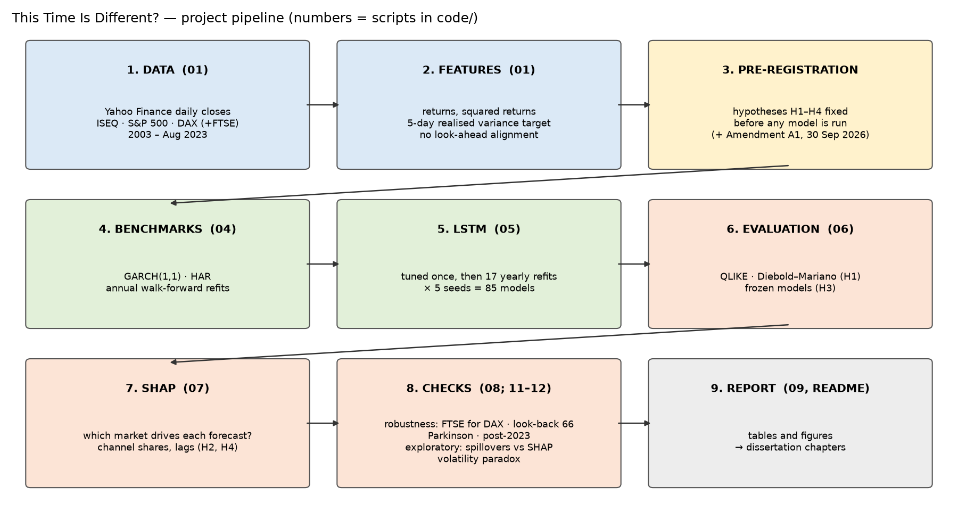
Figure 1. The whole project in one picture. Each box is a stage; the numbers are the scripts in the code folder.
Question | Short answer so far
Does the LSTM forecast Irish volatility better than GARCH and HAR? (RQ1) | No. Over 2007–2023 it is significantly less accurate than GARCH (and than HAR). But it was the most accurate model during COVID-19 and the 2022 shock.
Do the model’s explanations change with each crisis’s origin? (RQ2) | Partly. The US share rose most in the GFC, the euro share rose in the Irish debt crisis, but most pre-registered predictions were only partly met or not met. Ireland’s own market history drives about half of every forecast.
Does a model trained on past crises cope with a new one? (RQ3) | A model trained only on the calm 2003–07 boom failed badly in the GFC (4.3× HAR’s error). A model that had already seen the GFC and the Irish crisis beat HAR in COVID-19.
Are the explanations stable across training runs? (RQ4) | Fully stable in calm periods and 2022, less so in the GFC and the Irish crisis.
Do an econometric spillover measure and long-run crisis history tell the same story? (exploratory, added after the results) | Only partly. A Diebold–Yilmaz spillover measure agrees with the SHAP shares in 4 of 8 direction checks (both put the US highest in COVID-19). Irish volatility was calm before the GFC, but not unusually calm by Ireland’s own 70-year history.

- What is new: explanations used as testable ‘fingerprints’ of how crises travel, compared across crises of different origin, for a small open economy, plus a test of whether models learn from history.
- What is rigorous: hypotheses fixed in advance (pre-registration), strict no-look-ahead forecasting, formal statistical tests, five training seeds, robustness checks.
- What is honest: most hypotheses were not supported, and the report says so.
- What was added later: two exploratory extensions (E1, E2), written into a dated amendment before they were run and labelled exploratory, so they cannot rescue any hypothesis (Parts E10 and H9–H10).

Part B. The story and the theory

B1. Why volatility, not prices?
Stock prices move almost unpredictably from one day to the next — that is the Efficient Market Hypothesis (Fama, 1970). But how much they move is predictable: calm days follow calm days, and wild days follow wild days (volatility clustering; Cont, 2001). So forecasting volatility — the size of moves — is possible without contradicting market efficiency. Volatility matters because it is risk: it drives option prices, risk limits, capital requirements and investors’ decisions.
How to explain it out loud: I don’t try to predict whether the market goes up or down — nobody reliably can. I predict how bumpy the ride will be next week, which is predictable and is what risk managers need.

B2. Why Ireland?
Ireland is a small open economy: its trade, banks and stock market are tightly linked to the US, the UK and the euro area. Its stock market (the ISEQ) was hit by every major crisis of the last twenty years — sometimes from outside (the 2008 global crisis, COVID-19), sometimes partly from inside (the Irish banking and sovereign debt crisis). That makes it an ideal ‘laboratory’ for comparing how crises of different origin arrive.

B3. The three crises (and two test events)
Crisis | Window used | Where it came from | What happened in Ireland
Global Financial Crisis (GFC) | 9 Aug 2007 – 9 Mar 2009 | US sub-prime mortgages → global banking panic | Home-grown property and credit bubble burst at the same time; bank guarantee 30 Sep 2008; ISEQ fell 80.8% from its Feb 2007 peak to Mar 2009
Irish sovereign debt crisis | 23 Apr 2010 – 26 Jul 2012 | Euro-area debt crisis; bank rescues loaded debt onto the state | EU/IMF €85bn programme (Nov 2010); recovery from 2012
COVID-19 | 19 Feb 2020 – 30 Jun 2020 | A global health shock and lockdowns — outside the financial system | ISEQ −9.9% on 12 March 2020
2022 war / energy shock (test) | 10 Feb 2022 – 31 Oct 2022 | Russia’s invasion of Ukraine; energy prices; interest-rate rises | ISEQ −4.6% on 24 Feb 2022
Brexit (test, robustness only) | 1 Jun 2016 – 31 Jul 2016 | UK referendum | ISEQ −7.7% and −9.9% on 24 and 27 June 2016

B4. The theories behind the questions
- Minsky’s Financial Instability Hypothesis: long calm periods encourage risky borrowing until the system becomes fragile — ‘stability breeds instability’. My RQ3 turns this into a test: a model trained only on calm years should fail when the crisis comes.
- Reinhart & Rogoff, ‘This Time Is Different’: crises recur, but each generation thinks the old rules no longer apply. My title asks the machine-learning version: does a model that learned from past crises survive the next one?
- Contagion vs interdependence (Forbes & Rigobon, 2002): markets are always linked (interdependence); contagion means those links become stronger in a crisis. Correlations rise automatically when volatility rises, so naive tests over-find contagion — a caution I apply to my own results.
- Heat waves vs meteor showers (Engle, Ito & Lin, 1990): volatility can come from a market’s own news (a heat wave) or travel in from other markets (a meteor shower). My ‘domestic’ channel is the heat wave; the US and euro channels are meteor showers.
- The volatility paradox (Danielsson, Valenzuela & Zer, 2018): across 60 countries and up to 211 years, long spells of below-trend volatility — not high volatility — came before banking crises, because calm encourages credit and leverage. It is Minsky’s idea measured in data. My exploratory E2 checks whether this happened before each of my crises.

Part C. Glossary — every term in plain words
Grouped by topic. ‘In this project’ tells you exactly where the term appears.

C1. Markets and finance
Term | Meaning in plain words | In this project
Stock index | A number summarising the prices of many shares. | ISEQ Overall (Ireland), S&P 500 (US), DAX (Germany), FTSE 100 (UK)
ISEQ Overall | The index of all shares on Euronext Dublin, Ireland’s stock exchange. | Target market; the ‘domestic’ channel
S&P 500 / DAX / FTSE 100 | Main indices of the US, Germany (euro-area core) and UK markets. | US channel / euro channel / UK robustness channel
Close price | The last price of the trading day. | Only closes are used (Yahoo’s ISEQ opens are unreliable)
Return (log return) | Percentage change, measured as ln(today/yesterday). Log returns add up over days. | ret, us_ret, euro_ret
Squared return | Return × return. Always positive; a rough measure of how big the move was. | r2, us_r2, euro_r2
Volatility / variance | How much prices move. Variance = average squared return; volatility = its square root. | The thing being forecast
Realised variance (RV) | Sum of squared returns over a period — the variance that actually happened. | Target rv5_fwd = next 5 days
Annualised volatility | Volatility scaled to a year: √(5-day variance × 252/5). 20% = a typical year. | All volatility charts
Drawdown | Fall from a previous peak. | ISEQ −80.8% from Feb 2007 to Mar 2009
Volatility clustering | Big moves tend to follow big moves; calm follows calm. | Why volatility can be forecast (Figure: volatility clustering)
Leverage effect | Falls raise future volatility more than rises of the same size. | Why ‘direction’ matters in the GFC SHAP result
Stylised facts | Regular patterns seen in almost all financial returns (Cont, 2001). | Justify the design
Efficient Market Hypothesis | Prices already reflect available information, so returns are unpredictable. | Why the project forecasts risk, not price
Small open economy | A country whose economy depends heavily on foreign trade and capital. | Why Ireland is a good test case
Contagion / interdependence | Crisis-only strengthening of links / normal links. | RQ2 framing
Spillover / transmission channel | The route by which a shock in one market affects another. | Channels: domestic, US, euro (UK)
Bank–sovereign loop | Bank rescues make the government riskier, which makes banks riskier. | Irish debt crisis mechanism (Acharya et al.)
Troika / EU-IMF programme | Rescue loans to Ireland (€85bn, Nov 2010) by the EU, ECB and IMF. | Irish crisis timeline
VIX | Market ‘fear gauge’: expected US volatility from option prices. | Considered and dropped (overlaps S&P 500)
Volatility paradox | Low, calm volatility for a long time makes investors and banks take more risk, which makes a crisis more likely (‘stability is destabilising’). | Exploratory E2 (Danielsson et al., 2018)
OECD share-price index (FRED) | A monthly national stock index published by the OECD; each value is the average of the month’s daily closes. Free from the St. Louis Fed’s FRED website. | E2 data: Ireland (= ISEQ) from 1955, US 1957, Germany 1960

C2. Statistics and econometrics
Term | Meaning in plain words | In this project
Autocorrelation | How much a series is related to its own past values. | Volatility clustering figure
OLS regression | Fits a straight-line relationship by minimising squared errors. | HAR model
R² | Share of variation a regression explains (0 to 1). | HAR R² 0.11 (2007) to ~0.5
GARCH(1,1) | Model where today’s variance = constant + reaction to yesterday’s shock + memory of yesterday’s variance. | Benchmark 1
ω, α, β (GARCH) | Constant; reaction to shocks; memory. α + β = persistence (close to 1 = shocks fade slowly). | α ≈ 0.09, β ≈ 0.90, persistence 0.96–0.999
Student-t distribution / ν | A bell curve with fatter tails; ν (degrees of freedom) — smaller = fatter tails. | GARCH errors; ν ≈ 6–8
HAR model | Regression of future volatility on daily, weekly and monthly past volatility (Corsi, 2009). | Benchmark 2
Log transform | Taking natural logs to make skewed, positive data more symmetric. | Target and squared-return inputs are modelled in logs
Smearing (Duan) | Correction when converting a log forecast back to normal units (exp of an average log is too low). | HAR and LSTM back-transformation
Naive forecast | Simplest possible forecast: next week will look like last week. | Reference only
Loss function | Formula that scores a forecast’s error; lower = better. | QLIKE, MSE
MSE | Mean squared error: average of (actual − forecast)². | Secondary loss
QLIKE | RV/F − ln(RV/F) − 1. Robust to noisy volatility measures; punishes under-prediction more. | Primary loss (Patton, 2011)
Diebold–Mariano (DM) test | Tests whether two forecasts have the same average loss. | H1
HAC / Newey–West | Standard errors that allow for autocorrelation. | Needed because 5-day forecasts overlap
HLN correction | Small-sample adjustment to the DM test (Harvey, Leybourne & Newbold, 1997). | Every DM test
p-value | Probability of a result at least this extreme if there were really no difference. Below 0.05 = ‘significant’. | e.g. p = 0.003 LSTM vs GARCH
Confidence interval | A range that captures the uncertainty of an estimate (95% here). | SHAP channel shares
Bootstrap / block bootstrap | Estimate uncertainty by re-sampling the data many times; blocks keep neighbouring days together. | SHAP intervals (blocks of 10 days)
Spearman correlation | Agreement between two rankings (−1 to 1). | RQ4 stability
Stationarity | Statistical properties that do not drift over time. | Why log volatility is modelled
Vector autoregression (VAR) | A system of regressions in which each market’s value today depends on the recent past of all markets. | E1: VAR(4) on log volatility of ISEQ, S&P 500 and DAX
Forecast-error variance decomposition (FEVD) | Splits the uncertainty of a VAR forecast into the parts caused by shocks in each market. | E1
Generalized FEVD (Pesaran & Shin, 1998) | A version whose answer does not depend on the order in which the markets are listed; rows are rescaled to add up to 1. | E1 (Diebold & Yilmaz, 2012)
Spillover (connectedness) index | Share of forecast uncertainty that comes from other markets; the ‘total’ index averages it over all markets. | E1: 34.0% over 2003–2023
Directional / net spillover | How much a market gives to (‘to’) or receives from (‘from’) the others; net = to − from. Negative = net receiver. | ISEQ net −8.4 (receiver); US +7.7 (transmitter)
Rolling window | Re-estimating on the most recent fixed number of days, moving one day at a time. | E1: 200 days (100 and 300 as sensitivity)
Hodrick–Prescott (HP) filter | Splits a series into a smooth trend and deviations from it; λ sets how smooth the trend is. | E2: λ = 5,000, as in Danielsson et al.
One-sided (recursive) filter | A trend estimated at each date from past data only — no look-ahead. | E2 trend
Winsorising | Capping extreme values at chosen percentiles instead of deleting them. | E2: monthly returns capped at 0.5% / 99.5%
Percentile rank | Where a value sits in a distribution: the 20th percentile = lower than 80% of values. | E2: ‘unusually calm’ = bottom 20%

C3. Machine learning
Term | Meaning in plain words | In this project
Neural network | A flexible function built from layers of simple units, fitted to data. | LSTM
RNN | Recurrent neural network: reads a sequence step by step, keeping a memory. | LSTM is a kind of RNN
LSTM | Long Short-Term Memory network: an RNN with gates that decide what to remember, forget and output. | The main model
Gates (input, forget, output) | Learned switches controlling the LSTM’s memory (cell state). | Model explanation
Hidden units / layers | Size and depth of the network. | 64 units, 2 layers (tuned)
Look-back window | How many past days the model sees for each forecast. | 22 trading days (≈ one month)
Dropout | Randomly switching off units during training to prevent over-fitting. | 0.2
Epoch / batch | One pass over the training data / the number of examples per update. | 16–40 epochs; batch 64
Adam / learning rate | The optimisation algorithm / its step size. | Adam, 0.001
Training / validation / test | Data to fit on / to decide when to stop / to judge the final model — never mixed. | Validation = last 12 months of each training window
Early stopping | Stop training when validation error stops improving (patience = 15 epochs). | Every LSTM fit
Over-fitting | Memorising training data instead of learning general patterns. | Prevented by early stopping and dropout
Standardisation (scaler) | Rescaling inputs to mean 0, standard deviation 1 — fitted on training data only. | Every LSTM fit
Hyperparameter / tuning grid | Settings chosen before training / the small set of settings compared. | 8 configurations, chosen once, then frozen
Random seed | Starting number for the random parts of training; different seeds give slightly different models. | 5 seeds per year
Walk-forward / expanding window | Train on the past, forecast the next year, add that year, repeat. | 17 annual refits (2007–2023)
Out-of-sample | Forecasts for data the model has never seen. | All reported accuracy
Data leakage / look-ahead bias | Accidentally using future information — makes results look better than they are. | Prevented by design (Part E)
Frozen model | A model trained once and never updated. | RQ3

C4. Explainable AI
Term | Meaning in plain words | In this project
Explainability (XAI) | Methods that show why a model made a prediction. | SHAP
Shapley value | From game theory: a fair way to split a team’s payoff among players. | Theory behind SHAP
SHAP | SHapley Additive exPlanations: splits each forecast into contributions from each input (Lundberg & Lee, 2017). | RQ2, RQ4
Attribution | The contribution SHAP gives to one input for one forecast. | 132 per forecast (6 inputs × 22 days)
Baseline / background | The reference inputs a forecast is compared against. | 200 real windows from the model’s own training period
Additivity (completeness) | Attributions add up to (forecast − average forecast). | Checked: average gap 0.02
GradientShap / expected gradients | A fast SHAP method for neural networks using gradients (Erion et al., 2021). | Captum library, 1,024 samples
Integrated Gradients | Exact path-based attribution method (Sundararajan et al., 2017). | Cross-check in the smoke test
Channel share | Share of total |attribution| belonging to one market’s inputs. | Main SHAP measure
Lag profile | Share of attribution by how many days back the input is. | ‘How far back the model looks’
Fingerprint | The pattern of channel shares in a crisis window. | Compared across crises (RQ2)

C5. Research design
Term | Meaning in plain words | In this project
Research question (RQ) | The question the study answers. | RQ1–RQ4
Hypothesis (H) | A testable prediction; H0 = no effect. | H1–H4 (H2 has parts a–e)
Pre-registration | Writing hypotheses and methods down, dated, before seeing results. | PREREGISTRATION.md, committed before any model ran
Falsifiable | Could be shown wrong by the data. | Every hypothesis
Robustness check | Re-running with a different reasonable choice to see if conclusions hold. | FTSE, look-back 66, Parkinson, post-2023
Reproducibility | Anyone can re-run the code and get the same results. | Fixed seeds, cached data, scripts
Positivist / deductive | Knowledge from measurement / start from theory, test with data. | Research philosophy
Longitudinal time-series study | Following the same markets over time (not cross-sectional). | 2003–2023
Confirmatory vs exploratory analysis | Confirmatory = tests a hypothesis fixed in advance; exploratory = looks for patterns, chosen later, and cannot confirm anything. | H1–H4 confirmatory; E1–E2 exploratory
Amendment (to a pre-registration) | A dated, reasoned change or addition made after the original pre-registration, recorded before the new analysis is run. | Amendment A1, 30 Sep 2026 (commit 9c89f79)

Part D. The data

D1. Source and markets
Market | Yahoo ticker | Role | Why it was chosen
ISEQ Overall (Ireland) | ^ISEQ | Target and domestic channel | The market being forecast
S&P 500 (US) | ^GSPC | US channel | Origin of the GFC; largest market
DAX (Germany) | ^GDAXI | Euro channel | Euro-area core (Euro Stoxx 50 only on Yahoo from 2007)
FTSE 100 (UK) | ^FTSE | Robustness only | Strongest link with ISEQ (0.71) but overlaps DAX (0.84)

Daily Open/High/Low/Close/Volume downloaded with the free Python library yfinance, from 1 Oct 2002 to 30 Dec 2025, cached in data/raw so the study is reproducible. Main sample: 2 Jan 2003 – 31 Aug 2023 (5,243 complete trading days). Sep 2023 – Dec 2025 is used only for robustness.
Second source (exploratory E2 only): OECD monthly share-price indices from FRED — Ireland SPASTT01IEM661N (from January 1955), United States SPASTT01USM661N (1957) and Germany SPASTT01DEM661N (1960). Each monthly value is the average of the month’s daily closes; the Irish series is the ISEQ (monthly-return correlation 0.9996 with the Yahoo ISEQ, 2002–2025). Script 12 caches them in data/raw/FRED_*.csv. They are needed because a trend estimated only from the past needs decades of history.

D2. Every variable in the model dataset (data/processed/dataset.csv)
Column | Formula / meaning | Used by
ret | ISEQ log return: ln(close t / close t−1) | LSTM input; GARCH
r2 | ret² (LSTM uses ln(r2), floored at 1e-8) | LSTM input
rv5_fwd | r²(t+1) + … + r²(t+5): realised variance over the NEXT 5 days — the target | All models (target)
log_rv5_fwd | ln(rv5_fwd) | HAR and LSTM learn in logs
rv_d, rv_w, rv_m | r² today; mean of last 5 days; mean of last 22 days | HAR inputs
us_ret, us_r2 | S&P 500 log return and its square, as of day t | LSTM inputs (US channel)
euro_ret, euro_r2 | DAX log return and its square | LSTM inputs (euro channel)
uk_ret, uk_r2 | FTSE 100 log return and its square | Robustness run only
crisis | Label of the evaluation window (or ‘calm’) — never a model input | Evaluation only

D3. Data decisions, each with its evidence
Decision | Evidence | Why it matters
Use only closing prices; reject Garman–Klass volatility | Yahoo’s ISEQ ‘open’ equals the previous close on 38–75% of days in some periods; GK vs squared returns monthly correlation only 0.54 in 2003–06 | A volatility measure built on fake opening prices would be wrong
Target = next 5 days’ realised variance | One day’s squared return is very noisy; five days average the noise and match HAR’s weekly component | Less noisy target; ML gains larger at weekly horizons (Christensen et al., 2023)
Start Jan 2003 (drop the dot-com crash) | Only 668 days before the dot-com peak; Irish volatility barely rose then (median 14.9% vs 13.1%); a 2005 start leaves only 659 days before the GFC, 2003 gives 1,166 | Enough training history before the GFC
End Aug 2023 | CRH, Flutter and Smurfit left the ISEQ in 2023–24 (≈€74bn of ≈€152bn ISEQ 20 value) | After that the index is a different basket
Three markets (drop Nasdaq, VIX, US 10-year yield) | Nasdaq–S&P 0.95; VIX–S&P −0.73; yield–ISEQ 0.05 | Overlapping inputs make SHAP split credit arbitrarily (Aas et al., 2021)
Align foreign data as of day t | New York closes ≈21:00 Irish time; forecast issued 08:00 next morning | Uses only information truly available — no look-ahead

How to explain it out loud: I used free public data from Yahoo Finance for three stock markets. Before modelling I checked the data: the Irish opening prices turned out to be unreliable, so I only used closing prices; the index lost its three biggest companies in 2023, so I stopped the main sample there; and some candidate markets were almost copies of each other, so I kept three clearly different ones.

Part E. The methods

E1. The forecasting task
Every trading day t (2007 – Aug 2023), each model forecasts rv5_fwd(t): how much the ISEQ will move over the next five trading days, using only information available by the morning of day t+1. 4,230 forecast days in total.

E2. Benchmark 1 — GARCH(1,1) with Student-t errors
variance(t) = ω + α · shock(t−1)² + β · variance(t−1)
5-day forecast = sum of the 1-, 2-, 3-, 4- and 5-day-ahead variance forecasts

Estimated by maximum likelihood (Python ‘arch’ library) on daily ISEQ returns. Refitted once a year on all data up to 31 December; within the year the parameters are fixed but the forecasts update daily with new returns. Typical values: α ≈ 0.09, β ≈ 0.90, persistence α+β 0.957–0.999, tail parameter ν ≈ 6–8.
How to explain it out loud: GARCH says: tomorrow’s risk is a bit of a long-run average, plus a reaction to today’s surprise, plus most of today’s risk carried forward. It is the industry standard and famously hard to beat.

E3. Benchmark 2 — HAR
ln RV(next 5 days) = c + b_d · ln(today) + b_w · ln(last week avg) + b_m · ln(last month avg) + error

Estimated by OLS on the expanding window each year; the log forecast is converted back with Duan smearing. The monthly term carries most weight (b_m ≈ 0.43–0.73). The last 5 training days are dropped because their targets reach into the test year.
How to explain it out loud: HAR says: next week’s risk depends on today’s, last week’s and last month’s risk — like traders who look at different horizons. It is simple, and the standard benchmark for realised volatility.

E4. The LSTM
Element | Choice | Why
Inputs per day | 6: ISEQ, S&P 500 and DAX return and log squared return | Direction and size of moves in each market
Look-back | 22 trading days (≈ 1 month) | Tuned (66 was the alternative)
Architecture | 2 LSTM layers × 64 units → dropout 0.2 → one linear output | Tuned on the first windows only
Target | standardised ln(rv5_fwd) | Symmetric, always positive after back-transform
Training | Adam, learning rate 0.001, batch 64, up to 200 epochs, early stopping (patience 15) | Standard, prevents over-fitting
Validation | last 12 months of each training window | Decides when to stop; estimates the smearing factor
Refits | every year 2007–2023, expanding window, 5 seeds each (85 models) | Same protocol as the benchmarks
Forecast | mean of the 5 seeds, back-transformed with smearing | Reduces randomness from any single run

How to explain it out loud: The LSTM reads the last month of daily moves in the three markets, one day at a time, and keeps a memory of what matters. I train it on everything up to the end of each year, forecast the next year, then retrain — exactly as someone would have done in real time. I train five copies with different random starts and average them.

E5. How leakage (using the future) is prevented
- Every model is trained only on data up to 31 December before the year it forecasts.
- Scalers (standardisation) are fitted on training data only.
- The 5 days before each boundary are dropped, because their 5-day targets cross it.
- Foreign data are joined ‘as of’ day t, never t+1.
- Crisis labels are used only to split the evaluation — the models never see them.
- Tuning used only the first two windows; the chosen settings were then frozen.
- Hypotheses were committed to Git before any model was run; each script was committed before its results.

E6. How forecasts are judged
- QLIKE (primary): RV/F − ln(RV/F) − 1, averaged over days. 0 = perfect. It is ‘robust’: with a noisy measure of true volatility it still ranks forecasts correctly (Patton, 2011).
- MSE (secondary): average squared error.
- Diebold–Mariano test with HLN correction: is the average difference in loss between two models different from zero? Uses autocorrelation-robust errors with 4 lags because 5-day forecasts overlap.
- By window: losses are reported for calm days and each crisis; per-window tests are descriptive only (small samples).

E7. The ‘learning from history’ test (RQ3)
For each crisis, 5 LSTMs are trained only on data up to the day before the crisis window and never updated. Their QLIKE in the window is divided by HAR’s QLIKE. A ratio above 1 means worse than HAR. The annually refitted LSTM’s ratio is shown alongside.

E8. Explaining the LSTM with SHAP (RQ2, RQ4)
1. For each forecast day, take the model that actually made it (right year, each of the 5 seeds).
2. Pick 200 random input windows from that model’s training period as the reference (background).
3. Run GradientShap with 1,024 samples: each of the 132 inputs (6 inputs × 22 days) gets an attribution; together they add up to (forecast − average forecast).
4. Take absolute values and add them up by channel (domestic / US / euro), by lag (t-0 … t-21) and by type (returns vs squared returns).
5. Channel share = channel total ÷ grand total, per window (average of seeds).
6. 95% intervals: block bootstrap over days (blocks of 10 consecutive explained days, 1,000 draws).
7. ‘Rises’ = the window’s interval lies entirely above the calm-period share (pre-registered rule).
8. Stability: Spearman correlation of channel shares between every pair of seeds.
How to explain it out loud: SHAP asks: for this forecast, how much did each input push it up or down compared with a typical day? Adding those pushes up by market tells me which market the model was ‘listening to’. It describes the model, not the world — so I call the patterns fingerprints, not proof of contagion.

E9. Robustness checks
Check | What changes | Status
Parkinson volatility proxy | Forecasts are re-scored against high–low range volatility (2007–2023) | Done
FTSE instead of DAX (+ Brexit test) | Euro channel replaced by the UK; Brexit window explained (H2d) | Stopped at 58/85 models; to re-run
Look-back 66 days | LSTM sees three months instead of one | Not yet run
Extension Sep 2023 – Dec 2025 | After the ISEQ composition break | Not yet run

E10. Exploratory extensions (Amendment A1, added 30 Sep 2026)
Two extra analyses were chosen after the main results were known, so they are exploratory: no pass/fail rule, no effect on any hypothesis verdict, reported in full whatever they show. Their specification was written into PREREGISTRATION.md (Amendment A1) and committed to Git before either script was run (commit 9c89f79).
E1 — Does an econometric spillover measure agree with SHAP? Diebold & Yilmaz (2012) measure transmission with a VAR: how much of the uncertainty in forecasting one market’s volatility comes from shocks in each other market.
v(t) = log 5-day realised variance of [ISEQ, S&P 500, DAX] (same aligned data as the LSTM)
v(t) = c + B1·v(t−1) + B2·v(t−2) + B3·v(t−3) + B4·v(t−4) + e(t) VAR(4), OLS
share(i ← j) = Σh [(A_h Σ)ij]² / Σjj ÷ Σh (A_h Σ A_h′)ii, h = 0 … 9 (generalized FEVD)
then each row is rescaled to add up to 1

- Estimated on the 200 days up to each forecast day, moving one day at a time (as in Diebold & Yilmaz, 2012: VAR(4), 10-day horizon, 200-day windows).
- The ISEQ row gives three shares — own, from the US, from the DAX — directly comparable with the SHAP channel shares (domestic, US, euro). They are averaged over exactly the days explained with SHAP.
- Comparison (descriptive): does the change from calm have the same sign in both measures (4 crisis windows × 2 foreign channels = 8 checks)? Do both rank US vs euro the same way (5 windows)?
- Sensitivity: daily log squared returns instead of 5-day variance; 100- and 300-day windows.
- My own code (numpy) was checked against statsmodels on simulated data: coefficients, moving-average matrices and variance decompositions all matched.
How to explain it out loud: SHAP asks which markets the neural network listens to. Diebold–Yilmaz asks a simple linear model how much of Ireland’s forecast uncertainty comes from shocks in each market. If two very different tools tell the same story, the story is more believable; where they disagree, I learn what each tool measures.

E2 — Were the crises preceded by unusually calm markets? Danielsson, Valenzuela & Zer (2018) found that long spells of volatility below its trend come before banking crises. I apply their measure, market by market, with 70 years of monthly data.
σ(t) = standard deviation of the 12 monthly returns July (t−1) – June (t) × √12
τ(t) = last point of an HP trend (λ = 5,000) fitted to σ(first year … t) only one-sided
δlow(t) = min(σ(t) − τ(t), 0)
measure = mean δlow over the 5 July–June years before a window starts;
percentile within the same market’s history; bottom 20% = ‘unusually calm’

- Pre-crisis years: GFC 2003–07; Irish debt crisis 2005–09; COVID-19 2015–19.
- Expectation written in advance: calm before the credit-driven GFC (Ireland and the US), not before COVID-19 (an outside shock). One observation per market and crisis, so descriptive only.
- Differences from the paper: nominal (not inflation-adjusted) returns; monthly averages, not month-end prices; single markets, so no panel regression.
- Cross-check: FRED and Yahoo annual volatility correlate 0.89–0.91 (2004–23).
How to explain it out loud: Economists have noticed that long quiet spells in markets often come before banking crises, because calm encourages borrowing. I checked whether that happened before my three crises, using 70 years of Irish, US and German market data.

Part F. The code, script by script
All scripts are in code/ and are run in number order. Two shared modules hold the pieces every step must use identically: evaluation.py (windows, loss functions, the Diebold–Mariano test) and lstm_common.py (data preparation, the network, training and forecasting). Every script was committed to Git before its results.

F1. 01_data_pipeline.py — build the dataset
Item | Details
Purpose | Download the market data, check its quality, build the target and inputs, and draw the crisis chart.
Reads | Yahoo Finance (via yfinance), then the cached files in data/raw/
Writes | data/raw/*.csv, data/processed/dataset.csv, data/data_quality_report.txt, figures/crisis_chart.png
Run time | seconds (first run downloads data)

What it does, step by step:
1. Download ISEQ, S&P 500, DAX and FTSE daily prices (1 Oct 2002 – 30 Dec 2025) once, and cache them.
2. Compute ISEQ log returns and squared returns.
3. Build the target: the sum of the next five days’ squared returns.
4. Build HAR inputs: today’s, last week’s and last month’s average squared return.
5. Join each foreign market ‘as of’ the same date (never a later date) and compute its return and square.
6. Label evaluation windows (for evaluation only).
7. Run data-quality checks (stale opens, Garman–Klass vs Parkinson) and window statistics; save the report.
8. Draw the crisis chart.
Key lines (from your own code):
r = np.log(iseq["Close"]).diff() # daily log return
r2 = r ** 2
data["rv5_fwd"] = sum(r2.shift(-k) for k in range(1, 6)) # next 5 days = target
data["rv_w"] = r2.rolling(5).mean() # HAR weekly input
data = pd.merge_asof(data, feat, left_index=True, right_index=True,
direction="backward") # no look-ahead

How to explain it out loud: This script turns raw prices into the table the models learn from. The key idea is the target: for each day, the total squared movement over the next five days. Foreign markets are attached using only values known by that date.

F2. 02_handbook_figures.py — descriptive figures
Item | Details
Purpose | Six charts that show the data’s key features before any model: event windows, the calm boom, rolling correlations, volatility clustering, HAR ingredients, trading hours.
Reads | data/raw/*.csv
Writes | figures/hb_*.png
Run time | seconds

What it does, step by step:
1. Put all markets on the Irish trading calendar.
2. Plot each figure (see Part G).
How to explain it out loud: These are pictures of the raw facts — no modelling — used to motivate the design.

F3. 03_shap_smoke_test.py — tooling check
Item | Details
Purpose | Prove that the LSTM + GradientShap tooling works and that attributions add up, without looking at any crisis window.
Reads | data/processed/dataset.csv
Writes | figures/smoke_test_shap.png
Run time | about 30 seconds

What it does, step by step:
1. Train one small LSTM on 2003–2015, stop on 2016.
2. Explain only calm days in 2017 with GradientShap at 64, 256 and 1,024 samples.
3. Check additivity: gap fell 0.082 → 0.043 → 0.021; Integrated Gradients error ≈ 0.
4. Summarise by channel, input type and lag.
How to explain it out loud: Before the real analysis I tested the explanation tool on ordinary days only, so that nothing about the crises could influence my hypotheses.

F4. evaluation.py — shared evaluation rules
Item | Details
Purpose | One definition of the windows, the losses and the statistical test, imported by every step.
Reads | —
Writes | —
Run time | —

What it does, step by step:
1. WINDOWS: the five evaluation windows with their dates.
2. qlike(), mse(): the loss functions.
3. dm_hln(): Diebold–Mariano test with 4-lag long-run variance, HLN correction, t distribution.
4. loss_table(): mean losses per model for all days and each window.
Key lines (from your own code):
ratio = realised / forecast
qlike = ratio - np.log(ratio) - 1

lrv = gamma[0] + 2 * sum(gamma[1:]) # autocovariances up to lag h-1
dm = dbar / np.sqrt(lrv / n)
hln = dm * np.sqrt((n + 1 - 2*h + h*(h - 1)/n) / n) # small-sample correction

How to explain it out loud: Keeping the rules in one file guarantees every model is judged in exactly the same way.

F5. 04_benchmarks.py — GARCH and HAR
Item | Details
Purpose | Produce the benchmark forecasts with annual walk-forward refits.
Reads | data/processed/dataset.csv
Writes | results/benchmark_forecasts.csv, benchmark_losses.csv, benchmark_parameters.csv, figures/benchmark_forecasts.png
Run time | about 10 seconds

What it does, step by step:
1. For each test year 2007–2023: fit HAR (OLS in logs) on data up to 31 Dec of the previous year, dropping the last 5 days; back-transform with smearing.
2. Fit GARCH(1,1)-t on returns up to 31 Dec; forecast 1–5 days ahead from every day of the test year with fixed parameters; sum the five variances.
3. Add a naive reference (last week’s variance × 5).
4. Compute losses by window and the HAR-vs-GARCH DM test; plot.
Key lines (from your own code):
fit = sm.OLS(har_y.loc[tr], X).fit()
smear = np.mean(np.exp(fit.resid)) # Duan smearing
am = arch_model(returns, mean="Constant", vol="GARCH", p=1, q=1, dist="t")
res = am.fit(last_obs=start, disp="off") # data before the test year only
fc = res.forecast(horizon=5, start=test[0], reindex=False)

How to explain it out loud: Each year I re-estimate both classic models on everything known so far and forecast the whole next year. The ‘arch’ library’s alignment was checked on simulated data first.

F6. lstm_common.py — the LSTM set-up
Item | Details
Purpose | Everything the LSTM steps share, so the walk-forward, frozen models and SHAP use one identical set-up.
Reads | data/processed/dataset.csv
Writes | models/lstm/*.pt (via the scripts that call it)
Run time | —

What it does, step by step:
1. load_frame(): inputs (logs of squared returns) and the log target.
2. LSTMVol: LSTM layers → dropout → linear output from the last day’s hidden state.
3. split_positions(): fit rows and validation rows (last 12 months), with 5-day gaps at each boundary.
4. fit_model(): scale on fit rows only, train with Adam and early stopping, compute the smearing factor.
5. forecast(): build 22-day windows, predict, back-transform.
6. save_bundle()/load_bundle(): store models with their scalers.
Key lines (from your own code):
out, _ = self.lstm(x) # read the 22-day sequence
return self.head(self.drop(out[:, -1])).squeeze(-1) # forecast from the last day

val_start = train_end - pd.DateOffset(years=1) + pd.Timedelta(days=1)
fit = np.where(ok & has_y & (dates < val_start))[0][:-HORIZON] # 5-day gap

How to explain it out loud: This file is the recipe for one LSTM: what it sees, how it is trained, when it stops and how its output is turned back into a variance forecast.

F7. 05_lstm_walkforward.py — tune once, then 85 models
Item | Details
Purpose | Choose the LSTM settings on the first windows only, freeze them, then run the full walk-forward.
Reads | data/processed/dataset.csv
Writes | results/lstm_tuning.csv, lstm_training_log.csv, lstm_forecasts.csv; models/lstm/
Run time | about 15 minutes

What it does, step by step:
1. Tuning: 8 settings (look-back 22/66 × units 32/64 × layers 1/2) × refits for 2007 and 2008 × 2 seeds; pick the lowest mean validation loss → 22 / 64 / 2.
2. Walk-forward: 17 years × 5 seeds = 85 models, run in parallel (6 processes).
3. Forecast each test year with each seed; average the 5 seeds.
How to explain it out loud: I let the data choose the settings once, using only the earliest years, then locked them in so the test years could not influence the choice.

F8. 06_evaluation.py — the pre-registered tests
Item | Details
Purpose | Test H1 (accuracy) and H3 (learning from history).
Reads | results/benchmark_forecasts.csv, lstm_forecasts.csv
Writes | results/evaluation_losses.csv, evaluation_dm_tests.csv, evaluation_frozen.csv, figures/evaluation_*.png
Run time | about 3 minutes

What it does, step by step:
1. Loss table for LSTM, GARCH, HAR and naive, all days and each window.
2. DM-HLN tests LSTM vs GARCH and vs HAR (QLIKE and MSE), overall and per window.
3. Train frozen LSTMs up to the day before each crisis (5 seeds each), forecast the window, compare with HAR.
4. Print verdicts against the pre-registered rules; draw figures.
How to explain it out loud: This is where the predictions I wrote down in advance are checked against the data.

F9. 07_shap.py — explanation analysis
Item | Details
Purpose | Test H2 (fingerprints) and H4 (stability).
Reads | results/lstm_forecasts.csv, models/lstm/*.pt
Writes | results/shap_*.csv, figures/shap_channel_shares.png, figures/shap_lag_profiles.png
Run time | about 21 minutes (7.7 GB RAM: 2 workers)

What it does, step by step:
1. Select every day in each crisis window plus every 10th calm day (1,547 days).
2. For each day and seed, explain the model that made the forecast with GradientShap (1,024 samples, background of 200 training windows), 4 days at a time to fit memory.
3. Aggregate |attributions| by channel, lag and input type; bootstrap intervals; seed stability.
4. Apply the pre-registered verdict rules; draw figures. A DISS_VARIANT=ftse setting runs the FTSE robustness version.
Key lines (from your own code):
gs = GradientShap(b["model"])
attr = gs.attribute(xe[i:i + CHUNK], baselines=bg,
n_samples=1024, stdevs=0.0) # 22 days x 6 inputs per forecast

How to explain it out loud: For each forecast, SHAP splits the prediction into pushes from each input. I add the pushes up by market and compare crises with calm periods.

F10. 08_robustness.py — robustness checks
Item | Details
Purpose | Re-run the key results with different reasonable choices.
Reads | results files; data/raw/ISEQ.csv
Writes | results/robust_*.csv, robustness_summary.csv
Run time | about 1–1.5 hours for all parts

What it does, step by step:
1. parkinson: re-score forecasts against range-based volatility (done).
2. ftse: LSTM with FTSE instead of DAX; ftse_shap: Brexit test (H2d).
3. lookback66: LSTM with a 3-month look-back.
4. extension: Sep 2023 – Dec 2025.
5. summary: one comparison table.
How to explain it out loud: If a conclusion only holds for one particular choice, it is fragile. These checks show which conclusions survive.

F11. 09_report_figures.py and 10_pipeline_diagram.py
Item | Details
Purpose | Report figures from saved results only (forecasts in each crisis) and the pipeline diagram.
Reads | results/*.csv
Writes | figures/report_crisis_forecasts.png, figures/project_pipeline.png
Run time | seconds

What it does, step by step:
1. Plot realised vs forecast volatility in four windows.
2. Draw the project diagram.
How to explain it out loud: Presentation only — no model is re-run.

F12. 11_connectedness.py — exploratory E1: spillovers vs SHAP
Item | Details
Purpose | Compute Diebold–Yilmaz spillovers among ISEQ, S&P 500 and DAX volatility and compare them with the SHAP channel shares (Amendment A1).
Reads | data/processed/dataset.csv, results/lstm_forecasts.csv (which days SHAP explained), results/shap_channel_shares.csv
Writes | results/connectedness_full_sample.csv, connectedness_rolling.csv, connectedness_vs_shap.csv, connectedness_agreement.csv; figures/connectedness_rolling.png, connectedness_vs_shap.png
Run time | about 7 seconds

What it does, step by step:
1. Build log 5-day realised variance for the three markets from the aligned dataset.
2. For every day, fit a VAR(4) by OLS on the previous 200 days and compute the generalized variance decomposition at 10 days; keep the ISEQ row and the total spillover index.
3. Average the ISEQ row over the SHAP days in each window; compare with the SHAP shares (changes from calm, US-vs-euro ranking).
4. Repeat for the three sensitivity settings; save tables and draw two figures.
Key lines (from your own code):
X = np.hstack([np.ones((T - p, 1))] + [Y[p - j:T - j] for j in range(1, p + 1)])
coef = np.linalg.lstsq(X, Y[p:], rcond=None)[0] # VAR(4) by OLS
num = sum((a @ sigma) ** 2 for a in A) / np.diag(sigma) # generalized FEVD
den = sum(np.diag(a @ sigma @ a.T) for a in A)
theta = num / den[:, None]
return theta / theta.sum(axis=1, keepdims=True) # each row adds up to 1

How to explain it out loud: The script asks a classic econometric model the same question SHAP answered for the LSTM — which markets matter for Irish volatility — so the two answers can be compared window by window.

F13. 12_volatility_paradox.py — exploratory E2: calm before the storm?
Item | Details
Purpose | Apply Danielsson, Valenzuela & Zer’s (2018) low-volatility measure to Ireland, the US and Germany with monthly data from the 1950s (Amendment A1).
Reads | FRED (downloaded once, cached in data/raw/FRED_*.csv); data/raw/ISEQ.csv, GSPC.csv, GDAXI.csv for the cross-check
Writes | results/volatility_paradox_annual.csv, volatility_paradox_crises.csv, volatility_paradox_crosscheck.csv; figures/volatility_paradox.png
Run time | about 4 seconds

What it does, step by step:
1. Monthly log returns, winsorised at 0.5% / 99.5%.
2. Annual volatility from the 12 returns July–June (as in the paper), annualised.
3. One-sided HP trend (λ = 5,000): for each year, fit the filter to past years only and keep the last point.
4. Below-trend part δlow; its mean over the 5 years before each window; percentile within the market’s history.
5. Cross-check the FRED volatility against the Yahoo daily data (2004–2023); draw the figure.
Key lines (from your own code):
r = r.clip(r.quantile(0.005), r.quantile(0.995)) # winsorise
(g.std() * np.sqrt(12))[g.size() == 12] # July–June annual volatility
trend = [hpfilter(x[:t + 1], lamb=LAMBDA)[1][-1] for t in ...] # one-sided HP trend
low = dev.clip(upper=0) # below-trend part
low5 = low.rolling(L).mean().shift(1) # mean over the 5 years before

How to explain it out loud: The script measures how long and how far each market’s volatility stayed below its normal level before each crisis, and whether that calm was unusual for that market’s own history.

Part G. Every graph, explained
For each figure: what it shows, how to read it, the take-aways, and where it belongs in the dissertation.

G1. The Irish market 2003–2025 with the crisis windows
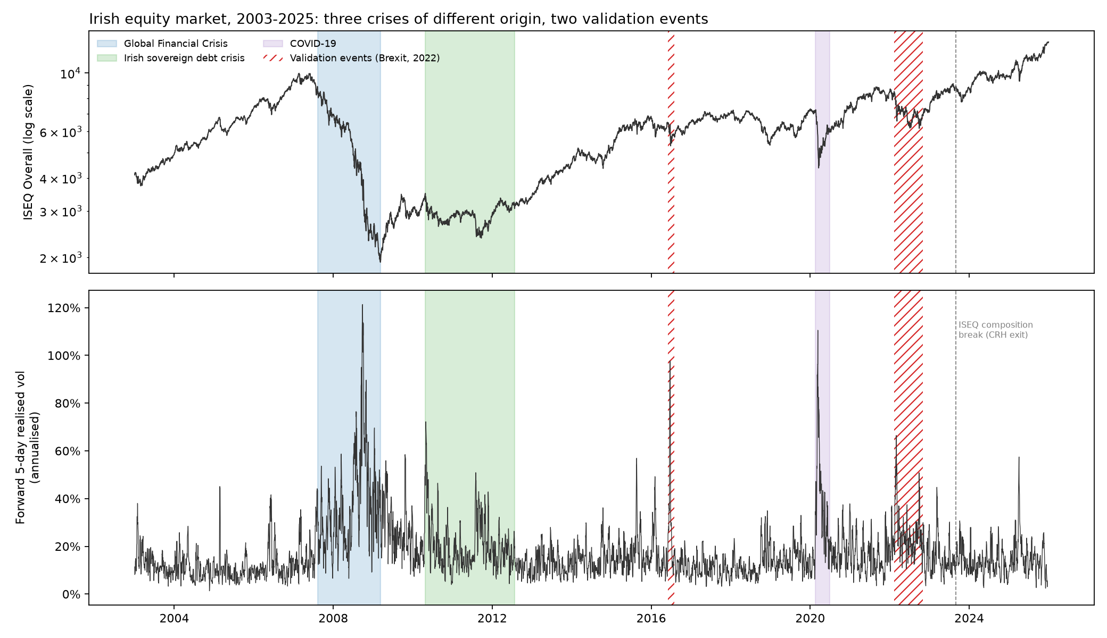
Figure 2. G1. The Irish market 2003–2025 with the crisis windows
Aspect | Explanation
What it shows | Top: the ISEQ index level (log scale). Bottom: forward 5-day realised volatility (annualised).
Axes and marks | x = date. Top y = index level on a log scale (equal distances = equal % changes). Bottom y = volatility (20% = normal year). Shaded = crisis windows; hatched = test events; dashed line = Sep 2023 break.
How to read it | Look for spikes in the bottom panel and match them to the shading.
Key take-aways | The GFC is by far the largest and longest spike (peak 121%); COVID is short and sharp (110%); Brexit is a single sharp spike (98%); calm years sit around 10–20%.
Where it goes | Chapter 3 (data) or Chapter 1 (motivation)

G2. How six shocks reached the Irish market
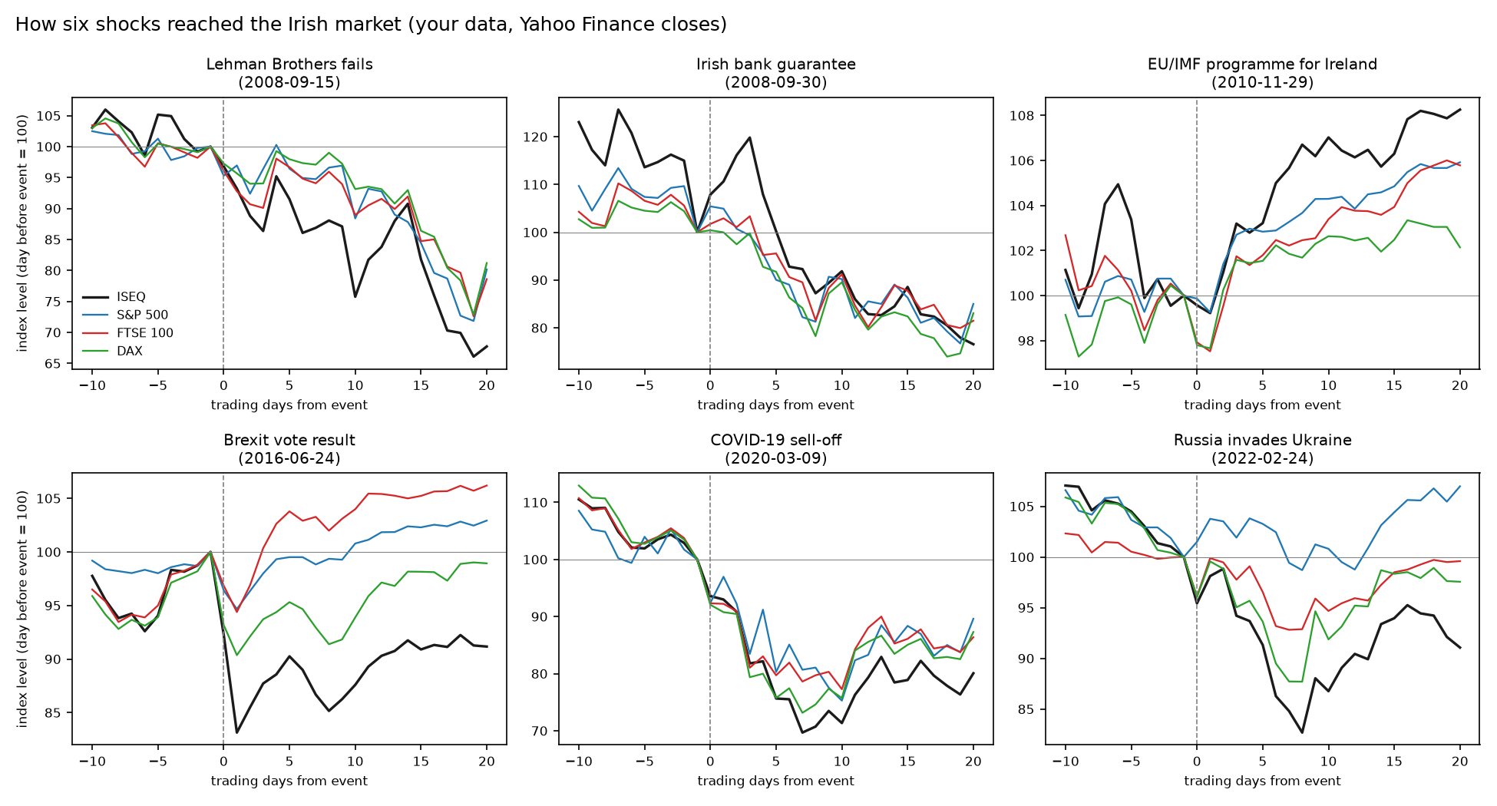
Figure 3. G2. How six shocks reached the Irish market
Aspect | Explanation
What it shows | Each panel: ISEQ, S&P 500, FTSE 100 and DAX from 10 days before to 20 days after an event, rescaled to 100 on the day before.
Axes and marks | x = trading days from the event; y = index level (100 = day before).
How to read it | Compare the black line (ISEQ) with the others after day 0.
Key take-aways | After Lehman the ISEQ fell further than the others; on guarantee day it jumped while others didn’t; after Brexit it fell hardest (the FTSE is in sterling, which fell); in 2022 ISEQ and DAX fell more than the S&P.
Where it goes | Chapter 2 (crisis history) or Chapter 4 (descriptives)

G3. Stability before the storm (Minsky)
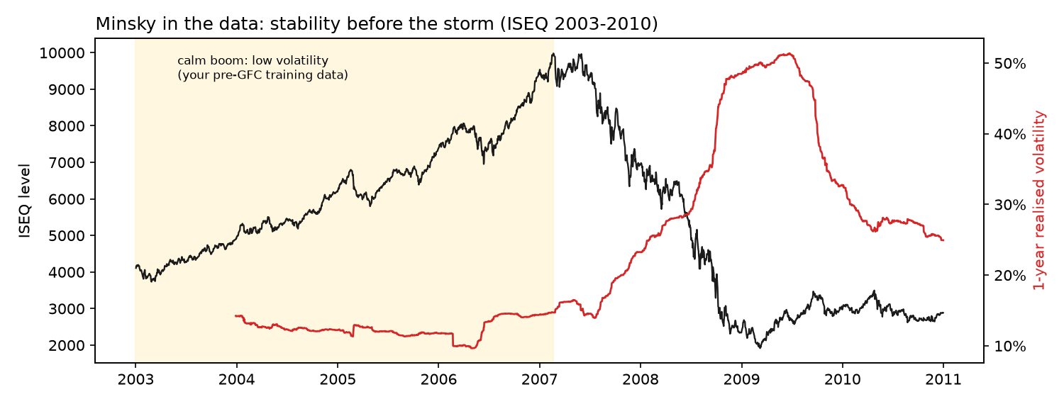
Figure 4. G3. Stability before the storm (Minsky)
Aspect | Explanation
What it shows | ISEQ level (black) and 1-year realised volatility (red), 2003–2010.
Axes and marks | Left y = index; right y = volatility. Yellow = calm boom (= pre-GFC training data).
How to read it | Watch the red line stay low while the index doubles, then shoot up.
Key take-aways | Volatility was 10–15% during the boom and about 50% in 2008–09 — the environment the first LSTM learned from was nothing like the crisis it faced.
Where it goes | Chapter 2 (Minsky) and Chapter 5 (RQ3 discussion)

G4. Links between Dublin and foreign markets over time
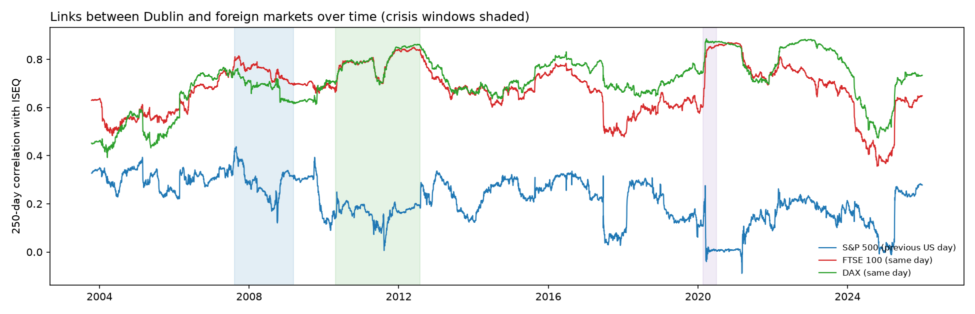
Figure 5. G4. Links between Dublin and foreign markets over time
Aspect | Explanation
What it shows | 250-day rolling correlation of ISEQ daily returns with London and Frankfurt (same day) and New York (previous US day).
Axes and marks | x = date; y = correlation (−1 to 1).
How to read it | Higher = markets move together more.
Key take-aways | European links rise towards 0.85 in the Irish crisis and COVID (Forbes & Rigobon’s warning: this can be a volatility effect). The New York link is weaker and collapses when a few extreme days enter the window.
Where it goes | Chapter 2 (contagion) or Chapter 3 (why three markets)

G5. Returns are hard to predict; volatility is not
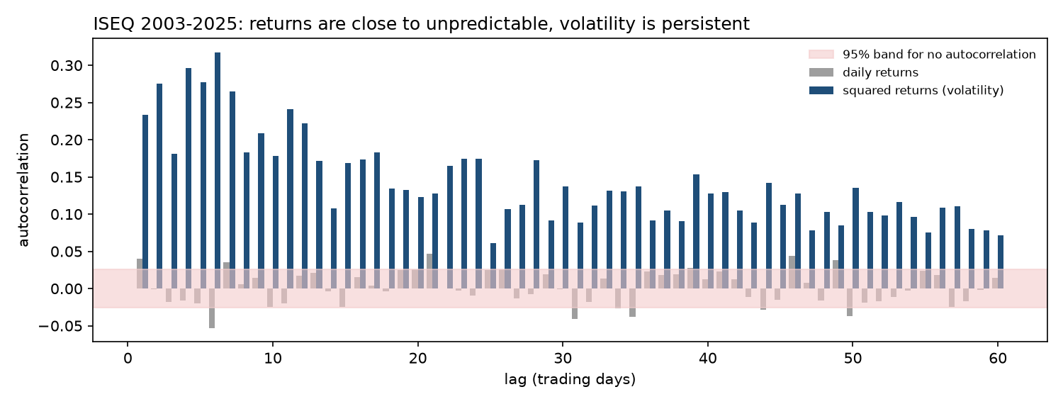
Figure 6. G5. Returns are hard to predict; volatility is not
Aspect | Explanation
What it shows | Autocorrelation of daily ISEQ returns (grey) and squared returns (blue) at lags 1–60.
Axes and marks | x = lag in days; y = autocorrelation. Pink band = what pure chance would give.
How to read it | Bars outside the band = real memory.
Key take-aways | Returns stay inside the band (unpredictable); squared returns are far outside even 60 days back (volatility clustering, long memory).
Where it goes | Chapter 2 or 3 (why forecast volatility)

G6. The three HAR ingredients during the GFC
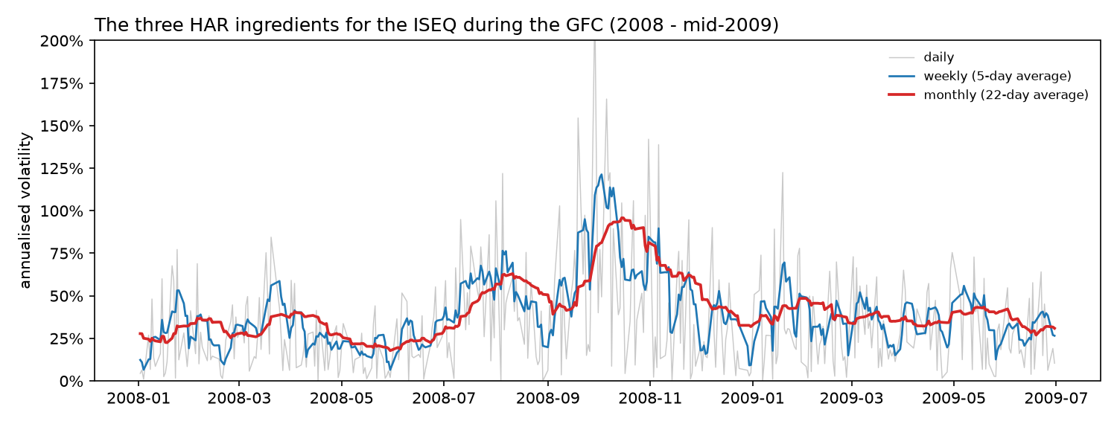
Figure 7. G6. The three HAR ingredients during the GFC
Aspect | Explanation
What it shows | Daily, weekly (5-day) and monthly (22-day) volatility of the ISEQ, 2008 – mid-2009.
Axes and marks | x = date; y = annualised volatility.
How to read it | Compare how noisy and how smooth the three lines are.
Key take-aways | Daily is very noisy; weekly follows turning points; monthly carries the slow level — HAR combines them.
Where it goes | Chapter 3 (HAR)

G7. Why New York’s day-t close can be used for Dublin’s day t+1
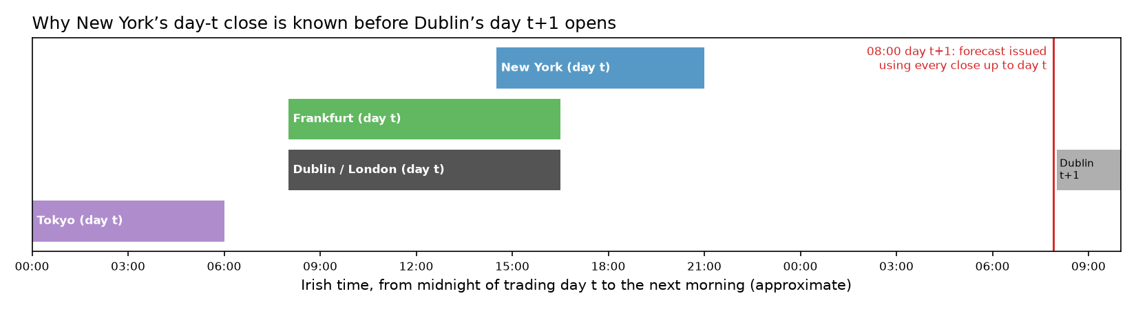
Figure 8. G7. Why New York’s day-t close can be used for Dublin’s day t+1
Aspect | Explanation
What it shows | Approximate trading hours of Tokyo, Dublin/London, Frankfurt and New York in Irish time, and the forecast time (08:00 next day).
Axes and marks | x = Irish time from midnight of day t to next morning.
How to read it | Everything to the left of the red line is known when the forecast is made.
Key take-aways | Using day-t closes from all markets is legitimate; using day t+1 would be look-ahead.
Where it goes | Chapter 3 (data alignment)

G8. SHAP smoke test (tooling check, not a result)
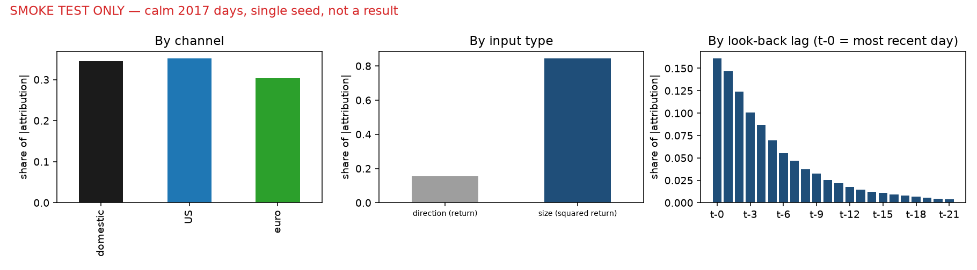
Figure 9. G8. SHAP smoke test (tooling check, not a result)
Aspect | Explanation
What it shows | Channel, input-type and lag shares for calm 2017 days from one test model.
Axes and marks | Bars = share of total |attribution|.
How to read it | Only proves the tool works.
Key take-aways | Attributions add up (Integrated Gradients error ≈ 0); do not interpret the values.
Where it goes | Appendix (method validation)

G9. Benchmark forecasts over the whole test period
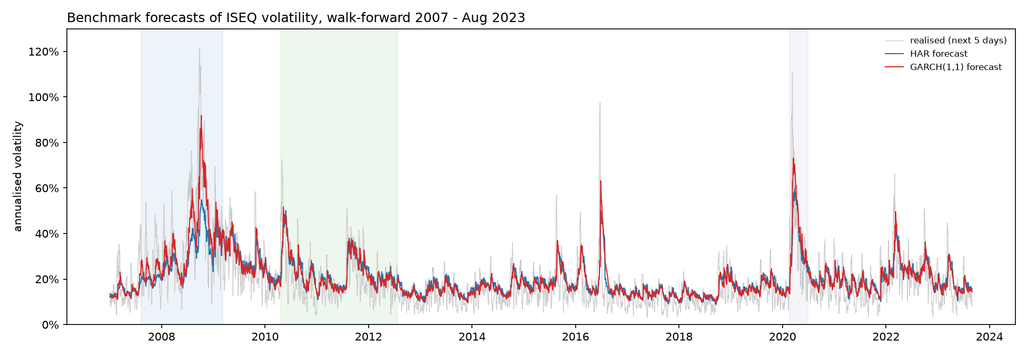
Figure 10. G9. Benchmark forecasts over the whole test period
Aspect | Explanation
What it shows | Realised 5-day volatility (grey) with HAR (blue) and GARCH (red) forecasts, 2007 – Aug 2023.
Axes and marks | x = date; y = annualised volatility.
How to read it | The closer the coloured lines to the grey spikes, the better.
Key take-aways | Both track the level well; in 2008 HAR peaks near 55% while GARCH reaches about 90% — HAR, trained only on calm years, reacted too little.
Where it goes | Chapter 4

G10. Forecast accuracy by window (the main RQ1 figure)
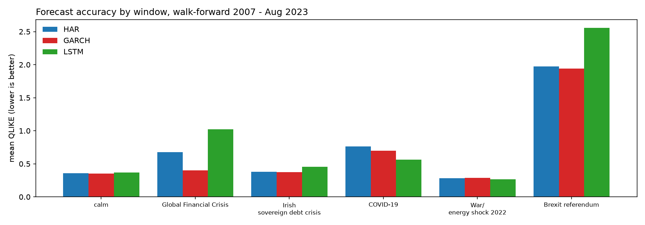
Figure 11. G10. Forecast accuracy by window (the main RQ1 figure)
Aspect | Explanation
What it shows | Mean QLIKE of HAR, GARCH and LSTM in calm periods and each window.
Axes and marks | x = window; y = QLIKE (lower = better).
How to read it | Compare bar heights within each group.
Key take-aways | GARCH is best overall and in the GFC and Irish crisis; the LSTM is best in COVID-19 and 2022 and worst in the GFC and Brexit.
Where it goes | Chapter 4 (RQ1)

G11. Forecasts inside each crisis
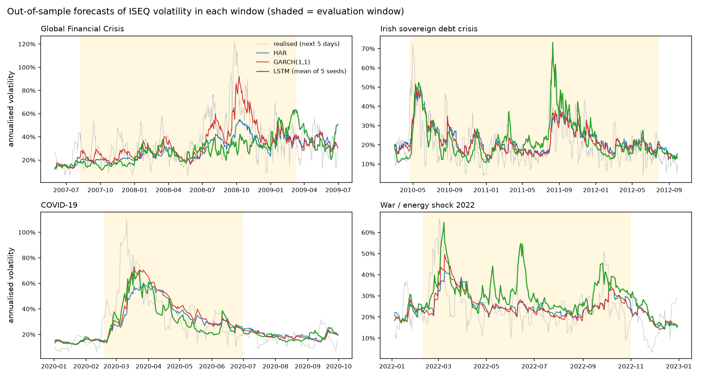
Figure 12. G11. Forecasts inside each crisis
Aspect | Explanation
What it shows | Realised volatility and the three forecasts in four windows (shaded).
Axes and marks | x = date; y = annualised volatility.
How to read it | Look at the peaks: who reaches them, and who comes back down in time.
Key take-aways | October 2008: LSTM ≈ 40% vs realised ≈ 120% — it could not imagine a crash that size. COVID: the LSTM followed the fall in volatility faster than both benchmarks.
Where it goes | Chapter 4 or 5

G12. Learning from history (RQ3)
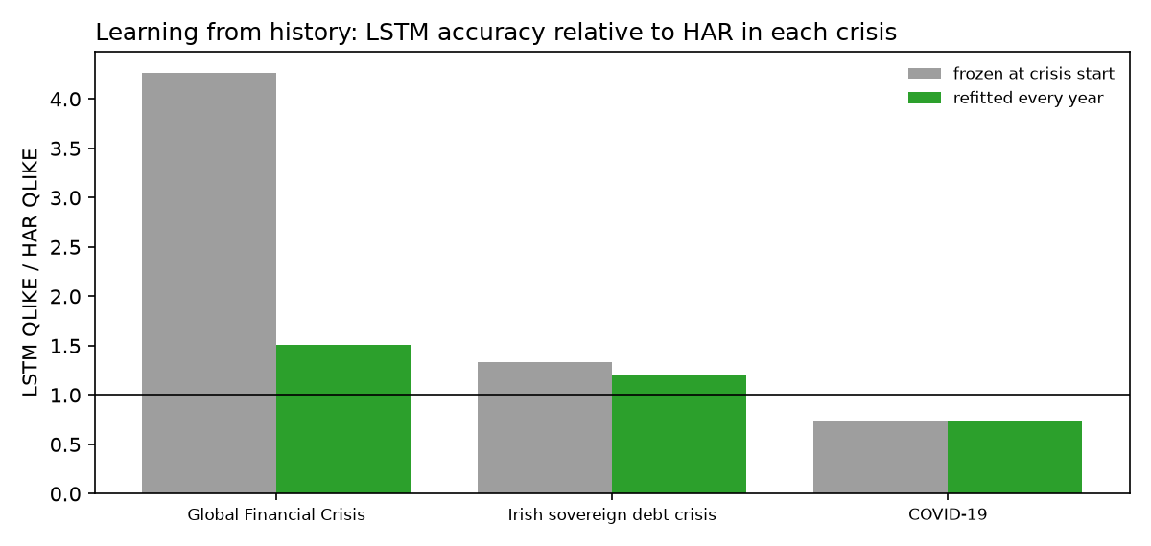
Figure 13. G12. Learning from history (RQ3)
Aspect | Explanation
What it shows | For each crisis: QLIKE of the LSTM ÷ QLIKE of HAR, for a model frozen at the crisis start (grey) and the annually refitted model (green).
Axes and marks | y = ratio; line at 1 = as good as HAR; below 1 = better.
How to read it | Compare grey bars across crises.
Key take-aways | GFC 4.26 (only calm history) → Irish crisis 1.33 → COVID 0.74 (better than HAR after learning from two crises).
Where it goes | Chapter 4 (RQ3) and Chapter 5

G13. Transmission fingerprints (the main RQ2 figure)
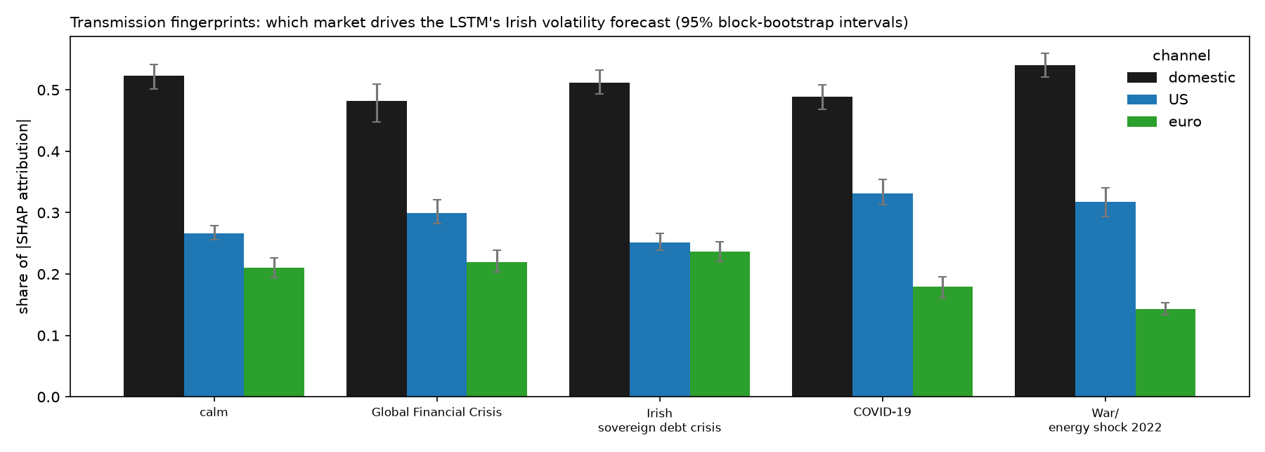
Figure 14. G13. Transmission fingerprints (the main RQ2 figure)
Aspect | Explanation
What it shows | Share of the LSTM’s attribution coming from each market, by window, with 95% intervals.
Axes and marks | y = share (the three bars in a group add to 1). Error bars = 95% block-bootstrap intervals.
How to read it | Compare each crisis bar with the same-coloured calm bar; a rise ‘counts’ if the whole interval is above.
Key take-aways | Domestic ≈ half everywhere; US rises in GFC, COVID and 2022; euro rises in the Irish crisis and falls in 2022.
Where it goes | Chapter 4 (RQ2)

G14. How far back the model looks
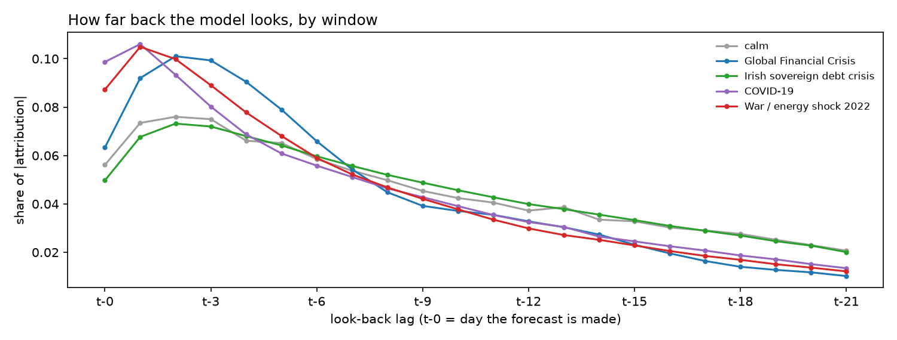
Figure 15. G14. How far back the model looks
Aspect | Explanation
What it shows | Share of attribution by look-back day (t-0 = forecast day … t-21), per window.
Axes and marks | x = days back; y = share of attribution.
How to read it | A curve peaked on the left = the model relies on the last few days.
Key take-aways | Fast crises (GFC, COVID, 2022) concentrate on the last 1–5 days; the slow Irish crisis looks like calm.
Where it goes | Chapter 4 (RQ2) or Chapter 5

G15. Spillovers into Irish volatility over time (exploratory E1)
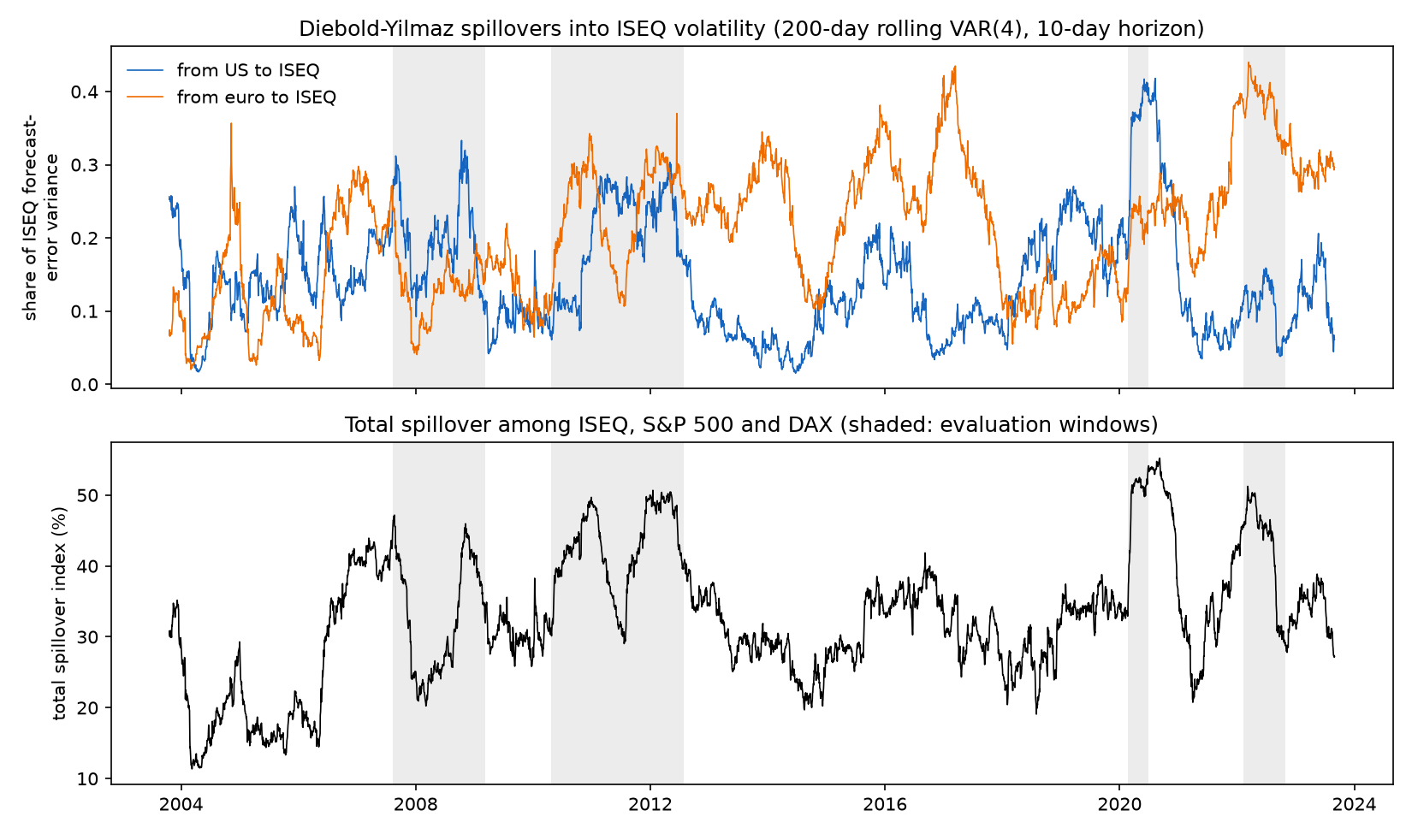
Figure 16. G15. Spillovers into Irish volatility over time (exploratory E1)
Aspect | Explanation
What it shows | Top: share of the ISEQ’s 10-day volatility forecast-error variance coming from the US (blue) and the DAX (orange), from a 200-day rolling VAR. Bottom: total spillover index among the three markets.
Axes and marks | x = date (2003–2023; the first 200 days are used to start). Top y = share (0–1). Bottom y = total spillover (%). Grey = evaluation windows.
How to read it | Higher = more of Ireland’s volatility is ‘imported’. Each point summarises the previous 200 days, so the lines react to a crisis with a delay.
Key take-aways | Total spillover peaks at 55% (Sep 2020) and is lowest at 11% (Mar 2004). The US share jumps in COVID-19 (up to 0.42); the DAX share is highest in 2016–17 and in 2022 (0.44). Window averages: calm 32.6%, GFC 32.5%, Irish crisis 42.7%, COVID 49.5%, 2022 42.7%.
Where it goes | Chapter 4 (exploratory section)

G16. Two views of transmission: SHAP vs Diebold–Yilmaz (exploratory E1)
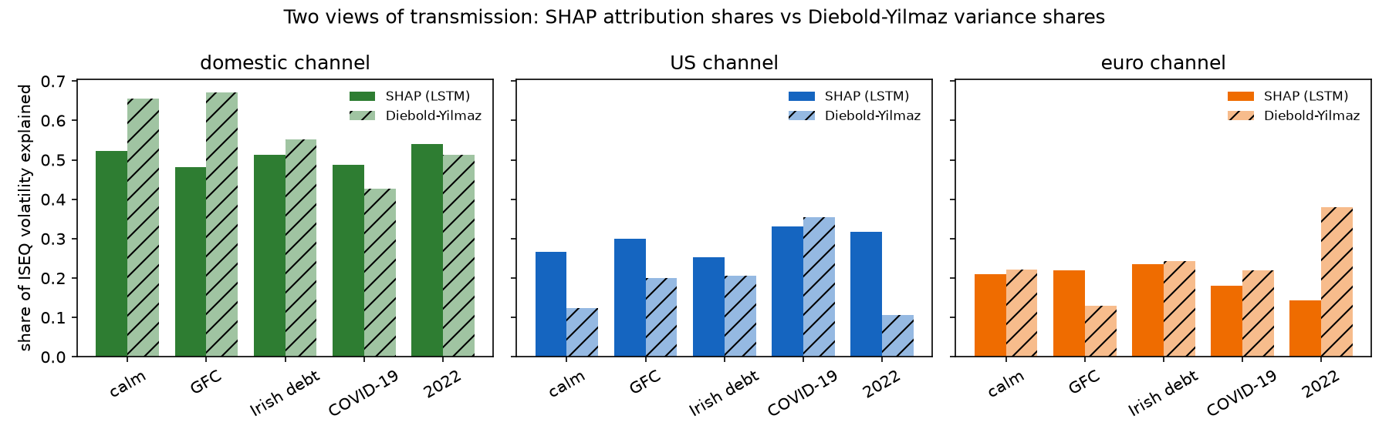
Figure 17. G16. Two views of transmission: SHAP vs Diebold–Yilmaz (exploratory E1)
Aspect | Explanation
What it shows | For each window, the SHAP channel share of the LSTM (solid) next to the Diebold–Yilmaz share (hatched), for the domestic, US and euro channels.
Axes and marks | x = window; y = share (each measure’s three shares add to 1 within a window).
How to read it | Compare the pattern across windows within each panel, not the levels: the two measures are built differently.
Key take-aways | Both put the US highest in COVID-19 and above calm in the GFC. They disagree most in 2022: the spillover measure’s euro share rises to 0.381 while SHAP’s falls to 0.143. Agreement overall: 4 of 8 direction checks, 2 of 5 rankings.
Where it goes | Chapter 4 (exploratory) and Chapter 5 (what the fingerprints measure)

G17. Were the crises preceded by calm? (exploratory E2)
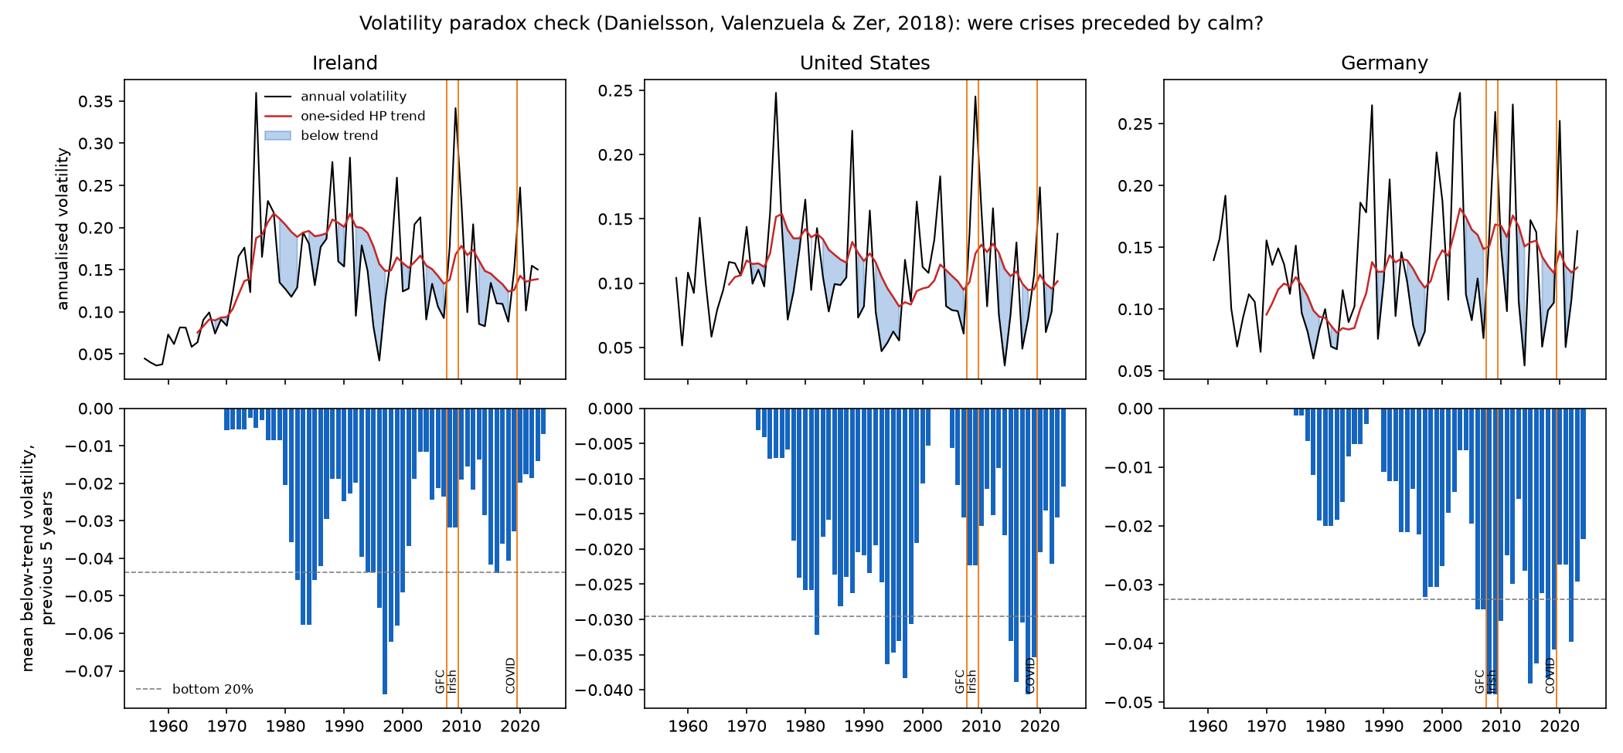
Figure 18. G17. Were the crises preceded by calm? (exploratory E2)
Aspect | Explanation
What it shows | Top row: annual volatility (black) and its one-sided HP trend (red), blue = below trend, for Ireland (1956–2023), the US and Germany. Bottom row: mean below-trend volatility over the previous 5 years; dashed line = bottom 20%.
Axes and marks | x = year (July–June years). Orange lines = the three crisis windows. Bottom y = negative numbers; further below zero = longer/deeper calm.
How to read it | A bar below the dashed line at a crisis = ‘unusually calm’ before it.
Key take-aways | Before the GFC only Germany is below the line (4th percentile — its deepest calm since the 1970s). Ireland was below trend in 2004–07 but only at the 40th percentile; its deepest calm was in 1992–96. No market was unusually calm before COVID-19.
Where it goes | Chapter 2 (history lens) or Chapter 4 (exploratory); Chapter 5 (Minsky discussion)

Part H. Every result, explained

H1. Forecast accuracy (RQ1) — main table
Window | Days | LSTM | GARCH | HAR | Naive
All test days | 4,230 | 0.463 | 0.380 | 0.414 | 0.802
Calm | 2,935 | 0.367 | 0.351 | 0.360 | 0.802
Global Financial Crisis | 402 | 1.021 | 0.401 | 0.676 | 0.834
Irish sovereign debt crisis | 574 | 0.455 | 0.374 | 0.380 | 0.802
COVID-19 | 92 | 0.562 | 0.700 | 0.763 | 1.053
War / energy shock 2022 | 185 | 0.264 | 0.290 | 0.282 | 0.506
Brexit referendum | 42 | 2.556 | 1.941 | 1.973 | 1.264

- Reading it: numbers are mean QLIKE; lower is better. GARCH wins overall; the LSTM wins in COVID-19 and 2022.
- Statistical tests (DM-HLN, all days): LSTM worse than GARCH (+0.083, p = 0.003) and than HAR (+0.049, p = 0.044). HAR worse than GARCH (p = 0.0007). H1 not supported.
- Where the gap comes from: mostly the GFC (LSTM 1.021 vs GARCH 0.401).
Possible explanations to examine (yours to argue, not conclusions):
- Before the GFC the LSTM had only 1,166 calm days to learn from; neural networks interpolate within what they have seen, while GARCH’s formula scales up automatically after a large shock.
- The LSTM learns log volatility with squared-error loss, which gives little weight to rare huge spikes.
- By 2020 the training data contained two crises — consistent with the LSTM’s COVID success.
- Brexit was a one-day political surprise; no model forecast it, and the naive forecast only ‘won’ by copying the spike afterwards.
How to explain it out loud: The deep-learning model was not better overall — the classic GARCH model was. But the picture changes by crisis: the LSTM was worst when it had only seen calm times, and best in COVID after it had learned from earlier crises. That is itself an answer to ‘this time is different?’.

H2. The models’ parameters
Model | Parameter | Range across refits | Meaning
GARCH | α (reaction) | 0.060 – 0.103 | about 9% of a shock feeds into next day’s variance
GARCH | β (memory) | 0.888 – 0.914 | about 90% of today’s variance carries over
GARCH | α + β | 0.957 – 0.999 | shocks fade very slowly (high persistence)
GARCH | ν (tails) | 6.2 – 8.3 | fatter tails than a normal distribution
HAR | monthly weight | 0.43 – 0.73 | the slow monthly level matters most
HAR | R² | 0.11 (2007) – 0.57 | fit improves once crisis years are in the training data
LSTM | epochs | 16 – 40 (mean 21) | early stopping ends training quickly
LSTM | smearing factor | 1.02 – 3.29 | log forecasts are scaled up; largest for 2008 (validation 2007 had the GFC start)
LSTM | seed spread | ≈13% (mean coefficient of variation) | individual seeds differ; averaging 5 reduces noise

H3. LSTM tuning
Best of 8: look-back 22, 64 units, 2 layers (mean validation loss 1.307; worst 1.432). Every setting scored above 1.0 — worse than predicting the training average — because the validation years (2006, 2007) differ from the calm 2003–05 training data. The same problem RQ3 measures.

H4. Learning from history (RQ3)
Crisis | Frozen LSTM / HAR | Refitted LSTM / HAR
Global Financial Crisis | 4.26 | 1.51
Irish sovereign debt crisis | 1.33 | 1.20
COVID-19 | 0.74 | 0.74

Pre-registered ranking GFC > COVID > Irish; observed GFC > Irish > COVID → H3 not supported as ranked, but the GFC is by far the worst, as the Minsky reasoning predicted. The COVID model, though it had never seen a pandemic, beat HAR.
How to explain it out loud: A model that had only ever seen good times was four times worse than a simple benchmark when the crash came. A model that had lived through two earlier crises handled a brand-new kind of crisis better than the benchmark.

H5. Transmission fingerprints (RQ2)
Window | Domestic | US | Euro
Calm | 0.523 | 0.266 | 0.211
GFC | 0.482 | 0.299 ↑ | 0.219
Irish sovereign debt crisis | 0.512 | 0.252 | 0.236 ↑
COVID-19 | 0.488 | 0.332 ↑ | 0.180
War / energy 2022 | 0.540 | 0.317 ↑ | 0.143 ↓

Hypothesis | Verdict | Why
H2a GFC: US rises most; domestic above calm | Not supported (partly) | US rises most, but domestic falls
H2b Irish: euro and domestic rise; US below GFC | Not supported (partly) | Euro rises, US below GFC, domestic not up
H2c COVID: shares towards equality | Supported, narrowly | Spread 0.308 vs 0.312 — tiny difference
H2e 2022: euro rises | Not supported | Euro falls to 0.143; US rises

- Domestic dominance: Ireland’s own recent history supplies about half of every forecast — the ‘heat wave’ is stronger than the ‘meteor showers’; compare Bekaert et al. (2014) on domestic contagion.
- Direction vs size: in the GFC 62% of attribution is on returns (direction) vs 41% in calm periods — consistent with the leverage effect (falls matter).
- Look-back: fast crises shorten the model’s memory to the last 1–5 days; the Irish crisis does not.
Caution: Shares describe the model’s forecasts, not causes; correlated markets can share credit, and shares can rise partly because volatility rises (Forbes & Rigobon). Always say ‘fingerprints consistent with…’.

H6. Stability of explanations (RQ4)
Window | Mean Spearman (3 channels) | Min | Mean Spearman (6 inputs)
Calm | 1.0 | 1.0 | 0.81
GFC | 0.7 | 0.5 | 0.62
Irish crisis | 0.7 | 0.5 | 0.83
COVID-19 | 0.8 | 0.5 | 0.82
2022 | 1.0 | 1.0 | 0.87

H4 (≥ 0.8 everywhere) not supported. With only three channels, one swapped pair drops Spearman to 0.5, so the measure is coarse; the 6-input version gives a finer picture. Least stable in the GFC — the window where the model was also least accurate.

H7. Robustness so far — Parkinson proxy
All days QLIKE: LSTM 0.295, GARCH 0.237, HAR 0.270. LSTM vs GARCH p = 0.001 (LSTM worse); LSTM vs HAR p = 0.13 (no significant difference). COVID: LSTM 0.315 vs GARCH 0.509. The main conclusions hold with a different volatility measure. The FTSE, look-back-66 and post-2023 checks are still to run.

H8. Scorecard
Hypothesis | Verdict
H1 accuracy | Not supported (LSTM significantly worse overall)
H2a GFC fingerprint | Not supported (partly)
H2b Irish fingerprint | Not supported (partly)
H2c COVID fingerprint | Supported, narrowly
H2d Brexit (FTSE run) | Pending
H2e 2022 fingerprint | Not supported
H3 learning-from-history ranking | Not supported as ranked (GFC largest, as predicted)
H4 stability | Not supported
E1 spillovers vs SHAP (exploratory, no test) | Weak agreement: 4 of 8 direction checks, 2 of 5 rankings
E2 volatility paradox (exploratory, no test) | Expectation not met for Ireland (40th percentile) or the US (42nd); Germany unusually calm (4th)

How to explain it out loud: Most of my predictions were wrong or only partly right — and because I wrote them down in advance, those are genuine findings, not failures. Science learns as much from predictions that fail.

H9. Exploratory E1 — spillovers vs SHAP
Window | Domestic: SHAP / DY | US: SHAP / DY | Euro: SHAP / DY
Calm | 0.523 / 0.655 | 0.266 / 0.124 | 0.211 / 0.221
GFC | 0.482 / 0.672 | 0.299 / 0.199 | 0.219 / 0.129
Irish sovereign debt crisis | 0.512 / 0.551 | 0.252 / 0.206 | 0.236 / 0.243
COVID-19 | 0.488 / 0.427 | 0.332 / 0.354 | 0.180 / 0.219
War / energy 2022 | 0.540 / 0.512 | 0.317 / 0.107 | 0.143 / 0.381

- Reading it: each cell is SHAP share / Diebold–Yilmaz share of the ISEQ’s volatility (DY ‘own’ = domestic).
- Agreement: the change from calm has the same sign in 4 of 8 cases; the US-vs-euro ranking matches in 2 of 5 windows. Sensitivity runs: sign 3–4 of 8, ranking 0–2 of 5 — the same picture.
- Where they agree: the US share is above calm in the GFC and highest in COVID-19 in both.
- Where they differ: 2022 (DY euro 0.381 — the H2e direction; SHAP euro 0.143) and calm (SHAP gives the US twice DY’s share).
- Full sample: total spillover 34.0%; the ISEQ is a net receiver (−8.4), the US a net transmitter (+7.7).
Possible explanations to examine (yours to argue, not conclusions):
- Different inputs: SHAP channels include each market’s returns (direction) as well as squared returns; the VAR uses volatility only. In the GFC, 62% of SHAP attribution was on returns.
- Different models: a linear VAR fitted on 200 days vs a non-linear LSTM trained on all earlier years — the LSTM used in 2022 had just learned from COVID-19, when the US channel mattered most.
- Timing: the US close of day t arrives after Dublin closes; the generalized decomposition shares same-day co-movement between markets, while SHAP attributes it to specific inputs.
- The 200-day window reacts late: the GFC window’s average total spillover (32.5%) is no higher than calm.
Caution: agreement or disagreement is descriptive; there is no test, and the two measures are different quantities. Report it as ‘the fingerprints depend on the lens’, not as proof either way.

H10. Exploratory E2 — the volatility paradox
Market | Before GFC (2003–07) | Before Irish crisis (2005–09) | Before COVID-19 (2015–19)
Ireland | −0.032 (40th) | −0.019 (62nd) | −0.020 (60th)
United States | −0.022 (42nd) | −0.017 (60th) | −0.020 (49th)
Germany | −0.049 (4th) ✓ | −0.036 (16th) ✓ | −0.027 (40th)

- Reading it: mean below-trend volatility over the 5 years before the window (more negative = longer/deeper calm), with its percentile in the market’s own history; ✓ = bottom 20% (‘unusually calm’).
- Result: the expectation (unusual calm before the GFC in Ireland and the US) is not met; only Germany was unusually calm — its deepest calm since the 1970s. No market was unusually calm before COVID-19, as expected.
- Cross-check: FRED vs Yahoo annual volatility correlation 0.90 (Ireland), 0.91 (US), 0.89 (Germany).
Possible explanations to examine (yours to argue, not conclusions):
- Ireland had a deeper calm in 1992–96 (measure −0.076), so 2003–07 looks ordinary by comparison.
- The five pre-GFC years include July 2002 – June 2003, a volatile post-dot-com year above trend; Ireland was below trend in the other four (2004–07).
- The Irish boom shows up more clearly in credit (Kelly, 2009: mortgages ≈7×, developer loans ≈11×) than in equity volatility.
- Monthly averages smooth volatility; one crisis per market cannot test a panel result.
How to explain it out loud: Ireland was calm before 2008 — below its normal volatility in four of the five years — but not unusually calm by its own history. Germany was. So the ‘calm before the storm’ story fits Germany better than Ireland in my data.

Part I. Limitations and honest caveats
- One market (Ireland) and three foreign channels; results may differ for other small economies.
- Daily data only: realised variance from daily squared returns is noisier than from intraday data, which also handicaps HAR (Andersen & Bollerslev, 1998).
- Yahoo Finance data quality (unreliable ISEQ opens); addressed by using closes only.
- Crisis windows are defined after the fact (used only for evaluation, never as inputs).
- Small windows: COVID (92 days) and Brexit (42 days) give limited statistical power.
- SHAP explains the model, not the economy; correlated markets share credit; shares can move with volatility.
- One architecture family and a small tuning grid, chosen on the earliest windows only.
- Smearing assumes the validation-year bias carries into the test year.
- ISEQ composition changed over time (banks, then the 2023–24 departures).
- Robustness checks FTSE, look-back 66 and post-2023 not yet complete.
- No economic-value test (e.g., trading or risk-management gains).
- The exploratory extensions (E1, E2) were chosen after the main results; they are descriptive, have no statistical test and cannot support or rescue any hypothesis.
- E1 compares different quantities: a linear VAR on volatility only vs SHAP on a non-linear model with return and volatility inputs.
- E2 rests on one crisis per market and on monthly-average data; it illustrates Danielsson et al.’s panel result but cannot test it.

Part J. Viva and interview questions — talking points
Short talking points to help you answer in your own words. Practise saying them aloud.
Question | Talking points
What is your project in one sentence? | Whether an explainable LSTM forecasts Irish stock-market volatility better than GARCH and HAR, and whether its explanations show different crises reaching Ireland through different markets.
Why volatility and not prices? | Price direction is close to unpredictable; volatility clusters and is forecastable, and it is the quantity risk management needs.
Why Ireland? | A small open economy hit by crises of different origin — ideal for comparing transmission.
Why only three markets? | Other candidates were near-duplicates (Nasdaq 0.95 with S&P; FTSE 0.84 with DAX; VIX −0.73 with S&P); overlapping inputs make SHAP unreliable.
Why start in 2003 and stop in August 2023? | Enough calm history before the GFC without the weak dot-com period; the ISEQ lost CRH, Flutter and Smurfit from September 2023.
Why a 5-day target? | Less noisy than one day, matches HAR’s weekly term, and ML gains are larger at weekly horizons.
How did you avoid look-ahead bias? | Annual refits on past data only, scalers fitted on training data, 5-day gaps at boundaries, as-of alignment, labels never used as inputs, tuning frozen after the first windows.
What is QLIKE and why use it? | A loss that ranks volatility forecasts correctly even when true volatility is measured with noise (Patton, 2011); it penalises under-prediction more.
What does the Diebold–Mariano test do? | Tests whether two models’ average losses differ, allowing for overlapping forecasts; HLN corrects for sample size.
Why GARCH and HAR as benchmarks? | The standard volatility models; GARCH(1,1) is famously hard to beat (Hansen & Lunde, 2005).
Why did the LSTM lose to GARCH? | Mainly the GFC: it had learned only from calm years and could not extrapolate to an unprecedented crash. Point to the frozen-model test and the October 2008 forecast.
So did the study fail? | No — the hypotheses were pre-registered and tested honestly; a negative result is informative and the crisis-by-crisis pattern (worst in GFC, best in COVID) is a finding.
What is SHAP? | A game-theory method that splits each forecast into contributions from each input; they add up to the forecast minus the average forecast.
Why GradientShap? | It is designed for neural networks and much faster than KernelSHAP for sequence inputs; checked with Integrated Gradients.
What does a channel share mean? | The fraction of the model’s total attribution coming from one market’s inputs in a given window.
Does SHAP prove contagion? | No — it describes the model. I call the patterns fingerprints consistent with transmission, and discuss Forbes & Rigobon’s volatility bias.
Why is the domestic share so large? | The ISEQ’s own recent volatility is the most direct predictor (like HAR); consistent with evidence that domestic factors dominated in the GFC.
Why did the euro share fall in 2022? | An open question to discuss — for example, a US-led inflation and rate shock; present it as a result that contradicts H2e. Note that the Diebold–Yilmaz measure (E1) shows the euro share rising in 2022, so the fall may be specific to what the LSTM learned.
Why five seeds? | Neural networks vary with random starts; averaging reduces noise and lets me test whether explanations are stable (RQ4).
What is pre-registration and why did you do it? | Writing hypotheses and methods down, dated in Git, before results — it prevents adjusting predictions after seeing the data.
What is smearing? | A correction when turning log forecasts back into variance, estimated on the validation year.
What would you do differently? | Intraday data, more markets, alternative architectures, economic-value tests, and complete robustness runs.
How is this different from existing work? | Bucci (2020) compares accuracy; Christensen et al. (2023) add variable importance (accumulated local effects) but not by crisis or by market channel; Sahiner (2023) measures spillovers without explaining a forecasting model. I use explanations as testable fingerprints across crises of different origin, for Ireland, plus a learning-from-history test.
What would a PhD add? | Time-varying connectedness (TVP-VAR, widely used by Irish finance groups) instead of my rolling Diebold–Yilmaz check; honest uncertainty (Monte Carlo intervals); more economies and asset classes (bonds, banks); a proper panel test of the volatility paradox.
Why did you add analyses after seeing the results — isn’t that p-hacking? | They are labelled exploratory; their specification was committed in a dated amendment before they were run; there is no pass/fail rule; they are reported in full; and they cannot change any hypothesis verdict.
What is the Diebold–Yilmaz spillover index? | From a VAR, the share of each market’s 10-day forecast-error variance caused by shocks in other markets; the generalized version does not depend on variable order. Total connectedness in my sample: 34%.
Why compare SHAP with Diebold–Yilmaz? | To see whether a standard econometric measure of transmission tells the same story as the model’s explanations. It agreed only weakly (4 of 8 direction checks), which shows the fingerprints depend on the lens — itself a finding.
Was the Irish market unusually calm before the GFC? | Calm — below trend in four of the five years — but not unusually so by Ireland’s own history since the 1970s (40th percentile). Germany was (4th percentile).
Where did AI help? | Planning, code and checks — declared in notes/ai_use.md; the dissertation text and interpretation are mine.

Part K. File map and how to reproduce everything
Path | What it is
README.md | Project page with all results and figures (GitHub front page)
PREREGISTRATION.md | Hypotheses and design, committed before any model ran; Amendment A1 (30 Sep 2026)
code/01 … 12 | Scripts in run order (Part F); 11–12 are the exploratory extensions
code/evaluation.py, code/lstm_common.py | Shared rules and LSTM set-up
data/raw/, data/processed/ | Downloaded prices (Yahoo; FRED for E2) and model dataset (rebuilt by 01 and 12; not in Git)
data/data_quality_report.txt | Evidence behind the data decisions
models/ | Trained LSTMs (not in Git; rebuilt by 05)
results/ | All tables (index in results/README.md)
figures/ | All charts (Part G)
docs/ | Research plan, Chapter 2 blueprint, literature handbook, this handbook
notes/decisions.md | Dated decisions with evidence
notes/ai_use.md | AI-assistance log

To reproduce: install the packages in requirements.txt, then run the scripts in order from the code folder (see README). Total time about 1 hour plus robustness checks. The exploratory scripts 11 and 12 take seconds.

