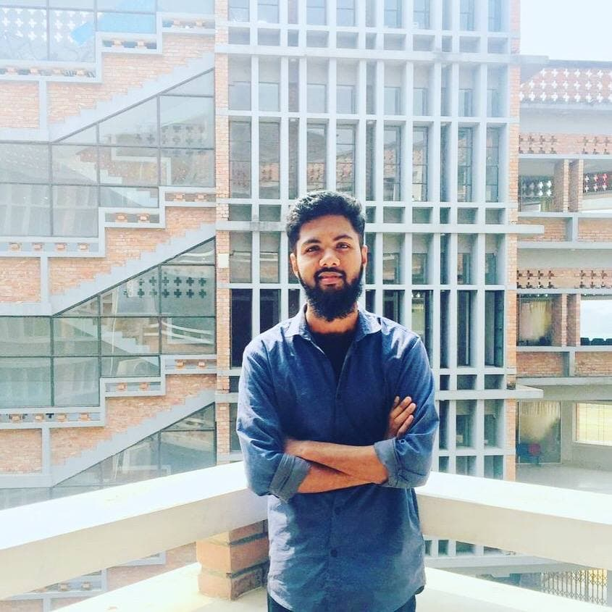

Contact

**Address:**

Jalalabad Cantonment,Sadar-Sylhet.

**Phone:**

+08801772761674

**Email:**

[shahrearahmedshuvon003@gmail.com](mailto:shahrearahmedshuvon003@gmail.com)

Languages

Bengali,English.

Hobbies

* Writing
* Photography
* Design
* Book Reading

Summary

Junior Web Developer specializing in front end development. Experienced with all stages of the development cycle for dynamic web projects. Well-versed in numerous programming languages including HTML5, PHP,Responsive,Flex,JQueary, JavaScript, CSS, MySQL. Strong background in project management and customer relations.

Skill Highlights

|  |  |
| --- | --- |
| * Project management * Strong decision maker * Complex problem solver | * Creative design * Innovative * Service-focused |

Experience

**Web Developer** - 11/2020 to 2/2021

**Shahrear Web Design**, Sylhet,Bangladesh.

* Cooperate with designers to create clean interfaces and simple, intuitive interactions and experiences.
* Develop project concepts and maintain optimal workflow.
* Work with senior developer to manage large, complex design projects for corporate clients.
* Complete detailed programming and development tasks for front end public and internal websites as well as challenging back-end server code.
* Carry out quality assurance tests to discover errors and optimize usability.

Education

Bachelor of Science: **Computer Science And Engineering** –

2019-2022(Running)

**Leading University**, Sylhet.

H.S.C:**Jalalabad Cantonment Public School And College** -2017(4.67).

S.S.C : **Jalalabad Cantonment Public School And College -**2015(5.00).

J.S.C :2012(5.00).

P.E.S.C:2009(5.00).

Certifications

Programming Languages: **C,C++,JavaScript, HTML5, PHP , CSS, SQL, MySQL**.

ChristopherMorgan