MENTAL HEALTH SUPPORT PLATFORM
Software Requirements & System Design Report

━━━━━━━━━━━━━━━━━━━━━━━━━━━━━━━━━━━━━━━━━━━━━━━━━━━━━━━━━━━━

Project Type: Web Application (Full Stack)
Duration: 12 Weeks
Institution: Kent Institute of Technology Australia
Industry Sponsor: Skillup Labs
Team: Mel23 Tech Solution
Date: April 2026

Team Members
Sanjana Tanwar (K240225) — Team Leader / Project Manager
Jubair Zaman Dipto (K240568) — Full-Stack / Tech Lead
S M Nalid Maola (K231528) — Backend Developer
Nabil Ashrafi (K231720) — Frontend Developer
Md Al Amin Sikder (K240094) — QA Engineer / Tester
Tranpreet Kaur Kumar (K241957) — UI/UX Designer

Academic Supervisor: Mr. Syed Altaf
Industry Sponsor Contact: Nabin Singh (wil@skilluplabs.com.au)

Table of Contents
1. Introduction
1.1 Purpose of the Project
1.2 Objective of the Project
1.3 Project Scope and Limitations
1.4 Assumptions
1.5 Company Profile
1.6 Organisation Chart
1.7 Roles and Responsibilities
1.8 Key Deliverables
1.9 Project Budget
1.10 Work Breakdown Structure
1.11 Gantt Chart
2. System Requirements
2.1 Functional Requirements
2.2 Non-Functional Requirements
3. System Architecture
3.1 Software and Hardware Architecture
3.2 Tech Stack (Detailed)
4. System Design
4.1 User Interface Design / Wireframes
5. Use Case Diagrams
6. Context Diagrams (Gane & Sarson Method)
7. Data Flow Diagrams (Gane & Sarson Method)
7.1 DFD Level 1
7.2 DFD Level 2
8. Sequence Diagrams
9. Entity Relationship Diagram & Data Dictionary
10. Class Diagram
11. Data Protection Impact Assessment (DPIA)
12. Test and Implementation Plan
13. Responses on Feedback from Supervisor
References
Appendix

1. Introduction
Let's be real—keeping your mental health in check is just as big a deal as hitting the gym, but actually getting help usually feels like a total nightmare. Between the weird stigma, not having a clue where to begin, or the massive headache of tracking down a specialist, it's so easy to just feel stuck. We really wanted to build something that actually works—a tool that makes checking in on your headspace feel totally natural and easy, without all the usual stress.
In this report, we're gonna walk you through exactly how our Mental Health Support Platform rolls. It's a super straightforward web app we built for real life, where you can log your mood, keep a private journal, and find solid resources—all while knowing your data is locked down tight.

1.1 Purpose of the Project
Our big goal was to carve out a safe little corner of the web where people can stay on top of their mental health every day. We didn't want to make things complicated; we're just sticking to the stuff that actually helps, like mood tracking and journaling, plus a library of legit articles—all kept 100% private.
We want to help you get to know yourself better by spotting emotional patterns before things get too heavy. By logging a daily mood and venting in a journal, you can see how far you've come, plus have some handy support info right there whenever you need a hand.
Since we're talking about personal stuff, we aren't messing around with security. We've built in some serious protection and private login systems to keep everything hush-hush. We also focused on making the dashboard look clean and simple so using it never feels like a total chore.
To make sure we actually pulled this off, we followed a solid plan—moving from research and design straight into the fun stuff like coding and testing, all to get a working prototype ready to go.

1.2 Objective of the Project
We're putting together a prototype that actually makes a difference in how people check in on themselves. Here's what we're aiming for:
- Analyse user needs related to mental health tracking and support
- Define system requirements for a secure support platform
- Design and implement a full-stack web application using React, Node.js and PostgreSQL
- Develop mood tracking, journaling, and AI chatbot features
- Implement secure authentication (JWT, OTP, bcrypt) and data protection mechanisms (AES-256)
- Provide access to curated mental health resources with categorization
- Enable real-time secure messaging between patients and clinicians
- Integrate appointment scheduling with Google Calendar synchronization
- Deploy a working prototype system on a cloud hosting environment

1.3 Project Scope and Limitations
What we're building (The fun stuff):
- User registration, authentication (JWT + OTP), and role-based access control (RBAC)
- Daily mood tracking with 1–10 scale, notes, and trend visualization
- Secure messaging with AES-256 encryption between patients and clinicians
- Appointment scheduling with slot conflict detection and Google Calendar sync
- AI-powered chatbot with NLP processing and clinician escalation (confidence < 70%)
- Emergency support button with < 1 second response time and crisis hotline display
- Clinical records management with consent-based access control
- Resource library with URL validation, categorization, and view tracking
- Administrative dashboard with analytics, audit trails, and compliance reporting
- Privacy controls including consent management and right to data deletion
What we aren't doing (The boundaries):
- The platform is a prototype and not intended for clinical diagnosis or treatment
- AI chatbot responses are supplementary and do not replace professional medical advice
- Real-time video consultation features are outside the current scope
- The system will be tested with simulated data, not real patient records
- Mobile-native application is out of scope (responsive web design will be provided)

1.4 Assumptions
- Users will have access to a modern web browser (Chrome, Firefox, Safari, Edge)
- Users have a stable internet connection for real-time features
- The development team has access to required development tools and cloud services
- Third-party APIs (Google Calendar, OpenAI, Twilio, SendGrid) will remain available during development
- The project will follow agile methodology with iterative development sprints
- Team members will be available throughout the 12-week project duration
- The academic supervisor and industry sponsor will provide timely feedback
- PostgreSQL database will be hosted on a cloud provider with automated backups

1.5 Company Profile
About Mel23 Tech Solution
We're just a group of students from Kent Institute of Technology Australia, teaming up for our big final project. With Mr. Syed Altaf guiding us and Skillup Labs having our backs as sponsors, we're working super hard to build something that actually helps people out.
Industry Sponsor: Skillup Labs
Skillup Labs has been an awesome sponsor. They've given us the shot to build this platform and are helping us learn how to create real-world tech that actually fits into the healthcare world.

Attribute | Details
Industry Provider | Skillup Labs
Program Contact | Nabin Singh
Contact Email | wil@skilluplabs.com.au
Academic Supervisor | Mr. Syed Altaf
Institution | Kent Institute of Technology Australia
Project Duration | 12 Weeks
Team Size | 6 Members

1.6 Organisation Chart
Here's a quick peek at how we've teamed up. It shows everyone in the mix, from our supervisor and sponsor down to the specific jobs each of us is tackling to get this done.
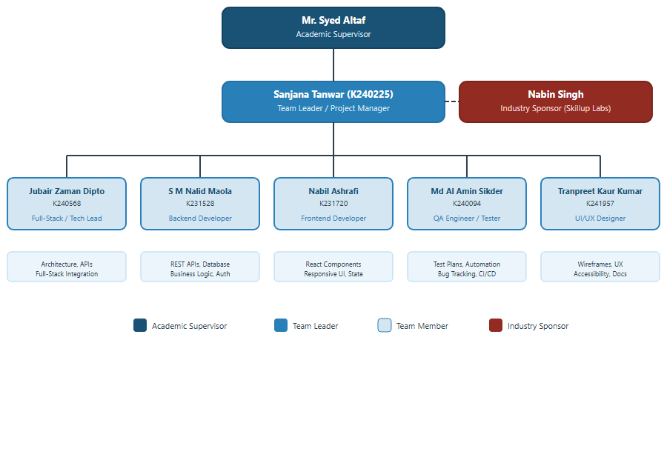
Figure 1.1: Organisation Chart — Mel23 Tech Solution

1.7 Roles and Responsibilities
Name / ID | Role | Responsibilities
Mr. Syed Altaf | Academic Supervisor | Provides academic guidance, reviews deliverables, evaluates team progress
Nabin Singh | Industry Sponsor | Provides industry context, project requirements, and real-world expectations
Sanjana Tanwar  K240225 | Team Leader /  Project Manager | Project coordination, sprint planning, stakeholder communication, progress tracking
Jubair Zaman Dipto  K240568 | Full-Stack /  Tech Lead | System architecture, API design, full-stack integration, code reviews
S M Nalid Maola  K231528 | Backend Developer | REST API development, database design, business logic, authentication
Nabil Ashrafi  K231720 | Frontend Developer | React component development, responsive UI, state management
Md Al Amin Sikder  K240094 | QA Engineer / Tester | Test planning, test automation, bug tracking, CI/CD pipeline
Tranpreet Kaur Kumar  K241957 | UI/UX Designer | Wireframes, UX research, accessibility compliance, design documentation

1.8 Key Deliverables
ID | Deliverable | Due
D1 | Problem Analysis Report | Week 2
D2 | Software Requirements Specification (SRS) | Week 3
D3 | System Architecture Documentation | Week 4
D4 | Database Schema Design (ERD) | Week 5
D5 | UI/UX Wireframes (Balsamiq Cloud) | Week 5
D6 | Functional Web Application Prototype | Week 9
D7 | Source Code Repository (GitHub) | Ongoing
D8 | Testing Documentation (Unit, Integration, E2E) | Week 11
D9 | Deployment Documentation | Week 11
D10 | Final Presentation & Demonstration | Week 12

1.9 Project Budget
Since we're students, we're keeping the budget tight and focusing on the must-haves—stuff like servers, the APIs that run our features, and our design tools. Here's what the numbers look like:

Item | Estimated Cost | Notes
Cloud Hosting (AWS/Render) | $0 – $50/month | Free tier / student credits
PostgreSQL Database Hosting | $0 – $20/month | Render/Supabase free tier
Domain Name | $10 – $15/year | Optional for demo
OpenAI API (Chatbot) | $10 – $30/month | GPT-3.5/4 usage during development
Twilio SMS API | $0 – $15/month | Trial credits available
SendGrid Email API | $0 | Free tier (100 emails/day)
Google Calendar API | $0 | Free tier
Balsamiq Cloud (Wireframes) | $0 | Educational license
GitHub (Version Control) | $0 | Free for students
Development Tools (VS Code etc.) | $0 | Free / open-source
Total Estimated Budget | $20 – $130/month

1.10 Work Breakdown Structure
To keep from getting overwhelmed, we've split the work into six big stages. We start by figuring out what's needed, plan out the details, design the look, write the code, test everything, and finally launch this thing.
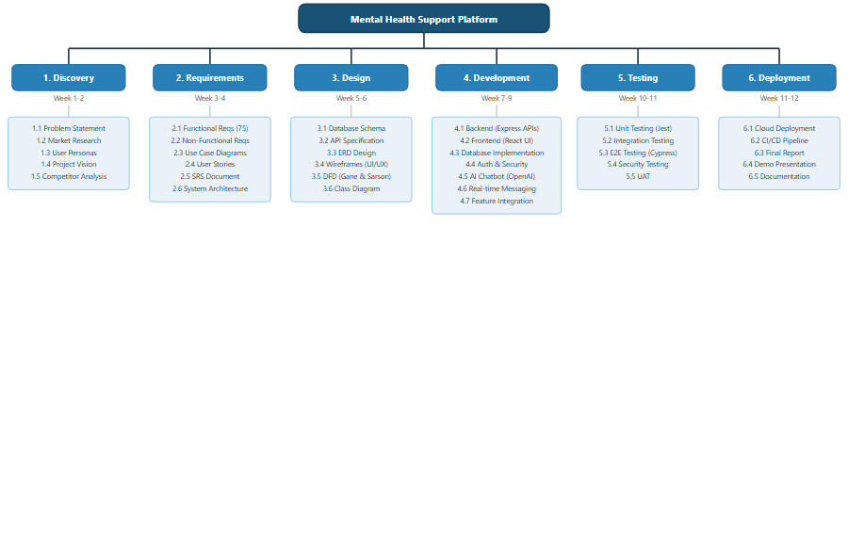
Figure 1.2: Work Breakdown Structure — Mental Health Support Platform
Phase / Timeline | Tasks
1. Discovery  (Week 1–2) | Problem Statement, Market Research, User Personas, Project Vision, Competitor Analysis
2. Requirements  (Week 3–4) | Functional Requirements (75), Non-Functional Requirements, Use Case Diagrams, User Stories, SRS Document, System Architecture
3. Design  (Week 5–6) | Database Schema, API Specification, ERD Design, Wireframes (UI/UX), DFD (Gane & Sarson), Class Diagram
4. Development  (Week 7–9) | Backend (Express APIs), Frontend (React UI), Database Implementation, Auth & Security, AI Chatbot (OpenAI), Real-time Messaging, Feature Integration
5. Testing  (Week 10–11) | Unit Testing (Jest), Integration Testing, E2E Testing (Cypress), Security Testing, User Acceptance Testing
6. Deployment  (Week 11–12) | Cloud Deployment, CI/CD Pipeline, Final Report, Demo Presentation, Documentation

1.11 Gantt Chart
This chart shows our whole 12-week plan. It's basically our roadmap to make sure we stay on track and hit all our big deadlines on time.

Period | Phase | Key Activities | Status
Week 1–2 | Discovery & Planning | Problem research, personas, vision | ✓
Week 3 | Requirements Documentation | SRS, functional/non-functional requirements | ✓
Week 4 | System Architecture Design | Architecture diagrams, tech stack decisions | ✓
Week 5 | Database & API Design | ERD, API spec, DFD diagrams | ✓
Week 6 | UI/UX Design | Wireframes (Balsamiq), design review | ✓
Week 7 | Backend Development Pt. 1 | Auth, user management, appointments APIs | In Progress
Week 8 | Backend Development Pt. 2 | Mood, messaging, chatbot, emergency APIs | In Progress
Week 9 | Frontend Development | React UI, dashboard, all page components | Planned
Week 10 | System Integration | Frontend-backend integration, real-time features | Planned
Week 11 | Testing & Deployment | Unit, integration, E2E, security testing, deploy | Planned
Week 12 | Final Demo & Report | Presentation, documentation, handover | Planned

2. System Requirements
This part is all about what the platform actually does. We put this list together by looking at our main goals, listening to our sponsors, and following the rules for making health apps safe and solid.

2.1 Functional Requirements
We've mapped out 75 specific things the app needs to do. This covers everything from logging in to how the AI chatbot works and how we keep your info safe.

FR# | Requirement | CRUD | Module
FR1 | Register new user account with unique email/SIM validation | Create | Authentication
FR2 | Verify accounts via OTP within a 5-second window | Create | Authentication
FR3 | Lock user account after 5 failed login attempts | Update | Authentication
FR4 | Record user login timestamp and IP address | Create | Audit
FR5 | Process password reset with 10-minute token validity | Update | Authentication
FR6 | Update profile fields with strict input validation | Update | Profile
FR7 | Upload and store profile image (size < 2MB) | Create | Profile
FR8 | User Login/Logout | Read | Authentication
FR9 | Schedule appointment with time-slot conflict detection | Create | Appointment
FR10 | Reject booking if timeslot is unavailable | Read | Appointment
FR11 | Reschedule appointments up to 2 hours before session | Update | Appointment
FR12 | Mark appointment as missed after 15-minute delay | Update | Appointment
FR13 | Dispatch booking confirmation within 1 minute | Create | Notification
FR14 | Approve pending appointments within 10-minute window | Update | Appointment
FR15 | Auto-cancel pending bookings after 30 minutes inactivity | Delete | Appointment
FR16 | Record clinical session notes post-consultation | Create | Clinical
FR17 | Restrict session note access based on consent flags | Read | Security
FR18 | View comprehensive patient history (authorized only) | Read | Clinical
FR19 | Retain patient records independently of clinician employment | Read | Compliance
FR20 | Reassign patients upon clinician departure | Update | Clinical
FR21 | Request access to previous medical records | Read | Clinical
FR22 | Log all medical record access and viewing actions | Create | Audit
FR23 | Encrypt all messages using AES-256 | Create | Security
FR24 | Deliver chat messages with < 2 seconds latency | Create | Messaging
FR25 | Store chat transcripts permanently in database | Create | Database
FR26 | Delete chat messages locally (soft delete only) | Delete | Messaging
FR27 | Submit daily mood entry with exact timestamp | Create | Mood
FR28 | Prevent duplicate mood entries within 1-hour timeframe | Create | Mood
FR29 | Generate automated weekly mood reports | Read | Mood
FR30 | Trigger risk alert if mood < 2 for 3 consecutive days | Create | AI
FR31 | Recommend resources based on mood patterns | Read | AI
FR32 | Respond to user queries via Chatbot within 3 seconds | Create | AI Chatbot
FR33 | Escalate Chatbot session if confidence < 70% | Update | AI Chatbot
FR34 | Record all Chatbot conversation transcripts | Create | AI Chatbot
FR35 | Review Chatbot logs via admin dashboard | Read | Admin
FR36 | Identify users with 7 days of inactivity | Read | AI
FR37 | Dispatch automated wellness check notifications | Create | Notification
FR38 | Activate emergency button with < 1 second response | Create | Emergency
FR39 | Display crisis hotline numbers on emergency trigger | Read | Emergency
FR40 | Log all emergency button activations | Create | Audit
FR41 | Add mental health resources via admin panel | Create | Content
FR42 | Validate resource URLs before publishing | Create | Content
FR43 | Track and aggregate resource view counts | Read | Analytics
FR44 | Generate monthly platform analytics reports | Read | Analytics
FR45 | Execute automated daily database backups at midnight | Create | System
FR46 | Restore database from backup within 1-hour window | Read | System
FR47 | Log system errors and exceptions automatically | Create | Monitoring
FR48 | Dispatch instant alerts for critical system errors | Create | Monitoring
FR49 | Select preferred interface language | Update | UI
FR50 | Load main dashboard within 3 seconds | Read | Performance
FR51 | Upload clinical documents and worksheets | Create | Clinical
FR52 | Validate document uploads (PDF format only) | Create | Clinical
FR53 | Download personal medical records securely | Read | Compliance
FR54 | Revoke data sharing consent instantaneously | Update | Security
FR55 | Restrict all access upon consent revocation | Update | Security
FR56 | Log all modifications to user consent settings | Create | Audit
FR57 | Integrate external SMS API for notifications | Create | Integration
FR58 | Retry failed API calls up to 3 times | Update | Integration
FR59 | Queue notifications during service downtimes | Create | Integration
FR60 | Deactivate user accounts via admin panel | Update | Admin
FR61 | Track active session duration per user | Read | Analytics
FR62 | Auto-logout after 15 minutes of inactivity | Update | Security
FR63 | Validate inputs to prevent SQL injection | Create | Security
FR64 | Generate complete audit trails for DB transactions | Create | Audit
FR65 | Assign and enforce RBAC | Update | Security
FR66 | Deny and log unauthorized API requests | Read | Security
FR67 | Synchronize appointments with Google Calendar | Create | Integration
FR68 | Dispatch follow-up for missed appointments | Create | Notification
FR69 | Rebook from missed session alerts | Create | Appointment
FR70 | Track clinician workload metrics | Read | Analytics
FR71 | Generate regulatory compliance reports | Read | Compliance
FR72 | Log complete history of data modifications | Create | Audit
FR73 | Restrict file uploads exceeding 5MB | Create | System
FR74 | Export reports to CSV | Read | Admin
FR75 | Maintain system monthly | Read | System

2.2 Non-Functional Requirements
Performance (NFRP01–NFRP04)
ID | Requirement | Category
NFRP01 | Page load time ≤ 3 seconds | Performance
NFRP02 | API response 95th percentile within 500ms | Performance
NFRP03 | Support 50 concurrent users minimum | Scalability
NFRP04 | Database queries complete within 200ms | Performance

Security (NFRS01–NFRS06)
ID | Requirement | Category
NFRS01 | Password hashing using bcrypt with 10 salt rounds | Security
NFRS02 | JWT tokens with 1-hour expiry | Security
NFRS03 | HTTPS/TLS 1.2+ for all communications | Security
NFRS04 | AES-256 encryption for data at rest | Security
NFRS05 | SQL injection and XSS prevention on all inputs | Security
NFRS06 | Rate limiting: 100 requests/IP/minute (HTTP 429) | Security

Usability (NFRU01–NFRU04)
ID | Requirement | Category
NFRU01 | Intuitive interface with ≤ 5 minute onboarding | Usability
NFRU02 | Responsive design: 320px – 1920px viewport | Usability
NFRU03 | WCAG 2.1 Level AA compliance | Accessibility
NFRU04 | Descriptive and actionable error messages | Usability

Reliability (NFRR01–NFRR03)
ID | Requirement | Category
NFRR01 | 99% system uptime | Reliability
NFRR02 | Graceful degradation for non-critical features | Reliability
NFRR03 | Daily automated backups with 7-day retention | Reliability

Maintainability (NFRM01–NFRM03)
ID | Requirement | Category
NFRM01 | ESLint enforced code standards | Maintainability
NFRM02 | Modular architecture with clear separation of concerns | Maintainability
NFRM03 | Scalable design supporting 10x user growth | Scalability

Privacy & Compliance (NFRC01–NFRC04)
ID | Requirement | Category
NFRC01 | Privacy by design principles throughout | Privacy
NFRC02 | Granular consent management | Compliance
NFRC03 | Data anonymisation for analytics | Privacy
NFRC04 | Right to deletion within 30 days | Compliance

3. System Architecture

3.1 Software and Hardware Architecture
We've designed this with a smart three-part setup. There's the part you see (frontend), the server doing the heavy lifting (backend), and the database keeping everything safe (storage). This keeps things snappy and makes it way easier to add new features later on.
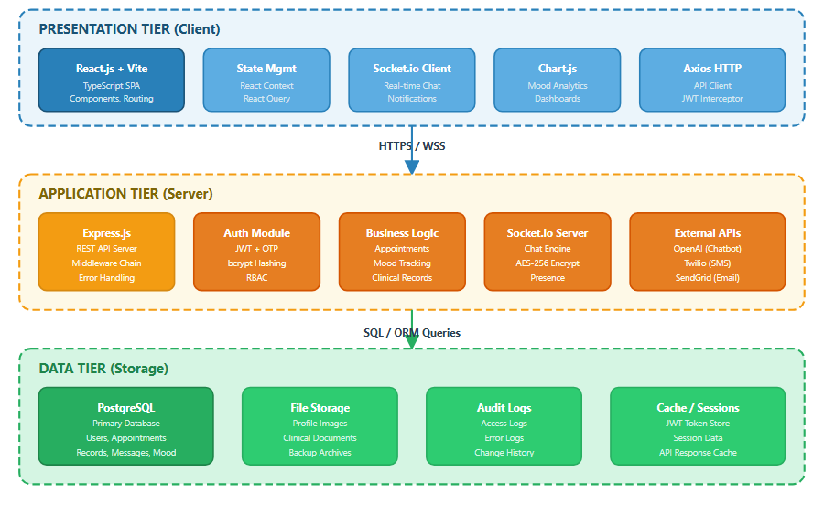
Figure 3.1: Three-Tier System Architecture Diagram
How the magic happens:
The stuff you see: We used React.js to make the site feel super fast. This is where you'll find your dashboard, charts, and chat box.
The "Brain": Our backend is powered by Node.js and Express. It handles all the logic, like your account, appointments, and the AI chatbot.
The Storage: We use PostgreSQL for all the important data, like your notes and mood logs. We've also got secure file storage and backups ready to go.
Communication: The app uses super secure connections to talk to the server, which then grabs or saves your info in the database.

3.2 Tech Stack (Detailed)
Component | Technology | Purpose
Frontend Framework | React.js 18+ with Vite | Component-based SPA with TypeScript support
State Management | React Context + React Query | Server state caching and local state management
UI Styling | Tailwind CSS / Material UI | Responsive design, utility-first CSS
Charts & Visualization | Chart.js / Recharts | Mood trend visualization, analytics dashboards
Real-time Communication | Socket.io (Client) | WebSocket-based chat and notifications
HTTP Client | Axios | API communication with JWT interceptor
Backend Runtime | Node.js 18+ | Server-side JavaScript runtime
API Framework | Express.js | RESTful API with middleware architecture
Authentication | JWT + bcrypt + OTP | Stateless auth, password hashing, 2FA
Chat Encryption | AES-256 | End-to-end message encryption
Database | PostgreSQL 15+ | Primary relational database (ACID compliant)
ORM | Prisma / Sequelize | Database abstraction and migration management
AI/NLP | OpenAI API (GPT-3.5/4) | Chatbot NLP processing
SMS Gateway | Twilio | SMS notifications and OTP delivery
Email Service | SendGrid | Transactional email notifications
Calendar Integration | Google Calendar API | Appointment synchronization
Testing (Unit) | Jest | Unit test framework for Node.js and React
Testing (E2E) | Cypress | End-to-end browser testing
Version Control | Git / GitHub | Source code management and collaboration
CI/CD | GitHub Actions | Automated testing and deployment pipeline
Cloud Hosting | Render / AWS | Application and database hosting
Wireframing | Balsamiq Cloud | Low-fidelity wireframe design

4. System Design

4.1 User Interface Design / Wireframes
We used Balsamiq to sketch out the main screens before we even touched the code. These drawings helped us figure out the best layout and how you'd actually use the app.
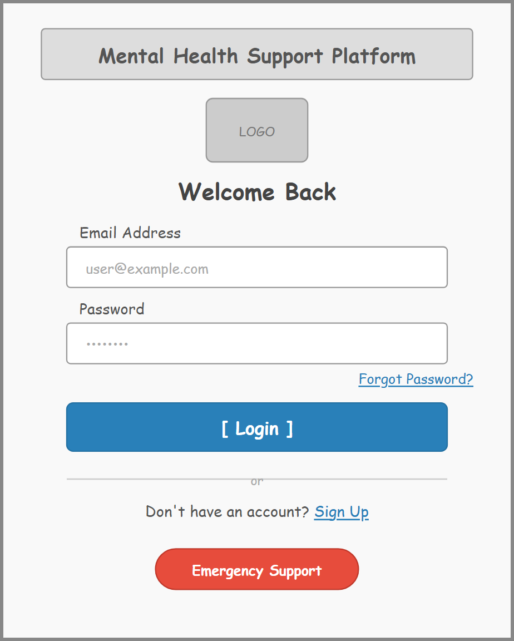
Figure 4.1: Login / Registration Page
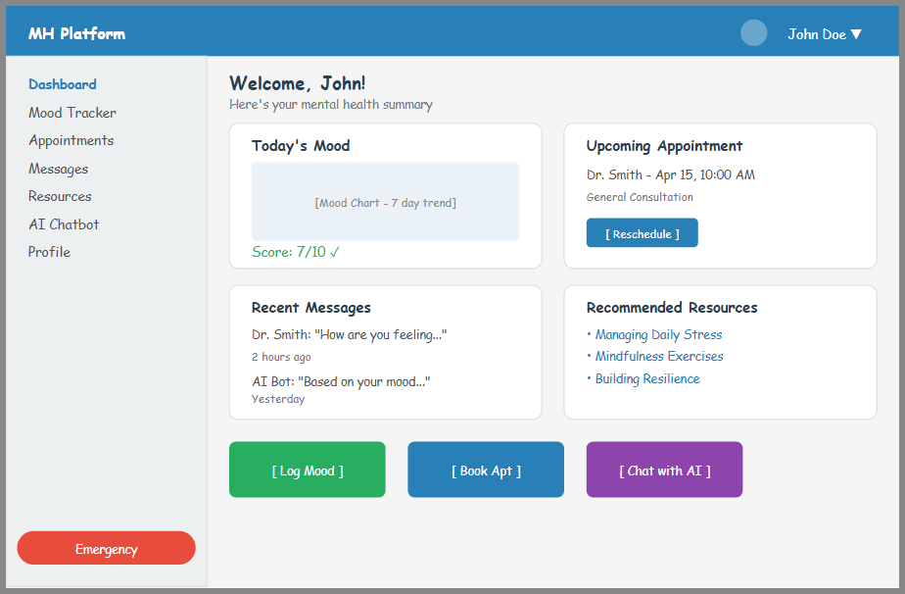
Figure 4.2: User Dashboard
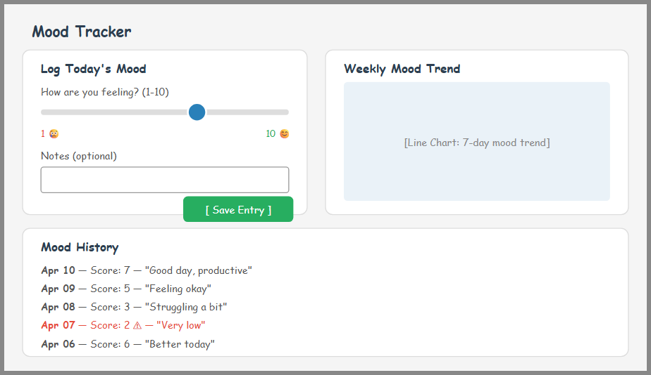
Figure 4.3: Mood Tracker Page
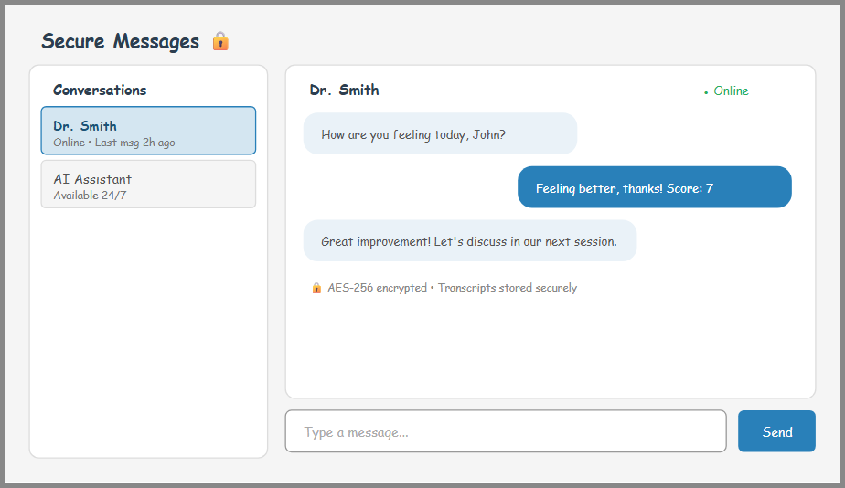
Figure 4.4: Secure Messaging Interface
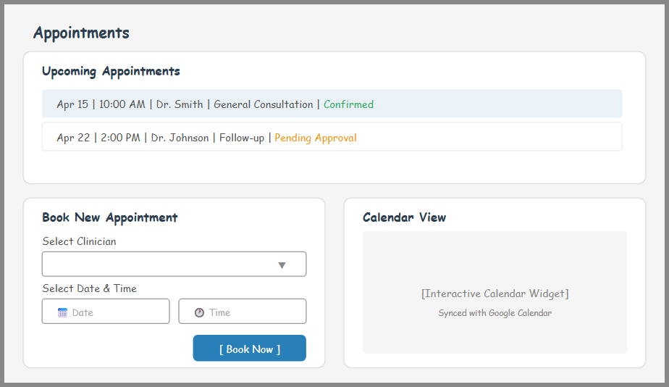
Figure 4.5: Appointments Page
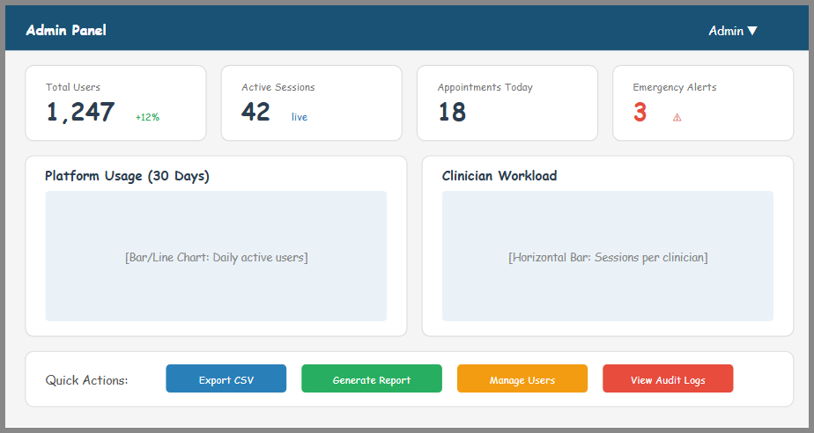
Figure 4.6: Admin Dashboard Panel

5. Use Case Diagrams
These diagrams show exactly how patients, clinicians, and admins will be using the platform we're building.
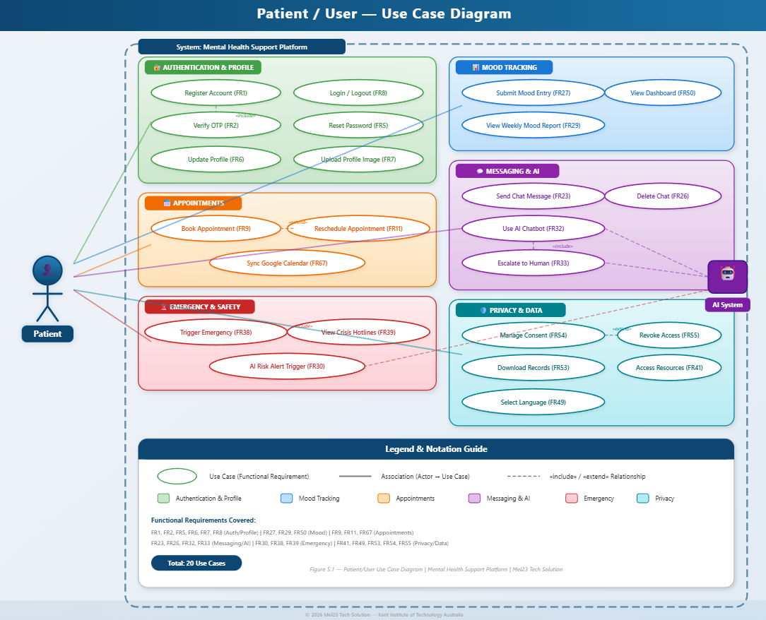
Figure 5.1: Patient / User — Use Case Diagram
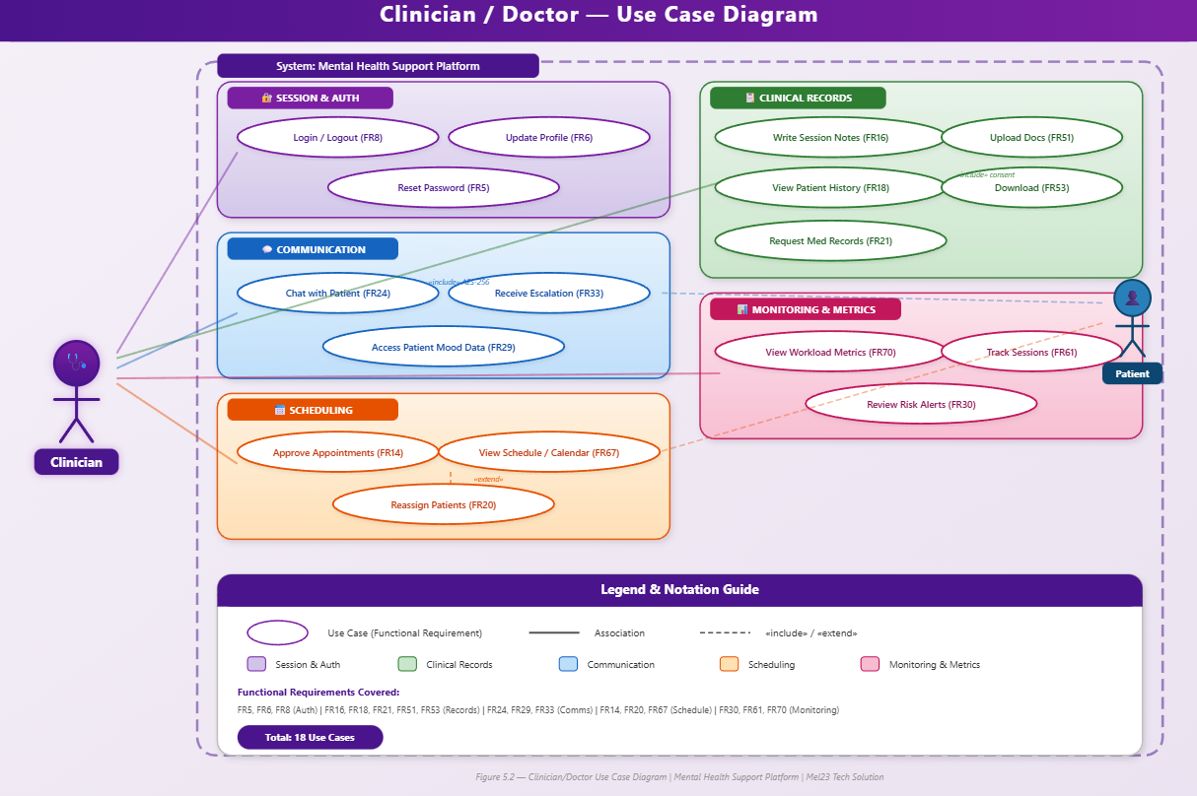
Figure 5.2: Clinician / Doctor — Use Case Diagram
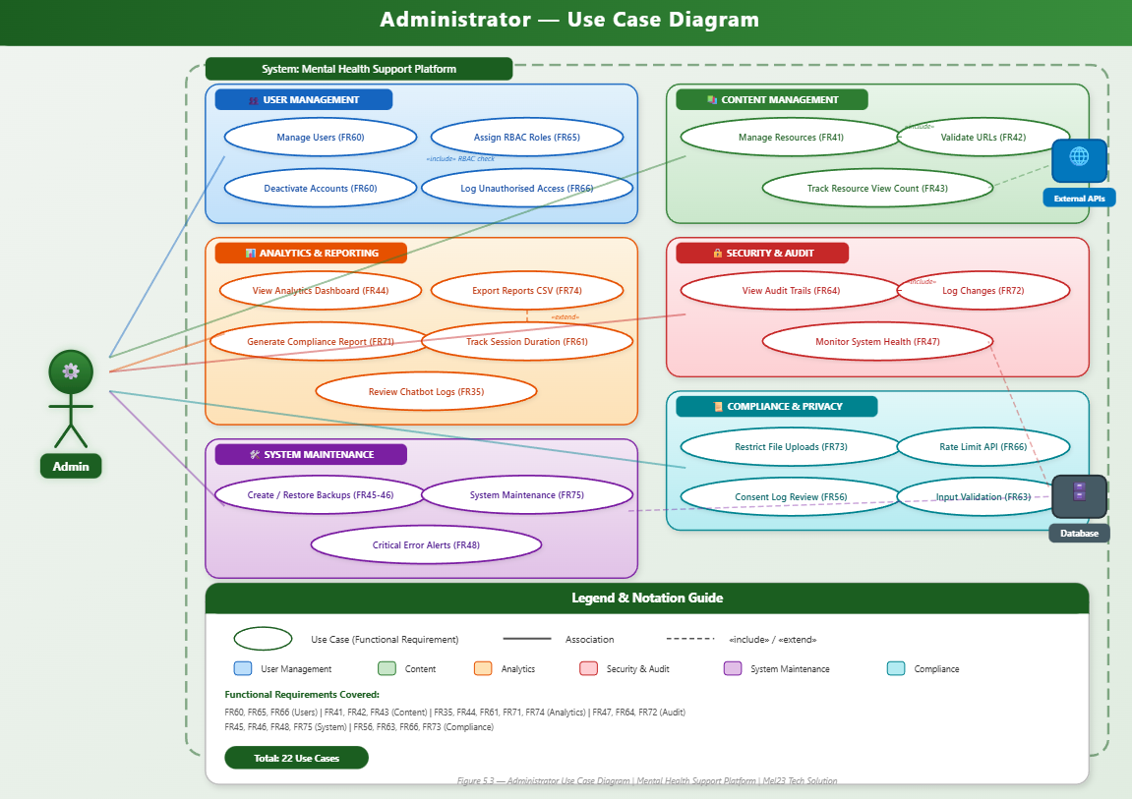
Figure 5.3: Administrator — Use Case Diagram
Quick Lowdown — Patient/User:
- Register Account (FR1), Login/Logout (FR8), Verify OTP (FR2), Reset Password (FR5)
- Update Profile (FR6), Upload Profile Image (FR7)
- Submit Mood Entry (FR27), View Mood Report (FR29)
- Book Appointment (FR9), Reschedule Appointment (FR11)
- Send Chat Message (FR23), Use AI Chatbot (FR32)
- Access Resources (FR41), Trigger Emergency (FR38)
- Manage Consent (FR54), View Dashboard (FR50), Download Records (FR53), Select Language (FR49)
Quick Lowdown — Clinician:
- Login/Logout (FR8), View Patient History (FR18), Write Session Notes (FR16)
- Approve Appointments (FR14), Chat with Patient (FR24), View Schedule (FR67)
- Request Medical Records (FR21), Reassign Patients (FR20)
- Upload Clinical Docs (FR51), View Workload Metrics (FR70), Access Patient Mood Data (FR29)
Quick Lowdown — Admin:
- Manage Users (FR60), Assign RBAC Roles (FR65), Manage Resources (FR41), Validate URLs (FR42)
- View Analytics Dashboard (FR44), Generate Compliance Reports (FR71)
- Review Chatbot Logs (FR35), Monitor System Health (FR47)
- Create/Restore Backups (FR45–46), Export Reports to CSV (FR74)
- Deactivate Accounts (FR60), View Audit Trails (FR64)

6. Context Diagrams (Gane & Sarson Method)
This diagram gives you a big-picture view of the whole thing. It shows how the platform hooks up with outside services like Google Calendar, messaging, and email tools.
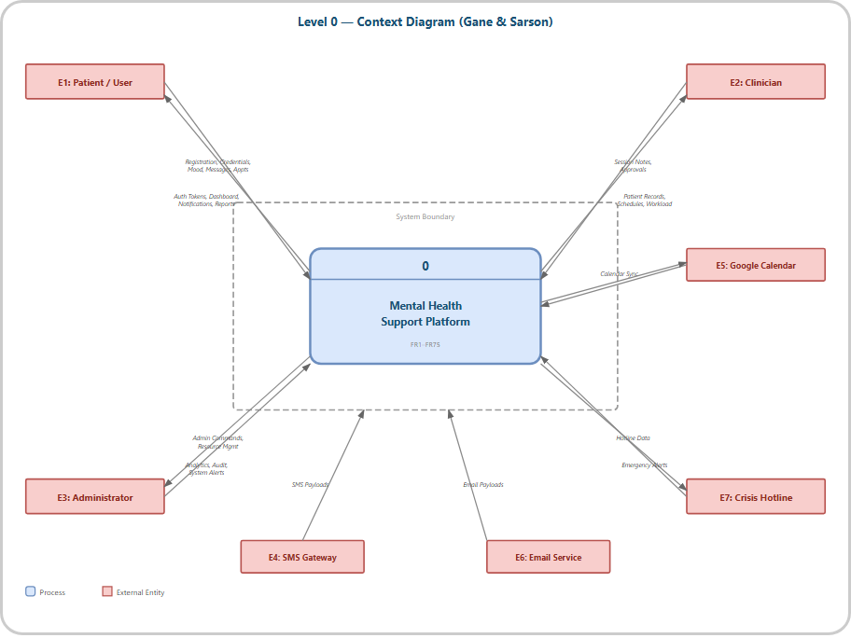
Figure 6.1: Level 0 — Context Diagram (Gane & Sarson)
The Outside Players (Entities):
- E1: Patient/User — Primary system user who registers, tracks mood, books appointments, and accesses resources
- E2: Clinician — Healthcare professional who manages appointments, writes session notes, and views patient records
- E3: Administrator — System administrator who manages users, resources, analytics, and system configuration
- E4: SMS Gateway (Twilio) — External service for sending SMS notifications and OTP codes
- E5: Google Calendar — External calendar service for appointment synchronization
- E6: Email Service (SendGrid) — External service for transactional email notifications
- E7: Crisis Hotline — External crisis support service providing hotline data for emergency scenarios

7. Data Flow Diagrams (Gane & Sarson Method)
These Data Flow Diagrams show the journey your info takes—from the moment you type it in to when it's tucked away in the database.

7.1 DFD Level 1
This first level breaks things down into 15 core jobs—like booking an appointment or checking your mood—and shows how they connect to where we store data.
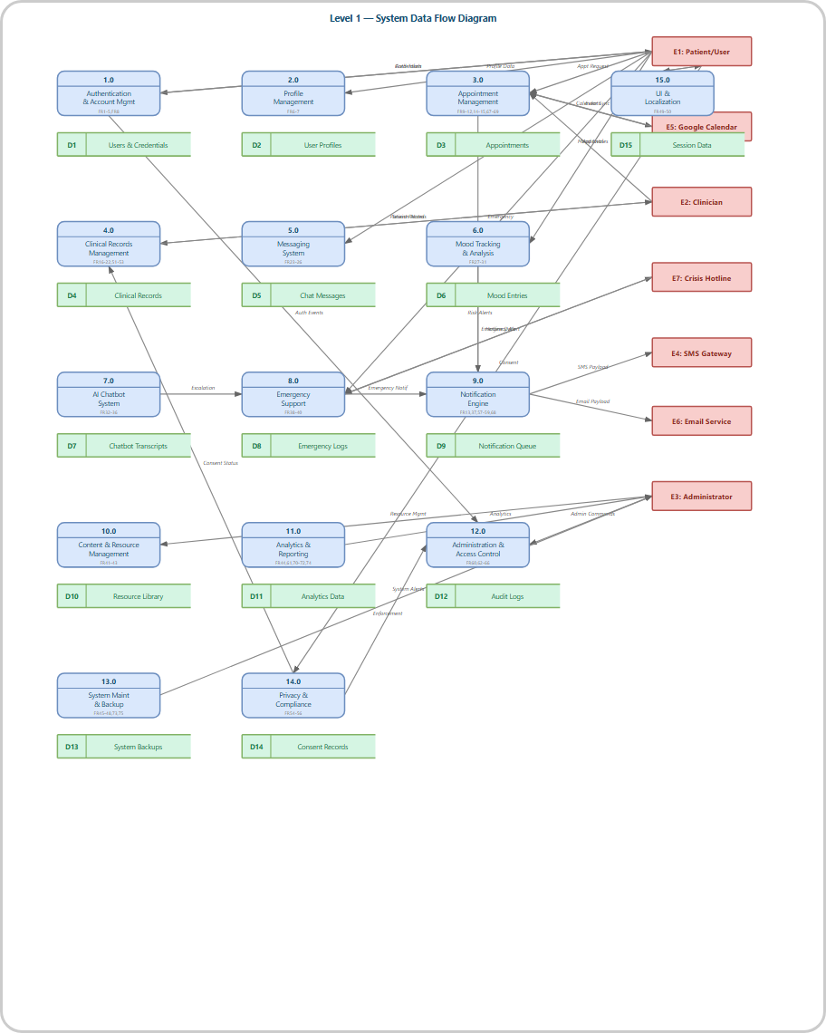
Figure 7.1: Level 1 — System Data Flow Diagram
Process | Name | FRs Covered
1.0 | Authentication & Account Management | FR1–5, FR8
2.0 | Profile Management | FR6–7
3.0 | Appointment Management | FR9–15, FR67–69
4.0 | Clinical Records Management | FR16–22, FR51–53
5.0 | Messaging System | FR23–26
6.0 | Mood Tracking & Analysis | FR27–31
7.0 | AI Chatbot System | FR32–36
8.0 | Emergency Support | FR38–40
9.0 | Notification Engine | FR13, FR37, FR57–59, FR68
10.0 | Content & Resource Management | FR41–43
11.0 | Analytics & Reporting | FR44, FR61, FR70–72, FR74
12.0 | Administration & Access Control | FR60, FR62–66
13.0 | System Maintenance & Backup | FR45–48, FR73, FR75
14.0 | Privacy & Compliance | FR54–56
15.0 | UI & Localization | FR49–50

Where we keep the data (Stores):

Store ID | Name
D1 | Users & Credentials
D2 | User Profiles
D3 | Appointments
D4 | Clinical Records
D5 | Chat Messages
D6 | Mood Entries
D7 | Chatbot Transcripts
D8 | Emergency Logs
D9 | Notification Queue
D10 | Resource Library
D11 | Analytics Data
D12 | Audit Logs
D13 | System Backups
D14 | Consent Records
D15 | Session Data

7.2 DFD Level 2
These detailed diagrams take a deep dive into each part of the system to show the actual logic and decisions going on under the hood.
Decomposes Process 1.0 into 7 sub-processes: Register User (FR1), Verify OTP (FR2), Lock Account (FR3), Log Login Activity (FR4), Password Reset (FR5), Login/Logout (FR8), and Delete & Anonymize (FR8d).
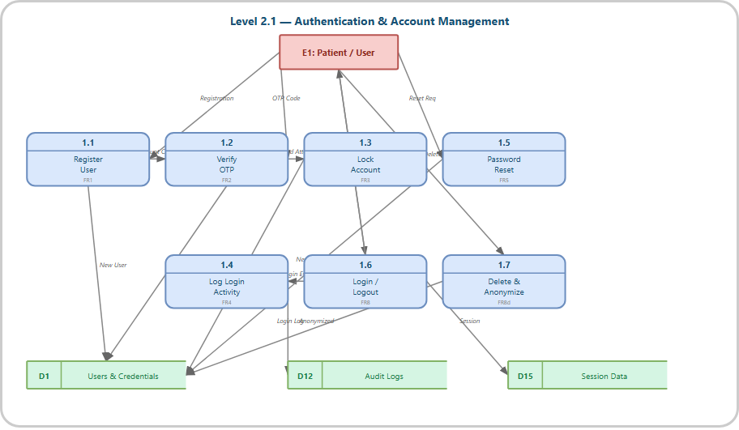
Figure 7.2.1: Level 2.1 — Authentication & Account Management
Decomposes Process 2.0 into 2 sub-processes: Update Profile Fields (FR6) and Upload Profile Image with < 2MB validation (FR7).
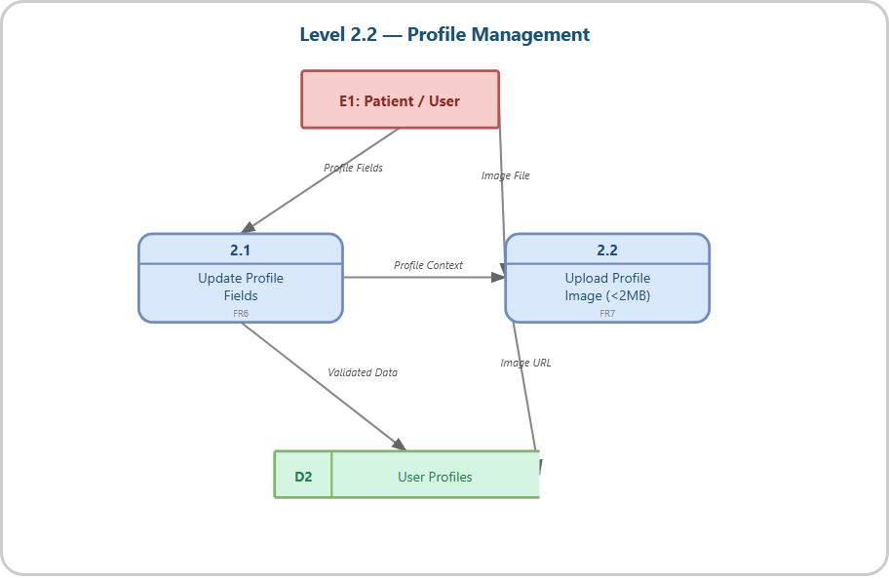
Figure 7.2.2: Level 2.2 — Profile Management
Decomposes Process 3.0 into 9 sub-processes covering scheduling (FR9), slot availability (FR10), rescheduling (FR11), missed marking (FR12), approval pending (FR14), auto-cancel (FR15), Google Calendar sync (FR67), follow-up notifications (FR68), and rebooking from alerts (FR69).
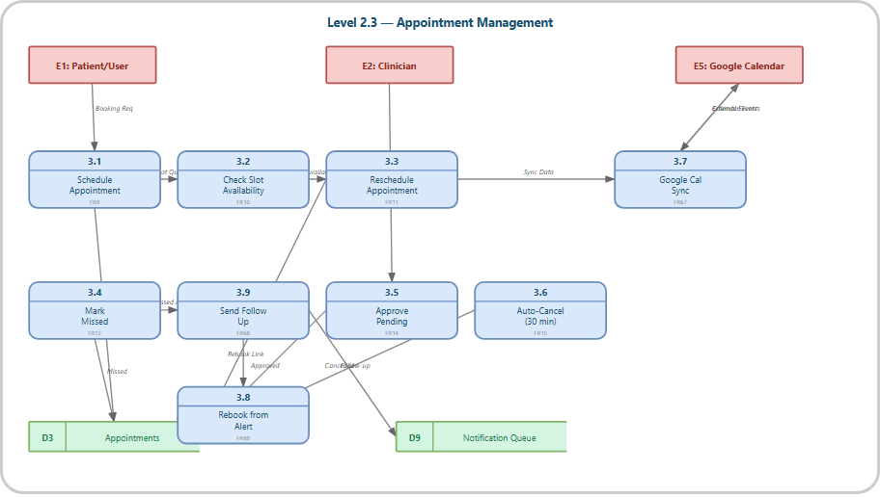
Figure 7.2.3: Level 2.3 — Appointment Management
Decomposes Process 4.0 into 10 sub-processes managing session notes (FR16), consent checking (FR17), patient history viewing (FR18), record retention (FR19), patient reassignment (FR20), medical record requests (FR21), access logging (FR22), clinical document upload (FR51), format validation (FR52), and record download (FR53).
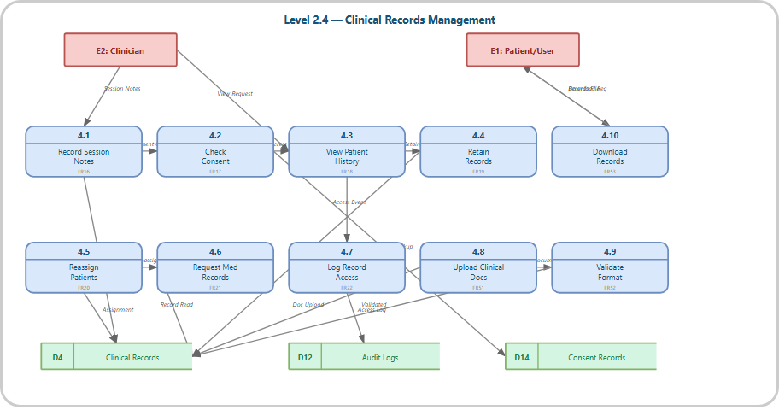
Figure 7.2.4: Level 2.4 — Clinical Records Management
Decomposes Process 5.0 into 4 sub-processes: message encryption with AES-256 (FR23), message delivery within 2 seconds (FR24), chat transcript storage (FR25), and soft delete functionality (FR26).
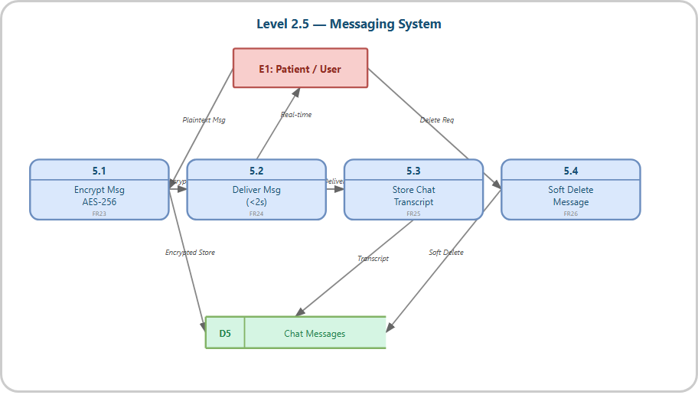
Figure 7.2.5: Level 2.5 — Messaging System
Decomposes Process 6.0 into 5 sub-processes: mood entry submission (FR27), duplicate prevention within 1-hour window (FR28), weekly mood report generation (FR29), risk alert triggering for consecutive low scores (FR30), and resource recommendation based on patterns (FR31).
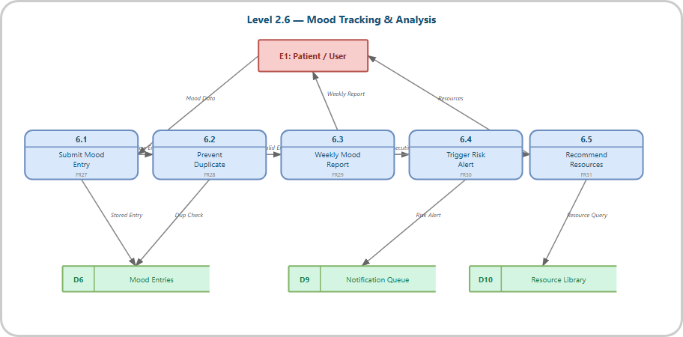
Figure 7.2.6: Level 2.6 — Mood Tracking & Analysis
Decomposes Process 7.0 into 5 sub-processes: query processing within 3 seconds (FR32), human escalation when confidence < 70% (FR33), transcript storage (FR34), admin log review (FR35), and inactive user detection after 7 days (FR36).
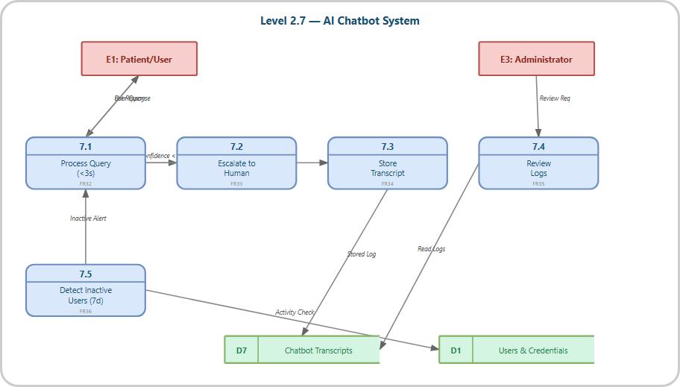
Figure 7.2.7: Level 2.7 — AI Chatbot System
Decomposes Process 8.0 into 3 sub-processes: emergency button activation with < 1 second response (FR38), crisis hotline display (FR39), and emergency activation logging (FR40).
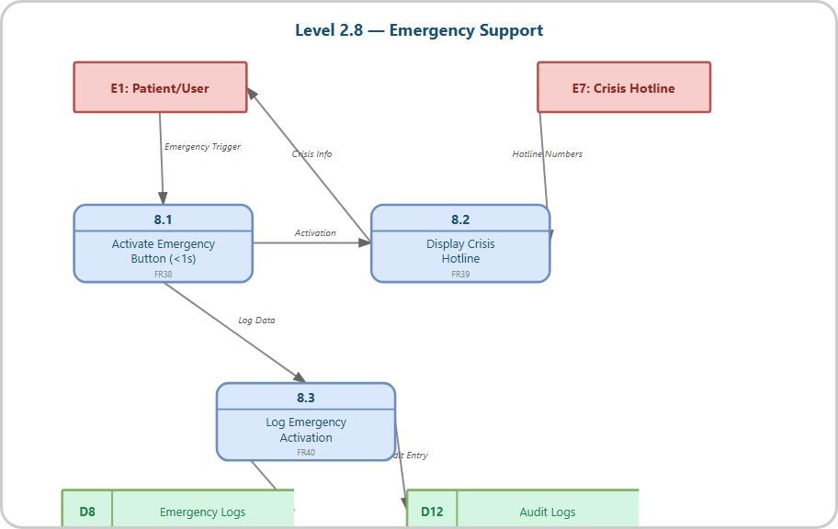
Figure 7.2.8: Level 2.8 — Emergency Support
Decomposes Process 9.0 into 6 sub-processes covering booking confirmation (FR13), wellness check dispatch (FR37), SMS/email integration (FR57), failed call retry up to 3 times (FR58), downtime queuing (FR59), and missed appointment follow-up (FR68).
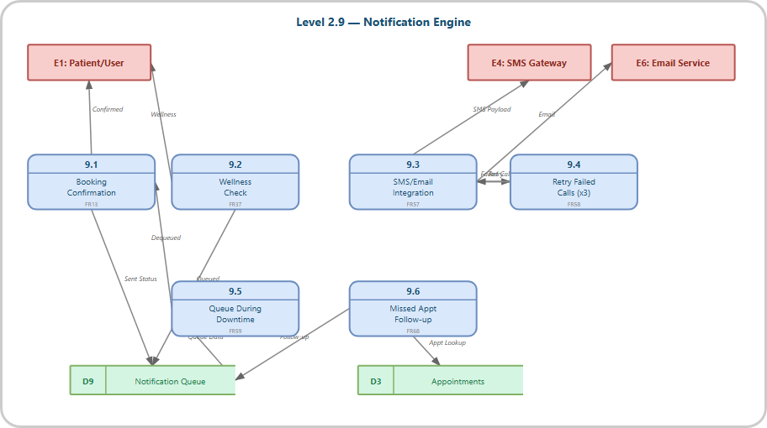
Figure 7.2.9: Level 2.9 — Notification Engine
Decomposes Process 10.0 into 3 sub-processes: resource addition via admin panel (FR41), URL validation before publishing (FR42), and view count tracking (FR43).
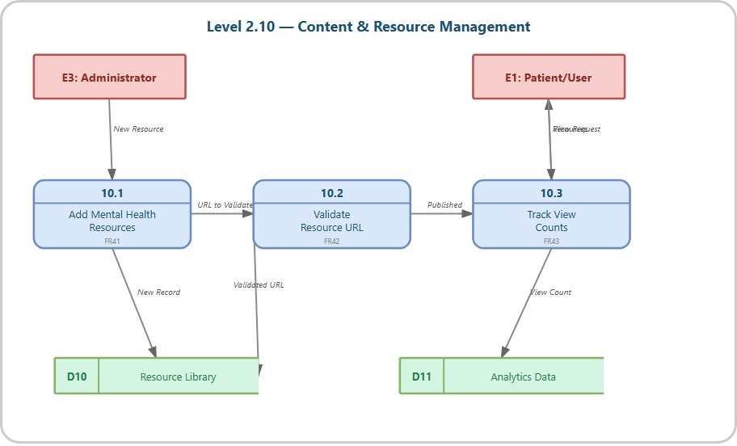
Figure 7.2.10: Level 2.10 — Content & Resource Management
Decomposes Process 11.0 into 6 sub-processes: monthly report generation (FR44), session duration tracking (FR61), clinician workload evaluation (FR70), compliance reporting (FR71), data modification logging (FR72), and CSV export (FR74).
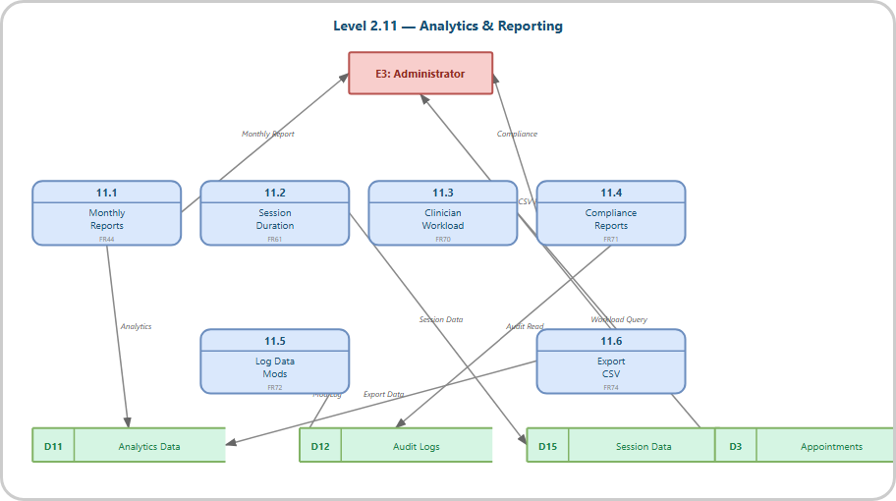
Figure 7.2.11: Level 2.11 — Analytics & Reporting
Decomposes Process 12.0 into 6 sub-processes: account deactivation (FR60), auto-logout after 15 minutes (FR62), input validation for SQL injection prevention (FR63), audit trail generation (FR64), RBAC assignment (FR65), and unauthorized API request denial (FR66).
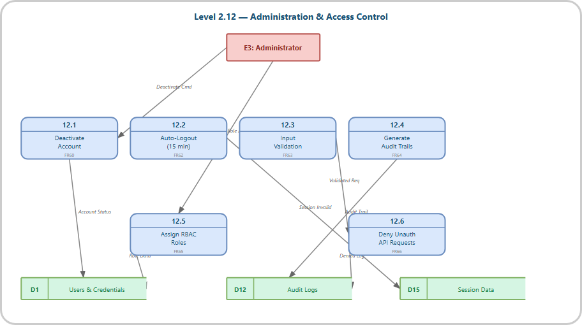
Figure 7.2.12: Level 2.12 — Administration & Access Control
Decomposes Process 13.0 into 6 sub-processes: daily midnight backup (FR45), backup restoration (FR46), system error logging (FR47), critical admin alerts (FR48), file upload limit enforcement at 5MB (FR73), and monthly maintenance (FR75).
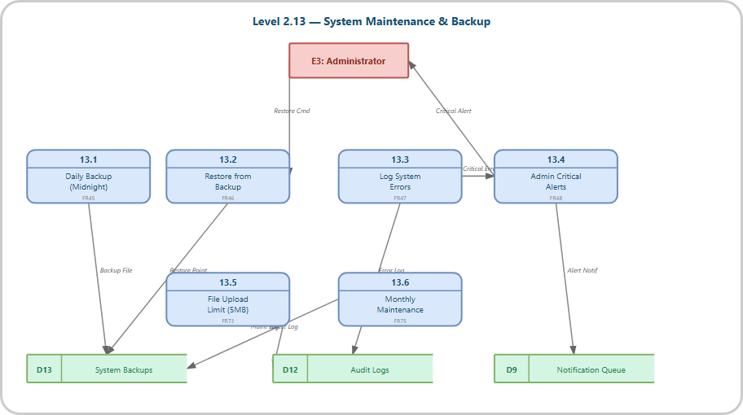
Figure 7.2.13: Level 2.13 — System Maintenance & Backup
Decomposes Process 14.0 into 3 sub-processes: instant consent revocation (FR54), access restriction on revocation (FR55), and consent change logging (FR56).
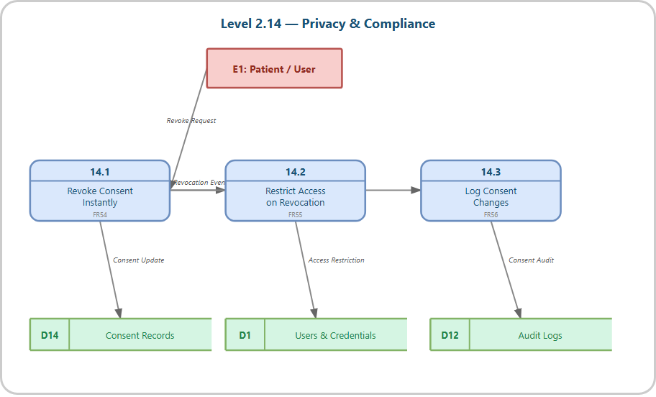
Figure 7.2.14: Level 2.14 — Privacy & Compliance
Decomposes Process 15.0 into 2 sub-processes: interface language selection (FR49) and dashboard loading within 3 seconds (FR50).
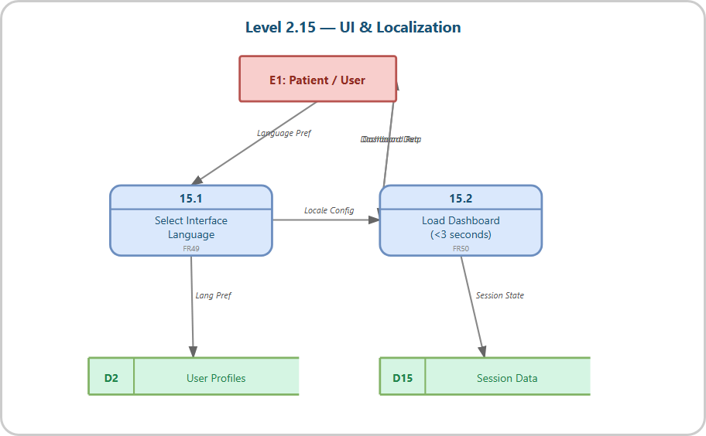
Figure 7.2.15: Level 2.15 — UI & Localization

8. Sequence Diagrams
These sequence diagrams show the exact steps data takes for specific jobs, like when you book an appointment or send a private chat.
This sequence diagram shows the complete user registration flow including data submission, database record creation, OTP email verification, OTP code verification, account verification update, JWT token generation, and dashboard rendering. The flow involves Patient, Frontend, API Server, and Database participants.
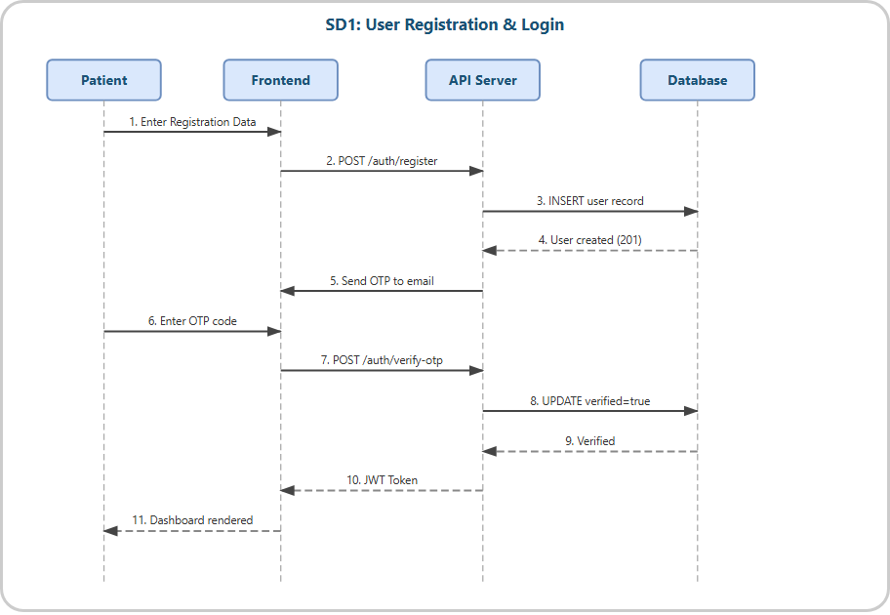
Figure 8.1: SD1 — User Registration & Login
This diagram illustrates the appointment booking process from clinician/date selection through slot availability checking, booking confirmation, database insertion, Google Calendar synchronization, and email notification dispatch. It involves Patient, Frontend, API Server, Database, and Google Calendar participants.
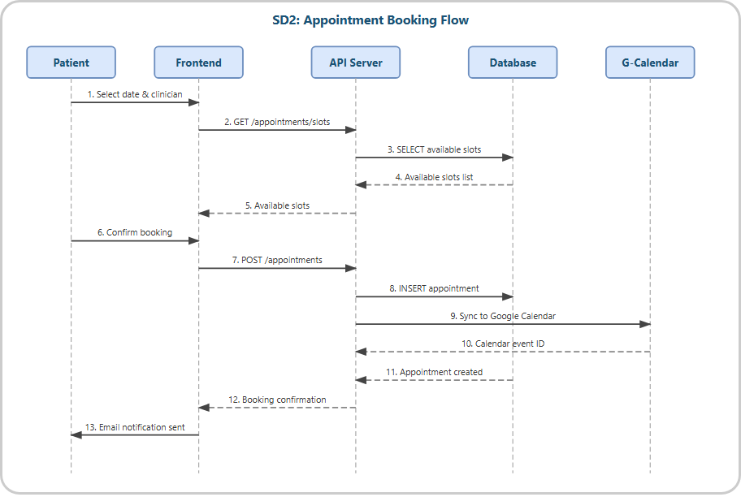
Figure 8.2: SD2 — Appointment Booking Flow
Shows the mood submission flow with duplicate checking (24-hour window), mood entry insertion, consecutive low-score detection (< 2 for 3 days), risk alert triggering, notification insertion, and dashboard update. Demonstrates the automated risk detection mechanism.
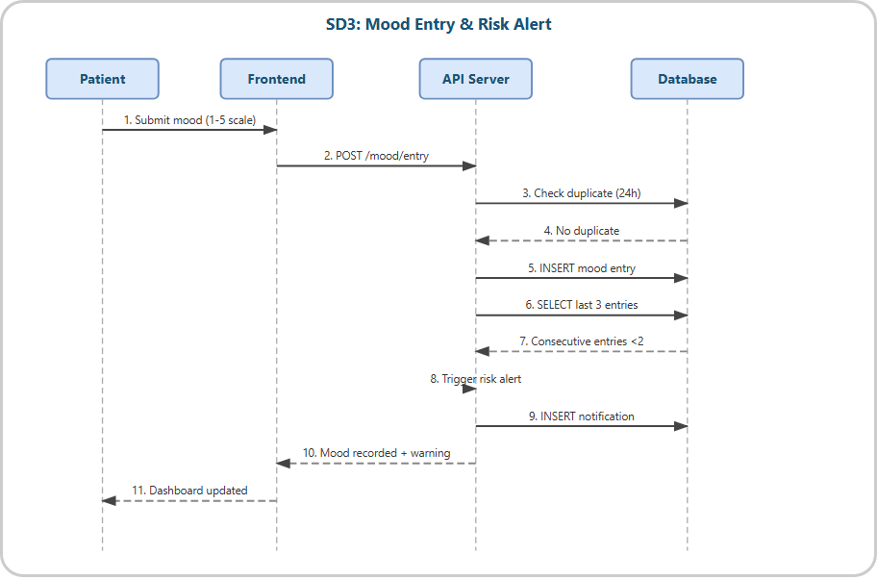
Figure 8.3: SD3 — Mood Entry & Risk Alert
Illustrates the AI chatbot conversation flow: message submission, API server processing, NLP query to AI engine, confidence scoring, response delivery (< 3 seconds), transcript storage, and automatic escalation to human clinician when confidence drops below 70%.
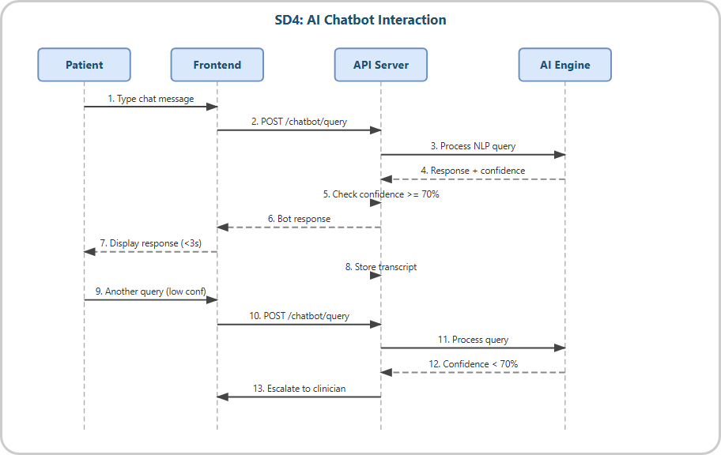
Figure 8.4: SD4 — AI Chatbot Interaction
Shows the critical emergency flow: button press, emergency activation API call, emergency log creation, crisis hotline data fetch from external service, crisis information display (< 1 second response), and audit trail insertion. Involves Patient, Frontend, API Server, Database, and Crisis Service.
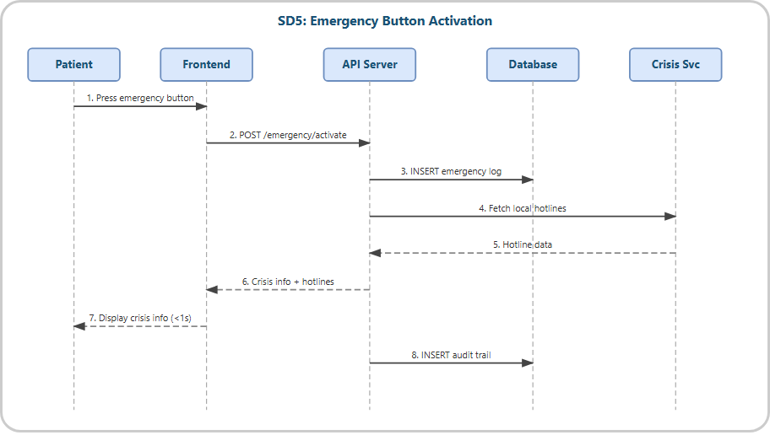
Figure 8.5: SD5 — Emergency Button Activation
Demonstrates the secure messaging flow: message composition, AES-256 encryption at the server, encrypted message storage, WebSocket real-time delivery (< 2 seconds), delivery confirmation, recipient notification, and soft delete functionality.
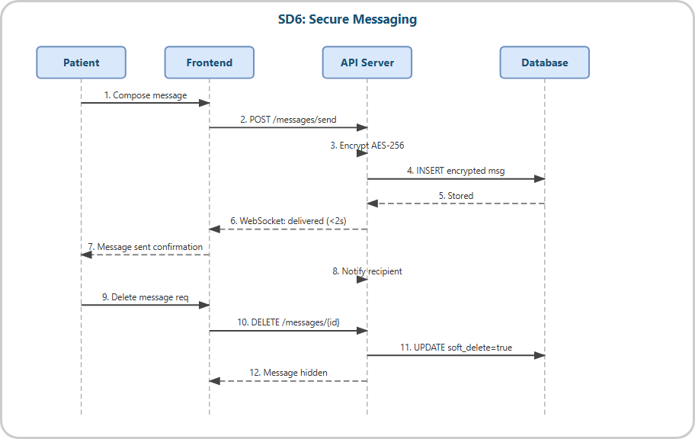
Figure 8.6: SD6 — Secure Messaging

9. Entity Relationship Diagram & Data Dictionary
This ERD is basically a map of our database. It shows how all the different tables—like users, appointments, and messages—fit together and talk to each other.
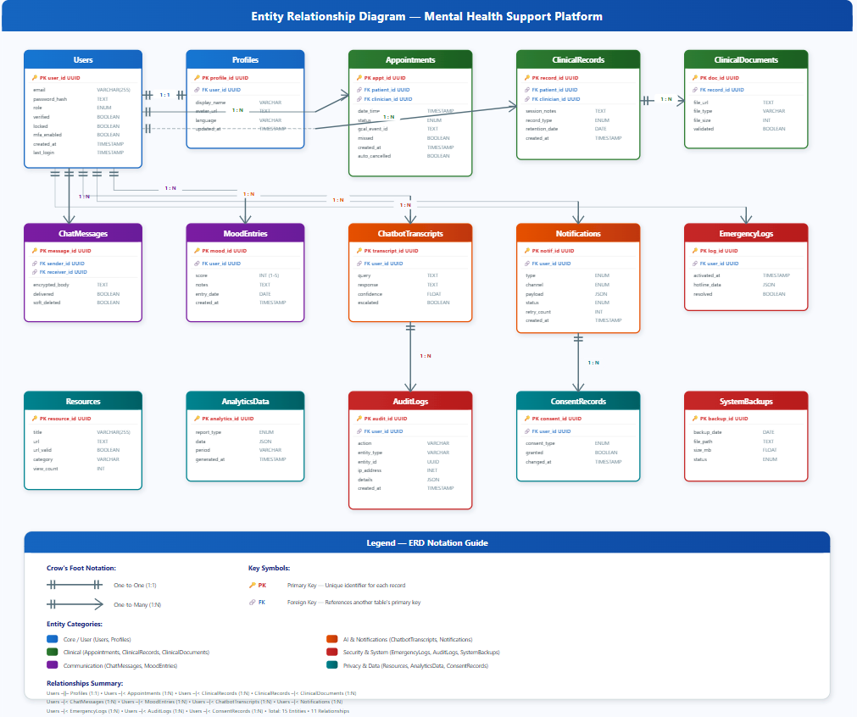
Figure 9.1: Entity Relationship Diagram — Mental Health Support Platform

9.1 Data Dictionary
These tables show you exactly what kind of info we're saving in every section of our database.
Table: Users
Column | Type | Constraints | Description
user_id | UUID | PK | Unique user identifier
email | VARCHAR(255) | UNIQUE, NOT NULL | User email address
password_hash | TEXT | NOT NULL | bcrypt hashed password (10 salt rounds)
role | ENUM | NOT NULL | patient | clinician | admin
verified | BOOLEAN | DEFAULT false | Email/OTP verification status
locked | BOOLEAN | DEFAULT false | Account lock after 5 failed attempts
mfa_enabled | BOOLEAN | DEFAULT false | Multi-factor authentication flag
created_at | TIMESTAMP | DEFAULT NOW() | Account creation timestamp
last_login | TIMESTAMP | NULLABLE | Most recent login timestamp

Table: Profiles
Column | Type | Constraints | Description
profile_id | UUID | PK | Unique profile identifier
user_id | UUID | FK → Users | References Users table
display_name | VARCHAR(100) | NOT NULL | User display name
avatar_url | TEXT | NULLABLE | Profile image URL (< 2MB)
language | VARCHAR(10) | DEFAULT 'en' | Interface language preference
updated_at | TIMESTAMP | DEFAULT NOW() | Last profile update

Table: Appointments
Column | Type | Constraints | Description
appt_id | UUID | PK | Unique appointment identifier
patient_id | UUID | FK → Users | Patient reference
clinician_id | UUID | FK → Users | Clinician reference
date_time | TIMESTAMP | NOT NULL | Appointment date and time
status | ENUM | NOT NULL | pending | confirmed | missed | cancelled
gcal_event_id | TEXT | NULLABLE | Google Calendar event ID
missed | BOOLEAN | DEFAULT false | Missed after 15-min delay
created_at | TIMESTAMP | DEFAULT NOW() | Booking creation time
auto_cancelled | BOOLEAN | DEFAULT false | Auto-cancelled after 30 min

Table: ClinicalRecords
Column | Type | Constraints | Description
record_id | UUID | PK | Unique record identifier
patient_id | UUID | FK → Users | Patient reference
clinician_id | UUID | FK → Users | Clinician reference
session_notes | TEXT | NOT NULL | Clinical session notes
record_type | ENUM | NOT NULL | consultation | follow-up | emergency
retention_date | DATE | NULLABLE | Data retention deadline
created_at | TIMESTAMP | DEFAULT NOW() | Record creation time

Table: ChatMessages
Column | Type | Constraints | Description
message_id | UUID | PK | Unique message identifier
sender_id | UUID | FK → Users | Message sender
receiver_id | UUID | FK → Users | Message receiver
encrypted_body | TEXT | NOT NULL | AES-256 encrypted message body
delivered | BOOLEAN | DEFAULT false | Delivery confirmation
soft_deleted | BOOLEAN | DEFAULT false | Soft delete flag (not purged)

Table: MoodEntries
Column | Type | Constraints | Description
mood_id | UUID | PK | Unique mood entry identifier
user_id | UUID | FK → Users | User reference
score | INT | CHECK (1-5) | Mood score (1=very low, 5=excellent)
notes | TEXT | NULLABLE | Optional mood notes
entry_date | DATE | NOT NULL | Date of mood entry
created_at | TIMESTAMP | DEFAULT NOW() | Entry creation time

Table: ChatbotTranscripts
Column | Type | Constraints | Description
transcript_id | UUID | PK | Unique transcript identifier
user_id | UUID | FK → Users | User reference
query | TEXT | NOT NULL | User query text
response | TEXT | NOT NULL | AI-generated response
confidence | FLOAT | NOT NULL | AI confidence score (0.0–1.0)
escalated | BOOLEAN | DEFAULT false | Escalated to human (< 70%)

Table: Notifications
Column | Type | Constraints | Description
notif_id | UUID | PK | Unique notification identifier
user_id | UUID | FK → Users | Recipient user reference
type | ENUM | NOT NULL | booking | wellness | alert | follow_up
channel | ENUM | NOT NULL | email | sms | in_app
payload | JSON | NOT NULL | Notification content payload
status | ENUM | DEFAULT 'pending' | pending | sent | failed | queued
retry_count | INT | DEFAULT 0 | API retry count (max 3)
created_at | TIMESTAMP | DEFAULT NOW() | Notification creation time

Table: EmergencyLogs
Column | Type | Constraints | Description
log_id | UUID | PK | Unique emergency log identifier
user_id | UUID | FK → Users | User who activated emergency
activated_at | TIMESTAMP | DEFAULT NOW() | Activation timestamp
hotline_data | JSON | NULLABLE | Crisis hotline information
resolved | BOOLEAN | DEFAULT false | Resolution status

Table: ConsentRecords
Column | Type | Constraints | Description
consent_id | UUID | PK | Unique consent identifier
user_id | UUID | FK → Users | User reference
consent_type | ENUM | NOT NULL | data_sharing | analytics | marketing
granted | BOOLEAN | NOT NULL | Consent granted or revoked
changed_at | TIMESTAMP | DEFAULT NOW() | Last consent change time

Table: AuditLogs
Column | Type | Constraints | Description
audit_id | UUID | PK | Unique audit entry identifier
user_id | UUID | FK → Users | User who performed action
action | VARCHAR(100) | NOT NULL | Action performed
entity_type | VARCHAR(50) | NOT NULL | Affected entity type
entity_id | UUID | NULLABLE | Affected entity ID
ip_address | INET | NULLABLE | Client IP address
details | JSON | NULLABLE | Additional action details
created_at | TIMESTAMP | DEFAULT NOW() | Audit entry time

10. Class Diagram
This class diagram is like the technical blueprint for the platform. It shows the main objects we've built and how we're making them work.
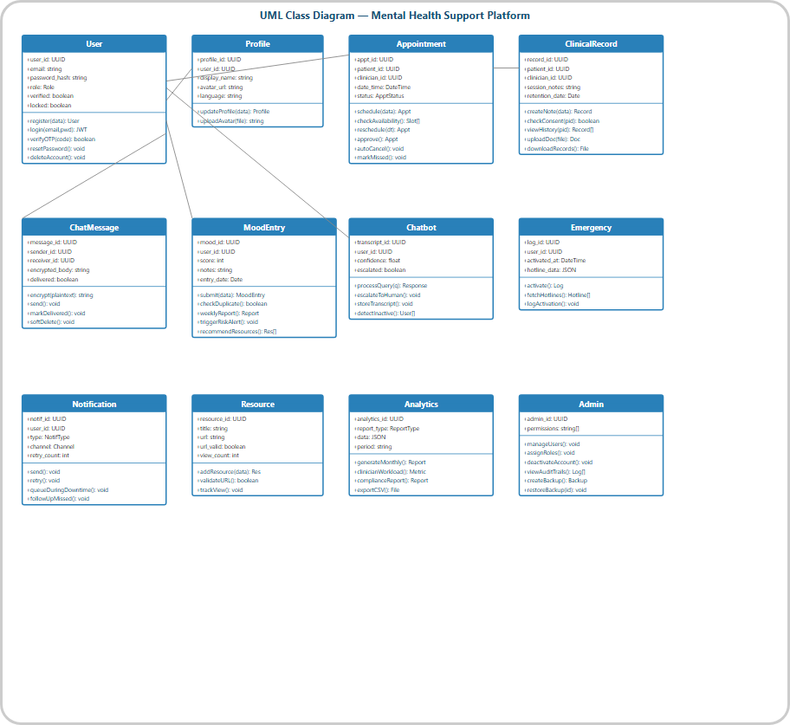
Figure 10.1: UML Class Diagram — Mental Health Support Platform
The system is built from 12 main classes:
- User — Core authentication entity with registration, login, OTP verification, password reset, and account deletion methods
- Profile — User profile management with display name, avatar upload, and language preferences
- Appointment — Scheduling system with conflict detection, slot checking, rescheduling, approval, auto-cancel, and missed marking
- ClinicalRecord — Medical records management with consent checking, session notes, document upload/download, and patient history viewing
- ChatMessage — Encrypted messaging (AES-256) with send, deliver, soft-delete operations
- MoodEntry — Daily mood tracking with duplicate prevention, weekly reporting, risk alerting, and resource recommendation
- Chatbot — AI-powered conversation with NLP query processing, human escalation, transcript storage, and inactive user detection
- Emergency — Emergency support activation with hotline fetching and activation logging
- Notification — Multi-channel notification system (email, SMS, in-app) with retry and downtime queuing
- Resource — Mental health resource library with URL validation, view tracking, and content management
- Analytics — Reporting engine with monthly reports, clinician workload metrics, compliance reports, and CSV export
- Admin — Administrative controls with user management, RBAC assignment, account deactivation, audit trail viewing, and backup management

11. Data Protection Impact Assessment (DPIA)
We did this assessment to catch any privacy risks before they could cause trouble. Since we're handling sensitive health info, we have to be extra careful.

11.1 Overview of Data Processing
We look after a few different types of info to keep the app running—from account details to your personal logs and chat records.
- Account Data — Email addresses, hashed passwords, login timestamps, IP addresses
- Profile Data — Display names, avatar images, language preferences
- Health Data — Mood scores, mood notes, clinical session notes, medical records
- Communication Data — Encrypted chat messages, chatbot transcripts
- Behavioral Data — Session duration, platform usage patterns, resource view counts
- Emergency Data — Emergency activation logs, crisis interaction records
- Consent Data — Data sharing preferences, consent change history

11.2 Risk Assessment
Risk | Severity | Mitigation Measures | Residual
Unauthorized access to health data | High | RBAC, JWT auth, consent-based access (FR17, FR65) | Low
Data breach of personal information | High | AES-256 encryption, bcrypt hashing, HTTPS (FR23, NFRS03) | Low
Unintended data retention | Medium | Right to deletion (FR8d), retention policies (FR19) | Low
Unauthorized data sharing | High | Consent management (FR54–55), immediate revocation | Low
Session hijacking | Medium | JWT 1hr expiry, auto-logout 15min (FR62, NFRS02) | Low
SQL injection / XSS attacks | High | Input validation (FR63), parameterized queries (NFRS05) | Low
Loss of data | Medium | Daily automated backups (FR45), restore within 1hr (FR46) | Low
Excessive API access | Medium | Rate limiting 100 req/IP/min (NFRS06) | Low
Emergency data misuse | Medium | Audit logging (FR40), access logging (FR22) | Low
Non-compliance with privacy laws | High | GDPR alignment, consent management (NFRC01–04) | Low

11.3 Privacy Controls Summary
Control | Implementation
Encryption at Rest | AES-256 for all sensitive data including messages and clinical records
Encryption in Transit | HTTPS/TLS 1.2+ for all client-server communications
Password Security | bcrypt hashing with 10 salt rounds; no plaintext storage
Authentication | JWT tokens with 1-hour expiry; OTP verification; multi-factor authentication
Access Control | Role-Based Access Control (RBAC) with Patient, Clinician, and Admin roles
Consent Management | Granular consent with instant revocation and immediate access restriction
Audit Trails | Complete logging of all database transactions, record access, and consent changes
Data Minimization | Only essential data collected; data anonymisation for analytics
Right to Deletion | User account deletion with data anonymisation within 24 hours
Backup & Recovery | Daily automated backups at midnight with 7-day retention; 1-hour restore SLA

12. Test and Implementation Plan

12.1 Testing Strategy
We're testing the whole system inside and out. This means checking individual bits of code and then testing the entire user experience to make sure it's perfect.
We're testing the whole system thoroughly. This means checking individual bits of code and then testing the entire user experience to make sure it's perfect.

Test Type | Tool | Scope | Acceptance Criteria
Unit Testing | Jest | Individual functions, API endpoints, React components | ≥ 80% code coverage
Integration Testing | Jest + Supertest | API endpoint chains, database interactions, auth flows | All critical paths
End-to-End Testing | Cypress | Complete user workflows from UI to database | Core user journeys
Security Testing | OWASP ZAP / Manual | SQL injection, XSS, auth bypass, rate limiting | Zero critical vulnerabilities
Performance Testing | Artillery / k6 | Page load < 3s, API response < 500ms, 50 concurrent users | Meet all NFR targets
User Acceptance Testing | Manual | Stakeholder validation of all features | All FRs verified

12.2 Test Cases Summary
ID | Test Case | FR | Procedure / Expected Result | Status
TC001 | User Registration | FR1 | Register with valid email → Account created | Pass
TC002 | Duplicate Email Rejection | FR1 | Register with existing email → Error message | Pass
TC003 | OTP Verification | FR2 | Enter valid OTP within 5s → Account verified | Pass
TC004 | Account Lockout | FR3 | 5 failed logins → Account locked | Pass
TC005 | Password Reset | FR5 | Reset with valid token (< 10 min) → Password updated | Pass
TC006 | Mood Entry Submission | FR27 | Submit mood 1–10 → Entry recorded | Pass
TC007 | Duplicate Mood Prevention | FR28 | Submit twice within 1 hour → Rejected | Pass
TC008 | Risk Alert Trigger | FR30 | 3 consecutive mood < 2 → Alert generated | Pass
TC009 | Appointment Booking | FR9 | Book available slot → Appointment created | Pass
TC010 | Conflict Detection | FR10 | Book occupied slot → Rejected | Pass
TC011 | Emergency Button | FR38 | Press emergency → Crisis info < 1s | Pass
TC012 | Message Encryption | FR23 | Send message → Stored encrypted (AES-256) | Pass
TC013 | Chatbot Response | FR32 | Send query → Response < 3 seconds | Pass
TC014 | Chatbot Escalation | FR33 | Low confidence → Escalated to clinician | Pass
TC015 | Consent Revocation | FR54 | Revoke consent → Access immediately restricted | Pass
TC016 | Auto-Logout | FR62 | 15 min inactivity → Session terminated | Pass
TC017 | RBAC Enforcement | FR65 | Patient access admin route → 403 Forbidden | Pass
TC018 | SQL Injection Prevention | FR63 | Inject SQL in input → Sanitized/blocked | Pass
TC019 | File Upload Limit | FR73 | Upload > 5MB file → Rejected | Pass
TC020 | Dashboard Load Time | FR50 | Load dashboard → Render < 3 seconds | Pass

12.3 Implementation Plan
Phase | Focus | Details
Phase 1  Week 7 | Backend Foundation | Express.js setup, PostgreSQL schema migration, JWT + OTP authentication, user CRUD APIs
Phase 2  Week 8 | Core Feature APIs | Mood tracking, appointment scheduling, messaging (AES-256), chatbot integration (OpenAI), emergency support APIs
Phase 3  Week 9 | Frontend Development | React component library, dashboard, mood tracker UI, messaging UI, appointment booking UI, admin panel
Phase 4  Week 10 | Integration & Real-time | Frontend-backend integration, Socket.io real-time chat, Google Calendar sync, notification engine, end-to-end testing
Phase 5  Week 11 | Testing & Deployment | Unit/integration/E2E testing, security audit, performance testing, cloud deployment (Render/AWS), CI/CD pipeline
Phase 6  Week 12 | Demo & Handover | Final demonstration, documentation completion, source code handover, deployment documentation

13. Responses on Feedback from Supervisor
This section is where we track the improvements we made based on the feedback we got from Mr. Altaf and Nabin Singh during our weekly catch-ups.

Week | Feedback | Response / Action Taken
Week 2 | Clarify the scope boundaries — what is in/out of scope for the prototype | Added explicit scope and limitations section (Section 1.3) distinguishing prototype features from production-level features. Clearly stated that video consultation, mobile-native app, and real clinical diagnosis are out of scope.
Week 3 | Ensure functional requirements are measurable and testable | Revised all 75 FRs to include specific measurable criteria (e.g., OTP within 5s, mood duplicate within 1hr, emergency response < 1s, API response < 500ms). Each FR now has a corresponding test case.
Week 4 | Architecture should clearly show separation of concerns | Designed and documented three-tier architecture (Presentation, Application, Data) with clear component separation. Added detailed architecture diagram with technology labels for each layer.
Week 5 | Data Flow Diagrams should follow Gane & Sarson method consistently | Redesigned all DFDs using Gane & Sarson notation. Created Level 0 Context Diagram, Level 1 DFD with 15 processes, and 15 Level 2 DFDs decomposing each process with proper data store references.
Week 5 | ERD should be database-ready with proper normalization | Designed ERD with 15 normalized entities, UUIDs as primary keys, proper foreign key relationships, and cross-reference modulation. Created comprehensive data dictionary with constraints.
Week 6 | Include security considerations throughout the design | Integrated DPIA (Section 11), implemented privacy controls table, added security-specific NFRs (NFRS01-06), and ensured all security FRs (FR23, FR54-55, FR62-66) are covered in DFDs and test cases.

References
[1] Sommerville, I. (2016). Software Engineering (10th ed.). Pearson Education.
[2] Pressman, R. S. & Maxim, B. R. (2020). Software Engineering: A Practitioner's Approach (9th ed.). McGraw-Hill.
[3] IEEE (1998). IEEE Std 830-1998: Recommended Practice for Software Requirements Specifications. IEEE.
[4] Gane, C. & Sarson, T. (1979). Structured Systems Analysis: Tools and Techniques. Prentice-Hall.
[5] OWASP Foundation (2021). OWASP Top 10 — 2021. https://owasp.org/Top10/
[6] React.js Documentation (2024). React — A JavaScript Library for Building User Interfaces. https://react.dev/
[7] Express.js Documentation (2024). Express — Fast, Unopinionated, Minimalist Web Framework. https://expressjs.com/
[8] PostgreSQL Documentation (2024). PostgreSQL: The World's Most Advanced Open Source Database. https://www.postgresql.org/docs/
[9] OpenAI API Documentation (2024). API Reference. https://platform.openai.com/docs/
[10] Google Calendar API Documentation (2024). Calendar API Overview. https://developers.google.com/calendar/
[11] Twilio Documentation (2024). Programmable Messaging. https://www.twilio.com/docs/
[12] SendGrid Documentation (2024). Email API. https://docs.sendgrid.com/
[13] Socket.IO Documentation (2024). Socket.IO. https://socket.io/docs/
[14] W3C (2018). Web Content Accessibility Guidelines (WCAG) 2.1. https://www.w3.org/TR/WCAG21/
[15] Information Commissioner's Office (ICO) (2022). Data Protection Impact Assessments. https://ico.org.uk/for-organisations/guide-to-data-protection/

Appendix

A. Table of Figures
Figure # | Description
Figure 1.1 | Organisation Chart — Mel23 Tech Solution
Figure 1.2 | Work Breakdown Structure
Figure 3.1 | Three-Tier System Architecture Diagram
Figure 4.1 | Login / Registration Page Wireframe
Figure 4.2 | User Dashboard Wireframe
Figure 4.3 | Mood Tracker Page Wireframe
Figure 4.4 | Secure Messaging Interface Wireframe
Figure 4.5 | Appointments Page Wireframe
Figure 4.6 | Admin Dashboard Panel Wireframe
Figure 5.1 | Patient / User Use Case Diagram
Figure 5.2 | Clinician / Doctor Use Case Diagram
Figure 5.3 | Administrator Use Case Diagram
Figure 6.1 | Level 0 Context Diagram (Gane & Sarson)
Figure 7.1 | Level 1 System Data Flow Diagram
Figure 7.2.1 | Level 2.1 — Authentication & Account Management DFD
Figure 7.2.2 | Level 2.2 — Profile Management DFD
Figure 7.2.3 | Level 2.3 — Appointment Management DFD
Figure 7.2.4 | Level 2.4 — Clinical Records Management DFD
Figure 7.2.5 | Level 2.5 — Messaging System DFD
Figure 7.2.6 | Level 2.6 — Mood Tracking & Analysis DFD
Figure 7.2.7 | Level 2.7 — AI Chatbot System DFD
Figure 7.2.8 | Level 2.8 — Emergency Support DFD
Figure 7.2.9 | Level 2.9 — Notification Engine DFD
Figure 7.2.10 | Level 2.10 — Content & Resource Management DFD
Figure 7.2.11 | Level 2.11 — Analytics & Reporting DFD
Figure 7.2.12 | Level 2.12 — Administration & Access Control DFD
Figure 7.2.13 | Level 2.13 — System Maintenance & Backup DFD
Figure 7.2.14 | Level 2.14 — Privacy & Compliance DFD
Figure 7.2.15 | Level 2.15 — UI & Localization DFD
Figure 8.1 | SD1 — User Registration & Login Sequence Diagram
Figure 8.2 | SD2 — Appointment Booking Flow Sequence Diagram
Figure 8.3 | SD3 — Mood Entry & Risk Alert Sequence Diagram
Figure 8.4 | SD4 — AI Chatbot Interaction Sequence Diagram
Figure 8.5 | SD5 — Emergency Button Activation Sequence Diagram
Figure 8.6 | SD6 — Secure Messaging Sequence Diagram
Figure 9.1 | Entity Relationship Diagram
Figure 10.1 | UML Class Diagram

B. Table of Tables
Table # | Description
Table 1.1 | Company Information
Table 1.2 | Roles and Responsibilities
Table 1.3 | Key Deliverables
Table 1.4 | Project Budget Estimates
Table 1.5 | WBS Phase Summary
Table 1.6 | Gantt Chart / Project Timeline
Table 2.1 | Functional Requirements (FR1–FR75)
Table 2.2 | Non-Functional Requirements
Table 3.1 | Technology Stack
Table 7.1 | Level 1 Process Descriptions
Table 7.2 | Data Store Definitions
Table 9.1–9.11 | Data Dictionary Tables
Table 11.1 | DPIA Risk Assessment
Table 11.2 | Privacy Controls Summary
Table 12.1 | Testing Strategy
Table 12.2 | Test Cases Summary
Table 12.3 | Implementation Plan
Table 13.1 | Supervisor Feedback Responses

