DEPARTMENT OF COMPUTER SCIENCE AND ENGINEERING

Web Programming Laboratory
CSE 3100

PROJECT REPORT
Title: Vehicle Rental Management System (DriveEase)

Submitted to: | Submitted by:
Kazi Saeed Alam  Assistant Professor  Department of Computer Science and Engineering  KUET  &  Mr. Ehsanul Karim  Lecturer  Department of Computer Science and Engineering  KUET. | Name:Md. Shahriar Hossain Prottoy  Roll:2207005  Section:A Year:Third Semester:First

1. Project Overview

1.1 Purpose
The Vehicle Rental Management System (DriveEase) is a comprehensive web based platform designed to streamline and automate the operations of a vehicle rental business. The system enables administrators to manage their fleet of vehicles, process bookings, track payments and generate reports, while providing customers with an intuitive interface to browse, compare and rent vehicles.

1.2 Objectives
- Develop a centralized platform for managing vehicle rental operations.
- Provide an intuitive customer facing interface for browsing and booking vehicles.
- Implement role based access control for administrators and customers.
- Enable real time vehicle availability tracking and booking conflict detection.
- Generate comprehensive business reports for revenue, fleet performance and customer analytics.
- Support multiple payment methods and automated payment tracking.
- Maintain a complete audit trail through notifications and booking history.

1.3 Problem Statement
Traditional vehicle rental businesses often rely on manual processes such as paper based booking records, spreadsheets for fleet management and phone based communication. These methods are error prone, time consuming, and do not scale well. Customers face difficulties in comparing vehicles, checking availability and making informed decisions. There is a need for a digital solution that automates the entire rental workflow, from vehicle browsing to booking confirmation, payment processing and report generation.

1.4 Scope
- Public vehicle browsing with search, filter, and comparison capabilities.
- User registration and authentication with role based access.
- Customer dashboard with booking management, wishlist and profile.
- Admin dashboard with fleet management, booking approval and analytics.
- Vehicle CRUD operations with multi image support.
- Booking system with date overlap conflict detection.
- Payment tracking with multiple payment method support
- Maintenance scheduling and cost tracking.
- Review and rating system with admin moderation.
- PDF report generation for revenue, vehicles, and customer analytics.
- Notification system for real time updates.

1.5 Target Users
User Role | Description | Key Capabilities
Administrator | System administrator managing the rental business | Fleet management, booking approval, payment processing, report generation, customer management
Customer | End-user renting vehicles | Browse vehicles, create bookings, manage wishlist, view invoices, submit reviews, manage profile
Guest | Unauthenticated visitor | Browse vehicles, view details, compare vehicles, read FAQ/About pages

2. Project Description
DriveEase is a full stack web application built on the Laravel 12 framework that provides a complete solution for vehicle rental management. The system follows the Model-View-Controller (MVC) architecture pattern and uses SQL queries for database operations, providing fine-grained control over data retrieval and manipulation.

2.1 What the System Does
The system serves as a complete rental management platform with three distinct interfaces: a public-facing website for vehicle browsing, a customer portal for booking management and an administrative panel for business operations. It handles the entire lifecycle of a vehicle rental from initial browsing through booking, payment and post rental review.

2.2 Why It Was Developed
The system was developed to address the challenges faced by vehicle rental businesses in managing their operations efficiently. It eliminates manual processes, reduces errors, and provides a modern, accessible platform for both business owners and customers.

2.3 Real-World Use Cases
- A customer needs to rent a car for a weekend trip and uses the platform to compare available vehicles by price, features and reviews.
- An administrator adds new vehicles to the fleet, sets pricing, and manages maintenance schedules.
- A customer submits a booking request and receives real-time notifications about booking status changes.
- The business owner generates monthly revenue reports to analyze business performance.
- An administrator reviews and moderates customer reviews to maintain quality standards.

2.4 Expected Benefits
- Reduced manual effort in managing bookings and fleet operations.
- Improved customer experience through self-service vehicle browsing and booking.
- Better business insights through comprehensive reporting and analytics.
- Enhanced accountability through complete audit trails and notification system.
- Scalable architecture that can grow with the business.

3. Technology Used

3.1 Backend Technologies
Technology | Version | Purpose | Role in Project
PHP | ^8.2 | Server-side scripting language | Core runtime for the Laravel framework, handles all server-side logic
Laravel | 12.x | PHP web application framework | Provides MVC architecture, routing, authentication, database abstraction, and templating
MySQL | 8.x | Relational database management system | Stores all application data including users, vehicles, bookings, and payments
Composer | ^2.x | PHP dependency manager | Manages backend packages and autoloading configuration

3.2 Frontend Technologies
Technology | Version | Purpose | Role in Project
HTML5 | - | Markup language | Structures all web pages and forms
CSS3 | - | Styling language | Provides visual styling, animations, and responsive design
Bootstrap | 5.3.2 | CSS framework | Provides responsive grid system, components, and utilities (loaded via CDN)
JavaScript | ES6+ | Programming language | Handles client-side interactivity, AJAX requests, and dynamic UI updates
jQuery | 3.7.1 | JavaScript library | Simplifies DOM manipulation, event handling, and AJAX calls (CDN)
Vite | 7.x | Frontend build tool | Bundles and optimizes frontend assets (CSS, JS)
Tailwind CSS | 4.x | Utility-first CSS framework | Available via Vite plugin for utility classes
Axios | 1.11.0 | HTTP client | Handles AJAX requests from the frontend

3.3 Supporting Technologies
Technology | Version | Purpose | Role in Project
Font Awesome | 6.5.0 | Icon library | Provides scalable vector icons throughout the UI (CDN)
SweetAlert2 | - | JavaScript alert library | Provides beautiful, customizable alert dialogs and toast notifications
Chart.js | 4.4.1 | JavaScript charting library | Renders interactive charts for admin dashboard analytics (CDN)
DataTables | 1.10.21 | jQuery table plugin | Enhances HTML tables with search, sort, and pagination (CDN)
Animate.css | 4.1.1 | CSS animation library | Provides smooth CSS animations for UI elements (CDN)
DomPDF | - | PDF generation library | Generates PDF reports for revenue and vehicle analytics
Nominatim API | - | Geolocation API | OpenStreetMap reverse geocoding for pickup location detection

4. System Architecture

4.1 MVC Architecture
The application follows the Model-View-Controller (MVC) architectural pattern provided by the Laravel framework. This pattern separates the application into three interconnected components:
Models: The application uses a single Eloquent model (User) and raw SQL queries via the DB facade for all other database operations. This provides direct control over SQL execution and query optimization.
Views: Blade templating engine renders all UI components with 48 Blade templates organized across three layout systems (public, admin, customer).
Controllers: 18 functional controllers handle HTTP requests, execute business logic using SQL queries, and return appropriate views or responses.

4.2 Routing System
All routes are defined in routes/web.php. The application uses 70 routes organized into three groups: public routes (17), customer routes (13), and admin routes (37). Route groups use middleware for authentication and authorization, with URL prefixes and name prefixes for organization.

4.3 Middleware
The application uses two custom middleware classes in addition to Laravel's built-in auth middleware:
Middleware | File | Purpose
auth | Built-in | Ensures user is authenticated before accessing protected routes
AdminMiddleware | app/Http/Middleware/AdminMiddleware.php | Restricts access to admin users only by checking role === "admin"
CustomerMiddleware | app/Http/Middleware/CustomerMiddleware.php | Restricts access to customer users only by checking role === "customer"

5. Project Folder Structure
app/ Contains the core application code including Controllers, Models, Middleware, Providers, and Support files.
app/Http/Controllers/ All 18 controllers organized by namespace: Root (HomeController, VehicleController), Auth (LoginController, RegisterController), Admin (7 controllers), Customer (5 controllers).
app/Models/ Contains the single Eloquent model: User.php.
app/Http/Middleware/ Custom middleware: AdminMiddleware and CustomerMiddleware.
app/Providers/ Service providers including AppServiceProvider (registers NotificationComposer).
app/Support/ Helper functions (helpers.php) for status badges, image URLs, and star ratings.
bootstrap/ Application bootstrapping and cache configuration.
config/ Configuration files for database, session, cache, mail, filesystems, and other services.
database/ Contains migrations (6 files creating 16 tables), seeders (7 files), and factories.
database/migrations/ Database schema definitions for all tables.
database/seeders/ Data seeders: UserSeeder, VehicleCategorySeeder, VehicleSeeder, BookingSeeder, MaintenanceSeeder, ReviewSeeder.
public/ Web-accessible root directory with index.php, CSS, JavaScript, and uploaded files (vehicles, categories, avatars).
resources/ Views, CSS, JavaScript source files, and language files.
resources/views/ 48 Blade templates organized: layouts/ (3), partials/ (2), auth/ (2), home/ (9), admin/ (21), customer/ (7).
routes/ Route definitions: web.php (70 routes), console.php.
storage/ Application storage: logs, compiled views, cache, and user-uploaded files.
tests/ PHPUnit test files (not implemented in current version).
vendor/ Composer-managed third-party packages and autoloader.

6. Database Design

6.1 Entity Relationships
The database consists of 16 tables with 13 foreign key constraints. The core entities are Users, Vehicles, Bookings, and Payments, with supporting tables for categories, images, reviews, wishlists, maintenance records, notifications, and communication.
Relationship | Type | Description
users → bookings | 1:N | A user can have multiple bookings
users → reviews | 1:N | A user can write multiple reviews
users → wishlists | 1:N | A user can wishlist multiple vehicles
users → notifications | 1:N | A user can receive multiple notifications
vehicle_categories → vehicles | 1:N | A category contains multiple vehicles
vehicles → vehicle_images | 1:N | A vehicle can have multiple images
vehicles → bookings | 1:N | A vehicle can be booked multiple times
vehicles → reviews | 1:N | A vehicle can receive multiple reviews
vehicles → maintenance_records | 1:N | A vehicle can have multiple maintenance records
bookings → payments | 1:1 | A booking has one associated payment
bookings → reviews | 1:N | A booking can have a review (nullable FK)

6.2 Schema Diagram
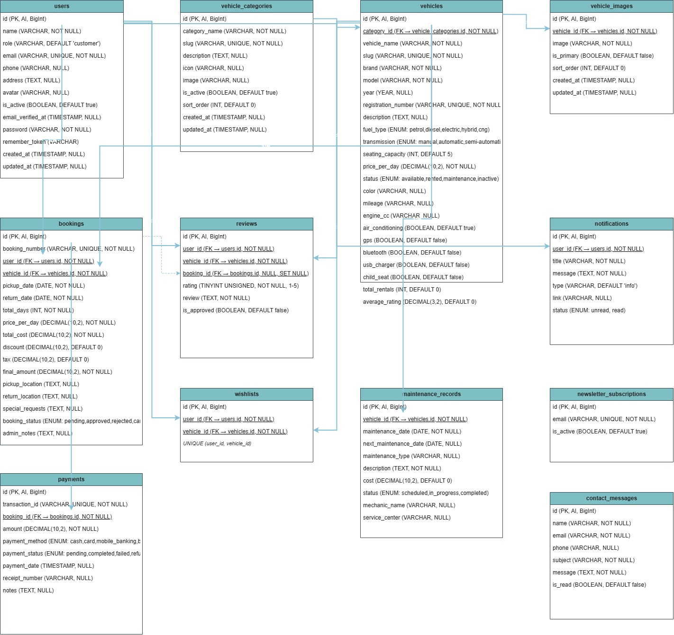

7. Authentication & Authorization

7.1 Authentication
The application implements session-based authentication using Laravel's built-in Auth system. Users authenticate via email and password, with passwords hashed using bcrypt.

Feature | Implementation
Login | POST /login → LoginController::login() validates credentials, checks is_active, calls Auth::login()
Registration | POST /register → RegisterController::register() creates user with "customer" role and hashed password
Logout | POST /logout → LoginController::logout() calls Auth::logout(), invalidates session, regenerates CSRF token
Remember Me | Optional "remember me" checkbox on login form sets remember token cookie
Session Storage | Database-backed sessions (SESSION_DRIVER=database) for persistence across server restarts
CSRF Protection | Laravel's built-in CSRF token verification on all POST/PUT/DELETE forms

7.2 Authorization
Authorization is implemented through a role-based access control system using two custom middleware classes.
Role | Middleware | Access Level
admin | AdminMiddleware | Full access to admin panel, fleet management, booking approval, payment processing, reports, and customer management
customer | CustomerMiddleware | Access to customer dashboard, booking creation/management, wishlist, profile, and reviews
guest | None (public) | Access to public pages: home, vehicle listings, vehicle details, about, contact, FAQ, login, registration

7.3 Role Checks
The User model implements two role-check methods used by middleware and controllers:
public function isAdmin(): bool { return $this->role === "admin"; }
public function isCustomer(): bool { return $this->role === "customer"; }

8. Project Features

Feature | Description | Controller/Method | Database Tables
Public Vehicle Browsing | Browse 45 vehicles across 8 categories with search, filter (fuel type, transmission, price range), sort, and pagination (12/page). | VehicleController | vehicles, vehicle_images, vehicle_categories
Vehicle Detail Page | View complete vehicle information including images, specifications, accessories, reviews, and related vehicles. | VehicleController::show | vehicles, vehicle_images, reviews
Vehicle Comparison | Compare up to 4 vehicles side-by-side on specifications, pricing, and features. | VehicleController::compare | vehicles, vehicle_images
Live Search | AJAX-powered search with instant results dropdown in the navigation bar. | VehicleController::search | vehicles
User Registration | Customer registration with name, email, phone, and password confirmation. | RegisterController | users
User Login/Logout | Session-based authentication with role-based redirection. | LoginController | users, sessions
Customer Dashboard | Overview of bookings, notifications, and quick actions. | Customer\DashboardController | bookings, notifications
Booking Creation | Date-overlap detection, cost calculation, and multi-step booking process. | Customer\BookingController | bookings, payments, notifications
Booking Management | View, cancel, and track booking status with real-time notifications. | Customer\BookingController | bookings, notifications
Invoice Generation | PDF-ready invoice view with booking and payment details. | Customer\BookingController::invoice | bookings, payments
Wishlist | Add/remove vehicles to personal wishlist with AJAX toggle. | Customer\WishlistController | wishlists
Profile Management | Update personal information, avatar, and password. | Customer\ProfileController | users
Review System | Submit reviews (1-5 stars) for completed bookings, pending admin approval. | Customer\ReviewController | reviews
Admin Dashboard | 10 key metrics, revenue chart, booking distribution, top vehicles, recent activity. | Admin\DashboardController | multiple tables
Vehicle CRUD | Full create/read/update/delete with multi-image upload and slug generation. | Admin\VehicleController | vehicles, vehicle_images
Category CRUD | Manage 8 vehicle categories with icons and images. | Admin\CategoryController | vehicle_categories
Booking Approval | Approve/reject/complete bookings with transaction-wrapped status updates. | Admin\BookingController | bookings, payments, vehicles
Payment Management | Track and update payment statuses with audit trail. | Admin\PaymentController | payments
Customer Management | View customer list, details, toggle active status. | Admin\CustomerController | users, bookings
Maintenance Tracking | Schedule and track vehicle maintenance with cost tracking. | Admin\MaintenanceController | maintenance_records, vehicles
Review Moderation | Approve/reject/delete customer reviews with rating recalculation. | Admin\ReviewController | reviews, vehicles
Reports & PDF Export | Revenue, vehicle performance, customer, and maintenance reports with PDF export. | Admin\ReportController | multiple tables
Geolocation API | Auto-detect pickup location using browser geolocation and Nominatim reverse geocoding. | JavaScript (client-side) | -
Newsletter Subscription | Email newsletter subscription via homepage form. | HomeController::newsletter | newsletter_subscriptions
Contact Form | Contact form submission with admin notification. | HomeController::contactSubmit | contact_messages
Notifications | Real-time notification system with bell icon and badge counts. | NotificationComposer | notifications
Responsive Design | Mobile-friendly layouts using Bootstrap 5.3.2 grid system. | All Blade views | -

9. Route Analysis

9.1 Public Routes
Method | URI | Controller | Middleware | Description
GET | / | HomeController@index | None | Home page
GET | /about | HomeController@about | None | About page
GET | /contact | HomeController@contact | None | Contact form
POST | /contact | HomeController@contactSubmit | None | Submit contact form
GET | /faq | HomeController@faq | None | FAQ page
GET | /privacy | HomeController@privacy | None | Privacy policy
GET | /terms | HomeController@terms | None | Terms of service
POST | /newsletter | HomeController@newsletter | None | Subscribe to newsletter
GET | /vehicles | VehicleController@index | None | Vehicle listing
GET | /vehicles/compare | VehicleController@compare | None | Compare vehicles
GET | /vehicles/search | VehicleController@search | None | AJAX search
GET | /vehicles/{slug} | VehicleController@show | None | Vehicle detail
GET | /login | LoginController@showForm | None | Login form
POST | /login | LoginController@login | None | Process login
POST | /logout | LoginController@logout | None | Logout
GET | /register | RegisterController@showForm | None | Registration form
POST | /register | RegisterController@register | None | Process registration

9.2 Customer Routes
Method | URI | Controller | Middleware | Description
GET | /customer/dashboard | Customer\DashboardController@index | auth, customer | Customer dashboard
GET | /customer/bookings | Customer\BookingController@index | auth, customer | My bookings list
GET | /customer/bookings/create/{slug} | Customer\BookingController@create | auth, customer | Create booking form
POST | /customer/bookings | Customer\BookingController@store | auth, customer | Submit booking
GET | /customer/bookings/{id} | Customer\BookingController@show | auth, customer | Booking detail
POST | /customer/bookings/{id}/cancel | Customer\BookingController@cancel | auth, customer | Cancel booking
GET | /customer/bookings/{id}/invoice | Customer\BookingController@invoice | auth, customer | View invoice
GET | /customer/wishlist | Customer\WishlistController@index | auth, customer | My wishlist
POST | /customer/wishlist/toggle | Customer\WishlistController@toggle | auth, customer | Toggle wishlist
GET | /customer/profile | Customer\ProfileController@edit | auth, customer | Edit profile
POST/PUT | /customer/profile | Customer\ProfileController@update | auth, customer | Update profile
POST | /customer/password | Customer\ProfileController@changePassword | auth, customer | Change password
POST | /customer/reviews | Customer\ReviewController@store | auth, customer | Submit review

9.3 Admin Routes
Method | URI | Controller | Middleware | Description
GET | /admin/dashboard | Admin\DashboardController@index | auth, admin | Admin dashboard
GET | /admin/vehicles | Admin\VehicleController@index | auth, admin | Vehicle list
GET | /admin/vehicles/create | Admin\VehicleController@create | auth, admin | Create vehicle form
POST | /admin/vehicles | Admin\VehicleController@store | auth, admin | Store vehicle
GET | /admin/vehicles/{id} | Admin\VehicleController@show | auth, admin | Vehicle detail
GET | /admin/vehicles/{id}/edit | Admin\VehicleController@edit | auth, admin | Edit vehicle form
PUT | /admin/vehicles/{id} | Admin\VehicleController@update | auth, admin | Update vehicle
DELETE | /admin/vehicles/{id} | Admin\VehicleController@destroy | auth, admin | Delete vehicle
GET | /admin/categories | Admin\CategoryController@index | auth, admin | Category list
GET | /admin/categories/create | Admin\CategoryController@create | auth, admin | Create category form
POST | /admin/categories | Admin\CategoryController@store | auth, admin | Store category
GET | /admin/categories/{id}/edit | Admin\CategoryController@edit | auth, admin | Edit category form
PUT | /admin/categories/{id} | Admin\CategoryController@update | auth, admin | Update category
DELETE | /admin/categories/{id} | Admin\CategoryController@destroy | auth, admin | Delete category
GET | /admin/bookings | Admin\BookingController@index | auth, admin | Booking list
GET | /admin/bookings/{id} | Admin\BookingController@show | auth, admin | Booking detail
POST | /admin/bookings/{id}/approve | Admin\BookingController@approve | auth, admin | Approve booking
POST | /admin/bookings/{id}/reject | Admin\BookingController@reject | auth, admin | Reject booking
POST | /admin/bookings/{id}/complete | Admin\BookingController@complete | auth, admin | Complete booking
GET | /admin/payments | Admin\PaymentController@index | auth, admin | Payment list
GET | /admin/payments/{id} | Admin\PaymentController@show | auth, admin | Payment detail
POST | /admin/payments/{id}/status | Admin\PaymentController@updateStatus | auth, admin | Update payment status
GET | /admin/customers | Admin\CustomerController@index | auth, admin | Customer list
GET | /admin/customers/{id} | Admin\CustomerController@show | auth, admin | Customer detail
POST | /admin/customers/{id}/toggle | Admin\CustomerController@toggleStatus | auth, admin | Toggle customer status
GET | /admin/maintenance | Admin\MaintenanceController@index | auth, admin | Maintenance list
GET | /admin/maintenance/create | Admin\MaintenanceController@create | auth, admin | Create maintenance form
POST | /admin/maintenance | Admin\MaintenanceController@store | auth, admin | Store maintenance record
GET | /admin/maintenance/{id}/edit | Admin\MaintenanceController@edit | auth, admin | Edit maintenance form
PUT | /admin/maintenance/{id} | Admin\MaintenanceController@update | auth, admin | Update maintenance record
DELETE | /admin/maintenance/{id} | Admin\MaintenanceController@destroy | auth, admin | Delete maintenance record
GET | /admin/reviews | Admin\ReviewController@index | auth, admin | Review list
POST | /admin/reviews/{id}/approve | Admin\ReviewController@approve | auth, admin | Approve review
POST | /admin/reviews/{id}/reject | Admin\ReviewController@reject | auth, admin | Reject review
DELETE | /admin/reviews/{id} | Admin\ReviewController@destroy | auth, admin | Delete review
GET | /admin/reports | Admin\ReportController@index | auth, admin | Reports landing
GET | /admin/reports/revenue | Admin\ReportController@revenue | auth, admin | Revenue report
GET | /admin/reports/vehicles | Admin\ReportController@vehicles | auth, admin | Vehicle report
GET | /admin/reports/customers | Admin\ReportController@customers | auth, admin | Customer report
GET | /admin/reports/maintenance | Admin\ReportController@maintenance | auth, admin | Maintenance report

10.Middleware
Middleware | Type | Purpose | Logic
auth | Built-in | Authentication guard | Checks if user is logged in via session. Redirects unauthenticated users to login page.
AdminMiddleware | Custom | Admin authorization | Verifies auth()->check() and auth()->user()->isAdmin(). Aborts with 403 if not admin.
CustomerMiddleware | Custom | Customer authorization | Verifies auth()->check() and auth()->user()->isCustomer(). Aborts with 403 if not customer.
VerifyCsrfToken | Built-in | CSRF protection | Verifies CSRF token on POST/PUT/DELETE requests. Excepts specific URIs if configured.
EncryptCookies | Built-in | Cookie encryption | Encrypts all cookies for security.
TrimStrings | Built-in | Input sanitization | Trims whitespace from all request input.
ConvertEmptyStringsToNull | Built-in | Input sanitization | Converts empty string inputs to null for database storage.

11. Security Features

11.1 CSRF Protection
All forms include Laravel's CSRF token (@csrf directive). The VerifyCsrfToken middleware validates tokens on all state-changing requests (POST, PUT, DELETE). This prevents Cross-Site Request Forgery attacks.

11.2 SQL Injection Prevention
All database queries use parameterized statements with bound parameters via DB::select(), DB::insert(), DB::update(). User input is never directly concatenated into SQL strings.

11.3 Password Hashing
Passwords are hashed using bcrypt (via Hash::make()) before storage. The User model casts the password field to "hashed" for automatic hashing. Login verification uses Hash::check().

11.4 XSS Prevention
Blade templating engine automatically escapes HTML output using htmlspecialchars(). User-supplied content is rendered safely in views.

11.5 Authentication
Session-based authentication with database-backed sessions. CSRF protection on all forms. "Remember me" functionality with encrypted cookies.

11.6 Authorization
Role-based access control using custom middleware (AdminMiddleware, CustomerMiddleware). Route groups enforce role requirements. Controller methods verify ownership for customer-specific operations.

11.7 Input Validation
Server-side validation on all form submissions using Laravel's Validator. Rules include required fields, type checking, length constraints, and database uniqueness checks.

11.8 Session Security
Database-backed sessions (SESSION_DRIVER=database) for persistence. Session invalidation on logout. CSRF token regeneration on login.

12.Version Control:
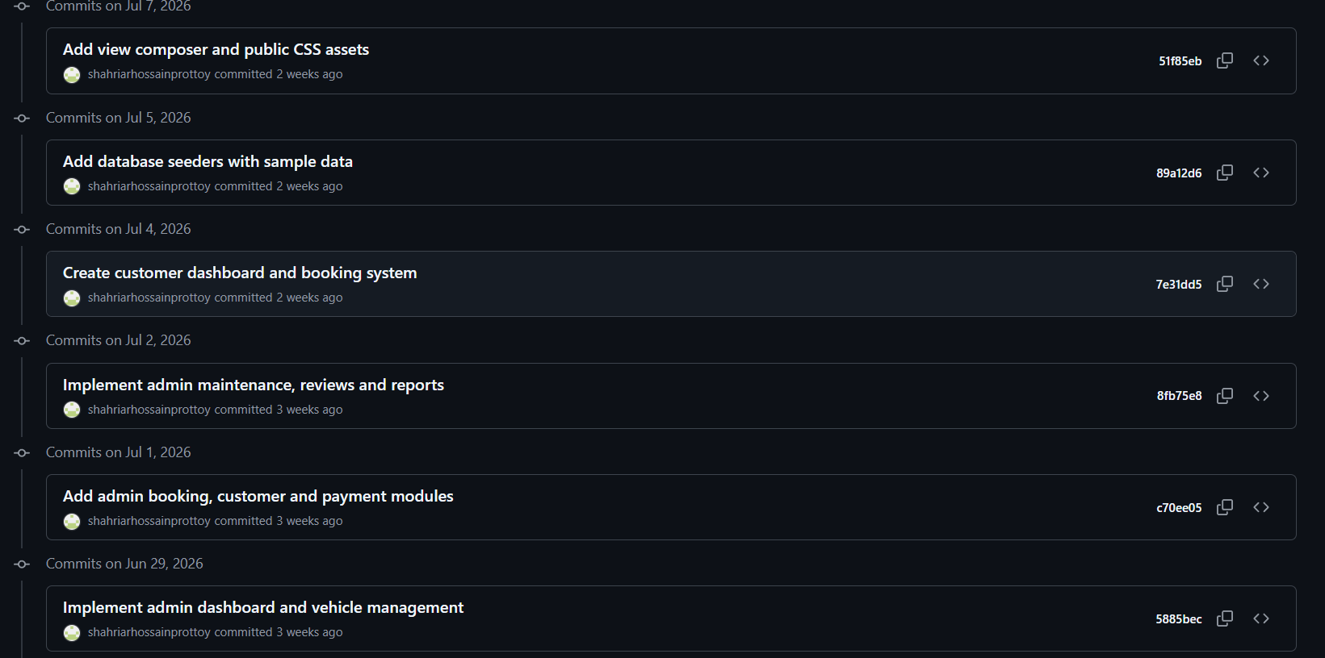
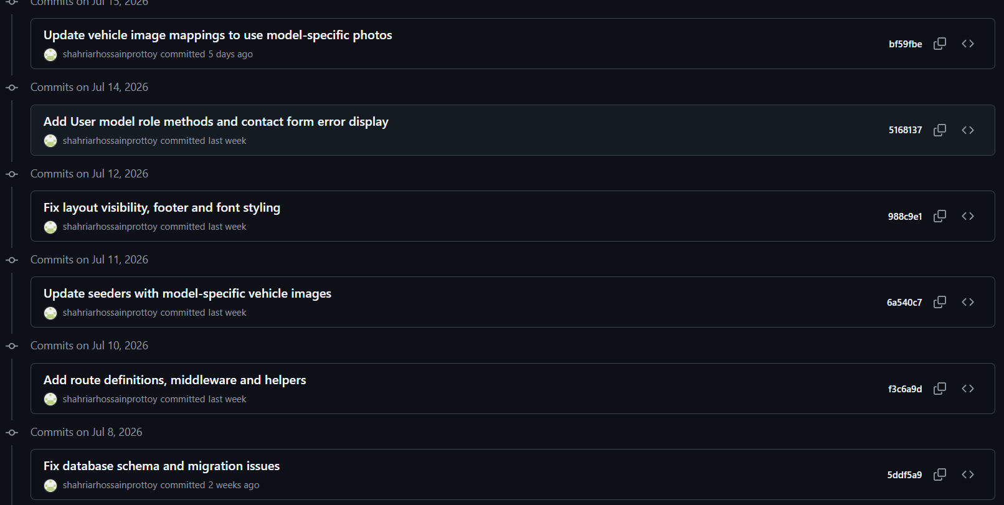
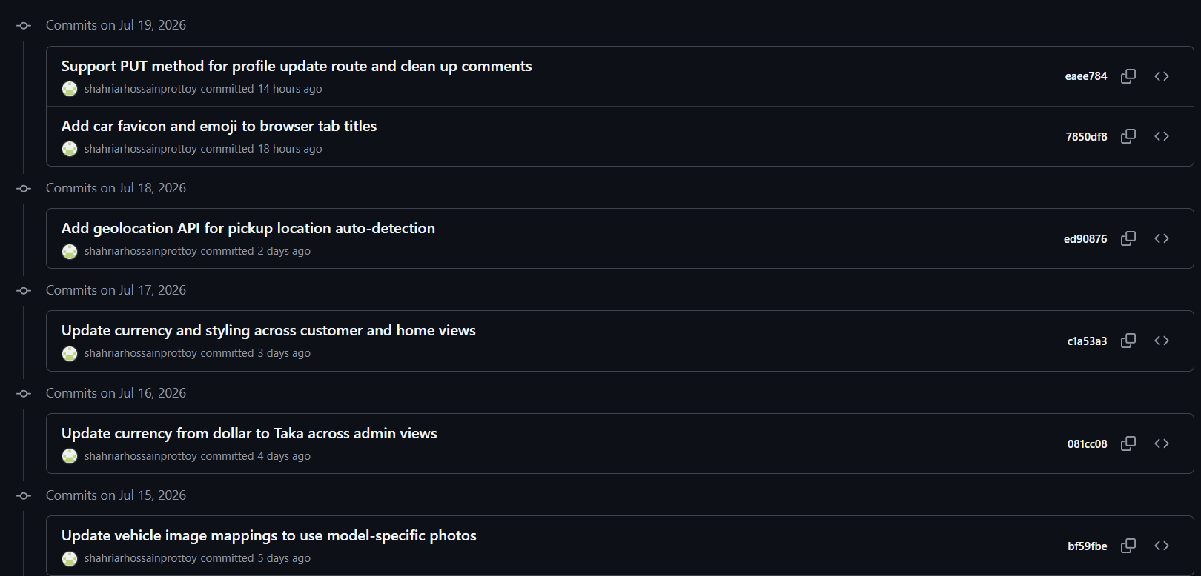

13.Screenshots:

Landing Page:
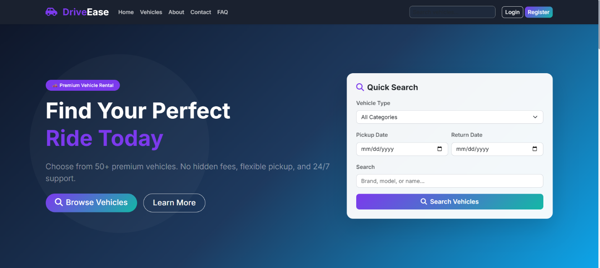

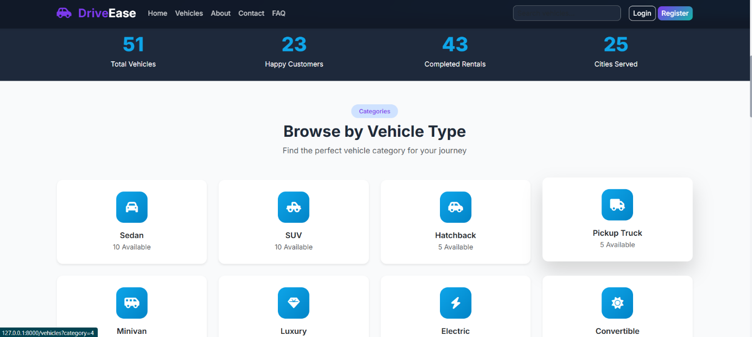

Vehicle Page:
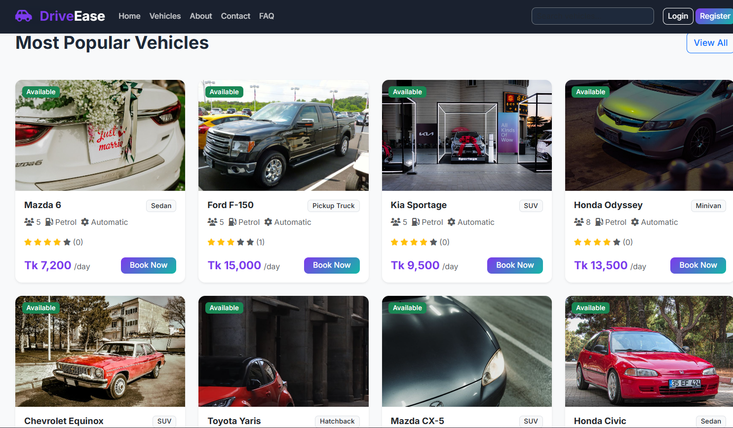
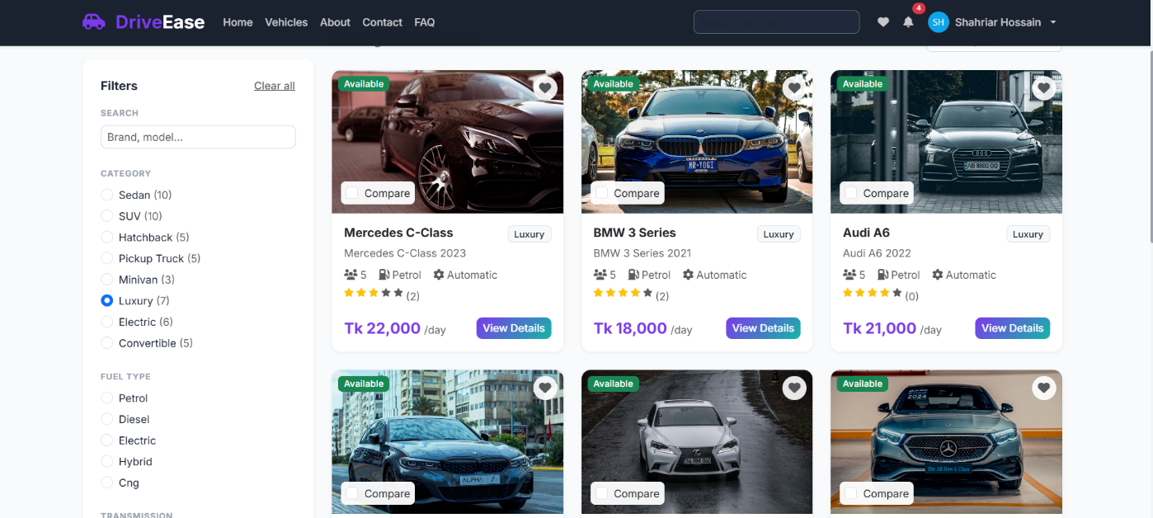
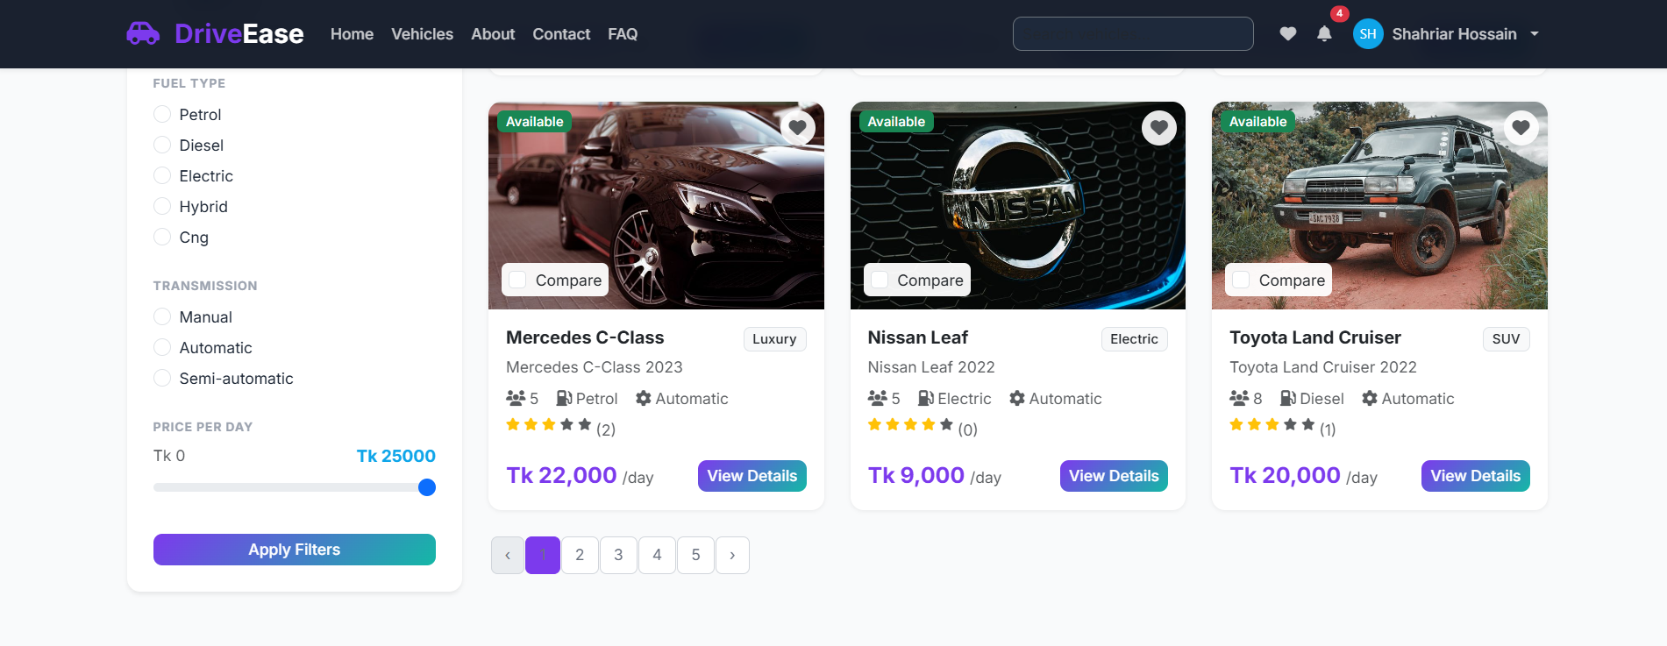

User Dashboard
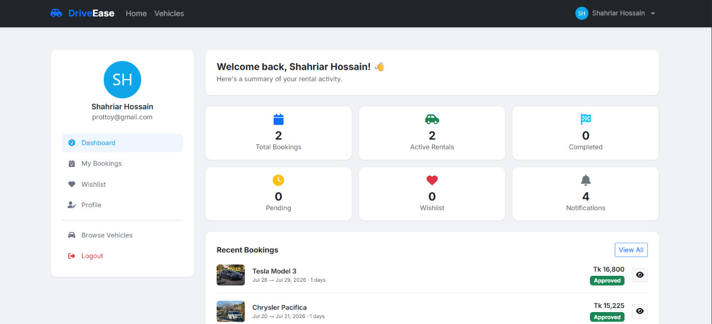
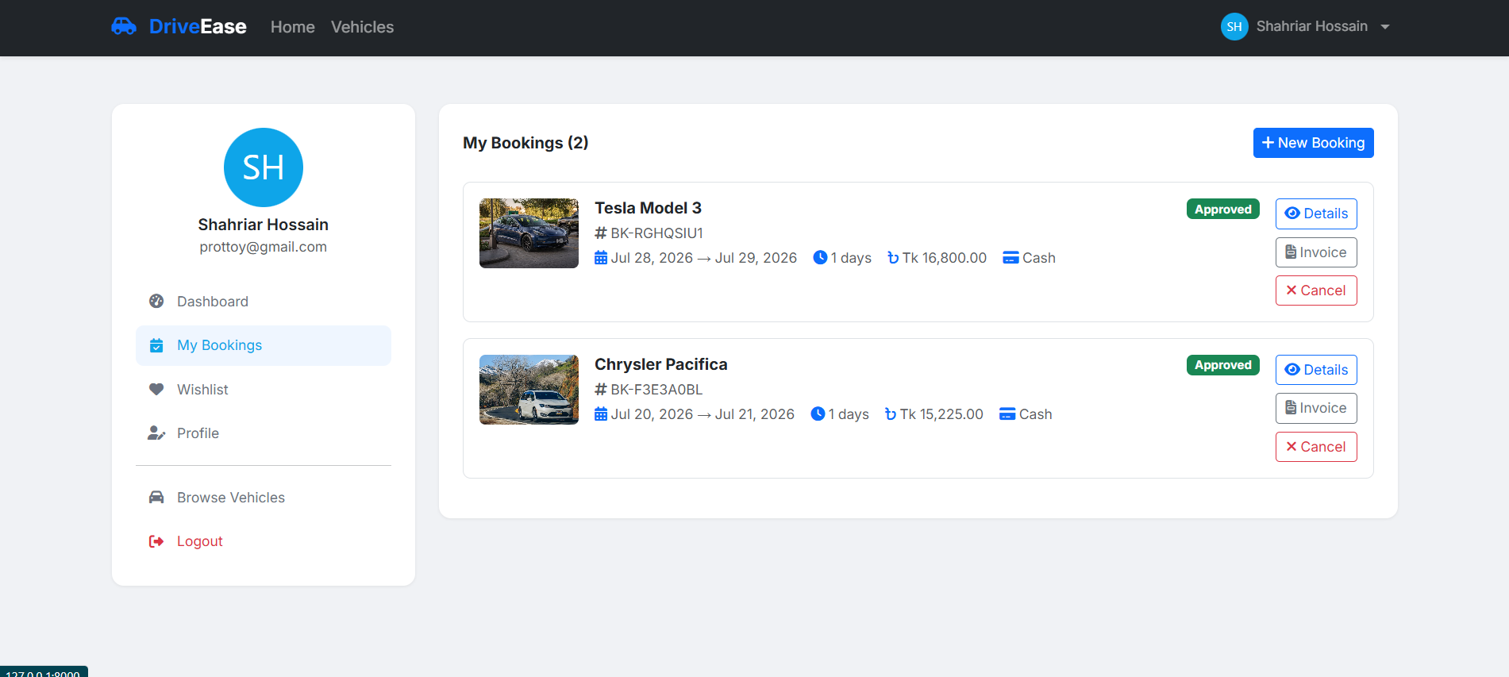

Admin Dashboard:
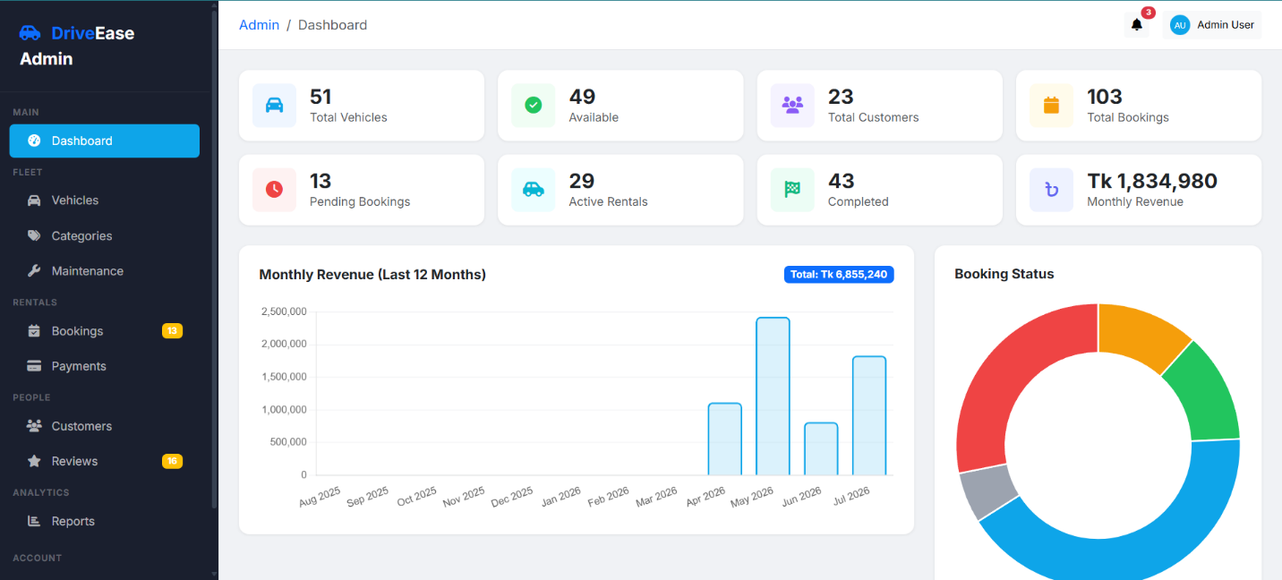
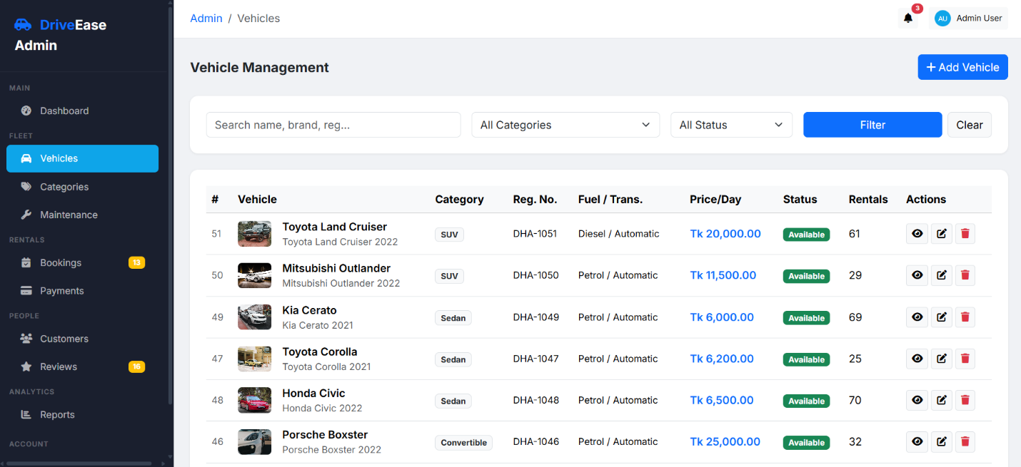
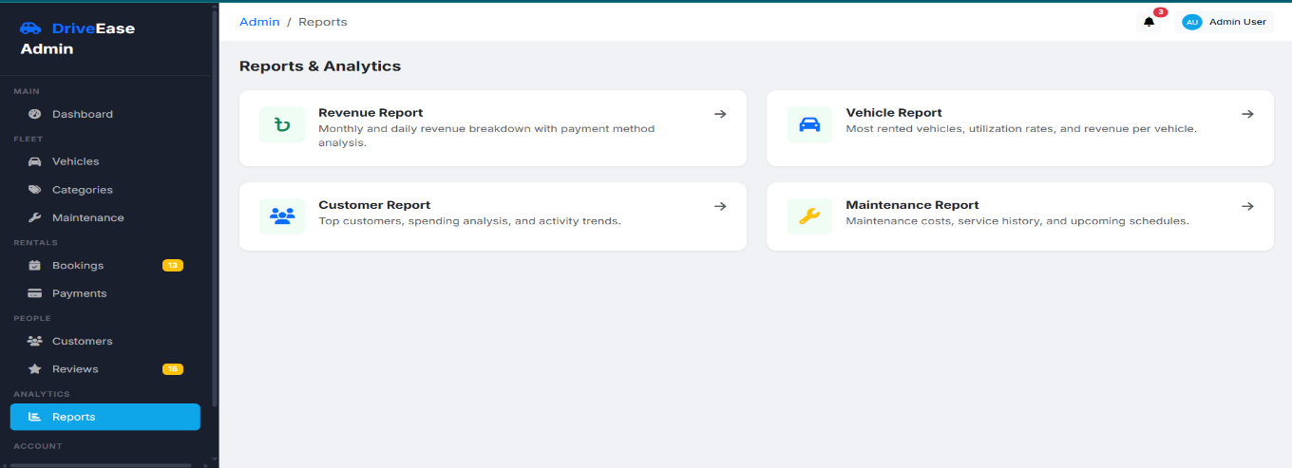

14. Future Improvements

14.1 Payment Gateway Integration
Integrate real payment gateways (Stripe, PayPal, bKash) for automated payment processing instead of manual payment tracking.

14.2 Eloquent Model Migration
Create Eloquent models for all domain entities (Vehicle, Booking, Payment, Review, etc.) to leverage relationships, scopes, accessors, and model events.

14.3 REST API Development
Build a RESTful API layer for mobile app integration and third-party service connectivity.

14.4 Real-Time Notifications
Implement WebSocket-based real-time notifications using Laravel Echo and Pusher for instant booking status updates.

14.5 Email Notifications
Configure SMTP/Mailtrap for actual email notifications instead of log-based mail driver.

14.6 Multi-Language Support
Add internationalization (i18n) support for multiple languages using Laravel's localization features.

14.7 Advanced Search
Implement Elasticsearch or Algolia for advanced full-text search with typo tolerance and faceted filtering.

14.8 Mobile Application
Develop a companion mobile application using React Native or Flutter for on-the-go vehicle booking.

14.9 Unit and Feature Tests
Write comprehensive PHPUnit tests for all controllers, models, and business logic to ensure code reliability.

14.10 CI/CD Pipeline
Set up GitHub Actions or similar CI/CD pipeline for automated testing, deployment, and code quality checks.

15. Conclusion
The Vehicle Rental Management System (DriveEase) successfully delivers a comprehensive web-based solution for managing vehicle rental operations. Built on the robust Laravel 12 framework with a SQL architecture, the system provides a complete suite of features for both administrators and customers.
The project demonstrates proficiency in modern web development practices including role based access control, database design with foreign key constraints, transaction-wrapped operations, responsive UI design with Bootstrap 5, and integration with third-party APIs (OpenStreetMap Nominatim for geolocation). The 48 Blade templates, 18 controllers, 16 database tables, and 70 routes form a well-organized and maintainable codebase.
Key achievements include the booking system with date overlap conflict detection, transaction-wrapped approval workflow, comprehensive reporting with PDF export, real-time notification system, and a modern responsive interface. The system handles the complete lifecycle from vehicle browsing through booking, payment tracking, and post-rental review.
The project provides a solid foundation that can be extended with payment gateway integration, Eloquent model migration, REST API development, and mobile application support. The modular architecture and clean separation of concerns make these future enhancements straightforward to implement.

16. References:
- Laravel Documentation. "Laravel 12.x - The PHP Framework for Web Artisans." Laravel, https://laravel.com/docs/12.x
- PHP: Hypertext Preprocessor. "PHP 8.2 Manual." PHP.net, https://www.php.net/docs.php
- MySQL 8.0 Reference Manual. Oracle Corporation, https://dev.mysql.com/doc/refman/8.0/en/
- Chart.js Contributors. "Chart.js - Simple yet flexible JavaScript charting." https://www.chartjs.org/

17. GitHub Repository: https://github.com/Shahriar1290/DriveEase

