# Conflict Scenario

## **Review**

### Interpersonal Conflict Management Styles

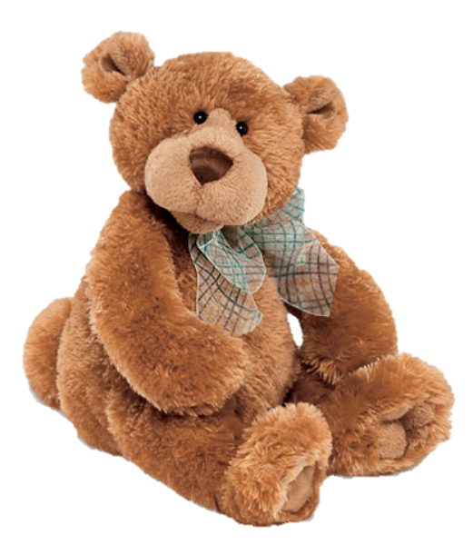

[CC 2.0 BY Matthew](https://www.flickr.com/photos/falcon1961/3304306800/)



[CC SA 3.0 Unported BY Jonathan Zander](https://en.wikipedia.org/wiki/File:Florida_Box_Turtle_Digon3.jpg)



[CC 3.0 BY Superawesomevectors](https://superawesomevectors.deviantart.com/art/Shark-Cartoon-Free-Vector-Illustration-643399222)



[CC0](https://pixabay.com/en/urban-lost-hiding-afraid-1002149/)

Low to High Concern for Other

Concern for Self

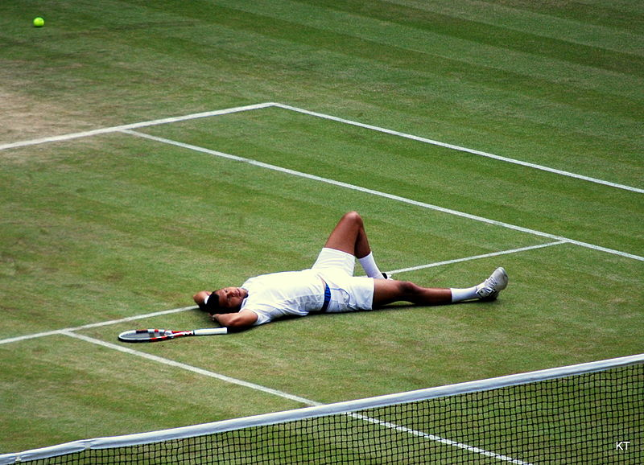

CC SA 2.0 Generic BY [Carine06 from UK](https://commons.wikimedia.org/wiki/File:Flickr_-_Carine06_-_%22I_give_up.%22.jpg)



CC 2.0 BY [Zabara Alexander](https://www.flickr.com/photos/zabara_tango/6955720271)

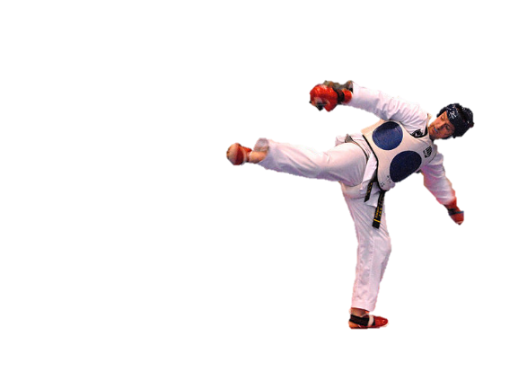

[CC0](https://commons.wikimedia.org/wiki/File:US_Army_53525_Soldiers_compete_in_Tae_Kwon_Do_tournament_for_Warrior_Country_level.jpg)

### **Interpersonal Conflict Resolution**

The following diagram shows a process that can be followed when trying to resolve interpersonal conflict.

### Listening

A considerable proportion of our communication involves listening, yet little attention is devoted to improving listening. HURIER is an acronym for tips that can be used to improve listening.

### “I” Phrases for Conflict Resolution

The “I” phrase is used during conflict resolutions to avoid attacking others. Open the conversation with a statement in first person, passive voice: “I feel … when … because … I would like …”

Adapted from (Dwyer 2012, p. 40)

## **Student Name and ID: Shahriar Haque** S0259035 - Joe

## **Student Name and ID:** Nicholas Paterno 12188564 - Jane

## **Scenario**

Find a partner. Read the scenario below. Choose one partner to be Joe Bloggs, and the other to be Jane Doe. Together, answer the following to help prepare you for the role play.

## **Scenario: Joe did not complete a task by the deadline**

Joe and Jane are working on a report that is due today. Joe was assigned the task of writing the executive summary. Unfortunately, Joe has not completed the task.

What is the most appropriate conflict management strategy for Jane to use in this situation? (Choose one)

Compete/Force

Compromise

Avoid/Withdraw

Collaborate/Confront

Accommodate/Smooth

Why did you choose the above conflict management strategy?

They proposed to Collaborate/Confront since you do not want to be too forceful and receive a huge negative backlash from the first interaction, although you want to be heard and still work to a solution where the things are heard and done.

### **Listen and Understand**

How could Jane start the conversation?

Opening up by checking on the wellbeing and to feel out if there is any particular things pre occupy their times.

Maybe even suggesting making time to work on it together to prompt progress.

Describe the purpose of the discussion. Describe the conflict. What questions could Jane ask to determine Joe’s perspective of the situation?

Purpose: To get him to work on the task at hand.  
Describe conflict: He hasn’t worked/ delayed working. (Procrastinated)  
  
Questions:  
- Are you okay?  
- Anything happening?   
- What’s been going on?   
  
Getting a feel for their current situation, attempting to understand and show empathy towards Joe.

Write sentences that features the “I” phrase, such as in the example below:

“I feel *[your feeling]* when *[their behaviour]* because *[effects on you]*. I would like *[alternative behaviour]*”.

I feel concerned that you are putting off your work because it causes more stress on me. I would like for you to continue and if you need help, I’m willing to help where I can.

Invent a reason why Joe did not complete the executive summary by the deadline.

I had a few too many tasks on my hands and couldn’t complete this.

How could Jane paraphrase Joe’s reason for missing the deadline to ensure that she understands Joe’s perspective?

I understand the pressure that puts on you, its seems like you have had a very big workload on your hands.

### **Empathise**

Now that Jane understands Joe’s perspective, how could Jane empathise with Joe? Write a response that shows that Jane identifies with Joe’s emotions.

Seems that you have been under a lot of stress, things have been busy in the office; I have had a lot of work on my plate it seems like everyone is under a lot of pressure during period in the office.

### **Apologise**

Include an apology if it is appropriate.

Maybe not appropriate here, however, to note, you could acknowledge that it had been very difficult and sorry to hear that it’s been a lot of stress.

### **Offer Solution**

What question could Jane ask to help build Joe’s involvement with potential solutions?

Ask if he needs help or assistance with anything.   
  
Prompt him to propose a solution first:   
  
Do you need help?   
Is there may be a different approach we can make?  
Ask how he feels?

Come up with a way for Jane and Joe to settle on a solution.

Potentially work on it together or share workloads. If they have similar jobs, maybe see if some of our tasks can be interchanged to better suit each other.

### **Resolution**

How could Jane resolve the conflict? Jane needs to ensure that Joe agrees. Write a response that outlines appreciation for the solution.

Re summarise, Confirm, and say that we are glad to have talked about it. And hopefully it improves.

### **Reconciliation**

How could Joe reconcile the relationship and let Jane know that she is important to him?

You have been a great work partner and I appreciate you coming to talk to me about this, I appreciate you a lot.

How can Jane let Joe know she is listening while Joe is talking?

Little verbal ticks like “mhm hmm”   
Facing directly  
Rubbing the chin  
Eye contact  
Nodding  
  
Non disruptive acknowledgements.

What could Jane do if Joe started to withdraw from the conflict at any stage?

would you like to come for a drink or movie to hang out for a bit after this?