Laptop Recommendation RAG Backend
Complete Architecture, Features, Workflow, Operation, and Deployment Guide

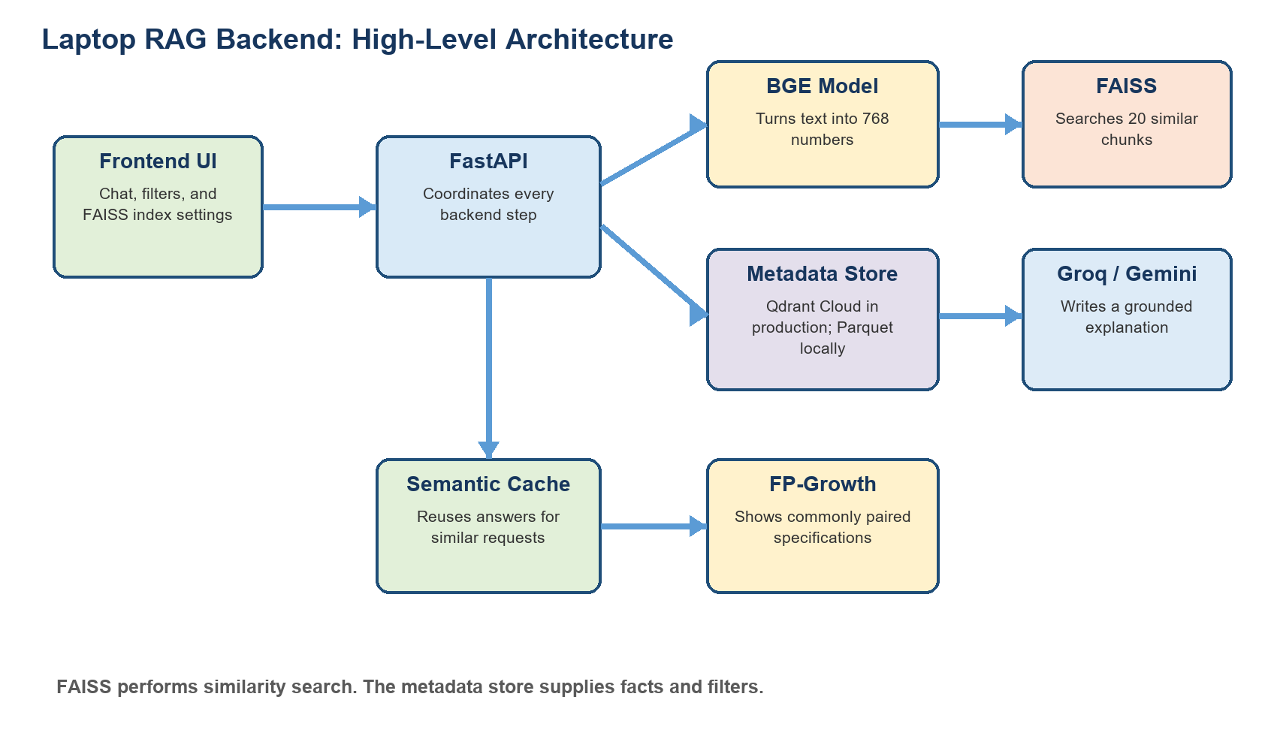
Figure 1. High-level architecture of the implemented backend.

Current status: The API is running locally at http://127.0.0.1:7860. All five FAISS indexes, the BGE model, 63,998 metadata records, progressive filtering, outlier rejection, semantic caching, and FP-Growth insights have been verified. No Groq or Gemini key is configured locally, so chat currently uses a grounded retrieval-only response.

Contents
1. Plain-Language Overview
2. Goals and Requirements
3. Architecture
4. Data and Embeddings
5. FAISS Indexes
6. Metadata Storage
7. Query Understanding
8. Complete Retrieval Workflow
9. Similarity Threshold
10. Progressive Metadata Filtering
11. Grounded Answer Generation
12. Semantic Cache
13. FP-Growth Insights
14. API Endpoints
15. Project Structure
16. Local Operation
17. Cloud Deployment
18. Testing and Verified Results
19. Security and Reliability
20. Limitations and Remaining Work
21. Glossary

1. Plain-Language Overview
This project is a laptop recommendation assistant. A person can describe what they need in ordinary language, such as 'I need a gaming laptop under 2000 USD with 16 GB RAM.' The backend searches a large collection of laptop specifications and review passages, checks measurable requirements, and returns the best supported choices.
The system is called Retrieval-Augmented Generation, usually shortened to RAG. Retrieval means finding useful facts before answering. Augmented means those facts are supplied to the answer-writing model. Generation means a language model turns the facts into a natural explanation. This is safer than asking a language model to answer from memory because the answer is tied to retrieved laptop records and source passages.
Simple analogy: FAISS acts like a very fast librarian who finds 20 relevant pages. The metadata store acts like a catalog that provides verified labels and specifications for those pages. The language model acts like an assistant who reads only those pages and explains the best choices.

2. Goals and Requirements
- Recommend laptops from the collected dataset rather than inventing products.
- Use Apache Spark outputs and BGE embeddings produced by the project pipeline.
- Use FAISS for vector similarity and approximate nearest-neighbor retrieval.
- Compare and expose multiple FAISS index families.
- Use IVF Flat as the default balanced index.
- Allow the frontend to choose another index per request.
- Use structured metadata filters after retrieving 20 similar candidates.
- Reject unrelated requests through a similarity threshold.
- Show retrieved context with recommendations.
- Support free local and cloud deployment options.
- Implement FP-Growth and semantic caching stretch goals.

3. Architecture


3.1 Component Responsibilities
Component | What it does | Why it exists
Frontend UI | Collects the question, filters, and selected FAISS index. | Gives users direct control without changing backend code.
FastAPI | Receives requests and coordinates every service. | Provides a documented HTTP API for any frontend.
Query parser | Separates measurable constraints from semantic preferences. | Prevents vague language from becoming unreliable numeric filters.
BGE model | Converts text into 768-dimensional normalized vectors. | Makes meaning mathematically searchable.
FAISS | Finds exactly 20 semantically similar chunks. | Provides fast similarity retrieval and meets the course requirement.
Metadata adapter | Retrieves specifications and applies filter passes. | Keeps facts separate from vector ranking.
Groq/Gemini | Writes a grounded recommendation explanation. | Makes retrieved facts easy to understand.
Semantic cache | Reuses compatible answers for similar questions. | Reduces latency and API use.
FP-Growth | Finds specification combinations that commonly occur together. | Provides data-mining insights beyond chatbot retrieval.

3.2 Modular Adapter Design
The backend does not place hosting-specific logic inside the retrieval algorithm. Storage, generation, embedding, and index management are separate service modules. Locally, metadata is read from Parquet because embedded Qdrant was too slow for 63,998 rich records on Windows. In production, the Qdrant adapter implements the same operations. The retrieval service therefore does not change when the deployment platform changes.

4. Data and Embeddings

4.1 Dataset Artifacts
Artifact | Purpose | Verified value
qdrant_records.parquet | Embeddings, source chunks, and laptop metadata. | 63,998 rows; about 217.66 MB
vector_id_mapping.parquet | Maps numeric IDs to chunk and laptop IDs. | 63,998 stable mappings
index_manifest.json | Records model, dimensions, thresholds, and index files. | Five production indexes
association_rules.json | Frontend-ready FP-Growth rules. | 371 rules

4.2 What an Embedding Is
An embedding is a list of numbers representing meaning. The BGE model turns each laptop chunk and each user query into 768 floating-point values. Texts with similar meanings usually produce vectors pointing in similar directions. This allows a gaming request to match review passages about graphics performance even when the exact words are different.
Embedding setting | Implemented value
Model | BAAI/bge-base-en-v1.5
Dimensions | 768
Numeric type | float32
Normalization | L2 normalized
Maximum sequence length | 512 tokens
Similarity metric | Inner product, equivalent to cosine for normalized vectors

4.3 Stable Shared IDs
Every source chunk receives a deterministic integer vector_id. The same ID is stored in all FAISS indexes and in Qdrant Cloud. FAISS can therefore return an ID and the backend can ask the metadata store for the exact corresponding laptop facts.
vector_id: 12540
chunk_id: 331689_review_para_7
laptop_id: 331689

5. FAISS Indexes
FAISS is the component that performs vector similarity search. The frontend can select an index for each request. The selected index changes only candidate generation; parsing, thresholds, metadata filtering, deduplication, and answer generation remain identical.
Index | How it works | Production size | Use
Flat IP | Compares the query with every vector. Exact rather than approximate. | 197.11 MB | Accuracy baseline
IVF Flat | Places vectors into clusters and searches selected clusters. | 200.74 MB | Default balanced choice
PQ | Compresses vectors into compact codes. | 7.44 MB | Very low memory
IVF+PQ | Combines clustering and vector compression. | 11.07 MB | Fast and compact
HNSW | Connects vectors in a navigable similarity graph. | 214.53 MB | Fast graph search

5.1 IVF Flat Defaults
nlist = 1011
nprobe = 64
metric = inner product
candidate_k = 20
nlist controls how many clusters exist. nprobe controls how many clusters are inspected for a query. A larger nprobe generally improves recall but takes more time. The backend accepts nprobe only for IVF-based indexes and efSearch only for HNSW.

6. Metadata Storage

6.1 Qdrant Cloud Production Mode
Qdrant Cloud stores the same BGE vectors, stable IDs, laptop specifications, and source text. After FAISS returns candidate IDs, the Qdrant adapter applies server-side metadata conditions restricted to those IDs. Qdrant is not used for the primary similarity search in this design; FAISS remains the retrieval engine.
- Vector configuration: 768 dimensions with cosine distance.
- Indexed payload fields: laptop_id, brand, price, RAM, storage, GPU tags, weight, and operating system.
- Cloud records use the same vector_id values as FAISS.

6.2 Local Parquet Mode
The local API currently uses a Parquet metadata adapter. This was chosen after embedded Qdrant proved too slow for loading the complete collection on Windows. The Parquet adapter reads every field except the large embedding column, indexes records by vector_id in memory, and implements the same retrieve, filter, and laptop-detail methods as the Qdrant adapter.
Important: Parquet mode is a local development convenience. Qdrant Cloud remains the intended persistent online database. Switching is controlled by METADATA_BACKEND and requires no retrieval-code change.

7. Query Understanding
The parser is rule-based for measurable requirements. This prevents a language model from inventing a budget, RAM amount, or GPU requirement. The complete original request remains the semantic query sent to BGE.
User wording | Parser result
under 1500 USD | maximum price = 1500
at least 16 GB RAM | minimum RAM = 16
512 GB SSD | minimum storage = 512 and storage type = SSD
must have RTX 4090 | exact GPU tag locked against relaxation
without RTX | excluded GPU tag
must not be Dell | excluded brand, locked
long battery life | semantic preference handled by BGE
around 1000 USD | ambiguous preference plus parser warning

7.1 Precedence
- Frontend-selected filters have the highest priority and are locked.
- Explicit query constraints are parsed next.
- Words such as must, required, and only make a field non-relaxable.
- Qualitative preferences remain semantic rather than becoming arbitrary metadata values.

8. Complete Retrieval Workflow
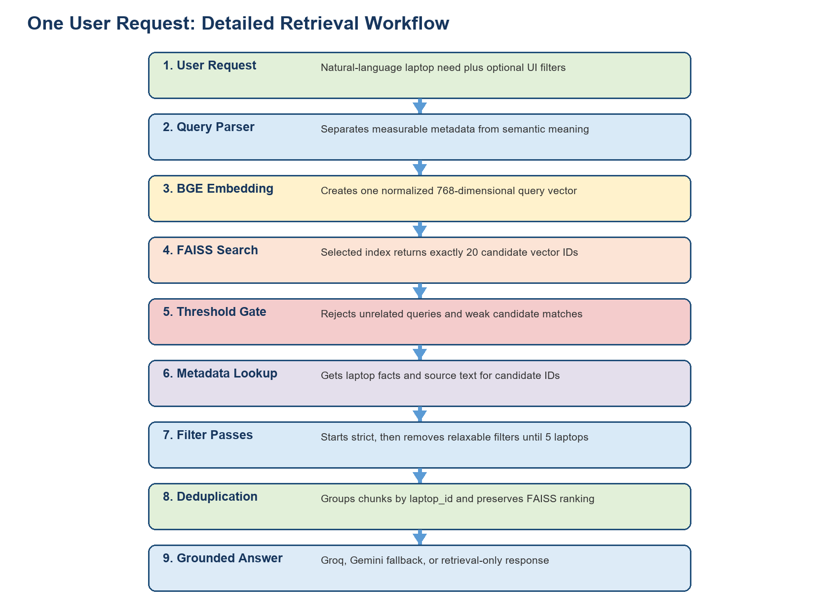
Figure 2. The complete processing sequence for one request.
- FastAPI validates the message, index name, top_k, nprobe, efSearch, threshold, and UI filters.
- The parser produces normalized metadata filters, semantic terms, warnings, and locked fields.
- BGE creates a normalized 768-dimensional query vector.
- The chosen FAISS index searches exactly 20 source chunks.
- FAISS scores are compared with the configured per-index similarity threshold.
- An unrelated query stops immediately if its best score is below the threshold.
- Weak individual candidates are removed even when the query itself is accepted.
- The metadata adapter retrieves facts for the surviving vector IDs.
- Metadata filtering begins with every parsed field and becomes broader only when necessary.
- Chunks are grouped by laptop_id so one laptop is not shown repeatedly.
- The best five unique laptops are supplied to the generator with source text.
- The API returns answer text, structured recommendations, sources, scores, filter information, and latency.

9. Similarity Threshold
A vector search always has a nearest result, even for an irrelevant question. Without protection, a recipe question could still receive arbitrary laptop recommendations. The threshold gate prevents that behavior.
- Query-level gate: reject the whole query when the best candidate is too weak.
- Candidate-level gate: remove individual results below the threshold.
- No metadata relaxation or LLM generation occurs for a rejected outlier.
- Thresholds are stored per FAISS index because approximate indexes produce different score distributions.
Verified example: The unrelated query 'How do I bake a chocolate cake?' received a top similarity of approximately 0.472, below the IVF Flat threshold of 0.60, and was correctly returned as no_relevant_match.

Calibration requirement: Current thresholds are initial values. The included calibrate_thresholds.py script should be run after collecting labeled in-domain and outlier queries.

10. Progressive Metadata Filtering
Metadata filters are applied after FAISS has found 20 semantically similar candidates. The FAISS search is performed once. The same candidates are filtered repeatedly, each time allowing more freedom, until five unique laptops remain or no broader pass exists.
Pass | Typical active filters | Purpose
Strict | Price, RAM, storage, GPU, brand, OS, weight | Try to satisfy everything.
Preferences relaxed | Drops brand, storage type, OS, and weight when relaxable | Remove secondary preferences.
Main requirements | Price, RAM, storage, and GPU plus locked fields | Keep major specifications.
Core requirements | Price plus locked fields | Protect the budget and mandatory constraints.
Locked only | UI filters and must/required/only constraints | Never violate explicit mandatory requirements.

Transparency: The response includes filter_level, filter_name, and relaxed_filters. The frontend can therefore tell the user exactly why broader matches were shown.

Verified budget behavior: A real request under 2000 USD returned five laptops priced at 1000, 900, 1200, 1700, and 735 USD. The budget remained active while RAM and GPU filters were relaxed to obtain five choices.

11. Grounded Answer Generation
The generator receives only the user request, valid filtered laptop metadata, source chunks, and information about relaxed filters. It is instructed to recommend only laptops in that context, avoid unsupported specifications, cite chunk IDs, mention relaxation, and admit insufficient evidence.
- Groq is attempted first when GROQ_API_KEY is available.
- Gemini is attempted when Groq fails because of a timeout, rate limit, or API error.
- A deterministic retrieval-only answer is returned when neither provider is configured or both fail.
Current local behavior: No LLM API keys are present. The running server returns a grounded retrieval-only list with laptop names, prices, and source chunk IDs. This allows complete retrieval testing without paid services.

12. Semantic Cache
The semantic cache stores completed compatible responses in memory. A new query can reuse an earlier response when their normalized BGE vectors are sufficiently similar and all behavior-changing settings match.
- Cache namespace includes filters, locked fields, index, search parameters, threshold, dataset version, prompt version, embedding model, and LLM model names.
- Responses from temporary LLM failures are not cached when providers are configured.
- The cache uses an LRU policy, which removes the least recently used entry when full.
- GET /cache/stats reports entries, hits, misses, and hit rate.
Verified example: The first real chat request reported cache_hit=false. Repeating the same request reported cache_hit=true.

13. FP-Growth Insights
FP-Growth is a data-mining algorithm that finds groups of items that frequently occur together. In this project, one transaction represents one laptop and items represent normalized specifications such as ram_16gb, storage_ssd, gpu_rtx, and display_144hz.
Output | Meaning | Generated count
Frequent itemset | A specification combination that appears often. | 259
Association rule | A pattern such as SSD + HDD often implying GTX. | 371
Support | How frequently the full combination appears. | Stored per rule
Confidence | How often the consequence appears when the antecedent appears. | Stored per rule
Lift | How much stronger the relationship is than random coincidence. | Stored per rule

The mining job runs offline through Spark MLlib, not during live chat requests. Results are saved in Parquet for analysis and JSON for the API endpoint. This keeps live requests fast and makes results reproducible.

14. API Endpoints
Method | Endpoint | Purpose
GET | /health | Liveness and component status.
GET | /ready | Returns 200 only when embedding, FAISS, and metadata are ready.
GET | /settings/indexes | Frontend index options, parameters, availability, and benchmark values.
POST | /retrieve | Retrieval and filtering without answer generation.
POST | /chat | Complete RAG response with retrieval and grounded answer.
GET | /laptops/{laptop_id} | All stored chunks and metadata for one laptop.
GET | /insights/specifications | FP-Growth association rules.
GET | /cache/stats | Semantic cache statistics.
GET | /docs | Interactive OpenAPI documentation.

14.1 Example Request
{
"message": "Gaming laptop under 2000 USD with 16 GB RAM",
"index_type": "ivf_flat",
"top_k": 5,
"nprobe": 64,
"filters": {}
}

14.2 Important Response Fields
- index_used: the actual FAISS index.
- candidate_k: always 20 under the current policy.
- top_similarity and similarity_threshold: relevance evidence.
- filter_level and relaxed_filters: metadata-filter transparency.
- recommendations: structured laptop objects.
- sources: chunk IDs, text, and FAISS similarity scores.
- provider: groq, gemini, or retrieval_only.
- cache_hit: whether semantic caching reused a response.

15. Project Structure
Backend/
app/
main.py FastAPI routes
config.py Environment configuration
models.py Request and response schemas
container.py Service construction
services/
embeddings.py BGE model adapter
faiss_manager.py Index loading and search
parser.py Query understanding
filtering.py Progressive filter policy
qdrant_store.py Qdrant Cloud adapter
local_metadata_store.py Local Parquet adapter
retrieval.py Retrieval orchestration
generator.py Groq/Gemini fallback
cache.py Semantic LRU cache
insights.py FP-Growth rule access
artifacts/ Indexes, mappings, metadata, rules
scripts/ Build, upload, evaluation, calibration
evaluation/ Query templates and outliers
tests/ Automated tests
Dockerfile Portable container
render.yaml Render deployment blueprint
.env Local configuration

16. Local Operation

16.1 Current Running Service
Item | Current value
URL | http://127.0.0.1:7860
Interactive documentation | http://127.0.0.1:7860/docs
Default index | IVF Flat
Metadata backend | Parquet
Embedding | BGE base English v1.5 on CPU
LLM | Retrieval-only until a Groq or Gemini key is configured

16.2 Commands
python -m pip install -r requirements.txt
python -m uvicorn app.main:app --host 127.0.0.1 --port 7860
Configuration: Backend/.env is loaded automatically. It is excluded from Git so secrets are not committed.

17. Cloud Deployment
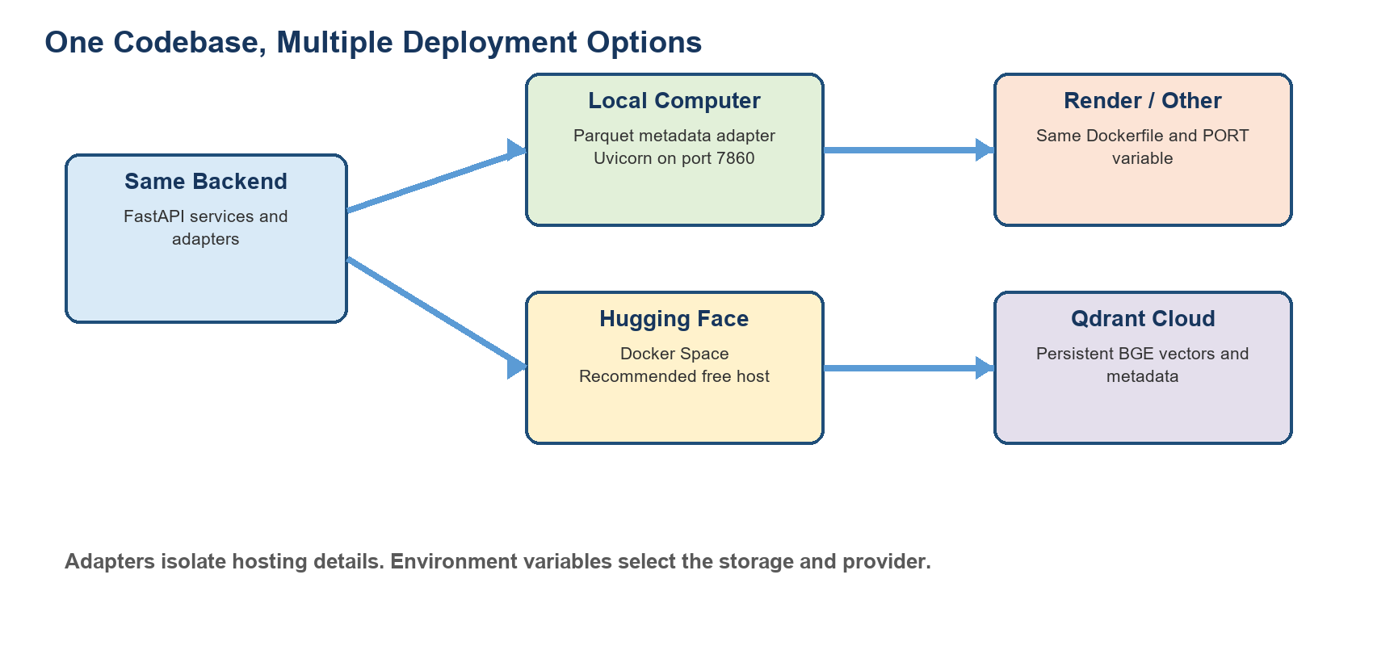
Figure 3. The same backend can run on multiple container hosts.

17.1 Qdrant Cloud Preparation
- Create a free Qdrant Cloud cluster.
- Set QDRANT_URL, QDRANT_API_KEY, and QDRANT_COLLECTION.
- Set METADATA_BACKEND=qdrant and remove LOCAL_METADATA_FILE.
- Run python scripts/upload_qdrant.py --recreate.
- Verify that Qdrant contains exactly 63,998 points.

17.2 Hugging Face Spaces
Hugging Face Docker Spaces is the recommended free host because it generally provides more memory than Render's free service. Upload the Backend directory to a Docker Space, store large index files through Git LFS or an artifact repository, and configure secrets in Space settings.

17.3 Render and Other Docker Hosts
The included Dockerfile reads the PORT environment variable, while render.yaml supplies a blueprint. Render's free memory may be insufficient for BGE plus a 200 MB FAISS index, so actual memory must be checked. ARTIFACT_BASE_URL lets the service download indexes instead of placing them in the image.
Environment variable | Purpose
METADATA_BACKEND | parquet locally or qdrant in production
QDRANT_URL / QDRANT_API_KEY | Cloud metadata and vector database access
GROQ_API_KEY | Primary generation provider
GEMINI_API_KEY | Fallback generation provider
ARTIFACT_BASE_URL | Optional remote index location
DEFAULT_INDEX | Initial FAISS index
INDEX_CACHE_SIZE | Number of FAISS indexes retained in memory
CORS_ORIGINS | Allowed frontend domains

18. Testing and Verified Results
Verification | Result
Automated tests | 11 of 11 passed
Python compilation | Application, scripts, and tests compile
FAISS artifacts | All five load and search with stable IDs
Production vector count | 63,998 in every index
Readiness endpoint | HTTP 200 with no startup errors
All index endpoints | Flat, IVF Flat, PQ, IVF+PQ, and HNSW returned results
Outlier query | Recipe query correctly rejected
Budget filtering | Returned prices remained at or below 2000 USD
Progressive filtering | Relaxation levels returned transparently
Semantic cache | Second identical chat request was a cache hit
FP-Growth | 259 itemsets and 371 rules generated

18.1 Retrieval Evaluation Still Required
The course requires at least 30 hand-labeled queries with expected relevant laptop IDs. The repository includes evaluation/queries.template.jsonl and scripts/evaluate_retrieval.py. Labels must be created by the team rather than fabricated. The runner evaluates all five indexes and reports precision@1/3/5, recall@1/3/5, filter level, returned count, outlier status, and latency.

19. Security and Reliability
- API keys are read from environment variables and .env is excluded from Git.
- Frontend index names and parameter ranges are validated by Pydantic.
- Unsupported index requests are rejected instead of being used as file paths.
- Index loading is protected by a lock, including mutable nprobe and efSearch settings.
- Artifacts are dimension-checked and manifest-checked before use.
- Qdrant readiness validates dimension, cosine distance, and exact point count.
- Outlier queries stop before metadata relaxation and generation.
- Locked constraints survive every metadata-filter pass.
- Grounded prompts restrict the LLM to retrieved laptop records.
- Separate /health and /ready endpoints distinguish a running process from a usable service.

20. Limitations and Remaining Work
- Qdrant Cloud has not been uploaded because cloud credentials were not provided.
- Groq and Gemini generation have not been tested with real keys; retrieval-only mode is verified.
- Initial similarity thresholds need calibration with labeled positive and negative queries.
- The 30-query relevance evaluation still requires human labels.
- The system is laptop-only, while the original description mentions phones and laptops; this scope should be approved or documented.
- A fixed FAISS k=20 may contain fewer than five unique laptops. The backend correctly returns fewer rather than inventing candidates.
- Free hosting can sleep and produce cold-start delays while BGE and FAISS load.
- Render free memory may be too low; Hugging Face Docker Spaces is safer for this model and index size.

21. Glossary
Term | General explanation
API | A defined way for software programs to communicate.
Backend | The server-side program that processes requests and accesses data.
Embedding | A numeric representation of text meaning.
Vector | An ordered list of numbers; here it represents text.
Cosine similarity | A measure of how closely two normalized vectors point in the same direction.
FAISS | A library optimized for finding similar vectors.
ANN | Approximate nearest neighbor search, which trades a little accuracy for speed.
IVF | An index technique that groups vectors into clusters.
PQ | A technique that compresses vectors into smaller codes.
HNSW | A graph-based method for navigating to similar vectors.
Qdrant | A database for vectors and associated metadata.
Metadata | Structured facts such as price, RAM, brand, and GPU.
RAG | Retrieval-Augmented Generation: retrieve evidence, then generate an answer.
LLM | A large language model that produces natural-language text.
Grounding | Restricting an answer to supplied evidence.
Outlier query | A request unrelated to the available laptop collection.
Cache | Stored earlier work that can be reused to save time.
FP-Growth | An algorithm for discovering items that frequently appear together.
Docker | A portable package containing an application and its runtime environment.

Conclusion
The implemented backend is a modular, evidence-based laptop recommendation system. It combines semantic understanding from BGE, selectable FAISS retrieval, structured metadata checks, transparent filter relaxation, outlier rejection, grounded generation, caching, and Spark data-mining insights. The same service runs locally today and can move to Qdrant Cloud and a free Docker host by changing environment configuration rather than rewriting the retrieval pipeline.

