**Khulna University of Engineering and Technology (KUET), Khulna**

**Department of Computer Science and Engineering (CSE)**

Course Name: Artificial Intelligence Laboratory

Course No.: CSE4110

Report On: **“Eat Best” Game**

Submitted to:

Abdul Aziz

Lecturer

Dept. of CSE, KUET

Taslim Uddin Raju

Lecturer

Dept. of CSE, KUET

Submitted by:

Shahriar Hossain Shanto (1607023)

Md. Noyan Ali (1607021)

Nohel Kumar Nath (1607013)

**Game Description**

* Collection of different types of fruit . Each fruit has a predefined calorie value with it’s weight.
* Randomly 5 fruits will be selected for each player ( Human and Computer) in each term. Player can consume total 1000g fruit.
* Fruit selection criteria is 0/1 Knapsack Algorithm.
* After 5 terms or exceeding weight, scores will be evaluated. High scorer will be winner

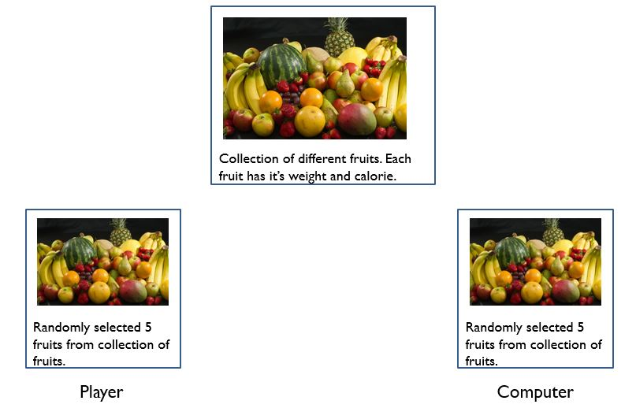

Figure 1: Abstraction of game’s fruit.

**Fruits Table**

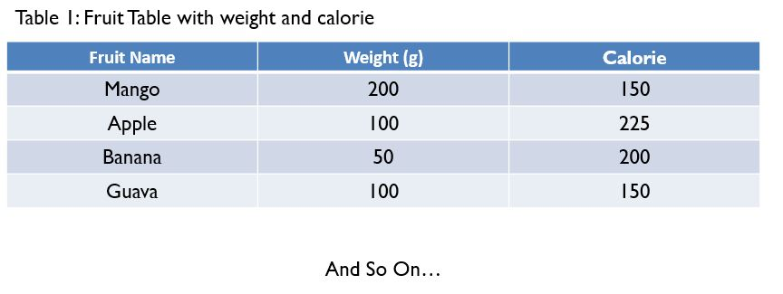**Flowchart of Game**

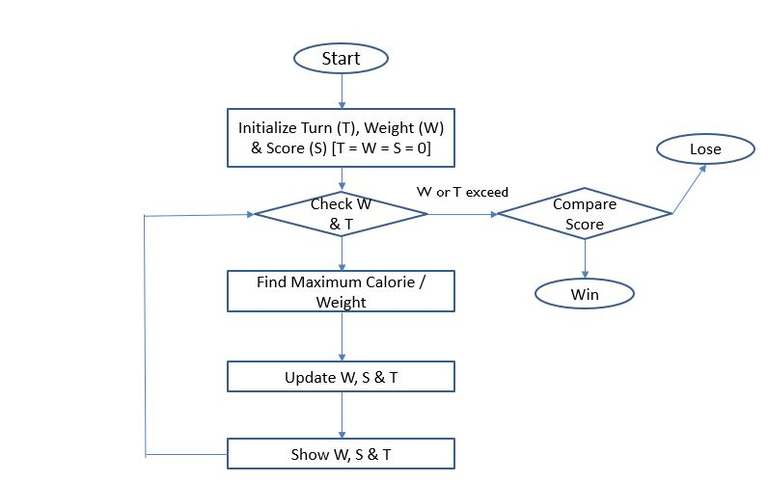

**Simulation**

