TITTLE: FIRE DETECTION WITH ARDUINO UNO, FIRE

SENSOR, BUZZER & LED

Abstract:

The objective of this experiment is to make a system which can detect if fire is caught. The system was made with Arduino connected with a buzzer, LED, and a fire sensor. It was also observed and understood that how a circuit made of fire sensor, buzzer, LED using Arduino uno can detect fire. Our vision was to finding a way in which people can be alerted as soon as possible when a fire is caught in any place.

INTRODUCTION:

In this project we learnt how to integrate sensor with Arduino uno. In this project we interfaced fire sensor with Arduino to learn all the steps to build fire alarm system by using Arduino and fire sensor module. Fire sensor module has photodiode to detect the light and op-amp to control the sensitivity. It is used to detect fire and provide High signal upon the detection. Arduino reads the signal and provides alert by turning on buzzer and led. Flame sensor used here is IR based flame sensor.To detect fire a fire sensor moduled named SBT-4447 was used. SBT-4447 is a fire sensor module which can be integrated with Arduino uno to detect fire. The purpose of the project was to make a system which can detect fire with the help of an Arduino.

WORKING PRINCIPLE

A fire detector is a sensor designed to detect and respond to the presence of a flame or fire. Responses to a detected flame depended on the installation , but can include sounding an alarm, deactivating a fuel line , and activating a fire suppression system. There are different type of fire detection. Here we have used IR(infrared) based fire detector. When Fire burns it emits a small amount of infra-red light, this light will be received by photodiode on sensor module.

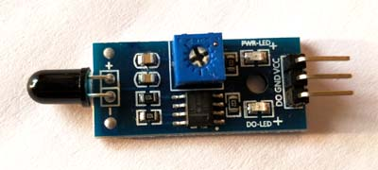

Fig: IR based fire sensor module SBY-4447

Then an op-amp check for change in voltage across the IR receiver, so if a fire is detected the output pin (DO) will give 0v(LOW), and if there is no fire the output pin will be 5v(HIGH). In this project we are using an **IR based flame sensor**. It is based on the YG1006 sensor which is a high speed and high sensitive NPN silicon phototransistor. It can detect infrared light with a wavelength ranging from 700nm to 1000nm and its detection angle is about 60°.  Flame sensor module consists of a photodiode (IR receiver), resistor, capacitor, potentiometer, and LM393 comparator in an integrated circuit. Working voltage is between 3.3v and 5v DC, with a digital output. Logic high on the output indicates presence of flame or fire. Logic low on output indicates absence of flame or fire.

Below is the pin description of fire sensor module:

|  |  |
| --- | --- |
| Pin | description |
| Vcc | 3.3-5v power supply |
| GND | ground |
| Dout | Digital output |

Arduino Uno is a open source microcontroller board based on ATmega328p microcontroller. It has 14 digital pins (out of which 6 pins can be used as PWM outputs), 6 analog inputs, on board voltage regulators etc. Arduino Uno has 32KB of flash memory, 2KB of SRAM and 1KB of EEPROM. It operates at the clock frequency of 16MHz. Arduino Uno supports Serial, I2C, SPI communication for communicating with other devices. The table below shows the technical specification of Arduino Uno.

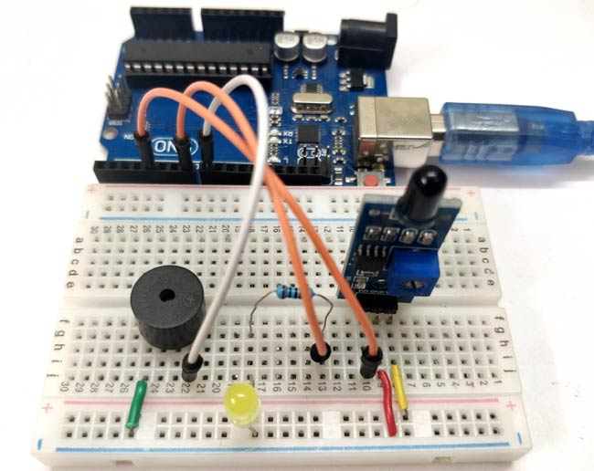

Fig: fire detection system with flame sensor, Arduino uno.

Fire sensor detects fire or flame based on the Infrared (IR) wavelength emitted by the flame. It gives logic 1 as output if flame is detected, otherwise it gives logic 0 as output. Arduino Uno checks the logic level on the output pin of the sensor and performs further tasks such as activating the buzzer and LED, sending an alert message.

CIRCUIT CONNECTION: vcc pin of flame sensor is connected to 5v pin on Arduino. GND ground pin is connected to GND pin on Arduino. Ao pin is connected to any analog pin on Arduino. Then longer led pin is connected to pin 13 on Arduino and shorter led leg is connected to GND on Arduino. Longer buzzer pin is connected to any digital pin on Arduino and shorter buzzer leg is connected to ground.

After that the code is uploaded after compiling. The software used for uploading the code is Arduino. The code is written on scratch.

APPARATUS:

-Arduino uno

- fire sensor module

- a buzzer

- LED

- jumper wires

-Arduino software

-Breadboard

-lighter

RESULTS:

The code for making fire detecting system is given:

Const int ledpin=13;//ledpin,flamepin,and buzpin are not changed though the process

Const int flamepin=A2;

Const int buzpin=11;

Const int threshold=200;//sets threshold value for flamesensor

Int flamesensvalue=0;//initialize flamesensor reading

Void setup(){

Serial.begin(9600);

pinMode(ledpin, OUTPUT);

pinMode(flamepin, INPUT);

pinMode(buzpin, OUTPUT);}

void loop(){

flamesensvalue=analogRead(flamepin);//reads analog data fromflame sensor

if(flamesensvalue<=threshold){//compares reading from flame sensor with threshold value

digitalWrite(ledpin,HIGH);//turns on led,buzzer

tone(buzpin,100);

delay(1000);//stops program for 1 sec

}

Else{

digitalWrite(ledpin,LOW);//turns off led,buzzer

noTone(buzpin);}}

TABLE & FIGURES:

CIRCUIT DIAGRAM:

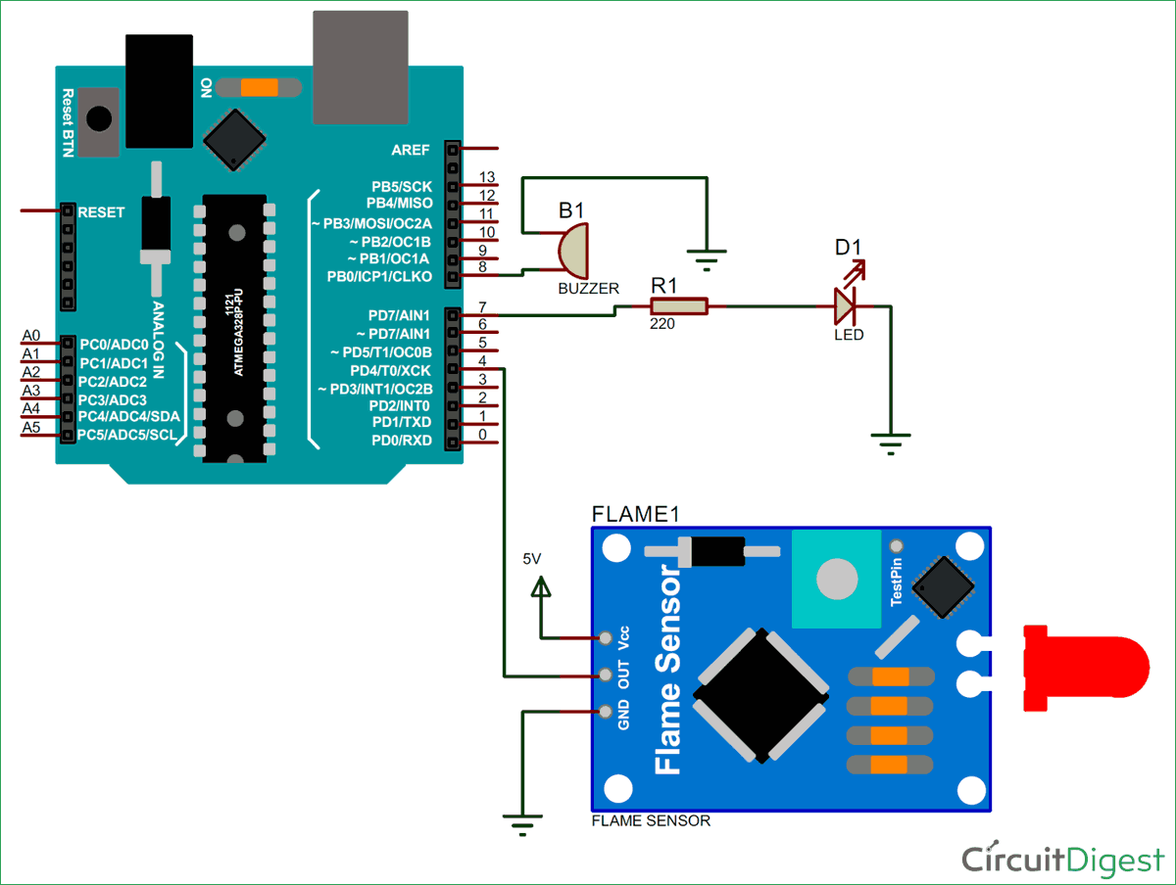

FIG: FIRE DETECTION SYSTEM WITH FLAME SENSOR AND ARDUINO

DISCUSSION & CONCLUSION

After completing this experiment fire detection mechanism of a fire detecting system comprising a fire sensor module and Arduino was understood by us properly. We learnt the working principle of an IR based fire sensor and how it can be interfaced with an Arduino to make a fire detection system. How a fire sensor senses when a fire is caught and how that signal is passed to Arduino was understood by us after doing the experiment. By turning ledpin on HIGH, and turning on buzpin High the system makes the led to light on and the buzzer sound on.

At the very beginning there were some problems. For some small errors the system was not working properly. There were some mistakes while connecting the circuits and while writing the code. That is why the led was not turning on after catching fire and the buzzer was not turned off. Later faults were identified and by correcting the mistakes we made the system work properly

This system is very much useful and necessary in our life, as it will help people to get alert when fire is caught. By using this system lives, & properties can be saves as soon as fire catches because it’s light of led and sound of buzzer help to know if a fire incident occurs.

Fire sensor has various use such as in hydrogen station. It can be used for combustion monitors for burners, oil and gas pipelines. It has applications in automotive manufacturing facilities, nuclear facilities.

Finally it can be said that our main purpose for this project has been fulfilled. We have been able to make a fire detecting system with a fire sensor, and Arduino to alert people when a fire incident occurs.

REFERENCE

[1] S. Kumar,” Interfacing Flame Sensor with Arduino to Build a Fire Alarm System,”circuitDigest.com, Aug. 2,2018.[online].Available: <https://circuitdigest.com/microcontroller-projects/arduino-flame-sensor-interfacing> [Accessed Dec. 13,2018].

[2] Firewize, ”Smoke, Gas and Flame Detectors-Principle of Operation, ” Firewize Services Pty. Ltd,unit 5,585 blackburn road,Victoria,3149,Australia,[online]. Available on:http://firewize.com/smoke-gas-flame-fire-detectors-principles-operation.[Accessed on 2015].

[3] Ravi,”Arduino Flame Sensor Interface,” electronics hub.com, jul.7, 2018,[online]. Available: [https://www.electronicshub.org/arduino-flame-sensor-interface/.[Accessed](https://www.electronicshub.org/arduino-flame-sensor-interface/.%5bAccessed) 2018].

[1] S. Kumar,” Interfacing Flame Sensor with Arduino to Build a Fire Alarm System,”circuitDigest.com, Aug. 2,2018.[online].Available: <https://circuitdigest.com/microcontroller-projects/arduino-flame-sensor-interfacing> [Accessed Dec. 13,2018].

[4] EDGEFX.in kits & solution,”Arduino uno Board with Real Time Application Projects,”Magazine pro Theme on Genesis Framework, Jan 2019.[online]. Available: [http://www.edgefx.in/arduino-uno-board-tutorial-and-its-applications/ [Accessed](http://www.edgefx.in/arduino-uno-board-tutorial-and-its-applications/%20%5bAccessed) 2019]

[5] K&Rprojects,”Arduino with Fire Sensor, LED and Buzzer,” yutube.com,Jan.2, 2018.[online]. Available: <https://kandrproject.blogspot.com/2018/01/arduino-with-fire-sensor-led-and-buzzer.html>. [ Accessed: 2018]

[1] S. Kumar,” Interfacing Flame Sensor with Arduino to Build a Fire Alarm System,”circuitDigest.com, Aug. 2,2018.[online].Available: <https://circuitdigest.com/microcontroller-projects/arduino-flame-sensor-interfacing> [Accessed Dec. 13,2018].