**Module 2_Assignment_2:**

**Topic: A report on Linux command output after running the VM.**

### **Run the VM:**

* **a. Download Kali Linux VM** I downloaded the Kali Linux ISO file and used VMware as my virtualization platform.
* **b. Add the Kali VM to the VM platform** I created a new virtual machine in VMware and added the Kali Linux ISO file to it.
* **c. Run the VM** After launching the VM, Kali Linux started successfully.

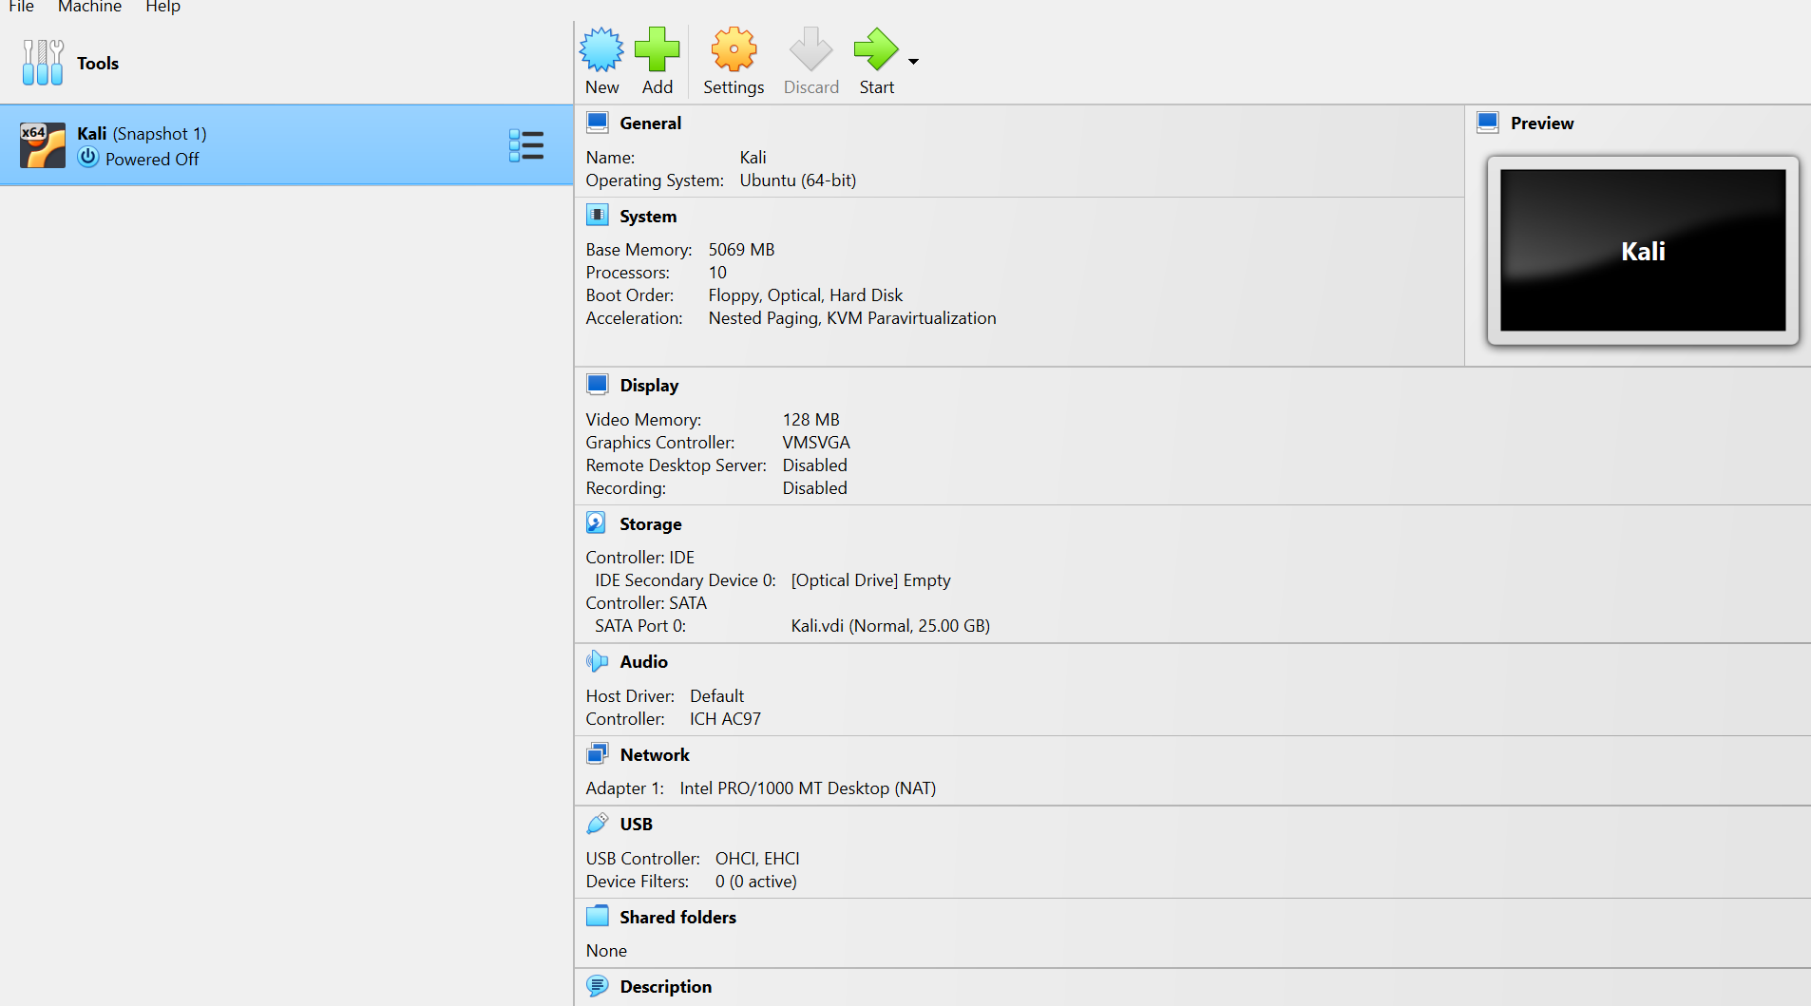

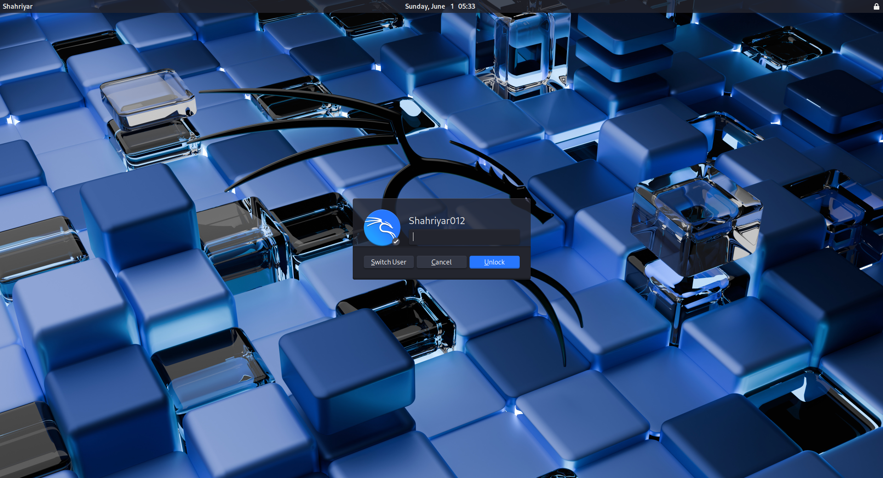

**Command Output:**

* pwd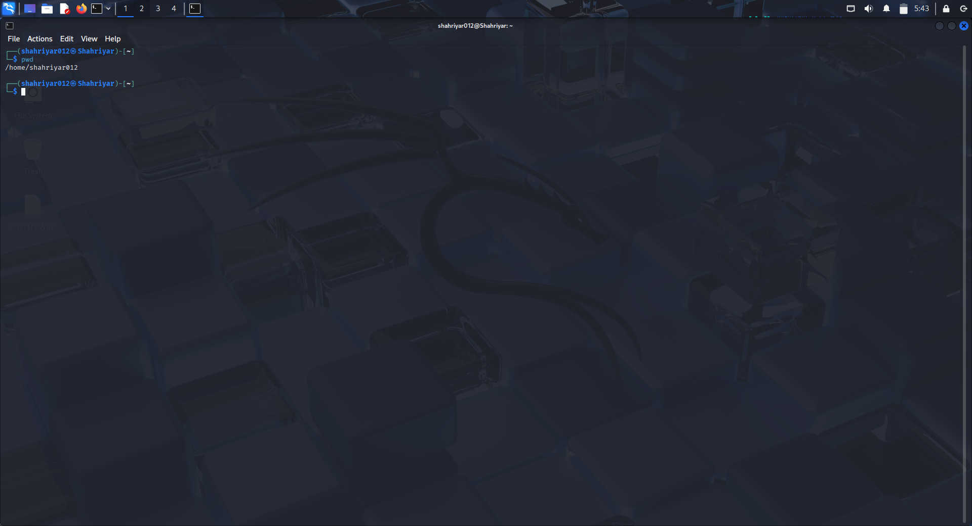

**Explanation:**

This command shows the current working directory.

* ls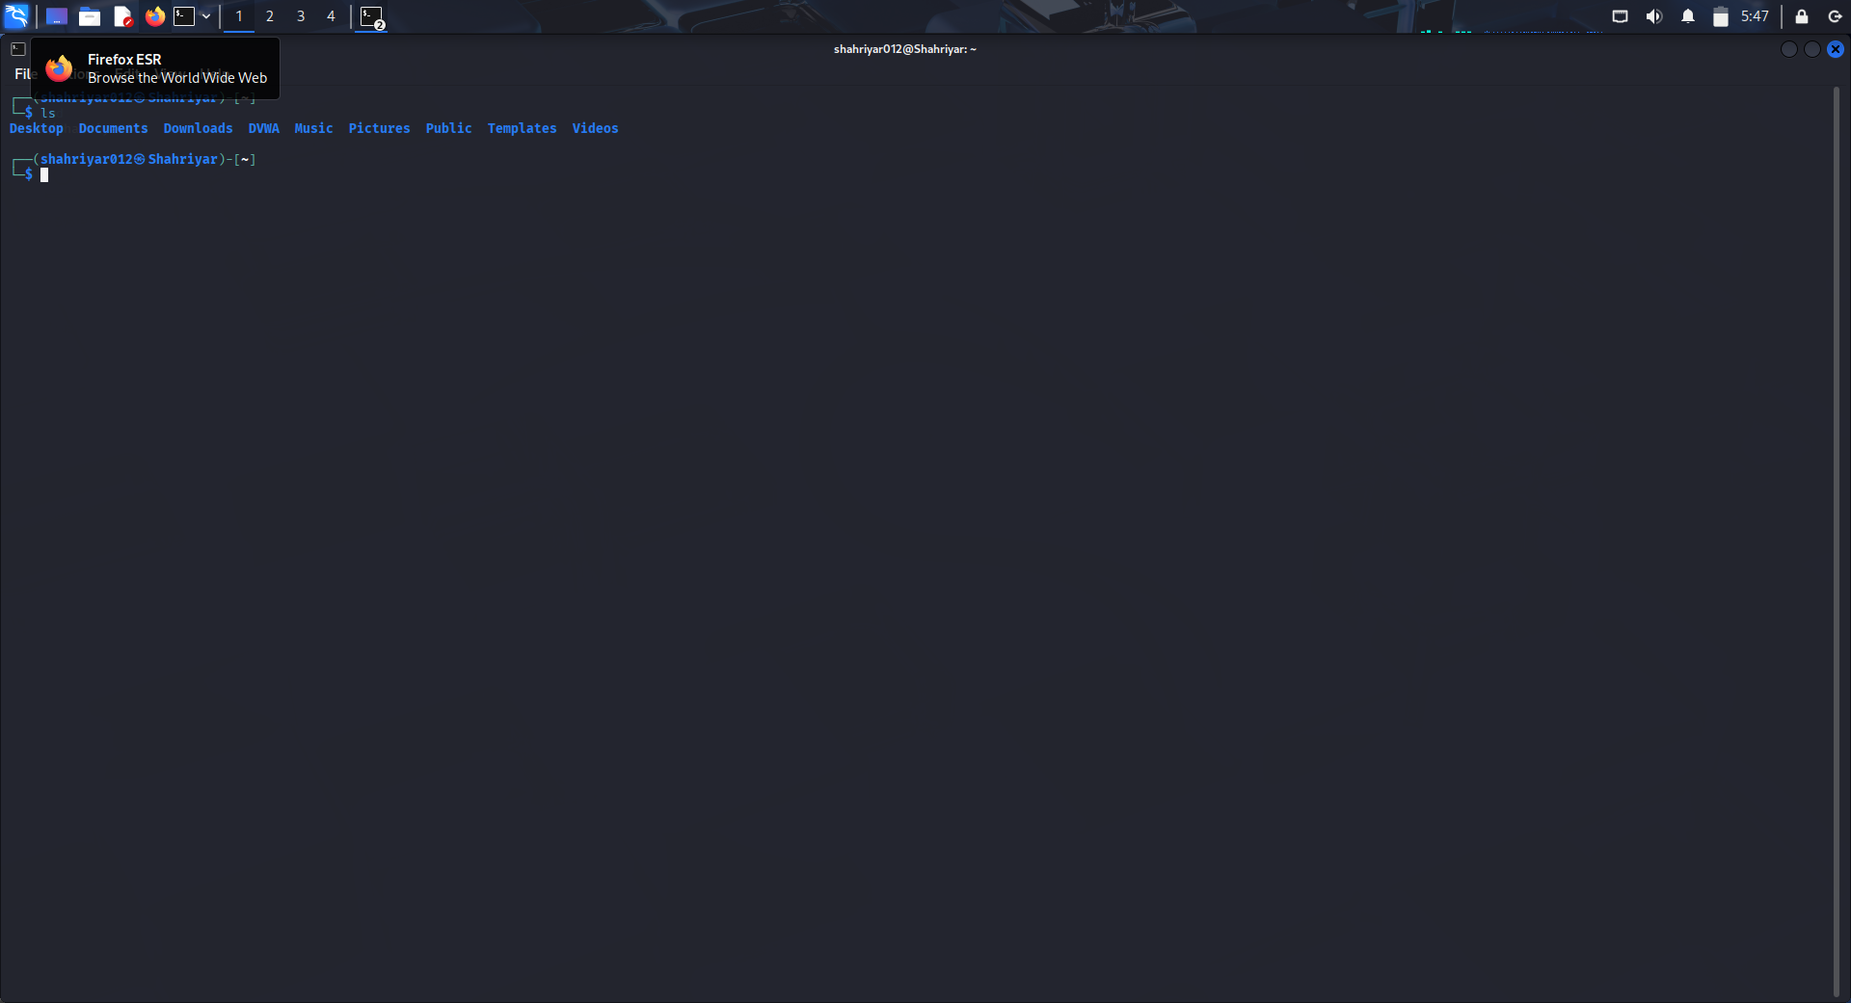

**Explanation:**

This command lists all files and folders in the current directory.

* Create file with cat command:

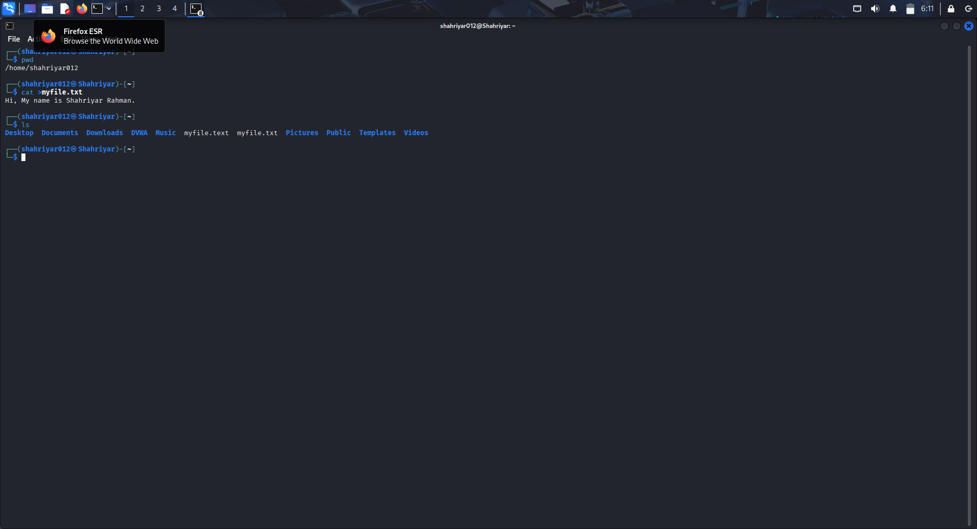

**Explanation:**

The cat command reads a file and displays its contents.

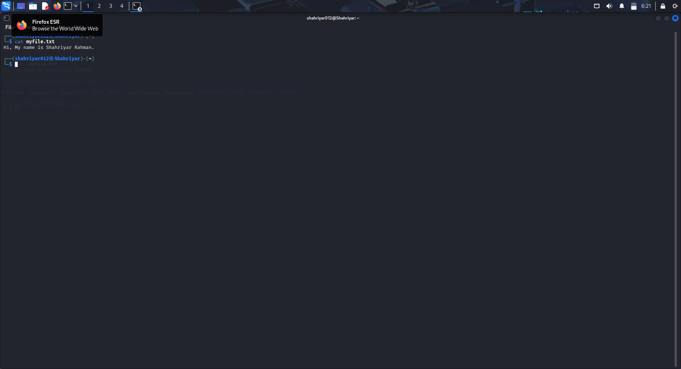

* **User Log in Command (whoami):**

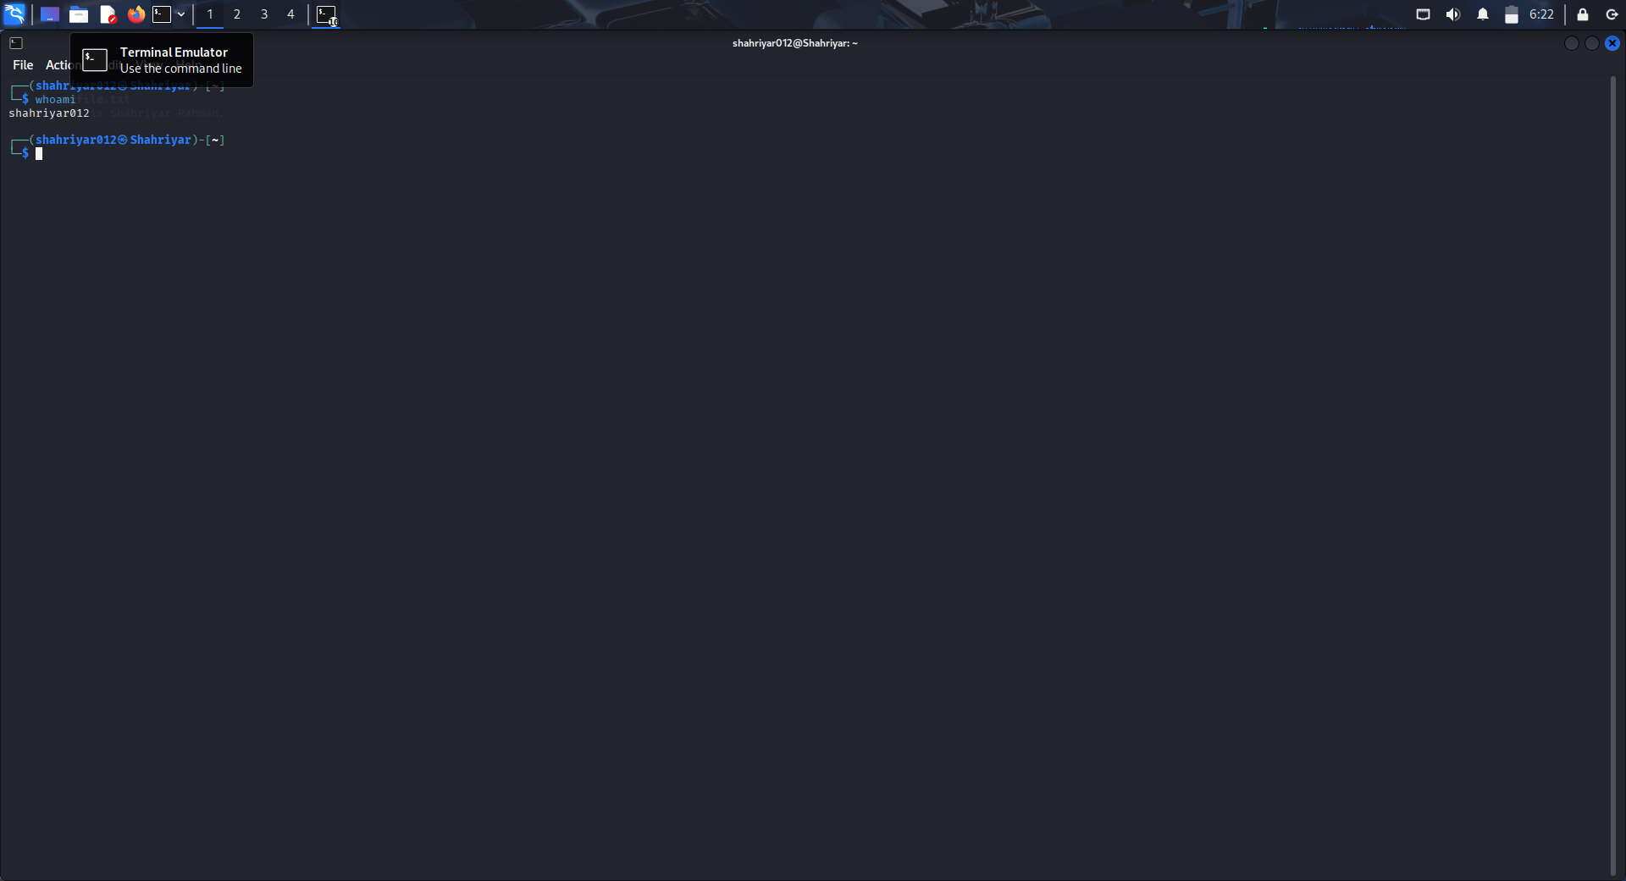

**Explanation:** The whoami command displays the username of the currently logged-in user.

* **find command to locate a file:**

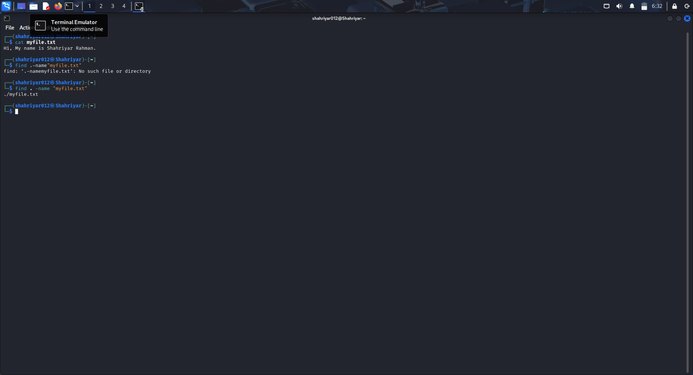

**Explanation:**

This command searches for a file named "myfile.txt" in the current directory and all subdirectories.

* **grep command to search for text in a file**

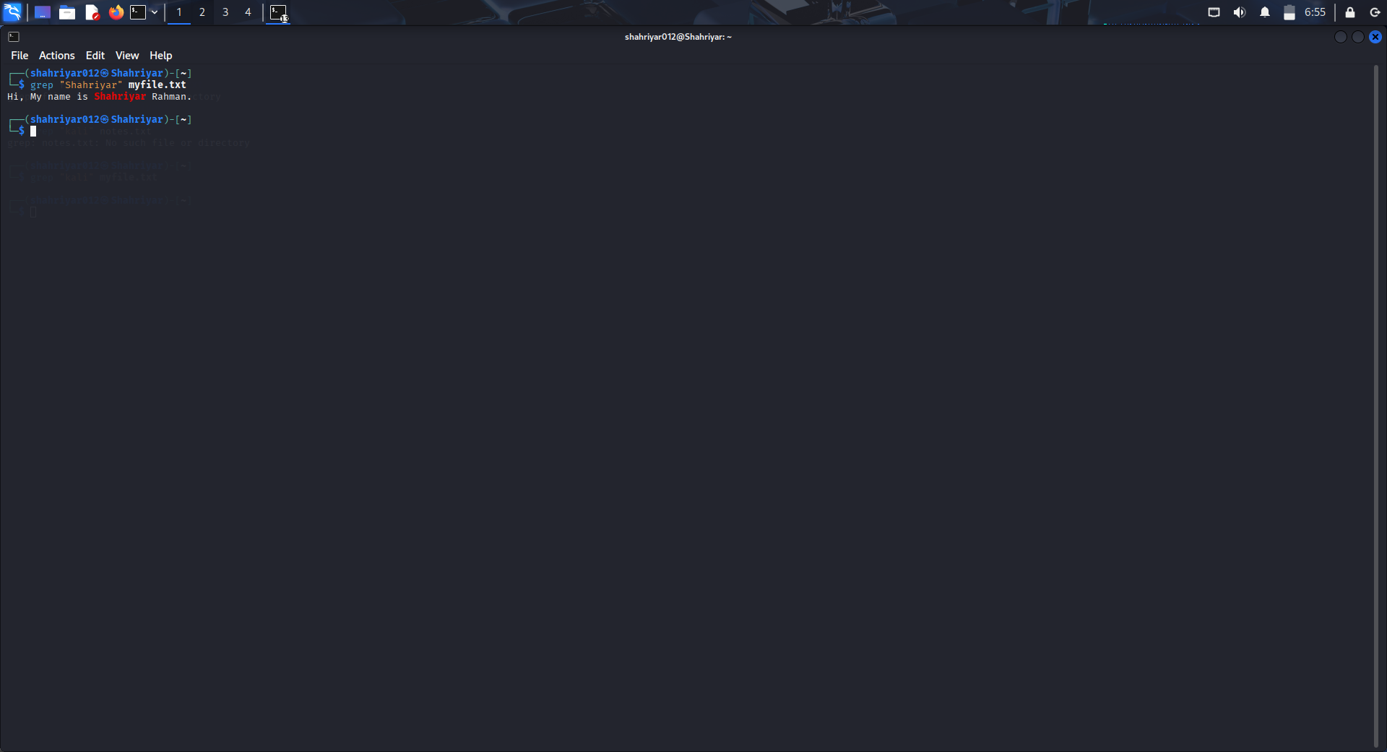

**Explanation:**

The grep command searches for specific text ("Kali") inside a file and displays the lines containing that text.

This report demonstrates how to set up and run a Kali Linux VM, and how to use essential Linux commands like pwd, ls, cat, find, grep and whoami . Each command is explained with examples and output to help understand its functionality clearly.