LABORATORIYA ISHI -7
Mavzu: PHP’da sessiya va cookie’lar bilan ishlash
Ishning maqsadi
Talabalarda PHP dasturlash tilida:
- Cookie va Session tushunchalarini o‘rganish
- Ularni yaratish, o‘qish va o‘chirishni amalda bajarish
- Foydalanuvchi ma’lumotlarini vaqtinchalik saqlashni tushunish

Nazariy qism
Cookie nima?
Cookie — bu foydalanuvchi brauzerida saqlanadigan kichik hajmdagi ma’lumot.
Xususiyatlari:
- Brauzerda saqlanadi
- Belgilangan vaqtgacha yashaydi
- Serverga har so‘rovda yuboriladi
PHP’da cookie yaratish:
setcookie("username", "Ali", time() + 3600);
Cookie’ni o‘qish:
echo $_COOKIE['username'];
Cookie’ni o‘chirish:
setcookie("username", "", time() - 3600);

Session nima?
Session — bu serverda saqlanadigan foydalanuvchi ma’lumotidir.
Xususiyatlari:
- Serverda saqlanadi
- Xavfsizroq
- Brauzer yopilganda yoki sessiya tugaganda o‘chadi
Session boshlash:
session_start();
Session qiymat berish:
$_SESSION['username'] = "Ali";
Session o‘qish:
echo $_SESSION['username'];
Session o‘chirish:
session_destroy();

19-topshiriq:
Vazifa: Accessibility panel (ochish/yopish), dark mode va font size funksiyalarini yarating. Panel holati va sozlamalar saqlansin.
(Panel → cookie, dark → cookie, font → session)
Vazifani bajarish:
index.php:
<?php
session_start();
if (isset($_POST['panel'])) {
setcookie('panel_state', $_POST['panel'], time() + 3600, '/');
$_COOKIE['panel_state'] = $_POST['panel'];
}
// Dark mode cookie
if (isset($_POST['dark'])) {
setcookie('dark_mode', $_POST['dark'], time() + 3600, '/');
$_COOKIE['dark_mode'] = $_POST['dark'];
}
// Font size session
if (isset($_POST['font'])) {
$_SESSION['font_size'] = $_POST['font'];
}
// Qiymatlarni olish
$panel_state = $_COOKIE['panel_state'] ?? 'closed';
$dark_mode = $_COOKIE['dark_mode'] ?? 'light';
$font_size = $_SESSION['font_size'] ?? '16px';
?>
<!DOCTYPE html>
<html lang="uz">
<head>
<meta charset="UTF-8">
<title>Accessibility Panel</title>
<link href="https://cdn.jsdelivr.net/npm/bootstrap@5.3.3/dist/css/bootstrap.min.css" rel="stylesheet">
<style>
body {
background-color: <?= $dark_mode === 'dark' ? '#222' : '#fff' ?>;
color: <?= $dark_mode === 'dark' ? '#fff' : '#000' ?>;
font-size: <?= $font_size ?>;
transition: all 0.3s ease;
}
.panel {
display: <?= $panel_state === 'open' ? 'block' : 'none' ?>;
border: 1px solid #ccc;
padding: 15px;
margin: 15px 0;
border-radius: 8px;
background: <?= $dark_mode === 'dark' ? '#333' : '#f9f9f9' ?>;
}
</style>
</head>
<body class="container py-4">
<h1 class="mb-4">Accessibility Panel Demo</h1>
<!-- Panel toggle -->
<form method="post" class="mb-3">
<button class="btn btn-primary" name="panel" value="<?= $panel_state === 'open' ? 'closed' : 'open' ?>">
<?= $panel_state === 'open' ? 'Panelni yopish' : 'Panelni ochish' ?>
</button>
</form>
<!-- Panel ichidagi sozlamalar -->
<div class="panel">
<form method="post" class="mb-3">
<!-- Dark mode -->
<button class="btn btn-dark" name="dark" value="<?= $dark_mode === 'dark' ? 'light' : 'dark' ?>">
<?= $dark_mode === 'dark' ? 'Light Mode' : 'Dark Mode' ?>
</button>
</form>
<form method="post" class="mb-3">
<!-- Font size -->
<label class="form-label">Font size:</label>
<select class="form-select w-auto d-inline" name="font" onchange="this.form.submit()">
<option value="14px" <?= $font_size==='14px'?'selected':'' ?>>14px</option>
<option value="16px" <?= $font_size==='16px'?'selected':'' ?>>16px</option>
<option value="18px" <?= $font_size==='18px'?'selected':'' ?>>18px</option>
<option value="20px" <?= $font_size==='20px'?'selected':'' ?>>20px</option>
</select>
</form>
</div>
<!-- Bootstrap JS (optional) -->
<script src="https://cdn.jsdelivr.net/npm/bootstrap@5.3.3/dist/js/bootstrap.bundle.min.js"></script>
</body>
</html>
Ishlash mantig‘i:
Fayl ochilganda: PHP session_start() orqali sessiyani ishga tushadi. Agar biz tugma bosgan bo‘lsak (panel, dark, font), u qiymatlar cookie yoki session’da saqlanadi.
Cookie va Session saqlash: Panel holati (open yoki closed) → cookie’da saqlanadi. Dark mode (dark yoki light) → cookie’da saqlanadi. Font size (14px, 16px, 18px, 20px) → session’da saqlanadi.
Sahifa qayta yuklanganda: PHP cookie va session qiymatlarini o‘qib oladi. CSS ichida background-color, color, font-size shu qiymatlarga qarab o‘zgaradi. Panelning display xususiyati cookie’dagi holatga qarab block yoki none bo‘ladi.
Foydalanuvchi tugma bosganda: Masalan, “Dark Mode” tugmasini bossak, dark_mode cookie dark bo‘ladi. Keyingi sahifa yuklanganda fon qora, matn oq bo‘lib chiqadi. “Font size” select’dan tanlasangiz, session’da saqlanadi va matn kattaligi o‘zgaradi.
Ko’rinishi:
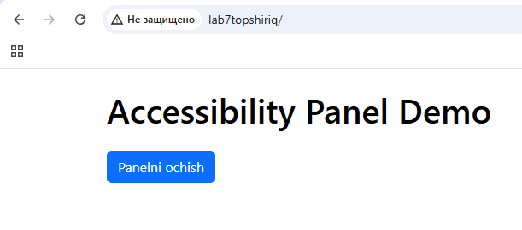
Panelni ochish tugmasini bossak:
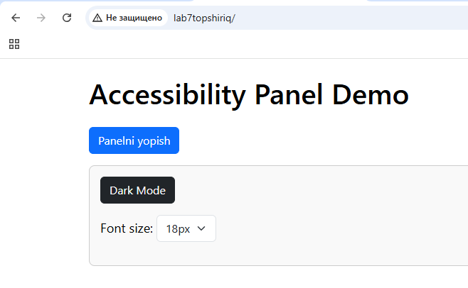
Dark Modeni bossak:
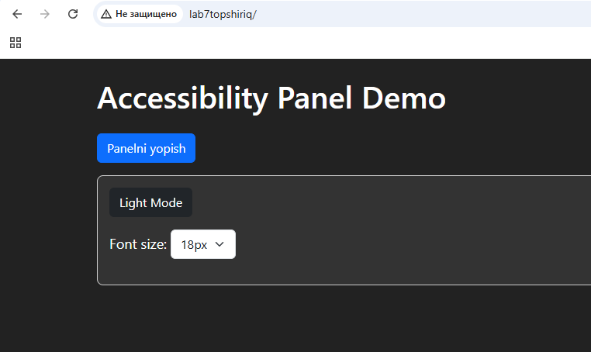
Select ochilsa:
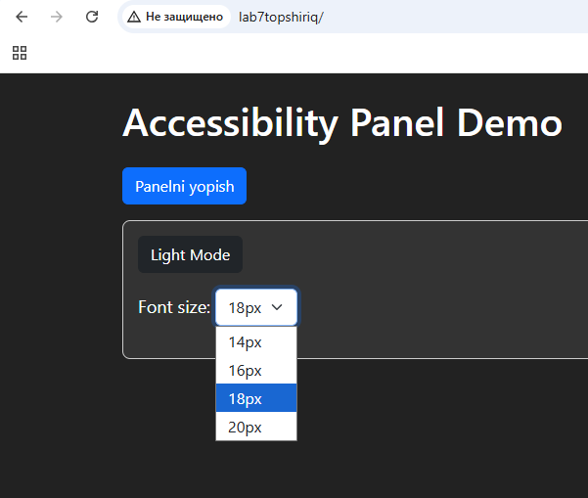
20px ga qo’yilsa:
