LABORATORIYA ISHI - 8

Mavzu: PHP orqali fayl yuklash va saqlash moduli

Ishning maqsadi:
Talabalar:
- PHP’da fayl yuklashni o‘rganadi
- Faylni serverga saqlashni amalga oshiradi
- Faylni tekshirish (format, hajm)ni bajaradi
- Xavfsiz upload tizimini yaratadi

Nazariy qism

Fayl yuklash qanday ishlaydi?
- Foydalanuvchi fayl tanlaydi
- Forma orqali serverga yuboradi
- PHP faylni $_FILES orqali qabul qiladi
- Fayl vaqtinchalik papkaga tushadi
- move_uploaded_file() orqali kerakli papkaga ko‘chiriladi

$_FILES haqida
$_FILES['file']
Elementlari:
- name – fayl nomi
- tmp_name – vaqtinchalik joylashuv
- size – hajmi
- type – turi
- error – xatolik

1-qadam: Oddiy fayl yuklash

index.php (forma)
<!DOCTYPE html>
<html>
<head>
<title>Fayl yuklash</title>
</head>
<body>
<form action="upload.php" method="post" enctype="multipart/form-data">
Fayl tanlang:
<input type="file" name="file">
<button type="submit">Yuklash</button>
</form>
</body>
</html>

upload.php (server qismi)
<?php
$target_dir = "uploads/";
$file_name = $_FILES["file"]["name"];
$tmp_name = $_FILES["file"]["tmp_name"];
move_uploaded_file($tmp_name, $target_dir . $file_name);
echo "Fayl yuklandi!";
?>

Papka tuzilishi
project/
│
├── index.php
├── upload.php
└── uploads/

2-qadam: Xavfsiz upload

Fayl turini tekshirish
<?php
$allowed = ['jpg', 'png', 'pdf'];
$file_name = $_FILES["file"]["name"];
$ext = strtolower(pathinfo($file_name, PATHINFO_EXTENSION));
if(!in_array($ext, $allowed)){
echo "Faqat JPG, PNG, PDF fayllar ruxsat etiladi!";
exit;
}
?>

Fayl hajmini tekshirish
<?php
$max_size = 2 * 1024 * 1024;
if($_FILES["file"]["size"] > $max_size){
echo "Fayl hajmi juda katta!";
exit;
}
?>

To‘liq xavfsiz uploadkodi
<?php
$target_dir = "uploads/";
$file_name = $_FILES["file"]["name"];
$tmp_name = $_FILES["file"]["tmp_name"];
$file_size = $_FILES["file"]["size"];
$allowed = ['jpg', 'png', 'pdf'];
$ext = strtolower(pathinfo($file_name, PATHINFO_EXTENSION));
if(!in_array($ext, $allowed)){
die("Noto‘g‘ri fayl turi!");
}
if($file_size > 2 * 1024 * 1024){
die("Fayl 2MB dan katta!");
}
$new_name = time() . "_" . $file_name;
if(move_uploaded_file($tmp_name, $target_dir . $new_name)){
echo "Fayl muvaffaqiyatli yuklandi!";
} else {
echo "Xatolik yuz berdi!";
}
?>

3-qadam: Ko‘p fayl yuklash

Forma
<form action="upload.php" method="post" enctype="multipart/form-data">
<input type="file" name="files[]" multiple>
<button type="submit">Yuklash</button>
</form>

PHP kodi
<?php
foreach($_FILES['files']['tmp_name'] as $key => $tmp_name){
$name = $_FILES['files']['name'][$key];
$tmp = $_FILES['files']['tmp_name'][$key];
move_uploaded_file($tmp, "uploads/" . $name);
}
echo "Barcha fayllar yuklandi!";
?>

4-qadam: Rasmni ko‘rsatish
<?php
$files = scandir("uploads/");
foreach($files as $file){
if($file != "." && $file != ".."){
echo "<img src='uploads/$file' width='150'><br>";
}}?>

5-qadam: Faylni o‘chirish
<?php
$file = $_GET['file'];
if(file_exists("uploads/" . $file)){
unlink("uploads/" . $file);
echo "Fayl o‘chirildi!";
}
?>

Qo‘shimcha funksiyalar

Papka yaratish
if(!is_dir("uploads")){
mkdir("uploads");
}

Fayl mavjudligini tekshirish
if(file_exists("uploads/" . $file_name)){
echo "Bu fayl allaqachon mavjud!";
}

Umumiy talablar
- enctype="multipart/form-data" majburiy
- Fayl turini tekshirish kerak
- Fayl hajmini cheklash kerak
- Fayl nomini o‘zgartirish tavsiya etiladi

Nazorat savollari
- $_FILES nima?
PHP’da fayl yuklanganda, u haqidagi barcha ma’lumot (nomi, hajmi, vaqtinchalik yo‘li, xatolik kodi) $_FILES massivida saqlanadi.
- move_uploaded_file() nima qiladi?
Faylni serverdagi vaqtinchalik joyidan ko‘rsatilgan papkaga ko‘chiradi va saqlab qo‘yadi.
- Fayl hajmi qanday tekshiriladi?
$_FILES['myfile']['size'] orqali baytlarda hajm olinadi. Keyin shart bilan tekshiriladi, masalan:
if ($_FILES['myfile']['size'] < 2*1024*1024) { // 2 MB
// ruxsat }
- Fayl kengaytmasi qanday olinadi?
pathinfo() funksiyasi orqali:
$ext = pathinfo($_FILES['myfile']['name'], PATHINFO_EXTENSION);
- Nega xavfsizlik muhim?
Chunki foydalanuvchi yuklagan fayl zararli bo‘lishi mumkin. Fayl nomini tozalash, kengaytmasini tekshirish va hajmni cheklash orqali serverni himoya qilamiz.
Topshiriqlar:

19-topshiriq
- Fayl yuklash
- Faylni vaqtinchalik nom bilan saqlash
- uploads-FIO/ da nomini o‘zgartirish
Topshiriqni bajarish:
Struktura:
Lab8topshiriq/
├── index.php
├── upload.php
└── uploads/
└── Shahrizoda/
index.php:
<!DOCTYPE html>
<html lang="uz">
<head>
<meta charset="UTF-8">
<title>Fayl yuklash</title>
<!-- Bootstrap CSS -->
<link href="https://cdn.jsdelivr.net/npm/bootstrap@5.3.3/dist/css/bootstrap.min.css" rel="stylesheet">
</head>
<body class="container py-5">
<h2 class="mb-4">Fayl yuklash formasi</h2>
<div class="card p-4 shadow-sm">
<form action="upload.php" method="post" enctype="multipart/form-data">
<div class="mb-3">
<label class="form-label">Ismingiz (FIO):</label>
<input type="text" name="fio" class="form-control" required>
</div>
<div class="mb-3">
<label class="form-label">Faylni tanlang:</label>
<input type="file" name="myfile" class="form-control" required>
</div>
<button type="submit" class="btn btn-primary">Yuklash</button>
</form>
</div>
<!-- Bootstrap JS -->
<script src="https://cdn.jsdelivr.net/npm/bootstrap@5.3.3/dist/js/bootstrap.bundle.min.js"></script>
</body>
</html>
upload.php:
<?php
// Foydalanuvchi FIO
$fio = trim($_POST['fio']);
$fio = preg_replace('/[^a-zA-Z0-9_-]/', '_', $fio); // xavfsizlik uchun
// Yuklangan fayl haqida ma'lumot
$file = $_FILES['myfile'];
?>
<!DOCTYPE html>
<html lang="uz">
<head>
<meta charset="UTF-8">
<title>Natija</title>
<!-- Bootstrap CSS -->
<link href="https://cdn.jsdelivr.net/npm/bootstrap@5.3.3/dist/css/bootstrap.min.css" rel="stylesheet">
</head>
<body class="container py-5">
<h2 class="mb-4">Fayl yuklash natijasi</h2>
<div class="card p-4 shadow-sm">
<?php
if ($file['error'] === UPLOAD_ERR_OK) {
$tmp_name = $file['tmp_name'];
$original_name = basename($file['name']);
$extension = pathinfo($original_name, PATHINFO_EXTENSION);
// FIO papkasini yaratish
$upload_dir = __DIR__ . "/uploads/$fio/";
if (!is_dir($upload_dir)) {
mkdir($upload_dir, 0777, true);
}
// Yangi fayl nomi
$new_name = $fio . "_" . time() . "." . $extension;
$destination = $upload_dir . $new_name;
if (move_uploaded_file($tmp_name, $destination)) {
echo "<div class='alert alert-success'>✅ Fayl muvaffaqiyatli yuklandi va saqlandi: <strong>uploads/$fio/$new_name</strong></div>";
} else {
echo "<div class='alert alert-danger'>❌ Faylni saqlashda xatolik yuz berdi.</div>";
}
} else {
echo "<div class='alert alert-danger'>❌ Fayl yuklashda xatolik.</div>";
}
?>
<a href="index.php" class="btn btn-secondary mt-3">Orqaga qaytish</a>
</div>
</body>
</html>
Ishlash tartibi:
- index.php → foydalanuvchi FIO va faylni tanlaydi.
- Fayl yuborilganda → upload.php uni qabul qiladi.
- Fayl vaqtinchalik nom bilan tushadi (tmp_name).
- uploads/FIO/ papkasi yaratiladi (agar mavjud bo‘lmasa).
- Fayl nomi FIO_vaqtKodni.ext ko‘rinishida o‘zgartiriladi va saqlanadi.
- Natija Bootstrap alert oynasida chiroyli ko‘rinishda chiqadi.
Ko’rinishi:
Ishga tushirsak shu sahifa ochiladi:
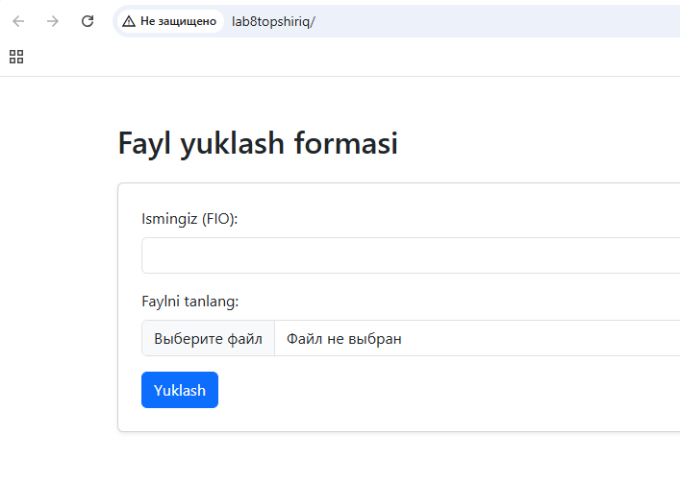
Ism yozdik va fayl tanlashga bossak kompyuterdagi fayllar ochiladi:
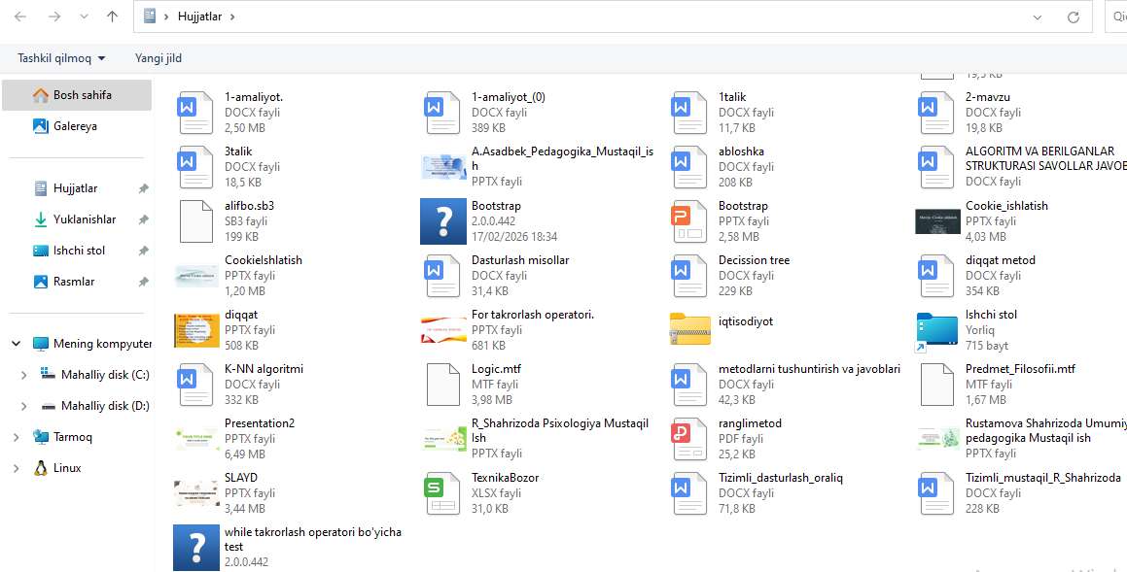
Faylni tanlaymiz:
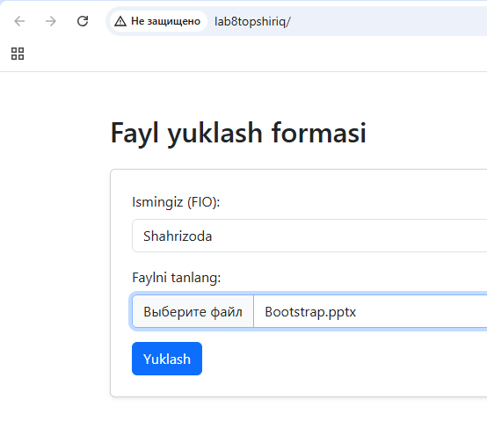
Yuklash bosilsa:
