LABORATORIYA ISHI №4
Mavzu: PHP orqali MySQL ma’lumotlar bazasiga ulanish
1. Ishning maqsadi
- Tayyor MySQL bazaga PHP orqali ulanish
- SELECT so‘rovlarini bajarish
- INNER JOIN orqali bir nechta jadval ma’lumotlarini chiqarish
- MySQLi (procedural, OOP) va PDO usullarini taqqoslash
- Ular orasidagi farqlarni amaliy ko‘rsatish
2. Nazariy qism
PHP orqali MySQL bilan ishlashning 3 asosiy usuli mavjud:
- MySQLi (Procedural)
- MySQLi (Object-Oriented)
- PDO (PHP Data Objects)

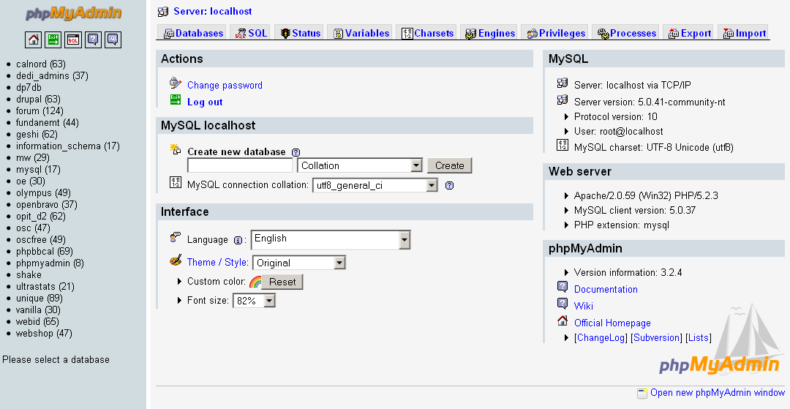
3. Amaliy baza (tayyor database)
Database: db_universitet
3 ta jadval:
fakultetlar
- id (PK)
- nomi
talabalar
- id (PK)
- ism
- kurs
- fakultet_id (FK)
fanlar
- id (PK)
- fan_nomi
- kredit
- talaba_id (FK)
4. Oddiy SELECT so‘rovi
SELECT * FROM talabalar;
5. JOIN so‘rovi
SELECT
talabalar.ism,
talabalar.kurs,
fakultetlar.nomi AS fakultet,
fanlar.fan_nomi
FROM talabalar
INNER JOIN fakultetlar ON talabalar.fakultet_id = fakultetlar.id
INNER JOIN fanlar ON talabalar.id = fanlar.talaba_id;
6. PHP orqali ulanish usullari
6.1 MySQLi – Procedural usul
<?php
$conn = mysqli_connect("localhost", "root", "", "db_universitet");
if (!$conn) {
die("Ulanish xatoligi: " . mysqli_connect_error());
}
$sql = "SELECT * FROM talabalar";
$result = mysqli_query($conn, $sql);
while ($row = mysqli_fetch_assoc($result)) {
echo $row['ism'] . " - " . $row['kurs'] . "<br>";
}
mysqli_close($conn);
?>
Xususiyatlari:
- Oddiy
- Faqat MySQL bilan ishlaydi
- Xavfsizlik PDO ga qaraganda pastroq
6.2 MySQLi – Object Oriented usul
<?php
$conn = new mysqli("localhost", "root", "", "db_universitet");
if ($conn->connect_error) {
die("Xatolik: " . $conn->connect_error);
}
$sql = "SELECT * FROM talabalar";
$result = $conn->query($sql);
while ($row = $result->fetch_assoc()) {
echo $row['ism'] . "<br>";
}
$conn->close();
?>
Xususiyatlari:
- OOP yondashuv
- Professionalroq
- Katta loyihalar uchun qulay
6.3 PDO usuli (Tavsiya etiladi)
<?php
try {
$conn = new PDO("mysql:host=localhost;dbname=db_universitet", "root", "");
$conn->setAttribute(PDO::ATTR_ERRMODE, PDO::ERRMODE_EXCEPTION);
$sql = "SELECT * FROM talabalar";
$stmt = $conn->query($sql);
while ($row = $stmt->fetch(PDO::FETCH_ASSOC)) {
echo $row['ism'] . "<br>";
}
} catch(PDOException $e) {
echo "Xatolik: " . $e->getMessage();
}
?>
Xususiyatlari:
- Turli DB lar bilan ishlaydi (MySQL, PostgreSQL, Oracle)
- Eng xavfsiz
- Prepared Statement kuchli
- try-catch bilan ishlaydi
7. PDO orqali JOIN misoli
<?php
try {
$conn = new PDO("mysql:host=localhost;dbname=db_universitet", "root", "");
$conn->setAttribute(PDO::ATTR_ERRMODE, PDO::ERRMODE_EXCEPTION);
$sql = "SELECT
talabalar.ism,
talabalar.kurs,
fakultetlar.nomi AS fakultet,
fanlar.fan_nomi
FROM talabalar
INNER JOIN fakultetlar
ON talabalar.fakultet_id = fakultetlar.id
INNER JOIN fanlar
ON talabalar.id = fanlar.talaba_id";
$stmt = $conn->query($sql);
echo "<table border='1'>";
echo "<tr><th>Ism</th><th>Kurs</th><th>Fakultet</th><th>Fan</th></tr>";
while ($row = $stmt->fetch(PDO::FETCH_ASSOC)) {
echo "<tr>
<td>{$row['ism']}</td>
<td>{$row['kurs']}</td>
<td>{$row['fakultet']}</td>
<td>{$row['fan_nomi']}</td>
</tr>";
}
echo "</table>";
} catch(PDOException $e) {
echo "Xatolik: " . $e->getMessage();
}
?>
8. Usullarni taqqoslash
Xususiyat | MySQLi Procedural | MySQLi OOP | PDO
DB turi | Faqat MySQL | Faqat MySQL | Ko‘p DB
Xavfsizlik | O‘rtacha | Yaxshi | Eng yaxshi
try-catch | Yo‘q | Yo‘q | Bor
Prepared | Bor | Bor | Juda kuchli
Professional | O‘rtacha | Yaxshi | Eng yaxshi
9. Natija
Laboratoriya ishida:
- Tayyor MySQL bazaga ulanish amalga oshirildi
- SELECT so‘rovi bajarildi
- INNER JOIN ishlatildi
- 3 xil PHP usuli taqqoslandi
- PDO eng tavsiya etiladigan usul ekanligi ko‘rsatildi
Topshiriqlar:

19-Qurilish kompaniya
Database: db_qurilish

Jadvallar:
obyektlar
- id
- nomi
- manzil
ishchilar
- id
- ism
- mutaxassislik
topshiriqlar
- id
- obyekt_id (FK)
- ishchi_id (FK)
- sana

JOIN vazifa:
Ishchi + Obyekt + Sana chiqarish.

Talaba nima qiladi?
- Topshiriqlar jadvali orqali bog‘laydi
- 3 jadval JOIN
- Natijani HTML jadvalda chiqaradi
Topshiriqni bajarish:
- Baza va jadvallarni yaratish:
CREATE DATABASE db_qurilish;
USE db_qurilish;
-- Obyektlar jadvali
CREATE TABLE obyektlar (
id INT AUTO_INCREMENT PRIMARY KEY,
nomi VARCHAR(100) NOT NULL,
manzil VARCHAR(200) NOT NULL
);
-- Ishchilar jadvali
CREATE TABLE ishchilar (
id INT AUTO_INCREMENT PRIMARY KEY,
ism VARCHAR(100) NOT NULL,
mutaxassislik VARCHAR(100) NOT NULL
);
-- Topshiriqlar jadvali
CREATE TABLE topshiriqlar (
id INT AUTO_INCREMENT PRIMARY KEY,
obyekt_id INT NOT NULL,
ishchi_id INT NOT NULL,
sana DATE NOT NULL,
FOREIGN KEY (obyekt_id) REFERENCES obyektlar(id),
FOREIGN KEY (ishchi_id) REFERENCES ishchilar(id)
);
-- Test ma’lumotlar
INSERT INTO obyektlar (nomi, manzil) VALUES
('Ko‘p qavatli uy', 'Toshkent, Chilonzor'),
('Ofis binosi', 'Samarqand, Registon'),
('Savdo markazi', 'Buxoro, G‘ijduvon');
INSERT INTO ishchilar (ism, mutaxassislik) VALUES
('Ali', 'Muhandis'),
('Vali', 'Arxitektor'),
('Dilshod', 'Quruvchi');
INSERT INTO topshiriqlar (obyekt_id, ishchi_id, sana) VALUES
(1, 1, '2026-03-10'),
(2, 2, '2026-03-11'),
(3, 3, '2026-03-12');
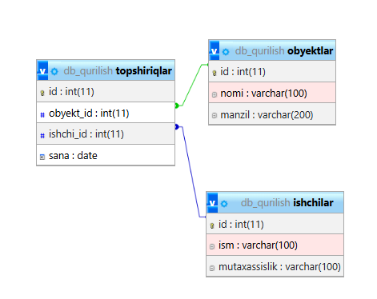
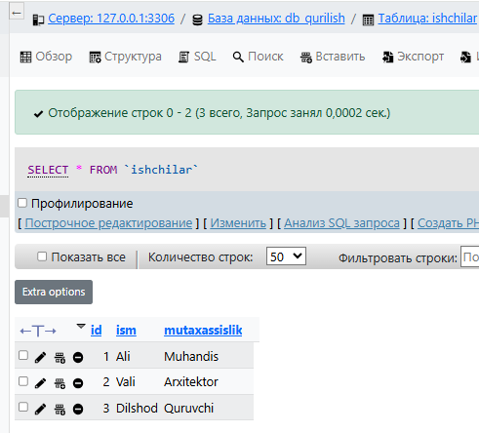
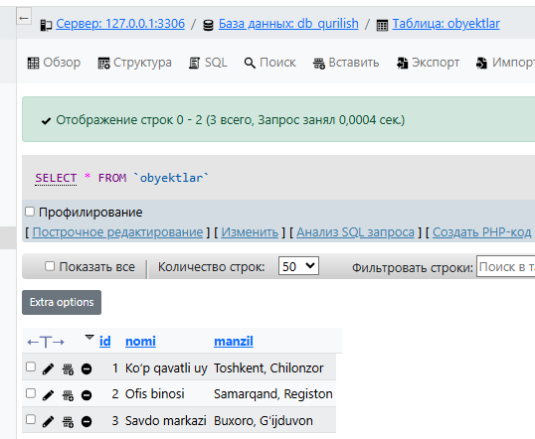
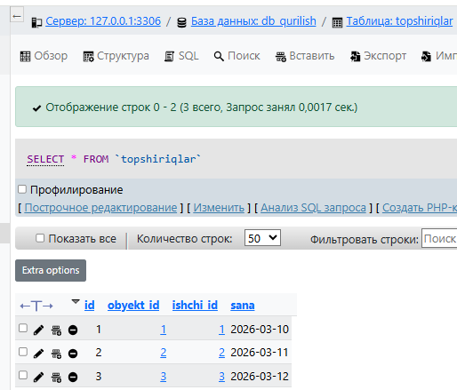
- MySQLga ulanish va JOIN so‘rov:
index.php:
<?php
// MySQL ulanish
$host = "localhost";
$user = "root"; // OpenServer default
$pass = "";
$db = "db_qurilish";
$conn = new mysqli($host, $user, $pass, $db);
// Xatolikni tekshirish
if ($conn->connect_error) {
die("Ulanishda xato: " . $conn->connect_error);
}
// JOIN so‘rov
$sql = "SELECT ishchilar.ism, obyektlar.nomi AS obyekt_nomi, topshiriqlar.sana
FROM topshiriqlar
JOIN ishchilar ON topshiriqlar.ishchi_id = ishchilar.id
JOIN obyektlar ON topshiriqlar.obyekt_id = obyektlar.id";
$result = $conn->query($sql);
?>
<!DOCTYPE html>
<html lang="uz">
<head>
<meta charset="UTF-8">
<title>Qurilish kompaniya topshiriqlari</title>
<!-- Bootstrap CSS -->
<link href="https://cdn.jsdelivr.net/npm/bootstrap@5.3.2/dist/css/bootstrap.min.css" rel="stylesheet">
</head>
<body class="bg-light">
<div class="container mt-5">
<h2 class="text-center mb-4 text-primary">Ishchilar va obyektlar topshiriqlari</h2>
<div class="card shadow">
<div class="card-body">
<table class="table table-striped table-hover">
<thead class="table-dark">
<tr>
<th scope="col">Ishchi</th>
<th scope="col">Obyekt</th>
<th scope="col">Sana</th>
</tr>
</thead>
<tbody>
<?php
if ($result->num_rows > 0) {
while($row = $result->fetch_assoc()) {
echo "<tr>
<td>".$row['ism']."</td>
<td>".$row['obyekt_nomi']."</td>
<td>".$row['sana']."</td>
</tr>";
}
} else {
echo "<tr><td colspan='3' class='text-center text-muted'>Ma’lumot topilmadi</td></tr>";
}
?>
</tbody>
</table>
</div>
</div>
</div>
<!-- Bootstrap JS -->
<script src="https://cdn.jsdelivr.net/npm/bootstrap@5.3.2/dist/js/bootstrap.bundle.min.js"></script>
</body>
</html>
<?php
$conn->close();
?>
Ko’rinishi:
