- Laboratoriya ishi
Mavzu: PHP orqali CRUD (Create, Read, Update, Delete) amallarini bajarish
Ishdan maqsad
- PHP va MySQL yordamida ma’lumotlar bazasi bilan ishlashni o‘rganish
- CRUD (Create, Read, Update, Delete) amallarini amalda bajarish
- HTML forma orqali ma’lumotlarni kiritish va qayta ishlash
- Ma’lumotlar bazasidagi yozuvlarni chiqarish, tahrirlash va o‘chirish
Kerakli dasturiy vositalar
- XAMPP / OpenServer / Denwer
- PHP 7.x yoki yuqori
- MySQL
- Brauzer (Chrome, Edge va h.k.)
- Kod muharriri (VS Code, Sublime va boshqalar)
Nazariy qism:
CRUD tushunchasi
CRUD – bu ma’lumotlar bazasida bajariladigan 4 asosiy amal:
Amal | Tavsif
Create | Yangi ma’lumot qo‘shish
Read | Ma’lumotlarni o‘qish (ko‘rish)
Update | Ma’lumotni tahrirlash
Delete | Ma’lumotni o‘chirish

1-qadam: Ma’lumotlar bazasini yaratish
phpMyAdmin orqali quyidagi SQL so‘rovni bajaring:
CREATE DATABASE talaba_db;
USE talaba_db;
CREATE TABLE talabalar (
id INT AUTO_INCREMENT PRIMARY KEY,
ism VARCHAR(50) NOT NULL,
familiya VARCHAR(50) NOT NULL,
yosh INT NOT NULL
);
2-qadam: Loyihaning fayl tuzilmasi
crud/
│
├── db.php
├── index.php
├── add.php
├── edit.php
├── delete.php
3-qadam: Ma’lumotlar bazasiga ulanish (db.php)
<?php
$conn = new mysqli("localhost", "root", "", "talaba_db");
if ($conn->connect_error) {
die("Ulanishda xatolik: " . $conn->connect_error);
}
?>
4-qadam: CREATE – Ma’lumot qo‘shish (add.php)
<?php
include 'db.php';
if(isset($_POST['submit'])){
$ism = $_POST['ism'];
$familiya = $_POST['familiya'];
$yosh = $_POST['yosh'];
$sql = "INSERT INTO talabalar (ism, familiya, yosh)
VALUES ('$ism', '$familiya', '$yosh')";
$conn->query($sql);
header("Location: index.php");
}
?>
<form method="POST">
Ism: <input type="text" name="ism"><br>
Familiya: <input type="text" name="familiya"><br>
Yosh: <input type="number" name="yosh"><br>
<button type="submit" name="submit">Saqlash</button>
</form>
5-qadam: READ – Ma’lumotlarni chiqarish (index.php)
<?php include 'db.php'; ?>
<a href="add.php">Yangi talaba qo‘shish</a>
<table border="1">
<tr>
<th>ID</th>
<th>Ism</th>
<th>Familiya</th>
<th>Yosh</th>
<th>Amallar</th>
</tr>
<?php
$result = $conn->query("SELECT * FROM talabalar");
while($row = $result->fetch_assoc()){
echo "<tr>
<td>{$row['id']}</td>
<td>{$row['ism']}</td>
<td>{$row['familiya']}</td>
<td>{$row['yosh']}</td>
<td>
<a href='edit.php?id={$row['id']}'>Tahrirlash</a>
<a href='delete.php?id={$row['id']}'>O‘chirish</a>
</td>
</tr>";
}
?>
</table>
6-qadam: UPDATE – Ma’lumotni tahrirlash (edit.php)
<?php
include 'db.php';
$id = $_GET['id'];
$result = $conn->query("SELECT * FROM talabalar WHERE id=$id");
$row = $result->fetch_assoc();
if(isset($_POST['update'])){
$ism = $_POST['ism'];
$familiya = $_POST['familiya'];
$yosh = $_POST['yosh'];
$conn->query("UPDATE talabalar
SET ism='$ism', familiya='$familiya', yosh='$yosh'
WHERE id=$id");
header("Location: index.php");
}
?>
<form method="POST">
Ism: <input type="text" name="ism" value="<?php echo $row['ism']; ?>"><br>
Familiya: <input type="text" name="familiya" value="<?php echo $row['familiya']; ?>"><br>
Yosh: <input type="number" name="yosh" value="<?php echo $row['yosh']; ?>"><br>
<button type="submit" name="update">Yangilash</button>
</form>
7-qadam: DELETE – Ma’lumotni o‘chirish (delete.php)
<?php
include 'db.php';
$id = $_GET['id'];
$conn->query("DELETE FROM talabalar WHERE id=$id");
header("Location: index.php");
?>
Topshiriqlar:
19.TOPSHIRIQ: “Logistika Transport”
Database: logistics_transport_db
Jadval: cargo_transfers
Ustunlar:
- transfer_id
- shipment_label
- origin_point
- destination_point
- dispatch_datetime
- delivery_datetime
- carrier_agent
- shipment_condition
Topshiriqni bajarish tartibi:
Database yaratish:
CREATE DATABASE logistics_transport_db;
USE logistics_transport_db;
CREATE TABLE cargo_transfers (
transfer_id INT AUTO_INCREMENT PRIMARY KEY,
shipment_label VARCHAR(100) NOT NULL,
origin_point VARCHAR(100) NOT NULL,
destination_point VARCHAR(100) NOT NULL,
dispatch_datetime DATETIME NOT NULL,
delivery_datetime DATETIME NOT NULL,
carrier_agent VARCHAR(100) NOT NULL,
shipment_condition VARCHAR(100) NOT NULL
);
Jadval bo’sh bo’lmasligi uchun shu malumotlarni sqlda qo’shdim:
INSERT INTO cargo_transfers (shipment_label, origin_point, destination_point, dispatch_datetime, delivery_datetime, carrier_agent, shipment_condition)
VALUES
('SHP-001', 'Toshkent', 'Samarqand', '2024-05-10 09:00:00', '2024-05-10 14:30:00', 'UzPost Logix', 'Yaxshi'),
('SHP-002', 'Andijon', 'Namangan', '2024-05-10 10:15:00', '2024-05-10 12:00:00', 'Express Cargo', 'Namlikdan himoyalangan'),
('SHP-003', 'Buxoro', 'Xiva', '2024-05-11 08:00:00', '2024-05-11 16:45:00', 'Silk Road Trans', 'Ehtiyotkorlik bilan'),
('SHP-004', 'Toshkent', 'Olmaota', '2024-05-12 06:00:00', '2024-05-13 18:00:00', 'Global Jet', 'Sovutilgan holatda'),
('SHP-005', 'Fargona', 'Qocha', '2024-05-12 11:30:00', '2024-05-12 13:00:00', 'Local Delivery', 'Yaxshi'),
('SHP-006', 'Termiz', 'Toshkent', '2024-05-13 07:00:00', '2024-05-14 10:00:00', 'Asia Express', 'Qadoqlangan'),
('SHP-007', 'Navoiy', 'Zarafshon', '2024-05-13 09:45:00', '2024-05-13 15:20:00', 'Mining Trans', 'Og`ir yuk'),
('SHP-008', 'Nukus', 'Urganch', '2024-05-14 14:00:00', '2024-05-14 17:30:00', 'Arals Logist', 'Tez sinuvchan'),
('SHP-009', 'Toshkent', 'Guliston', '2024-05-15 08:30:00', '2024-05-15 10:45:00', 'Zamin Cargo', 'Yaxshi');
Fayl joylashuvi: OpenServer\domains\logistics_transport
Papka ichida quyidagi fayllarni joylashtiramiz:
config.php:
<?php
$servername = "localhost";
$username = "root";
$password = "";
$dbname = "logistics_transport_db";
$conn = new mysqli($servername, $username, $password, $dbname);
if ($conn->connect_error) {
die("Ulanishda xato: " . $conn->connect_error);
}
?>
create.php:
<?php include 'config.php'; ?>
<!DOCTYPE html>
<html lang="uz">
<head>
<meta charset="UTF-8">
<title>Yangi Yuk Transferi</title>
<link href="https://cdn.jsdelivr.net/npm/bootstrap@5.3.0/dist/css/bootstrap.min.css" rel="stylesheet">
</head>
<body class="bg-light">
<div class="container mt-5">
<h2 class="text-center mb-4">Yangi Yuk Transferi Qo‘shish</h2>
<form method="POST" action="">
<div class="mb-3">
<label class="form-label">Shipment Label</label>
<input type="text" name="shipment_label" class="form-control" required>
</div>
<div class="mb-3">
<label class="form-label">Origin Point</label>
<input type="text" name="origin_point" class="form-control" required>
</div>
<div class="mb-3">
<label class="form-label">Destination Point</label>
<input type="text" name="destination_point" class="form-control" required>
</div>
<div class="mb-3">
<label class="form-label">Dispatch Datetime</label>
<input type="datetime-local" name="dispatch_datetime" class="form-control" required>
</div>
<div class="mb-3">
<label class="form-label">Delivery Datetime</label>
<input type="datetime-local" name="delivery_datetime" class="form-control" required>
</div>
<div class="mb-3">
<label class="form-label">Carrier Agent</label>
<input type="text" name="carrier_agent" class="form-control" required>
</div>
<div class="mb-3">
<label class="form-label">Shipment Condition</label>
<input type="text" name="shipment_condition" class="form-control" required>
</div>
<button type="submit" name="save" class="btn btn-success">Saqlash</button>
</form>
</div>
</body>
</html>
<?php
if(isset($_POST['save'])){
$sql = "INSERT INTO cargo_transfers (shipment_label, origin_point, destination_point, dispatch_datetime, delivery_datetime, carrier_agent, shipment_condition)
VALUES ('".$_POST['shipment_label']."','".$_POST['origin_point']."','".$_POST['destination_point']."','".$_POST['dispatch_datetime']."','".$_POST['delivery_datetime']."','".$_POST['carrier_agent']."','".$_POST['shipment_condition']."')";
if($conn->query($sql) === TRUE){
echo "<div class='alert alert-success text-center mt-3'>Yuk transferi muvaffaqiyatli qo‘shildi!</div>";
} else {
echo "Xato: " . $conn->error;
}
}
?>
index.php:
<?php include 'config.php'; ?>
<!DOCTYPE html>
<html lang="uz">
<head>
<meta charset="UTF-8">
<title>Yuk Transferlari</title>
<link href="https://cdn.jsdelivr.net/npm/bootstrap@5.3.0/dist/css/bootstrap.min.css" rel="stylesheet">
</head>
<body>
<div class="container mt-5">
<h2 class="text-center mb-4">Yuk Transferlari Ro‘yxati</h2>
<a href="create.php" class="btn btn-primary mb-3">+ Yangi Transfer</a>
<table class="table table-bordered table-striped">
<thead class="table-dark">
<tr>
<th>ID</th>
<th>Label</th>
<th>Origin</th>
<th>Destination</th>
<th>Dispatch</th>
<th>Delivery</th>
<th>Carrier</th>
<th>Condition</th>
<th>Amallar</th>
</tr>
</thead>
<tbody>
<?php
$result = $conn->query("SELECT * FROM cargo_transfers");
while($row = $result->fetch_assoc()){
echo "<tr>
<td>".$row['transfer_id']."</td>
<td>".$row['shipment_label']."</td>
<td>".$row['origin_point']."</td>
<td>".$row['destination_point']."</td>
<td>".$row['dispatch_datetime']."</td>
<td>".$row['delivery_datetime']."</td>
<td>".$row['carrier_agent']."</td>
<td>".$row['shipment_condition']."</td>
<td>
<a href='update.php?id=".$row['transfer_id']."' class='btn btn-warning btn-sm'>Tahrirlash</a>
<a href='delete.php?id=".$row['transfer_id']."' class='btn btn-danger btn-sm'>O‘chirish</a>
</td>
</tr>";
}
?>
</tbody>
</table>
</div>
</body>
</html>
update.php:
<?php
include 'config.php';
$id = $_GET['id'];
$result = $conn->query("SELECT * FROM cargo_transfers WHERE transfer_id=$id");
$row = $result->fetch_assoc();
if(isset($_POST['update'])){
$sql = "UPDATE cargo_transfers SET
shipment_label='".$_POST['shipment_label']."',
origin_point='".$_POST['origin_point']."',
destination_point='".$_POST['destination_point']."',
dispatch_datetime='".$_POST['dispatch_datetime']."',
delivery_datetime='".$_POST['delivery_datetime']."',
carrier_agent='".$_POST['carrier_agent']."',
shipment_condition='".$_POST['shipment_condition']."'
WHERE transfer_id=$id";
if($conn->query($sql) === TRUE){
echo "<div class='alert alert-success text-center mt-3'>Ma’lumot muvaffaqiyatli yangilandi!</div>";
} else {
echo "Xato: " . $conn->error;
}
}
?>
<!DOCTYPE html>
<html lang="uz">
<head>
<meta charset="UTF-8">
<title>Yuk Transferini Tahrirlash</title>
<link href="https://cdn.jsdelivr.net/npm/bootstrap@5.3.0/dist/css/bootstrap.min.css" rel="stylesheet">
</head>
<body class="bg-light">
<div class="container mt-5">
<h2 class="text-center mb-4">Yuk Transferini Tahrirlash</h2>
<form method="POST">
<div class="mb-3">
<label class="form-label">Shipment Label</label>
<input type="text" name="shipment_label" class="form-control" value="<?php echo $row['shipment_label']; ?>" required>
</div>
<div class="mb-3">
<label class="form-label">Origin Point</label>
<input type="text" name="origin_point" class="form-control" value="<?php echo $row['origin_point']; ?>" required>
</div>
<div class="mb-3">
<label class="form-label">Destination Point</label>
<input type="text" name="destination_point" class="form-control" value="<?php echo $row['destination_point']; ?>" required>
</div>
<div class="mb-3">
<label class="form-label">Dispatch Datetime</label>
<input type="datetime-local" name="dispatch_datetime" class="form-control" value="<?php echo date('Y-m-d\TH:i', strtotime($row['dispatch_datetime'])); ?>" required>
</div>
<div class="mb-3">
<label class="form-label">Delivery Datetime</label>
<input type="datetime-local" name="delivery_datetime" class="form-control" value="<?php echo date('Y-m-d\TH:i', strtotime($row['delivery_datetime'])); ?>" required>
</div>
<div class="mb-3">
<label class="form-label">Carrier Agent</label>
<input type="text" name="carrier_agent" class="form-control" value="<?php echo $row['carrier_agent']; ?>" required>
</div>
<div class="mb-3">
<label class="form-label">Shipment Condition</label>
<input type="text" name="shipment_condition" class="form-control" value="<?php echo $row['shipment_condition']; ?>" required>
</div>
<button type="submit" name="update" class="btn btn-warning">Yangilash</button>
<a href="index.php" class="btn btn-secondary">Orqaga</a>
</form>
</div>
</body>
</html>
delete.php:
<?php
include 'config.php';
$id = $_GET['id'];
$sql = "DELETE FROM cargo_transfers WHERE transfer_id=$id";
if($conn->query($sql) === TRUE){
echo "<div class='alert alert-success text-center mt-3'>Yuk transferi muvaffaqiyatli o‘chirildi!</div>";
echo "<div class='text-center'><a href='index.php' class='btn btn-primary mt-3'>Orqaga qaytish</a></div>";
} else {
echo "Xato: " . $conn->error;
}
?>
Umumiy ishlashi:
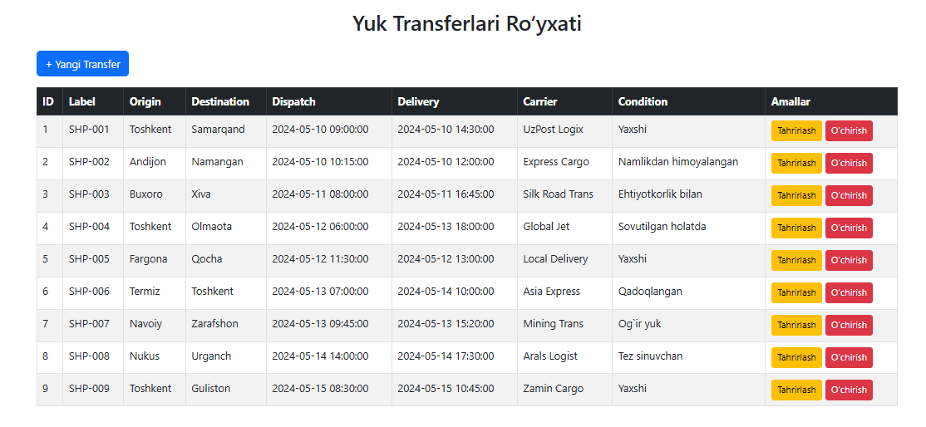
Bu +Yangi transfer qismi:
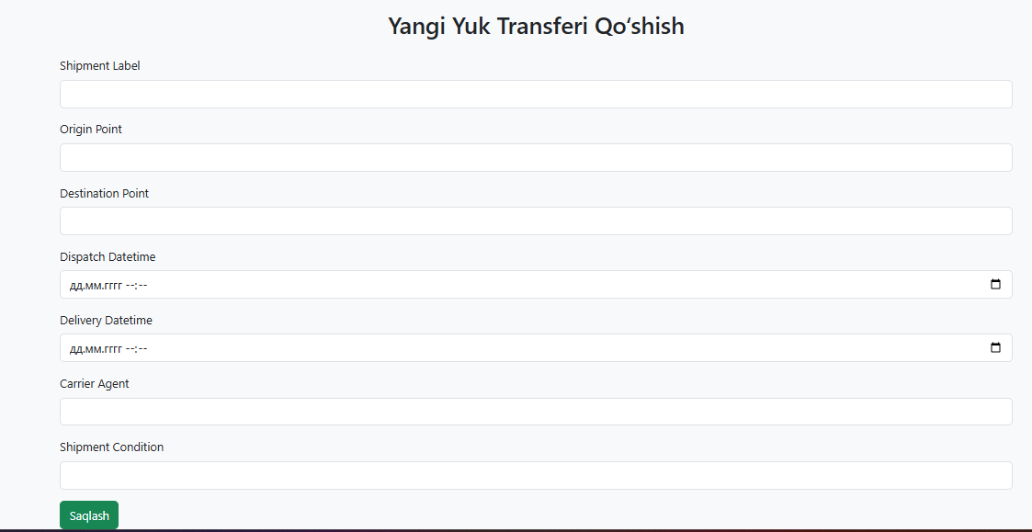
Transfer qo’shish:
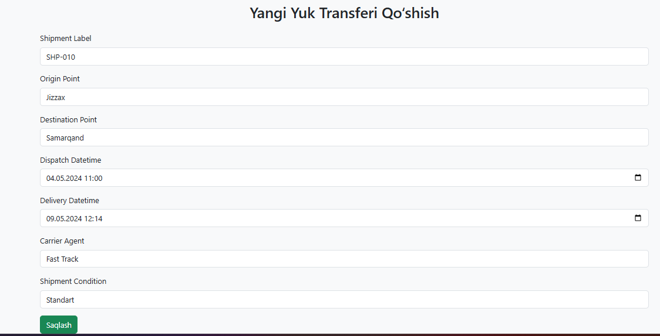
Transfer qo’shildi:

Ko’rish:
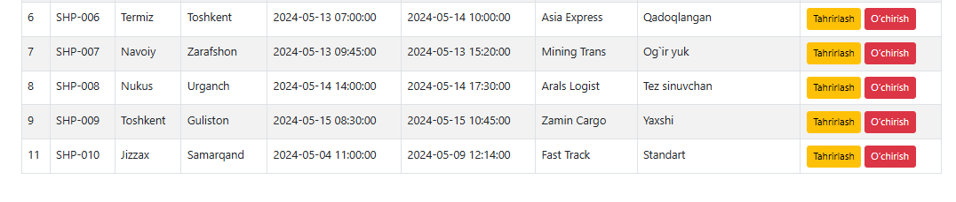
Yangilash:
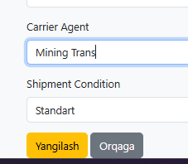
Yangilandi:

Ko’rinishi:
O’chirish:


