AI-Assisted Test Conducting Web Application


Project ID: Fall-2024-30
Session: BSCS Fall 2021 to 2025
Project Advisor: Tahseen Fatima
Submitted By
Shahroz Khan | 70126011
Muhammad Abdullah | 70127751

Department of Computer Science & IT
The University of Lahore
Lahore, Pakistan

Declaration
We have read the project guidelines and we understand the meaning of academic dishonesty, in particular plagiarism and collusion. We here by declare that the work we submitted for our final year project, entitled AI-Assisted Test Conducting Web Application is original work and has not been printed, published or submitted before as final year project, research work, publication or any other documentation.

Group Member 1 Name: Shahroz Khan
SAP No: 70126011

Signature:

Group Member 2 Name: Muhammad Abdullah
SAP No: 70127751

Signature:

Statement of Submission
This is to certify that Shahroz Khan Roll No. 70126011 and Muhammad Abdullah Roll No. 70127751 have successfully submitted the final project named as: AI-Assisted Test Conducting Web Application, at Computer Science & IT Department, The University of Lahore, Lahore Pakistan, to fulfill the partial requirement of the degree of BS in Computer Science.

Supervisor Name: Tahseen Fatima
Signature:
Date:

Dedication
This project is dedicated to my father, who taught me that the best kind of knowledge to have been that which is learned for its own sake. It is also dedicated to my mother, who taught me that even the largest task can be accomplished if it is done one step at a time.

Abstract
The AI-Assisted Test Conducting Web Application aims to revolutionize traditional test-taking and assessment procedures by integrating artificial intelligence to automate and streamline the test creation process. The primary goal is to address inefficiencies and human errors associated with manual test preparation and execution, especially in large educational settings.
The project tackles the problem of limited flexibility and scalability in current online test platforms, which lack AI-driven features for automated test generation. By incorporating AI, the platform allows examiners to generate various types of tests (MCQs, Q&A, coding tasks) based on uploaded study materials, improving both the accuracy and efficiency of assessments.
The development process involves creating a cloud-based web application with separate portals for examiners and Applicants. Examiners can upload materials, generate tests with AI assistance, and manage student performance, while Applicants can take tests online or offline. The platform also features a robust reporting system, providing detailed insights into individual and session-level performance.
Results from preliminary testing show that the AI model successfully generates accurate and relevant test questions, while users find the interface intuitive and efficient. In conclusion, the platform offers a scalable, secure, and user-friendly solution to the evolving needs of educational institutions and corporate training environments, with significant potential for global market expansion.

Area of the Project
Web Application and Artificial Intelligence.

Technologies used
For frontend technologies:
- HTML
- CSS
- JavaScript
- Bootstrap
- React.Js
For backend technologies:
- Python
- Django
- Django Rest Framework
- Postgress SQL

List of Tables

Table 1: existing apps 13
Table 2: Functional requirement 21
Table 3: Applicant Create Account 28
Table 4: Usecase Applicant Login 29
Table 5: Usecase Take Test 31
Table 6: Usecase Practice Test 33
Table 7: Usecase Offline Test Management 35
Table 8: Usecase Create Examiner Account 37
Table 9: Usecase login Examiner Account 38
Table 10: Usecase Generate test Examiner Account 39
Table 11: Usecase manage Session Examiner Account 41
Table 12: Usecase Analyze Result Examiner Account 43
Table 13: Usecase Login Admin Account 45
Table 14: Usecase Manage Examiner Account 46
Table 15: Usecase Manage Applicant Account 48
Table 16: Usecase Monitor test session 50
Table 17: Usecase Configure System Settings 52
Table 18: Usecase Generate Usage Reports 54
Table 19: Usecase Resolve System Alerts 56

List of Figures

Figure 1: Usecase Diagram for Applicant Account 27
Figure 2: Usecase Diagram login Applicant Account 28
Figure 3:Usecase Diagram Take Test Applicant Account 30
Figure 4: Usecase Diagram Practice Test Applicant Account 32
Figure 5: Usecase Diagram Offline Test Management Applicant Account 34
Figure 6: Usecase Diagram Create Examiner Account 36
Figure 7: Usecase Diagram login Examiner Account 37
Figure 8: Usecase Diagram Generate Test Examiner Account 38
Figure 9: Usecase Diagram manage Session Examiner Account 40
Figure 10: Usecase Diagram Analyze Result Examiner Account 42
Figure 11: Usecase Diagram login Admin Account 44
Figure 12: Usecase Diagram Manage Examiner Account 45
Figure 13: Usecase Diagram Manage Applicant Account 47
Figure 14: Usecase Diagram Monitor test session 49
Figure 15: Usecase Diagram Configure System Settings 51
Figure 16: Usecase Diagram Generate Usage Reports 53
Figure 17: Usecase Diagram Resolve System Alerts 55
Figure 18 Architecture Diageam 58
Figure 19 Collaboration Diagram 65
Figure 20 Component Diagram 67
Figure 21 Deployment Diagram 68

Table of Content

Declaration 1
Statement of Submission 2
Dedication 3
Abstract 4
Area of the Project 5
Technologies used 5
List of Tables 6
List of Figures 7
1. Chapter 1: Introduction to the problem 12
1.1 Introduction 13
1.1.1 Problem Statement 13
1.1.2 Rationale of the project 13
1.2 Purpose 13
1.3 Objective 13
1.3.1 AI-Driven test creation 13
1.3.2 Enhanced User Experience 14
1.3.3 Comprehensive Reporting 14
1.3.4 Customization and flexibility 14
1.4 Existing Solution 15
1.4.1 ExamSoft 15
1.4.2 Questionmark 16
1.4.3 Google Forms (Quizzes) 16
1.4.4 Sky Prep 16
1.4.5 ProctorU 16
1.5 Proposed Solution 16
2. Chapter 2: Software Requirement Specification 18
2.1 Introduction 19
2.1.1 Purpose 19
2.2 2.1.2 Scope 19
2.2.1 Definitions, Acronyms, and Abbreviations 19
Definitions: 19
Acronyms: 20
2.3 Overall Description 20
2.3.1 Product Perspective 20
2.3.2 Product Functions 22
2.3.3 User Characteristics 25
2.3.4 Constraints 25
2.3.5 Assumptions and dependencies 25
2.4 Specific requirements 26
2.4.1 Functional Requirements 26
2.4.2 Non-functional Requirements 27
3. Chapter 3 Use Case Analysis 28
3.1 Applicant Usecase 29
3.2 Examiner Usecase 38
3.3 Admin Usecase 46
4. Chapter 4: Design 59
4.1 Architecture Diagram 60
4.2 ERD with data dictionary 60
4.3 Data Flow diagram 61
4.4 Class Diagram 62
4.5 Activity Diagram 63
4.6 Sequence Diagram 64
4.7 Collaboration Diagram 65
4.8 State Transition Diagram 66
4.9 Component Diagram 67
4.10 Deployment Diagram 67
5. Chapter 5: User Manual 68
5.1 Welcome Screen: 69
5.2 Signup Page: 70
5.3 Login Page: 70
5.4 Applicant Dashboard: 71
5.5 Applicant Practice test creation: 71
5.6 Applicant Test: 72
5.7 Applicant Enrols New Session: 73
5.8 Enrolled Session by Applicant: 73
5.10 Test Information by Admin 74
5.11 Approved Examiner Request: 75
5.12 Examiner Information: 75
5.13 Examiner Dashboard: 76
5.14 Session: 76
5.15 Create Test: 77
5.16 Enrolled Applicants: 77
5.18 Create New Session: 78
5.19 Applicants Request: 79
6. References 80
7. Appendix 81
7.1 Appendix A: Acronyms and Abbreviations 81
7.2 Appendix B: Glossary 82
7.3 Appendix C: Tools and Technologies 83
7.4 Appendix D: User Roles 84
7.5 Appendix E: Future Enhancements 84

Chapter 1: Introduction to the problem

Introduction

Problem Statement
The traditional method of conducting tests and assessments in educational institutions, online courses, and corporate training programs is often time-consuming, prone to human errors, and lacks the flexibility to adapt to diverse assessment needs. The existing solutions frequently fall short in providing a comprehensive and efficient platform for test creation, management, and analysis. This limitation hinders the effectiveness of assessment processes and creates challenges for both educators and learners.

Rationale of the project
To address these shortcomings, this project proposes the development of a user-friendly and efficient AI-assisted test conducting web application. This groundbreaking platform aims to revolutionize the way tests are created, Administered, and evaluated by leveraging the power of artificial intelligence. By automating various aspects of the testing process, the proposed application will significantly enhance efficiency, accuracy, and scalability, setting a new standard for assessment tools.

Purpose
The primary purpose of the AI-Assisted Test Conducting Web Application is to simplify the test creation process by utilizing artificial intelligence to generate tests from uploaded study materials, such as documents or videos. By integrating AI into test generation, examiners can save significant time and effort. The platform is designed to cater to various users, including educators in academic institutions, online course providers, and corporate training programs, who require a more scalable, flexible, and automated solution for conducting assessments.
This system will enhance the educational experience by offering examinees personalized practice tests, automated grading, and detailed performance reports, helping them track and improve their academic performance. For examiners, it streamlines the test preparation process, improving speed and accuracy, while providing valuable insights into student outcomes, making the overall process more efficient and user-friendly.

Objective

AI-Driven test creation
The core objective of this project is to automate the generation of test questions using AI. This is designed to significantly reduce the time and effort examiner spend manually creating exams. The AI will:
- Extract questions from uploaded study materials such as text documents, PDFs, or even multimedia files like videos.
- Generate multiple question formats, including multiple-choice questions (MCQ’s), coding tasks, and short-answer or essay questions, ensuring a wide range of assessments.
- The difficulty level feature aims to standardize test difficulty and ensure consistency in test quality across different sessions.

Enhanced User Experience
The platform aims to provide an intuitive and user-friendly interface for educators and Administrators. Key aspects include:
- Simple test creation process: Examiners can easily upload content, from which the system automatically generates tests. No technical knowledge is required to operate the system, making it accessible to all users.
- Streamlined management tools: Examiners will have access to a comprehensive dashboard where they can create new test sessions and view performance reports with just a few clicks.
- Personalized experiences for examinees: The application will allow examinees to engage in practice modes, where they can generate tests based on their study materials using ai, which tailors the learning experience to their individual needs.

Comprehensive Reporting
The platform will provide in-depth performance analytics that are critical for educators to understand examinee progress and areas of improvement. This includes:
- Detailed individual and session-level reports: The system will track each examinee’s performance, breaking it down into categories (e.g., question type, difficulty level, subject area).
- Feedback and improvement suggestions: Based on examinee performance, the system will offer AI-generated recommendations on areas that need improvement, helping both examinees and examiner understand where focus is required.

Customization and flexibility
The platform will offer customizable features for both examiner and examinee, addressing various helpful needs:
- Custom test creation: Examiner can either rely on AI-generated tests or create their own custom exams by manually selecting or editing questions, offering flexibility in test design.
- Personalized practice tests: Examinee will have the ability to upload their own materials, and the AI will generate practice questions based on their specific content. This makes the system useful for personal study outside the formal classroom environment.
- Offline test-taking capabilities: For areas with limited internet access, the platform will allow examinees to download tests, complete them offline, and upload their results when they regain connectivity. This feature ensures the platform can be used in a variety of learning environments.

Existing Solution
APPS | Test creation | Test check | Detail report | Test preparation
ExamSoft | Not with AI | Not with AI | Yes | Not with AI
Questionmark | Not with AI | Not with AI | No | Not with AI
Google Forms | Not with AI | Not with AI | Yes | No
Sky prep | Not with AI | Not with AI | Yes | No
ProctorU | No | Yes | Yes | No
Table 1: existing apps

ExamSoft
- Features: ExamSoft is an assessment platform that provides secure exam delivery, detailed performance reports, and automated grading. It supports different question types and is widely used in educational institutions.
- Limitations: While it offers many test Administration tools, it lacks the AI-driven automated test generation that your platform proposes. It also doesn’t provide personalized practice modes or offline test-taking options.

Questionmark
- Features: Questionmark provides online assessments, tests, and quizzes, with the ability to generate reports and analytics. It supports multiple question types and has integrations with other platforms.
- Limitations: Similar to other platforms, it does not include AI-driven test creation or personalized practice tests. Most of the test creation and management is manual.

Google Forms (Quizzes)
- Features: Google Forms allows educators to create quizzes, set correct answers, and automatically grade multiple-choice questions.
- Limitations: It lacks AI-driven test generation and comprehensive reporting features. Test creation is manual, and there are no advanced features like coding question integration or offline test-taking.

Sky Prep
- Features: an LMS that offers customizable course creation, assessment tools, and detailed reporting features. It supports user management with role-based access, automated notifications, and certification tracking
- Limitations: However, it lacks advanced AI features like automated test generation and personalized learning, which may limit its scalability for more complex educational needs.

ProctorU
- Features: ProctorU uses AI to monitor students during live, online exams. It offers a blend of AI-based automated proctoring and live human proctors to oversee assessments. The AI can flag suspicious behavior such as irregular eye movements, background noise, or multiple people appearing on camera.
- Limitations: ProctorU focuses primarily on proctoring, not on generating or managing exams. It doesn’t have AI-based test creation or personalized practice modes.

Proposed Solution
The proposed web application aims to overcome these limitations by offering a more comprehensive and efficient solution. Key features of the proposed solution include:
- AI-driven test generation: The application will utilize AI algorithms to automatically generate test questions from uploaded content, ensuring relevance and quality.
- Flexible question types: The platform will support a wide range of question formats, including MCQs, QnA and coding tasks with an integrated GCC compiler.
- User-friendly interface: A simple and intuitive interface will make it easy for educators to create, manage, and Administer tests.
- Personalized practice mode: Applicants will be able to generate customized practice tests based on their own study materials, providing targeted practice and feedback.
- Comprehensive reporting: Detailed performance reports will be generated for both individual Applicants and entire sessions, allowing educators to assess learning outcomes and identify areas for improvement.
- Scalability and security: The platform will be built on a cloud-based infrastructure to ensure scalability and reliability, while strong data security measures will protect sensitive information.
By addressing these shortcomings, the proposed solution offers a superior alternative to existing testing platforms, providing a more effective and efficient way to conduct assessments in various educational and training settings.

Chapter 2: Software Requirement Specification

Introduction

2.1.1 Purpose
The purpose of this document is to delineate the software requirements for the AI-Assisted Test Conducting Web Application. It comprehensively outlines both the functional and non-functional requirements necessary for designing and implementing the platform. The aim is to provide an efficient solution for test creation, management, and analysis, leveraging artificial intelligence to automate various aspects of the testing process. The intended audience for this document includes the development team, project stakeholders, and end-users who will utilize the software for managing tests and generating AI-driven test content.

2.1.2 Scope
The scope of the AI-Assisted Test Conducting Web Application is to deliver an advanced platform that enhances the entire process of test creation, management, and analysis. The application will:
- Automate Test Generation: Utilize AI to create relevant and high-quality test questions from various uploaded study materials, including documents and videos.
- Support Multiple Question Types: Provide support for various question formats, such as multiple-choice questions (MCQ’s), questions and answers (QnA).
- User-Friendly Interface: Ensure an intuitive and accessible interface for both examiners and Applicants, making it easy to create, manage, and take tests.
- Personalized Practice Mode: Offer a mode where users can generate practice tests based on their own materials, enhancing personalized learning.
- Comprehensive Reporting: Generate detailed performance reports that help educators and Applicants assess and improve performance.
- Offline Capability: Allow users to take tests offline, ensuring the application is usable in various learning environments.
The product will not include payment processing or integration with external learning management systems (LMS) in its initial version, focusing solely on the core functionalities to meet assessment needs efficiently.

Definitions, Acronyms, and Abbreviations
Following are the definitions, acronyms and abbreviation.

Definitions:
- Test Generation: The process of creating test questions from study materials.
- AI: Artificial Intelligence, technology to automate tasks that typically require human intelligence.

Acronyms:
- MCQ’s: Multiple Choice Questions.
- QnA: Questions and Answers.
- AI: Artificial Intelligence.

Overall Description

Product Perspective
The AI-Assisted Test Conducting Web Application is an independent and self-contained system designed to improve the way tests are created and managed in educational and corporate settings. It includes features for AI-driven test generation, detailed performance reporting, and offline test-taking capabilities.

System Interfaces
The application will interface with external data sources materials (e.g., documents, videos) and databases to store questions and user results. This ensures seamless integration for test generation and data management.

User Interfaces
The platform will feature a user-friendly interface with a dashboard for examiners to create and manage tests, and a test-taking interface for Applicants. This includes intuitive navigation and interaction elements, making it accessible to users with varying technical expertise.
- Examiner Interface for managing tests, generating reports, participant selection, and creating sessions for managing test.
- Test Taker interface for enrolling in sessions, taking tests, practice test, and reviewing performance.
- Admin Interface overview of user activities, verify or approve examiner account and access comprehensive report.

Hardware Interfaces
No specific hardware is required apart from standard devices like computers or mobile devices with internet access.

Software Interfaces
The system will depend on common web browsers (e.g., Chrome, Firefox) for its user interface and cloud-based services for data storage and processing. Compatibility with common operating systems (Windows, macOS, Linux) will be ensured.

Communication Interfaces
The system will communicate over secure HTTP/HTTPS protocols. It will also require internet connectivity for online usage but provide offline test-taking capability.

Memory Constraints
The platform will optimize memory usage to ensure efficient operation, requiring sufficient server resources to manage multiple simultaneous test sessions, offline test attempt and AI processes.

Operations
The system will include normal operations like data backups, updates, and maintenance. Special operations such as disaster recovery procedures will ensure data integrity and availability.

Site Adaptation Requirement
The AI-Assisted Test Conducting Web Application is designed to be highly adaptable for various educational environments. Key points include:
- Customization: Supports different languages, grading systems, and administrative policies to fit diverse institutions.
- Easy Setup: Simple installation and configuration, minimizing the need for technical support.
- Data Initialization: Tools for importing initial data such as user information and study materials.
- Training and Documentation: Comprehensive resources to help users get started quickly.
- Offline Functionality: Allows offline test-taking in areas with limited internet access, with results uploaded once connectivity is restored.

Product Functions
The platform will have the following functional requirements:
ID | Name | Description | Input | Output | Basic Workflow
FR_01 | Create Account | Allows new users to register on the platform. | User details (Name, Email, Password) | Account creation confirmation | Users enter their details, click submit, and the system creates and saves the account in the database.
FR_02 | Login Account | Enables existing users to log in to their accounts. | Email and Password | User is logged in and taken to their dashboard | Users enter email and password, click login, and the system verifies credentials and grants access.
FR_03 | Generate Test | Uses AI to create test questions from uploaded study materials. | Study materials (documents, videos) | Generated test questions | Examiners upload study materials, and the AI processes these to generate various types of test questions.
FR_04 | Enrol for Test | Allows Applicants to enrol in test sessions. | User details and test selection | Enrolment confirmation | Users select a test session, provide necessary details, and receive a confirmation of their enrolment.
FR_05 | Take Test | Provides an interface for Applicants to take their tests. | User interactions with the test interface (answers to questions) | Submitted test answers | Applicants answer the test questions and submit their answers through the interface.
FR_06 | Practice Mode | Allows Applicants to generate and take practice tests. | User-uploaded study materials | Personalized practice test | Applicants upload study materials, and the AI generates a practice test based on these materials.
FR_07 | Generate Report | Creates detailed performance reports. | Test results | Performance report | The system compiles test results and generates a report detailing performance metrics.
FR_08 | Manage Users | Allows Admins to manage user accounts. | Admin commands for adding, removing, or editing users | Updated user information | Admins perform user management tasks through a dedicated interface, and the system updates user records accordingly.
FR_09 | Create Test Session | Enables examiners to set up new test session | Session details (date, time, participants, test content) | Test session schedule | Examiners provide session details, and the system schedules the test session.
FR_10 | View Reports | Allows users to view generated performance reports. | Report request from users | Display of requested reports | Users request to view reports, and the system retrieves and displays the relevant data.
Table 2: Functional requirement

User Characteristics
- Examiners: Educators, trainers, and Administrators with basic computer skills. No AI or technical expertise required.
- Applicants: Students, trainees, or professionals taking tests. Basic internet navigation skills are sufficient.

Constraints
This section describes the constraints that may limit the developer’s options in designing and implementing the AI-Assisted Test Conducting Web Application. These constraints include regulatory policies, hardware limitations, integration requirements, and other critical considerations.
- Regulatory Policies: The platform will comply with data protection regulations like GDPR.
- Hardware Limitations: Requires devices with internet access for online test-taking.
- Parallel Operations: The system must support multiple simultaneous test sessions.
- Criticality: Given its role in education and certification, the platform must be reliable with minimal downtime.
- Security: High level of security needed for test content, Applicant data, and performance reports.

Assumptions and dependencies

Internet Connectivity
The system assumes that users (examiners and Applicants) will have consistent internet connectivity to access all online features, including test sessions, AI-driven test generation, and report downloads. Offline test capabilities assume intermittent access, allowing users to complete tests offline and upload results once reconnected.

AI Libraries
The application relies on external AI libraries, such as OpenAI, to support AI-driven functionalities, including question generation and customized practice modes. Continuous updates and compatibility of these libraries are essential for maintaining and enhancing AI performance.

Device Compatibility
It is assumed that users will access the system from devices (e.g., desktops, laptops, tablets, or smartphones) compatible with modern web browsers, ensuring optimal performance across various platforms.

Specific requirements
This section will describe the functional and non-functional requirements of System at a sufficient level of detail for the designers to design a system satisfying the User requirements and testes to verify that the system satisfies the requirements.

Functional Requirements
This section describes the main functions and modules of the application.

User Authentication and Access Control
- The system will authenticate users (Admin, examiner, and Applicant roles) through a secure login system.
- Admin will control access by approving or denying examiner accounts and manage permissions based on user roles.

Test Session Creation
- Examiners can create test sessions by uploading documents or videos, and the system will use AI to generate questions.
- Examiners can also manually input questions to customize tests as needed.

AI-Assisted Test Generation
- AI algorithms will generate various question types (MCQs, QnA, coding tasks) from uploaded study materials, saving time and ensuring question relevance.

Practice Mode for Applicants
- The system will provide a practice mode where Applicants can upload their study materials, and AI will generate personalized practice tests based on this content.

Offline Test Mode
- Applicants can download a test to complete offline and then upload their answers when reconnected, with AI analyzing and providing feedback.

Report Generation and Analytics
- Detailed performance reports will be generated at both individual and session levels, including test scores, completion times, and areas for improvement.

Non-functional Requirements
This sub-section describes the non-functional requirements that ensure usability, reliability, performance, and scalability of the application.

Usability
- The application will provide a user-friendly interface accessible to all user types (Admin, Examiner, Applicant).
- The design will follow standard usability guidelines to ensure intuitive navigation, ease of access, and minimal learning curve for users, including those with limited technical experience.

Performance
- The system will be capable of handling high user traffic, especially during peak testing times, ensuring minimal latency and quick response times.
- The AI-driven features, such as test generation and reporting, will be optimized for fast processing to avoid delays.

Scalability
- The system will be designed with modular components and cloud-based architecture to allow easy scaling as the number of users or system load increases.
- Support for additional LMS integrations and new AI features will be possible without disrupting current operations.

Security
- All data (user credentials, test results, performance data) will be encrypted to protect against unauthorized access.
- The system will enforce secure login procedures, including multi-factor authentication, and comply with data protection regulations such as GDPR.

Chapter 3 Use Case Analysis

Applicant Usecase
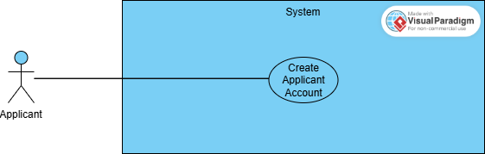
Figure 1: Usecase Diagram for Applicant Account

Use Case ID | UC_01
Use Case Name | Create Applicant Account
Description | Allows an Applicant to register and gain access to the system.
Primary Actor | Applicant
Secondary Actor | None
Pre-Condition | Applicant accesses the registration page.
Post-Condition | Applicant account is created.
Basic Flow | Actor Action | System Action
 | Applicant accesses the registration page.  Applicant fills out the form. | System displays registration form.  System validates input.  System creates the account.
Alternate Flow | If email exists, system shows an error message.
Table 3: Applicant Create Account

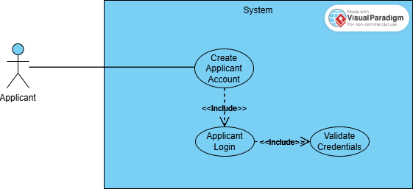
Figure 2: Usecase Diagram login Applicant Account

Use Case ID | UC_02
Use Case Name | Applicant Login
Description | Allows an Applicant to log into the system.
Primary Actor | Applicant
Secondary Actor | None
Pre-Condition | Applicant has valid credentials.
Post-Condition | Applicant accesses their dashboard.
Basic Flow | Actor Action | System Action
 | Applicant accesses the login page.  Applicant provides credentials. Applicant accesses their dashboard. | System displays the login form.  System validates input.  System validates credentials.
Alternate Flow | If credentials are invalid, system displays an error message.
Table 4: Usecase Applicant Login
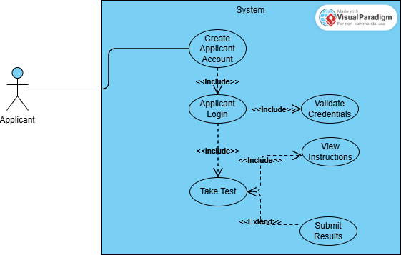
Figure 3:Usecase Diagram Take Test Applicant Account
Use Case ID | UC_03
Use Case Name | Take Test
Description | Enables Applicants to take assigned tests.
Primary Actor | Applicant
Secondary Actor | None
Pre-Condition | Applicant is enrolled in a session.
Post-Condition | Test is submitted and saved in the system.
Basic Flow | Actor Action | System Action
 | Applicant selects an active test.  Applicant completes the test.  Applicant submits the test. | System displays instructions.  System records responses.
Alternate Flow | If session is inactive, system restricts access.
Table 5: Usecase Take Test
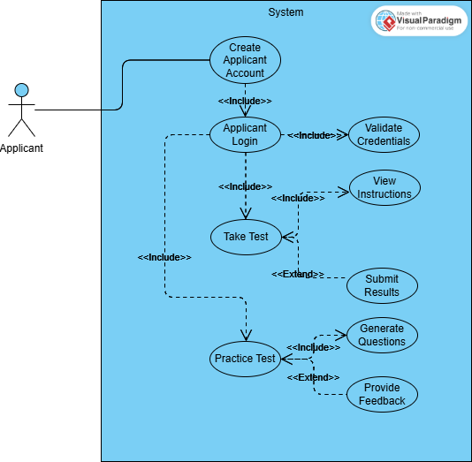
Figure 4: Usecase Diagram Practice Test Applicant Account
Use Case ID | UC_04
Use Case Name | Practice Test
Description | Allows Applicants to generate and attempt practice tests.
Primary Actor | Applicant
Secondary Actor | None
Pre-Condition | Applicant uploads study material or selects a topic.
Post-Condition | Feedback is provided after the test.
Basic Flow | Actor Action | System Action
 | Applicant selects "Practice Test."  Applicant completes the practice test. | System generates test questions.  System provides feedback.
Alternate Flow | If AI fails to generate questions, system uses default questions.
Table 6: Usecase Practice Test

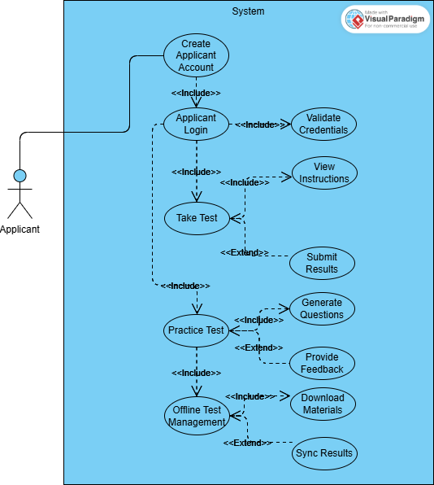
Figure 5: Usecase Diagram Offline Test Management Applicant Account

Use Case ID | UC_05
Use Case Name | Offline Test Management
Description | Allows Applicants to attempt tests offline and sync results later.
Primary Actor | Applicant
Secondary Actor | None
Pre-Condition | Offline mode is enabled, and test is downloaded.
Post-Condition | Test results are synchronized once online.
Basic Flow | Actor Action | System Action
 | Applicant selects "Offline Mode."  Applicant completes the test offline. | System downloads test materials.  System synchronizes results upon reconnection.
Alternate Flow | If synchronization fails, system retries or prompts the user.
Table 7: Usecase Offline Test Management

Examiner Usecase
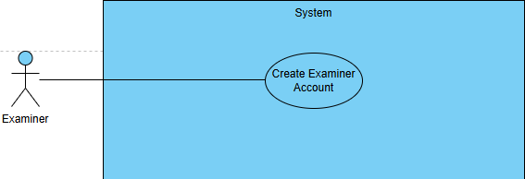
Figure 6: Usecase Diagram Create Examiner Account

Use Case ID | UC_06
Use Case Name | Create Examiner Account
Description | Allows an Examiner to register and gain access to the system.
Primary Actor | Examiner
Secondary Actor | None
Pre-Condition | Examiner accesses the registration page.
Post-Condition | Examiner account is created.
Basic Flow | Actor Action | System Action
 | Examiner accesses the registration page.  Examiner fills out the form. | System displays the registration form.  System validates and creates the account.
Alternate Flow | If email exists, system shows an error message.
Table 8: Usecase Create Examiner Account

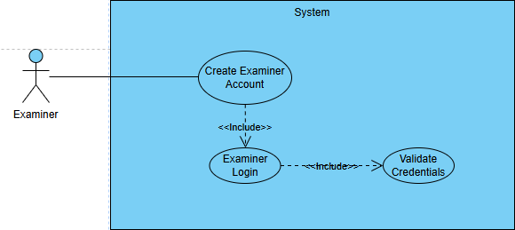
Figure 7: Usecase Diagram login Examiner Account

Use Case ID | UC_07
Use Case Name | Examiner Login
Description | Allows an Examiner to log into the system.
Primary Actor | Examiner
Secondary Actor | None
Pre-Condition | Examiner has valid credentials.
Post-Condition | Examiner accesses their dashboard.
Basic Flow | Actor Action | System Action
 | Examiner accesses the login page.  Examiner provides credentials.  Examiner accesses their dashboard. | System displays the login form.  System validates credentials.
Alternate Flow | If credentials are invalid, system displays an error message.
Table 9: Usecase login Examiner Account
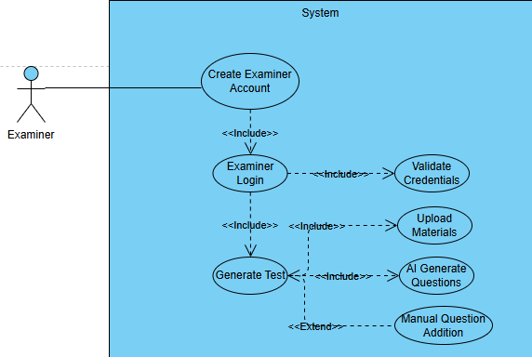
Figure 8: Usecase Diagram Generate Test Examiner Account

Use Case ID | UC_08
Use Case Name | Generate Test
Description | Allows an Examiner to create a test using AI based on study materials.
Primary Actor | Examiner
Secondary Actor | None
Pre-Condition | Examiner is logged in.
Post-Condition | Test is created and stored in the system.
Basic Flow | Actor Action | System Action
 | Examiner selects "Generate Test" on the dashboard.  Examiner uploads materials.  Examiner reviews and finalizes the test. | System prompts for input materials.  . AI generates questions.
Alternate Flow | If AI fails, system enables manual question addition.
Table 10: Usecase Generate test Examiner Account

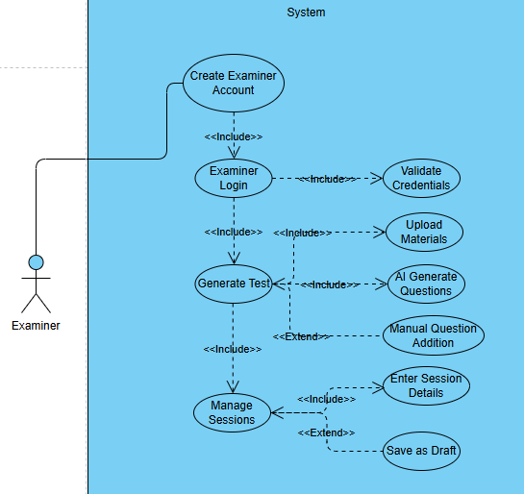
Figure 9: Usecase Diagram manage Session Examiner Account

Use Case ID | UC_09
Use Case Name | Manage Sessions
Description | Enables Examiners to create and manage test sessions.
Primary Actor | Examiner
Secondary Actor | None
Pre-Condition | Examiner is logged in.
Post-Condition | Session is created and saved in the system.
Basic Flow | Actor Action | System Action
 | Examiner selects "Manage Sessions" on the dashboard.  Examiner configures and saves the session. | System prompts for session details
Alternate Flow | If session details are incomplete, system shows an error.
Table 11: Usecase manage Session Examiner Account

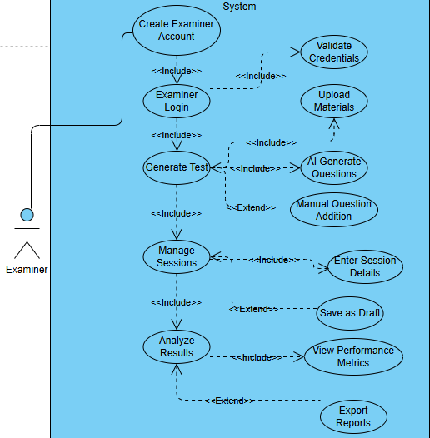
Figure 10: Usecase Diagram Analyze Result Examiner Account

Use Case ID | UC_10
Use Case Name | Analyze Results
Description | Allows an Examiner to analyze test performance metrics.
Primary Actor | Examiner
Secondary Actor | None
Pre-Condition | Test results exist in the system.
Post-Condition | Examiner reviews detailed metrics and exports reports if needed.
Basic Flow | Actor Action | System Action
 | Examiner selects "Analyze Results" on the dashboard.  Examiner selects a test. | System displays available test results.  System shows metrics (e.g., average score, individual performance).
Alternate Flow | Examiner exports data as a report.
Table 12: Usecase Analyze Result Examiner Account

Admin Usecase
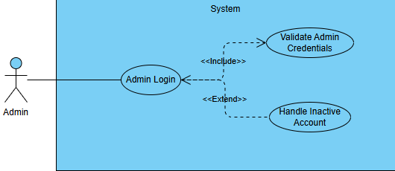
Figure 11: Usecase Diagram login Admin Account

Use Case ID | UC_11
Use Case Name | Admin Login
Description | Allows the Admin to log into the system and access administrative functionalities.
Primary Actor | Admin
Secondary Actor | None
Pre-Condition | Admin has valid login credentials.
Post-Condition | Admin is granted access to the Admin dashboard.
Basic Flow | Actor Action | System Action
 | Admin accesses the login page.  Admin provides credentials and submits.  Admin is redirected to the Admin dashboard. | System validates credentials.  System displays login form.
Alternate Flow | 1. If credentials are invalid, the system displays an error message.  2. If the account is inactive, the system prompts for reactivation.
Table 13: Usecase Login Admin Account

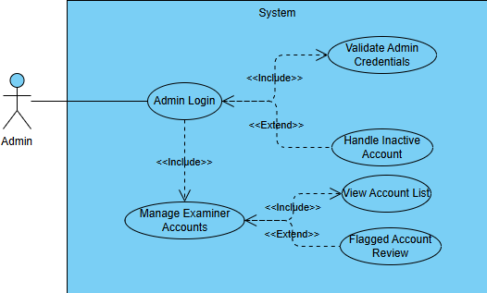
Figure 12: Usecase Diagram Manage Examiner Account

Use Case ID | UC_12
Use Case Name | Manage Examiner Accounts
Description | Allows the Admin to manage Examiner accounts, including approval, deactivation, or deletion.
Primary Actor | Admin
Secondary Actor | None
Pre-Condition | Admin is logged in.
Post-Condition | Examiner account status is updated.
Basic Flow | Actor Action | System Action
 | Admin views the list of Examiner accounts.  Admin selects an account.  Admin approves, deactivates, or deletes the account. | System updates the account status.
Alternate Flow | If an account is flagged, the system notifies the Admin for review.
Table 14: Usecase Manage Examiner Account

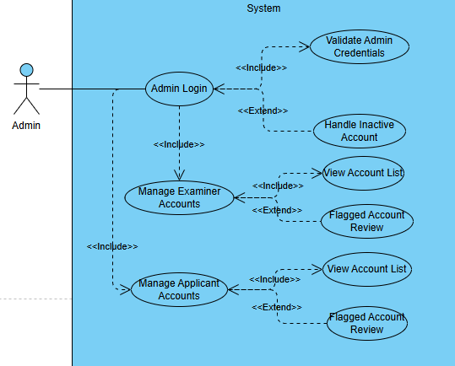
Figure 13: Usecase Diagram Manage Applicant Account

Use Case ID | UC_13
Use Case Name | Manage Applicant Accounts
Description | Allows the Admin to manage Applicant accounts, including approval, deactivation, or deletion.
Primary Actor | Admin
Secondary Actor | None
Pre-Condition | Admin is logged in.
Post-Condition | Applicant account status is updated.
Basic Flow | Actor Action | System Action
 | Admin views the list of Applicant accounts.  Admin selects an account.  Admin approves, deactivates, or deletes the account. | System updates the account status.
Alternate Flow | If an account is flagged, the system notifies the Admin for review.
Table 15: Usecase Manage Applicant Account

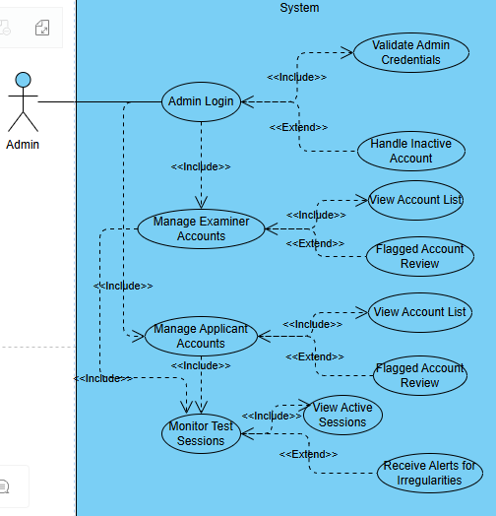
Figure 14: Usecase Diagram Monitor test session

Use Case ID | UC_14
Use Case Name | Monitor Test Sessions
Description | Allows the Admin to oversee active test sessions for compliance and security.
Primary Actor | Admin
Secondary Actor | Examiner, Applicant
Pre-Condition | Test sessions are active.
Post-Condition | Admin has oversight of session activity.
Basic Flow | Actor Action | System Action
 | Admin accesses the "Monitor Test Sessions" option.  Admin reviews session details for irregularities. | System displays active sessions.
Alternate Flow | Admin receives alerts for unusual activity.
Table 16: Usecase Monitor test session
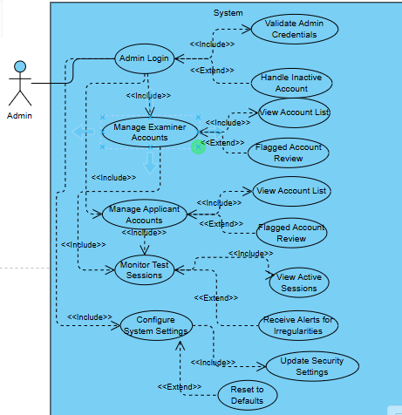
Figure 15: Usecase Diagram Configure System Settings

Use Case ID | UC_15
Use Case Name | Configure System Settings
Description | Allows the Admin to configure global system settings, such as security, notifications, and test parameters.
Primary Actor | Admin
Secondary Actor | None
Pre-Condition | Admin is logged in.
Post-Condition | System settings are updated.
Basic Flow | Actor Action | System Action
 | Admin accesses the "Configure Settings" page.  Admin updates settings. | System saves changes.
Alternate Flow | Admin resets settings to default.
Table 17: Usecase Configure System Settings
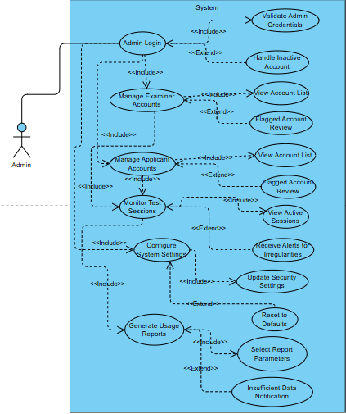
Figure 16: Usecase Diagram Generate Usage Reports

Use Case ID | UC_16
Use Case Name | Generate Usage Reports
Description | Allows the Admin to generate usage reports for monitoring system activity and trends.
Primary Actor | Admin
Secondary Actor | None
Pre-Condition | System usage data is available.
Post-Condition | Usage reports are generated.
Basic Flow | Actor Action | System Action
 | Admin selects "Generate Reports."  Admin confirms and generates the report. | System prompts for report parameters
Alternate Flow | If data is insufficient, system notifies the Admin.
Table 18: Usecase Generate Usage Reports

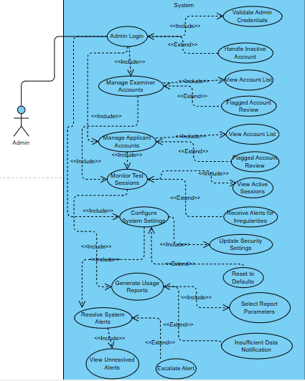
Figure 17: Usecase Diagram Resolve System Alerts

Use Case ID | UC_17
Use Case Name | Resolve System Alerts
Description | Allows the Admin to resolve alerts related to system anomalies, such as security breaches or flagged accounts.
Primary Actor | Admin
Secondary Actor | None
Pre-Condition | Alerts must be active in the system.
Post-Condition | Alerts are resolved or escalated if necessary.
Basic Flow | Actor Action | System Action
 | Admin accesses the "System Alerts" panel.  Admin resolves the alert. | System displays unresolved alerts  System logs the resolution.
Alternate Flow | Admin escalates the alert for external intervention.
Table 19: Usecase Resolve System Alerts

Chapter 4: Design

Architecture Diagram
Define the graphical representation of the concepts, their principles, elements and components that are part of your project.

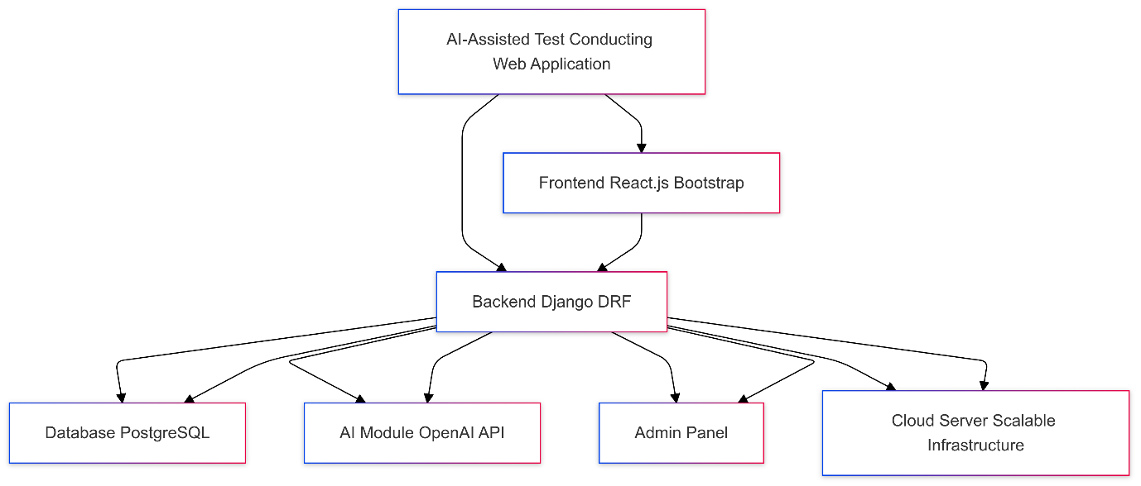
Figure 18: Architecture Diagram

ERD with data dictionary
Entity Relationship Diagram with complete relations with dependencies of your project
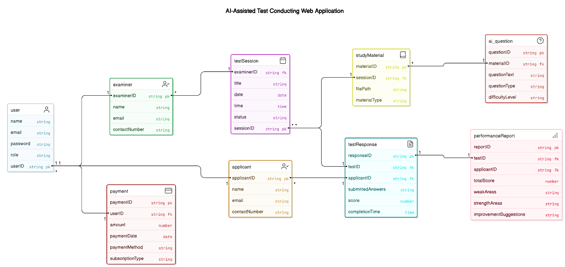
Figure 19: ERD Diagram

Data Flow diagram

Level 0

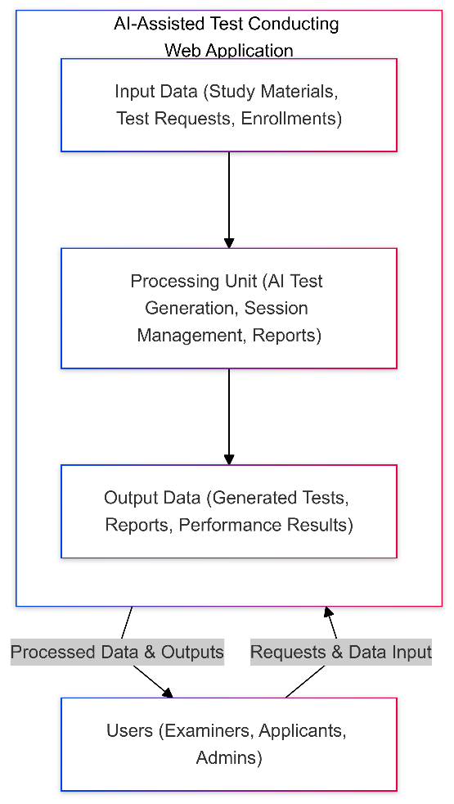
Figure 20: DFD level 0

Level 1
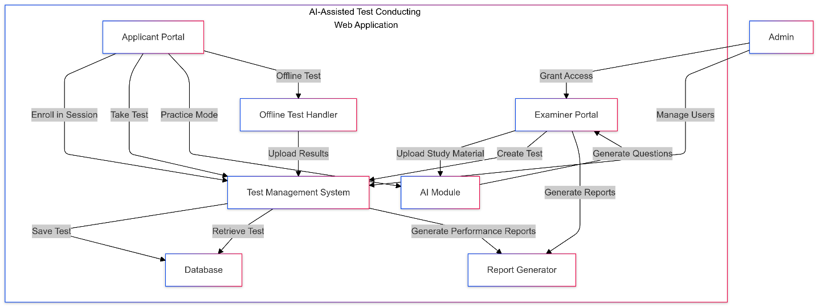

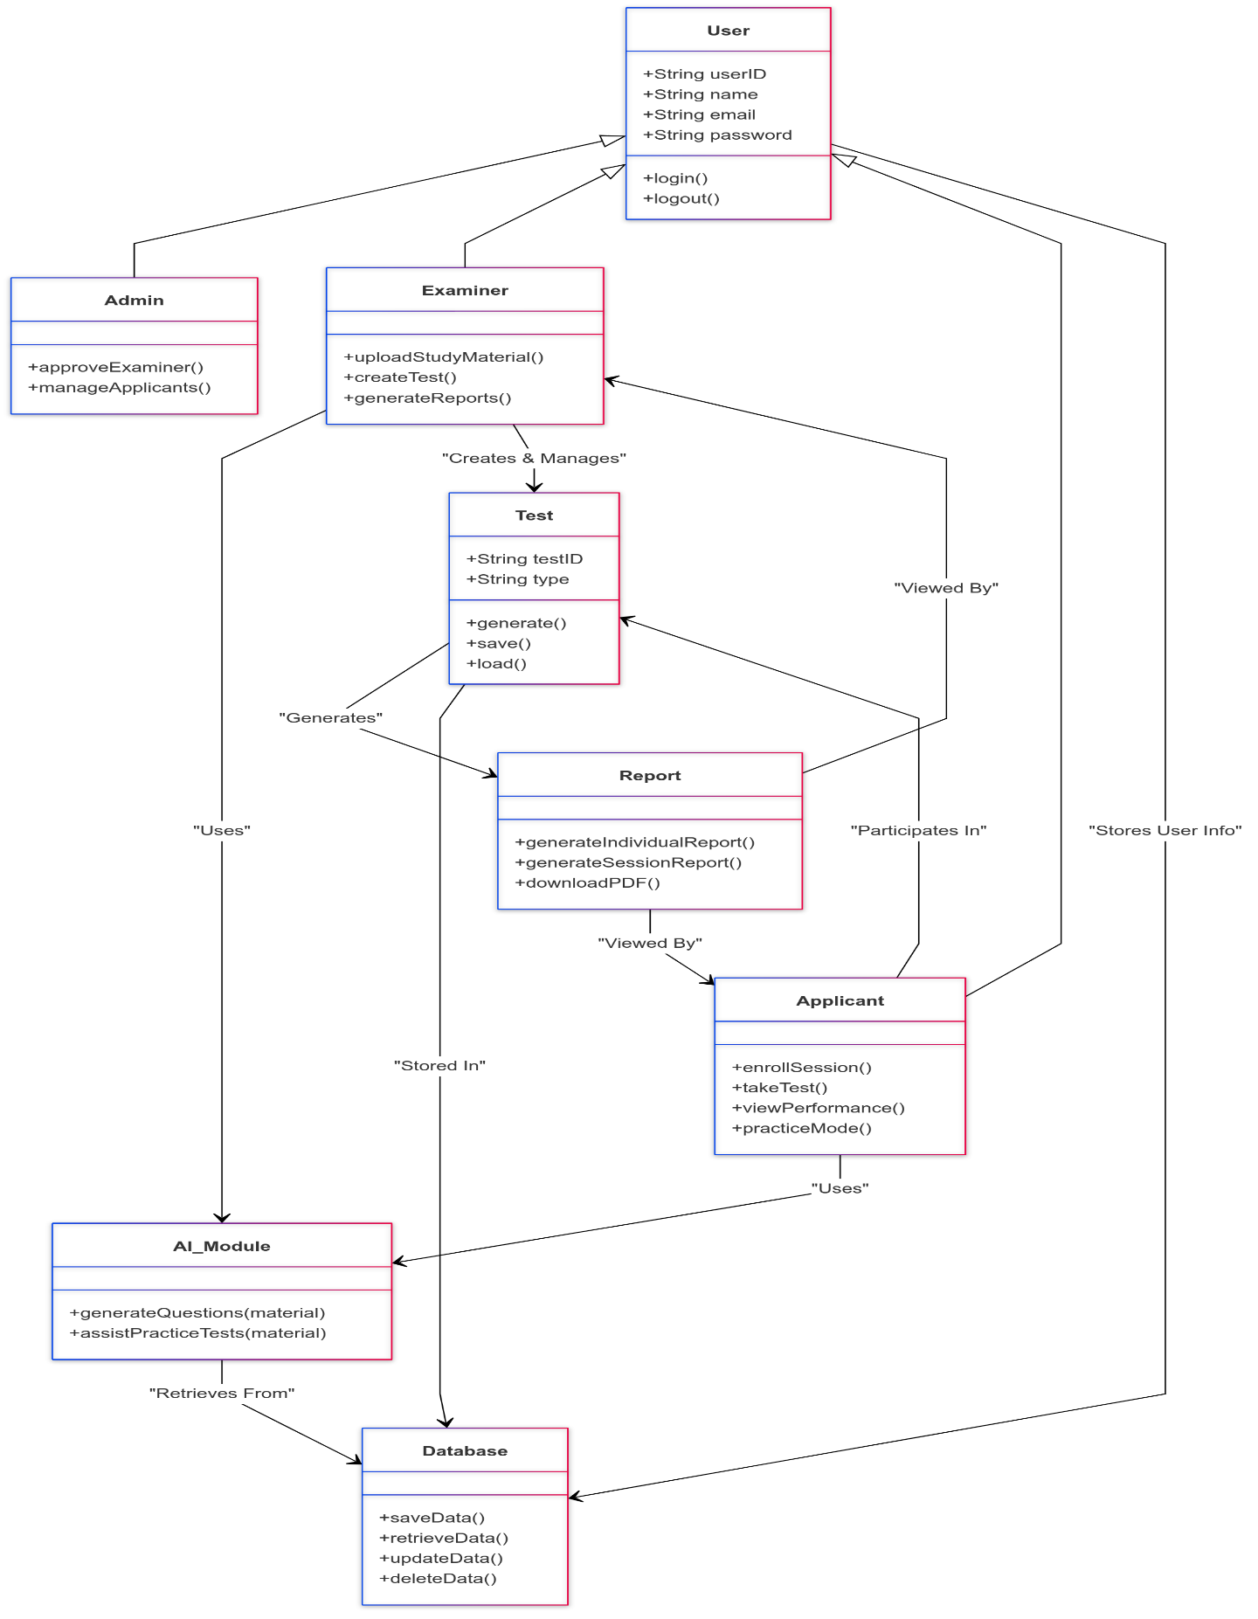
Class Diagram
Figure 21: Class Diagram

Activity Diagram
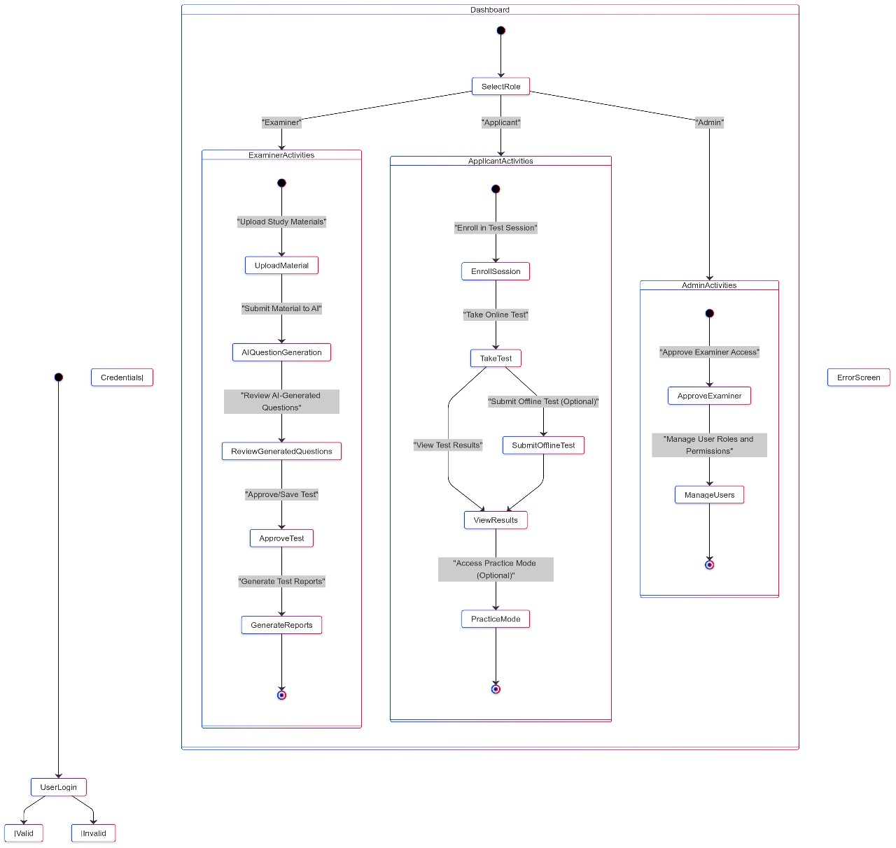
Figure 22: Activity Diagram

Sequence Diagram
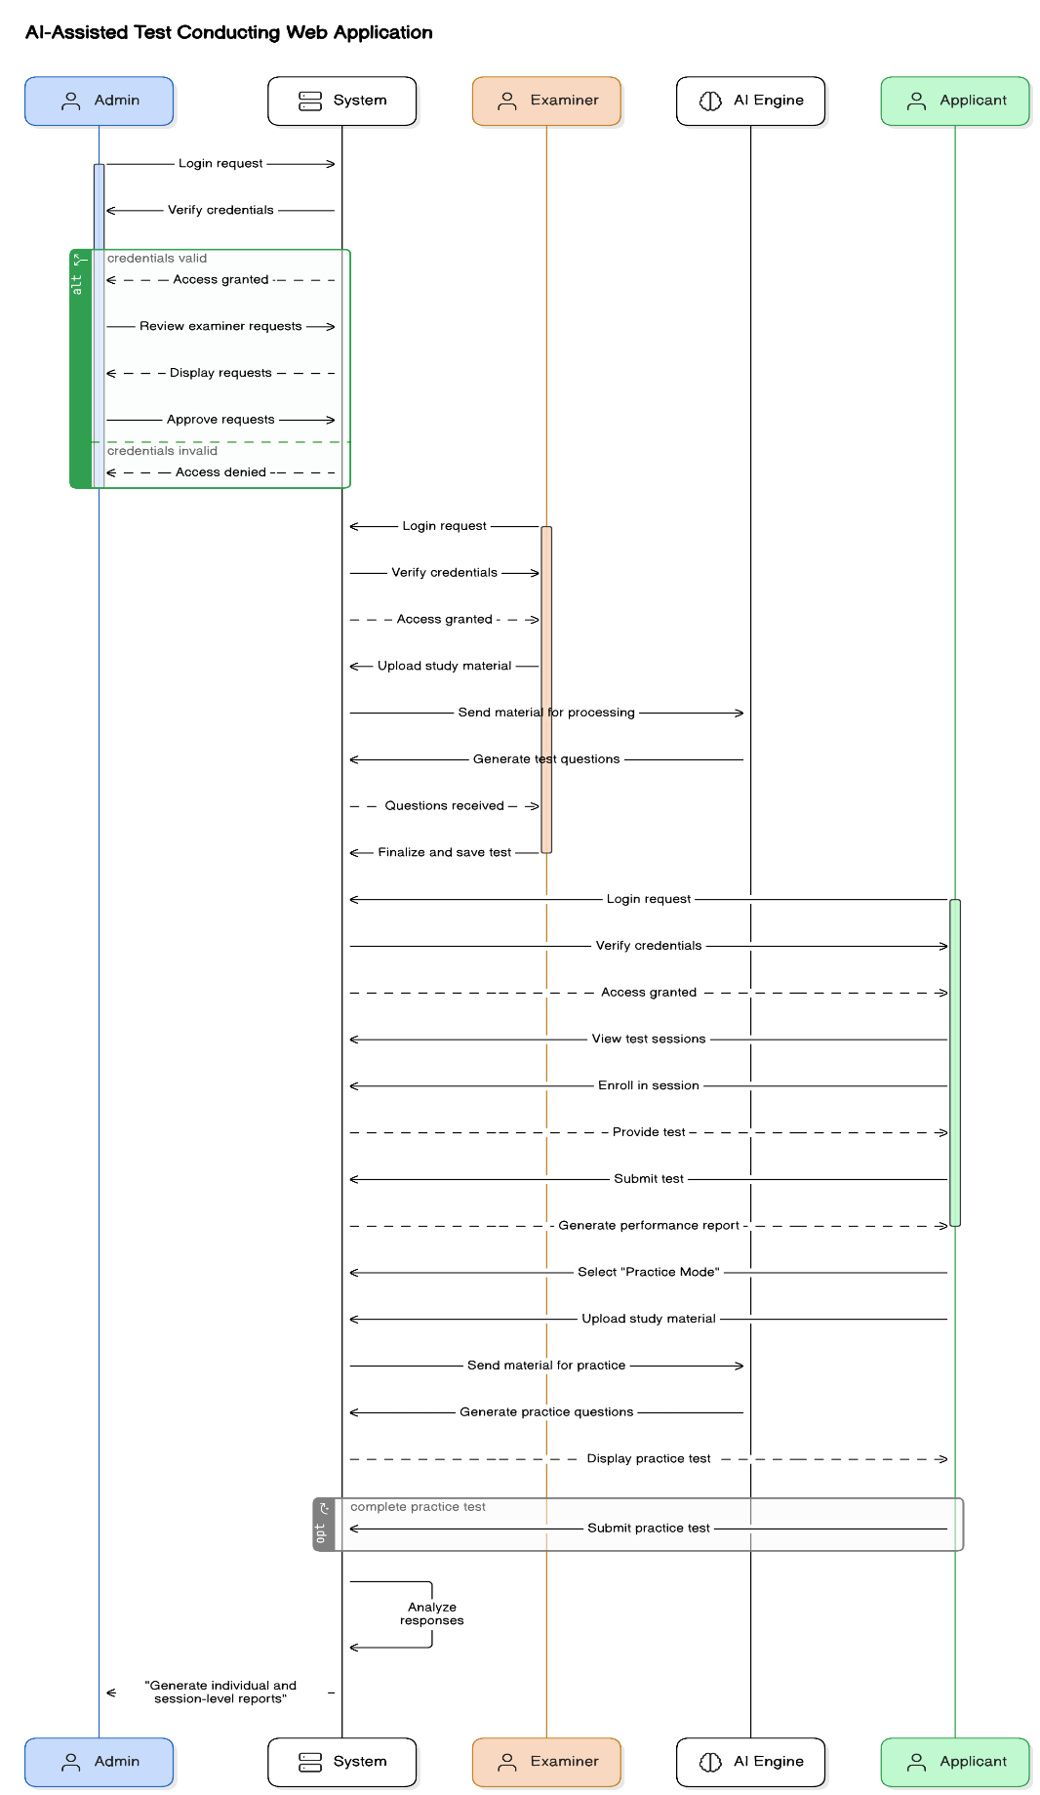
Figure 23: Sequence Diagram

Collaboration Diagram
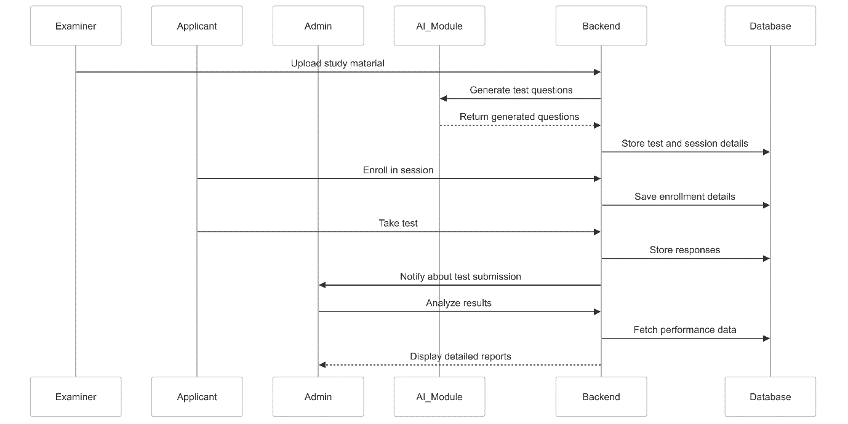
Figure 24: Collaboration Diagram

State Transition Diagram

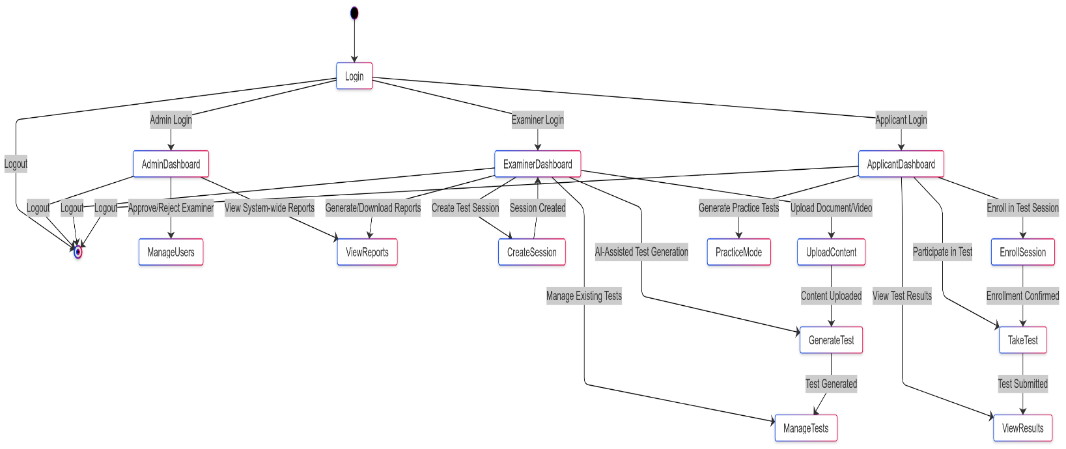
Figure 25: State Diagram

Component Diagram

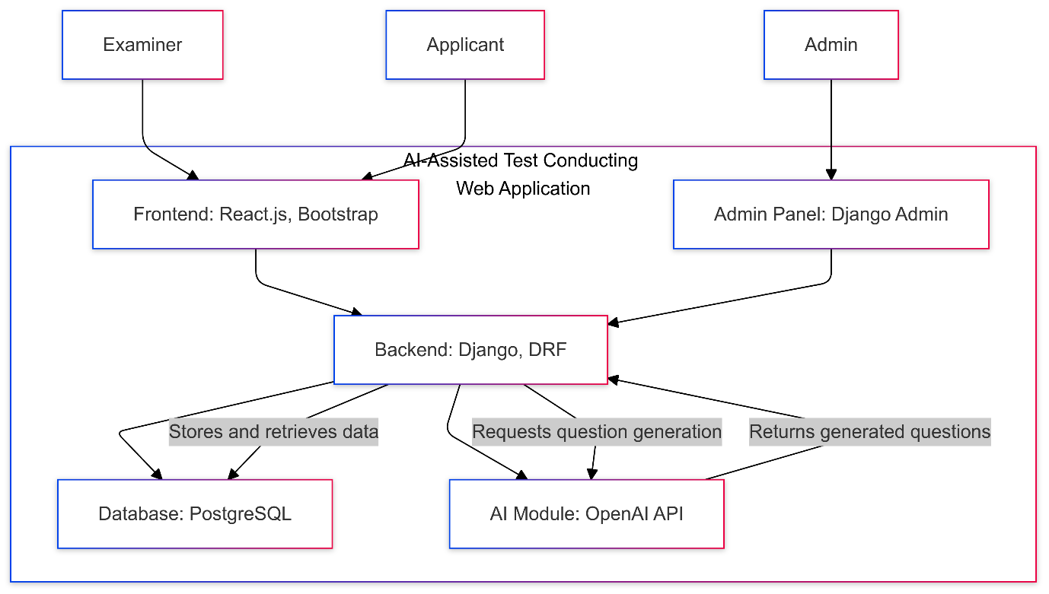
Figure 26: Component Diagram

Deployment Diagram
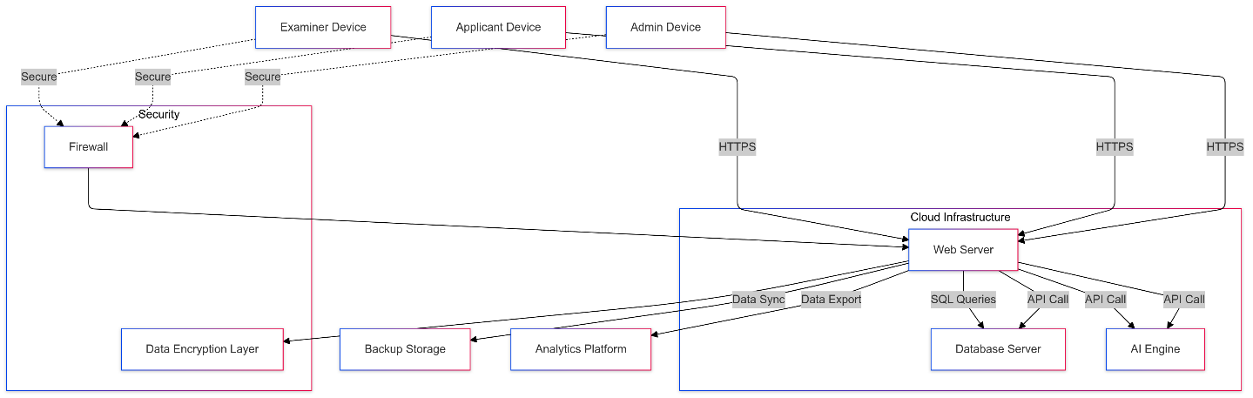
Figure 27: Deployment Diagram

Figure 28 Deployment Diagram

Chapter 5: User Manual

Welcome Screen:
This is the welcoming screen the user will seen first when open the web application.
The user will click on get started button or get started as Examiner to proceed next.
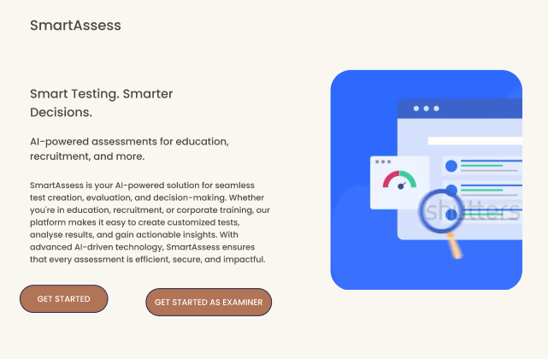

Signup Page:
After welcoming page user will signup by giving following information:
- Username
- Email
- Password
If the user is Examiner the will check the checkbox for Examiner.
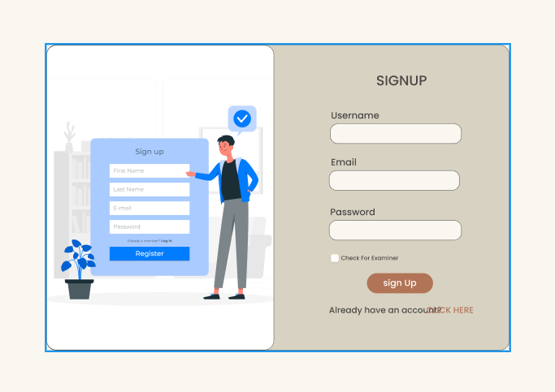

Login Page:
After Signup user will Login by providing their Email and password
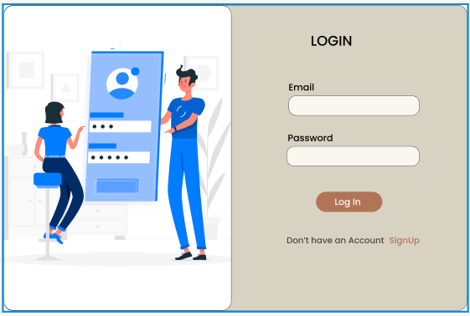

Applicant Dashboard:
This below screen will be shown to the Examinee user. Examiner will get the following option:
- Enroll new Session
- Logout
- Practice with AI
- Enrolled Session
To see or participate in enrolled session Examinee will click on respective session.
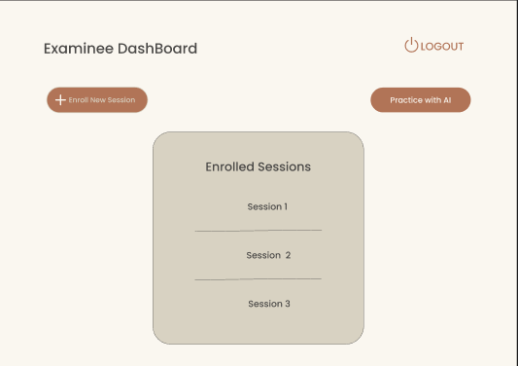

Applicant Practice test creation:
This screen shows practice test screen. Examinee can practice here by providing the material. AI will automatically generate quiz for Examinee.
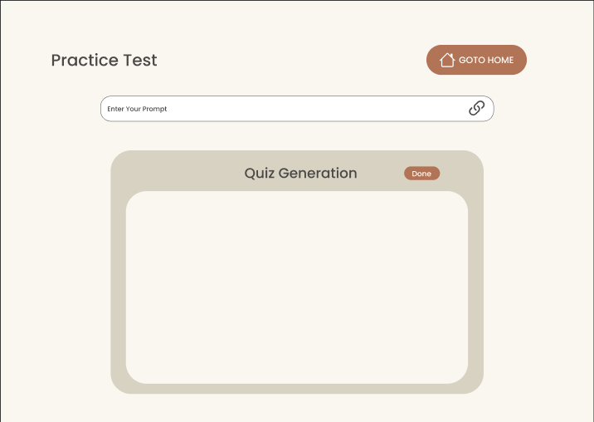

Applicant Test:
This Screen shows Test. Examinee will attempt the quiz before the timer ends and on completion click on done button.
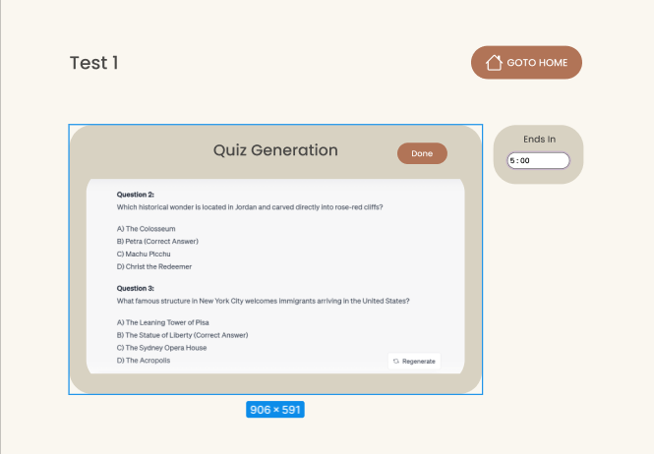

Applicant Enrols New Session:
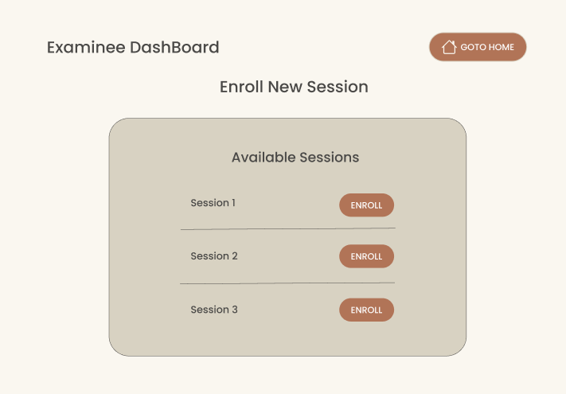

Enrolled Session by Applicant:
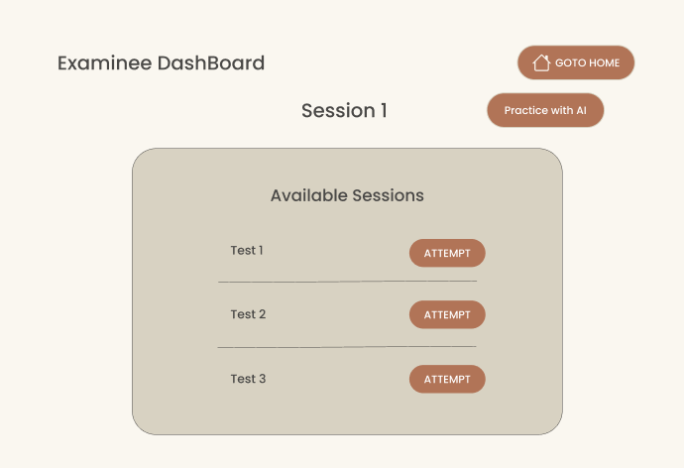

  - Session information by Admin:
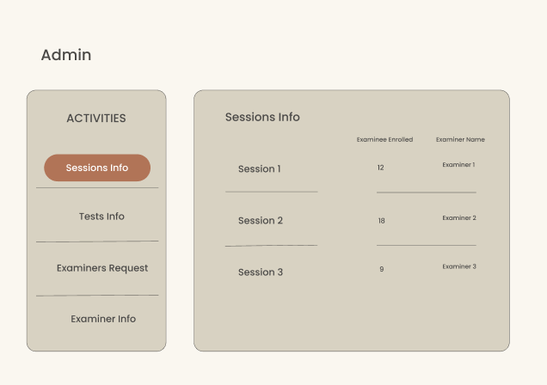

Test Information by Admin
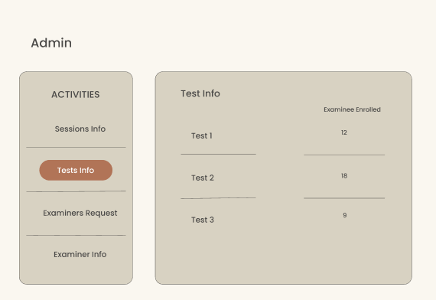

Approved Examiner Request:
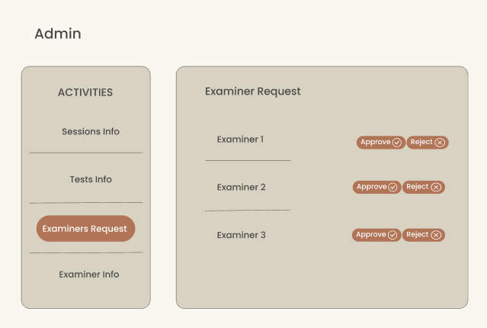

Examiner Information:
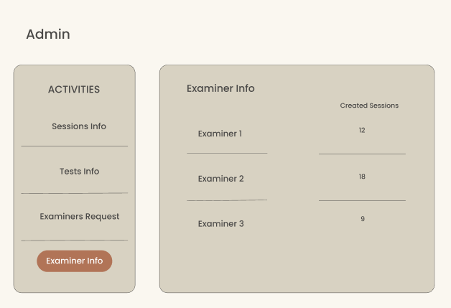

Examiner Dashboard:
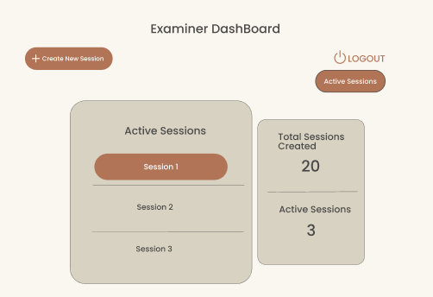

Session:
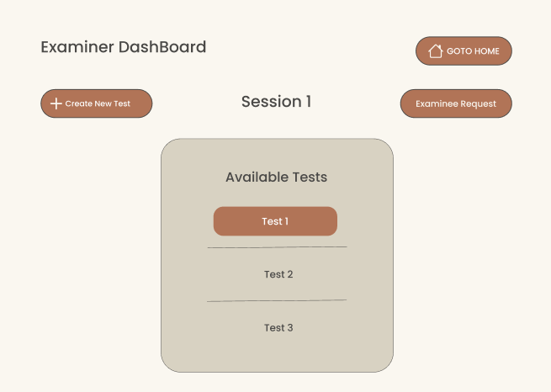

Create Test:
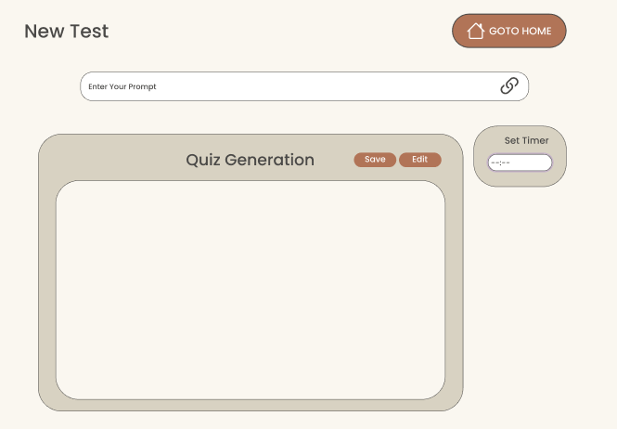

Enrolled Applicants:
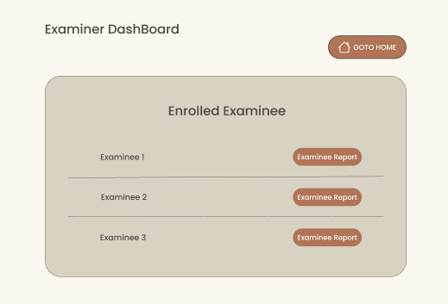
  - Total Session:
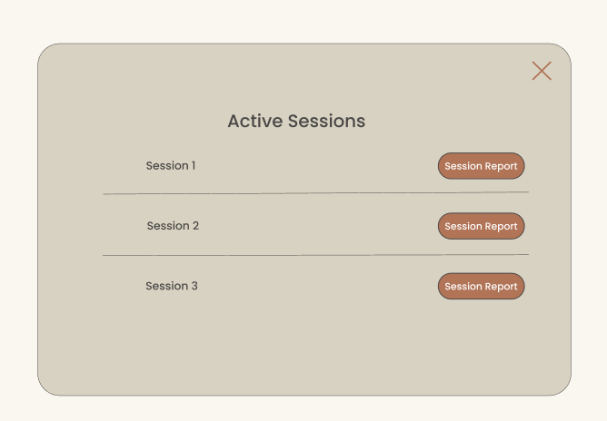

Create New Session:
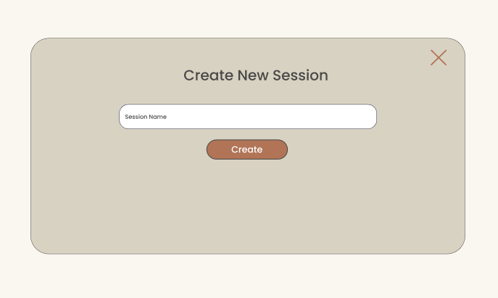

Applicants Request:
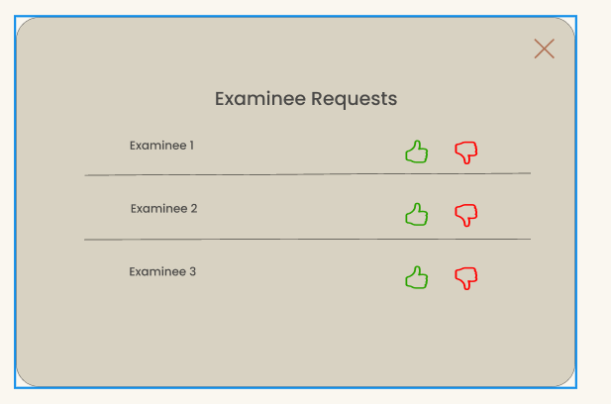

References
- Python Django Documentation, "Django: The Web Framework for Perfectionists with Deadlines," [Online]. Available: https://docs.djangoproject.com/. Accessed: Dec. 2024.
- React.js Documentation, "React – A JavaScript Library for Building User Interfaces," [Online]. Available: https://reactjs.org/. Accessed: Dec. 2024.
- PostgreSQL Global Development Group, "PostgreSQL 13 Documentation," [Online]. Available: https://www.postgresql.org/docs/. Accessed: Dec. 2024.
- OpenAI API Documentation, "GPT-4 API for AI-Driven Test Generation," [Online]. Available: https://platform.openai.com/docs/. Accessed: Dec. 2024.
- H. G. van der Veen, Artificial Intelligence in Education: Promises and Implications for Teaching and Learning, Springer, 2020.
- D. Jones, Learning React: Modern Patterns for Developing Scalable Frontend Applications, O'Reilly Media, 2021.
- B. Smith and K. Gupta, Cloud-Based Solutions for Scalable Web Applications, Wiley Press, 2022.
- T. Fatima, Web Application Development using Django Framework, Packt Publishing, 2021.

Appendix

Appendix A: Acronyms and Abbreviations
Acronym | Description
AI | Artificial Intelligence
MCQ | Multiple Choice Questions
DRF | Django Rest Framework
UI | User Interface
REST API | Representational State Transfer Application Programming Interface
CRUD | Create, Read, Update, Delete
ERD | Entity Relationship Diagram
SRS | Software Requirement Specification

Appendix B: Glossary
- Artificial Intelligence (AI):
A branch of computer science that enables machines to simulate human intelligence processes, such as learning and problem-solving.
- Django Rest Framework (DRF):
A powerful toolkit for building Web APIs using Django, providing features such as serialization, authentication, and API views.
- React.js:
A JavaScript library for building user interfaces, particularly for single-page applications.
- PostgreSQL:
A powerful, open-source object-relational database system that emphasizes extensibility and standards compliance.
- Test Session:
A scheduled time period during which registered applicants take an exam generated by the platform.
- Offline Mode:
A feature that allows applicants to download a test, complete it without an internet connection, and upload the results when back online.

Appendix C: Tools and Technologies
Tool/Technology | Description
Django | A high-level Python web framework for rapid development of web apps.
Django Rest Framework | A framework for creating RESTful APIs using Django.
React.js | A JavaScript library for building dynamic user interfaces.
PostgreSQL | An open-source relational database management system.
OpenAI API | An API that provides AI-driven capabilities, such as natural language processing.
Bootstrap | A frontend framework for responsive web design.

Appendix D: User Roles
- Applicant:
A user who enrolls in test sessions, takes exams, and practices using AI-generated questions.
- Examiner:
A user who uploads study materials, creates test sessions, and analyzes results.
- Admin:
A user who manages accounts, monitors sessions, and generates reports.

Appendix E: Future Enhancements
The following features can be added to improve the platform:
- Payment Integration:
Allowing institutions to charge users for premium services or custom tests.
- LMS Integration:
Providing integration with external Learning Management Systems (LMS) for broader adoption.
- Multilingual Support:
Enabling users to take tests and view reports in multiple languages.

