To do this, we will use **LCD image converter.**You can find it here : <https://sourceforge.net/projects/lcd-image-converter/>

* **Resize your image** to the size of your screen (240x240)
* Click on **New Image**
* Go to **Image / Import**and choose your image

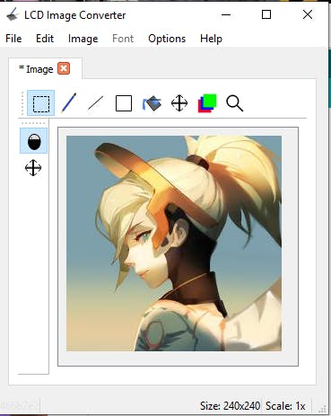

* Go to **Options / Conversion**
* Choose Preset : **Color R5G6B5**
* Go to the **Image**Tab
* Change **Block Size** to **16bit**

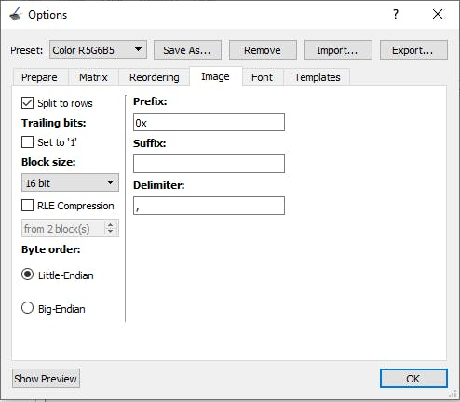

Don't forget to change the block size.

* Click on **Show Preview**
* Copy all the code

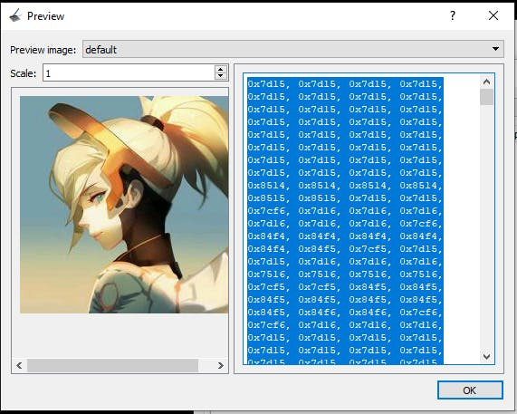

* Paste it **inside the array**

const uint16_t mercy [] PROGMEM = {// --> PASTE HERE};

That's it, upload the code, and it should display your image.