**Laying the foundation for your Marketplace.**

**Type: E-Commerce**

**Description:**

Incorporate glow-in-the-dark threads into intricate

embroidery patterns to create a mesmerising effect.

Design abayas using eco-friendly materials like organic

cotton, recycled polyester, or plant-based textiles.

**Collection Ideas:**

1: Seasonal collection ( Spring, Summer fall, Winter ).

2: Occasion - based collection ( Wedding, Eid,

Ramadan ).

3: Destination - inspired collections ( Dubau, Paris,

Istanbul ).

**Marketing Strategies:**

1: Influencer partnerships.

2: Social media contests and giveaways.

3: Email marketing and newsletters.

4: Collaborations with modest fashion bloggers.

5: Pop-up shops and events.

**Customer Engagement:**

1: Loyalty programs and rewards.

2: Personalized styling services.

3: Customer feedbacks and review incentives.

4: Exclusive events and promotions.

5: Abaya customisation and alteration service.  
  
  
**Product Line:**

Abaya: Various styles, fabrics and colours.

Accessories: Hijabis, scarves and scarfpins.

**Target Market:**

Demographics: Muslims women aged 25 - 45.

Psychographics: Fashions - conscious, mosest,

and culturally sensitive.

Geographic Location: Middle East, North Africa,

and South Asia.  
  
  
**Data Schema:**  
  
• Customers  
• User ID  
• User name  
• Email  
• Password  
• Phone No  
• Address  
  
  
**Products**  
  
• Product ID  
• Product Name  
• Product Name  
• Description  
• Price  
  
  
**Diagram :**  
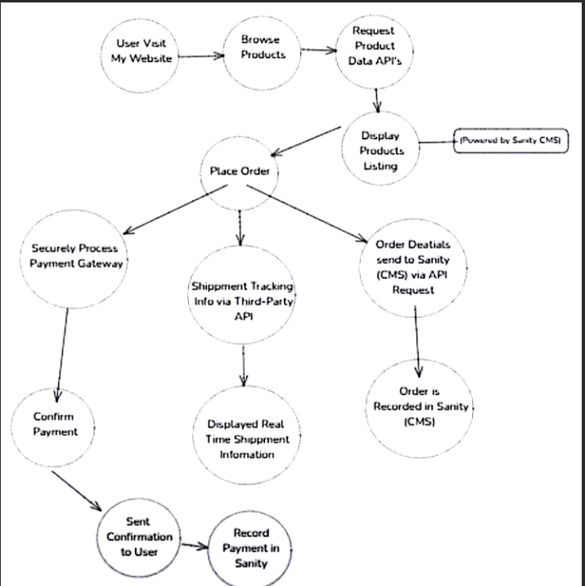

| **Error Test:** | |
| --- | --- |
| **Test Case ID** | **Test Case description** | | **Test Steps** | **Expected Result** | **Actual Result** | **Status** |

|  |  |  |  |  |  |  |  |  |  |  |  |  |  |  |  |  |  |
| --- | --- | --- | --- | --- | --- | --- | --- | --- | --- | --- | --- | --- | --- | --- | --- | --- | --- |
| TC001 | | Ensure responsiveness on mobile | | | Resize browser window > Check layout | | Layout adjusts properly to screen size | | | Responsive layout working as intended | | | |  |  |  | | --- | --- | --- | |  | Passed |  | | |
|  | |  | | |  | |  | | |  | | |  | |
| TC002 | | Check cart functionality | | | Add product to cart > Verify cart contents | | |  |  | | --- | --- | | Show fallback UI with error message |  | | | | |  |  | | --- | --- | |  | Error message shown | | | | |  |  |  | | --- | --- | --- | |  | Passed |  | | |
|  | |  | | |  | |  | | |  | | |  | |
| TC003 | | Test API error handling | | | Disconnect API > Refresh page | | Cart updates with added product | | | Cart updates as expected | | | |  |  |  | | --- | --- | --- | |  | Passed |  | | |
|  |  | |  |  | |  | |  |  | |  |  | |

|  |  |  |  |  |  |  |  |  |
| --- | --- | --- | --- | --- | --- | --- | --- | --- |
|  |  |  |  |  |  |  |  |  |

Overview:

This report outlines the results of the error tests conducted on the website's key features, including responsiveness, cart functionality, and API error handling. The tests were performed to verify that the system handles errors appropriately and provides users with clear feedback.

**Optimization Test :**This report provides insights into the key performance metrics of the website based on Lighthouse auditing. The metrics covered include Accessibility, Best Practices, SEO, and Performance. The website shows strong performance in some areas, while there is room for improvement in others, particularly in performance.

Key Metrics

* Accessibility : 96
* Best Practices Score: 100
* SEO Score: 100
* Performance Score: 94

