GROUP Number : 7
Name : Shahrukh Padaniya C0769542
Swapnil Sevak C0777195
Subject : Principles of Embedded Programming.{1025}

Lab-3 : Create your own C programs, you can submit in a word or pdf file with thescreen shot of the output and the source code in text form. your programshould achieve:
1. Get some integers from your keyboard input.
2. Archive three arithmetic operations with the integers you just enter.
3. Print out both operations and their results.

Code:-

#include <stdio.h>

int main()
{
int a,b,add,sub,multiplication;
printf("Enter first numbers:- ");
scanf("%d",&a);
printf("Enter second numbers:- ");
scanf("%d",&b);
add=a+b;
sub=a-b;
multiplication=a*b;
printf("Addition \n %d + %d = %d \n",a,b,add);
printf("Subtraction \n %d - %d = %d \n",a,b,sub);
printf("Multiplication \n %d * %d = %d \n",a,b,multiplication);
}

Screenshot:-
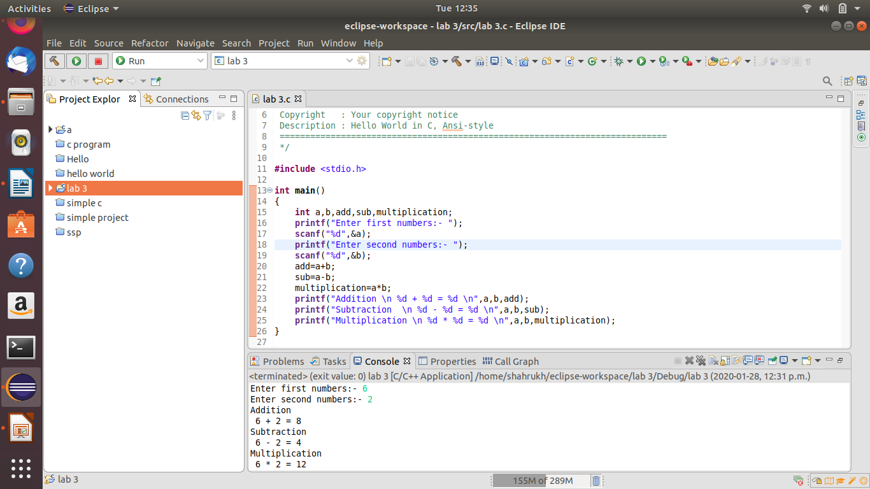
3.1 - Try to print out your name by enter a sequence of integer number.

Code:-

#include <stdio.h>

int main()
{
int a,b,c,d,e,f,g;
printf("Enter ASCII values of your name:-");
scanf("%d%d%d%d%d%d%d",&a,&b,&c,&d,&e,&f,&g);
printf("%c%c%c%c%c%c%c",a,b,c,d,e,f,g);
}

Screenshot:-

